AVD 4 Testers guide or how to test Android App.

1. First of all you need to create 5 AVD

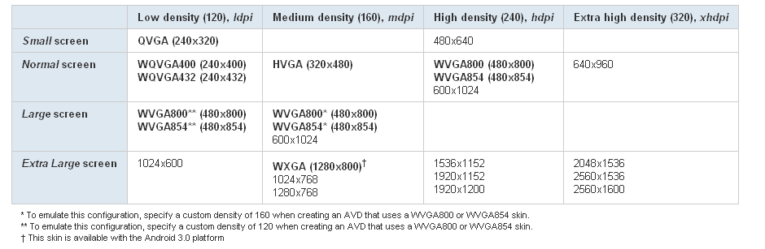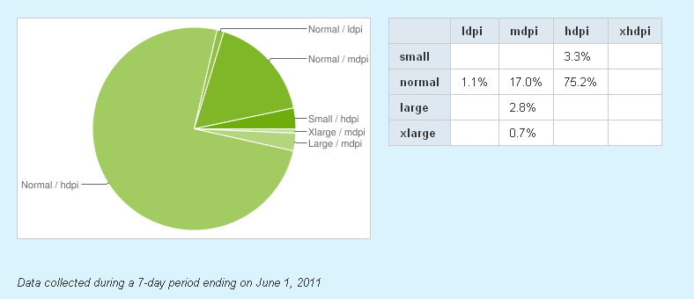

**As you see, the most popular Android version – that’s 2.2**

**And there are 6 types of devices you need to test.**

1. **Normal_ldpi (WQVGA400 density 120)**
2. **Normal_mdpi (HVGA density 160)**
3. **Normal_hdpi (WVGA800 density 240)**
4. **Small_ldpi (QVGA density 120)**
5. **Large_ldpi (WVGA800 density 120)**
6. **Large_mdpi (WVGA800 density 160)**

**P.S. If you have real devices – test on it. AVD don’t provide full view))))**

**1) Go to the AVD Manager and tap New**

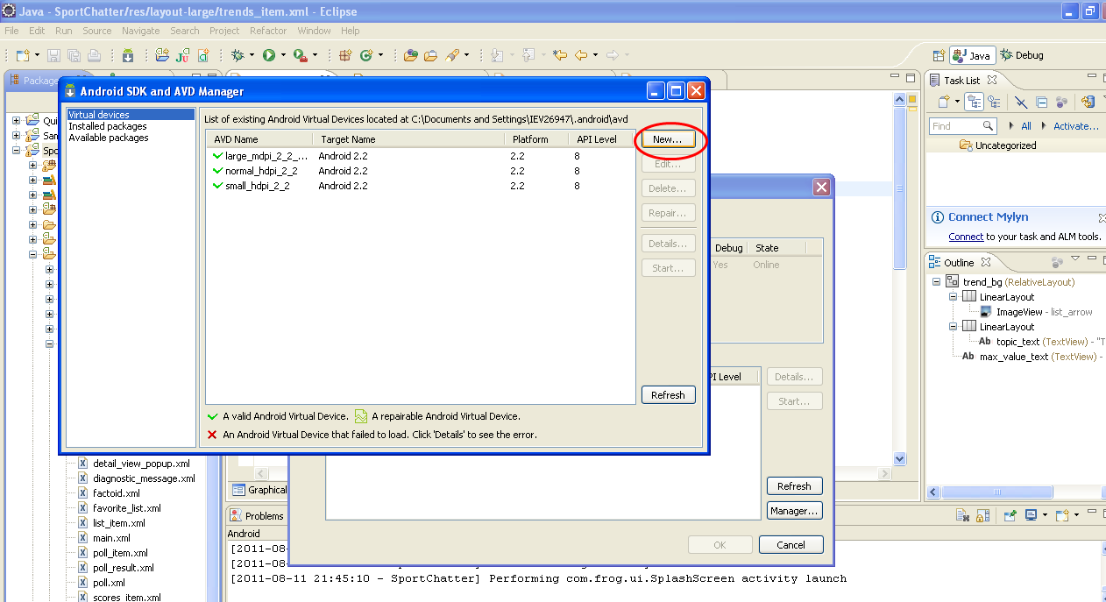

Create normal ldpi AVD with 2.2Android

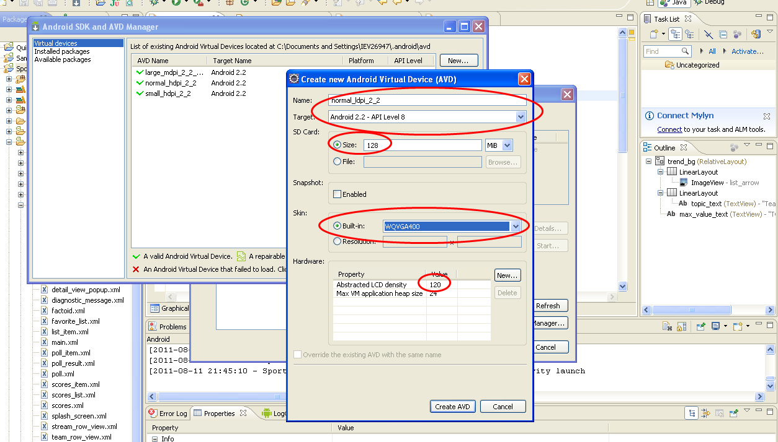

Create normal mdpi AVD with 2.2Android

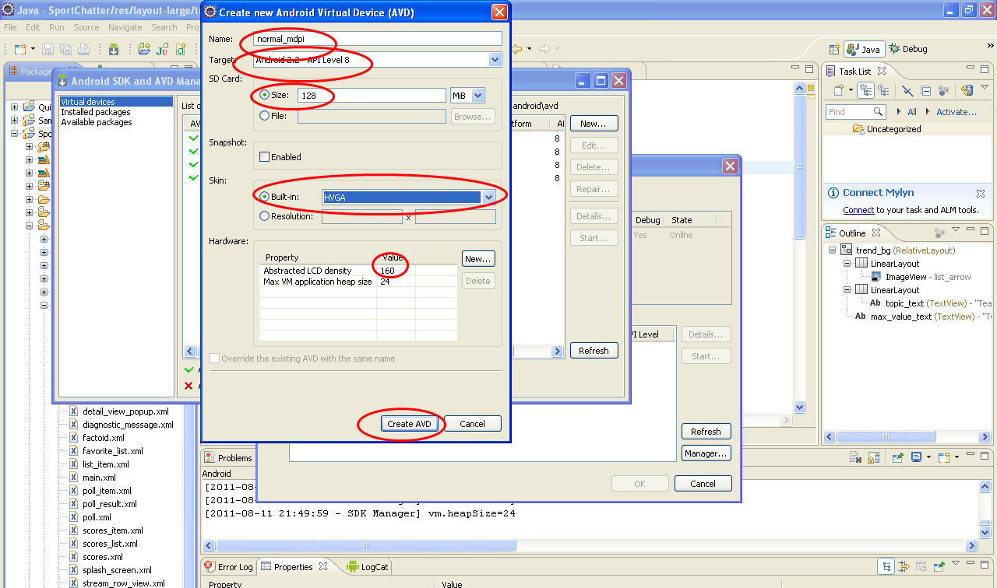

And next 4 one……)))))

After

Go to the Run configuration menu and put **“– scale 96dpi**” as show on a picture below. It provides scale to densities of your monitor which is 96dpi

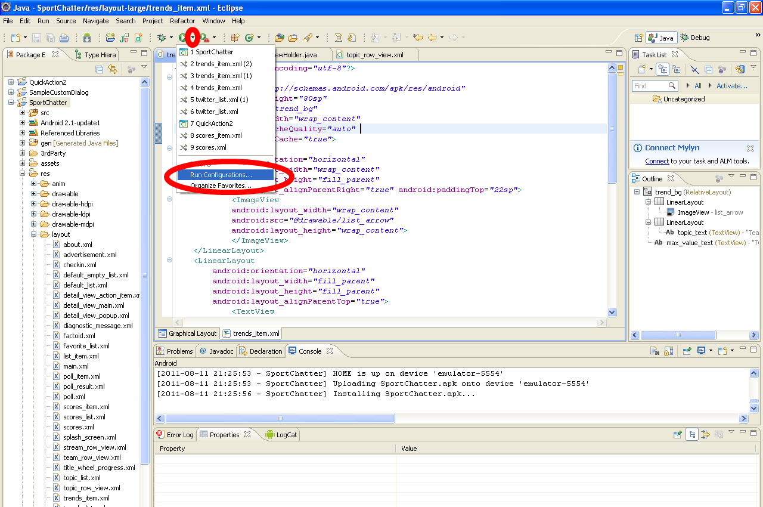

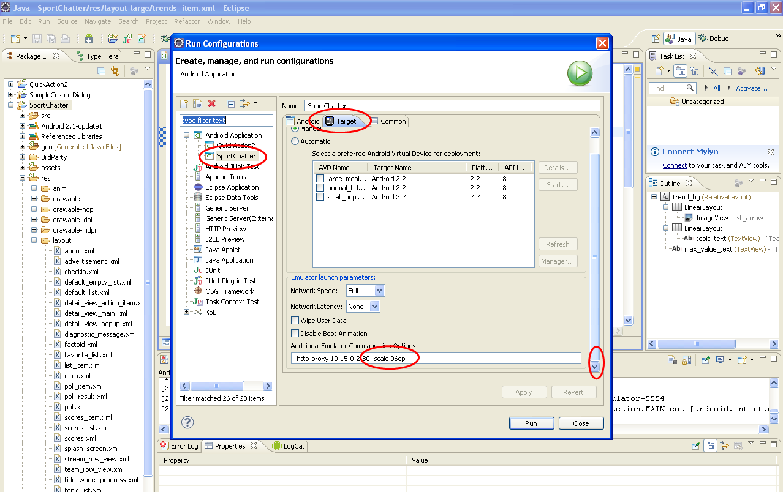

Tap Run and you will have something like that=)))

