**Assignment 1: KWIC-index system**

Code Repository URL: <https://github.com/Pingxia/CS3213_KWIC>

|  |  |  |
| --- | --- | --- |
| Name | Bai Xuefeng | Zheng Pingxia |
| Matriculation Number | A0105655H | A0105662L |
| Implemented | Logic, Storage | UI |

# Introduction

KWIC index system is a search mechanism for information in a long list of lines. The input includes a list of ‘words to ignore’ and a list of ‘titles to process’. For each input, it will be repeatedly removing the first word and appending it at the end of the line. The output will be a list of circularly shifted lines in ascending alphabetical order.

# User Guide

Below is the list of supported functions:

1.

# Design and Architecture

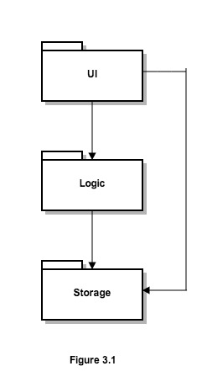

UI handles user input and displays output.

Logic executes the actual commands.

Storage stores all the data (lists etc)

UI is in charge of taking in user inputs and displaying outputs to screen. UI will set the storage component and then call logic component to calculate the actual circular shifts and sort the list. Figure 3.2 is a sequence diagram showing

# Implementation

UI component includes a MainUI class, an InputPanel class and an OutputPanel class.

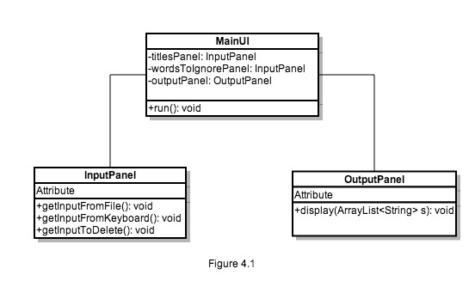

Logic component includes a Manager class, a CircularShifter class and a

Storage component includes a Data class.