**Title: Directed evolution of colE1 plasmid replication compatibility: a fast tractable tunable model for investigating biological orthogonality.**

**Authors:**

Santiago Chaillou*,1, Pinelopi-Eleftheria Stamou*,2, Leticia Torres2, Ana B. Riesco2, Warren Hazelton2, Vitor B. Pinheiro1,#.

1 KU Leuven, Department of Pharmaceutical and Pharmacological Sciences, Rega Institute for Medical Research, Herestraat, 49, 3000, Belgium

2 University College London, Institute of Structural and Molecular Biology, University College London, Gower Street, London, WC1E 6BT, UK

* contributed equally to the publication.

# corresponding author: v.pinheiro@kuleuven.be

**Supplementary information:**

Supplementary Table 1: Primers used in this work 3

Supplementary Table 2: Number of events post single-cell gating used in the analysis of plasmid populations. 3

Supplementary Figure 1: Viable colE1 origins identified by NGS and screening. 4

Supplementary Table 3: Analysis by next generation sequencing of recovered viable origins. 4

Supplementary Figure 2: Compatibility selection in liquid culture. 5

Supplementary Figure 3: NGS analysis after large-scale selection for plasmid compatibility. 5

Supplementary Table 4: Analysis by next generation sequencing of recovered compatible origins. 6

Supplementary Figure 4: High-throughput screening assay for the selection of colE1-compatible origins of replication. 6

Supplementary Figure 5: Characterisation of selected colE1 origin variants for their compatibility with colE1. 7

Supplementary Figure 6: Impact of culture medium on plasmid compatibility and characterization of cross-compatibility. 8

Supplementary Figure 7: Sequence analysis of engineered colE1 origins and quantification of plasmid copy number per cell. 9

Supplementary Figure 8: Pairwise compatibility between origins in plasmids expressing fluorescent proteins. 10

Supplementary Figure 9: Plasmid intercompatibility assays. 11

Supplementary notes: 12

Appendix 1: Asymmetric plasmid compatibility simulated as a Lotka-Volterra system (Jupyter notebook running Julia 1.7.2) 13

|  |  |
| --- | --- |
| Primer name | Primer sequence |
| Construct and library assembly | |
| ES VCTR FW | AAAGGTCTCAAGTGTAGCCGTAGTTAGGC |
| ES VCTR RV | AAAGGTCTCACAAGCAGCAGATTACGCG |
| ES ULTR RNAI FW | GGGGGTCTCACACTTAGAAG |
| ES ULTR REV | ACACACAGGTCTCACTTGC |
| ES COLEI ins GIBS FW | CTACGCATGGCTCAAAACACCCCTTGT |
| ES COLEI ins GIBS RV | TTTTTCCATAGGCTCCGCC |
| ES 002 FW | AAAGGTCTCACGTTAAAGGAAGCTGAGTTGGCT |
| ES 002 RV | AAAGGTCTCATAGAGGGGAATTGTTATCCGC |
| ES 003 FW | AAAGGTCTCATCTAGGGCTAACAGGAGGAATTAAC |
| ES 003 RV | AAAGGTCTCAAACGCATCCGCCAAAACAGC |
| ES BAD GFP FW | AAAGGTCTCACCCGTTTTTTGGGCTAAC |
| ES BAD GFP RV | AAAGGTCTCAGCTTCGCTTCTGCGTTCTGAT |
| ES PET GFP FW | AAAGGTCTCAAAGCCCGAAAGGAA |
| ES PET GFP RV | AAAGGTCTCACGGGAATTGTTATCCGCT |
| ES sfGFP plasm ampl FW | GGCGGAGCCTATGGAAAAA |
| ES sfGFP plasm ampl RV | GGGGTGTTTTGAGCCATGCGTAGAGGATCTGCTCA |
| SC_pBAD_dOri_FW | AAACGTCTCACTTGCATGTGTCAGAGGTTTTCAC |
| SC_pBAD_dOri_RV | AAACGTCTCATCACTCAGTGGAACGAAAACTCAC |
| SC_pBAD_dOri_dATB_RV | AAACGTCTCATCACTGTAGAAACGCAAAAAGGCC |
| SC_pET_addOri_addATB_FW | AAAGGTCTCAGTGACGTTTACAATTTCAGGTGGC |
| SC_pET_addOri_addATB_RV | AAAGGTCTCACAAGATCAGCTCACTCAAAGGC |
| SC_pWH_addOri_addATB_FW | AAAGGTCTCAGTGATTCCGTGATGGTAACTTCAC |
| SC_pWH_addOri_FW | AAAGGTCTCAGTGAGCAAGGATCTTCTTGAGATCC |
| SC_pWH_addOri_addATB_RV | AAAGGTCTCACAAGAATCATCTGGCCATTCGATG |
| AR_pWHalpha_Fw | TATGGAAAAACGCCAGCAACG |
| AR_pWHalpha_Rv | AAGATCCTTGCACTCGAGTTGATCG |
| VP023F | TTTGGTCTCA AAGTTGCACTCGAGTTGATCGGGC |
| VP023R | TTTGGTCTCA TTCCGCCTTTTTACGGTTCCTGGCC |
|  |  |
| WH81 | TCCTCGAGGCTTGGATTCTC |
| WH82 | TGCACTCGAGTTGATCGGG |
| WH83 | TGCCCGATCAACTCGAGTGCAAGGATCTTCTTGAGATCC |
| WH84 | AACGAGACATCATTTTTTGCCCTCGTTATCTAG |
| WH85 | AGGGCAAAAAATGATGTCTCGTTTAGATAAAAG |
| WH86 | AGAATCCAAGCCTCGAGGAAGATCCTTTGATCTTTTCTAC |
| WH87 | TCCCTATCAGTGATAGAGAACCTCTAGAAATAATTTTGTTTAAC |
| WH88 | ATCAATGATAGAGTGTCAACATTTCGCGGGATCGAG |
| TetA | GTTGACACTCTATCATTGATAGAGTTATTTTACCACTCCCTATCAGTGATAGAGAA |
| TetAR | TTCTCTATCACTGATAGGGAGTGGTAAAATAACTCTATCAATGATAGAGTGTCAAC |
| Sequencing |  |
| ES seq-ing 001 | TCACTCAAAGGCGGTAA |
| ES seq-ing 002 | TGTCGGGTCATGTGAGCAA |
| ES seq-ing 002 FW | ATGGCTCATAACACCCCTTGT |
| NGS_Forward primer | TTCTGCGCGTAATCTGCTGC |
| NGS_Reverse primer | GGCCTAACTACGGCTACACTAG |
| ES DEEP SEQ PET ini FW | AATGATACGGCGACCACCGAGATCTACACTCTTTCCCTACACGACGCTCTTCCGATCTNNNTGACCATTCTGCGCGTAATCTGCTGC |
| ES DEEP SEQ PET vai FW | AATGATACGGCGACCACCGAGATCTACACTCTTTCCCTACACGACGCTCTTCCGATCTNNN ACAGTGTTCTGCGCGTAATCTGCTGC |
| ES DEEP SEQ PET RV | CAAGCAGAAGACGGCATACGAGATCGGTCTCGGCATTCCTGCTGAACCGCTCTTCCGATCTGGCCTAACTACGGCTACACTAG |
| Digital PCR |  |
| SC_dPCR_Chl_FW | AATAAAGGCCGGATAAAACTTG |
| SC_dPCR_Chl_RV | CTGGATATACCACCGTTGATAT |
| SC_dPCR_Chl_probe | /56-FAM/AATATCCAG/ZEN/CTGAACGGTCTGG/3IABKFQ/ |
| SC_dPCR_ter_FW | AATAACATTCATTGGGTTGGTC |
| SC_dPCR_ter_RV | GCATGGTTAATCACGATGTAAT |
| SC_dPCR_ter_probe | /5HEX/AATAGCTAC/ZEN/CTCATCCGCGAAG/3IABKFQ/ |

Supplementary Table 1: Primers used in this work**.** All primers are shown in 5’→3’ orientation. Chemical modifications for the primers used in digital PCR were as follows: /56-FAM/ - fluorescein; /ZEN/ - ZENTMquencher; /3IABKFQ/ - Iowa Black® FQ; /5HEX/ - Hexachlorofluorescein.

|  |  |
| --- | --- |
| Plasmid combination | # events |
| Intercompatibility experiments | |
| D4_1 (all) | 2754 |
| D4_1 (CM only) | 43973 |
| D4_1 (no ATB) | 9029 |
| G6 (all) | 6736 |
| G6 (CM only) | 10225 |
| G6 (no ATB) | 3597 |
| G4 (all) | 2417 |
| G4 (CM only) | 9626 |
| G4 (no ATB) | 3046 |
|  |  |
| Pairwise_intercompatibility experiments | |
| D4_2 + colE1 (CM) | 8804 |
| D4_2 + colE1 (no ATB) | 6896 |
| D4_1 + colE1 (no ATB) | 1520 |
| colE1 + G4 (no ATB) | 8195 |
| colE1 + G6 (no ATB) | 5304 |
| D4_1 + D4_2 (CM only) | 1903 |
| D4_1 + D4_2 (no ATB) | 6851 |
| D4_2 + G6 (CM only) | 2625 |
| D4_2 + G6 (no ATB) | 9647 |
| D4_2 + G4 (CM only) | 1399 |
| D4_2 + G4 (no ATB) | 2428 |

Supplementary Table 2: Number of events post single-cell gating used in the analysis of plasmid populations.Naming of the experiments refers to the origins from each plasmid as described in the main text. Compatibility experiments carried out in the presence of kanamycin, chloramphenicol and ampicillin are shown as (all). Where only chloramphenicol was used in the experiment, samples are shown as (CM only). Experiments carried out in the absence of any antibiotic are shown as (no ATB).

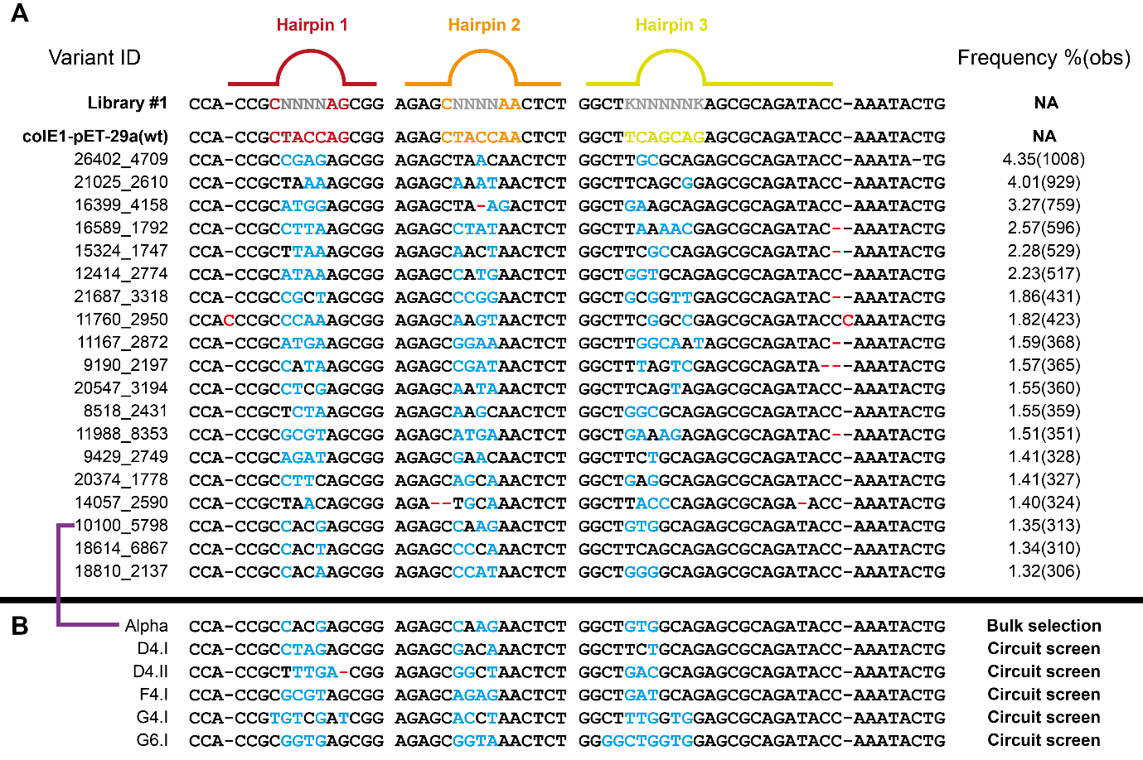

Supplementary Figure 1: Viable colE1 origins identified by NGS and screening. **A.** NGS analysis of viable colE1 origins isolated from transformation of library #1. Mutations away from the wild-type sequence introduced by the library are shown in blue, mutations arising from selection are shown in red. Frequency of isolated origins is shown with the individual number of observations in brackets. The ID (automatically generated in sequencing) of one of the unique sequences is picked (arbitrarily) to name the group. NA – not applicable. **B.** Engineered colE1 origins described in this work.

|  |  |
| --- | --- |
| Pipeline step | Sequences output |
| Total read number | 31144 |
| Quality trimming | 31144 (100%) |
| Filtering by 5’ sequence | 29916 (96%) |
| Filtering by 5’ sequence #2 | 29151 (94%) |
| Filtering by 3’ sequence | 27175 (87%) |
| Filtering by 3’ sequence #2 | 23183* (74%) |
| Unique sequences | 1903 |

Supplementary Table 3: Analysis by next generation sequencing of recovered viable origins.Total read number obtained and the impact of the analysis pipeline are shown. *Number of sequences used in downstream analysis.

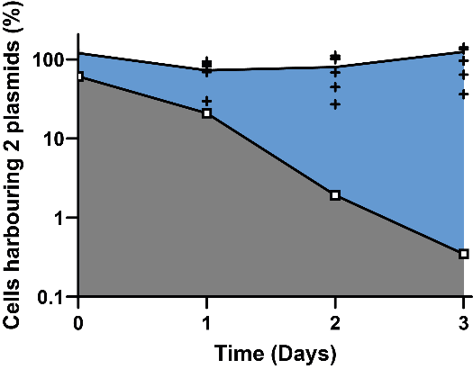

Supplementary Figure 2: Compatibility selection in liquid culture. *E. coli* harbouring pSB1C3 (colE1 origin) and transformed with pET29 containing its wild-type (colE1; white squares) or a library of viable origins (black crosses) were serially passaged, with samples plated in the absence of antibiotics (to determine total CFU) or in the presence of both antibiotics (to determine CFU still harbouring both plasmids). As expected, under the growth conditions, the wild type colE1 origin is rapidly lost from the population.

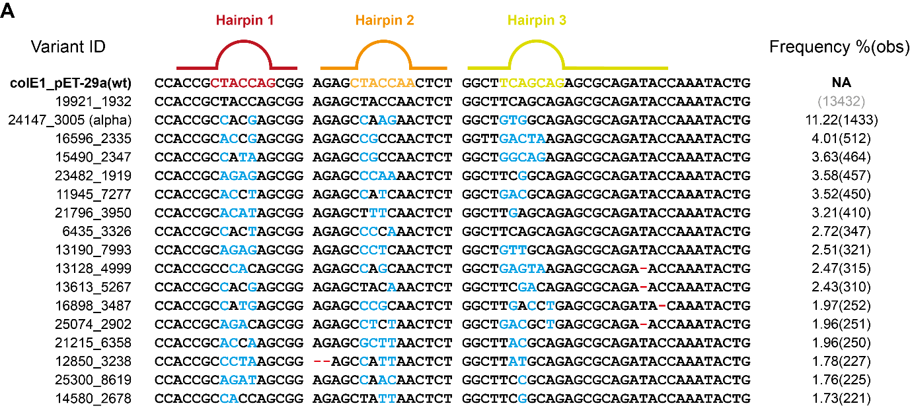

Supplementary Figure 3: NGS analysis after large-scale selection for plasmid compatibility. NGS analysis of colE1 origins isolated after selection of viable colE1 variants co-transformed with wild-type colE1. Mutations away from the wild-type sequence introduced by the library are shown in blue, mutations arising from selection are shown in red. Frequency of isolated origins is shown with the individual number of observations in brackets. Wild-type colE1 sequences were identified in the experiment (a limitation of the approach used to prepare plasmid DNA for NGS) and are excluded from the analysis – the number of observations is still given. The ID (automatically generated in sequencing) of one of the unique sequences is picked (arbitrarily) to name the group. NA – not applicable.

|  |  |
| --- | --- |
| Pipeline step | Sequences output |
| Total read number | 28438 |
| Quality trimming | 28438 (100%) |
| Filtering by 5’ sequence | 27876 (98%) |
| Filtering by 5’ sequence #2 | 27708 (97%) |
| Filtering by 3’ sequence | 26777 (94%) |
| Filtering by 3’ sequence #2 | 26206* (92%) |
| Unique sequences | 1185 |

Supplementary Table 4: Analysis by next generation sequencing of recovered compatible origins.Total read number obtained and the impact of the analysis pipeline are shown. *Number of sequences used in downstream analysis.

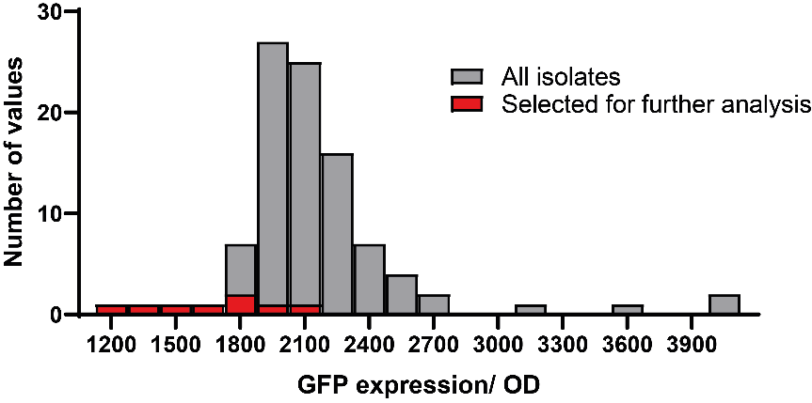

Supplementary Figure 4: High-throughput screening assay for the selection of colE1-compatible origins of replication.Histogram representation of the data shown in Figure 3C, highlighting the fluorescence values of the variants selected for further study.

Supplementary Figure 5: Characterisation of selected colE1 origin variants for their compatibility with colE1. **A.** Serial cultures of *E. coli* cells co-transformed with reporter (harbouring one of D4.I, F4, G4, G6 and wild-type origins of replication) and regulatory (harbouring D4.I, F4, G4 or G6 origins) were used to test the compatibility of the selected variants against wild-type and to confirm their self-incompatibility. The percentage of cells expressing GFP was calculated by diluting a culture aliquot (after 1 or 7 days of passaging) and plating in LB agar supplemented with chloramphenicol (to retain reporter plasmid). Bar graphs are overlaid with compatibility to wild-type shown in green (light or dark depending on passage number) and self-incompatibility shown in orange (light or dark depending on passage number). **B.** Example of transformation plate used to calculate values in **A.** Here, D4.I was used in both regulatory and reporter plasmids and the results show the distribution of plasmids after 7 days of passaging. Fluorescent images from GFP (green) and control channels (red) are overlaid and CFU counted. **C.** Complementary experiment where after passaging in the absence of antibiotic selection, cultures are plated in media supplemented with kanamycin (regulatory plasmid antibiotic marker) or with both antibiotics to monitor plasmid loss. Bar graphs are overlaid with compatibility to wild-type shown in green and self-incompatibility shown in orange. **D.** Plasmids isolated after coc-culture experiments, showing that both plasmids are retained throughout the experiment. Notably, it is possible to see the variation of copy number between the origins described and how D4.II has a lower copy number than G6 (in contrast to Figure 4C) when in the presence of wild-type origin. Evolved origins are present in the reporter construct (pGFP) while wild-type origins were used in the regulatory plasmid (pTetR). Transformation of isolated reporter constructs confirm that most are still able to express GFP (data not shown). Sequencing of isolated reporter constructs from this experiment confirm that promoter, RBS and GFP gene did not acquire any mutations within the experimental time frame (data not shown). While not shown, the data are available in the online Github repository.

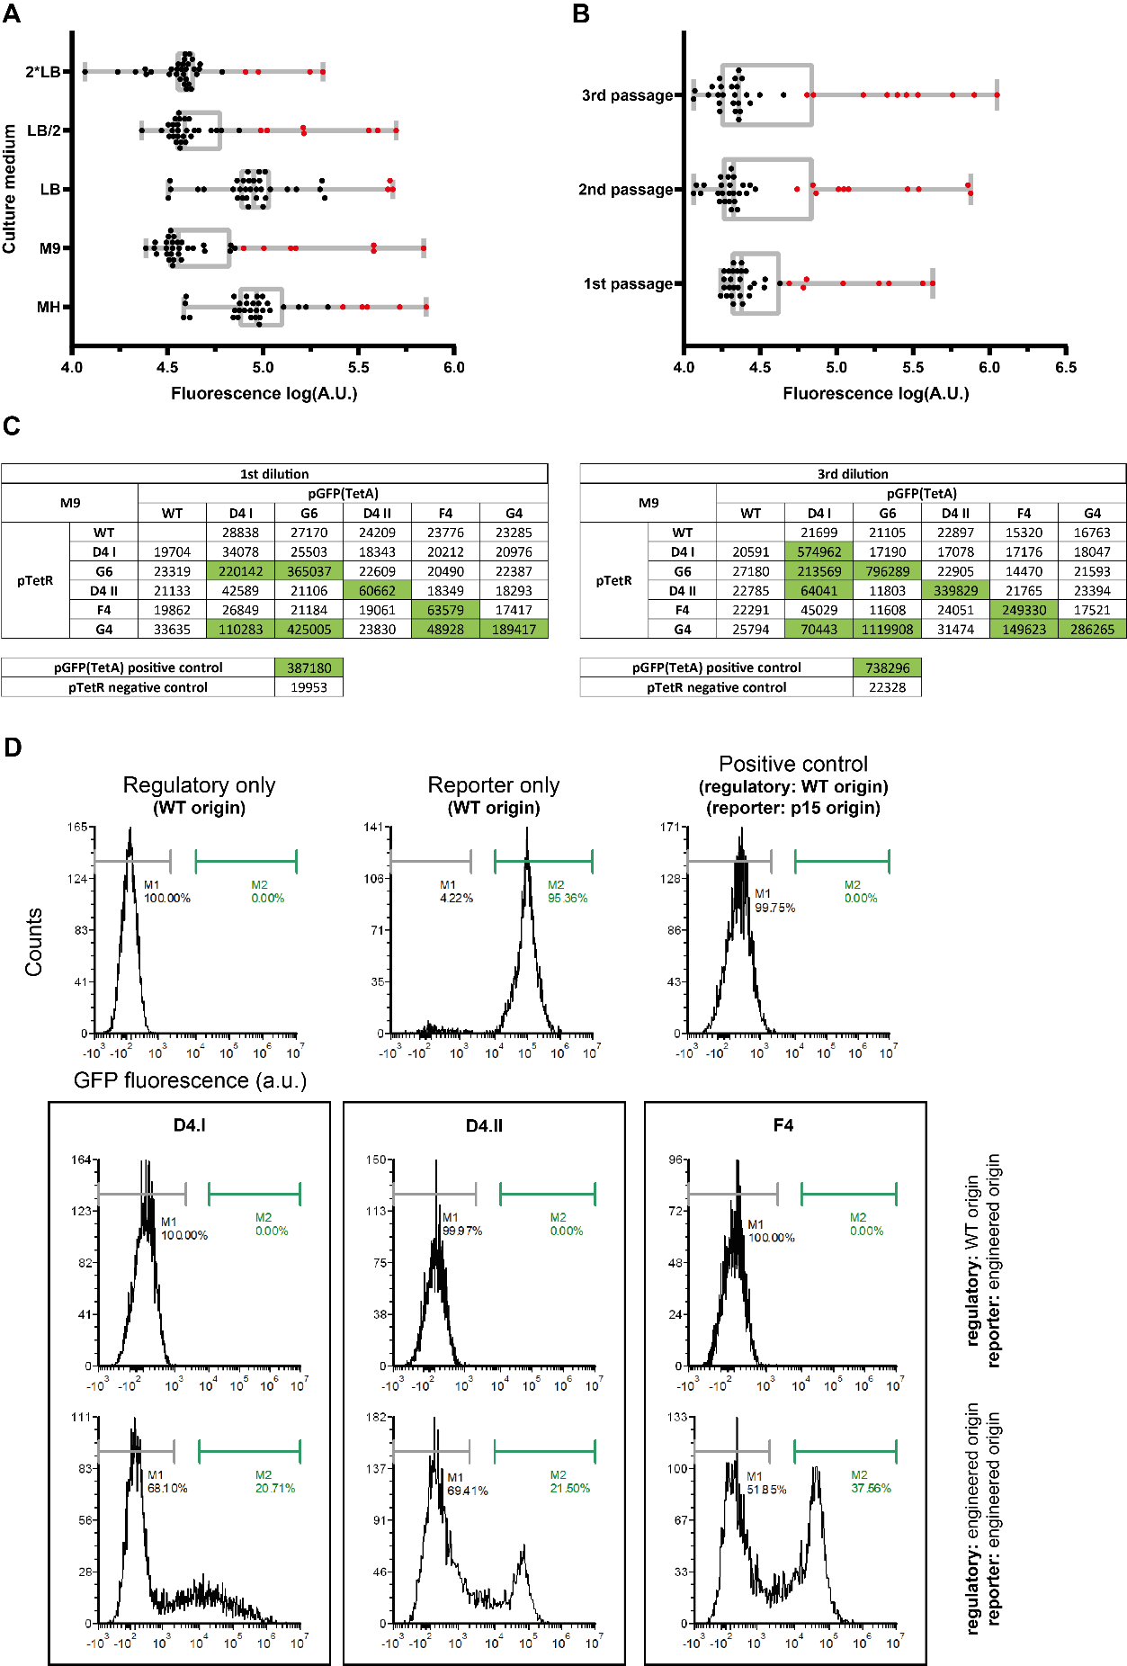

Supplementary Figure 6: Impact of culture medium on plasmid compatibility and characterization of cross-compatibility. **A.** Box plot showing the distribution of normalized fluorescence for cross-compatibility assays carried out in different culture media (single passage). Outliers (2% cut-off in ROUT analysis), that is significantly expressing GFP, are shown in red. **B.** Box plot showing the impact of passaging in cross-compatibility assays in M9 media. Outliers (2% cut-off in ROUT analysis), that is significantly expressing GFP, are shown in red. **C.** Cross-compatibility results (normalized fluorescence values) obtained in M9 after one or two passages. Outliers identified in **B.** are shown in green. The third passage is shown in Figure 4A. **D.** Flow cytometry analysis of cross-compatibility assays showing controls and selected replication origins, their compatibility to wild-type colE1 origins and their self-incompatibility. Markers show ranges used to quantify non-fluorescence (grey) and fluorescent (green) fractions of the populations. Each experiment included at least 6200 events post single-cell gating.

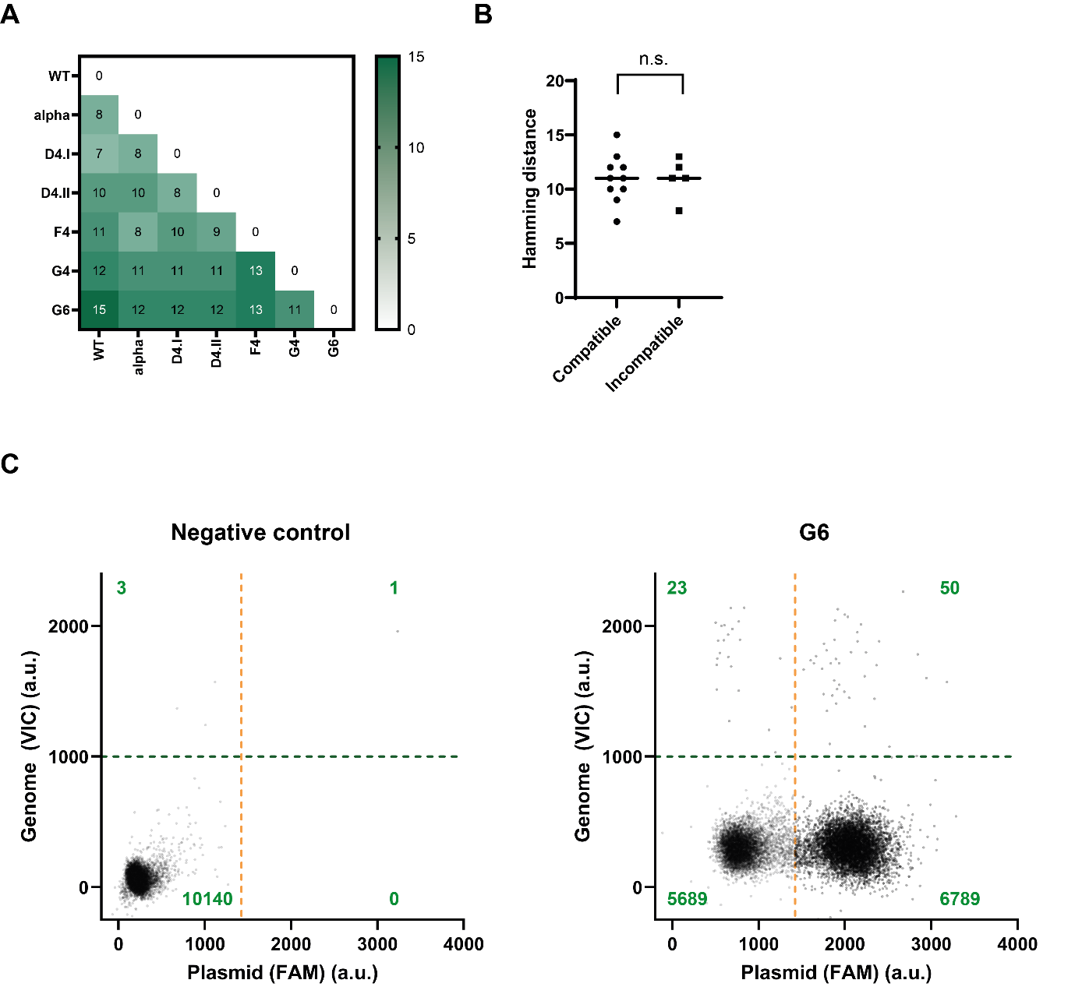

Supplementary Figure 7: Sequence analysis of engineered colE1 origins and quantification of plasmid copy number per cell. **A.** Hamming distance (number of substitutions between 2 sequences) between the engineered origins of replication. **B.** Hamming distance distribution between compatible and incompatible colE1 origins (using data presented in Figure 4A). A Kolmogorov-Smirnov test was used to compare the two Hamming distance distributions but no significant different was observed. **C.** Examples of digital PCR results to show negative control (no template) and results obtained for G6 engineered origin. The quadrants are determined automatically by the analysis program and the number of observations in each quadrant are shown in green.

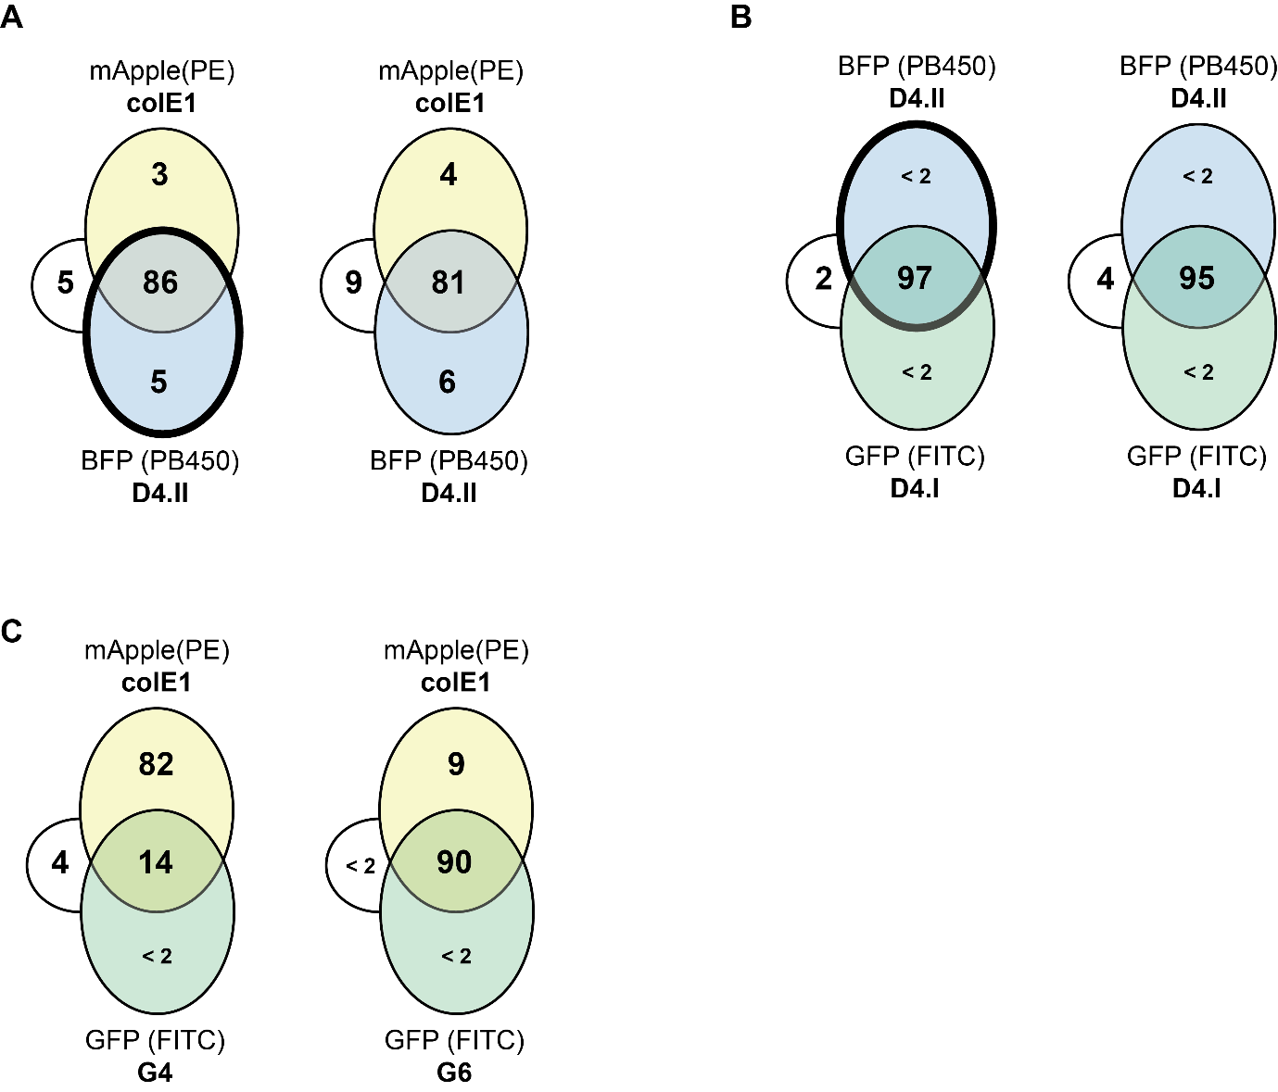

Supplementary Figure 8: Pairwise compatibility between origins in plasmids expressing fluorescent proteins.Summary of flow cytometry analysis of cultures post-serial passaging in M9 used to investigate plasmid retention and plasmid compatibility. Origins and fluorescent protein encoded are shown around the edges of the Venn diagram: D4.II origin in mTagBFP2-pBAD (blue), colE1 origin in mApple-pBAD (yellow) and other origins in GFP-pBAD (green). Thick borders show experiments where chloramphenicol was used to ensure D4.II plasmid retention. **A.** D4.II and colE1 origins. **B.** D4.I and D4.II origins. Both show that chloramphenicol selection has little impact on the retention of the plasmids. **C.** colE1 origins and G4 or G6. Under the culture conditions used for this experiment, the G4 origin is lost from the population (in alignment with what was seen in SI Fig 5C, but different from what was observed in the high-throughput assay (Figure 4A). These experiments were also used as controls for the 3-way intercompatibility assays.

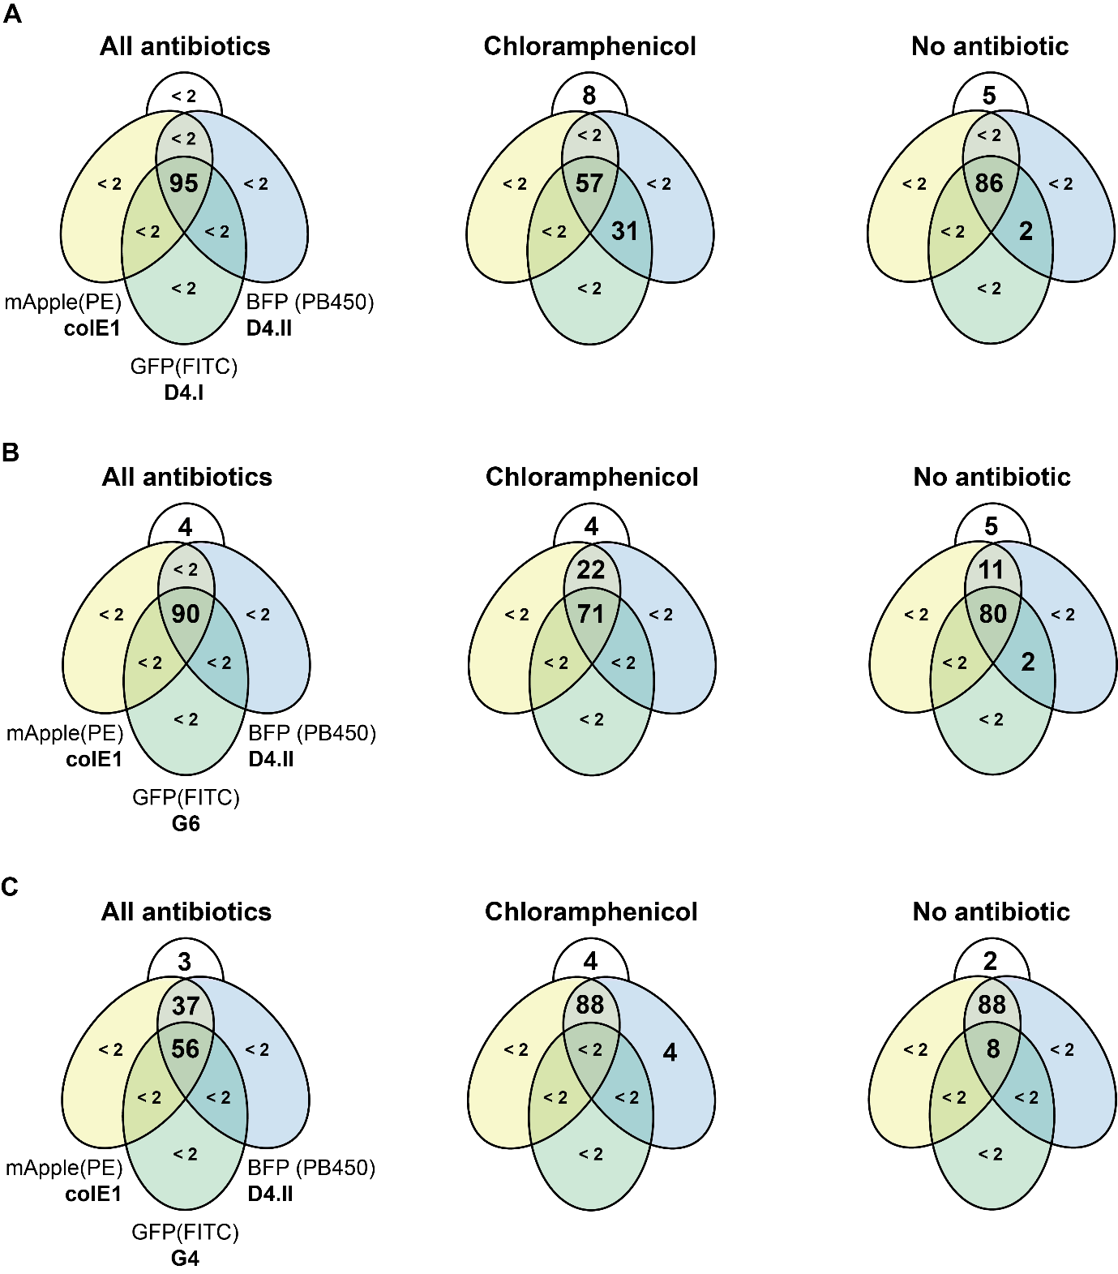

Supplementary Figure 9: Plasmid intercompatibility assays. Summary of flow cytometry analysis of cultures post-serial passaging in M9 used to investigate plasmid retention and plasmid compatibility. Cells co-transformed with three plasmids harbouring different plasmid origin combinations were serially passaged in M9 before being analysed by flow cytometry to determine which plasmids had been retained in culture. Plasmid origins and fluorescent proteins are shown for each combination around the Venn diagram. BFP is shown in blue, mApple in yellow and GFP in green. Cultures were maintained with all antibiotics (ampicillin, chloramphenicol and kanamycin), or with only chloramphenicol, or without any added antibiotics. **A.** Origins D4.I, D4.II and wild-type colE1. Passaging of the culture in the presence of chloramphenicol results in significant wild-type colE1 loss. **B.** Origins G6, D4.II and colE1. Plasmid harbouring G6 origin is preferentially lost from culture but at slow rates, ensuring that most of the population retains all 3 plasmids. **C.** Origins G4, D4.II and wild-type colE1. In contrast to the pairwise assays, plasmids with the G4 origin were rapidly lost from the population, even in the presence of all three antibiotics, suggesting that it may not as stable as other origins or that its low copy number puts it in a significant disadvantage during replication.

Supplementary notes:

**Polymerase Chain Reaction.** PCR was used to generate the biological constructs for this work. Unless stated otherwise, all reactions were carried out in 50 μL with the following reaction components: 1X Q5 reaction buffer, 0.5 μM of each primer, 200 μM dNTPs, 0.2 ng/μL of template, 0.02 U/μl Q5 enzyme (New England Biolabs), and deionized sterile water to complete the reaction volume. The reaction conditions typically consisted of an initial denaturation at 95°C for 30 seconds, followed by 30 – 32 cycles of 95°C for 20 seconds, 50 - 72°C for 30 seconds, 72°C for 30 seconds/kb of the target DNA product. All reactions included final 72°C extension for 5 minutes.

**Raw data.** All data and analyses generated in this project are publicly available at <https://github.com/PinheiroLab/Engineered_colE1_origins>. Sequences for the newly described colE1 origins have been deposited on GenBank under the following accession numbers: OL702929, OL702930, OL702931, OL702932, OL702933 and OL702934. Next generation sequencing data has been deposited on NCBI SRA under the following accession number: PRJNA783752.

Appendix 1: Asymmetric plasmid compatibility simulated as a Lotka-Volterra system (Jupyter notebook running Julia 1.7.2)

**Asymmetric plasmid compatibility simulated as a Lotka-Volterra system**

Vitor Pinheiro (v1.0) - 15.05.22

*## Packages required for calculation and visualization*using DifferentialEquationsusing Plots

**Setting up a 2-population Lotka-Volterra (LV) system**

**function** two_plasmid_competition!(du, u, p, t) *## 2-population generic LV system* A, B = u a1, a2, a3, b1, b2, b3 = p du[1] = dA = a1*A - a2*A^2 + a3*A*B du[2] = dB = b1*B - b2*B^2 + b3*A*B**end**

two_plasmid_competition! (generic function with 1 method)

*## Parameters*a1 = 1 *#= For simplicity we have placed a1 and b1 as 1. Consequently, time does not represent a convenient unit (e.g. minutes)=#*a2 = 1/100 *## a1/a2 is the carrying capacity of plasmid A  
#= More accurately, the carrying capacity needs to be represented as 1/(x+y), where x refers to the carrying capacity  
 without antibiotic selection and y is the increase in copy number driven by antibiotic selection =#*a3 = - 7/1000 *## impact of B on A*b1 = 1b2 = 1/50 *## b1/b2 is the carrying capacity of plasmid B*b3 = - 17/1000 *## impact of A on B  
  
## Initial conditions  
#= Because experimentally cells are grown in the presence of both antibiotics, the initial conditions   
should be the carrying capacity of each of the plasmids. Nevertheless, this type of LV system always converges  
towards a single equilibrium point. Therefore most starting conditions will lead to the same long-term result =#*a0 = 1/a2b0 = 1/b2 *## Reformatting parameters for function*p = [a1, a2, a3, b1, b2, b3]u0 = [a0, b0];

*## Solution  
  
#= While the LV system can be solved analytically, we provide here the numerical solution to avoid having to introduce error   
 checking for equilibrium positions that are not in the real positive space for both populations. =#*tspan = (0.0, 100.0) *# gives the model 100 units of time to run*problem = ODEProblem(two_plasmid_competition!, u0, tspan, p)solution = solve(problem, AutoVern7(Rodas5()), dt=0.1)solution(100) *## returns the two plasmid populations at t = 100*

2-element Vector{Float64}: 99.9999955110674 2.621838197958631e-15

*## Plots the two populations as a function of time*plot(solution, vars=(0,2), linewidth = 3, ylims = (0.0,max(a0,b0)), label = "B(t)")plot!(solution, vars=(0,1), linewidth = 3, label = "A(t)")

**Analysing the parameter space of a 2-population LV system**

*## Solving the predicted interaction across a large window of interaction parameters*a3_range = -0.02:0.0001:0 *# sets up the range of the investigation*b3_range = -0.02:0.0001:0results_A = zeros(length(a3_range), length(b3_range)) *# prepares a matrix for entering the results*results_B = zeros(length(a3_range), length(b3_range))**for** i = 1:length(a3_range) **for** j = 1:length(b3_range) a3 = a3_range[i] b3 = b3_range[j] p = [a1, a2, a3, b1, b2, b3] u0 = [a0, b0]; tspan = (0.0, 100.0) *# gives the model 100 units of time to run* problem = ODEProblem(two_plasmid_competition!, u0, tspan, p) solution = solve(problem, AutoVern7(Rodas5()), dt=0.1) results_A[i,j] = solution(100)[1] results_B[i,j] = solution(100)[2]  **end****end**

*## Effect on population A*heatmap(a3_range, b3_range, results_A, c = :thermal, xlabel = "Effect of oriA on oriB (b3)", ylabel = "Effect of oriB on oriA (a3)", title = "Plasmid A", clims = (0.0,max(a0,b0)))

*## Effect on population B*heatmap(a3_range, b3_range, results_B, c = :thermal, xlabel = "Effect of oriA on oriB (b3)", ylabel = "Effect of oriB on oriA (a3)", title = "Plasmid B", clims = (0.0,max(a0,b0)))

*## Determining areas of co-existence*compatibility = zeros(length(a3_range), length(b3_range)) *# prepares a matrix for entering the results***for** n = 1: length(results_A) **if** results_A[n] <= 1 || results_B[n] <= 1 *#= Because the system is continuous, it tolerates very small numbers which would have no real meaning  
 in a discrete system. As such, we have used here a cut-off of 1, below which the discrete nature of the real system   
 would break down =#* compatibility[n] = 0.0 **else** compatibility[n] = 1.0 **end****end**heatmap(a3_range, b3_range, compatibility, c = :blues, colorbar=false, xlabel = "Effect of oriA on oriB (b3)",ylabel = "Effect of oriB on oriA (a3)", title = "Compatibility parameter space") *# light blue = incompatible, dark blue = compatible*

**Analysing 2-plasmid populations based on the dPCR data obtained**

*## From our dPCR data we have that:  
  
#= G4: a2 = 1/48  
 F4: a2 = 1/73  
 D4.2: a2 = 1/117  
 G6: a2 = 1/203  
 D4.1: a2 = 1/441  
 WT: a2 = 1/774  
 when in the presence of antibiotics in the media.  
   
 Let's say that antibiotic selection doubles the copy number of a plasmid.  
 The nature of the change is not important, as long as there is a change.  
 =#*

**Example 1A: D4.1 (A) vs G6 (B) - with G6 under selection**

a2 = 2/441 *## a1/a2 is the carrying capacity of plasmid A*b2 = 1/203 *## b1/b2 is the carrying capacity of plasmid B*a0 = 1/a2b0 = 1/b2 *## Solving the predicted interaction across a large window of interaction parameters*a3_range = -0.02:0.0001:0 *# sets up the range of the investigation*b3_range = -0.02:0.0001:0results_A = zeros(length(a3_range), length(b3_range)) *# prepares a matrix for entering the results*results_B = zeros(length(a3_range), length(b3_range))**for** i = 1:length(a3_range) **for** j = 1:length(b3_range) a3 = a3_range[i] b3 = b3_range[j] p = [a1, a2, a3, b1, b2, b3] u0 = [a0, b0]; tspan = (0.0, 100.0) *# gives the model 100 units of time to run* problem = ODEProblem(two_plasmid_competition!, u0, tspan, p) solution = solve(problem, AutoVern7(Rodas5()), dt=0.1) results_A[i,j] = solution(100)[1] results_B[i,j] = solution(100)[2]  **end****end** *## Determining areas of co-existence*compatibility_d41tog6 = zeros(length(a3_range), length(b3_range)) *# prepares a matrix for entering the results***for** n = 1: length(results_A) **if** results_A[n] <= 1 || results_B[n] <= 1 *#= Because the system is continuous, it tolerates very small numbers which would have no real meaning  
 in a discrete system. As such, we have used here a cut-off of 1, below which the discrete nature of the real system   
 would break down =#* compatibility_d41tog6[n] = 0.0 **else** compatibility_d41tog6[n] = 1.0 **end****end**heatmap(a3_range, b3_range, compatibility_d41tog6, c = :blues, colorbar=false, xlabel = "Effect of D4.1 on G6 (b3)",ylabel = "Effect of G6 on D4.1 (a3)", title = "Compatibility parameter space") *# light blue = incompatible, dark blue = compatible*

**Example 1B: D4.1 (A) vs G6 (B) - with D4.1 under selection**

a2 = 1/441 *## a1/a2 is the carrying capacity of plasmid A*b2 = 2/203 *## b1/b2 is the carrying capacity of plasmid B*a0 = 1/a2b0 = 1/b2 *## Solving the predicted interaction across a large window of interaction parameters*a3_range = -0.02:0.0001:0 *# sets up the range of the investigation*b3_range = -0.02:0.0001:0results_A = zeros(length(a3_range), length(b3_range)) *# prepares a matrix for entering the results*results_B = zeros(length(a3_range), length(b3_range))**for** i = 1:length(a3_range) **for** j = 1:length(b3_range) a3 = a3_range[i] b3 = b3_range[j] p = [a1, a2, a3, b1, b2, b3] u0 = [a0, b0]; tspan = (0.0, 100.0) *# gives the model 100 units of time to run* problem = ODEProblem(two_plasmid_competition!, u0, tspan, p) solution = solve(problem, AutoVern7(Rodas5()), dt=0.1) results_A[i,j] = solution(100)[1] results_B[i,j] = solution(100)[2]  **end****end** *## Determining areas of co-existence*compatibility_g6tod41 = zeros(length(a3_range), length(b3_range)) *# prepares a matrix for entering the results***for** n = 1: length(results_A) **if** results_A[n] <= 1 || results_B[n] <= 1 *#= Because the system is continuous, it tolerates very small numbers which would have no real meaning  
 in a discrete system. As such, we have used here a cut-off of 1, below which the discrete nature of the real system   
 would break down =#* compatibility_g6tod41[n] = 0.0 **else** compatibility_g6tod41[n] = 1.0 **end****end**heatmap(a3_range, b3_range, compatibility_g6tod41, c = :blues, colorbar=false, xlabel = "Effect of D4.1 on G6 (b3)",ylabel = "Effect of G6 on D4.1 (a3)", title = "Compatibility parameter space") *# light blue = incompatible, dark blue = compatible*

┌ Warning: Interrupted. Larger maxiters is needed.└ @ SciMLBase C:\Users\vbbpi\.julia\packages\SciMLBase\Vg9hW\src\integrator_interface.jl:331

**Example 1C: Identifying parameters that satisfy all experimental conditions**

*## Determining area of parameter space that explains the actual data*viable_parameters = zeros(length(a3_range), length(b3_range)) *# starting an empty matrix  
  
#= From experimental, we know that when D4.1 is selected, the plasmids are incompatible.  
When G6 is selected, the plasmids are compatible. Therefore the viable parameter space  
is where compatibility_g6tod41 is 0 but where compatibility_d41tog6 = 1 =#***for** n = 1: length(compatibility_d41tog6) **if** compatibility_d41tog6[n] == 1.0 && compatibility_g6tod41[n] == 0.0 viable_parameters[n] = 1.0 **else** viable_parameters[n] = 0.0 **end****end**heatmap(a3_range, b3_range, viable_parameters, c = :cividis, colorbar=false, xlabel = "Effect of D4.1 on G6 (b3)",ylabel = "Effect of G6 on D4.1 (a3)", title = "Experimental parameter space") *# dark blue = not compatible with experimental results; yellow = compatible with experimental results*

**Example 2A: G4 vs WT**

This is an important example because it is an intermediate step towards analysing how G4, WT and D4.2 interact.

*# G4 vs WT - selection on G4*a2 = 1/48 *## a1/a2 is the carrying capacity of plasmid A*b2 = 2/774 *## b1/b2 is the carrying capacity of plasmid B*a0 = 1/a2b0 = 1/b2 *## Solving the predicted interaction across a large window of interaction parameters*a3_range = -0.02:0.0001:0 *# sets up the range of the investigation*b3_range = -0.02:0.0001:0results_A = zeros(length(a3_range), length(b3_range)) *# prepares a matrix for entering the results*results_B = zeros(length(a3_range), length(b3_range))**for** i = 1:length(a3_range) **for** j = 1:length(b3_range) a3 = a3_range[i] b3 = b3_range[j] p = [a1, a2, a3, b1, b2, b3] u0 = [a0, b0]; tspan = (0.0, 100.0) *# gives the model 100 units of time to run* problem = ODEProblem(two_plasmid_competition!, u0, tspan, p) solution = solve(problem, AutoVern7(Rodas5()), dt=0.1) results_A[i,j] = solution(100)[1] results_B[i,j] = solution(100)[2]  **end****end** *## Determining areas of co-exitence*compatibility_g4towt = zeros(length(a3_range), length(b3_range)) *# prepares a matrix for entering the results***for** n = 1: length(results_A) **if** results_A[n] <= 1 || results_B[n] <= 1 *#= Because the system is continuous, it tolerates very small numbers which would have no real meaning  
 in a discrete system. As such, we have used here a cut-off of 1, below which the discrete nature of the real system   
 would break down =#* compatibility_g4towt[n] = 0.0 **else** compatibility_g4towt[n] = 1.0 **end****end** *# G4 vs WT - selection on WT*a2 = 2/48 *## a1/a2 is the carrying capacity of plasmid A*b2 = 1/774 *## b1/b2 is the carrying capacity of plasmid B*a0 = 1/a2b0 = 1/b2 *## Solving the predicted interaction across a large window of interaction parameters*a3_range = -0.02:0.0001:0 *# sets up the range of the investigation*b3_range = -0.02:0.0001:0results_A = zeros(length(a3_range), length(b3_range)) *# prepares a matrix for entering the results*results_B = zeros(length(a3_range), length(b3_range))**for** i = 1:length(a3_range) **for** j = 1:length(b3_range) a3 = a3_range[i] b3 = b3_range[j] p = [a1, a2, a3, b1, b2, b3] u0 = [a0, b0]; tspan = (0.0, 100.0) *# gives the model 100 units of time to run* problem = ODEProblem(two_plasmid_competition!, u0, tspan, p) solution = solve(problem, AutoVern7(Rodas5()), dt=0.1) results_A[i,j] = solution(100)[1] results_B[i,j] = solution(100)[2]  **end****end** *## Determining areas of co-exitence*compatibility_wttog4 = zeros(length(a3_range), length(b3_range)) *# prepares a matrix for entering the results***for** n = 1: length(results_A) **if** results_A[n] <= 1 || results_B[n] <= 1 *#= Because the system is continuous, it tolerates very small numbers which would have no real meaning  
 in a discrete system. As such, we have used here a cut-off of 1, below which the discrete nature of the real system   
 would break down =#* compatibility_wttog4[n] = 0.0 **else** compatibility_wttog4[n] = 1.0 **end****end** *## Determining area of parameter space that explains the actual data*viable_parameters_g4wt = zeros(length(a3_range), length(b3_range)) *# starting an empty matrix  
  
#= From experimental, we know that irrespective of selection, these plasmids remain compatible.  
Therefore the viable parameter space is where compatibility_wttog4 is 1 and where compatibility_g4towt = 1 =#***for** n = 1: length(compatibility_wttog4) **if** compatibility_wttog4[n] == 1.0 && compatibility_g4towt[n] == 1.0 viable_parameters_g4wt[n] = 1.0 **else** viable_parameters_g4wt[n] = 0.0 **end****end**

heatmap(a3_range, b3_range, viable_parameters_g4wt, c = :cividis, colorbar=false, xlabel = "Effect of G4 on WT (b3)",ylabel = "Effect of WT on G4 (a3)", title = "Experimental parameter space") *# dark blue = not compatible with experimental results; yellow = compatible with experimental results*

**Example 2B: G4 vs. D4.2**

*# G4 vs D4.2 - selection on G4*a2 = 1/48 *## a1/a2 is the carrying capacity of plasmid A*b2 = 2/117 *## b1/b2 is the carrying capacity of plasmid B*a0 = 1/a2b0 = 1/b2 *## Solving the predicted interaction across a large window of interaction parameters*a3_range = -0.02:0.0001:0 *# sets up the range of the investigation*b3_range = -0.02:0.0001:0results_A = zeros(length(a3_range), length(b3_range)) *# prepares a matrix for entering the results*results_B = zeros(length(a3_range), length(b3_range))**for** i = 1:length(a3_range) **for** j = 1:length(b3_range) a3 = a3_range[i] b3 = b3_range[j] p = [a1, a2, a3, b1, b2, b3] u0 = [a0, b0]; tspan = (0.0, 100.0) *# gives the model 100 units of time to run* problem = ODEProblem(two_plasmid_competition!, u0, tspan, p) solution = solve(problem, AutoVern7(Rodas5()), dt=0.1) results_A[i,j] = solution(100)[1] results_B[i,j] = solution(100)[2]  **end****end** *## Determining areas of co-existence*compatibility_g4tod42 = zeros(length(a3_range), length(b3_range)) *# prepares a matrix for entering the results***for** n = 1: length(results_A) **if** results_A[n] <= 1 || results_B[n] <= 1 *#= Because the system is continuous, it tolerates very small numbers which would have no real meaning  
 in a discrete system. As such, we have used here a cut-off of 1, below which the discrete nature of the real system   
 would break down =#* compatibility_g4tod42[n] = 0.0 **else** compatibility_g4tod42[n] = 1.0 **end****end** *# G4 vs D4.2 - selection on D4.2*a2 = 2/48 *## a1/a2 is the carrying capacity of plasmid A*b2 = 1/117 *## b1/b2 is the carrying capacity of plasmid B*a0 = 1/a2b0 = 1/b2 *## Solving the predicted interaction across a large window of interaction parameters*a3_range = -0.02:0.0001:0 *# sets up the range of the investigation*b3_range = -0.02:0.0001:0results_A = zeros(length(a3_range), length(b3_range)) *# prepares a matrix for entering the results*results_B = zeros(length(a3_range), length(b3_range))**for** i = 1:length(a3_range) **for** j = 1:length(b3_range) a3 = a3_range[i] b3 = b3_range[j] p = [a1, a2, a3, b1, b2, b3] u0 = [a0, b0]; tspan = (0.0, 100.0) *# gives the model 100 units of time to run* problem = ODEProblem(two_plasmid_competition!, u0, tspan, p) solution = solve(problem, AutoVern7(Rodas5()), dt=0.1) results_A[i,j] = solution(100)[1] results_B[i,j] = solution(100)[2]  **end****end** *## Determining areas of co-existence*compatibility_d42tog4 = zeros(length(a3_range), length(b3_range)) *# prepares a matrix for entering the results***for** n = 1: length(results_A) **if** results_A[n] <= 1 || results_B[n] <= 1 *#= Because the system is continuous, it tolerates very small numbers which would have no real meaning  
 in a discrete system. As such, we have used here a cut-off of 1, below which the discrete nature of the real system   
 would break down =#* compatibility_d42tog4[n] = 0.0 **else** compatibility_d42tog4[n] = 1.0 **end****end** *## Determining area of parameter space that explains the actual data*viable_parameters_g4d42 = zeros(length(a3_range), length(b3_range)) *# starting an empty matrix  
  
#= From experimental, we know that irrespective of selection, these plasmids remain compatible.  
Therefore the viable parameter space is where compatibility_wttog4 is 1 and where compatibility_g4towt = 1 =#***for** n = 1: length(compatibility_d42tog4) **if** compatibility_g4tod42[n] == 1.0 && compatibility_d42tog4[n] == 1.0 viable_parameters_g4d42[n] = 1.0 **else** viable_parameters_g4d42[n] = 0.0 **end****end**

heatmap(a3_range, b3_range, viable_parameters_g4d42, c = :cividis, colorbar=false, xlabel = "Effect of G4 on D4.2 (b3)",ylabel = "Effect of D4.2 on G4 (a3)", title = "Experimental parameter space") *# dark blue = not compatible with experimental results; yellow = compatible with experimental results*

**Example 2C: WT vs. D4.2**

*# WT vs D4.2 - selection on WT*a2 = 1/774 *## a1/a2 is the carrying capacity of plasmid A*b2 = 2/117 *## b1/b2 is the carrying capacity of plasmid B*a0 = 1/a2b0 = 1/b2 *## Solving the predicted interaction across a large window of interaction parameters*a3_range = -0.02:0.0001:0 *# sets up the range of the investigation*b3_range = -0.02:0.0001:0results_A = zeros(length(a3_range), length(b3_range)) *# prepares a matrix for entering the results*results_B = zeros(length(a3_range), length(b3_range))**for** i = 1:length(a3_range) **for** j = 1:length(b3_range) a3 = a3_range[i] b3 = b3_range[j] p = [a1, a2, a3, b1, b2, b3] u0 = [a0, b0]; tspan = (0.0, 100.0) *# gives the model 100 units of time to run* problem = ODEProblem(two_plasmid_competition!, u0, tspan, p) solution = solve(problem, AutoVern7(Rodas5()), dt=0.1) results_A[i,j] = solution(100)[1] results_B[i,j] = solution(100)[2]  **end****end** *## Determining areas of co-existence*compatibility_wttod42 = zeros(length(a3_range), length(b3_range)) *# prepares a matrix for entering the results***for** n = 1: length(results_A) **if** results_A[n] <= 1 || results_B[n] <= 1 *#= Because the system is continuous, it tolerates very small numbers which would have no real meaning  
 in a discrete system. As such, we have used here a cut-off of 1, below which the discrete nature of the real system   
 would break down =#* compatibility_wttod42[n] = 0.0 **else** compatibility_wttod42[n] = 1.0 **end****end** *# WT vs D4.2 - selection on D4.2*a2 = 2/774 *## a1/a2 is the carrying capacity of plasmid A*b2 = 1/117 *## b1/b2 is the carrying capacity of plasmid B*a0 = 1/a2b0 = 1/b2 *## Solving the predicted interaction across a large window of interaction parameters*a3_range = -0.02:0.0001:0 *# sets up the range of the investigation*b3_range = -0.02:0.0001:0results_A = zeros(length(a3_range), length(b3_range)) *# prepares a matrix for entering the results*results_B = zeros(length(a3_range), length(b3_range))**for** i = 1:length(a3_range) **for** j = 1:length(b3_range) a3 = a3_range[i] b3 = b3_range[j] p = [a1, a2, a3, b1, b2, b3] u0 = [a0, b0]; tspan = (0.0, 100.0) *# gives the model 100 units of time to run* problem = ODEProblem(two_plasmid_competition!, u0, tspan, p) solution = solve(problem, AutoVern7(Rodas5()), dt=0.1) results_A[i,j] = solution(100)[1] results_B[i,j] = solution(100)[2]  **end****end** *## Determining areas of co-existence*compatibility_d42towt = zeros(length(a3_range), length(b3_range)) *# prepares a matrix for entering the results***for** n = 1: length(results_A) **if** results_A[n] <= 1 || results_B[n] <= 1 *#= Because the system is continuous, it tolerates very small numbers which would have no real meaning  
 in a discrete system. As such, we have used here a cut-off of 1, below which the discrete nature of the real system   
 would break down =#* compatibility_d42towt[n] = 0.0 **else** compatibility_d42towt[n] = 1.0 **end****end** *## Determining area of parameter space that explains the actual data*viable_parameters_wtd42 = zeros(length(a3_range), length(b3_range)) *# starting an empty matrix  
  
#= From experimental, we know that irrespective of selection, these plasmids remain compatible.  
Therefore the viable parameter space is where compatibility_wttog4 is 1 and where compatibility_g4towt = 1 =#***for** n = 1: length(compatibility_d42tog4) **if** compatibility_d42towt[n] == 1.0 && compatibility_wttod42[n] == 1.0 viable_parameters_wtd42[n] = 1.0 **else** viable_parameters_wtd42[n] = 0.0 **end****end**

heatmap(a3_range, b3_range, viable_parameters_wtd42, c = :cividis, colorbar=false, xlabel = "Effect of WT on D4.2 (b3)",ylabel = "Effect of D4.2 on WT (a3)", title = "Experimental parameter space") *# dark blue = not compatible with experimental results; yellow = compatible with experimental results*

**Setting up a 3-population LV system**

*## 3-population LV system***function** three_plasmid_competition!(du, u, p, t) *## 2-population generic LV system* A, B, C = u a1, a2, a3, a4, b1, b2, b3, b5, c1, c2, c4, c5 = p du[1] = dA = a1*A - a2*A^2 + a3*A*B + a4*A*C *#= To improve clarity, indexes were selected to facilitate interaction identification  
 x3 for interactions between A and B, x4 for A and C, and x5 for B and C =#* du[2] = dB = b1*B - b2*B^2 + b3*A*B + b5*B*C du[3] = dC = c1*C - c2*C^2 + c4*A*C + c5*B*C**end**

three_plasmid_competition! (generic function with 1 method)

*## Parameters*a1 = 1 *# for simpliticy chosen as 1*b1 = 1c1 = 1a2 = 1/100 *# a1/a2 is the carrying capacity of plasmid A*b2 = 1/100 *# b1/b2 is the carrying capacity of plasmid B*c2 = 1/100 *# c1/c2 is the carrying capacity of plasmid B*a3 = - 1/1000 *## impact of B on A*b3 = - 5/1000 *## impact of A on B*a4 = - 1/1000 *## impact of C on A*c4 = - 4/1000 *## impact of A on C*b5 = - 2/1000 *## impact of C on B*c5 = - 1/1000 *## impact of B on C  
  
## Initial conditions*a0 = 1/a2b0 = 1/b2c0 = 1/c2 *## Reformatting parameters for function*p = [a1, a2, a3, a4, b1, b2, b3, b5, c1, c2, c4, c5]u0 = [a0, b0, c0];

*## Solution  
  
#= While the LV system can be solved analytically, we provide here the numerical solution to avoid having to introduce error   
 checking for equilibrium positions that are not in the real positive space for both populations. =#* tspan = (0.0, 100.0) *# gives the model 100 units of time to run* problem = ODEProblem(three_plasmid_competition!, u0, tspan, p) solution = solve(problem, AutoVern7(Rodas5()), dt=0.1)  solution(100) *## returns the two plasmid populations at t = 100*

3-element Vector{Float64}: 89.70100057995595 43.18937064960836 59.80066705330398

plot(solution, vars=(0,3), linewidth = 3, ylims = (0.0,max(a0,b0)), label = "C(t)")plot!(solution, vars=(0,1), linewidth = 3, label = "A(t)")plot!(solution, vars=(0,2), linewidth = 3, label = "B(t)")

*## Solving the predicted interaction across a large window of interaction parameters  
#= Unlike the 2-plasmid system with 2 parameters, the 3-plasmid system has a total of 6 parameters dealing with the interaction  
between the origins. That makes it very difficult to explore all at once and to vizualise them all. Below, we show the impact of a  
negative impact of plasmid C on plasmid A (i.e. a4) across a wide range of A and B interactions.=#*a3_range = -0.02:0.0002:0 b3_range = -0.02:0.0002:0a4_range = -0.02:0.0002:0results_A = zeros(length(a3_range), length(b3_range), length(a4_range)) *# prepares a tensor for entering the results*results_B = zeros(length(a3_range), length(b3_range), length(a4_range))results_C = zeros(length(a3_range), length(b3_range), length(a4_range))**for** i = 1:length(a3_range) **for** j = 1:length(b3_range) **for** k = 1: length(a4_range) a3 = a3_range[i] b3 = b3_range[j] a4 = a4_range[k] p = [a1, a2, a3, a4, b1, b2, b3, b5, c1, c2, c4, c5] u0 = [a0, b0, c0]; tspan = (0.0, 100.0) *# gives the model 100 units of time to run* problem = ODEProblem(three_plasmid_competition!, u0, tspan, p) solution = solve(problem, AutoVern7(Rodas5()), dt=0.1) results_A[i,j,k] = solution(100)[1] results_B[i,j,k] = solution(100)[2]  results_C[i,j,k] = solution(100)[3]  **end** **end****end**

*## Determining areas of co-exitence*compatibility_3way = zeros(length(a3_range), length(b3_range), length(a4_range)) *# prepares a matrix for entering the results***for** n = 1: length(results_A) **if** results_A[n] <= 1 || results_B[n] <= 1 || results_C[n] <= 1 *#= Because the system is continuous, it tolerates very small numbers which would have no real meaning  
 in a discrete system. As such, we have used here a cut-off of 1, below which the discrete nature of the real system   
 would break down =#* compatibility_3way[n] = 0.0 **else** compatibility_3way[n] = 1.0 **end****end** *## Vizualizing the impact of varying parameters on the population*steps = length(a4_range)t = range(1, length(a4_range), length = steps)anim = @animate **for** i ∈ 1:steps title_range = "Effect of oriC on oriA, a4=$(a4_range[i])" heatmap(a3_range, b3_range, compatibility_3way[i,:,:], c = :thermal, colorbar=false, xlabel = "Effect of oriA on oriB (b3)", ylabel = "Effect of oriB on oriA (a3)", title = title_range, clims=(0,1))**end**gif(anim, "compatibility_3way.gif", fps = 5) *# dark blue = not compatible with experimental results; yellow = compatible with experimental results*

┌ Info: Saved animation to │ fn = c:\Users\vbbpi\OneDrive - KU Leuven\50_Publications\21_New_plasmids\compatibility_3way.gif└ @ Plots C:\Users\vbbpi\.julia\packages\Plots\1KWPG\src\animation.jl:114

Plots.AnimatedGif("c:\\Users\\vbbpi\\OneDrive - KU Leuven\\50_Publications\\21_New_plasmids\\compatibility_3way.gif")

**Using 2-population data to analyse 3-population interactions**

*## Using two-plasmid ranges to look at 3 plasmid interactions  
#= Experimental data sets out possible range of parameter values that relate to specific interactions between plasmids and therefore  
these should remain constant for more complex systems =#  
  
# Using WT(A), D4.2(B) and G4(C), we obtain the following ranges for the parameters From the data:*a3_range = -0.01:0.002:0b3_range = -0.002:0.0005:0a4_range = -0.02:0.004:0c4_range = -0.002:0.0005:0b5_range = -0.02:0.004:0c5_range = -0.01:0.002:0

-0.01:0.002:0.0

compatibility_wt_d42_g4 = zeros(length(a3_range), length(b3_range), length(a4_range), length(c4_range), length(b5_range), length(c5_range)); *#= This creates an empty tensor with dimensions equal to the available ranges of parameters being considered.  
 Because of the high dimensionality of the data, mapping the individual populations across this paramter landscape  
 will not even be attemtped directly.  
  
 Instead, calculations will focus on identifying the presence and size of viable parameter space for three experimental conditions,   
 while creating a list of possible solutions: =#*possible_param_wt_d42_g4 = Array{Array{Float64 , 1}, 1}(undef,0) *#=  
 Example 3: G4, D4.2 and WT being cross-compatible (not the obtained data)  
 Example 4: G4, D4.2 and WT leading to loss of G4 (when all populations are under selection)  
 Example 5: G4, D4.2 and WT leading to loss of G4 (when only D4.2 is under selection)  
 Example 6: G4, D4.2 and WT leading to loss of G4 (in the absence of selection)  
 =#*

Vector{Float64}[]

**Example 3: G4, D4.2 and WT compatible**

This is a theoretical example not in agreement with our data (see SI Fig 9C)

*## Example 3: G4, D42 and WT intercompatible  
#= for all three populations to be compatible (while under selection), then there must be at least one set of interaction   
 parameters for which co-existence is possible, i.e. A(t), B(t) and C(t) all real and positive.  
=#***for** a = 1:length(a3_range) **for** b = 1:length(b3_range) **for** i = 1:length(a4_range) **for** j = 1:length(c4_range) **for** x = 1:length(b5_range) **for** y = 1:length(c5_range) a3 = a3_range[a] b3 = b3_range[b] a4 = a4_range[i] b4 = c4_range[j] b5 = b5_range[x] c5 = c5_range[y] a2 = 1/774 b2 = 1/117 c2 = 1/48 p = p = [a1, a2, a3, a4, b1, b2, b3, b5, c1, c2, c4, c5] u0 = [a0, b0, c0]; tspan = (0.0, 100.0) *# gives the model 100 units of time to run* problem = ODEProblem(three_plasmid_competition!, u0, tspan, p) solution = solve(problem, AutoVern7(Rodas5()), dt=0.1) **if** solution(100)[1] > 1 && solution(100)[2] > 1 && solution(100)[3] > 1 compatibility_wt_d42_g4[a,b,i,j,x,y] = 1.0 append!(possible_param_wt_d42_g4, [[a3, b3, a4, c4, b5, c5]]) **else** compatibility_wt_d42_g4[a,b,i,j,x,y] = 0.0 **end** **end** **end** **end** **end** **end****end**

solution_found_3way = sum(compatibility_wt_d42_g4)  *#= Since each viable solution is assigned the value of 1.0, then the sum gives the number of possible combinations tested   
for which the conditions are valid =#*

2165.0

solution_fraction_3way = solution_found_3way/length(compatibility_wt_d42_g4) *#= This yields the fraction of the sampled space that is viable  
=#*

0.06682098765432098

possible_param_wt_d42_g4 *#= this returns a list of parameter combinations that fulfil the selection criteria (here in Example 3 - all plasmids co-existing) =#*

2165-element Vector{Vector{Float64}}: [-0.01, -0.002, -0.02, -0.004, -0.02, -0.004] [-0.01, -0.002, -0.02, -0.004, -0.02, -0.002] [-0.01, -0.002, -0.02, -0.004, -0.02, 0.0] [-0.01, -0.002, -0.02, -0.004, -0.02, -0.004] [-0.01, -0.002, -0.02, -0.004, -0.02, -0.002] [-0.01, -0.002, -0.02, -0.004, -0.02, 0.0] [-0.01, -0.002, -0.02, -0.004, -0.02, -0.004] [-0.01, -0.002, -0.02, -0.004, -0.02, -0.002] [-0.01, -0.002, -0.02, -0.004, -0.02, 0.0] [-0.01, -0.002, -0.02, -0.004, -0.02, -0.004] ⋮ [-0.004, 0.0, -0.016, -0.004, -0.008, 0.0] [-0.004, 0.0, -0.016, -0.004, -0.008, 0.0] [-0.004, 0.0, -0.016, -0.004, -0.008, 0.0] [-0.004, 0.0, -0.016, -0.004, -0.008, 0.0] [-0.002, -0.0005, -0.02, -0.004, -0.008, 0.0] [-0.002, -0.0005, -0.02, -0.004, -0.008, 0.0] [-0.002, -0.0005, -0.02, -0.004, -0.008, 0.0] [-0.002, -0.0005, -0.02, -0.004, -0.008, 0.0] [-0.002, -0.0005, -0.02, -0.004, -0.008, 0.0]

**Example 4: G4, D4.2 and WT leading to loss of G4 (when all populations are under selection)**

*# Example 4: G4, D4.2 and WT leading to loss of G4 (when all populations are under selection)*compatibility_wt_d42_nog4 = zeros(length(a3_range), length(b3_range), length(a4_range), length(c4_range), length(b5_range), length(c5_range))possible_param_wt_d42_nog4 = Array{Array{Float64 , 1}, 1}(undef,0)**for** a = 1:length(a3_range) **for** b = 1:length(b3_range) **for** i = 1:length(a4_range) **for** j = 1:length(c4_range) **for** x = 1:length(b5_range) **for** y = 1:length(c5_range) a3 = a3_range[a] b3 = b3_range[b] a4 = a4_range[i] b4 = c4_range[j] b5 = b5_range[x] c5 = c5_range[y] a2 = 1/774 b2 = 1/117 c2 = 1/48 p = p = [a1, a2, a3, a4, b1, b2, b3, b5, c1, c2, c4, c5] u0 = [a0, b0, c0]; tspan = (0.0, 100.0) *# gives the model 100 units of time to run* problem = ODEProblem(three_plasmid_competition!, u0, tspan, p) solution = solve(problem, AutoVern7(Rodas5()), dt=0.1) **if** solution(100)[1] > 1 && solution(100)[2] > 1 && solution(100)[3] < 1 compatibility_wt_d42_nog4[a,b,i,j,x,y] = 1.0 append!(possible_param_wt_d42_nog4, [[a3, b3, a4, c4, b5, c5]]) **else** compatibility_wt_d42_nog4[a,b,i,j,x,y] = 0.0 **end** **end** **end** **end** **end** **end****end**

solution_found_3way_nog4 = sum(compatibility_wt_d42_nog4)  *#= Since each viable solution is assigned the value of 1.0, then the sum gives the number of possible combinations tested   
for which the conditions are valid =#*

13725.0

solution_fraction_3way_nog4 = solution_found_3way_nog4/length(compatibility_wt_d42_nog4) *#= This yields the fraction of the sampled space that is viable  
=#*

0.4236111111111111

possible_param_wt_d42_nog4 *#= this returns a list of parameter combinations that fulfil the selection criteria (here in Example 3 - all plasmids co-existing) =#*

13725-element Vector{Vector{Float64}}: [-0.01, -0.0015, -0.016, -0.004, -0.02, -0.004] [-0.01, -0.0015, -0.016, -0.004, -0.02, -0.004] [-0.01, -0.0015, -0.016, -0.004, -0.02, -0.004] [-0.01, -0.0015, -0.016, -0.004, -0.02, -0.004] [-0.01, -0.0015, -0.016, -0.004, -0.02, -0.004] [-0.01, -0.0015, -0.008, -0.004, -0.016, -0.002] [-0.01, -0.0015, -0.008, -0.004, -0.016, -0.002] [-0.01, -0.0015, -0.008, -0.004, -0.016, -0.002] [-0.01, -0.0015, -0.008, -0.004, -0.016, -0.002] [-0.01, -0.0015, -0.008, -0.004, -0.016, -0.002] ⋮ [0.0, 0.0, 0.0, -0.004, -0.004, -0.004] [0.0, 0.0, 0.0, -0.004, -0.004, -0.002] [0.0, 0.0, 0.0, -0.004, -0.004, 0.0] [0.0, 0.0, 0.0, -0.004, 0.0, -0.01] [0.0, 0.0, 0.0, -0.004, 0.0, -0.008] [0.0, 0.0, 0.0, -0.004, 0.0, -0.006] [0.0, 0.0, 0.0, -0.004, 0.0, -0.004] [0.0, 0.0, 0.0, -0.004, 0.0, -0.002] [0.0, 0.0, 0.0, -0.004, 0.0, 0.0]

**Example 5: G4, D4.2 and WT leading to loss of G4 (when only D4.2 is under selection)**

*# Example 5: G4, D4.2 and WT leading to loss of G4 (when only D4.2 is under selection)*compatibility_wt_d42_nog4_2 = zeros(length(a3_range), length(b3_range), length(a4_range), length(c4_range), length(b5_range), length(c5_range))possible_param_wt_d42_nog4_2 = Array{Array{Float64 , 1}, 1}(undef,0)**for** a = 1:length(a3_range) **for** b = 1:length(b3_range) **for** i = 1:length(a4_range) **for** j = 1:length(c4_range) **for** x = 1:length(b5_range) **for** y = 1:length(c5_range) a3 = a3_range[a] b3 = b3_range[b] a4 = a4_range[i] b4 = c4_range[j] b5 = b5_range[x] c5 = c5_range[y] a2 = 2/774 b2 = 1/117 c2 = 2/48 p = p = [a1, a2, a3, a4, b1, b2, b3, b5, c1, c2, c4, c5] u0 = [a0, b0, c0]; tspan = (0.0, 100.0) *# gives the model 100 units of time to run* problem = ODEProblem(three_plasmid_competition!, u0, tspan, p) solution = solve(problem, AutoVern7(Rodas5()), dt=0.1) **if** solution(100)[1] > 1 && solution(100)[2] > 1 && solution(100)[3] < 1 compatibility_wt_d42_nog4_2[a,b,i,j,x,y] = 1.0 append!(possible_param_wt_d42_nog4_2, [[a3, b3, a4, c4, b5, c5]]) **else** compatibility_wt_d42_nog4_2[a,b,i,j,x,y] = 0.0 **end** **end** **end** **end** **end** **end****end**

solution_found_3way_nog4_2 = sum(compatibility_wt_d42_nog4_2)  *#= Since each viable solution is assigned the value of 1.0, then the sum gives the number of possible combinations tested   
for which the conditions are valid =#*

21300.0

solution_fraction_3way_nog4_2 = solution_found_3way_nog4_2/length(compatibility_wt_d42_nog4_2) *#= This yields the fraction of the sampled space that is viable  
=#*

0.6574074074074074

possible_param_wt_d42_nog4_2 *#= this returns a list of parameter combinations that fulfil the selection criteria (here in Example 3 - all plasmids co-existing) =#*

21300-element Vector{Vector{Float64}}: [-0.008, -0.002, -0.02, -0.004, -0.02, -0.01] [-0.008, -0.002, -0.02, -0.004, -0.02, -0.008] [-0.008, -0.002, -0.02, -0.004, -0.016, -0.01] [-0.008, -0.002, -0.02, -0.004, -0.016, -0.008] [-0.008, -0.002, -0.02, -0.004, -0.012, -0.01] [-0.008, -0.002, -0.02, -0.004, -0.012, -0.008] [-0.008, -0.002, -0.02, -0.004, -0.008, -0.01] [-0.008, -0.002, -0.02, -0.004, -0.008, -0.008] [-0.008, -0.002, -0.02, -0.004, -0.004, -0.01] [-0.008, -0.002, -0.02, -0.004, -0.004, -0.008] ⋮ [0.0, 0.0, 0.0, -0.004, -0.004, -0.004] [0.0, 0.0, 0.0, -0.004, -0.004, -0.002] [0.0, 0.0, 0.0, -0.004, -0.004, 0.0] [0.0, 0.0, 0.0, -0.004, 0.0, -0.01] [0.0, 0.0, 0.0, -0.004, 0.0, -0.008] [0.0, 0.0, 0.0, -0.004, 0.0, -0.006] [0.0, 0.0, 0.0, -0.004, 0.0, -0.004] [0.0, 0.0, 0.0, -0.004, 0.0, -0.002] [0.0, 0.0, 0.0, -0.004, 0.0, 0.0]

**Example 6: G4, D4.2 and WT leading to loss of G4 (in the absence of selection)**

*# Example 6: G4, D4.2 and WT leading to loss of G4 (in the absence of selection)*compatibility_wt_d42_nog4_noab = zeros(length(a3_range), length(b3_range), length(a4_range), length(c4_range), length(b5_range), length(c5_range))possible_param_wt_d42_nog4_noab = Array{Array{Float64 , 1}, 1}(undef,0)**for** a = 1:length(a3_range) **for** b = 1:length(b3_range) **for** i = 1:length(a4_range) **for** j = 1:length(c4_range) **for** x = 1:length(b5_range) **for** y = 1:length(c5_range) a3 = a3_range[a] b3 = b3_range[b] a4 = a4_range[i] b4 = c4_range[j] b5 = b5_range[x] c5 = c5_range[y] a2 = 2/774 b2 = 2/117 c2 = 2/48 p = p = [a1, a2, a3, a4, b1, b2, b3, b5, c1, c2, c4, c5] u0 = [a0, b0, c0]; tspan = (0.0, 100.0) *# gives the model 100 units of time to run* problem = ODEProblem(three_plasmid_competition!, u0, tspan, p) solution = solve(problem, AutoVern7(Rodas5()), dt=0.1) **if** solution(100)[1] > 1 && solution(100)[2] > 1 && solution(100)[3] < 1 compatibility_wt_d42_nog4_noab[a,b,i,j,x,y] = 1.0 append!(possible_param_wt_d42_nog4_noab, [[a3, b3, a4, c4, b5, c5]]) **else** compatibility_wt_d42_nog4_noab[a,b,i,j,x,y] = 0.0 **end** **end** **end** **end** **end** **end****end**solution_found_3way_nog4_noab = sum(compatibility_wt_d42_nog4_noab) solution_fraction_3way_nog4_noab = solution_found_3way_nog4_noab/length(compatibility_wt_d42_nog4_noab)possible_param_wt_d42_nog4_noab

30275-element Vector{Vector{Float64}}: [-0.01, -0.002, -0.02, -0.004, -0.02, -0.01] [-0.01, -0.002, -0.02, -0.004, -0.02, -0.008] [-0.01, -0.002, -0.02, -0.004, -0.02, -0.006] [-0.01, -0.002, -0.02, -0.004, -0.02, -0.004] [-0.01, -0.002, -0.02, -0.004, -0.02, -0.002] [-0.01, -0.002, -0.02, -0.004, -0.02, 0.0] [-0.01, -0.002, -0.02, -0.004, -0.016, -0.01] [-0.01, -0.002, -0.02, -0.004, -0.016, -0.008] [-0.01, -0.002, -0.02, -0.004, -0.016, -0.006] [-0.01, -0.002, -0.02, -0.004, -0.016, -0.004] ⋮ [0.0, 0.0, 0.0, -0.004, -0.004, -0.004] [0.0, 0.0, 0.0, -0.004, -0.004, -0.002] [0.0, 0.0, 0.0, -0.004, -0.004, 0.0] [0.0, 0.0, 0.0, -0.004, 0.0, -0.01] [0.0, 0.0, 0.0, -0.004, 0.0, -0.008] [0.0, 0.0, 0.0, -0.004, 0.0, -0.006] [0.0, 0.0, 0.0, -0.004, 0.0, -0.004] [0.0, 0.0, 0.0, -0.004, 0.0, -0.002] [0.0, 0.0, 0.0, -0.004, 0.0, 0.0]

**Combining multiple datasets to further refine parameter estimation**

*#= Because we have selections with full antibiotics, with only chloramphenicol, and without antibiotics, we can intersect the different   
sets of parameters to further restrict the range of possible parameters.  
  
Paramter sets (let it be called p_possible) compatible with all the data generated will be:  
 p_possible ∈ possible_param_wt_d42_nog4  
 p_possible ∈ possible_param_wt_d42_nog4_2  
 p_possible ∈ possible_param_wt_d42_nog4_noab  
  
=#*p_possible = intersect(possible_param_wt_d42_nog4, possible_param_wt_d42_nog4_noab, possible_param_wt_d42_nog4_2)

2441-element Vector{Vector{Float64}}: [-0.008, -0.002, -0.02, -0.004, 0.0, -0.008] [-0.008, -0.0015, -0.02, -0.004, -0.008, -0.008] [-0.008, -0.0015, -0.02, -0.004, -0.004, -0.008] [-0.008, -0.0015, -0.02, -0.004, 0.0, -0.008] [-0.008, -0.0015, -0.016, -0.004, 0.0, -0.008] [-0.008, -0.001, -0.02, -0.004, -0.02, -0.01] [-0.008, -0.001, -0.02, -0.004, -0.02, -0.008] [-0.008, -0.001, -0.02, -0.004, -0.016, -0.01] [-0.008, -0.001, -0.02, -0.004, -0.016, -0.008] [-0.008, -0.001, -0.02, -0.004, -0.012, -0.01] ⋮ [0.0, 0.0, 0.0, -0.004, -0.004, -0.004] [0.0, 0.0, 0.0, -0.004, -0.004, -0.002] [0.0, 0.0, 0.0, -0.004, -0.004, 0.0] [0.0, 0.0, 0.0, -0.004, 0.0, -0.01] [0.0, 0.0, 0.0, -0.004, 0.0, -0.008] [0.0, 0.0, 0.0, -0.004, 0.0, -0.006] [0.0, 0.0, 0.0, -0.004, 0.0, -0.004] [0.0, 0.0, 0.0, -0.004, 0.0, -0.002] [0.0, 0.0, 0.0, -0.004, 0.0, 0.0]

*#= Assuming that the continuous selection of antibiotics must yield cells with all 3 plasmids (i.e. SI Figure 9C being wrong), then  
paramter sets (let it be called p_possible2) compatible with all the data generated will be:  
 p_possible2 ∈ possible_param_wt_d42_g4  
 p_possible2 ∈ possible_param_wt_d42_nog4_2  
 p_possible2 ∈ possible_param_wt_d42_nog4_noab  
  
resulting in: =#*p_possible = intersect(possible_param_wt_d42_g4, possible_param_wt_d42_nog4_noab, possible_param_wt_d42_nog4_2)

2-element Vector{Vector{Float64}}: [-0.006, -0.001, -0.016, -0.004, -0.004, -0.004] [-0.002, -0.0005, -0.02, -0.004, -0.008, 0.0]

*#= In conclusion, LV sysmtes are able to fully explain the data providing testable hypotheses that can be further explored in the lab.  
Crucially, it permits interaction between plasmids to be asymmetric (i.e. orthogonality itself is directional) and quantitative. It is   
also likely that robustness of the system can be linked to the permissible parameter space and to how metabolic burdens lead to fluctuation  
on the number of plasmids per cell. =#*