# Asymmetric plasmid compatibility simulated as a Lotka-Volterra system

This model is part of Chaillou and Stamou et al., The Directed evolution of colE1 plasmid replication compatibility: a fast tractable tunable model for investigating biological orthogonality.

Vitor Pinheiro (v1.0) - 15.05.22

## Packages required for calculation and visualization  
using DifferentialEquations  
using Plots

## Setting up a 2-population Lotka-Volterra (LV) system

function two_plasmid_competition!(du, u, p, t) ## 2-population generic LV system  
 A, B = u  
 a1, a2, a3, b1, b2, b3 = p  
 du[1] = dA = a1*A - a2*A^2 + a3*A*B  
 du[2] = dB = b1*B - b2*B^2 + b3*A*B  
end

two_plasmid_competition! (generic function with 1 method)

## Parameters  
a1 = 1 #= For simplicity we have placed a1 and b1 as 1. Consequently, time does not represent a convenient unit (e.g. minutes)=#  
a2 = 1/100 ## a1/a2 is the carrying capacity of plasmid A  
#= More accurately, the carrying capacity needs to be represented as 1/(x+y), where x refers to the carrying capacity  
 without antibiotic selection and y is the increase in copy number driven by antibiotic selection =#  
a3 = - 7/1000 ## impact of B on A  
b1 = 1  
b2 = 1/50 ## b1/b2 is the carrying capacity of plasmid B  
b3 = - 17/1000 ## impact of A on B  
  
## Initial conditions  
#= Because experimentally cells are grown in the presence of both antibiotics, the initial conditions   
should be the carrying capacity of each of the plasmids. Nevertheless, this type of LV system always converges  
towards a single equilibrium point. Therefore most starting conditions will lead to the same long-term result =#  
a0 = 1/a2  
b0 = 1/b2  
  
## Reformatting parameters for function   
p = [a1, a2, a3, b1, b2, b3]  
u0 = [a0, b0];

## Solution  
  
#= While the LV system can be solved analytically, we provide here the numerical solution to avoid having to introduce error   
 checking for equilibrium positions that are not in the real positive space for both populations. =#  
tspan = (0.0, 100.0) # gives the model 100 units of time to run  
problem = ODEProblem(two_plasmid_competition!, u0, tspan, p)  
solution = solve(problem, AutoVern7(Rodas5()), dt=0.1)  
  
solution(100) ## returns the two plasmid populations at t = 100

2-element Vector{Float64}:  
 99.9999955110674  
 2.621838197958631e-15

## Plots the two populations as a function of time  
plot(solution, vars=(0,2), linewidth = 3, ylims = (0.0,max(a0,b0)), label = "B(t)")  
plot!(solution, vars=(0,1), linewidth = 3, label = "A(t)")

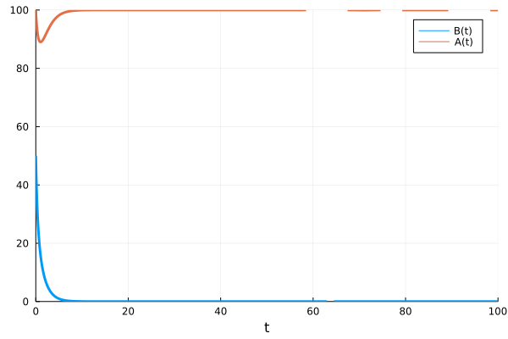

## Analysing the parameter space of a 2-population LV system

## Solving the predicted interaction across a large window of interaction parameters  
a3_range = -0.02:0.0001:0 # sets up the range of the investigation  
b3_range = -0.02:0.0001:0  
  
results_A = zeros(length(a3_range), length(b3_range)) # prepares a matrix for entering the results  
results_B = zeros(length(a3_range), length(b3_range))  
  
for i = 1:length(a3_range)  
 for j = 1:length(b3_range)  
 a3 = a3_range[i]  
 b3 = b3_range[j]  
 p = [a1, a2, a3, b1, b2, b3]  
 u0 = [a0, b0];  
 tspan = (0.0, 100.0) # gives the model 100 units of time to run  
 problem = ODEProblem(two_plasmid_competition!, u0, tspan, p)  
 solution = solve(problem, AutoVern7(Rodas5()), dt=0.1)  
  
 results_A[i,j] = solution(100)[1]  
 results_B[i,j] = solution(100)[2]   
 end  
end

## Effect on population A  
heatmap(a3_range, b3_range, results_A, c = :thermal, xlabel = "Effect of oriA on oriB (b3)",  
 ylabel = "Effect of oriB on oriA (a3)", title = "Plasmid A", clims = (0.0,max(a0,b0)))

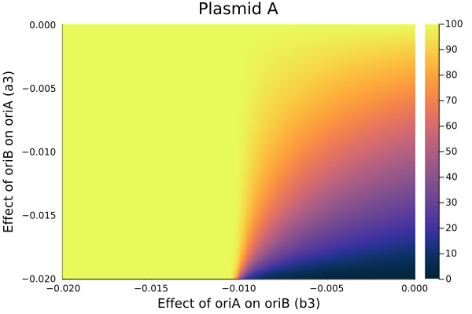

## Effect on population B  
heatmap(a3_range, b3_range, results_B, c = :thermal, xlabel = "Effect of oriA on oriB (b3)",  
 ylabel = "Effect of oriB on oriA (a3)", title = "Plasmid B", clims = (0.0,max(a0,b0)))

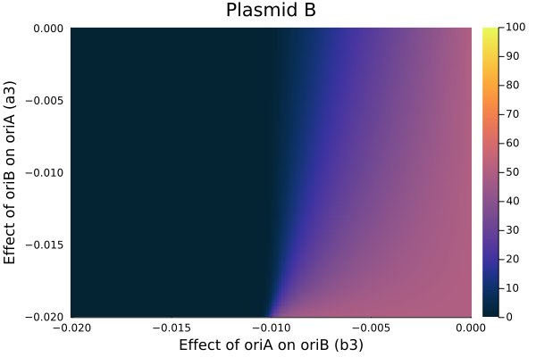

## Determining areas of co-existence  
compatibility = zeros(length(a3_range), length(b3_range)) # prepares a matrix for entering the results  
  
for n = 1: length(results_A)  
 if results_A[n] <= 1 || results_B[n] <= 1  
 #= Because the system is continuous, it tolerates very small numbers which would have no real meaning  
 in a discrete system. As such, we have used here a cut-off of 1, below which the discrete nature of the real system   
 would break down =#  
 compatibility[n] = 0.0  
 else  
 compatibility[n] = 1.0  
 end  
end  
heatmap(a3_range, b3_range, compatibility, c = :blues, colorbar=false, xlabel = "Effect of oriA on oriB (b3)",  
ylabel = "Effect of oriB on oriA (a3)", title = "Compatibility parameter space")  
  
# light blue = incompatible, dark blue = compatible

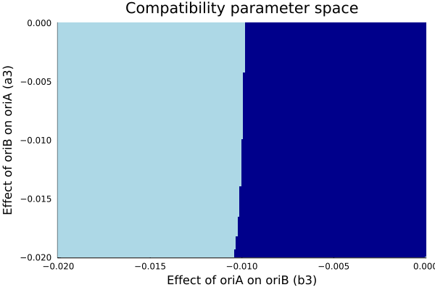

## Analysing 2-plasmid populations based on the dPCR data obtained

## From our dPCR data we have that:  
  
#= G4: a2 = 1/48  
 F4: a2 = 1/73  
 D4.2: a2 = 1/117  
 G6: a2 = 1/203  
 D4.1: a2 = 1/441  
 WT: a2 = 1/774  
 when in the presence of antibiotics in the media.  
   
 Let's say that antibiotic selection doubles the copy number of a plasmid.  
 The nature of the change is not important, as long as there is a change.  
 =#

### Example 1A: D4.1 (A) vs G6 (B) - with G6 under selection

a2 = 2/441 ## a1/a2 is the carrying capacity of plasmid A  
b2 = 1/203 ## b1/b2 is the carrying capacity of plasmid B  
a0 = 1/a2  
b0 = 1/b2  
  
  
## Solving the predicted interaction across a large window of interaction parameters  
a3_range = -0.02:0.0001:0 # sets up the range of the investigation  
b3_range = -0.02:0.0001:0  
  
results_A = zeros(length(a3_range), length(b3_range)) # prepares a matrix for entering the results  
results_B = zeros(length(a3_range), length(b3_range))  
  
for i = 1:length(a3_range)  
 for j = 1:length(b3_range)  
 a3 = a3_range[i]  
 b3 = b3_range[j]  
 p = [a1, a2, a3, b1, b2, b3]  
 u0 = [a0, b0];  
 tspan = (0.0, 100.0) # gives the model 100 units of time to run  
 problem = ODEProblem(two_plasmid_competition!, u0, tspan, p)  
 solution = solve(problem, AutoVern7(Rodas5()), dt=0.1)  
  
 results_A[i,j] = solution(100)[1]  
 results_B[i,j] = solution(100)[2]   
 end  
end  
  
## Determining areas of co-existence  
compatibility_d41tog6 = zeros(length(a3_range), length(b3_range)) # prepares a matrix for entering the results  
  
for n = 1: length(results_A)  
 if results_A[n] <= 1 || results_B[n] <= 1  
 #= Because the system is continuous, it tolerates very small numbers which would have no real meaning  
 in a discrete system. As such, we have used here a cut-off of 1, below which the discrete nature of the real system   
 would break down =#  
 compatibility_d41tog6[n] = 0.0  
 else  
 compatibility_d41tog6[n] = 1.0  
 end  
end  
heatmap(a3_range, b3_range, compatibility_d41tog6, c = :blues, colorbar=false, xlabel = "Effect of D4.1 on G6 (b3)",  
ylabel = "Effect of G6 on D4.1 (a3)", title = "Compatibility parameter space")  
  
# light blue = incompatible, dark blue = compatible

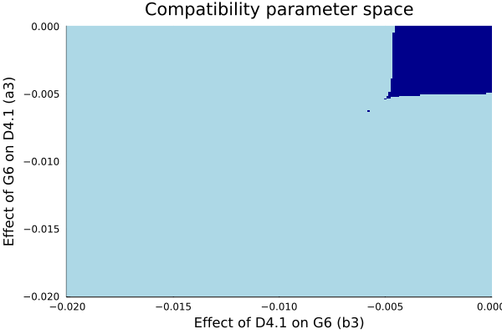

### Example 1B: D4.1 (A) vs G6 (B) - with D4.1 under selection

a2 = 1/441 ## a1/a2 is the carrying capacity of plasmid A  
b2 = 2/203 ## b1/b2 is the carrying capacity of plasmid B  
a0 = 1/a2  
b0 = 1/b2  
  
  
## Solving the predicted interaction across a large window of interaction parameters  
a3_range = -0.02:0.0001:0 # sets up the range of the investigation  
b3_range = -0.02:0.0001:0  
  
results_A = zeros(length(a3_range), length(b3_range)) # prepares a matrix for entering the results  
results_B = zeros(length(a3_range), length(b3_range))  
  
for i = 1:length(a3_range)  
 for j = 1:length(b3_range)  
 a3 = a3_range[i]  
 b3 = b3_range[j]  
 p = [a1, a2, a3, b1, b2, b3]  
 u0 = [a0, b0];  
 tspan = (0.0, 100.0) # gives the model 100 units of time to run  
 problem = ODEProblem(two_plasmid_competition!, u0, tspan, p)  
 solution = solve(problem, AutoVern7(Rodas5()), dt=0.1)  
  
 results_A[i,j] = solution(100)[1]  
 results_B[i,j] = solution(100)[2]   
 end  
end  
  
## Determining areas of co-existence  
compatibility_g6tod41 = zeros(length(a3_range), length(b3_range)) # prepares a matrix for entering the results  
  
for n = 1: length(results_A)  
 if results_A[n] <= 1 || results_B[n] <= 1  
 #= Because the system is continuous, it tolerates very small numbers which would have no real meaning  
 in a discrete system. As such, we have used here a cut-off of 1, below which the discrete nature of the real system   
 would break down =#  
 compatibility_g6tod41[n] = 0.0  
 else  
 compatibility_g6tod41[n] = 1.0  
 end  
end  
heatmap(a3_range, b3_range, compatibility_g6tod41, c = :blues, colorbar=false, xlabel = "Effect of D4.1 on G6 (b3)",  
ylabel = "Effect of G6 on D4.1 (a3)", title = "Compatibility parameter space")  
  
# light blue = incompatible, dark blue = compatible

┌ Warning: Interrupted. Larger maxiters is needed.  
└ @ SciMLBase C:\Users\vbbpi\.julia\packages\SciMLBase\Vg9hW\src\integrator_interface.jl:331

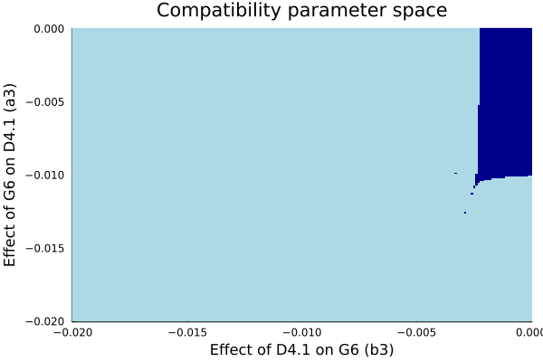

### Example 1C: Identifying parameters that satisfy all experimental conditions

## Determining area of parameter space that explains the actual data  
  
viable_parameters = zeros(length(a3_range), length(b3_range)) # starting an empty matrix  
  
#= From experimental, we know that when D4.1 is selected, the plasmids are incompatible.  
When G6 is selected, the plasmids are compatible. Therefore the viable parameter space  
is where compatibility_g6tod41 is 0 but where compatibility_d41tog6 = 1 =#  
  
for n = 1: length(compatibility_d41tog6)  
 if compatibility_d41tog6[n] == 1.0 && compatibility_g6tod41[n] == 0.0  
 viable_parameters[n] = 1.0  
 else  
 viable_parameters[n] = 0.0  
 end  
end  
  
heatmap(a3_range, b3_range, viable_parameters, c = :cividis, colorbar=false, xlabel = "Effect of D4.1 on G6 (b3)",  
ylabel = "Effect of G6 on D4.1 (a3)", title = "Experimental parameter space")  
  
# dark blue = not compatible with experimental results; yellow = compatible with experimental results

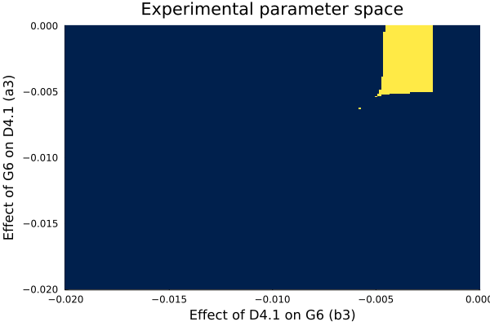

### Example 2A: G4 vs WT

This is an important example because it is an intermediate step towards analysing how G4, WT and D4.2 interact.

# G4 vs WT - selection on G4  
a2 = 1/48 ## a1/a2 is the carrying capacity of plasmid A  
b2 = 2/774 ## b1/b2 is the carrying capacity of plasmid B  
a0 = 1/a2  
b0 = 1/b2  
  
  
## Solving the predicted interaction across a large window of interaction parameters  
a3_range = -0.02:0.0001:0 # sets up the range of the investigation  
b3_range = -0.02:0.0001:0  
  
results_A = zeros(length(a3_range), length(b3_range)) # prepares a matrix for entering the results  
results_B = zeros(length(a3_range), length(b3_range))  
  
for i = 1:length(a3_range)  
 for j = 1:length(b3_range)  
 a3 = a3_range[i]  
 b3 = b3_range[j]  
 p = [a1, a2, a3, b1, b2, b3]  
 u0 = [a0, b0];  
 tspan = (0.0, 100.0) # gives the model 100 units of time to run  
 problem = ODEProblem(two_plasmid_competition!, u0, tspan, p)  
 solution = solve(problem, AutoVern7(Rodas5()), dt=0.1)  
  
 results_A[i,j] = solution(100)[1]  
 results_B[i,j] = solution(100)[2]   
 end  
end  
  
## Determining areas of co-exitence  
compatibility_g4towt = zeros(length(a3_range), length(b3_range)) # prepares a matrix for entering the results  
  
for n = 1: length(results_A)  
 if results_A[n] <= 1 || results_B[n] <= 1  
 #= Because the system is continuous, it tolerates very small numbers which would have no real meaning  
 in a discrete system. As such, we have used here a cut-off of 1, below which the discrete nature of the real system   
 would break down =#  
 compatibility_g4towt[n] = 0.0  
 else  
 compatibility_g4towt[n] = 1.0  
 end  
end  
  
# G4 vs WT - selection on WT  
a2 = 2/48 ## a1/a2 is the carrying capacity of plasmid A  
b2 = 1/774 ## b1/b2 is the carrying capacity of plasmid B  
a0 = 1/a2  
b0 = 1/b2  
  
  
## Solving the predicted interaction across a large window of interaction parameters  
a3_range = -0.02:0.0001:0 # sets up the range of the investigation  
b3_range = -0.02:0.0001:0  
  
results_A = zeros(length(a3_range), length(b3_range)) # prepares a matrix for entering the results  
results_B = zeros(length(a3_range), length(b3_range))  
  
for i = 1:length(a3_range)  
 for j = 1:length(b3_range)  
 a3 = a3_range[i]  
 b3 = b3_range[j]  
 p = [a1, a2, a3, b1, b2, b3]  
 u0 = [a0, b0];  
 tspan = (0.0, 100.0) # gives the model 100 units of time to run  
 problem = ODEProblem(two_plasmid_competition!, u0, tspan, p)  
 solution = solve(problem, AutoVern7(Rodas5()), dt=0.1)  
  
 results_A[i,j] = solution(100)[1]  
 results_B[i,j] = solution(100)[2]   
 end  
end  
  
## Determining areas of co-exitence  
compatibility_wttog4 = zeros(length(a3_range), length(b3_range)) # prepares a matrix for entering the results  
  
for n = 1: length(results_A)  
 if results_A[n] <= 1 || results_B[n] <= 1  
 #= Because the system is continuous, it tolerates very small numbers which would have no real meaning  
 in a discrete system. As such, we have used here a cut-off of 1, below which the discrete nature of the real system   
 would break down =#  
 compatibility_wttog4[n] = 0.0  
 else  
 compatibility_wttog4[n] = 1.0  
 end  
end  
  
## Determining area of parameter space that explains the actual data  
  
viable_parameters_g4wt = zeros(length(a3_range), length(b3_range)) # starting an empty matrix  
  
#= From experimental, we know that irrespective of selection, these plasmids remain compatible.  
Therefore the viable parameter space is where compatibility_wttog4 is 1 and where compatibility_g4towt = 1 =#  
  
for n = 1: length(compatibility_wttog4)  
 if compatibility_wttog4[n] == 1.0 && compatibility_g4towt[n] == 1.0  
 viable_parameters_g4wt[n] = 1.0  
 else  
 viable_parameters_g4wt[n] = 0.0  
 end  
end

heatmap(a3_range, b3_range, viable_parameters_g4wt, c = :cividis, colorbar=false, xlabel = "Effect of G4 on WT (b3)",  
ylabel = "Effect of WT on G4 (a3)", title = "Experimental parameter space")  
# dark blue = not compatible with experimental results; yellow = compatible with experimental results

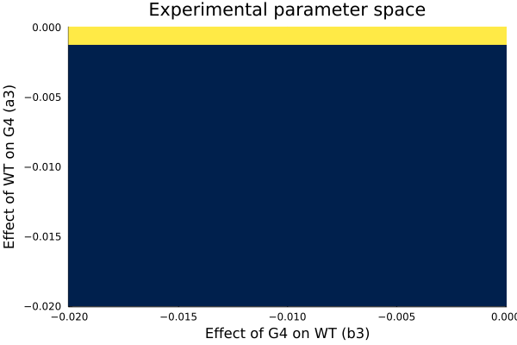

### Example 2B: G4 vs. D4.2

# G4 vs D4.2 - selection on G4  
a2 = 1/48 ## a1/a2 is the carrying capacity of plasmid A  
b2 = 2/117 ## b1/b2 is the carrying capacity of plasmid B  
a0 = 1/a2  
b0 = 1/b2  
  
  
## Solving the predicted interaction across a large window of interaction parameters  
a3_range = -0.02:0.0001:0 # sets up the range of the investigation  
b3_range = -0.02:0.0001:0  
  
results_A = zeros(length(a3_range), length(b3_range)) # prepares a matrix for entering the results  
results_B = zeros(length(a3_range), length(b3_range))  
  
for i = 1:length(a3_range)  
 for j = 1:length(b3_range)  
 a3 = a3_range[i]  
 b3 = b3_range[j]  
 p = [a1, a2, a3, b1, b2, b3]  
 u0 = [a0, b0];  
 tspan = (0.0, 100.0) # gives the model 100 units of time to run  
 problem = ODEProblem(two_plasmid_competition!, u0, tspan, p)  
 solution = solve(problem, AutoVern7(Rodas5()), dt=0.1)  
  
 results_A[i,j] = solution(100)[1]  
 results_B[i,j] = solution(100)[2]   
 end  
end  
  
## Determining areas of co-existence  
compatibility_g4tod42 = zeros(length(a3_range), length(b3_range)) # prepares a matrix for entering the results  
  
for n = 1: length(results_A)  
 if results_A[n] <= 1 || results_B[n] <= 1  
 #= Because the system is continuous, it tolerates very small numbers which would have no real meaning  
 in a discrete system. As such, we have used here a cut-off of 1, below which the discrete nature of the real system   
 would break down =#  
 compatibility_g4tod42[n] = 0.0  
 else  
 compatibility_g4tod42[n] = 1.0  
 end  
end  
  
# G4 vs D4.2 - selection on D4.2  
a2 = 2/48 ## a1/a2 is the carrying capacity of plasmid A  
b2 = 1/117 ## b1/b2 is the carrying capacity of plasmid B  
a0 = 1/a2  
b0 = 1/b2  
  
  
## Solving the predicted interaction across a large window of interaction parameters  
a3_range = -0.02:0.0001:0 # sets up the range of the investigation  
b3_range = -0.02:0.0001:0  
  
results_A = zeros(length(a3_range), length(b3_range)) # prepares a matrix for entering the results  
results_B = zeros(length(a3_range), length(b3_range))  
  
for i = 1:length(a3_range)  
 for j = 1:length(b3_range)  
 a3 = a3_range[i]  
 b3 = b3_range[j]  
 p = [a1, a2, a3, b1, b2, b3]  
 u0 = [a0, b0];  
 tspan = (0.0, 100.0) # gives the model 100 units of time to run  
 problem = ODEProblem(two_plasmid_competition!, u0, tspan, p)  
 solution = solve(problem, AutoVern7(Rodas5()), dt=0.1)  
  
 results_A[i,j] = solution(100)[1]  
 results_B[i,j] = solution(100)[2]   
 end  
end  
  
## Determining areas of co-existence  
compatibility_d42tog4 = zeros(length(a3_range), length(b3_range)) # prepares a matrix for entering the results  
  
for n = 1: length(results_A)  
 if results_A[n] <= 1 || results_B[n] <= 1  
 #= Because the system is continuous, it tolerates very small numbers which would have no real meaning  
 in a discrete system. As such, we have used here a cut-off of 1, below which the discrete nature of the real system   
 would break down =#  
 compatibility_d42tog4[n] = 0.0  
 else  
 compatibility_d42tog4[n] = 1.0  
 end  
end  
  
## Determining area of parameter space that explains the actual data  
  
viable_parameters_g4d42 = zeros(length(a3_range), length(b3_range)) # starting an empty matrix  
  
#= From experimental, we know that irrespective of selection, these plasmids remain compatible.  
Therefore the viable parameter space is where compatibility_wttog4 is 1 and where compatibility_g4towt = 1 =#  
  
for n = 1: length(compatibility_d42tog4)  
 if compatibility_g4tod42[n] == 1.0 && compatibility_d42tog4[n] == 1.0  
 viable_parameters_g4d42[n] = 1.0  
 else  
 viable_parameters_g4d42[n] = 0.0  
 end  
end

heatmap(a3_range, b3_range, viable_parameters_g4d42, c = :cividis, colorbar=false, xlabel = "Effect of G4 on D4.2 (b3)",  
ylabel = "Effect of D4.2 on G4 (a3)", title = "Experimental parameter space")  
# dark blue = not compatible with experimental results; yellow = compatible with experimental results

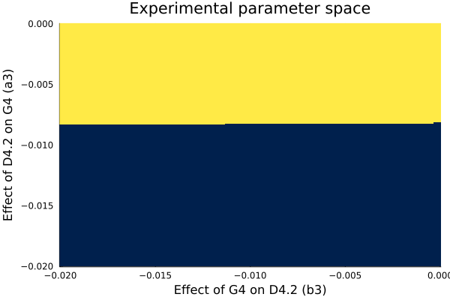

### Example 2C: WT vs. D4.2

# WT vs D4.2 - selection on WT  
a2 = 1/774 ## a1/a2 is the carrying capacity of plasmid A  
b2 = 2/117 ## b1/b2 is the carrying capacity of plasmid B  
a0 = 1/a2  
b0 = 1/b2  
  
  
## Solving the predicted interaction across a large window of interaction parameters  
a3_range = -0.02:0.0001:0 # sets up the range of the investigation  
b3_range = -0.02:0.0001:0  
  
results_A = zeros(length(a3_range), length(b3_range)) # prepares a matrix for entering the results  
results_B = zeros(length(a3_range), length(b3_range))  
  
for i = 1:length(a3_range)  
 for j = 1:length(b3_range)  
 a3 = a3_range[i]  
 b3 = b3_range[j]  
 p = [a1, a2, a3, b1, b2, b3]  
 u0 = [a0, b0];  
 tspan = (0.0, 100.0) # gives the model 100 units of time to run  
 problem = ODEProblem(two_plasmid_competition!, u0, tspan, p)  
 solution = solve(problem, AutoVern7(Rodas5()), dt=0.1)  
  
 results_A[i,j] = solution(100)[1]  
 results_B[i,j] = solution(100)[2]   
 end  
end  
  
## Determining areas of co-existence  
compatibility_wttod42 = zeros(length(a3_range), length(b3_range)) # prepares a matrix for entering the results  
  
for n = 1: length(results_A)  
 if results_A[n] <= 1 || results_B[n] <= 1  
 #= Because the system is continuous, it tolerates very small numbers which would have no real meaning  
 in a discrete system. As such, we have used here a cut-off of 1, below which the discrete nature of the real system   
 would break down =#  
 compatibility_wttod42[n] = 0.0  
 else  
 compatibility_wttod42[n] = 1.0  
 end  
end  
  
# WT vs D4.2 - selection on D4.2  
a2 = 2/774 ## a1/a2 is the carrying capacity of plasmid A  
b2 = 1/117 ## b1/b2 is the carrying capacity of plasmid B  
a0 = 1/a2  
b0 = 1/b2  
  
  
## Solving the predicted interaction across a large window of interaction parameters  
a3_range = -0.02:0.0001:0 # sets up the range of the investigation  
b3_range = -0.02:0.0001:0  
  
results_A = zeros(length(a3_range), length(b3_range)) # prepares a matrix for entering the results  
results_B = zeros(length(a3_range), length(b3_range))  
  
for i = 1:length(a3_range)  
 for j = 1:length(b3_range)  
 a3 = a3_range[i]  
 b3 = b3_range[j]  
 p = [a1, a2, a3, b1, b2, b3]  
 u0 = [a0, b0];  
 tspan = (0.0, 100.0) # gives the model 100 units of time to run  
 problem = ODEProblem(two_plasmid_competition!, u0, tspan, p)  
 solution = solve(problem, AutoVern7(Rodas5()), dt=0.1)  
  
 results_A[i,j] = solution(100)[1]  
 results_B[i,j] = solution(100)[2]   
 end  
end  
  
## Determining areas of co-existence  
compatibility_d42towt = zeros(length(a3_range), length(b3_range)) # prepares a matrix for entering the results  
  
for n = 1: length(results_A)  
 if results_A[n] <= 1 || results_B[n] <= 1  
 #= Because the system is continuous, it tolerates very small numbers which would have no real meaning  
 in a discrete system. As such, we have used here a cut-off of 1, below which the discrete nature of the real system   
 would break down =#  
 compatibility_d42towt[n] = 0.0  
 else  
 compatibility_d42towt[n] = 1.0  
 end  
end  
  
## Determining area of parameter space that explains the actual data  
  
viable_parameters_wtd42 = zeros(length(a3_range), length(b3_range)) # starting an empty matrix  
  
#= From experimental, we know that irrespective of selection, these plasmids remain compatible.  
Therefore the viable parameter space is where compatibility_wttog4 is 1 and where compatibility_g4towt = 1 =#  
  
for n = 1: length(compatibility_d42tog4)  
 if compatibility_d42towt[n] == 1.0 && compatibility_wttod42[n] == 1.0  
 viable_parameters_wtd42[n] = 1.0  
 else  
 viable_parameters_wtd42[n] = 0.0  
 end  
end

heatmap(a3_range, b3_range, viable_parameters_wtd42, c = :cividis, colorbar=false, xlabel = "Effect of WT on D4.2 (b3)",  
ylabel = "Effect of D4.2 on WT (a3)", title = "Experimental parameter space")  
# dark blue = not compatible with experimental results; yellow = compatible with experimental results

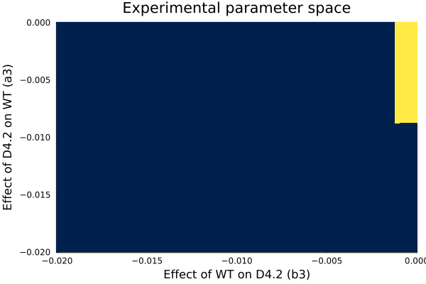

## Setting up a 3-population LV system

## 3-population LV system  
function three_plasmid_competition!(du, u, p, t) ## 2-population generic LV system  
 A, B, C = u  
 a1, a2, a3, a4, b1, b2, b3, b5, c1, c2, c4, c5 = p  
 du[1] = dA = a1*A - a2*A^2 + a3*A*B + a4*A*C  
 #= To improve clarity, indexes were selected to facilitate interaction identification  
 x3 for interactions between A and B, x4 for A and C, and x5 for B and C =#  
 du[2] = dB = b1*B - b2*B^2 + b3*A*B + b5*B*C  
 du[3] = dC = c1*C - c2*C^2 + c4*A*C + c5*B*C  
end

three_plasmid_competition! (generic function with 1 method)

## Parameters  
a1 = 1 # for simpliticy chosen as 1  
b1 = 1  
c1 = 1  
  
a2 = 1/100 # a1/a2 is the carrying capacity of plasmid A  
b2 = 1/100 # b1/b2 is the carrying capacity of plasmid B  
c2 = 1/100 # c1/c2 is the carrying capacity of plasmid B  
  
a3 = - 1/1000 ## impact of B on A  
b3 = - 5/1000 ## impact of A on B  
a4 = - 1/1000 ## impact of C on A  
c4 = - 4/1000 ## impact of A on C  
b5 = - 2/1000 ## impact of C on B  
c5 = - 1/1000 ## impact of B on C  
  
## Initial conditions  
a0 = 1/a2  
b0 = 1/b2  
c0 = 1/c2  
  
## Reformatting parameters for function   
p = [a1, a2, a3, a4, b1, b2, b3, b5, c1, c2, c4, c5]  
u0 = [a0, b0, c0];

## Solution  
  
#= While the LV system can be solved analytically, we provide here the numerical solution to avoid having to introduce error   
 checking for equilibrium positions that are not in the real positive space for both populations. =#  
 tspan = (0.0, 100.0) # gives the model 100 units of time to run  
 problem = ODEProblem(three_plasmid_competition!, u0, tspan, p)  
 solution = solve(problem, AutoVern7(Rodas5()), dt=0.1)  
   
 solution(100) ## returns the two plasmid populations at t = 100

3-element Vector{Float64}:  
 89.70100057995595  
 43.18937064960836  
 59.80066705330398

plot(solution, vars=(0,3), linewidth = 3, ylims = (0.0,max(a0,b0)), label = "C(t)")  
plot!(solution, vars=(0,1), linewidth = 3, label = "A(t)")  
plot!(solution, vars=(0,2), linewidth = 3, label = "B(t)")

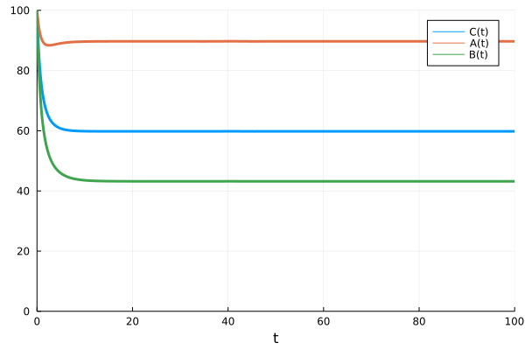

## Solving the predicted interaction across a large window of interaction parameters  
#= Unlike the 2-plasmid system with 2 parameters, the 3-plasmid system has a total of 6 parameters dealing with the interaction  
between the origins. That makes it very difficult to explore all at once and to vizualise them all. Below, we show the impact of a  
negative impact of plasmid C on plasmid A (i.e. a4) across a wide range of A and B interactions.=#  
  
a3_range = -0.02:0.0002:0   
b3_range = -0.02:0.0002:0  
a4_range = -0.02:0.0002:0  
  
results_A = zeros(length(a3_range), length(b3_range), length(a4_range)) # prepares a tensor for entering the results  
results_B = zeros(length(a3_range), length(b3_range), length(a4_range))  
results_C = zeros(length(a3_range), length(b3_range), length(a4_range))  
  
for i = 1:length(a3_range)  
 for j = 1:length(b3_range)  
 for k = 1: length(a4_range)  
 a3 = a3_range[i]  
 b3 = b3_range[j]  
 a4 = a4_range[k]  
 p = [a1, a2, a3, a4, b1, b2, b3, b5, c1, c2, c4, c5]  
 u0 = [a0, b0, c0];  
 tspan = (0.0, 100.0) # gives the model 100 units of time to run  
 problem = ODEProblem(three_plasmid_competition!, u0, tspan, p)  
 solution = solve(problem, AutoVern7(Rodas5()), dt=0.1)  
  
 results_A[i,j,k] = solution(100)[1]  
 results_B[i,j,k] = solution(100)[2]   
 results_C[i,j,k] = solution(100)[3]   
 end  
 end  
end

## Determining areas of co-exitence  
compatibility_3way = zeros(length(a3_range), length(b3_range), length(a4_range)) # prepares a matrix for entering the results  
  
for n = 1: length(results_A)  
 if results_A[n] <= 1 || results_B[n] <= 1 || results_C[n] <= 1  
 #= Because the system is continuous, it tolerates very small numbers which would have no real meaning  
 in a discrete system. As such, we have used here a cut-off of 1, below which the discrete nature of the real system   
 would break down =#  
 compatibility_3way[n] = 0.0  
 else  
 compatibility_3way[n] = 1.0  
 end  
end  
  
## Vizualizing the impact of varying parameters on the population  
steps = length(a4_range)  
t = range(1, length(a4_range), length = steps)  
  
anim = @animate for i ∈ 1:steps  
 title_range = "Effect of oriC on oriA, a4=$(a4_range[i])"  
 heatmap(a3_range, b3_range, compatibility_3way[i,:,:], c = :thermal, colorbar=false, xlabel = "Effect of oriA on oriB (b3)",  
 ylabel = "Effect of oriB on oriA (a3)", title = title_range, clims=(0,1))  
end  
gif(anim, "compatibility_3way.gif", fps = 5)  
  
# dark blue = not compatible with experimental results; yellow = compatible with experimental results

┌ Info: Saved animation to   
│ fn = c:\Users\vbbpi\OneDrive - KU Leuven\50_Publications\21_New_plasmids\compatibility_3way.gif  
└ @ Plots C:\Users\vbbpi\.julia\packages\Plots\1KWPG\src\animation.jl:114

Plots.AnimatedGif("c:\\Users\\vbbpi\\OneDrive - KU Leuven\\50_Publications\\21_New_plasmids\\compatibility_3way.gif")

## Using 2-population data to analyse 3-population interactions

## Using two-plasmid ranges to look at 3 plasmid interactions  
#= Experimental data sets out possible range of parameter values that relate to specific interactions between plasmids and therefore  
these should remain constant for more complex systems =#  
  
# Using WT(A), D4.2(B) and G4(C), we obtain the following ranges for the parameters From the data:  
a3_range = -0.01:0.002:0  
b3_range = -0.002:0.0005:0  
a4_range = -0.02:0.004:0  
c4_range = -0.002:0.0005:0  
b5_range = -0.02:0.004:0  
c5_range = -0.01:0.002:0

-0.01:0.002:0.0

compatibility_wt_d42_g4 = zeros(length(a3_range), length(b3_range), length(a4_range), length(c4_range),  
 length(b5_range), length(c5_range));  
  
 #= This creates an empty tensor with dimensions equal to the available ranges of parameters being considered.  
 Because of the high dimensionality of the data, mapping the individual populations across this paramter landscape  
 will not even be attemtped directly.  
  
 Instead, calculations will focus on identifying the presence and size of viable parameter space for three experimental conditions,   
 while creating a list of possible solutions: =#  
  
possible_param_wt_d42_g4 = Array{Array{Float64 , 1}, 1}(undef,0)  
  
#=  
 Example 3: G4, D4.2 and WT being cross-compatible (not the obtained data)  
 Example 4: G4, D4.2 and WT leading to loss of G4 (when all populations are under selection)  
 Example 5: G4, D4.2 and WT leading to loss of G4 (when only D4.2 is under selection)  
 Example 6: G4, D4.2 and WT leading to loss of G4 (in the absence of selection)  
 =#

Vector{Float64}[]

### Example 3: G4, D4.2 and WT compatible

This is a theoretical example not in agreement with our data (see SI Fig 9C)

## Example 3: G4, D42 and WT intercompatible  
#= for all three populations to be compatible (while under selection), then there must be at least one set of interaction   
 parameters for which co-existence is possible, i.e. A(t), B(t) and C(t) all real and positive.  
=#  
  
for a = 1:length(a3_range)  
 for b = 1:length(b3_range)  
 for i = 1:length(a4_range)  
 for j = 1:length(c4_range)  
 for x = 1:length(b5_range)  
 for y = 1:length(c5_range)  
  
 a3 = a3_range[a]  
 b3 = b3_range[b]  
 a4 = a4_range[i]  
 b4 = c4_range[j]  
 b5 = b5_range[x]  
 c5 = c5_range[y]  
  
 a2 = 1/774  
 b2 = 1/117  
 c2 = 1/48  
  
 p = p = [a1, a2, a3, a4, b1, b2, b3, b5, c1, c2, c4, c5]  
 u0 = [a0, b0, c0];  
 tspan = (0.0, 100.0) # gives the model 100 units of time to run  
 problem = ODEProblem(three_plasmid_competition!, u0, tspan, p)  
 solution = solve(problem, AutoVern7(Rodas5()), dt=0.1)  
  
 if solution(100)[1] > 1 && solution(100)[2] > 1 && solution(100)[3] > 1  
 compatibility_wt_d42_g4[a,b,i,j,x,y] = 1.0  
 append!(possible_param_wt_d42_g4, [[a3, b3, a4, c4, b5, c5]])  
 else  
 compatibility_wt_d42_g4[a,b,i,j,x,y] = 0.0  
 end  
 end  
 end  
 end  
 end  
 end  
end

solution_found_3way = sum(compatibility_wt_d42_g4)   
#= Since each viable solution is assigned the value of 1.0, then the sum gives the number of possible combinations tested   
for which the conditions are valid =#

2165.0

solution_fraction_3way = solution_found_3way/length(compatibility_wt_d42_g4)  
#= This yields the fraction of the sampled space that is viable  
=#

0.06682098765432098

possible_param_wt_d42_g4  
#= this returns a list of parameter combinations that fulfil the selection criteria (here in Example 3 - all plasmids co-existing) =#

2165-element Vector{Vector{Float64}}:  
 [-0.01, -0.002, -0.02, -0.004, -0.02, -0.004]  
 [-0.01, -0.002, -0.02, -0.004, -0.02, -0.002]  
 [-0.01, -0.002, -0.02, -0.004, -0.02, 0.0]  
 [-0.01, -0.002, -0.02, -0.004, -0.02, -0.004]  
 [-0.01, -0.002, -0.02, -0.004, -0.02, -0.002]  
 [-0.01, -0.002, -0.02, -0.004, -0.02, 0.0]  
 [-0.01, -0.002, -0.02, -0.004, -0.02, -0.004]  
 [-0.01, -0.002, -0.02, -0.004, -0.02, -0.002]  
 [-0.01, -0.002, -0.02, -0.004, -0.02, 0.0]  
 [-0.01, -0.002, -0.02, -0.004, -0.02, -0.004]  
 ⋮  
 [-0.004, 0.0, -0.016, -0.004, -0.008, 0.0]  
 [-0.004, 0.0, -0.016, -0.004, -0.008, 0.0]  
 [-0.004, 0.0, -0.016, -0.004, -0.008, 0.0]  
 [-0.004, 0.0, -0.016, -0.004, -0.008, 0.0]  
 [-0.002, -0.0005, -0.02, -0.004, -0.008, 0.0]  
 [-0.002, -0.0005, -0.02, -0.004, -0.008, 0.0]  
 [-0.002, -0.0005, -0.02, -0.004, -0.008, 0.0]  
 [-0.002, -0.0005, -0.02, -0.004, -0.008, 0.0]  
 [-0.002, -0.0005, -0.02, -0.004, -0.008, 0.0]

### Example 4: G4, D4.2 and WT leading to loss of G4 (when all populations are under selection)

# Example 4: G4, D4.2 and WT leading to loss of G4 (when all populations are under selection)  
compatibility_wt_d42_nog4 = zeros(length(a3_range), length(b3_range), length(a4_range), length(c4_range),  
 length(b5_range), length(c5_range))  
possible_param_wt_d42_nog4 = Array{Array{Float64 , 1}, 1}(undef,0)  
  
  
for a = 1:length(a3_range)  
 for b = 1:length(b3_range)  
 for i = 1:length(a4_range)  
 for j = 1:length(c4_range)  
 for x = 1:length(b5_range)  
 for y = 1:length(c5_range)  
  
 a3 = a3_range[a]  
 b3 = b3_range[b]  
 a4 = a4_range[i]  
 b4 = c4_range[j]  
 b5 = b5_range[x]  
 c5 = c5_range[y]  
  
 a2 = 1/774  
 b2 = 1/117  
 c2 = 1/48  
  
 p = p = [a1, a2, a3, a4, b1, b2, b3, b5, c1, c2, c4, c5]  
 u0 = [a0, b0, c0];  
 tspan = (0.0, 100.0) # gives the model 100 units of time to run  
 problem = ODEProblem(three_plasmid_competition!, u0, tspan, p)  
 solution = solve(problem, AutoVern7(Rodas5()), dt=0.1)  
  
 if solution(100)[1] > 1 && solution(100)[2] > 1 && solution(100)[3] < 1  
 compatibility_wt_d42_nog4[a,b,i,j,x,y] = 1.0  
 append!(possible_param_wt_d42_nog4, [[a3, b3, a4, c4, b5, c5]])  
 else  
 compatibility_wt_d42_nog4[a,b,i,j,x,y] = 0.0  
 end  
 end  
 end  
 end  
 end  
 end  
end

solution_found_3way_nog4 = sum(compatibility_wt_d42_nog4)   
#= Since each viable solution is assigned the value of 1.0, then the sum gives the number of possible combinations tested   
for which the conditions are valid =#

13725.0

solution_fraction_3way_nog4 = solution_found_3way_nog4/length(compatibility_wt_d42_nog4)  
#= This yields the fraction of the sampled space that is viable  
=#

0.4236111111111111

possible_param_wt_d42_nog4  
#= this returns a list of parameter combinations that fulfil the selection criteria (here in Example 3 - all plasmids co-existing) =#

13725-element Vector{Vector{Float64}}:  
 [-0.01, -0.0015, -0.016, -0.004, -0.02, -0.004]  
 [-0.01, -0.0015, -0.016, -0.004, -0.02, -0.004]  
 [-0.01, -0.0015, -0.016, -0.004, -0.02, -0.004]  
 [-0.01, -0.0015, -0.016, -0.004, -0.02, -0.004]  
 [-0.01, -0.0015, -0.016, -0.004, -0.02, -0.004]  
 [-0.01, -0.0015, -0.008, -0.004, -0.016, -0.002]  
 [-0.01, -0.0015, -0.008, -0.004, -0.016, -0.002]  
 [-0.01, -0.0015, -0.008, -0.004, -0.016, -0.002]  
 [-0.01, -0.0015, -0.008, -0.004, -0.016, -0.002]  
 [-0.01, -0.0015, -0.008, -0.004, -0.016, -0.002]  
 ⋮  
 [0.0, 0.0, 0.0, -0.004, -0.004, -0.004]  
 [0.0, 0.0, 0.0, -0.004, -0.004, -0.002]  
 [0.0, 0.0, 0.0, -0.004, -0.004, 0.0]  
 [0.0, 0.0, 0.0, -0.004, 0.0, -0.01]  
 [0.0, 0.0, 0.0, -0.004, 0.0, -0.008]  
 [0.0, 0.0, 0.0, -0.004, 0.0, -0.006]  
 [0.0, 0.0, 0.0, -0.004, 0.0, -0.004]  
 [0.0, 0.0, 0.0, -0.004, 0.0, -0.002]  
 [0.0, 0.0, 0.0, -0.004, 0.0, 0.0]

### Example 5: G4, D4.2 and WT leading to loss of G4 (when only D4.2 is under selection)

# Example 5: G4, D4.2 and WT leading to loss of G4 (when only D4.2 is under selection)  
compatibility_wt_d42_nog4_2 = zeros(length(a3_range), length(b3_range), length(a4_range), length(c4_range),  
 length(b5_range), length(c5_range))  
possible_param_wt_d42_nog4_2 = Array{Array{Float64 , 1}, 1}(undef,0)  
  
  
for a = 1:length(a3_range)  
 for b = 1:length(b3_range)  
 for i = 1:length(a4_range)  
 for j = 1:length(c4_range)  
 for x = 1:length(b5_range)  
 for y = 1:length(c5_range)  
  
 a3 = a3_range[a]  
 b3 = b3_range[b]  
 a4 = a4_range[i]  
 b4 = c4_range[j]  
 b5 = b5_range[x]  
 c5 = c5_range[y]  
  
 a2 = 2/774  
 b2 = 1/117  
 c2 = 2/48  
  
 p = p = [a1, a2, a3, a4, b1, b2, b3, b5, c1, c2, c4, c5]  
 u0 = [a0, b0, c0];  
 tspan = (0.0, 100.0) # gives the model 100 units of time to run  
 problem = ODEProblem(three_plasmid_competition!, u0, tspan, p)  
 solution = solve(problem, AutoVern7(Rodas5()), dt=0.1)  
  
 if solution(100)[1] > 1 && solution(100)[2] > 1 && solution(100)[3] < 1  
 compatibility_wt_d42_nog4_2[a,b,i,j,x,y] = 1.0  
 append!(possible_param_wt_d42_nog4_2, [[a3, b3, a4, c4, b5, c5]])  
 else  
 compatibility_wt_d42_nog4_2[a,b,i,j,x,y] = 0.0  
 end  
 end  
 end  
 end  
 end  
 end  
end

solution_found_3way_nog4_2 = sum(compatibility_wt_d42_nog4_2)   
#= Since each viable solution is assigned the value of 1.0, then the sum gives the number of possible combinations tested   
for which the conditions are valid =#

21300.0

solution_fraction_3way_nog4_2 = solution_found_3way_nog4_2/length(compatibility_wt_d42_nog4_2)  
#= This yields the fraction of the sampled space that is viable  
=#

0.6574074074074074

possible_param_wt_d42_nog4_2  
#= this returns a list of parameter combinations that fulfil the selection criteria (here in Example 3 - all plasmids co-existing) =#

21300-element Vector{Vector{Float64}}:  
 [-0.008, -0.002, -0.02, -0.004, -0.02, -0.01]  
 [-0.008, -0.002, -0.02, -0.004, -0.02, -0.008]  
 [-0.008, -0.002, -0.02, -0.004, -0.016, -0.01]  
 [-0.008, -0.002, -0.02, -0.004, -0.016, -0.008]  
 [-0.008, -0.002, -0.02, -0.004, -0.012, -0.01]  
 [-0.008, -0.002, -0.02, -0.004, -0.012, -0.008]  
 [-0.008, -0.002, -0.02, -0.004, -0.008, -0.01]  
 [-0.008, -0.002, -0.02, -0.004, -0.008, -0.008]  
 [-0.008, -0.002, -0.02, -0.004, -0.004, -0.01]  
 [-0.008, -0.002, -0.02, -0.004, -0.004, -0.008]  
 ⋮  
 [0.0, 0.0, 0.0, -0.004, -0.004, -0.004]  
 [0.0, 0.0, 0.0, -0.004, -0.004, -0.002]  
 [0.0, 0.0, 0.0, -0.004, -0.004, 0.0]  
 [0.0, 0.0, 0.0, -0.004, 0.0, -0.01]  
 [0.0, 0.0, 0.0, -0.004, 0.0, -0.008]  
 [0.0, 0.0, 0.0, -0.004, 0.0, -0.006]  
 [0.0, 0.0, 0.0, -0.004, 0.0, -0.004]  
 [0.0, 0.0, 0.0, -0.004, 0.0, -0.002]  
 [0.0, 0.0, 0.0, -0.004, 0.0, 0.0]

### Example 6: G4, D4.2 and WT leading to loss of G4 (in the absence of selection)

# Example 6: G4, D4.2 and WT leading to loss of G4 (in the absence of selection)  
compatibility_wt_d42_nog4_noab = zeros(length(a3_range), length(b3_range), length(a4_range), length(c4_range),  
 length(b5_range), length(c5_range))  
possible_param_wt_d42_nog4_noab = Array{Array{Float64 , 1}, 1}(undef,0)  
  
  
for a = 1:length(a3_range)  
 for b = 1:length(b3_range)  
 for i = 1:length(a4_range)  
 for j = 1:length(c4_range)  
 for x = 1:length(b5_range)  
 for y = 1:length(c5_range)  
  
 a3 = a3_range[a]  
 b3 = b3_range[b]  
 a4 = a4_range[i]  
 b4 = c4_range[j]  
 b5 = b5_range[x]  
 c5 = c5_range[y]  
  
 a2 = 2/774  
 b2 = 2/117  
 c2 = 2/48  
  
 p = p = [a1, a2, a3, a4, b1, b2, b3, b5, c1, c2, c4, c5]  
 u0 = [a0, b0, c0];  
 tspan = (0.0, 100.0) # gives the model 100 units of time to run  
 problem = ODEProblem(three_plasmid_competition!, u0, tspan, p)  
 solution = solve(problem, AutoVern7(Rodas5()), dt=0.1)  
  
 if solution(100)[1] > 1 && solution(100)[2] > 1 && solution(100)[3] < 1  
 compatibility_wt_d42_nog4_noab[a,b,i,j,x,y] = 1.0  
 append!(possible_param_wt_d42_nog4_noab, [[a3, b3, a4, c4, b5, c5]])  
 else  
 compatibility_wt_d42_nog4_noab[a,b,i,j,x,y] = 0.0  
 end  
 end  
 end  
 end  
 end  
 end  
end  
  
solution_found_3way_nog4_noab = sum(compatibility_wt_d42_nog4_noab)   
solution_fraction_3way_nog4_noab = solution_found_3way_nog4_noab/length(compatibility_wt_d42_nog4_noab)  
possible_param_wt_d42_nog4_noab

30275-element Vector{Vector{Float64}}:  
 [-0.01, -0.002, -0.02, -0.004, -0.02, -0.01]  
 [-0.01, -0.002, -0.02, -0.004, -0.02, -0.008]  
 [-0.01, -0.002, -0.02, -0.004, -0.02, -0.006]  
 [-0.01, -0.002, -0.02, -0.004, -0.02, -0.004]  
 [-0.01, -0.002, -0.02, -0.004, -0.02, -0.002]  
 [-0.01, -0.002, -0.02, -0.004, -0.02, 0.0]  
 [-0.01, -0.002, -0.02, -0.004, -0.016, -0.01]  
 [-0.01, -0.002, -0.02, -0.004, -0.016, -0.008]  
 [-0.01, -0.002, -0.02, -0.004, -0.016, -0.006]  
 [-0.01, -0.002, -0.02, -0.004, -0.016, -0.004]  
 ⋮  
 [0.0, 0.0, 0.0, -0.004, -0.004, -0.004]  
 [0.0, 0.0, 0.0, -0.004, -0.004, -0.002]  
 [0.0, 0.0, 0.0, -0.004, -0.004, 0.0]  
 [0.0, 0.0, 0.0, -0.004, 0.0, -0.01]  
 [0.0, 0.0, 0.0, -0.004, 0.0, -0.008]  
 [0.0, 0.0, 0.0, -0.004, 0.0, -0.006]  
 [0.0, 0.0, 0.0, -0.004, 0.0, -0.004]  
 [0.0, 0.0, 0.0, -0.004, 0.0, -0.002]  
 [0.0, 0.0, 0.0, -0.004, 0.0, 0.0]

## Combining multiple datasets to further refine parameter estimation

#= Because we have selections with full antibiotics, with only chloramphenicol, and without antibiotics, we can intersect the different   
sets of parameters to further restrict the range of possible parameters.  
  
Paramter sets (let it be called p_possible) compatible with all the data generated will be:  
 p_possible ∈ possible_param_wt_d42_nog4  
 p_possible ∈ possible_param_wt_d42_nog4_2  
 p_possible ∈ possible_param_wt_d42_nog4_noab  
  
=#  
p_possible = intersect(possible_param_wt_d42_nog4, possible_param_wt_d42_nog4_noab, possible_param_wt_d42_nog4_2)

2441-element Vector{Vector{Float64}}:  
 [-0.008, -0.002, -0.02, -0.004, 0.0, -0.008]  
 [-0.008, -0.0015, -0.02, -0.004, -0.008, -0.008]  
 [-0.008, -0.0015, -0.02, -0.004, -0.004, -0.008]  
 [-0.008, -0.0015, -0.02, -0.004, 0.0, -0.008]  
 [-0.008, -0.0015, -0.016, -0.004, 0.0, -0.008]  
 [-0.008, -0.001, -0.02, -0.004, -0.02, -0.01]  
 [-0.008, -0.001, -0.02, -0.004, -0.02, -0.008]  
 [-0.008, -0.001, -0.02, -0.004, -0.016, -0.01]  
 [-0.008, -0.001, -0.02, -0.004, -0.016, -0.008]  
 [-0.008, -0.001, -0.02, -0.004, -0.012, -0.01]  
 ⋮  
 [0.0, 0.0, 0.0, -0.004, -0.004, -0.004]  
 [0.0, 0.0, 0.0, -0.004, -0.004, -0.002]  
 [0.0, 0.0, 0.0, -0.004, -0.004, 0.0]  
 [0.0, 0.0, 0.0, -0.004, 0.0, -0.01]  
 [0.0, 0.0, 0.0, -0.004, 0.0, -0.008]  
 [0.0, 0.0, 0.0, -0.004, 0.0, -0.006]  
 [0.0, 0.0, 0.0, -0.004, 0.0, -0.004]  
 [0.0, 0.0, 0.0, -0.004, 0.0, -0.002]  
 [0.0, 0.0, 0.0, -0.004, 0.0, 0.0]

#= Assuming that the continuous selection of antibiotics must yield cells with all 3 plasmids (i.e. SI Figure 9C being wrong), then  
paramter sets (let it be called p_possible2) compatible with all the data generated will be:  
 p_possible2 ∈ possible_param_wt_d42_g4  
 p_possible2 ∈ possible_param_wt_d42_nog4_2  
 p_possible2 ∈ possible_param_wt_d42_nog4_noab  
  
resulting in: =#  
p_possible = intersect(possible_param_wt_d42_g4, possible_param_wt_d42_nog4_noab, possible_param_wt_d42_nog4_2)

2-element Vector{Vector{Float64}}:  
 [-0.006, -0.001, -0.016, -0.004, -0.004, -0.004]  
 [-0.002, -0.0005, -0.02, -0.004, -0.008, 0.0]

#= In conclusion, LV sysmtes are able to fully explain the data providing testable hypotheses that can be further explored in the lab.  
Crucially, it permits interaction between plasmids to be asymmetric (i.e. orthogonality itself is directional) and quantitative. It is   
also likely that robustness of the system can be linked to the permissible parameter space and to how metabolic burdens lead to fluctuation  
on the number of plasmids per cell. =#