**ASSIGNMENT 3**

**Q2**

**ANS-**

Created new DB- Assignment_4

Then created a collections nyse_new

Created index on key: stock_volume in ascending order

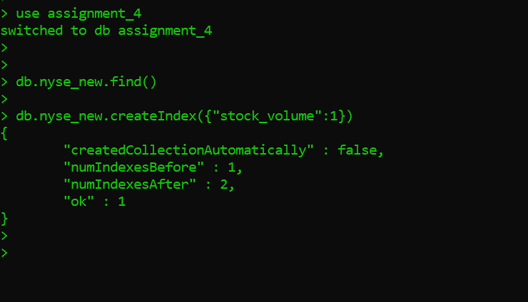

**Then imported the nyse data to this collection using bat file**

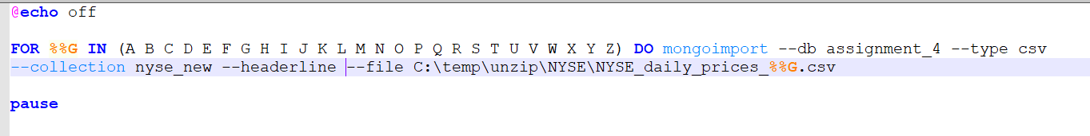

**The indexes are correctly created.**

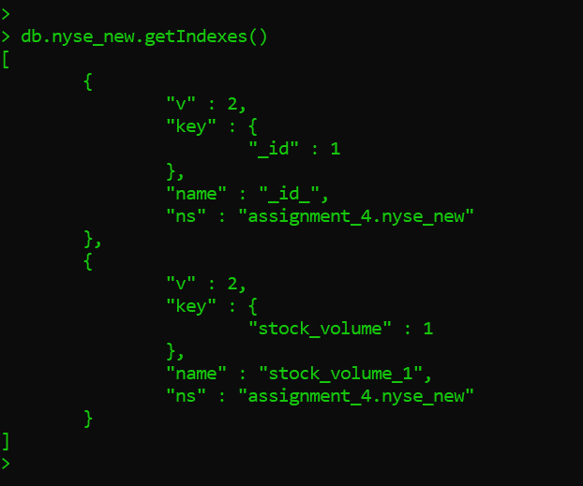

**Q3**

**Ans—**

**Imported all the nyse data to new collection stocks**

**Then after that created index** on key: stock_symbol in ascending order

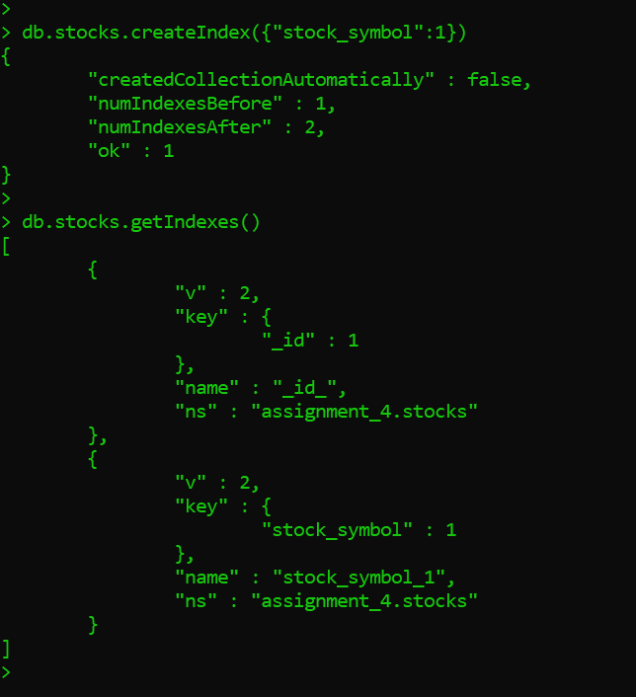

**Q4**

**Ans:**