**Assignment 4**

**Part 2**

**Code in Package- com.hadoop.assignment4.part_2**

**Output Screenshot--**

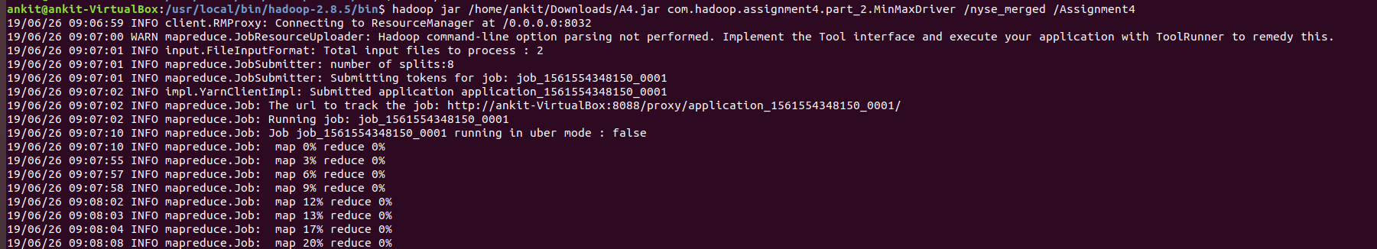 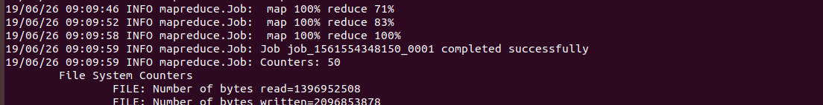

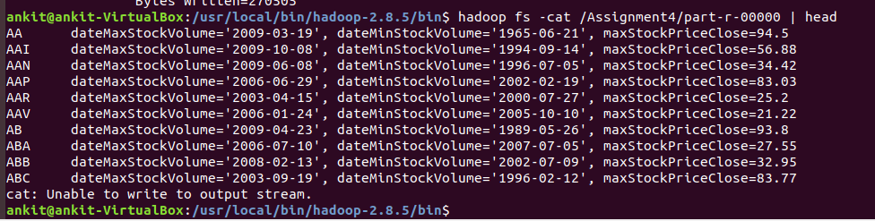

**Part 3**

**Code in Package- com.hadoop.assignment4.part_3**

The running time of this part was much more than running time of part_2.

**Output Screenshot--**

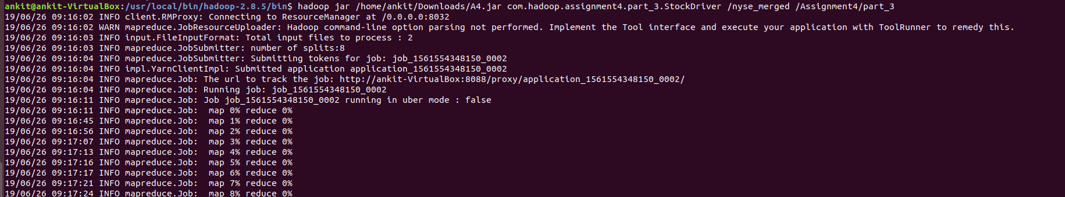

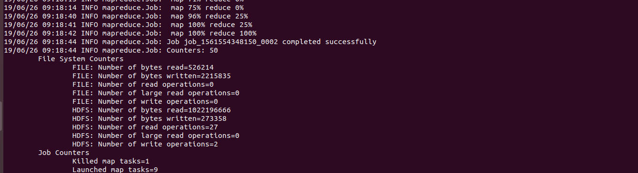

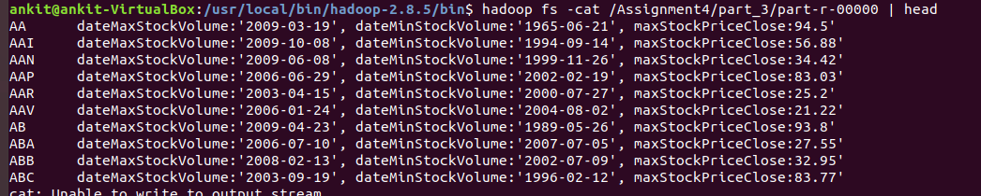

**Part 4**

**Code in Package- com.hadoop.assignment4.part_4**

**Output Screenshot--**

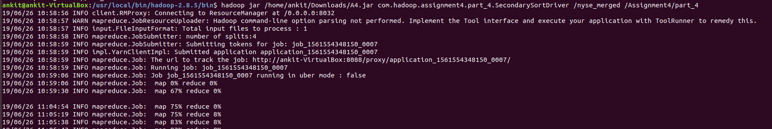

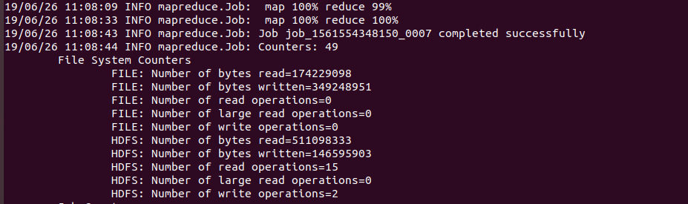

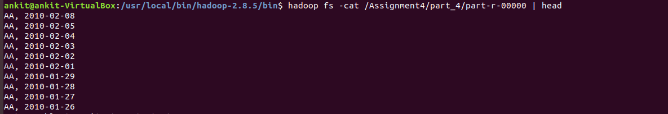

**Part 5**

**Code in Package- com.hadoop.assignment4.part_5**

**Output Screenshot:**

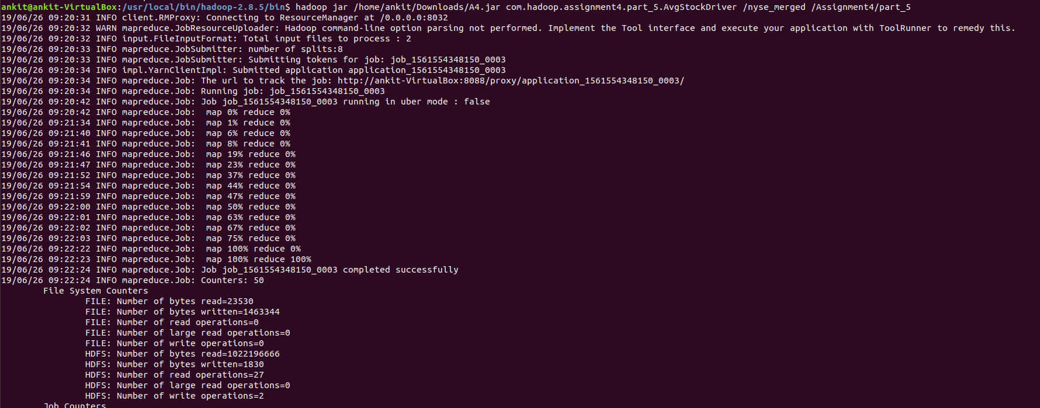

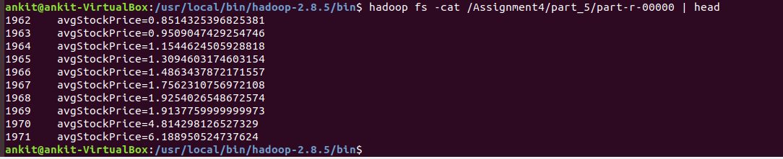

**Part 6**

**Code in Package- com.hadoop.assignment4.part_6**

**Output Screenshot:**

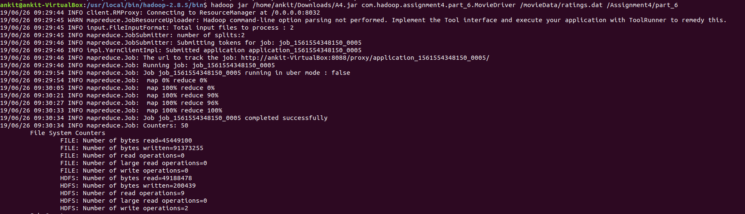

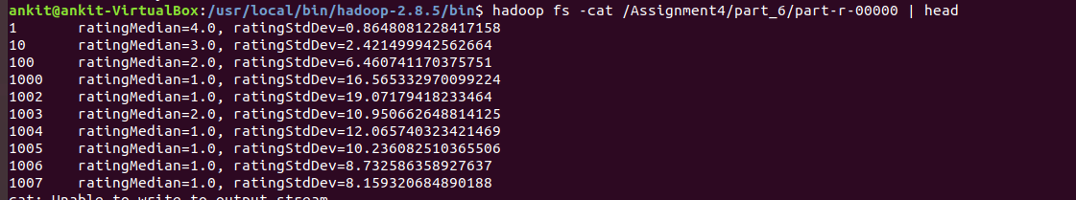

**Part 7**

**Code in Package- com.hadoop.assignment4.part_7**

**Output Screenshot:**

