

**PROJECT REPORT**

# Online Shop Mobile

|  |  |
| --- | --- |
| **Semester:** | Web Apps Development |
| **Class:** | WD04 |
| **Group:** | Group 1 |
| **Instructor** | Vũ Trần Lâm |
| **Team members:** | NDE19011 – Lê Ngọc Xuân  NDE18034– Tạ Văn Ước  NDE18033 – Nguyễn Văn Duyệt |

# Index

Project Name_____________________________________________________________1

Table Content____________________________________________________________2

1. Project Introduction__________________________________________3
2. Analyze System Requirements__________________________________4
3. Design Details_______________________________________________69
4. Task Assign_________________________________________________82
5. Deployment Diagram_________________________________________83
6. Task Assign

# Project introduction

The website helps customer view and order phones and other accessories

1. Admin access the separate management page to control and manage the home page

Proposed System

1. Proposed System

* The website helps customers choose to buy phone
* Management page help admin to manage operation and editing
* Easy to use

1. The scope of the project to be applied

* For customer and admin
* This project is a website that runs on multiple devices with installed chrome, google, coccoc,… and network connection

1. System Name

Mobile Shop Online

1. Deployment Environment

* Hardware: Computer systems (pc, laptop), chip i3, ram 8G
* Software:

system: Windows 10

+ Database : phpMy Admin

+ 000Webhost

1. Development Tools

* Draw.Io ,Violetumleditor, Visual studio Code, MySQL Server

6. Customer Requirements

(system features)

Use Case:

Actor: Customer

1 Search Mobile

2 Buy Mobile

3 Manage Customer Order

Actor: Admin

1 Manage Customer

2 Manage Admin Orders

3 Manage Categories

4 Manage Logictics

5 Manage Mobile

6 Manage News

# Analyze System Requirements

1. Use Case

Full Use Case

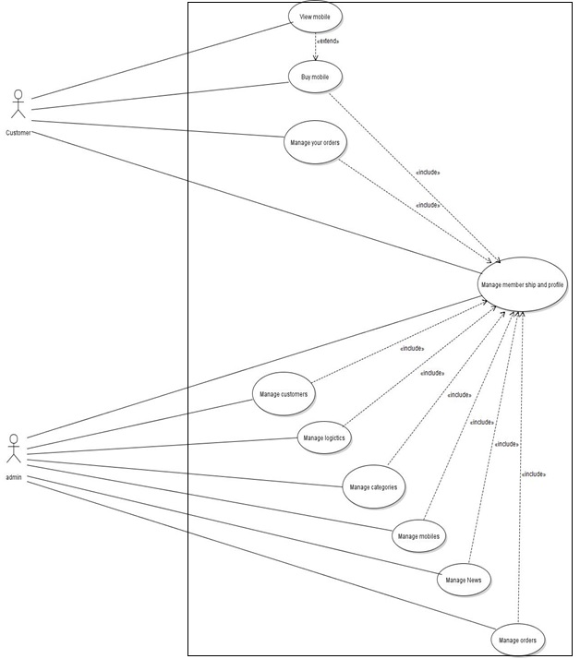

UC_01. Search Mobile



|  |  |
| --- | --- |
| Use Case Name | Search Mobile |
| Use Case ID | UC_01.1 |
| Description | When users access the website and want to search  mobile . User can search for mobile phones by entering the desired mobile phone name |
| Actor | Online customer |
| Organizational Benefits | Increase sales by helping customer view and search mobile in the most convenient way |
| Triggers | Customer enter the name of the mobile phone they want to search |
| Preconditions | Customer access the website and clicks on search mobile |
| Postconditions | Customer can search for mobile they want to find |
| Main Course | 1. Customer choose to view the product by entering the product name in the search box  2. Customer enter mobile name into the search box  3. The system will display the mobile or mobile list |
| Alternate Courses | AC01 the customer successfully searches for the phone and wants to click to see product details  1.Back to step 1 of the main course, the system determines that customers choose to view the product through searching  2.The system displays details of selected products that customers want to see  3.The system reminds customers that you want to see this product |
| Exceptions | EX 1 Customer has entered wrong mobile name or mobile is not in stock  1.System notifies customer that can not find mobile  2.Return customer to Main Course 1 |

|  |  |
| --- | --- |
| Use Case Name | View recommend mobile |
| Use Case ID | UC_01.2 |
| Description | When users access the website and wants to see the mobile , users can click on the suggestion to see it |
| Actor | Online customer |
| Organizational Benefits | Increase sales by helping customer see more recommend products |
| Triggers | Customer click on any of the recommend products  to view more details |
| Preconditions | Customer access the website and clicks on the suggested product |
| Postconditions | Customer can view a wider variety of phones from the recommendations |
| Main Course | 1.Customer choose to view the product by selecting and clicking on any recommended product  2.The system will display phone introduction details |
| Alternate Courses | Customer select and view the phone in the successful introduction |
| Exceptions | EX 1 Customer has not clicked on any product in the suggestion  1.The phone does not show up in the system because the customer has not clicked on any product  2. Returning customer to Main dish 1 |

|  |  |
| --- | --- |
| Use Case Name | View by categories |
| Use Case ID | UC_01.3 |
| Description | When users access the website and wants to see the phone, the users can find the phone by category |
| Actor | Online customer |
| Organizational Benefits | Increase sales by helping customer see products conveniently and quickly |
| Triggers | Customer can choose to view by category to see phone |
| Preconditions | Customer access the website and choose the category |
| Postconditions | Customer can view phones by viewing category |
| Main Course | 1.Customer choose to view the product by clicking on the menu to view by category  2.the system displays the phone by category |
| Alternate Courses | Customers choose to view according to the category and product display system |
| Exceptions | EX 1. Customer does not click on the list box or the cell phone is not in  stock  1.The system does not display the phone because the customer has not click  2. Returning customer to Main Course 1 |

UC_02. Buy mobile



|  |  |
| --- | --- |
| Use Case Name | Add to cart |
| Use Case ID | UC_02.1 |
| Description | When users access the website and want to add mobile phones to cart, customers will have to click the Buy Now button. |
| Actor | Online customer |
| Organizational Benefits | Increase sales by helping customer buy mobile phone in the most convenient way |
| Triggers | customers click the Buy Now button |
| Preconditions | Customer access the website and viewing a mobile phone |
| Postconditions | The mobile phone selected to be added is visible to customers when they views their cart |
| Main Course | 1.Customer view mobile phone in catalog  2.Customer click Buy Now button  3. System notifies customer that added mobile phone to their cart  4. System stores the mobile phone in customer’s cart  5. System redirects the customers to their cart to view the full list |
| Alternate Courses | AC1 Customers add mobile phone to cart successfully and want to add more mobile phone to cart  1.Return to Main Course step 1  System  determines customers already have this product in the cart  1. The system notify customers already have this product in the cart  2. System prompts customer that you want to add this product |
| Exceptions | EX1 Customer decides to purchase the mobile phone now  1.See UC_02.4 use case  EX2 Customer decides to edit the mobile phone now  1. See UC_02.2 use case  EX3 System fails on added mobile phone to cart  1.System notifies customer that an error has occurred  2. Return customer to Main Course step 1  EX4  System  determines customers already have this product in the cart  1. The system notify customers already have this product in the cart  2. System prompts customer that you want to add this product  3. Return to Main Course step 1 |

|  |  |
| --- | --- |
| Use Case Name | Edit cart |
| Use Case ID | UC_02.2 |
| Description | When customers view items in cart, they want to edit items in their cart |
| Actor | Online customer |
| Organizational Benefits | Increase sales by helping customer edit mobile phone in their cart |
| Triggers | The Customer selects an option to edit cart |
| Preconditions | Customer View list items in their cart |
| Postconditions | Mobile phone in Cart is edited successfully |
| Main Course | 1.Customer view list mobile phone in cart  2.Customers enter the quantity that customers want to edit  3.The system saves the amount that customers want to buy and re-calculate the total price |
| Alternate Courses | AC1 Customer don’t want to edit cart  1. Return to Main Course step 1 |
| Exceptions | EX1 Customer have no mobile phone in shopping cart  1.See UC_02.1 use case  EX2 System fails on edited mobile phone in cart  1.System notifies customer that an error has occurred  2. Return customer to Main Course step 1 |

|  |  |
| --- | --- |
| Use Case Name | Checkout |
| Use Case ID | UC_02.3 |
| Description | Customer want to purchase the mobile phone |
| Actor | Online customer |
| Organizational Benefits | Increase sales by helping customer purchase mobile phone |
| Triggers | The Customer selects an option to purchase |
| Preconditions | Customer login and have a mobile phone in shopping cart |
| Postconditions | Mobile phone is sold to customers |
| Main Course | 1.Customer click Purchase button in shopping cart  2.System determines customer is not logged in and redirects customer to log on  3.Customer log on  3.System direct customer to purchase page  4.Customer choose a payment method  5.The system processing and confirm payment method of customer |
| Alternate Courses | AC1 System determines customer is already log on  1.Return Main Course step 3  AC2 Customer log off again  1.Return customer to Main Course step 2  AC3 Customer does not have an account already  1.Customer create account  2.System confirm account creation  3.Return customer to MC step 3 |
| Exceptions | EX1 System fails on pay bill  1.System notifies customer that an error has occurred  2. Return customer to Main Course step 3 |

|  |  |
| --- | --- |
| Use Case Name | View cart |
| Use Case ID | UC_02. |
| Description | Customer want view cart |
| Actor | Online customer |
| Organizational Benefits | Increase sales by helping customer purchase mobile phone |
| Triggers | The Customer selects an option to view shopping cart |
| Preconditions | Customer access to website |
| Postconditions | Shopping cart is displayed |
| Main Course | 1.Customer access to homepage of website  2.Customer select an option to view shopping cart  3.System redirects user to shopping cart  4.System display mobile phone list in shopping cart |
| Alternate Courses | AC1 Customer access link of shopping cart instead of access to homepage  1.Return user to MC step 4 |
| Exceptions | EX1System fails on display shopping cart  1.System notifies customer that an error has occurred  2. Return customer to Main Course step 1 |

UC_03.Manage your order



|  |  |
| --- | --- |
| Use Case Name | View order |
| Use Case ID | UC_03.1 |
| Description | The user visits the website and see his order |
| Actor | Online customer |
| Organizational Benefits | Helps user to view their orders and then choose to pay for their orders |
| Triggers | Customers choose to view individual order history |
| Preconditions | Customers view and manage products ordered |
| Postconditions | Customers view successful order history |
| Main Course | 1.Customers login the website choose to show order history  2.The system displays the order history |
| Alternate Courses | AC1 The customer visits the website and view order history  Customers choose to view order history and the system display a list of ordered products |
| Exceptions | EX1 Customers do not choose to view the ordered products   1.See UC_04 use case  Ex2 The system cannot display a list of ordered rows  1.The system notifies customers that an error has occurred  2. Returning Client to Main Course Step 1 |

|  |  |
| --- | --- |
| Use Case Name | Edit order |
| Use Case ID | UC_03.2 |
| Description | The user visits the website to view the ordered product and to select to edit the order |
| Actor | Online customer |
| Organizational Benefits | Customer can manage and edit his order list |
| Triggers | The customer selects the edit item to edit the order |
| Preconditions | The customer access to the website selects edit order |
| Postconditions | Customers selects successful order edit |
| Main Course | 1.Customers login the website choose to show order history  2.The system displays the customer order history  3.Customer choose to edit order  4.The system reminds customers that they want to save new order updates ? |
| Alternate Courses | AC1 The customer selects a product to further modify, reduce quantity or cancel an order |
| Exceptions | EX1  The customer has no items in the shopping cart   1.See UC_02.1 use case  Ex2 The system cannot display the product list for editing  1.The system notifies customers that an error has occurred  2. Returning Client to Main Course Step 1  Ex3 New orders are not updated by the system  1.The system reported an unexpected error  2.System brings customers back to Main course Step 1 |

|  |  |
| --- | --- |
| Use Case Name | Cancel order |
| Use Case ID | UC_03.3 |
| Description | The customer visits the website to view the product and choose to cancel the order |
| Actor | Online customer |
| Organizational Benefits | Customers can delete ordered products |
| Triggers | The customer choose to delete the product ordered |
| Preconditions | The customer visits the website and the product is ordered |
| Postconditions | Customers successfully deleted the order |
| Main Course | 1.Customers login the website choose to show order history  2.The system displays the order history  3.The customer chooses to delete the product ordered  4.The system reminds customers if they really want to delete orders |
| Alternate Courses | AC1 The customer cancel order successfully  Customers choose to delete another order or exit |
| Exceptions | EX1  The customer has not placed any orders to cancel  1.See UC_03.1 use case  Ex2 The customer cannot delete an order  1.The system notifies customers that an error has occurred  2. Returning Client to Main Course Step 1 |

UC_04. Manage membership and profile

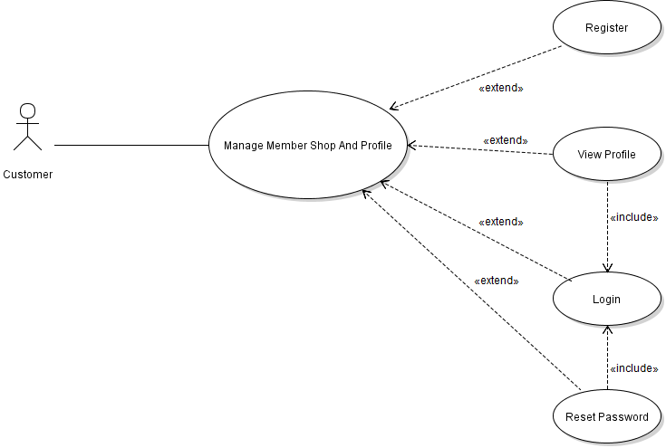

|  |  |
| --- | --- |
| Use Case Name | Login |
| Use Case ID | UC_04.1 |
| Description | Customers want to login to continue accessing the website |
| Actor | Online customer |
| Organizational Benefits | Customers can receive incentives when logging into the website |
| Triggers | After entering the username and password , click on the confirmation box |
| Preconditions | Customers access the website with an existing account or register a new account and access the website |
| Postconditions | Customers successfully login to website |
| Main Course | 1.Customers visiting the website  2.Customers enters username and password  3.Customers clicks the login confirmation box  4.Notifirmation system successfully login and redirected to the homepage |
| Alternate Courses | AC1 Customers login to website successfully  System confirmation successful login |
| Exceptions | EX1 Customer enters wrong username or password  1.See UC_04 use case  Ex2 The customer cannot login to the account  1.The system reported that an error occurred  2.The system returns the customer to the login screen |

|  |  |
| --- | --- |
| Use Case Name | Register |
| Use Case ID | UC_04.2 |
| Description | Customers creates a new account to login to the website |
| Actor | Online customer |
| Organizational Benefits | Customers enters the website and choose to register |
| Triggers | Customers create a new account and use it to login to the website to receive exclusive offers |
| Preconditions | Customers enter and confirm creating a new account |
| Postconditions | Customers successfully register |
| Main Course | 1.Customers visiting the website  2.Customers enters username and password, email, phone number  3.Customers clicks on the confirmation box of registration  4.System successfully registered us  5.The system brings customers back to the login page to register |
| Alternate Courses | AC1 Customers register  successfully  System confirmation successful register |
| Exceptions | EX1 Customer does not enter information  1.See UC_04 use case  Ex2 The customer cannot create an account  1.The system reported that an error occurred  2.The system returns the customer to the login screen |

|  |  |
| --- | --- |
| Use Case Name | View profile |
| Use Case ID | UC_04.3 |
| Description | The customer login with an existing account and chooses to display personal information |
| Actor | Online customer |
| Organizational Benefits | Customers can view personal information |
| Triggers | Customers choose to see personal news |
| Preconditions | The customer accesses the website login in with an existing account and chooses to view personal information |
| Postconditions | Customers successfully view personal information |
| Main Course | 1.Customers login with existing account  2.Customers choose to view personal information  3.System display customers` personal information |
| Alternate Courses | AC1 Customers login and choose to view personal information successfully  The system displays customer personal information |
| Exceptions | EX1 Customer enters wrong username or password  1.See UC_04 use case  Ex2 The client login but cannot view the personal information  1.The system notifies that an error has occurred  Ex3 Customer does not have an account to login  1. Suggested customers system can create accounts in the registration section |

|  |  |
| --- | --- |
| Use Case Name | Reset Password |
| Use Case ID | UC_04.4 |
| Description | The customer login and choose to edit account |
| Actor | Online customer |
| Organizational Benefits | Customers can change the password of the account |
| Triggers | Customers choose to edit account password |
| Preconditions | The customer accesses the website with an existing account and chooses to edit the account password |
| Postconditions | Customers successfully edit password |
| Main Course | 1.Customers login with existing account  2.Customers choose to edit password  3.Customer enter the new password  4.Customer successfully fixed password |
| Alternate Courses | AC1 Customers successfully edit password  The system saves the password after editing |
| Exceptions | EX1 Customer enters an inappropriate  1.See UC_04 use case  Ex2 System encountered an error that prevented the customer from editing the password  1.The system notifies that an error has occurred |

UC_05. Manage Logictics

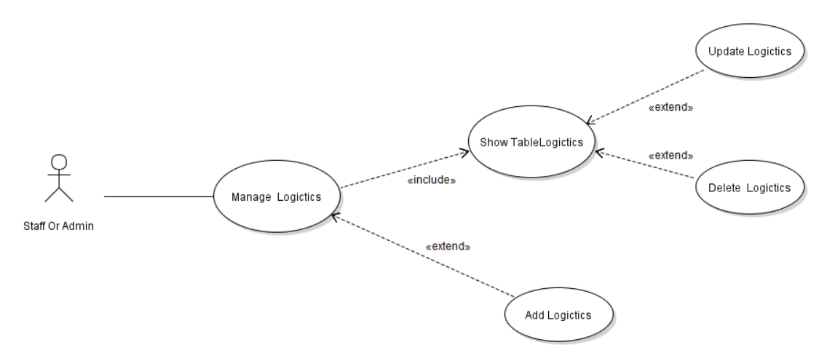

|  |  |
| --- | --- |
| Use Case Name | Show Table Logictis |
| Use Case ID | UC_05.1 |
| Description | Admin can see the list of logictics |
| Actor | Admin |
| Organizational Benefits | This function help admin manage logictics in the most convenient way |
| Triggers | Admin select manage logictics |
| Preconditions | User must be logged in as admin member |
| Postconditions | Display table logictics |
| Main Course | 1.Admin choose to see the list of logictics  2.The system confirms and displays the list of logictics |
| Alternate Courses | The system display table list of logictics |
| Exceptions | EX1 User does not choose to view list of logictics  The system does not display the list of logictics  EX2 The system cannot find data in the database |

|  |  |
| --- | --- |
| Use Case Name | Edit logictics |
| Use Case ID | UC_05.2 |
| Description | Admin can edit logictics |
| Actor | Admin |
| Organizational Benefits | This function help admin manage logictics edit logictics |
| Triggers | Admin select manage logictics and choose edit logictics |
| Preconditions | User must be logged in as admin member |
| Postconditions | Display view edit logictics |
| Main Course | 1.Admin choose to see the list of logictics  2.The system confirms and displays the list of logictics  3. Admin choose edit logictics  4.The system display view edit logictics  5.Admin import new logictics |
| Alternate Courses | The system display new logictics |
| Exceptions | EX1 Admin does not choose edit logictics  EX2 Admin doesn’t import new logictics  1.The system don’t display new logictics |

|  |  |
| --- | --- |
| Use Case Name | Delete logictics |
| Use Case ID | UC_05.3 |
| Description | In managing Mobile Shop Online website, admin can delete logictics |
| Actor | Admin |
| Organizational Benefits | This function help admin in the most convenient way |
| Triggers | Admin select an option to delete logictics |
| Preconditions | User must be logged in as administrator |
| Postconditions | Admin is delete logictics |
| Main Course | 1.Admin select the logictics you want to delete  2.Web reminders really want to delete?  3.Admin selects to confirm deletion of the directory  4.The selected logictics has been deleted |
| Alternate Courses | AC1 User do not enter password  1.Return user to MC step 6  AC2 User logs off again  1. Return user to MC step 1 |
| Exceptions | EX1 decides to delete the logictics  1.The system confirms deletion of the selected logictics  System EX2 deletes the list unsuccessfully  1. The system notifies the user that an error has occurred  2.Return user to MC step 3 |

|  |  |
| --- | --- |
| Use Case Name | Add logictics |
| Use Case ID | UC_05.4 |
| Description | In managing Mobile Shop Online website, admin can add  logictics |
| Actor | Admin |
| Organizational Benefits | This function help admin manage admin in the most convenient way |
| Triggers | User select an option to add logictics |
| Preconditions | User must be logged in as administrator |
| Postconditions | Admin is add logictics |
| Main Course | 1.Admin choose add logictics  2.The system show view add new logictics  3.Admin import new logictics the database |
| Alternate Courses | AC1 User do not enter password  1.Return user to MC step 6  AC2 User logs off again  1. Return user to MC step 1 |
| Exceptions | EX1 admin don’t choose add logictics  1.The system don’t show view add logictics  EX2 the system don’t connect database  1.Display don’t add new logictics |

UC_06. Manage customer

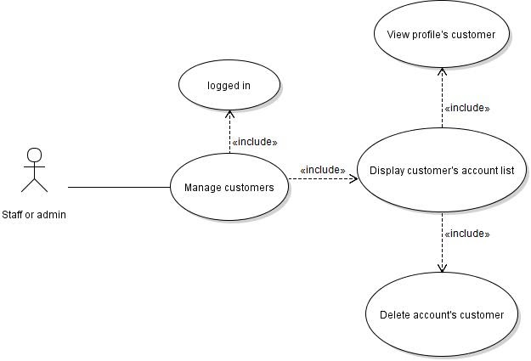

|  |  |
| --- | --- |
| Use Case Name | Display customer’s account list |
| Use Case ID | UC_06.1 |
| Description | In managing Mobile Shop Online website, admin can view customer’s account list |
| Actor | Admin |
| Organizational Benefits | This function help Admin manage customers in the most convenient way |
| Triggers | User select an option to display customer’s account list |
| Preconditions | User must be logged in as administrator |
| Postconditions | Customer’s account list are displayed |
| Main Course | 1.User login as Admin member  2.System redirects user to admin page  3.User select an option to manage customer  4.System redirects user to manage customer page and display customer account list |
| Alternate Courses | AC1 User logs off again  1. Return user to MC step 1 |
| Exceptions | EX1 User decides to delete customer account  1.See “Delete customer’s account” use case  EX2 User decides to view profile customer  1.See “View customer profile” use case  EX3 System fails on displayed customer account list  1.System notifies user that an error has occurred  2.Return user to MC step 2 |

|  |  |
| --- | --- |
| Use Case Name | View customer profile |
| Use Case ID | UC_06.2 |
| Description | In managing Mobile Shop Online website, admin can view customer profile |
| Actor | Admin |
| Organizational Benefits | This function help admin manage customers in the most convenient way |
| Triggers | User select a customer account to view profile |
| Preconditions | User must be logged in as admin member |
| Postconditions | Customer profile is displayed |
| Main Course | 1.User login as admin member  2.System redirects user to admin page  2.User select manage customer  3.System display list of customer  4.User select a customer account to view profile  5.System display customer profile |
| Alternate Courses | AC1 User logs off again  1. Return user to MC step 1 |
| Exceptions | EX1 User decides to delete customer account  1.See “Delete customer’s account” use case  EX2 System fails on displayed customer profile  1.System notifies user that an error has occurred  2.Return user to MC step 2 |

|  |  |
| --- | --- |
| Use Case Name | Display customer’s account list |
| Use Case ID | UC_06.3 |
| Description | In managing Mobile Shop Online website, admin can delete customer account |
| Actor | admin |
| Organizational Benefits | This function help admin manage customers in the most convenient way |
| Triggers | User select an option to delete customer account |
| Preconditions | User must be logged in as admin member |
| Postconditions | Customer’s account is deleted |
| Main Course | 1.User login as admin member  2.System redirects user to the customer management page  2.User select manage customer  3.System display list of customer  4.User select an option to delete customer account  5.System prompt user to enter password to confirm  6.System validate and save to the database |
| Alternate Courses | AC1 User logs off again  1. Return user to MC step 1  AC2 User want to view customer profile before delete  1.User select an option to view customer profile  2.System redirects user to customer profile page  3.User select an option to delete customer account  4.Return user to MC step 5  AC3 User do not enter password to confirm  1.Return user to MC step 3 |
| Exceptions | EX1 System fails on displayed customer account list  1.System notifies user that an error has occurred  2.Return user to MC step 2 |

UC_07. Manage mobile

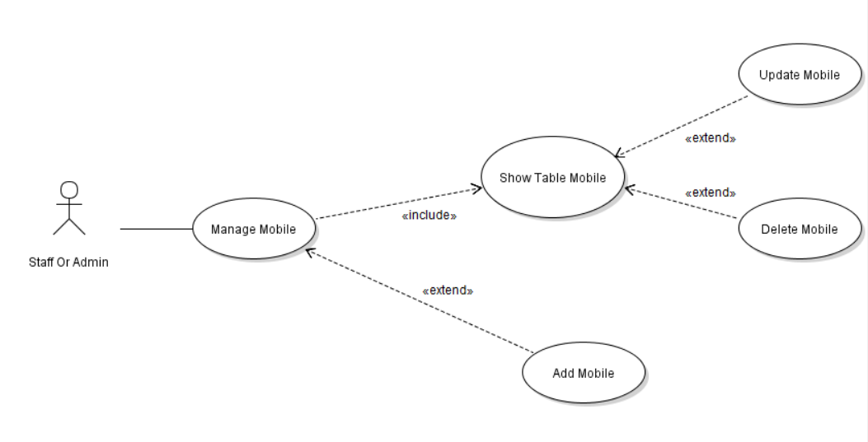

|  |  |
| --- | --- |
| Use Case Name | Add mobile |
| Use Case ID | UC_07.1 |
| Description | In managing Mobile Shop Online website, admin can add mobile phone |
| Actor | Admin |
| Organizational Benefits | This function help admin manage mobile phone  in the most convenient way |
| Triggers | User select an option to add a new mobile phone |
| Preconditions | User must be logged in as admin member |
| Postconditions | A new mobile phone is created |
| Main Course | 1.User login as admin member  2.System redirects user to admin page  3.User select manage mobile  4.System redirects user to manage mobile page  5.User select an option to create new mobile  6.System redirects user to create mobile page  7.User enter information of mobile and click  Create button  8.System validates and save to the database |
| Alternate Courses | AC1 User logs off again  1. Return user to MC step 1 |
| Exceptions | EX1 User decides to edit mobile  1.See “Edit mobile” use case  EX2 System fails on create mobile  1.System notifies user that an error has occurred  2.Return user to MC step 6 |

|  |  |
| --- | --- |
| Use Case Name | Display mobile list |
| Use Case ID | UC_07.2 |
| Description | In managing Mobile Shop Online website, admin can display mobile list |
| Actor | Admin |
| Organizational Benefits | This function help admin manage mobile phone  in the most convenient way |
| Triggers | User select an option to view mobile list |
| Preconditions | User must be logged in as admin member |
| Postconditions | mobile list is displayed |
| Main Course | 1.User login as admin member  2.System redirects user to admin page  3.User select manage mobile  4.System redirects user to manage mobile page and display mobile list |
| Alternate Courses | AC1 User logs off again  1. Return user to MC step 1 |
| Exceptions | EX1 User decides to edit mobile  1.See “Edit mobile” use case  EX2 System fails on display mobile list  1.System notifies user that an error has occurred  2.Return user to MC step 2  EX3 User decides to create new mobile  1.See “add mobile” use case  EX3 User decides to delete mobile now  1.See “delete mobile” use case |

|  |  |
| --- | --- |
| Use Case Name | Edit mobile |
| Use Case ID | UC_07.3 |
| Description | In managing Mobile Shop Online website, admin can edit mobile phone |
| Actor | admin |
| Organizational Benefits | This function help admin manage mobile phone  in the most convenient way |
| Triggers | User select an option to edit mobile phone |
| Preconditions | User must be logged in as admin member |
| Postconditions | A mobile phone is edited |
| Main Course | 1.User login as admin member  2.System redirects user to admin page  3.User select manage mobile  4.System redirects user to manage mobile page  5.User select a mobile phone to edit  6.System redirects user to mobile phone details page  7.User enter information of mobile and click  Save  8.System validates and save to the database |
| Alternate Courses | AC1 User logs off again  1. Return user to MC step 1  AC2 System determines user viewing mobile phone details  1.Return user to MC step 7 |
| Exceptions | EX1 User decides to delete mobile phone  1.See “delete mobile” use case  EX2 System fails on edit mobile phone  1.System notifies user that an error has occurred  2.Return user to MC step 6 |

|  |  |
| --- | --- |
| Use Case Name | Delete mobile |
| Use Case ID | UC_07.4 |
| Description | In managing Mobile Shop Online website, admin can delete mobile |
| Actor | admin |
| Organizational Benefits | This function help admin manage mobile phone  in the most convenient way |
| Triggers | User select an option to delete mobile phone |
| Preconditions | User must be logged in as admin member |
| Postconditions | A new mobile phone is deleted |
| Main Course | 1.User login as admin member  2.System redirects user to admin page  3.User select manage mobile  4.System redirects user to manage mobile page  5.User select an option to delete  mobile  6.System prompts user to confirm delete mobile  7.User confirm to delete now  8.System validates and save to the database  9.System redirects user to manage mobile page |
| Alternate Courses | AC1 User logs off again  1. Return user to MC step 1  AC2 System determines user is viewing mobile phone details  1.Return user to MC step 5 |
| Exceptions | EX1 User decides to edit mobile  1.See “Edit mobile” use case  EX2 System fails on delete mobile  1.System notifies user that an error has occurred  2.Return user to MC step 4 |

UC_08. Manage categories

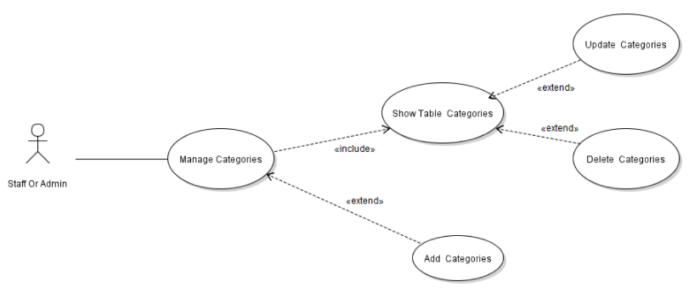

|  |  |
| --- | --- |
| Use Case Name | Show Table Categories |
| Use Case ID | UC_08.1 |
| Description | Admin can see the list of categories |
| Actor | Admin |
| Organizational Benefits | This function help admin manage categories in the most convenient way |
| Triggers | Admin select manage categories |
| Preconditions | User must be logged in as admin member |
| Postconditions | Display table categories |
| Main Course | 1.Admin choose to see the list of categories  2.The system confirms and displays the list of categories |
| Alternate Courses | The system display table list of categories |
| Exceptions | EX1 User does not choose to view list of categories  The system does not display the list of categories  EX2 The system cannot find data in the database |

|  |  |
| --- | --- |
| Use Case Name | Edit Categories |
| Use Case ID | UC_08.2 |
| Description | Admin can edit categories |
| Actor | Admin |
| Organizational Benefits | This function help admin edit categories |
| Triggers | Admin select manage categories and choose edit categories |
| Preconditions | User must be logged in as admin member |
| Postconditions | Display view edit categories |
| Main Course | 1.Admin choose to see the list of categories  2.The system confirms and displays the list of categories  3. Admin choose edit categories  4.The system display view edit categories  5.Admin import new categories |
| Alternate Courses | The system display new categories |
| Exceptions | EX1 Admin does not choose edit categories  EX2 Admin doesn’t import new categories  1.The system don’t display new categories |

|  |  |
| --- | --- |
| Use Case Name | Delete Categories |
| Use Case ID | UC_08.3 |
| Description | In managing Mobile Shop Online website, admin can delete categories |
| Actor | Admin |
| Organizational Benefits | This function help admin in the most convenient way |
| Triggers | Admin select an option to delete categories |
| Preconditions | User must be logged in as administrator |
| Postconditions | Admin is delete categories |
| Main Course | 1.Admin select the categories you want to delete  2.Web reminders really want to delete?  3.Admin selects to confirm deletion of the directory  4.The selected categories has been deleted |
| Alternate Courses | AC1 User do not enter password  1.Return user to MC step 6  AC2 User logs off again  1. Return user to MC step 1 |
| Exceptions | EX1 decides to delete the categories  1.The system confirms deletion of the selected categories  System EX2 deletes the list unsuccessfully  1. The system notifies the user that an error has occurred  2.Return user to MC step 3 |

|  |  |
| --- | --- |
| Use Case Name | Add logictics |
| Use Case ID | UC_08.4 |
| Description | In managing Mobile Shop Online website, admin can add  categories |
| Actor | Admin |
| Organizational Benefits | This function help admin manage admin in the most convenient way |
| Triggers | User select an option to add categories |
| Preconditions | User must be logged in as administrator |
| Postconditions | Admin is add Categories |
| Main Course | 1.Admin choose add categories  2.The system show view add new categories  3.Admin import new categories the database |
| Alternate Courses | AC1 User do not enter password  1.Return user to MC step 6  AC2 User logs off again  1. Return user to MC step 1 |
| Exceptions | EX1 admin don’t choose add categories  1.The system don’t show view add categories  EX2 the system don’t connect database  1.Display don’t add new categories |

UC_09. Manage Admin Order

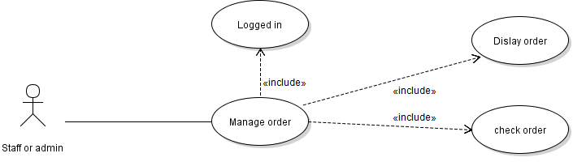

|  |  |
| --- | --- |
| Use Case Name | Display order |
| Use Case ID | UC_09.1 |
| Description | In managing Mobile Shop Online website, admin can view order of customer |
| Actor | Admin |
| Organizational Benefits | This function help admin manage order in the most convenient way |
| Triggers | User select an option to display order list |
| Preconditions | User must be logged in as admin member |
| Postconditions | Order list is displayed |
| Main Course | 1.User login as admin member  2.System redirects user to the admin page  3.User select an option to manage order  4.System redirects user to manage order page and display order list |
| Alternate Courses | AC1 User logs off again  1.Return user to MC step 1 |
| Exceptions | EX1 User want to check order  1.See “check order” use case  EX2 System fails on displayed order  list  1.System notifies user that an error has occurred  2.Return user to MC step 2 |

|  |  |
| --- | --- |
| Use Case Name | Check order |
| Use Case ID | UC_09.2 |
| Description | In managing Mobile Shop Online website, admin can check order of customer |
| Actor | Admin |
| Organizational Benefits | This function help admin manage order in the most convenient way |
| Triggers | User select an option to check order |
| Preconditions | User must be logged in as admin member |
| Postconditions | Order of customer is confirmed |
| Main Course | 1.User login as admin member  2.System redirects user to the admin page  3.User select an option to manage order  4.System redirects user to manage order page and display order list  5.User select an option to check order of customer  6.System redirects user to order detail of customer  7.User confirm order of customer  8.System redirects user to list order |
| Alternate Courses | AC1 User logs off again  1.Return user to MC step 1 |
| Exceptions | EX1 System fails on confirm order of customer  1.System notifies user that an error has occurred  2.Return user to MC step 4 |

UC_10 Manage News

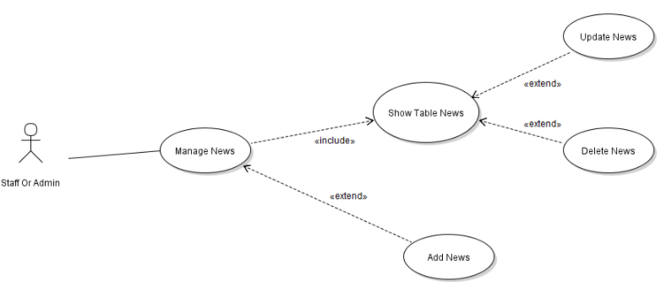

|  |  |
| --- | --- |
| Use Case Name | Show Table News |
| Use Case ID | UC_10.1 |
| Description | Admin can see the list of news |
| Actor | Admin |
| Organizational Benefits | This function help admin manage news  in the most convenient way |
| Triggers | Admin select manage news |
| Preconditions | User must be logged in as admin member |
| Postconditions | Display table news |
| Main Course | 1.Admin choose to see the list of news  2.The system confirms and displays the list of news |
| Alternate Courses | The system display table list of news |
| Exceptions | EX1 User does not choose to view list of news  The system does not display the list of news  EX2 The system cannot find data in the news |

|  |  |
| --- | --- |
| Use Case Name | Edit News |
| Use Case ID | UC_10.2 |
| Description | Admin can edit news |
| Actor | Admin |
| Organizational Benefits | This function help admin edit news |
| Triggers | Admin select manage News and choose edit news |
| Preconditions | User must be logged in as admin member |
| Postconditions | Display view edit news |
| Main Course | 1.Admin choose to see the list of news  2.The system confirms and displays the list of news  3. Admin choose edit news  4.The system display view edit news  5.Admin import new news |
| Alternate Courses | The system display new news |
| Exceptions | EX1 Admin does not choose edit news  EX2 Admin doesn’t import new news  1.The system don’t display new news |

|  |  |
| --- | --- |
| Use Case Name | Delete News |
| Use Case ID | UC_10.3 |
| Description | In managing Mobile Shop Online website, admin can delete news |
| Actor | Admin |
| Organizational Benefits | This function help admin in the most convenient way |
| Triggers | Admin select an option to delete news |
| Preconditions | User must be logged in as administrator |
| Postconditions | Admin is delete news |
| Main Course | 1.Admin select the news you want to delete  2.Web reminders really want to delete?  3.Admin selects to confirm deletion of the directory  4.The selected categories has been deleted |
| Alternate Courses | AC1 User do not enter password  1.Return user to MC step 6  AC2 User logs off again  1. Return user to MC step 1 |
| Exceptions | EX1 decides to delete the news  1.The system confirms deletion of the selected news  System EX2 deletes the list unsuccessfully  1. The system notifies the user that an error has occurred  2.Return user to MC step 3 |

|  |  |
| --- | --- |
| Use Case Name | Add News |
| Use Case ID | UC_10.4 |
| Description | In managing Mobile Shop Online website, admin can add  news |
| Actor | Admin |
| Organizational Benefits | This function help admin manage admin in the most convenient way |
| Triggers | User select an option to add news |
| Preconditions | User must be logged in as administrator |
| Postconditions | Admin is add news |
| Main Course | 1.Admin choose add news  2.The system show view add new news  3.Admin import new categories the news |
| Alternate Courses | AC1 User do not enter password  1.Return user to MC step 6  AC2 User logs off again  1. Return user to MC step 1 |
| Exceptions | EX1 admin don’t choose add news  1.The system don’t show view add news  EX2 the system don’t connect database  1.Display don’t add new news |

1. Activity Diagram:

Edit mobile

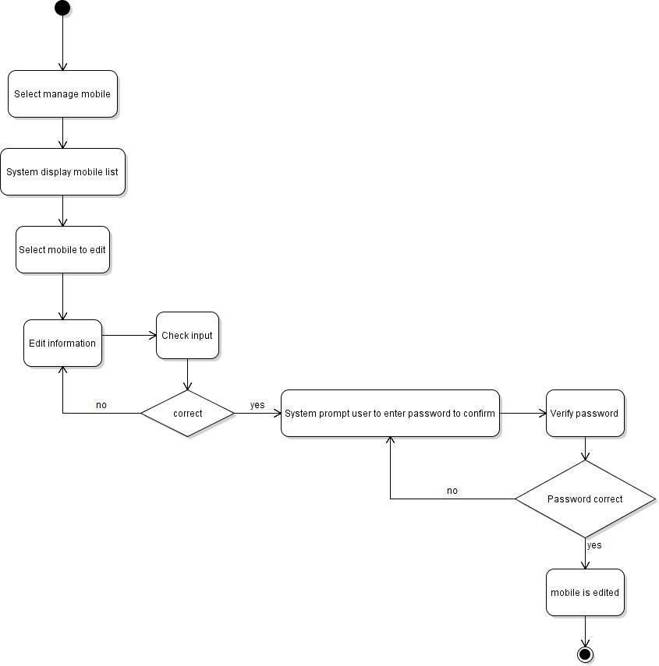

View cart

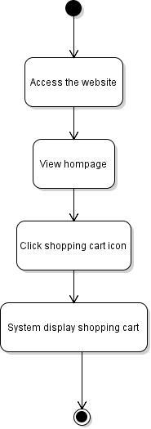

Edit cart

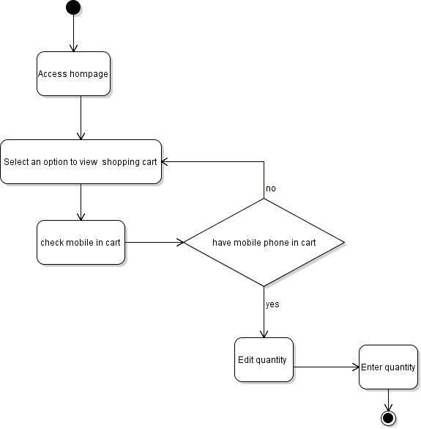

Add to card

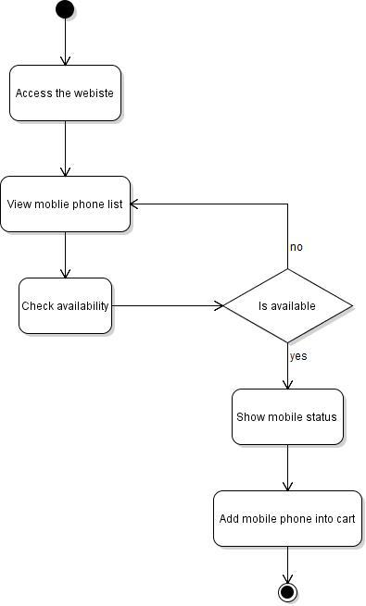

Delete Mobile

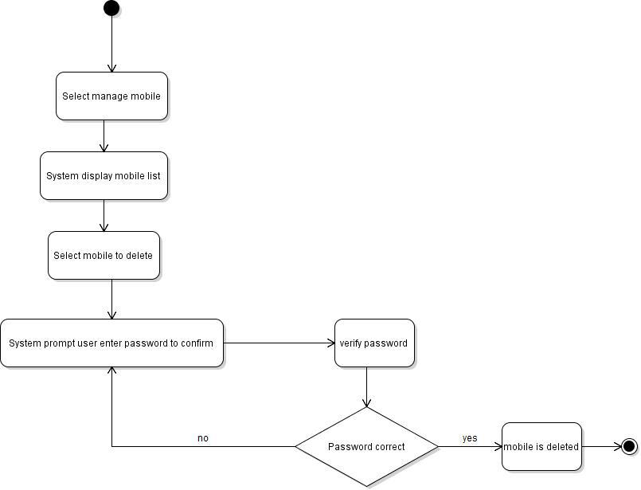

Manage Category

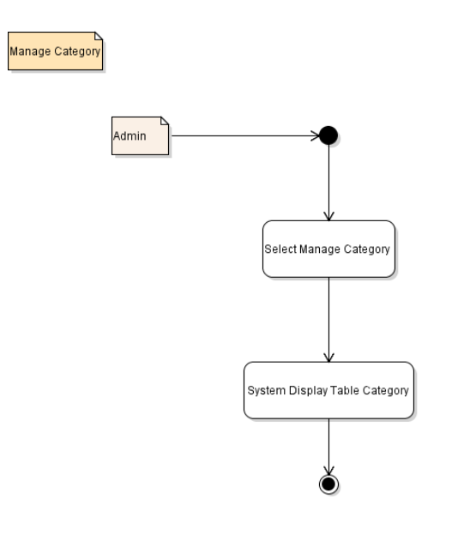

Manage News

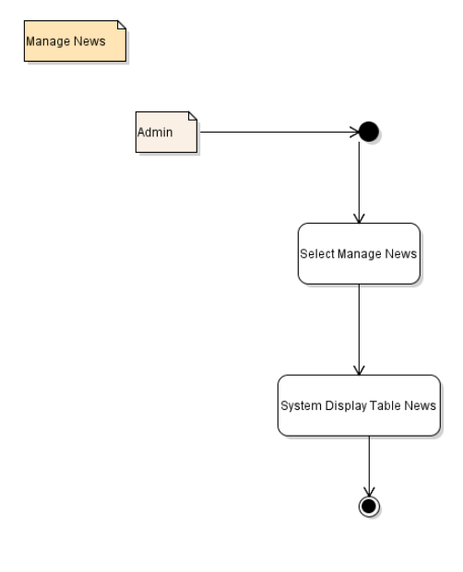

Manage Logictics

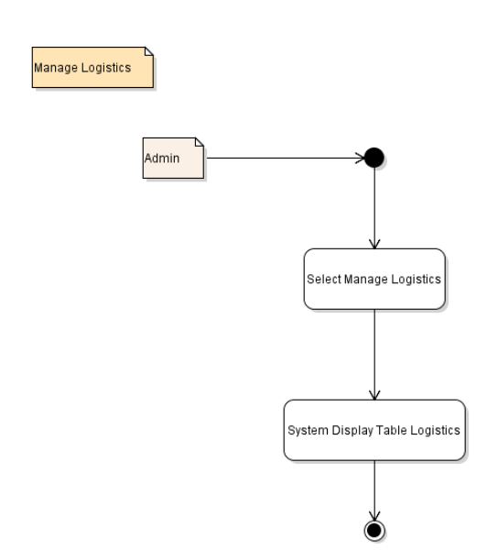

Manage Order

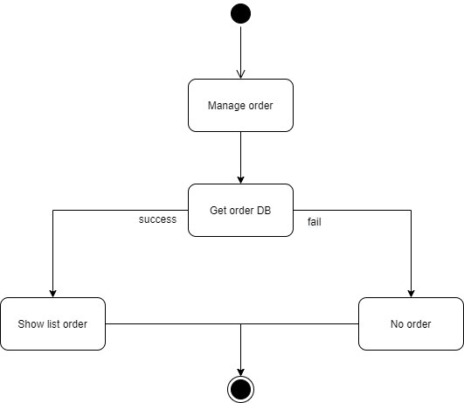

Show List Order

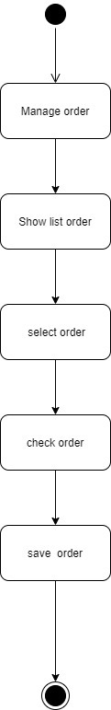

1. Sequen Diagram

3.1 Buy Mobile

Buy Mobile

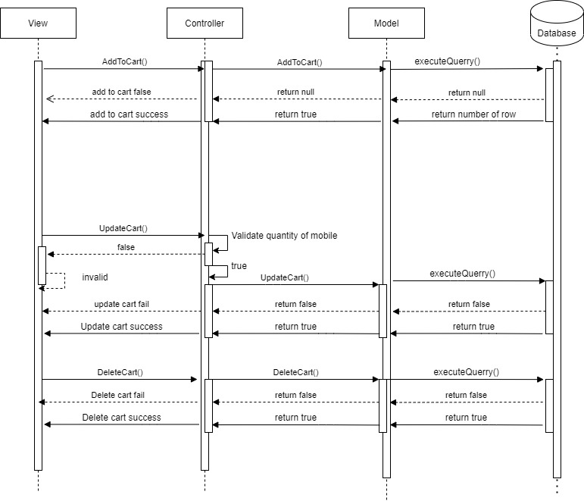

Check Out

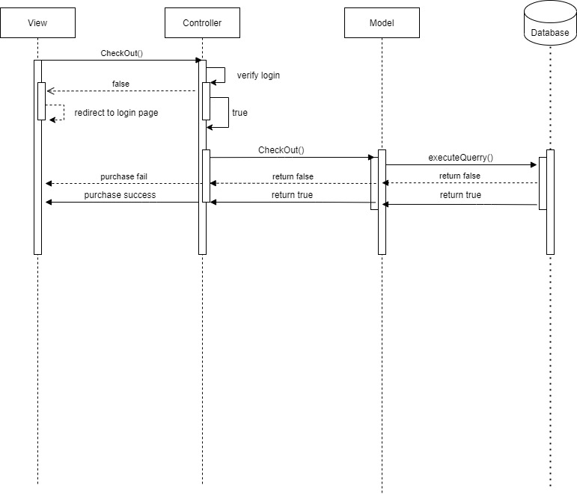

Manage Customer

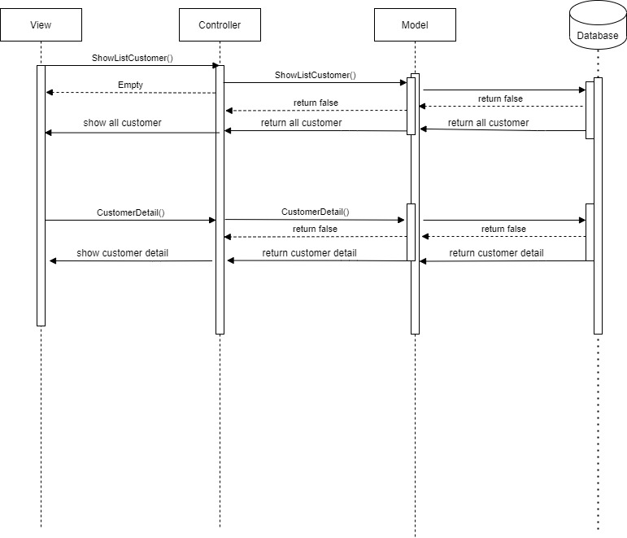

Manage Mobile

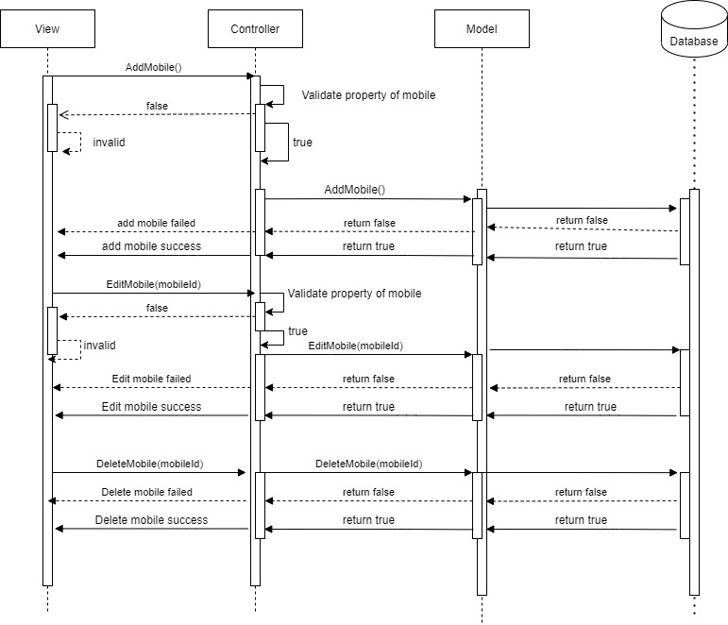

Manage Order

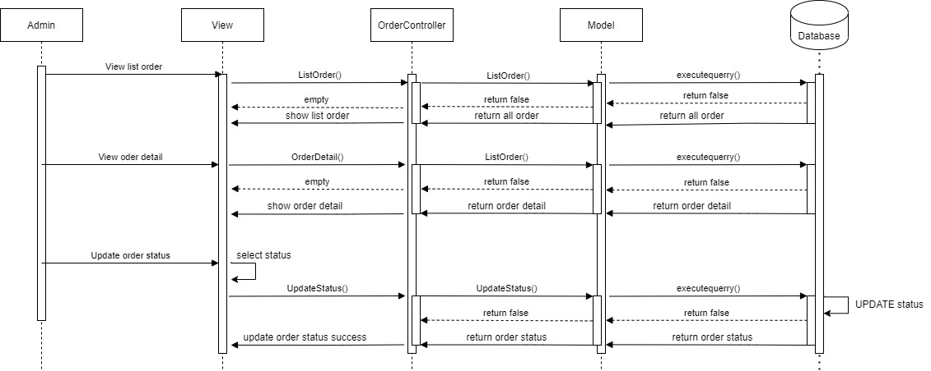

View Mobile

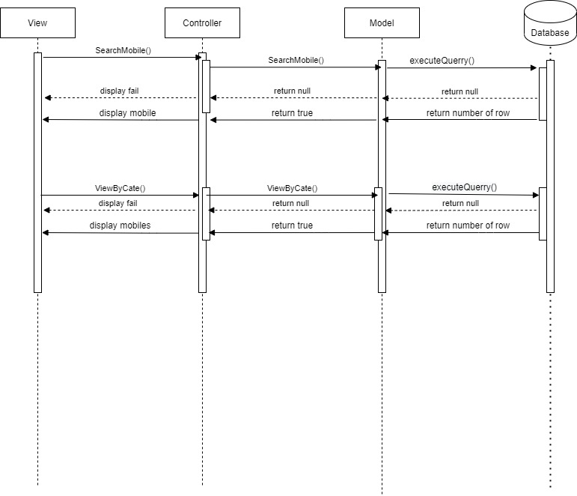

Manage News

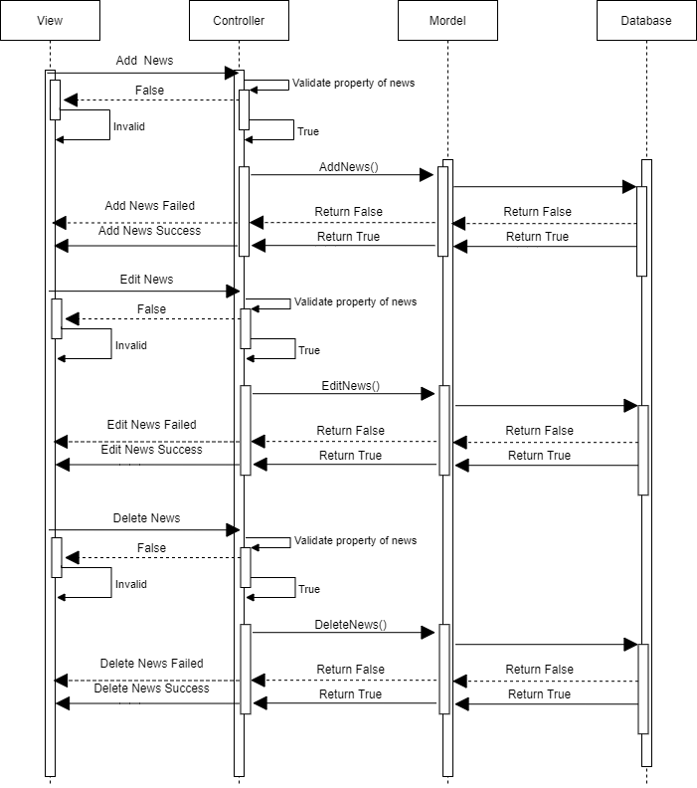

Manage Categories

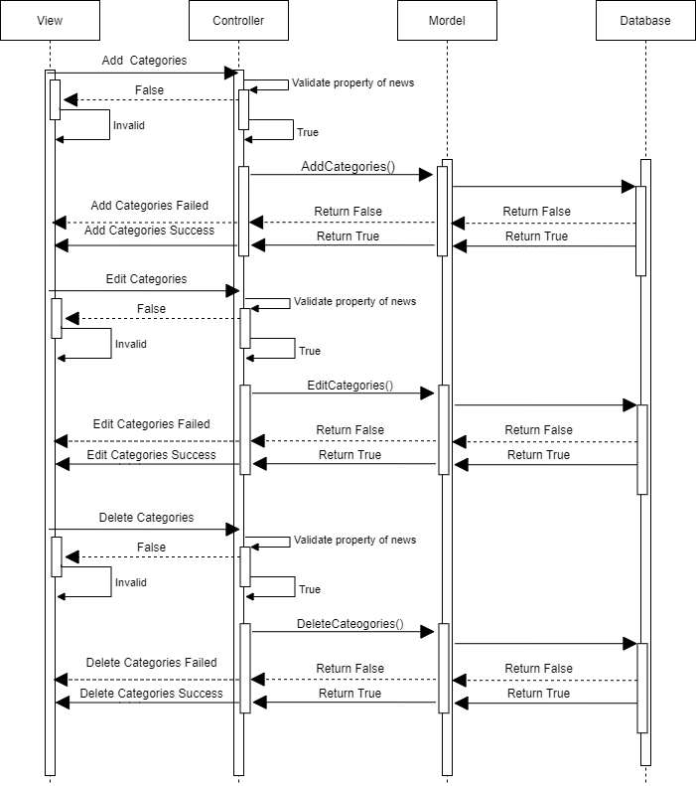

Manage Logictics

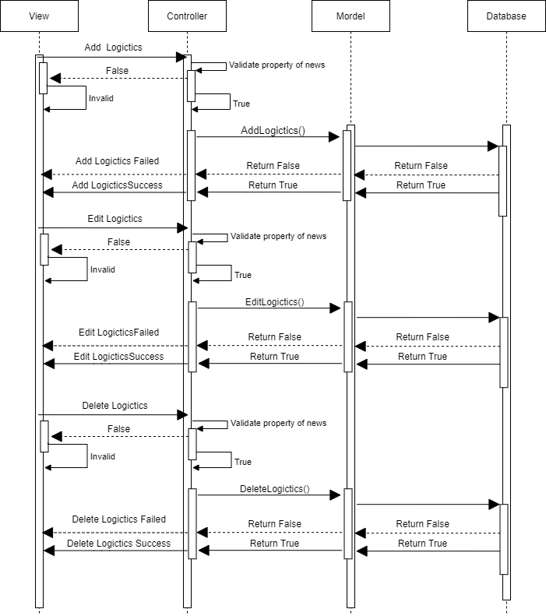

# Design Details

1. UI Design

Home Page

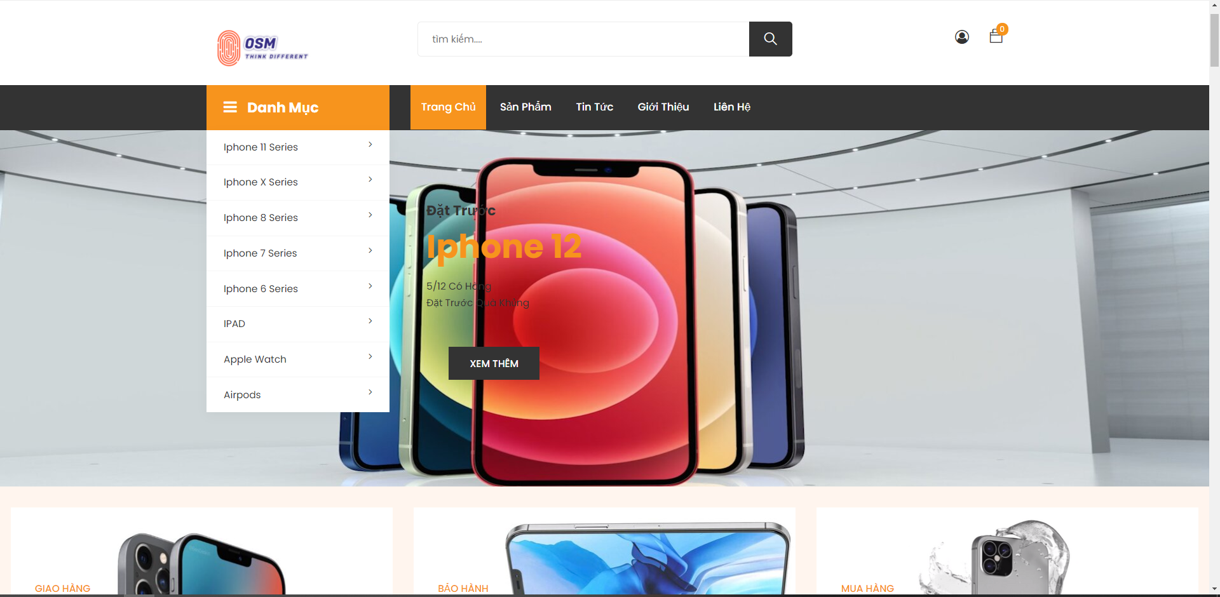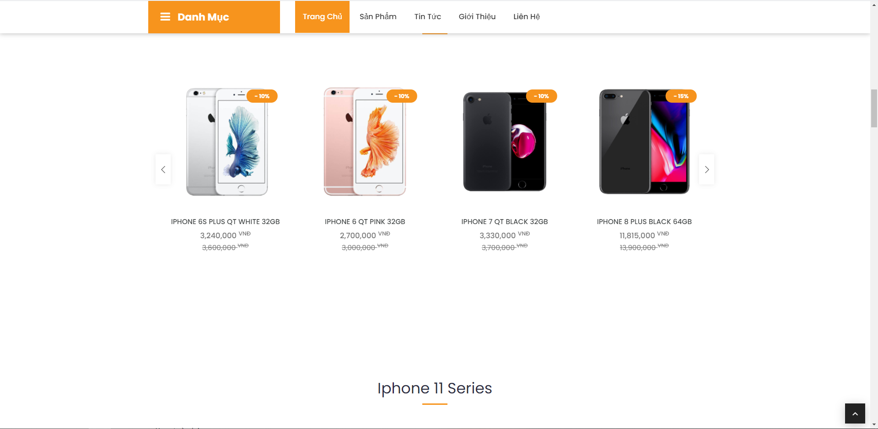

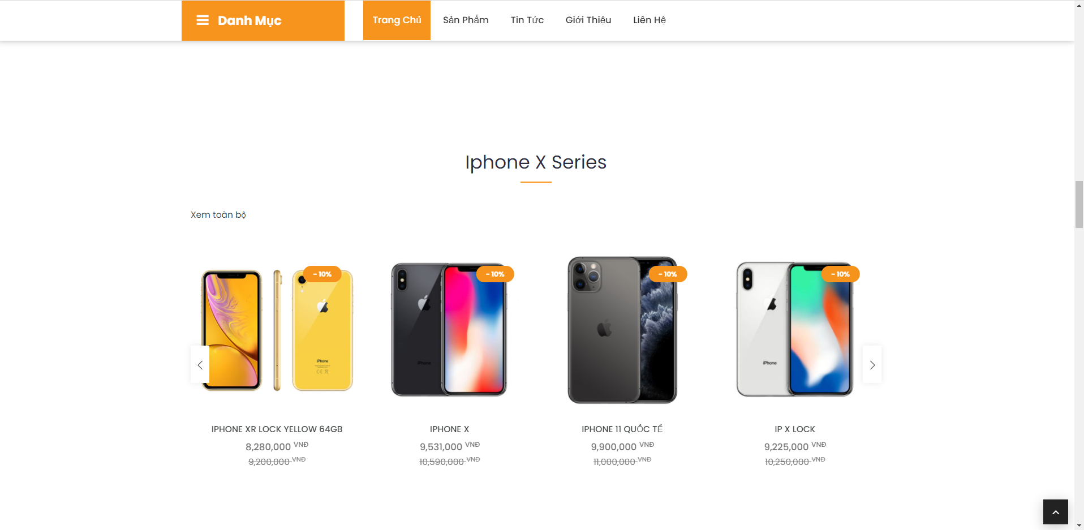

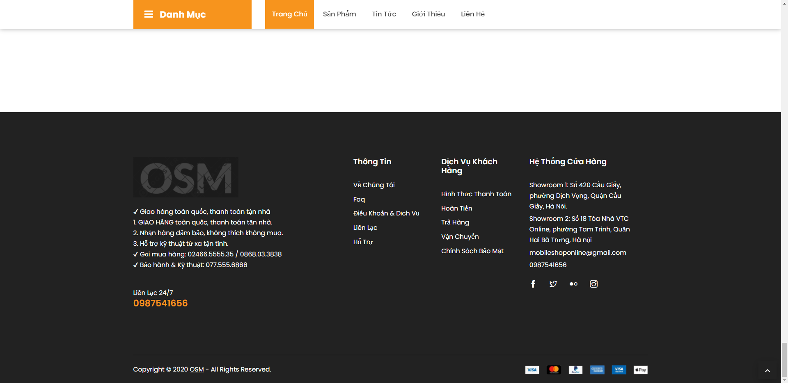

Order product

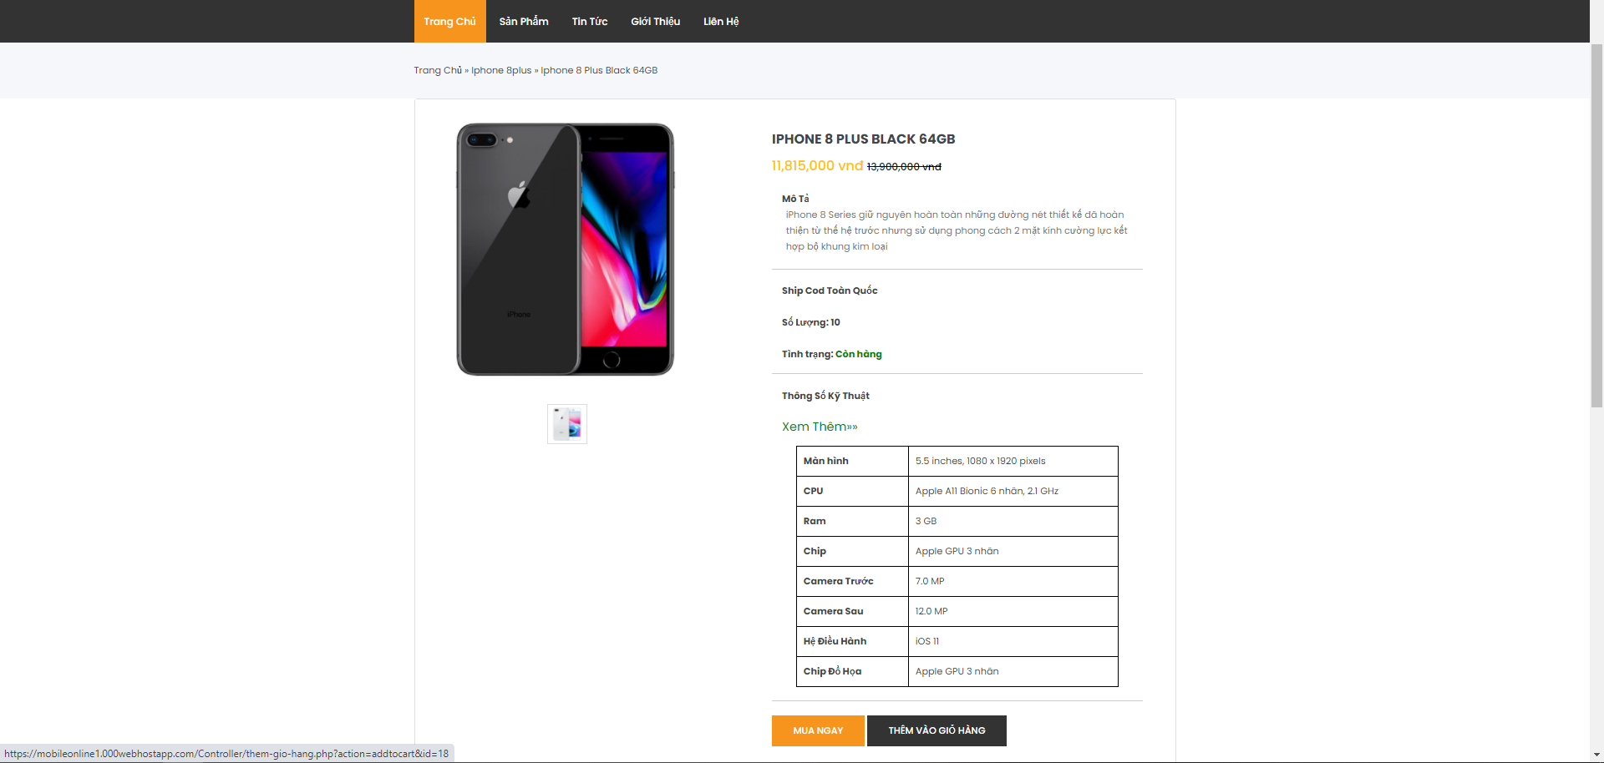

Buy product

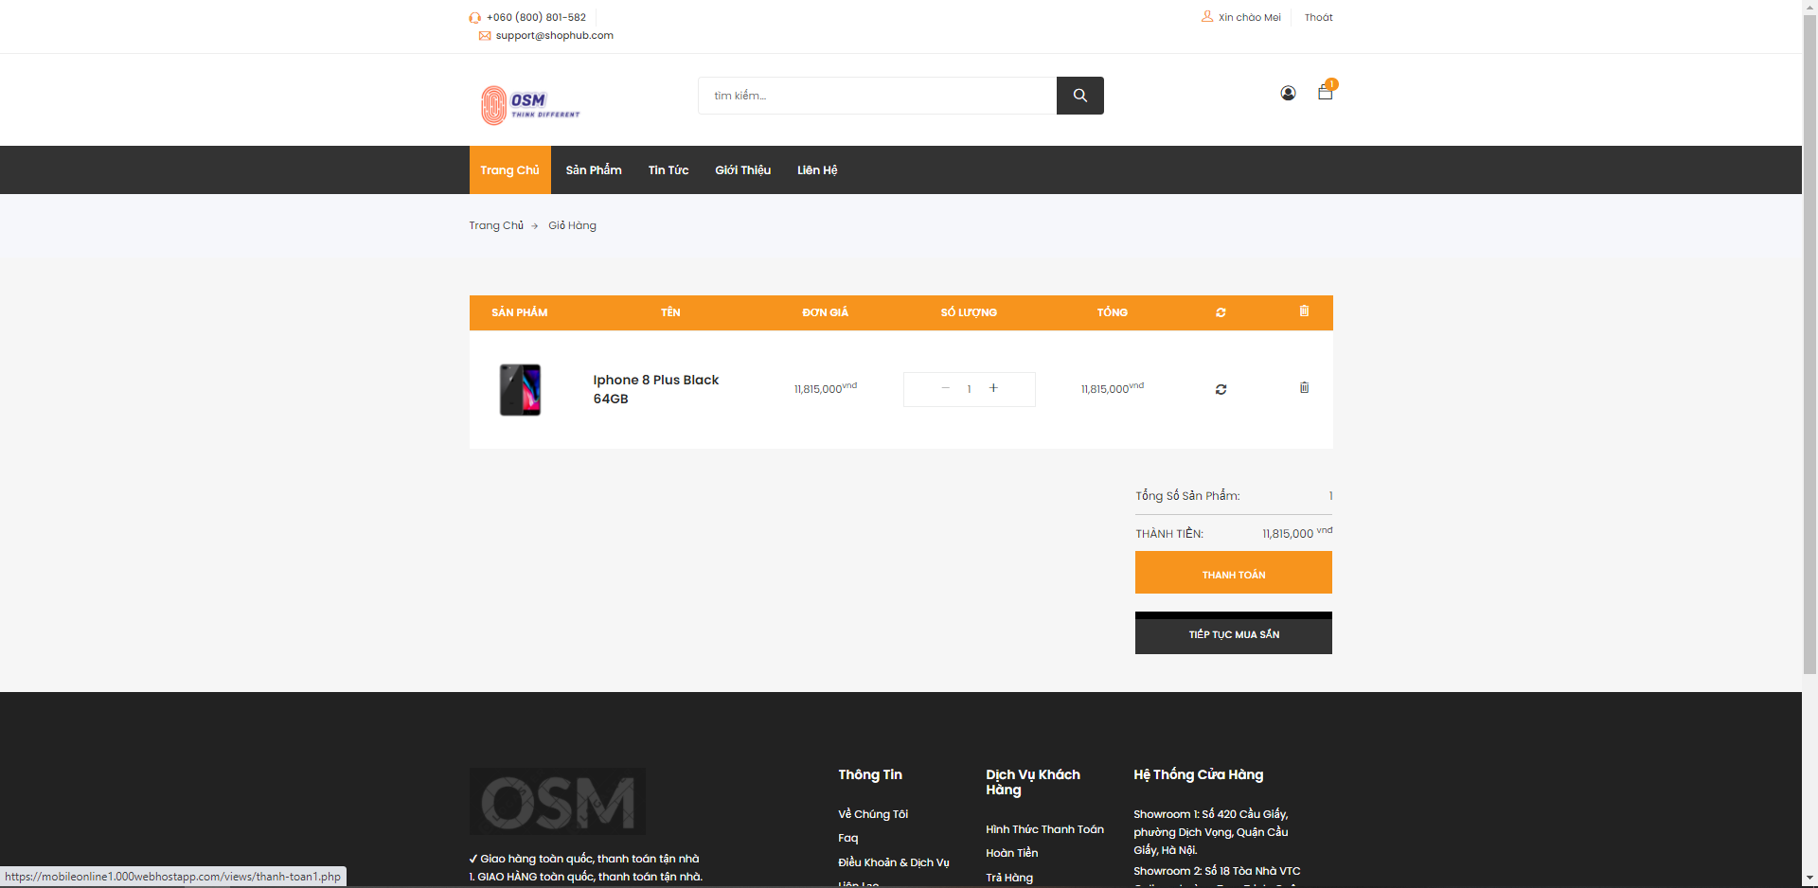

Payment and shipping

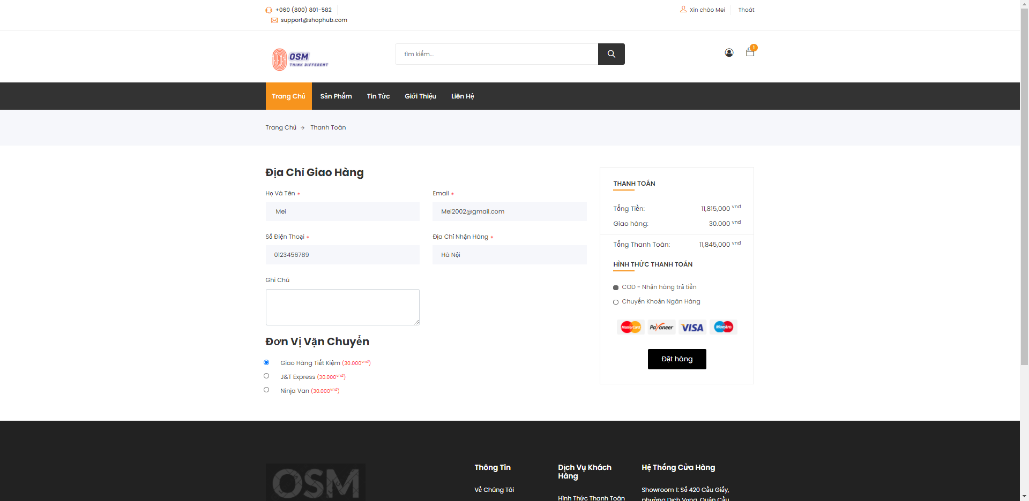

Successful buy product

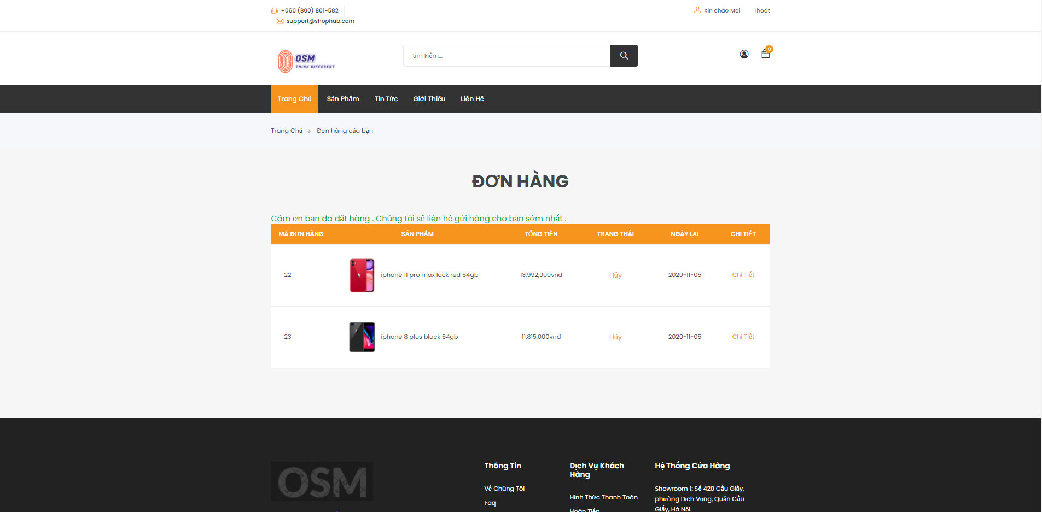

1. Code Design (Class Diagram)

(Class Diagram):

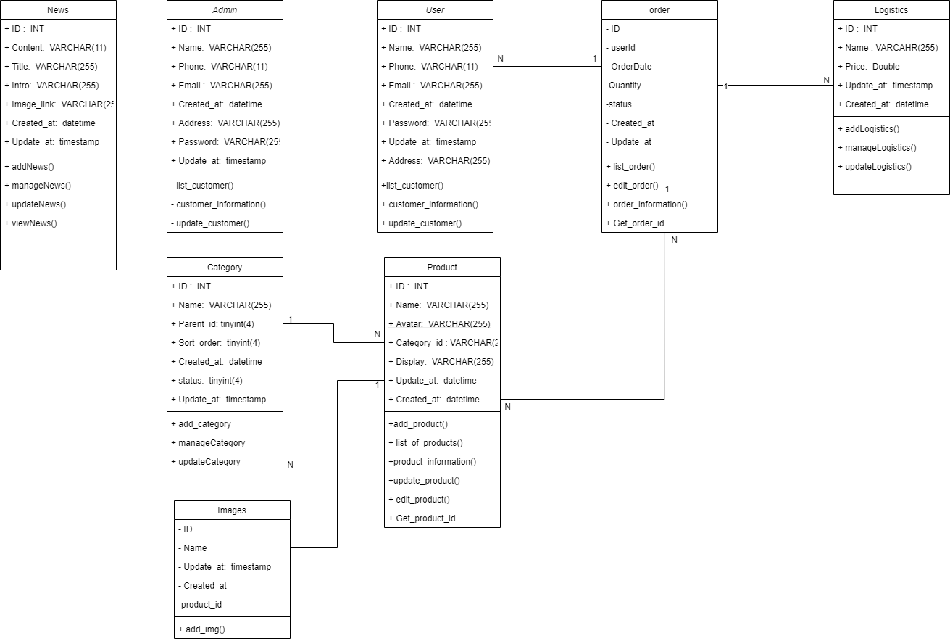

1. Database Design
   1. Entity Relationship Diagram

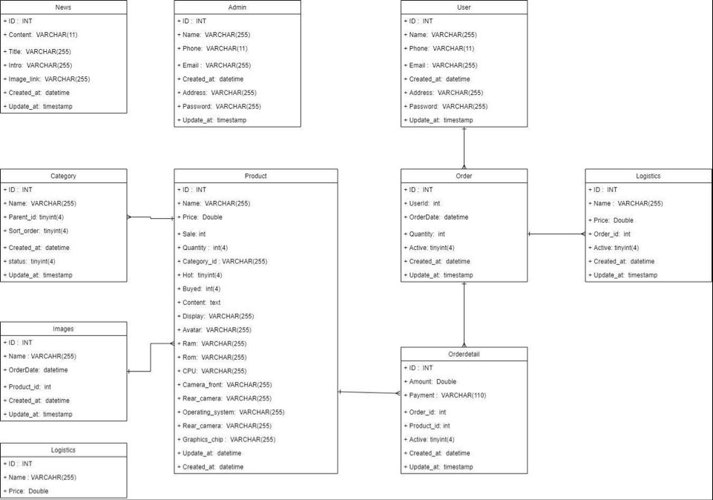

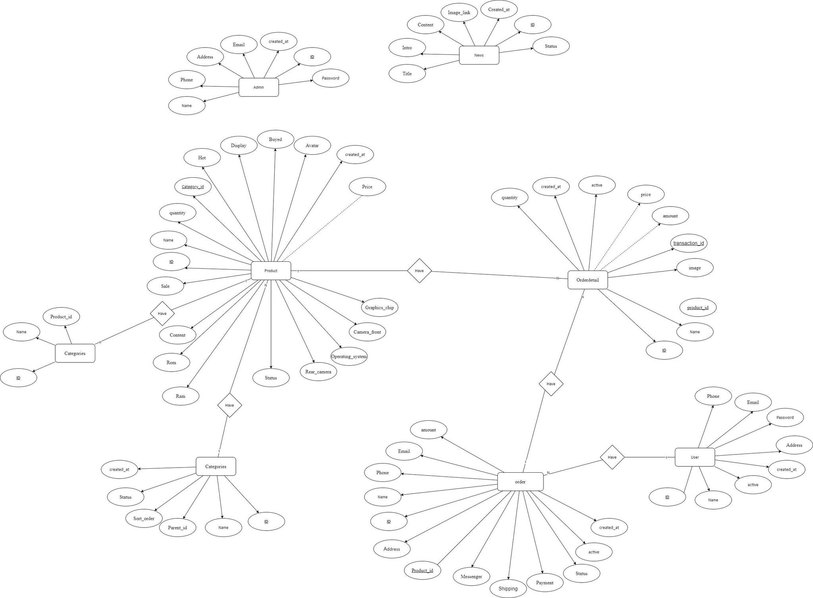

* 1. Database Design Details



|  |  |  |  |
| --- | --- | --- | --- |
| User | | | |
| Column Name | Data Type | Constraints | Description |
| ID | int | Primary Key, Autoincrement |  |
| Name | nvarchar(100) | NOT NULL |  |
| Phone | int(11) | NOT NULL |  |
| Email | nvarchar(100) | NOT NULL | UserEmail |
| Address | nvarchar(100) | NOT NULL |  |
| Password | nvarchar(50) | NOT NULL |  |
| created_at | datetime | NOT NULL |  |
| active | tinyint(4) | NOT NULL |  |

|  |  |  |  |
| --- | --- | --- | --- |
| Admin | | | |
| Column Name | Data Type | Constraints | Description |
| ID | int | Primary Key, Autoincrement |  |
| Name | nvarchar(100) | NOT NULL |  |
| Phone | int(11) | NOT NULL |  |
| Email | nvarchar(100) | NOT NULL | AdminEmail |
| Password | nvarchar(100) | NOT NULL |  |
| Address | nvarchar(50) | NOT NULL |  |
| created_at | datetime | CURRENT_TIMESTAMP |  |

|  |  |  |  |
| --- | --- | --- | --- |
| Product | | | |
| Column Name | Data Type | Constraints | Description |
| ID | int | Primary Key, Autoincrement |  |
| Name | varchar(200) | NOT NULL |  |
| Sale | nvarchar(50) | NOT NULL |  |
| Price | double | NOT NULL |  |
| quantity | int | NOT NULL |  |
| Category_id | int | NOT NULL, FK |  |
| Content | text | NOT NULL |  |
| Hot | tinyint(4) | NOT NULL |  |
| Display | varchar(100) | NOT NULL |  |
| Buyed | int | NOT NULL |  |
| Avatar | varchar(255) | NOT NULL |  |
| Ram | varchar(100) | NOT NULL |  |
| Rom | varchar(100) | NOT NULL |  |
| CPU | varchar(200) | NOT NULL |  |
| Camera_front | varchar(200) | NOT NULL |  |
| Rear_camera | varchar(200) | NOT NULL |  |
| Operating_system | varchar(100) | NOT NULL |  |
| Graphics_chip | varchar(100) | NOT NULL |  |
| Status | tinyint(4) | NOT NULL |  |
| Created_at | timestamp | CURRENT_TIMESTAMP |  |

|  |  |  |  |
| --- | --- | --- | --- |
| Orderdetail | | | |
| Column Name | Data Type | Constraints | Description |
| ID | int(11) | Primary Key, Autoincrement |  |
| product_id | int(11) | NOT NULL, FK |  |
| quantity | int(50) | NOT NULL |  |
| name | varchar(255) | NOT NULL |  |
| price | int | NOT NULL |  |
| image | varchar(255) | NOT NULL |  |
| amount | int(50) | NOT NULL |  |
| order_id | int(11) | NOT NULL , FK |  |
| created_at | timestamp | CURRENT_TIMESTAMP |  |

|  |  |  |  |
| --- | --- | --- | --- |
| Order | | | |
| Column Name | Data Type | Constraints | Description |
| ID | int | Primary key |  |
| Name | varchar(255) | NOT NULL |  |
| Address | varchar(255) | NOT NULL |  |
| Phone | INT(11) | NOT NULL |  |
| Amount | float | NOT NULL |  |
| Email | varchar(200) | NOT NULL |  |
| Payment | varchar(100) | NOT NULL |  |
| Shipping | varchar(255) | NOT NULL |  |
| Active | tinyint(5) | NOT NULL |  |
| Created_at | timestamp | CURRENT_TIMESTAMP |  |
| Orderdetail_id | int(11) | NOT NULL,FK |  |
| Status | tinyint(5) | NOT NULL |  |
| Messenger | varchar(100) | NOT NULL |  |

|  |  |  |  |
| --- | --- | --- | --- |
| News | | | |
| Column Name | Data Type | Constraints | Description |
| ID | int | Primary Key, Autoincrement |  |
| Title | varchar(255) | NOT NULL |  |
| Intro | varchar(255) | NOT NULL |  |
| Content | text | NOT NULL |  |
| Image_link | varchar(255) | NOT NULL |  |
| Created_at | timestamp | CURRENT_TIMESTAMP |  |
| Status | tinyint(4) | NOT NULL |  |

|  |  |  |  |
| --- | --- | --- | --- |
| Categories | | | |
| Column Name | Data Type | Constraints | Description |
| ID | int | Primary Key, Autoincrement |  |
| Name | varchar(50) | NOT NULL |  |
| Parent_id | int(11) | NOT NULL |  |
| Sort_order | tinyint(4) | NOT NULL |  |
| Status | tinyint(4) | NOT NULL |  |
| Created_at | timestamp | CURRENT_TIMESTAMP |  |

|  |  |  |  |
| --- | --- | --- | --- |
| Img | | | |
| Column Name | Data Type | Constraints | Description |
| ImgId | int(11) | Primary Key, Autoincrement |  |
| ImgName | varchar(50) | NOT NULL |  |
| Product_id | int(11) | NOT NULL, FK |  |

|  |  |  |  |
| --- | --- | --- | --- |
| Logictics | | | |
| Column Name | Data Type | Constraints | Description |
| id | Int(11) | Primary Key, Autoincrement |  |
| name | varchar(255) | NOT NULL |  |
| price | varchar(255) | NOT NULL |  |

# Task Assign (to each team member)

|  |  |  |  |  |  |  |
| --- | --- | --- | --- | --- | --- | --- |
| Group 1 | Mobile Shop Online | | | | | |
| No | Task name | Description | Start Date | End Date | Member | Self assessment |
| 1 | Major Analysis | system analysis | 1/8/2020 | 6/8/2020 | Xuan | 100% |
| 2 | Draw  Use Case 1,2,3 | Design Use Case | 9/8/2020 | 15/8/2020 | Xuan | 100% |
| 3 | Draw  Use Case 4,5,6 | Design Use Case | 9/8/2020 | 15/8/2020 | Uoc | 100% |
| 4 | Draw  Use Case 7,8,9 | Design Use Case | 9/8/2020 | 15/8/2020 | Duyet | 100% |
| 5 | Draw  Sequence 1,2,3 | Design Sequence | 9/8/2020 | 15/8/2020 | Xuan | 100% |
| 6 | Draw  Sequence 4,5,6 | Design Sequence | 9/8/2020 | 15/8/2020 | Uoc | 100% |
| 7 | Draw  Sequence 7,8,9 | Design Sequence | 9/8/2020 | 15/8/2020 | Duyet | 100% |
| 8 | Design Database | Design | 17/8/2020 | 20/8/2020 | Xuan | 100% |
| 9 | Create And Insert database | Code | 22/8/2020 | 27/8/2020 | Uoc, Duyet | 100% |
| 10 | Code Use case  1,2,3 | Code | 31/8/2020 | 20/10/2020 | Xuan | 100% |
| 11 | Code Use case  1,2,3 | Code | 31/8/2020 | 20/10/2020 | Uoc | 100% |
| 12 | Code Use case  1,2,3 | Code | 31/8/2020 | 20/10/2020 | Duyet | 100% |
| 11 | Complete document | Write doc | 21/10/2020 | 4/11/2020 | Duyet | 100% |
| 12 | Complete slide | Write slide | 25/10/2020 | 4/11/2020 | Xuan | 100% |

# Deployment Diagram

