To build a histogram by column, just click on the column name. To build a complex diagram, select a rectangular area so that all columns except the first one are numeric.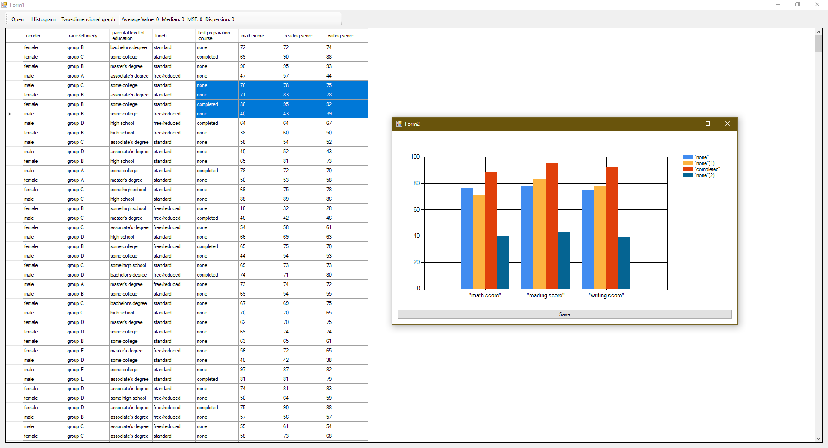

To build a two-dimensional graph, select 2 columns (via cntrl + LMB). The second column must be numeric.