Nathan Robertson

User Manual

Table of Contents

|  |  |
| --- | --- |
| Introduction |  |
| About Classroom Robots | Page 1 |
| User Manual |  |
| New Classroom | Page 2 |
| Open Classroom | Page 4 |
| Edit Classroom | Page 5 |
| Clear Classroom | Page 6 |
| Save Classroom | Page 6 |
| New Student | Page 7 |
| Add Student | Page 8 |
| Add Desk | Page 8 |
| View Students | Page 9 |

Introduction

# About Classroom Robots

Classroom Robots is the new way to keep track of your Classroom layout. Design and create new seating arrangements with ease.

# New Classroom

To add a new classroom, follow the steps below:

1. Click on the “File->New->Classroom” menu button.

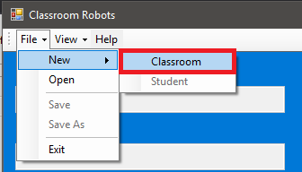

1. You will be presented with the “Add Classroom” form.

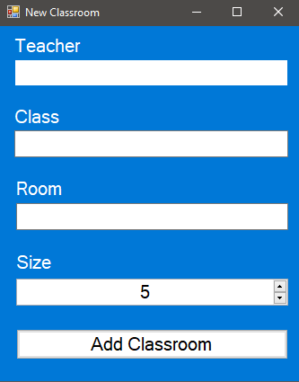

1. Enter the teacher’s name.



1. Enter the class name.



1. Enter the room number.

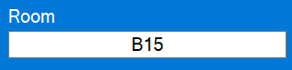

1. Enter the classroom size (5-30).

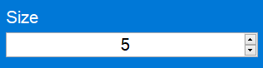

1. Click the “Add Classroom” button.

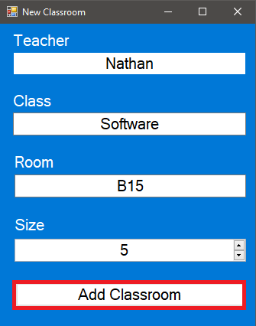

# Open Classroom

To open a classroom, save file follow the steps below.

1. Click on the “File->Open” menu button or (Ctrl+O)

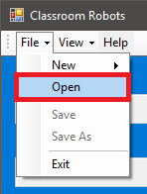

1. Navigate to the save file.

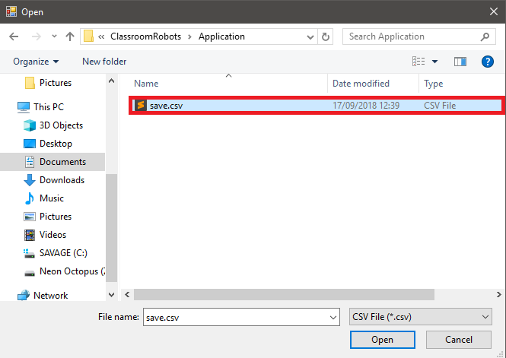

1. Click on the “Open” button.

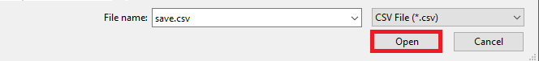

# Edit Classroom

To Edit a classroom, follow the steps below:

1. If you wish to edit the teacher’s name simply click on the teachers name and type in a new name.

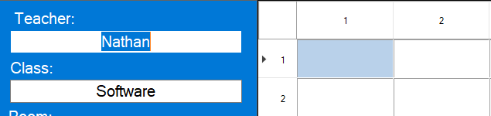

1. If you wish to edit the Class Name simply click on the class name and type in a new name.

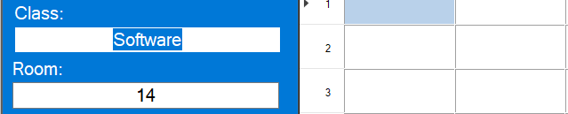

1. If you wish to edit the Room Number simply click on the room number and type in a new room number.

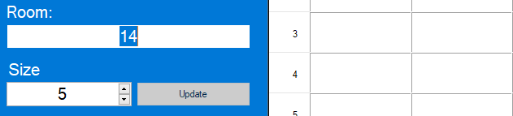

1. If you wish to edit the classroom size, simply click on the classroom size and type in a new number or use the arrow keys.

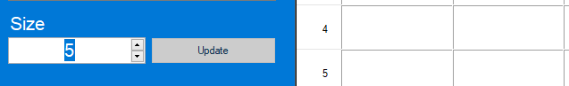

# Clear Classroom

To clear a classroom of all students and desks follow the steps below:

1. Click on the “Clear Classroom” button.

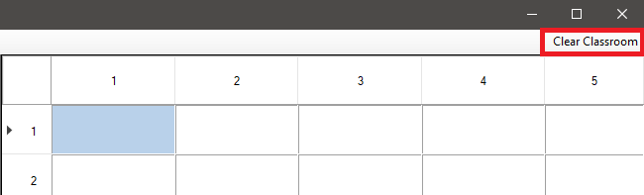

# Save Classroom

To save a classroom simply follow the steps below:

1. Click “File->Save” or (Ctrl+S).

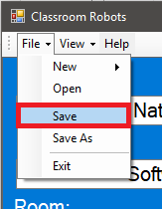

1. You will be presented with a save dialog, navigate to where you want the file to be saved.

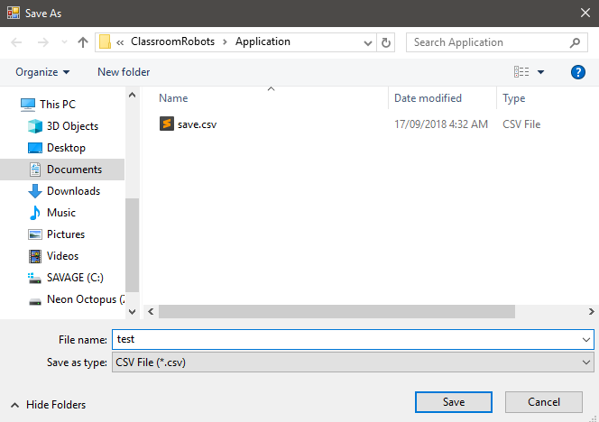

1. Click the “Save” button.

# New student

To create a new student, follow the steps below:

1. Click on “File->New->Student”

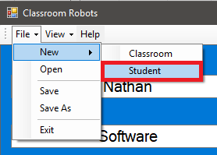

1. You will be presented with the add student form, enter the student’s name.

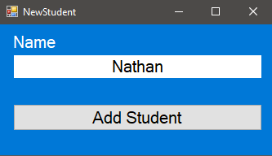

1. Click the “Add Student” Button.

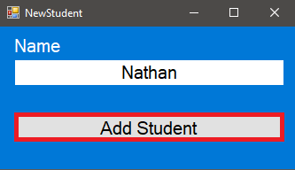

# Add Student

To add a student to the classroom layout simply follow the steps below:

1. right click the cell you would like them to be in, click “Add Student-> their name”.

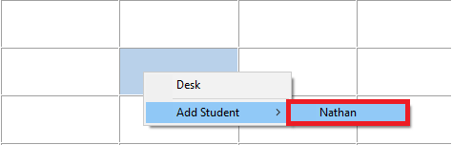

# Add Desk

To add a desk simply follow the steps bellow:

1. Right click on the cell you would like to be a desk, click “Desk”.

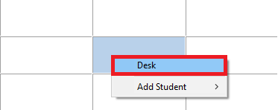

# View students

To view all students and their positions simply follow the steps below:

1. Click “View->Students”.

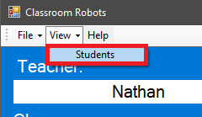

1. You will be presented with the View Students form. Here you can search through all students in the classroom viewing there X and Y positions. They have been sored into a binary tree for maximum efficiency.

