Nathan Robertson

User Manual

Table of Contents

|  |  |
| --- | --- |
| Introduction |  |
| About My-Friend-Tracker | Page 1 |
| User Manual |  |
| Add Friend | Page 2 |
| Navigate | Page 4 |
| * Navigate with Buttons | Page 4 |
| * Navigate with Search | Page 4 |
| * Navigate with DataView | Page 4 |
| Update Friend | Page 3 |
| Delete Friend | Page 3 |
| View Upcoming Birthdays | Page 4 |

Introduction

# About My-Friend-Tracker

My-Friend-Tracker is the new way to keep track of your friend’s birthdays, likes and dislikes. You will always know what to get them on their birthday with our app.

# Add Friend

To add a new friend follow the steps below:

1. Click on the “Add Friend” button.

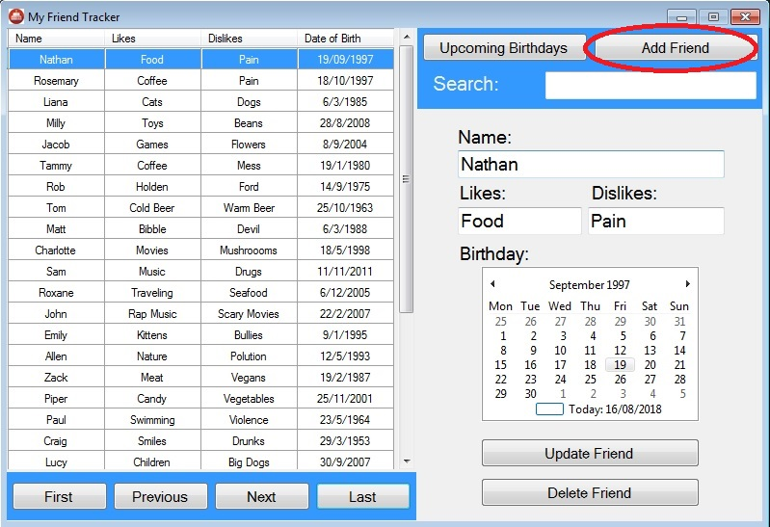

1. You will be presented with the “Add Friend” form.

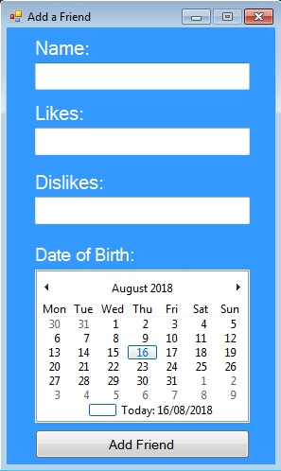

1. Enter your friend’s name.

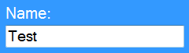

1. Enter what your friend likes.

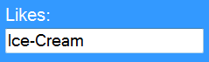

1. Enter what your friend dislikes.



1. Enter your friend’s birthday.

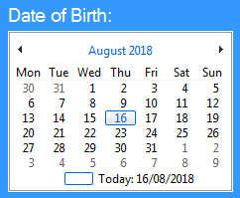

1. Click the “Add Friend” button.

C:\Users\0100623918\Documents\SoftwareProject\Documentation\Untitled.png

# Navigate

To navigate the My-Friend-Tracker app you have 3 options. Either the “Next”, “Previous”, “First” and “Last” buttons. The search box or simply just scrolling through the DataView and clicking on the friend.

# Navigate with buttons

To navigate with the buttons follow the steps below:

1. If you wish to navigate to the next friend simply click the “Next” button.

C:\Users\0100623918\Documents\SoftwareProject\Documentation\Untitled.png

1. If you wish to navigate to the previous friend simply click the “Previous” button.

C:\Users\0100623918\Documents\SoftwareProject\Documentation\Untitled.png

1. If you wish to navigate to the first friend simply click the “First” button.

C:\Users\0100623918\Documents\SoftwareProject\Documentation\Untitled.png

1. If you wish to navigate to the last friend simply click the “Last” button.

C:\Users\0100623918\Documents\SoftwareProject\Documentation\Untitled.png

# Navigate with Search

To navigate with the search box follow the steps below:

1. Enter the name of your friend you want to search for.

C:\Users\0100623918\Documents\SoftwareProject\Documentation\Untitled.png

1. If there is a match then the friend will be selected.

Note: The search is case sensitive.

# Navigate with the DataView

To navigate with the DataView follow the steps below:

1. Scroll through the DataView and click on the friend you want to select.
2. Use the arrow keys to navigate to the friend you want to select.

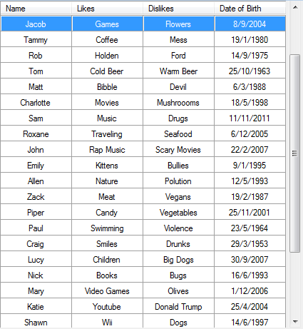

# Update Friend

To update one of your friends follow the steps below:

1. Navigate to the friend you want to update and their information will be loaded into the form next to the DataView.

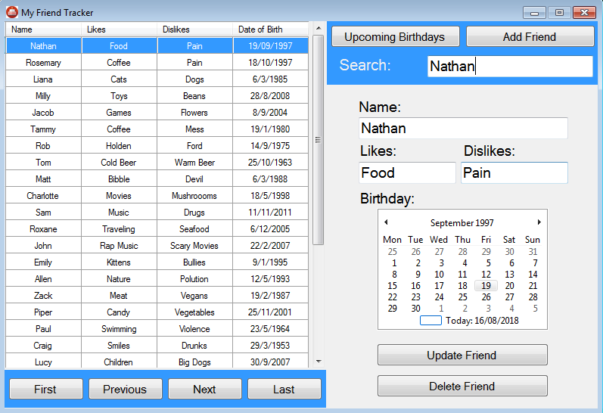

1. Edit the appropriate textbox.

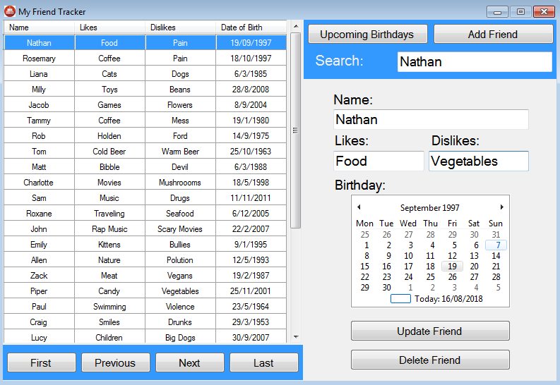

1. Click on the “Update Friend” button.

C:\Users\0100623918\Documents\SoftwareProject\Documentation\Untitled.png

# Delete Friend

To delete one of your friends follow the steps below:

1. Navigate to the friend you want to delete and their information will be loaded into the form next to the DataView.



1. Click on the “Delete Friend” button.

C:\Users\0100623918\Documents\SoftwareProject\Documentation\Untitled.png

# View Upcoming Birthdays

To view the upcoming birthdays for any given month follow the steps below:

1. Click on the “Upcoming Birthdays” button.

C:\Users\0100623918\Documents\SoftwareProject\Documentation\Untitled.png

1. You will be presented with the “Upcoming Birthdays” window.

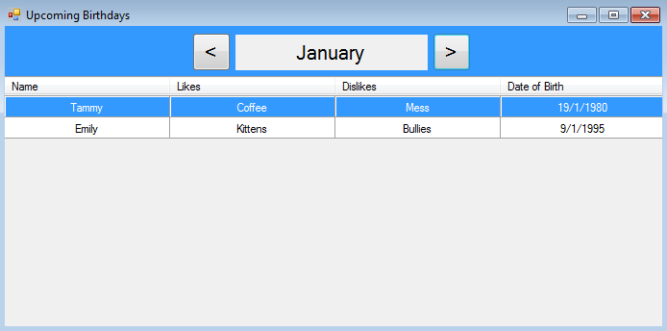

1. Use the “<” and “>” buttons to navigate through the different months.

C:\Users\0100623918\Documents\SoftwareProject\Documentation\Untitled.png