Figure 1
Reasons That Private Practices Were Sold (2024)
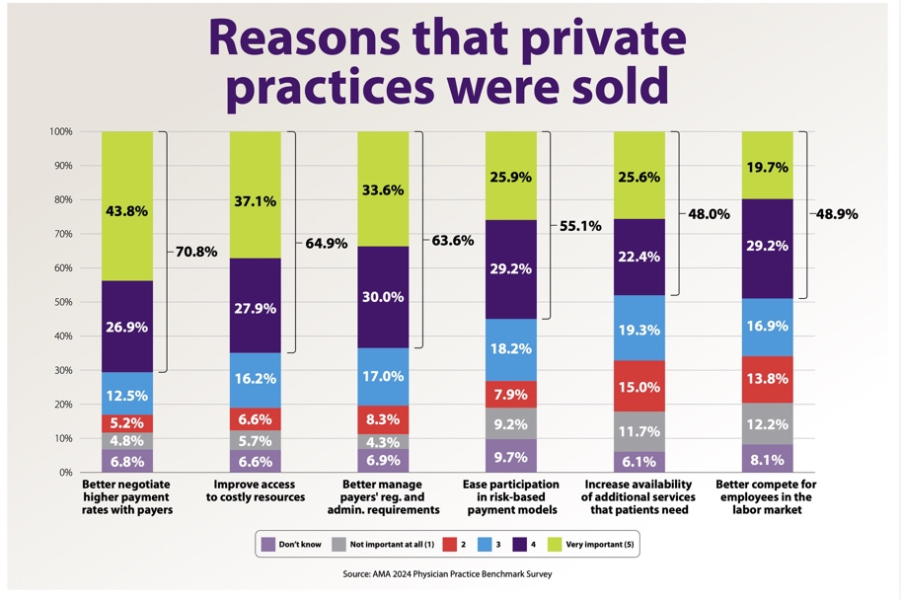
Note. From Kane (2025), Exhibit 4, based on the AMA 2024 Physician Practice Benchmark Survey. The bracketed percentages represent the sum of “important” and “very important” responses.

Figure 2
Hospital-Physician Vertical Integration Trends, 2013–2019
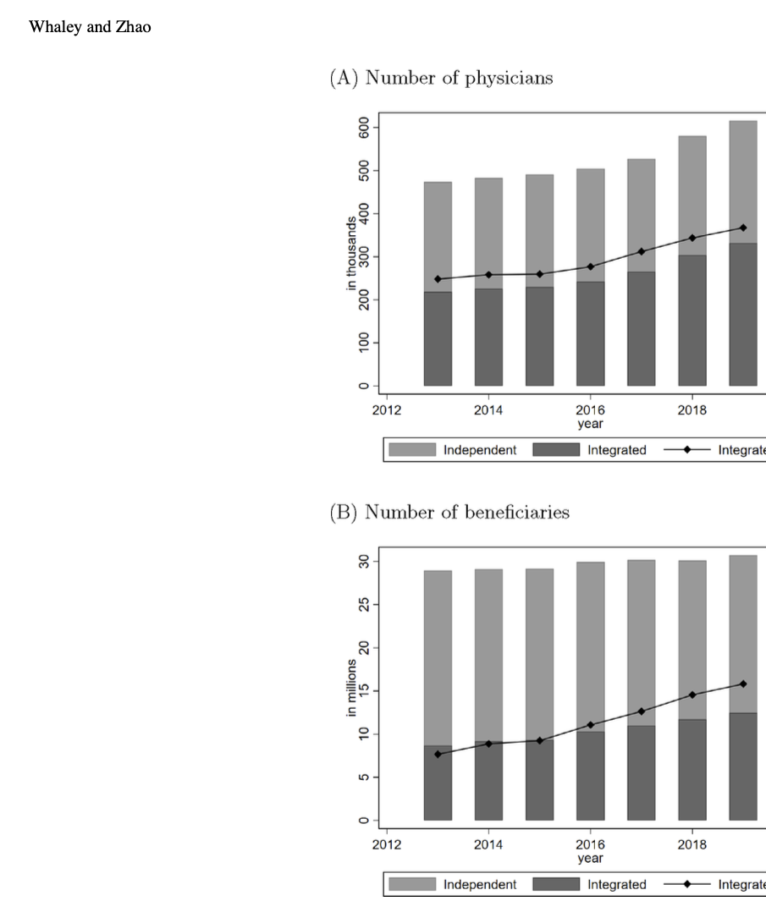
Note. Reproduced from Whaley and Zhao (2024), Figure 1, Journal of Public Economics, 238, 105175. The original figure reports integration trends among physicians and Medicare beneficiaries in the study sample.

Figure 3
Physician Prices Around Physician Integration
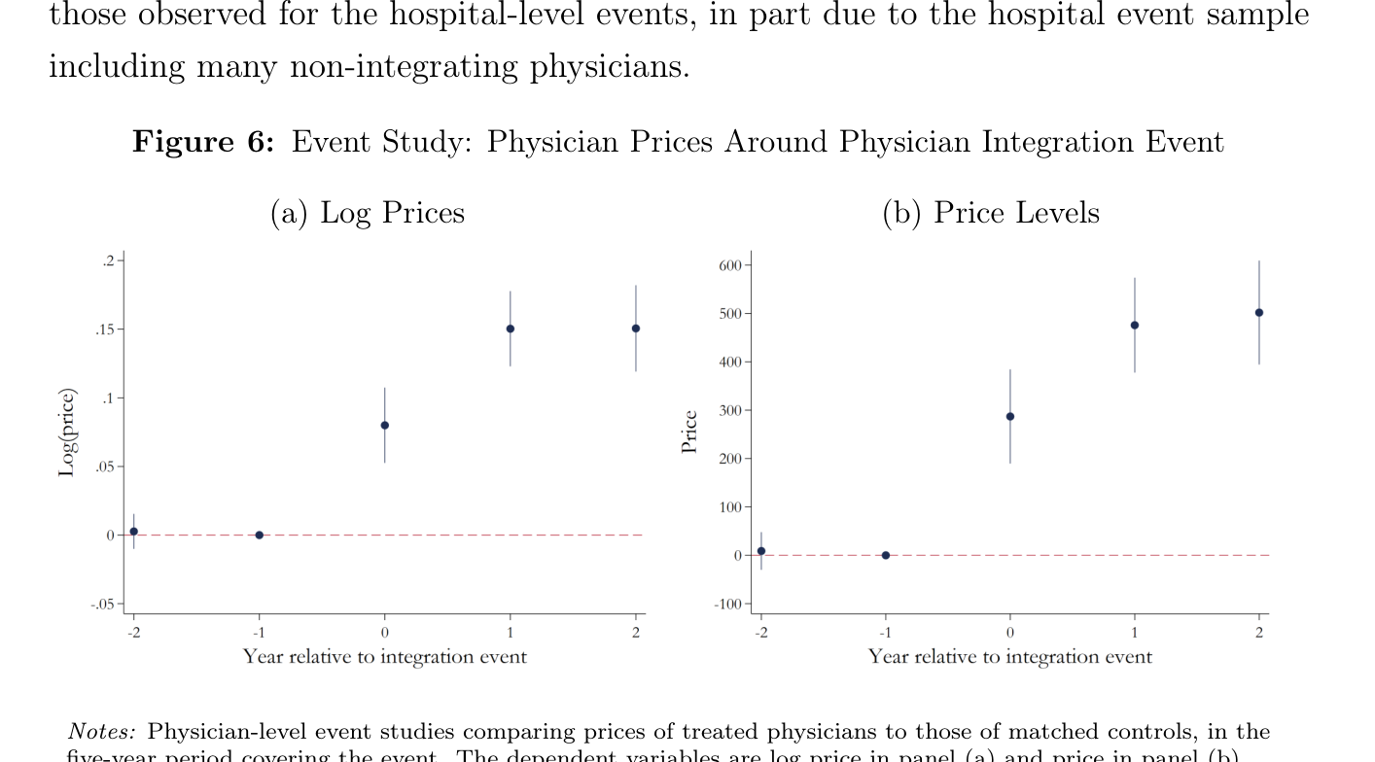
Note. Reproduced from Cooper et al. (2025), Figure 6, Are Hospital Acquisitions of Physician Practices Anticompetitive? NBER Working Paper No. 34039. This is the principal empirical price figure used in the analysis.

Figure 4
Summary of Hospital-Physician Integration Results: Costs, Quality, and Utilization
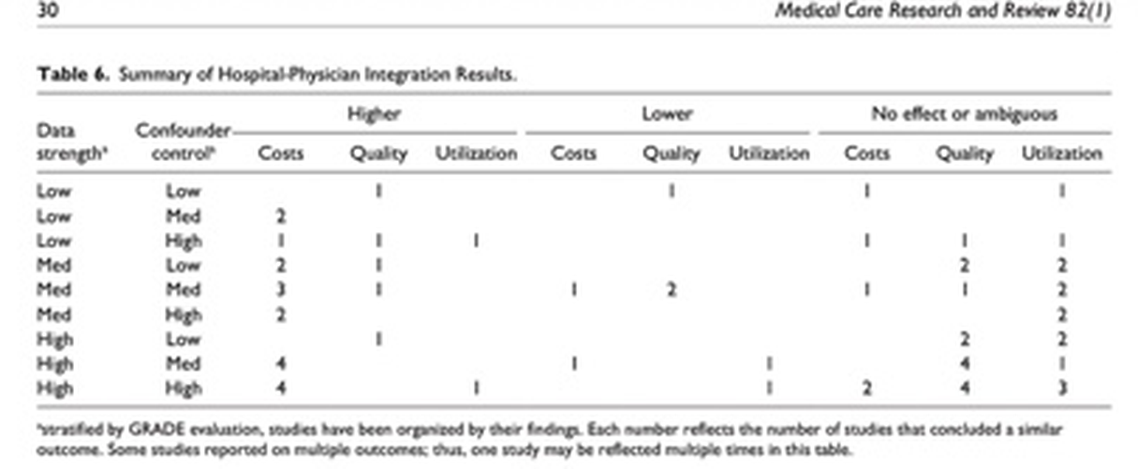
Note. Reproduced from Harris et al. (2025), Table 6, Medical Care Research and Review, 82(1), 3–42. The table summarizes study findings by data strength and confounder control; some studies reported multiple outcomes.

