**1.1 INTRODUCTION**

This task goes for improvement of an Online Railway Reservation Utility which encourages the Railway clients to deal with their reservations on the web, and the Railway executives to adjust the backend databases in a User-Friendly way.

The Customers are required to enlist on the server for gaining admittance to the database and question result recovery. Upon enlistment, every client has a record which is basically the 'see level' for the client. The record contains far reaching data of the client entered amid enlistment and grants the client to gain admittance to his past reservations, enquire about movement admission and accessibility of seats, make a crisp reservations, update his record subtleties, and so on. The Railway Administrator is the second party in the exchanges. The manager is required to login utilizing an ace secret word, when validated as a chairman, one approaches and right of change to all the data put away in the database at the server. This incorporates the record data of the clients, traits and measurements of stations, depiction of the train stoppages and physical portrayal of mentors, every one of the reservations that have been made, and so on. The railroad director has the option to adjust any data put away at the server

Railroad Reservation framework venture gave the office to traveler to quick access and effectively check the train accessibility exceptionally quick. This well ordered technique is given. This undertaking is created in the c# and asp.net Language. Practically legitimate remarks are given at wanted position and the task is easy to use different capacity are use in this undertaking.

This venture is well with the programming in c#, asp.net with SQL server .

**CHAPTER-2**

**SOFTWARE ANALYSIS**

**2.1 SYSTEM OBJECTIVES**

The principal organize in the product advancement life cycle is prerequisite investigation. It encourages us in understanding the path clients of the product need to utilize it and what highlights they hope to be performed by the product. This first stage is imperative to the whole procedure as everything done thereafter is based on this stage.

The fundamental points of investigation stage are

a. Understanding prerequisites through meetings and gatherings with concerned people and associations and furthermore discourses with the client of the framework

b. Preparing report showing the necessities indicated by the client

c. Thinking about the practicality of the framework

d. After the total review according to prerequisites, concluding the details by talking about with clients and coming at specific resolutions.

**2.2 Relation to External Environment**

This task helps in two noteworthy angles –

It encourages the general population to book the train tickets.

It likewise causes the Admin to oversee understudy enlistment, see client demands in like manner and answer to them utilizing instant message in their enrolled record.

**2.3 Design Considerations**

**Approach:**The venture has been planned utilizing JAVA, JAVASCRIPT and FRONT-END FRAMEWORK like BOOTSTRAPPING and DERBY CLIENT for Database reason.

**2.4 System Architecture**

The window application works in two structures

• Customer who will enroll  

In this structure client required to enroll himself with his substantial data.  

• Admin who will answer to clients' solicitation subsequent to booking the ticket

administrator login will be endorsed by database.

**CHAPTER-3**

**SYSTEM SPECIFICATION**

**3.1 Hardware requirements**

In equipment necessity we require each one of those segments which will give us the stage to the improvement of the task. The base equipment required for the advancement of this task is as per the following—

Specialized Device – like Laptop, PC,mobile i.e any gadget which can bolster web and UI.

**3.2 Software requirements**

**APPROACH**

The assurance and conclusion of necessity of programming to be created is done in this stage. This stage is essentially reports situated. In this stage, whatever is assembled in examination stage is placed in organized and coherent habits.

The primary objectives of this stage are…

1. To determine the whole procedure intelligently by methods for information stream graph.

2. To put the progression arranged clarification of occasions and strategies by utilizing organized English as well as choice tables.

3. To give a total arrangement of highlights given by the product which will be base for programming configuration stage.

**3.2 Data Flow Diagrams..**

a. Information Flow Diagram models a framework by utilizing outer substances from which information streams to a procedure which changes the information and makes yield information streams which go to different procedures or outside elements.

b. As the initial step, the whole framework can be portrayed by one Data Flow Diagram, which gives a framework outline, called a Context Diagram.

c. The progressive extension of a DFD from the setting graph to those giving more subtleties is known as leveling of DFD which improves forms by partitioning them into more stages.

**Context Diagram:**

**4.1 Architecture Overview**

This application utilizes JAVASCRIPT,JAVA,DERBY CLIENT dialects for front end and back end of this undertaking.

JAVA DATABASE CONNECTIVITY is utilized for associations bring information, and show information.

DERBYCLIENT is utilized for database, and associations.

HTML ,CSS,BOOTSTRAPPING are utilized for front end of this task.

**4.2 Software Process Model**

The Software Process Model utilized is the Spiral Model. The decision for this model is in the light of the Enhancements that we anticipate for what's to come. The upgrades would be in the region of security and check of different frameworks brought into the product.

**Requirements :-**

Database for administrator and client record.

GUI modules (Admin board , client board ,online interface).

Train finding and booking by inquiry preparing.

**Why Spiral Model :-**

We organize our necessities and got a thought regarding required usefulness that the product must perform . Our first undertaking is to make graphical UI which is equipped for serving client. Client can scan for the trains that have been gone into the database by the administrator. We have made it winding in light of the fact that our site requires normal updations : train refreshes , ticket crossing out updates , situate accessibility refreshes and furthermore train timing refreshes. In this way, the stages at getting rehashed and that is the reason we exceedingly require winding model of programming development cycle(SDLC).

Henceforth we make different model well ordered adding greater usefulness to every model and consolidated every one of these models into a solitary working unit for example programming . Along these lines we pick Spiral model for our undertaking.

**4.3 Process Modules**

The functionalities and duties of the framework were parceled and afterward appointed to subsystems or parts as depicted beneath.

**4.3.1 Graphical User Interface**

The UI that the product gives to the client is intelligent. It gives different various structures, one for administrator of frameworks and the other for the instructors and nearby functionalities.

To See the UI:

See Below Screenshots toward the finish of Report.

**4.3.2 Connection**

This App manages the foundation of an association between the database and nearby framework utilizing java and derby-customer.

**CHAPTER-5**

**SYSTEM DESIGN DETAILS**

**5.1 GUI Module Name and Description**

**5.2 SYSTEM FLOWCHART AND E-R DIAGRAM**

Entity relationship diagram is extremely essential, calculated model of information and it is central to the physical database structure. This examination is then used to sort out information as relations, normalizing relations, and getting a Relational database.

The element relationship model for information utilizes three highlights to depict information.

These are… .

1. Entities which determine particular true things in an application

2. Relationship, which associate substances and speak to important conditions between them.

3. Attributes which indicate properties of substances and connections

**E-R Diagram**

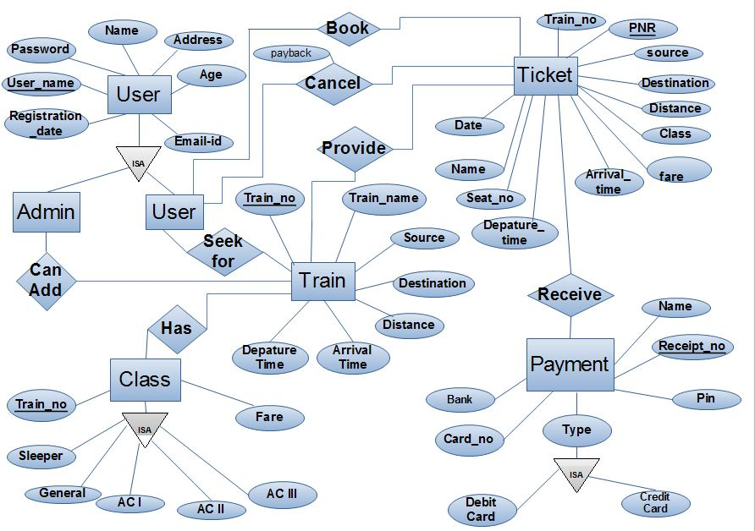

**CHAPTER-6**

**TESTING**

Programming Testing reveals mistakes in the product. It is an essential component of programming quality affirmation and speaks to a definitive audit of particular, plan and coding. Testing show that product work seemed, by all accounts, to be working as indicated by detail that execution necessities seem to have been met. Moreover information gathered as is directed give a decent sign of programming unwavering quality and with some sign of programming quality all in all. The essential targets of testing process are:

1. Testing is a procedure of executing a program with the aim of finding a blunder.

2. A great experiment is one that has a likelihood of finding an up 'til now unfamiliar mistake.

**6.1 TESTING OBJECTIVES:**

Programming testing confirms that the product meets the prerequisites. It includes the activity of a framework or application under controlled conditions and assessing the outcomes. The controlled conditions incorporate both typical and unusual conditions. Testing is finished with the aim of discovering blunders. We ought not test a program to demonstrate that it works, yet to locate the most extreme number of blunders conceivable. We start testing with the suspicion that it contains blunders. Testing ought to deliberately endeavor to influence things to turn out badly and after that watch the conduct of the item in those conditions.

**Unit Testing:**

After the coding step we do the unit test for venture in this test we check the task as unit shrewd. Full task is isolating into number of modules so we check each module independently in this testing we use driver and stub for the most part for testing.Driver and stub are the product. In the application program driver is just as a principle program and stub will be stub serve to supplant modules that are subordinate the part to be tried.

**Specifications:**

Obviously recorded detail for each component at each dimension is an unequivocal guide not exclusively to what must be actualized, yet additionally to what must be tried. Each predefined necessity ought to be tended to by something like one test.

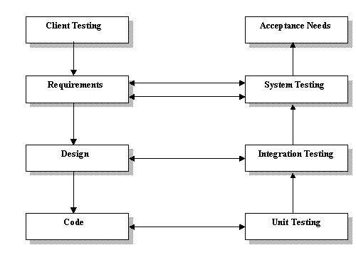

**6.2 INTEGRATION TESTING:**

**Integration Testing-** This is the trying of joined pieces of an application to decide whether they work together accurately. The parts can be code modules, singular applications and so on. The objective is to check whether the modules can be incorporated legitimately. Consequently the accentuation is on trying interfaces between modules.

|  |  |  |  |
| --- | --- | --- | --- |
| Integration Testing | | | |
| Check whether all independent modules work properly after integration. | All the Modules after thorough individual testing are merged together and run in the FMX (executable) setup. | Absolute success in running the system. | Complete success in running the system. as a whole with a few minor problems regarding the client server connection which were resolved after some trials on the spot. |

**6.3 SYSTEM TESTING**

**System testing** confirms that all components of the entire PC framework (equipment, individuals, databases, programming and so forth) work legitimately and that the general framework capacity and execution is accomplished. The reference report for this procedure is the prerequisites record and the objective is to check whether the product meets its necessities.

Some essential criteria can be –

(a) Stop when planned time for testing lapses.

(b) Stop when all experiments execute without recognizing mistakes.

Be that as it may, these can't be exclusively depended upon. On the off chance that you have run your total test set and found no mistakes, it doesn't really pursue that the program is sans blunder. The test set might be inadequate. It ought to likewise be accentuated that the measure of testing will rely upon the expense of a mistake. Basic projects or code fragments will require more exhaustive testing than the more inconsequential capacities.

**Loops:** straightforward, clear circles have unequivocal circle control factors and can be tried in a couple of Cases. Neatly settled circles can be tried in a limited number of blends. Tangled, specially appointed circles can't be essentially tried.

**Logic-based**: Straightforward IF-THEN_ELSE builds and case articulations or choice table based rationale is unequivocal and simple to assess. The factors that immediate the ways are Explicit and recognizable. Confounded, specially appointed rationale can be a bad dream to unravel.

**Syntax**: Clear partition of information approval into linguistic structure, field-esteem and connection Analysis makes it conceivable to do sentence structure testing free of field esteems and further Processing. This partition modularizes testing and takes out the vast majority of the confounded communications that would somehow or another must be tried.

**CHAPTER-7**

**SYSTEM IMPLEMENTATION AND MAINTENANCE**

**7.1 Implementation**

Usage incorporates every one of those exercises that occur to change over from old framework to the upgraded one. The new framework might be totally new.

**Top-down implementation:**

Top down implementation starts with the client summoned module and moves in the direction of the modules that don't call some other modules. The usage may continue profundity first or broadness first.

**Bottom- Up implementation:**

Usage starts with modules that don't call some other modules and work toward the fundamental program. Test bridle are utilized to test singular modules. The principle module comprises the last test tackle.

**Stubs:**

Stub writing computer programs is the execution simple of top-down and stepwise refinement. It underpins steady program advancement by taking into consideration blunder and improvement. A stub program is a stripped-down, skeleton form of a last program.

# MAINTAINENCE

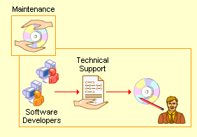

The upkeep begins after the last programming item is conveyed to the customer. The support stage distinguishes and executes the change related with the redress of blunders that may emerge after the client has begun utilizing the created programming. This additionally keeps up the change related with changes in the product condition and client prerequisites. When the framework is a live one, Maintenance stage is significant. Administration after deal is an unquestionable requirement and clients/customers must be helped after the framework is actualized.

The support gave our framework after establishment is as per the following:

As a matter of first importance there was a Classification of Maintenance Plan which implied that the general population associated with giving the after help were separated. The primary

Obligation was on the shoulders of the Project Manager who might be educated in the event that any bug showed up in the framework or some other sort of issue rose causing an unsettling influence in working. The Project head thusly would approach us to take care of the different issues at specialized dimension. (Eg The structure isn't tolerating information in an appropriate configuration or it isn't sparing information in the database.)