SUPPLY & DEMAND
Supply: More people Sell
Price Decreases.--Support
Demand: More people Buy.
Price Increases.--Resistance
DOW THEORY
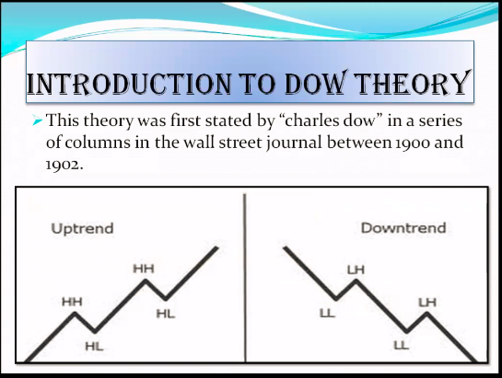
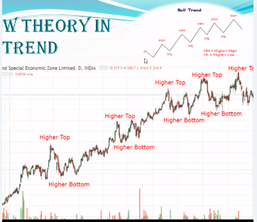
Uptrend: HH & HL
e.g Adani Ports ….HL…Buy
Downtrend: LH & LL
This can be applied in any TIME FRAME.
Daily- Preferable.
TREND REVERSAL
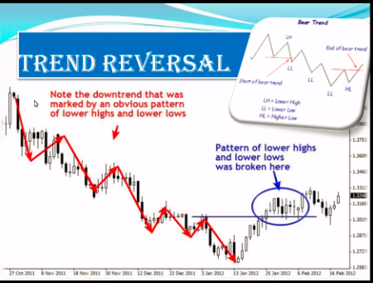
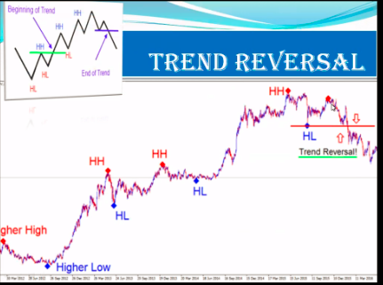
Trend Switches.
E.g. Adani Port
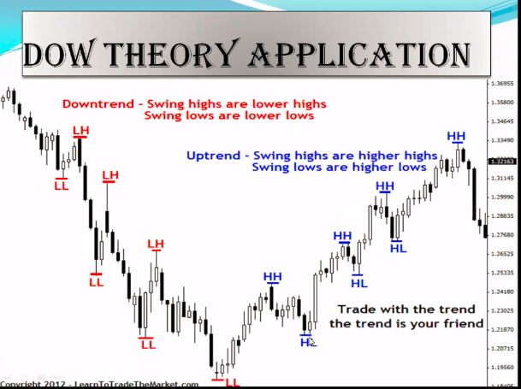
DOW THEORY APPLICATION
Trade with Trend.
15 min
60 min
Daily Chart
You can apply it in Commodity as well.

PATTERNS- Every pattern has its own Target
DOUBLE TOP PATTERN
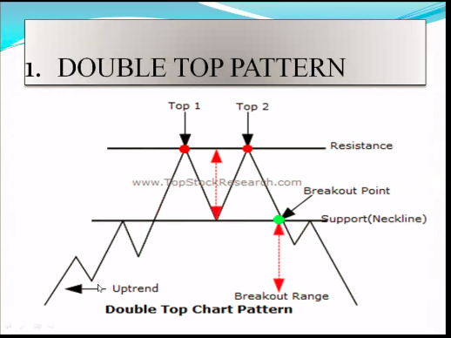
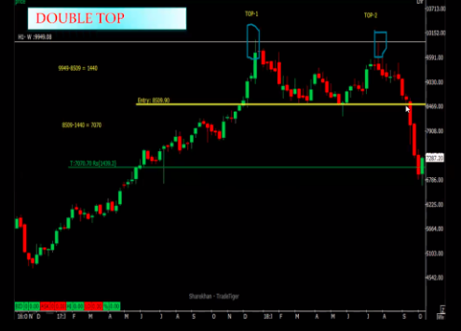
E.g. Maruti

DOUBLE BOTTOM PATTERN
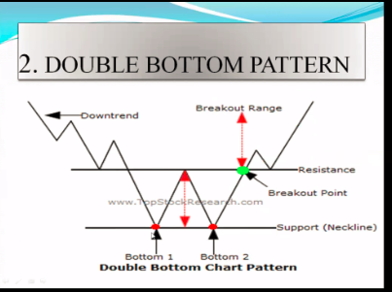
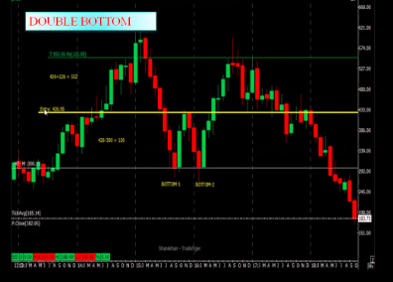
RECTANGLE PATTERN/ Channel
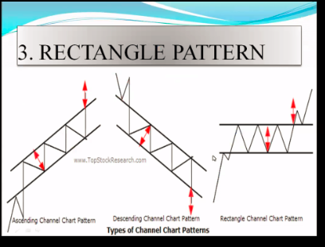
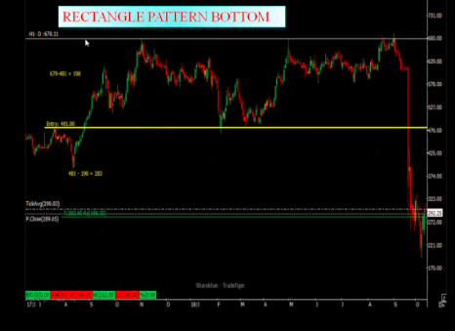
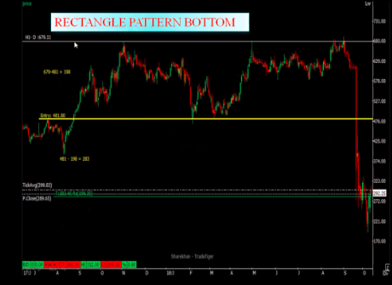
DESCENDING TRIANGLE
