EPS ( Earnings Per Share)
Eg Reliance
How much does it earn for business. Eg Rs 50

EPS= Net profit after Tax/Outstanding /Shares
Earning positive is good.
PE ( Profit Earning)
Eg 1200/50 = 24
So we are paying 24 times more.
It tells how expensive it is.
If expensive it is less likely to go up.

E.g Axis Bank PE 55
HDFC 28/35

E.g Earnings will be declared after 2 months but Fundamentals do not support.

EPS | Earnings per share | Net profit after Tax/Shares | Updated Quarterly after 3 months.  When Results are declared. | Positive and Higher is good
PE | Price to Earning | Current price in market/EPS | After EOD daily | 9 or 10 or less the better.

Sometimes the PE is High eg Kotak Bank…means people are willing to pay more
But then it will move up/Zig Zag and down.
NIFTY
FII invest when PE is 15-18 and exit around 20. As valuations are high.
BANKING STOCKS PE RATIO
PE of Federal Bank is 16 so it ca go from 75 to 90.

EPS should be more and PE should be less.

RESULTS are Like Gear Setters.
4 the Gear--- 80-100Km
5 the Gear—Can go 120.

NIFTY WEIGHTAGE
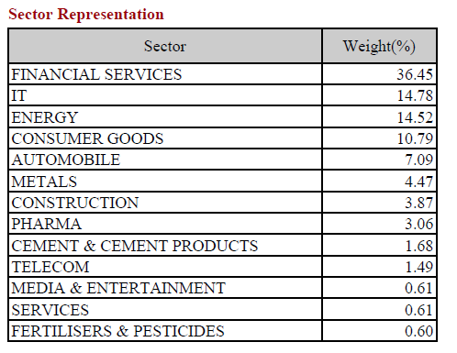
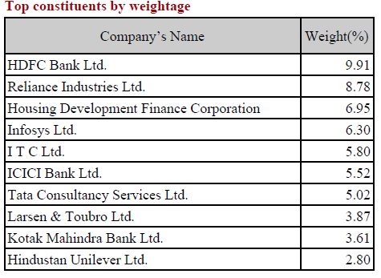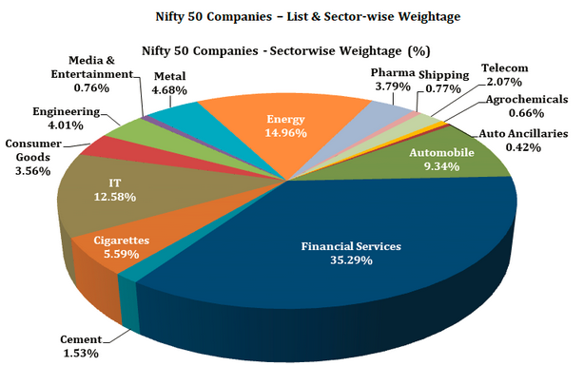
Oil Price
1. Aviation
2. Automobiles.
Currency
- IT
- Pharma

