1. Write Java code to define List . Insert 5 floating point numbers in List, and using an iterator, find the sum of the numbers in List.
Ans:
import java.util.ArrayList;
import java.util.Iterator;
import java.util.List;
public class Q1 {
public static void main(String[] args) {
float sum=0.0f;
List<Float> arraylist=new ArrayList<Float>();
arraylist.add(4.5f);
arraylist.add(5.5f);
arraylist.add(6.5f);
arraylist.add(7.5f);
arraylist.add(8.5f);
Iterator<Float> iterator= arraylist.iterator();
System.out.println("sum of elements in list is:");
while (iterator.hasNext())
{
sum+=iterator.next();
}
System.out.println(sum);
}
}
Output:
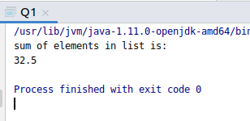

2.Write a method that takes a string and returns the number of unique characters in the string

Ans:
import java.util.LinkedHashSet;
import java.util.Scanner;
import java.util.Set;
public class Q2 {
public static void main(String[] args) {
Scanner sc= new Scanner(System.in);
String name= sc.nextLine();
String[] str= name.split("");
Set<String> uniqueelements= new LinkedHashSet<String>();
for (String s1: str)
{
uniqueelements.add(s1);
}
System.out.println("Total number of unique character are :" +uniqueelements.size()+" And the unique characters are :"+uniqueelements);
}
}

Output:
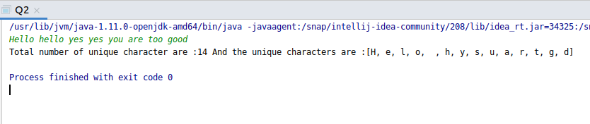

3.Write a method that takes a string and print the number of occurrence of each character characters in the string.

Ans.

import java.util.HashMap;
import java.util.Map;
import java.util.Scanner;
public class Q3 {
public static void countoccurence(String str)
{
HashMap<Character, Integer> hasmap= new HashMap<>();
char[] chararray= str.toCharArray();
for (char c: chararray)
{
if (hasmap.containsKey(c))
{
hasmap.put(c,hasmap.get(c)+1);
}
else {
hasmap.put(c,1);
}
}
for (Map.Entry entry: hasmap.entrySet())
{
System.out.println(entry.getKey()+" "+ entry.getValue());
}
}
public static void main(String[] args) {
Scanner sc= new Scanner(System.in);
String str= sc.nextLine();
countoccurence(str);
}
}
Output:
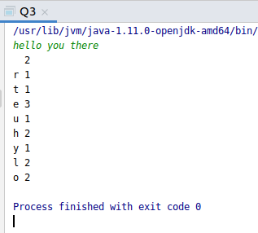

4.Write a program to sort HashMap by value.

Ans:

import java.util.*;
import java.util.Map.Entry;
public class Q4 {
public static void main(String[] args) {
HashMap<String, Integer> obj = new HashMap<String, Integer>();
obj.put("Pinki", 23);
obj.put("John", 33);
obj.put("Divya", 43);
obj.put("Kashish", 61);
obj.put("Aditi", 34);
obj.put("Nidhi", 84);
Map<String, Integer> obj1 = sorting(obj);
for (Map.Entry<String, Integer> i : obj1.entrySet()) {
System.out.println("Key=" + i.getKey() + " " + "Value=" + i.getValue());
}
}
public static HashMap<String, Integer> sorting(HashMap<String, Integer> h) {
List<Map.Entry<String, Integer>> list = new LinkedList<Map.Entry<String, Integer>>(h.entrySet());
Collections.sort(list, new Comparator<Entry<String, Integer>>() {
@Override
public int compare(Map.Entry<String, Integer> t2, Map.Entry<String, Integer> t1) {
return (t2.getValue()).compareTo(t1.getValue());
}
});
HashMap<String,Integer> hashmap=new LinkedHashMap<String,Integer>();
for(Map.Entry<String,Integer> i: list)
{
hashmap.put(i.getKey(),i.getValue());
}
return hashmap;
}
}

Output:
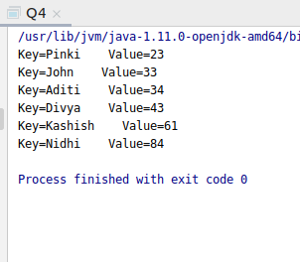

5.Write a program to sort Employee objects based on highest salary using Comparator. Employee class{ Double Age; Double Salary; String Name}

Ans:
import java.util.ArrayList;
import java.util.Collections;
import java.util.Comparator;
import java.util.List;
class Employee
{
double age;
double salary;
String name;
public Employee(double age, double salary, String name) {
this.age = age;
this.salary = salary;
this.name = name;
}
public double getAge() {
return age;
}
public double getSalary() {
return salary;
}
public String getName() {
return name;
}
public void setAge(double age) {
this.age = age;
}
public void setSalary(double salary) {
this.salary = salary;
}
public void setName(String name) {
this.name = name;
}
}
class SortEmployee implements Comparator<Employee>
{
@Override
public int compare(Employee employee, Employee employee1) {
if(employee.getSalary()< employee1.getSalary())
return 1;
else if (employee.getSalary()> employee1.getSalary())
return -1;
else
return 0;
}
}
public class Q5 {
public static void main(String[] args) {
List<Employee> emp= new ArrayList<Employee>();
Employee e1= new Employee(21,2300,"pinki");
Employee e2=new Employee(23,2009,"pari");
Employee e3=new Employee(30,1000,"john");
emp.add(e1);
emp.add(e2);
emp.add(e3);
Collections.sort(emp,new SortEmployee());
for(Employee emp1:emp)
{
System.out.println(emp1.getName()+" "+ emp1.getSalary());
}
}
}

Output:
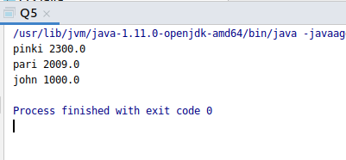

6.Write a program to sort the Student objects based on Score , if the score are same then sort on First Name . Class Student{ String Name; Double Score; Double Age}

Ans:
import java.util.ArrayList;
import java.util.Collections;
import java.util.Comparator;
import java.util.List;
class Students
{
double age;
double score;
String name;
public Students(double age, double score, String name) {
this.age = age;
this.score = score;
this.name = name;
}
public double getAge() {
return age;
}
public double getScore() {
return score;
}
public String getName() {
return name;
}
public void setAge(double age) {
this.age = age;
}
public void setScore(double score) {
this.score = score;
}
public void setName(String name) {
this.name = name;
}
}
class SortStudents implements Comparator<Students>
{
@Override
public int compare(Students student, Students student1) {
if(student.getScore()> student1.getScore())
return 1;
else if (student.getScore()<student1.getScore())
return -1;
else
return student.getName().compareTo(student1.getName());
}
}
public class Q6 {
public static void main(String[] args) {
List<Students> stud= new ArrayList<Students>();
Students s1= new Students(21,2300,"pinki");
Students s2=new Students(23,2009,"pari");
Students s3=new Students(30,1000,"john");
Students s4=new Students(24,1000,"shivam");
Students s5=new Students(25,1000,"abhinav");
stud.add(s1);
stud.add(s2);
stud.add(s3);
stud.add(s4);
stud.add(s5);
Collections.sort(stud,new SortStudents());
for(Students stud1:stud)
{
System.out.println(stud1.getName()+" "+ stud1.getScore());
}
}
}
Output:

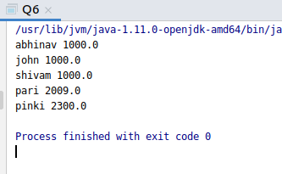

7.Print the elements of an array in the decreasing frequency if 2 numbers have same frequency then print the one which came first.

Ans:
import java.util.*;
public class Q7 {
public static void main(String[] args) {
int[] arr = new int[]{2,2,2,5,7,4,4,5,6,6,5};
LinkedHashMap<Integer, Integer> hashMap = new LinkedHashMap<>();
for (int i=0;i<arr.length;i++) {
if (hashMap.containsKey(arr[i])){
hashMap.put(arr[i],hashMap.get(arr[i])+1);
} else {
hashMap.put(arr[i],1);
}
}
List<Map.Entry<Integer,Integer>> list = new LinkedList<Map.Entry<Integer, Integer>>(hashMap.entrySet());
Collections.sort(list, new Comparator<Map.Entry<Integer, Integer>>() {
@Override
public int compare(Map.Entry<Integer, Integer> obj, Map.Entry<Integer, Integer> obj1) {
if (obj.getValue() > obj1.getValue()) {
return -1;
}
if (obj1.getValue() > obj.getValue()) {
return 1;
}
return 0;
}
});
LinkedHashMap<Integer, Integer> map = new LinkedHashMap<>();
for(Map.Entry<Integer,Integer> entry:list) {
map.put(entry.getKey(),entry.getValue());
}
for(Map.Entry<Integer,Integer> entry: map.entrySet()) {
System.out.println("Value is : "+entry.getKey() + " and its frequency is : " + entry.getValue());
}
}
}
Output:

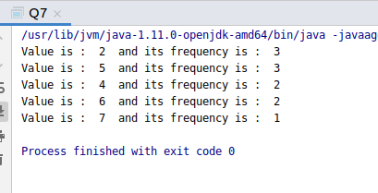

8.Design a Data Structure SpecialStack that supports all the stack operations like push(), pop(), isEmpty(), isFull() and an additional operation getMin() which should return minimum element from the SpecialStack. (Expected complexity O(1))

Ans:

class SpecialStack {
private int array[];
private static int top;
private int capacity;
int minelement;
public SpecialStack(int size) {
array = new int[size];
capacity = size;
top =-1;
}
static boolean isEmpty() {
if (top == -1) {
System.out.println("SpecialStack is empty");
return true;
}
return false;
}
void isFull() {
if (top == capacity - 1) {
System.out.println("SpecialStack is full");
}
}
void getMin() {
if (isEmpty()) {
System.out.println("SpecialStack is empty");
} else {
System.out.println("Current Minimum element is : " + minelement);
}
}
void pop() {
if (isEmpty()) {
System.out.println("SpecialStack is empty\n");
return;
}
System.out.print("Top element popped \t");
int top1 = array[top--];
if (top1 < minelement) {
System.out.println(minelement);
minelement = minelement *2 -top1;
}
else {
System.out.print(top1+"\n");
}
}
void push(int element) {
if (isEmpty()) {
minelement = element;
array[++top] = element;
System.out.println(element + " is inserted");
return;
}
if (element < minelement) {
array[++top] = 2*element - minelement;
minelement = element;
}
else {
array[++top] = element;
}
System.out.println(element + " is inserted");
}
}
public class Q8{
public static void main(String[] args) {
SpecialStack specialStack = new SpecialStack(10);
specialStack.push(45);
specialStack.push(10);
specialStack.push(67);
specialStack.push(89);
specialStack.pop();
specialStack.pop();
specialStack.getMin();
}
}

Output:
