- Create Database.
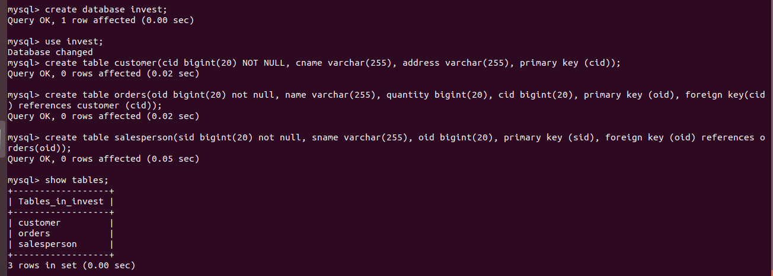
- Design Schema
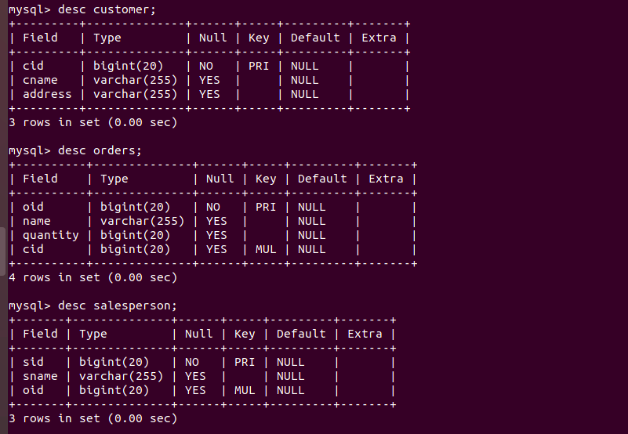

- Create tables
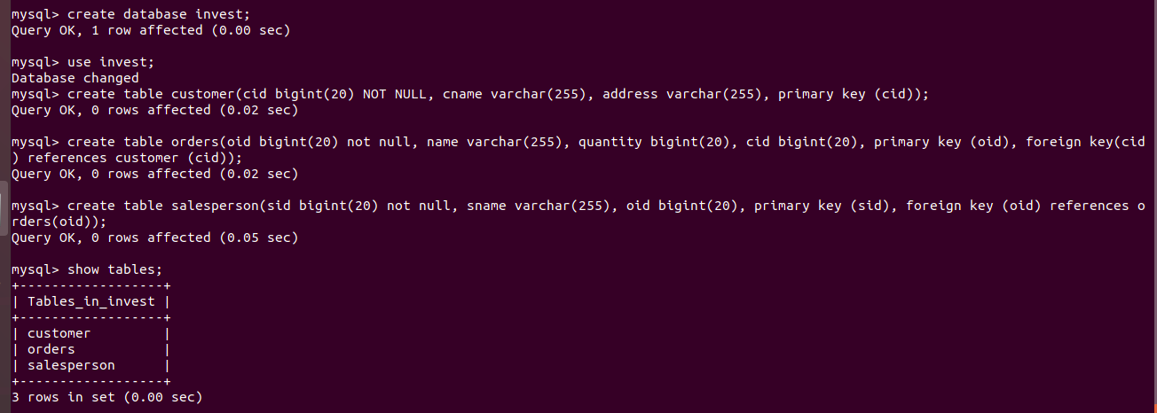
- Insert sample data
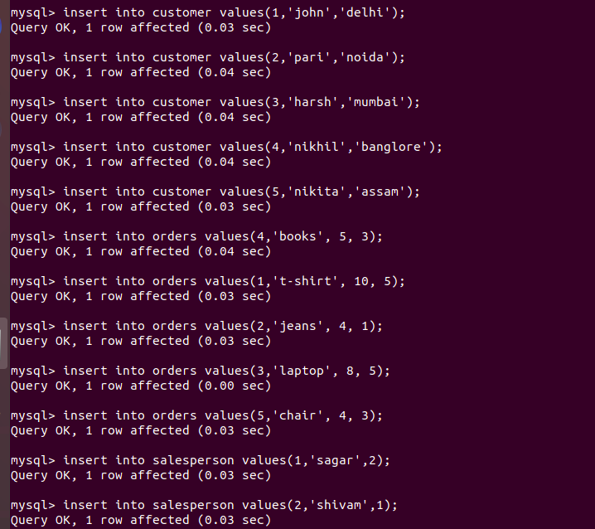
- Find the sales person have multiple orders.
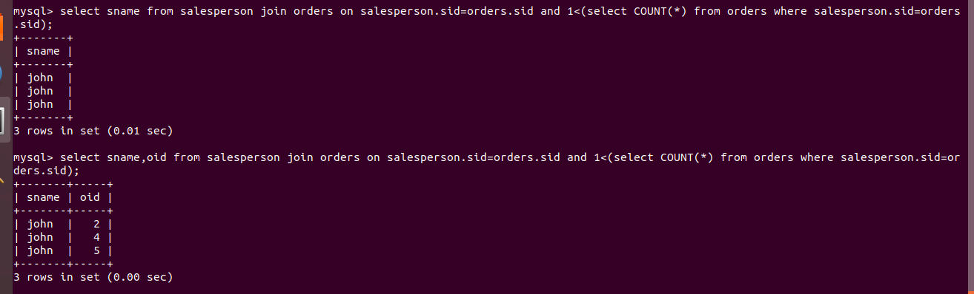

- Find the all sales person details along with order details
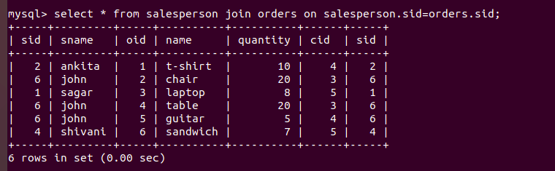
- Create index
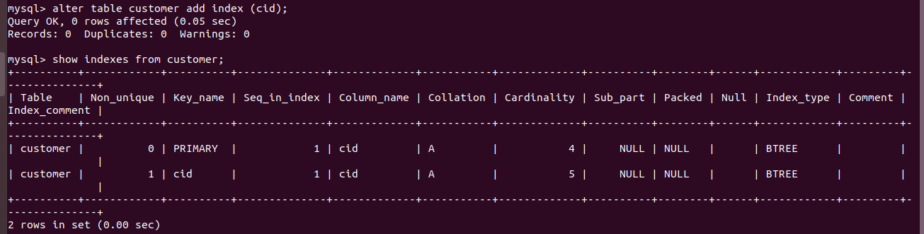
- How to show index on a table
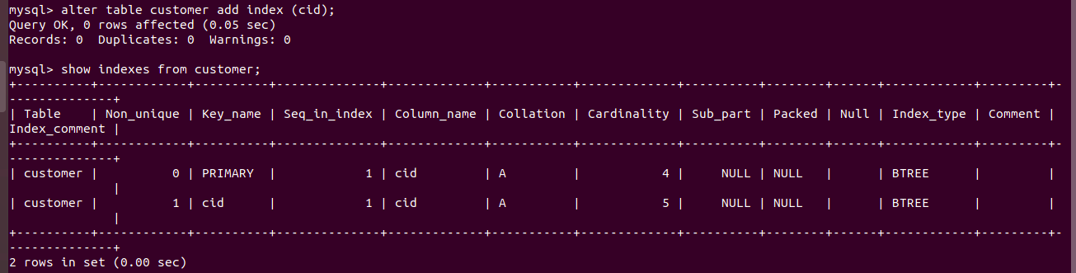

- Find the order number, sale person name, along with the customer to whom that order belongs to
