Q1. Write a program to replace a substring inside a string with other string ?

Ans:

public class Q1 {
public static void main(String[] args) {
String str= "Hello World";
System.out.println(str);
String s = str.replaceAll("ell","yes");
System.out.println(s);
}
}
Output:
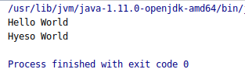

Q2. Write a program to find the number of occurrences of the duplicate words in a string and print them ?

Ans:
import java.util.Scanner;
public class Q2 {
public static void main(String[] args) {
String s;
Scanner sc = new Scanner(System.in);
System.out.println("Enter a string:");
s = sc.nextLine();
System.out.println("You entered String: "+s);
s = s.toLowerCase();
String Words[]= s.split(" ");
int count=0,i,j;
for( i=0 ;i<= Words.length;i++) {
count = 1;
for (j = i + 1; j < Words.length; j++) {
if (Words[i].equals(Words[j])) {
count++;
Words[j] = "0";
}
}
if (count > 1 && Words[i]!="0") {
System.out.println(Words[i] + " " + count);
}
}
}
}

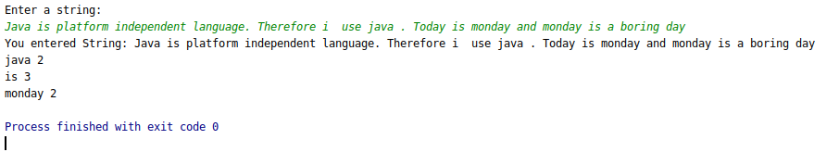
Q3. Write a program to find the number of occurrences of a character in a string without using loop?

Ans:
public class Q3 {
public static void main(String[] args) {
String str="Abstract class: is a restricted class that cannot be used to create objects".toLowerCase();
int a = str.length() - str.replace("a", "").length();
System.out.println("Occurence of a : "+a);
}
}
output:
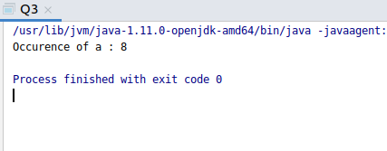

Q4. Calculate the number & Percentage Of Lowercase Letters,Uppercase Letters, Digits And Other Special Characters In A String

Ans:
import java.util.Scanner;
public class Q4 {
static void charpercent(String str)
{ int total= str.length();
int i, upper=0,lower=0,digit=0,others=0;
for(i=0;i<str.length();i++)
{
char ch= str.charAt(i);
if(Character.isUpperCase(ch))
{
upper++;
}
else if(Character.isLowerCase(ch))
{
lower++;
}
else if(Character.isDigit(ch))
{
digit++;
}
else
{
others++;
}
}
double upperpercentage = (upper*100.0)/total;
double lowerpercentage = (lower*100.0)/total;
double digitpercentage = (digit*100.0)/total;
double otherpercentage = (others*100.0)/total;
System.out.println("Input string is " + str +" : ");
System.out.println("No. of upper case letters are:\t"+upper +"\t And its percentage is\tH :"+upperpercentage);
System.out.println("No. of lower case letters are:\t"+lower +"\t And its percentage is\tH :"+lowerpercentage);
System.out.println("No. of digits are:\t"+digit +"\t And its percentage is\tH :"+digitpercentage);
System.out.println("No. of other characters are:\t"+others +"\t And its percentage is\tH :"+otherpercentage);
}
public static void main(String[] args)
{
Scanner sc = new Scanner(System.in);
System.out.println("Enter the string: \t");
String s = sc.nextLine();
charpercent(s);
}
}
Output:
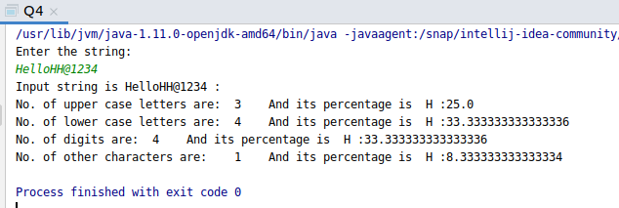
Q5. Find common elements between two arrays.
Ans:

public class Q5 {
public static void main(String[] args) {
int a[]={3,5,4,2,7,6,6};
int b[]={3,6,5,7,8,9};
int i,j;
for (i=0;i<a.length;i++)
{
for (j=0;j<b.length;j++)
{
if(a[i]==b[j])
{
b[j]=0;
System.out.println(a[i]);
}
}
}
}
}

Output:

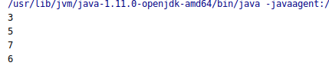

Q6. There is an array with every element repeated twice except one. Find that element
Ans:
public class Q6 {
public static void singleNumber(int[] A)
{
int ans = A[0];
for(int i=1;i<A.length;i++)
{
ans = ans^A[i];
}
System.out.println(ans);
}
public static void main(String[] args) {
int[] a = {2,2,3,3,4,4,5};
singleNumber(a);
}
}
Output: Ans should be 5 as 5 is not repeated twice.
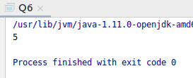

Q7. Write a program to print your Firstname,LastName & age using static block,static method & static variable respectively

Ans:
public class Q7 {
static int age=23 ;
static {
System.out.println("Firstname : Pinki" );
}
static void surname()
{
System.out.println("Lastname: Bhati");
}
public static void main(String[] args) {
System.out.println("Age is :" + Q7.age);
surname();
}
}

Output:
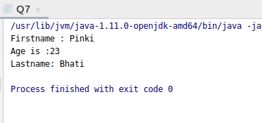

Q8. Write a program to reverse a string and remove character from index 4 to index 9 from the reversed string using String Buffer

Ans:

import java.util.Scanner;
public class Q8 {
public static void main(String[] args) {
String str ="Hello world";
System.out.println("Input string is :" + str);
str = new StringBuffer(str).reverse().toString();
System.out.println("Reversed string is :"+str);
str = new StringBuffer(str).delete(4,10).toString();
System.out.println("New string after removing index 4 to 9 is :"+str);

}
}

OUTPUT:
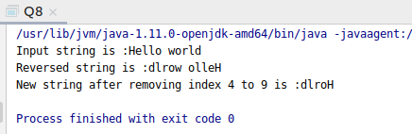

Q9.Write a program to display values of enums using a constructor & getPrice() method (Example display house & their prices)

Ans:public class Q9 {
public enum houseName{
A(10000),B(20000),C(30500),D(15000),E(20500);
private int p;
houseName(int price)
{
p=price;
}
int getPrice()
{
return p;
}
}
public static void main(String[] args)
{
System.out.println("House Name : Price ");
System.out.println(houseName.A +": "+ houseName.A.getPrice()+" Rupees");
System.out.println(houseName.B +": "+ houseName.B.getPrice()+" Rupees");
System.out.println(houseName.C +": "+ houseName.C.getPrice()+" Rupees");
System.out.println(houseName.D +": "+ houseName.D.getPrice()+" Rupees");
System.out.println(houseName.E +": "+ houseName.E.getPrice()+" Rupees");
}
}
Output:
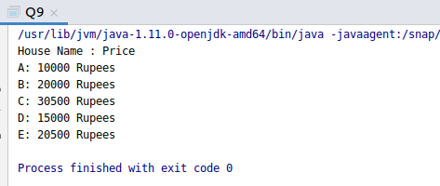

Q10.Write a single program for following operation using overloading
A) Adding 2 integer number
B) Adding 2 double
C) multiplying 2 float
D) multiplying 2 int
E) concate 2 string
F) Concate 3 String
Ans:

import java.util.Scanner;
public class Q10
{
public static Scanner sc = new Scanner(System.in);
public int add(int a,int b) throws RuntimeException
{
return a+b;
}
public double add(double a,double b) throws RuntimeException
{
return a+b;
}
public float multiply(float a,float b) throws RuntimeException
{
return a*b;
}
public int multiply(int a,int b) throws RuntimeException
{
return a*b;
}
public String conc(String s1,String s2) throws RuntimeException
{return s1.concat(s2);}
public String conc(String s1,String s2,String s3) throws RuntimeException
{return s1.concat(s2.concat(s3));}
public static void main(String[] args) {
int a;
Q10 m = new Q10();
System.out.println("enter choice");
System.out.println("1 for addition of two integers");
System.out.println("2 for addition of two doubles");
System.out.println("3 for multiplication of two floats");
System.out.println("4 for multiplication of two int");
System.out.println("5 for concatenate two strings");
System.out.println("6 for concatenate three strings");
a = sc.nextInt();
switch (a) {
case 1:
System.out.println("enter first integer value");
int x = sc.nextInt();
System.out.println("enter second integer value");
int y = sc.nextInt();
System.out.println(m.add(x, y));
break;
case 2:
System.out.println("enter first double value");
double x1 = sc.nextDouble();
System.out.println("enter second double value");
double y1 = sc.nextDouble();
System.out.println(m.add(x1, y1));
break;
case 3:
System.out.println("enter first float value");
float x2 = sc.nextFloat();
System.out.println("enter second float value");
float y2 = sc.nextFloat();
System.out.println(m.multiply(x2, y2));
break;
case 4:
System.out.println("enter first int value");
int x3 = sc.nextInt();
System.out.println("enter second second value");
int y3 = sc.nextInt();
System.out.println(m.multiply(x3, y3));
break;
case 5:
System.out.println("enter first String");
String x4 = sc.next();
System.out.println("enter second String");
String y4 = sc.next();
System.out.println(m.conc(x4, y4));
break;
case 6:
System.out.println("enter first string");
String x5 = sc.next();
System.out.println("enter second string");
String y5 = sc.next();
System.out.println("enter third string");
String z5 = sc.next();
System.out.println(m.conc(x5,y5,z5));
break;
default:
System.out.println("wrong choice");
}
}
}
OUTPUT:

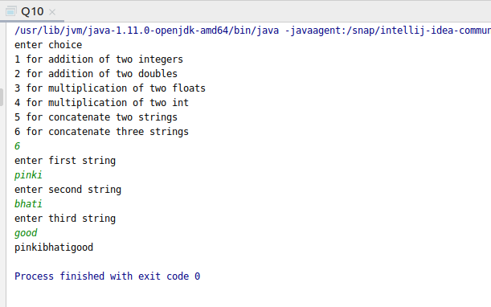

Q11.Create 3 sub class of bank SBI,BOI,ICICI all 4 should have method called getDetails which provide there specific details like rateofinterest etc,print details of every banks

Ans:
abstract class Bank{
float rateofinterest;
String branchname;
public abstract void getdetails();
}
class SBI extends Bank{
public void getdetails()
{ rateofinterest=20.0f;
branchname="palam";
System.out.println("Rate of interest of SBI bank is :" +rateofinterest);
System.out.println("Branch Name of SBI bank is :"+ branchname);
}
}
class BOI extends Bank{
public void getdetails()
{ rateofinterest = 30.23f;
branchname="sadar";
System.out.println("Rate of interest of BOI bank is :" +rateofinterest);
System.out.println("Branch Name of BOI bank is :"+ branchname);
}
}
class ICICI extends Bank{
public void getdetails()
{ rateofinterest=50.9f;
branchname="noida";
System.out.println("Rate of interest of ICICI bank is :" +rateofinterest);
System.out.println("Branch Name of ICICI bank is :"+ branchname);
}
}
public class Q11 {
public static void main(String[] args) {
Bank b= new SBI();
b.getdetails();
System.out.println("\n");
b= new BOI();
b.getdetails();
System.out.println("\n");
b= new ICICI();
b.getdetails();
}
}

OUTPUT:
