1. Create Java classes having suitable attributes for Library management system.Use OOPs concepts in your design.Also try to use interfaces and abstract classes.
Ans:

Note:
I have made a Login class which is abstract and have 2 variables id and password of String type.Librarian class is extending Login class and some function like addBookItem(), issueBook(),calculateFine(Date duedate) are also part of this class as any librarian would perform such actions .Student class also extends Login class and Student class have some function like searchBook(),returnBook(),requestBook().
There is a Book class which have some attributes like ISBN number,title,publisher,author,price etc.

import java.util.Date;

abstract class Login {
private String id;
private String password;
Login(String id,String password)
{
this.id=id;
this.password=password;
}
}
class librarian extends Login
{
librarian(String id, String password) {
super(id, password);
}
public void addBookItem(String bookItem)
{
//function to add books in the library
}
public void issueBook(String bookItem)
{
//function to issue books to member
}
public void calculateFine(Date duedate)
{
//function to issue fine for books returned after due date
}
}
class Student extends Login
{
private Date dateOfMembership;
private int totalBooks;
Student(String id, String password) {
super(id, password);
}
public void searchBook(String bookItem)
{
//member searches for book hhe wants to issue
}
public void requestBook(String bookItem)
{
//issue book from librarian
}
public void returnBook(String bookItem)
{
//return book to librarian
}
}
class Book {
private String ISBN;
private String title;
private String publisher;
private String authors;
private double price;
private Date dueDate;
public Date getDueDate() {
return dueDate;
}
public void setDueDate(Date dueDate) {
this.dueDate = dueDate;
}
public String getISBN() {
return ISBN;
}
public void setISBN(String ISBN) {
this.ISBN = ISBN;
}
public String getTitle() {
return title;
}
public void setTitle(String title) {
this.title = title;
}
public String getPublisher() {
return publisher;
}
public void setPublisher(String publisher) {
this.publisher = publisher;
}
public String getAuthors() {
return authors;
}
public void setAuthors(String authors) {
this.authors = authors;
}
public double getPrice() {
return price;
}
public void setPrice(double price) {
this.price = price;
}
}
public class Q1 {
public static void main(String[] args) {
Book bookitem = new Book();
Student student = new Student("Pinki","pinki@123");
librarian lib = new librarian("Chetna","Chetna@123");
lib.addBookItem(bookitem.getTitle());
student.searchBook(bookitem.getTitle());
student.requestBook(bookitem.getTitle());
lib.issueBook(bookitem.getTitle());
student.returnBook(bookitem.getTitle());
lib.calculateFine(bookitem.getDueDate());
}
}

2. WAP to sorting string without using string Methods?.
Ans:
import java.util.Arrays;
public class Q2 {
public static void swap(int i,int j,char[] arr)
{
char temp= arr[i];
arr[i]=arr[j];
arr[j]=temp;
}
public static void main(String[] args) {
String str="hello world";
System.out.println("Original string is : "+ str);
char arr[] =str.toCharArray();
for(int i=0;i<arr.length;i++)
{
for(int j=i+1;j<arr.length;j++)
{
if(Character.toLowerCase(arr[j])< Character.toLowerCase(arr[i]))
{
swap(i,j,arr);
}
}
}
System.out.println("sorted string :"+ String.valueOf(arr));
}
}
Output:
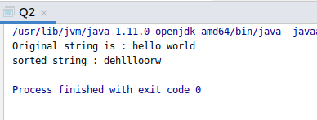

3. WAP to produce NoClassDefFoundError and ClassNotFoundException exception.
Ans:class NewFile {
public void NewFun() {
System.out.println("NewFile class ");
}
}
public class Q3 {
public static void main(String[] args) {
try{
Class.forName("New");
}
catch (ClassNotFoundException ex)
{
ex.printStackTrace();
}
NewFile nf=new NewFile();
nf.NewFun();
}
}

Note:
1. We got ClassNotFoundException because i have not created “New“ class.

2. Compile the program first and then delete the NewFile.class file . Try to run the code again , then we will get NoClassDefFoundError.

Output:
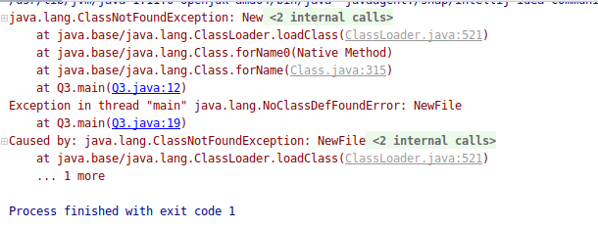

4. WAP to create singleton class.
Ans:
class Singleton {

static Singleton single ;
public String str;
private Singleton() {
str=" This is singleton class";
/* hinder other classes to create an object of this class. */
}
public static Singleton getInstance()
{
if(null==single)
{
single = new Singleton();
}
return single;
}
}
public class Q4 {
public static void main(String[] args) {
Singleton s1 = Singleton.getInstance();
Singleton s2 = Singleton.getInstance();
s1.str= (s1.str).toUpperCase();
System.out.println("String of s1 is : "+s1.str);
System.out.println("String of s2 is : "+s2.str);

// Singleton s2= new Singleton();/* Can't be created because Singleton() has private access in Singleton.*/
}
}
NOTE: I have changed the variable str of object s1 to uppercase, but when we access the variable str of object s2 , the changes will be reflected. Because all the objects created of Singleton class is pointing to single object created of singleton class for the first time.

Output:
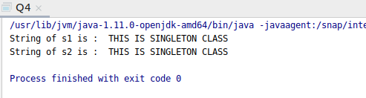
5. WAP to show object cloning in java using cloneable and copy constructor both.
Ans:
A) Object cloning in java using cloneable
code:

class CheckClone implements Cloneable{
int i;
int j;
@Override
public String toString() {
return "CheckClone{" + "i=" + i + ", j=" + j + '}';
}
@Override
public Object clone() throws CloneNotSupportedException{
return super.clone();
}
}
public class Q5 {
public static void main(String[] args) throws CloneNotSupportedException{
CheckClone clone= new CheckClone();
clone.i=5;
clone.j=7;
CheckClone clone1= (CheckClone) clone.clone();
System.out.println(clone);
System.out.println(clone1);
}
}

Output:
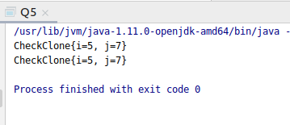

B) Object cloning in java using copy constructor
Code:
public class Q5Second {
int one, two;
Q5Second()
{
one =5;
two =6;
}
Q5Second(Q5Second sc )
{ int one1 =sc.one;
int two1 =sc.two;
}
public static void main(String[] args) {
Q5Second obj = new Q5Second();
Q5Second obj2 =new Q5Second(obj);
System.out.println(" Values of one and two for obj are :"+(obj.one) +" and "+(obj.two)+" respectively .");
System.out.println(" Values of one and two for obj1 are :"+(obj2.one1) +"and "+(obj2.two1)+" respectively .");
}
}

Output:
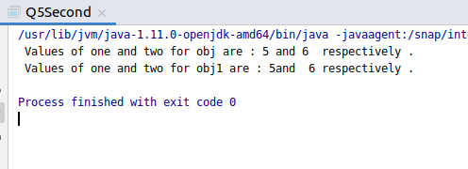

6. WAP showing try, multi-catch and finally blocks.
Ans:
public class Q6 {
public static void main(String[] args) {
try{
int arr[]=new int[5];
arr[5]=2/0;

}
catch(ArithmeticException e)
{
System.out.println("Arithmetic Exception occurs \n");
}
catch (ArrayIndexOutOfBoundsException e)
{
System.out.println("ArrayIndexOutOfBounds Exception occurs \n ");
}
catch(Exception e)
{
e.printStackTrace();
}
finally {
System.out.println("This is finally block \n");
}
}
}

Output:
Only one catch block executes at a time.

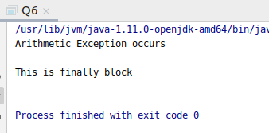

7. WAP to convert seconds into days, hours, minutes and seconds.
Ans:
import java.util.Scanner;
public class Q7 {
static void ConvertSec(int seconds)
{
int days= seconds/(24 * 3600);
seconds = seconds % (24 * 3600);
int hours = seconds/3600;
seconds = seconds% 3600;
int minutes = seconds / 60;
seconds %= 60;
int Seconds = seconds;
System.out.println(days + " days "+ hours +" hours "+ minutes + " minutes " + seconds + " seconds");
}
public static void main(String[] args) {
Scanner sc= new Scanner(System.in);
System.out.println("Enter Seconds: \t");
int sec= sc.nextInt();
ConvertSec(sec);
}
}
Output:
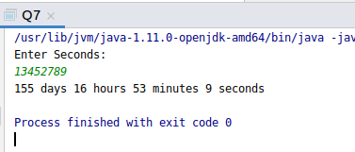

8. WAP to read words from the keyboard until the word done is entered. For each word except done, report whether its first character is equal to its last character. For the required loop, use a
a)while statement
b)do-while statement
Ans:
import java.util.Scanner;
public class Q8 {
public static void main(String[] args) {
System.out.println("Using while loop :: ");
Scanner keyboard = new Scanner(System.in);
System.out.println("Enter a word : ");
String str = keyboard.next();
while(!str.equals("done"))
{
if(str.charAt(0) == str.charAt(str.length()-1))
{
System.out.println("First and last character are equal in the str: " + str);
}
else
{
System.out.println("First and last character are not equal in the str: " + str);
}
str = keyboard.next();
}
System.out.println("Now Using do-while loop :: ");
Scanner keyboard1= new Scanner(System.in);
System.out.println("Enter a word : ");
String str1 = keyboard.next();
do {
if(str1.charAt(0) == str1.charAt(str1.length() - 1))
{
System.out.println("First and last character are equals for the str: " + str1);
}
else
{ System.out.println("First and last character are NOT equals for the str: " + str1);
}
str1 = keyboard.next();
}
while(!str1.equals("done"));
}
}
Output:
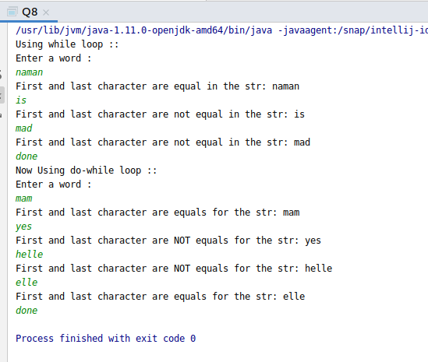
9. Design classes having attributes for furniture where there are wooden chairs and tables, metal chairs and tables. There are stress and fire tests for each products.
Ans:
import java.util.Scanner;
interface Furniture {
public void stressTest();
public void fireTest();
}
abstract class Chair implements Furniture {
public abstract String chairType();
}
abstract class Table implements Furniture {
public abstract String tableType();
}
class MetalChair extends Chair {
@Override
public void stressTest() {
}
@Override
public void fireTest() {
}
@Override
public String chairType() {
String s = "This is a metal Chair";
return s;
}
}
class MetalTable extends Table {
@Override
public void stressTest() {
System.out.println("Passed Stress Test");
}
@Override
public void fireTest() {
System.out.println("Passed Fire Test");
}
@Override
public String tableType() {
String s = "This is a metal Table";
return s;
}
}
class WoodenTable extends Table {
@Override
public void stressTest() {
System.out.println("Failed Stress Test");
}
@Override
public void fireTest() {
System.out.println("Failed Fire Test");
}
@Override
public String tableType() {
String s = "This is a wooden Table";
return s;
}
}
class WoodenChair extends Chair {
@Override
public void stressTest() {
}
@Override
public void fireTest() {
}
@Override
public String chairType() {
String s = "This is a wooden chair";
return s;
}
}
public class Q9{
public static void main(String[] args){
Table table = null;
Scanner input = new Scanner(System.in);
String str = input.next();
if(str.equals("wooden")){
table = new WoodenTable();
} else if (str.equals("metal")){
table = new MetalTable();
}
System.out.println(table.tableType());
table.stressTest();
table.fireTest();
}
}

Output:
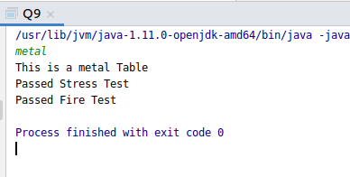

10. Design classes having attributes and method(only skeleton) for a coffee shop. There are three different actors in our scenario and i have listed the different actions they do also below
* Customer
- Pays the cash to the cashier and places his order, get a token number back
- Waits for the intimation that order for his token is ready
- Upon intimation/notification he collects the coffee and enjoys his drink
( Assumption: Customer waits till the coffee is done, he wont timeout and cancel the order. Customer always likes the drink served. Exceptions like he not liking his coffee, he getting wrong coffee are not considered to keep the design simple.)
* Cashier
- Takes an order and payment from the customer
- Upon payment, creates an order and places it into the order queue
- Intimates the customer that he has to wait for his token and gives him his token
( Assumption: Token returned to the customer is the order id. Order queue is unlimited. With a simple modification, we can design for a limited queue size)
* Barista
- Gets the next order from the queue
- Prepares the coffee
- Places the coffee in the completed order queue
- Places a notification that order for token is ready

Ans:
Note: We have to create only the skeleton for the shop .

class Customer {
private String Name;
private double PhoneNo;
private int TokenNo;
Customer(String name,double phone)
{
this.Name =name;
this.PhoneNo =phone;
}
public String getName() {
return Name;
}
public void setName(String name) {
this.Name = name;
}
public double getPhoneNo() {
return PhoneNo;
}
public void setPhoneNo(double phoneNo) {
this.PhoneNo = phoneNo;
}
public int getTokenNo() {
return TokenNo;
}
public void setTokenNo(int tokenNo) {
this.TokenNo = tokenNo;
}
public void PlaceOrder(String Name, double phoneNo)
{
//we will place order on the basis of name and phone number
}
public void checkOrderStatus(int tokeno)
{
// we will checkorderstatus on the basis of tokenno given to the customer
}
public void collectOrder(int tokeno)
{
// customer can collect the coffee after entering tokenno
}
public void payment()
{
//payment done through this function
}
}

class Cashier {
String nameOfCashier;
int CashierId;
public String getNameOfCashier() {
return nameOfCashier;
}
public void setNameOfCashier(String nameOfCashier) {
this.nameOfCashier = nameOfCashier;
}
public int getCashierId() {
return CashierId;
}
public void setCashierId(int cashierId) {
CashierId = cashierId;
}
public void takeOrder(String customerName)
{
//cashier will take the order
}
public void giveTokenNo(String customerName)
{
//this will be called when customer places an order so cashier will provide him with a tokenno
}
public void receivePayment(int tokenno)
{
//
}
public void addItToPendingQueue(int tokeno)
{
}
}

class Barista {
public void getOrderFromPendingQueue()
{
}
public void prepareOrder()
{
}
public void insertOrderIntoCompletedOrderQueue()
{
}
public void PushNotification()
{
}
}

public class Q10 {
public static void main(String[] args) {
Cashier cashier = new Cashier();
Barista barista = new Barista();
Customer customer = new Customer("PINKI",786543290);
customer.PlaceOrder(customer.getName(),customer.getPhoneNo());
cashier.takeOrder(customer.getName());
cashier.giveTokenNo(customer.getName());
cashier.receivePayment(customer.getTokenNo());
cashier.addItToPendingQueue(customer.getTokenNo());
customer.checkOrderStatus(customer.getTokenNo());
barista.getOrderFromPendingQueue();
barista.prepareOrder();
barista.PushNotification();
barista.insertOrderIntoCompletedOrderQueue();
customer.collectOrder(customer.getTokenNo());
customer.payment();
}
}

11. Convert the following code so that it uses nested while statements instead of for statements:
int s = 0;
int t = 1;
for (int i = 0; i < 10; i++)
{
s = s + i;
for (int j = i; j > 0; j−−)
{
t = t * (j - i);
}
s = s * t;
System.out.println("T is " + t);
}
System.out.println("S is " + s);

Ans:
Actual result using Nested for loop:
public class Q11First {
public static void main(String[] args) {
int s = 0;
int t = 1;
for (int i = 0; i < 10; i++)
{
s = s + i;
for (int j = i; j > 0; j--)
{
t = t * (j - i);
}
s = s * t;
System.out.println("T is " + t);
}
System.out.println("S is " + s);
}
}
Output:

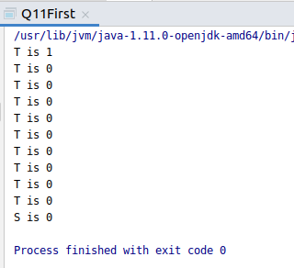

Result using Nested while loop:
public class Q11Second {
public static void main(String[] args) {
int s = 0;
int t = 1;
int i=0;
int j;
while(i<10)
{ s = s + i;
j=i;
while(j>0)
{
t = t * (j - i);
j--;
}
s = s * t;
System.out.println("T is " + t);
i++;
}
System.out.println("S is " + s);
}
}
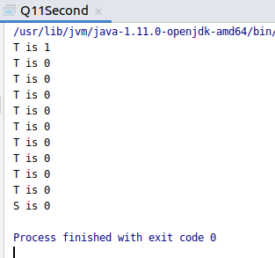
Output:

12.What will be the output on new Child(); ?
Ans: class Grandparent {
static {
System.out.println("static - grandparent");
}
{
System.out.println("instance - grandparent");
}
public Grandparent() {
System.out.println("constructor - grandparent");
}
}
class Parent extends Grandparent {
{
System.out.println("instance - parent");
}
public Parent() {
System.out.println("constructor - parent");
}
static {
System.out.println("static-parent");
}
}

class Child extends Parent {
public Child() {
System.out.println("constructor - child");
}
static {
System.out.println("static - child");
}
{
System.out.println("instance - child");
}
}
public class Q12{
public static void main(String[] args) {
System.out.println("-------------------");
Grandparent gp = new Child();
System.out.println("-------------------");
Parent parent= new Child();
System.out.println("-------------------");
Child ch= new Child();

}
}
Output:
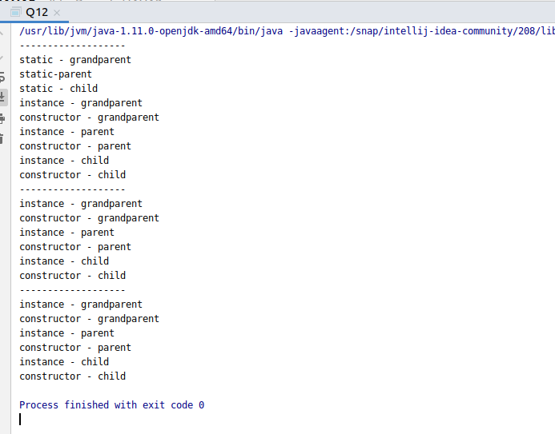

Q13. Create a custom exception that do not have any stack trace.
Ans:
class NewException extends Exception{
String str;
NewException(String str)
{
this.str=str;
}
@Override
public String toString() {
return "NewException{" +
"str='" + str + '\'' +
'}';
}
}
public class Q13 {
public static void main(String[] args) {
try{
throw new NewException("New exception found ");
}
catch (Exception e)
{
e.printStackTrace();
}
}
}
Output:
