1.How are inline and block elements different from each other?
Ans.
An inline element does not start on a new line and only takes up as much width as necessary.
eg.<span>,<strong>,<select>.
A block-level element always starts on a new line and takes up the full width available (stretches out to the left and right as far as it can).
Eg. <div>, <header>, <footer>, <form>.

2.Explain the difference between visibility:hidden and display:none
Ans.
display:none means that the tag in question will not appear on the page at all (although you can still interact with it through the dom). There will be no space allocated for it between the other tags.
visibility:hidden means that unlike display:none, the tag is not visible, but space is allocated for it on the page. The tag is rendered, it just isn't seen on the page.

3. Explain the clear and float properties.
Ans. The clear property specifies what elements can float beside the cleared element and on which side.
The clear property can have one of the following values:
- none - Allows floating elements on both sides. This is default
- left - No floating elements allowed on the left side
- right- No floating elements allowed on the right side
- both - No floating elements allowed on either the left or the right side
- inherit - The element inherits the clear value of its parent.
The float property is used for positioning and formatting content e.g. let a section float left to the text in a div.
The float property can have one of the following values:
- left - The element floats to the left of its container
- right - The element floats to the right of its container
- none - The element does not float (will be displayed just where it occurs in the text). This is default
- inherit - The element inherits the float value of its parent

4. Explain difference between absolute, relative,fixed and static.
Ans. The position property specifies the type of positioning method used for an element.
There are five different position values:
- Static:Static positioned elements are not affected by the top, bottom, left, and right properties.

- Relative:This element is positioned relative to its normal position.
- Fixed:This element is positioned relative to the viewport, which means it always stays in the same place even if the page is scrolled.
- Absolute:This element is positioned relative to the nearest positioned ancestor (instead of positioned relative to the viewport, like fixed).
- Sticky:This element is positioned based on the user's scroll position.

5. Write the HTML code to create a table in which there are 4 columns( ID , Employee Name, Designation, Department) and at least 6 rows. Also do some styling to it.
Ans.
<SOURCE CODE>
<!DOCTYPE html>
<html>
<head>
<style>
table {
font-family: arial, sans-serif;
border-collapse: collapse;
width: 100%;
}
td, th {
border: 1px solid #a9a9a9;
text-align: left;
padding: 8px;
}
tr:nth-child(even) {
background-color: cyan;
}
tr:nth-child(odd) {
background-color: grey;
}
</style>
</head>
<body>
<h2>Employee Details</h2>
<table>
<tr>
<th>ID</th>
<th>Employee Name</th>
<th>Designation</th>
<th>Department</th>
</tr>
<tr>
<td>4001</td>
<td>Mohammed Azeem</td>
<td>Trainee</td>
<td>.Net</td>
</tr>
<tr>
<td>4002</td>
<td>Pinki Bhati</td>
<td>Trainee</td>
<td>JVM</td>
</tr>
<tr>
<td>4003</td>
<td>Himanshu Bhansali</td>
<td>Trainee</td>
<td>FEEN</td>
</tr>
<tr>
<td>4004</td>
<td>Vishesh</td>
<td>Trainee</td>
<td>.Net</td>
</tr>
<tr>
<td>4005</td>
<td>Shivam Sharma</td>
<td>Trainee</td>
<td>JVM</td>
</tr>
<tr>
<td>4006</td>
<td>Latika</td>
<td>Trainee</td>
<td>.Net</td>
</tr>
</table>
</body>
</html>
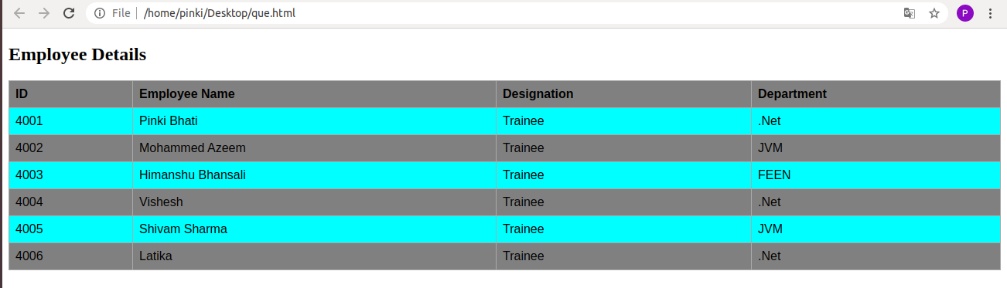

6. Why do we use meta tags?
Ans. The <meta> tag provides metadata about the HTML document. Metadata will not be displayed on the page, but will be machine parsable.
  - Meta elements are typically used to specify page description, keywords, author of the document, last modified, and other metadata. Also, it helps to improve the SEO( Search Engine Optimization) of a web page by using certain keywords related to the web page.
  - <meta> tags always go inside the < head > element.

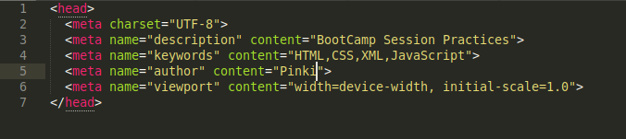

7. Explain box model.
Ans. All HTML elements can be considered as boxes. In CSS, the term "box model" is used when talking about design and layout.
The CSS box model is essentially a box that wraps around every HTML element. It consists of: margins, borders, padding, and the actual content.

8. What are the different types of CSS Selectors?

a) CSS id Selector
The id selector uses the id attribute of an HTML element to select a specific element.
The id of an element is unique within a page, so the id selector is used to select one unique element!

b) CSS class Selector
The class selector selects HTML elements with a specific class attribute.
c) CSS Universal Selector
The universal selector (*) selects all HTML elements on the page.

* {
text-align: center;
color: blue;
}
d) CSS Grouping Selector
The grouping selector selects all the HTML elements with the same style definitions.

e)CSS element Selector
The element selector selects HTML elements based on the element name.

9. Define Doctype.
Ans. The <!DOCTYPE> declaration must be the very first thing in your HTML document, before the <html> tag.
The <!DOCTYPE> declaration is not an HTML tag; it is an instruction to the web browser about what version of HTML the page is written in.
In HTML 4.01, the <!DOCTYPE> declaration refers to a DTD, because HTML 4.01 was based on SGML. The DTD specifies the rules for the markup language, so that the browsers render the content correctly.

10. Explain 5 HTML5 semantic tags.
Ans:
a) <section> element:
The <section> element defines a section in a document.
<section>
<h1>WWF</h1>
<p>The World Wide Fund for Nature (WWF) is....</p>
</section>
b)<article> Element
The <article> element specifies independent, self-contained content.
An article should make sense on its own, and it should be possible to read it independently from the rest of the web site.
<article>
<h1>What Does WWF Do?</h1>
<p>WWF's mission is to stop the degradation of our planet's natural environment,and build a future in which humans live in harmony with nature.</p>
</article>
c)<header> Element
The <header> element specifies a header for a document or section.
The <header> element should be used as a container for introductory content.
d)<footer> Element
The <footer> element specifies a footer for a document or section.
A <footer> element should contain information about its containing element.

e) <nav> Element
The <nav> element defines a set of navigation links.

11. Create a html for this form.
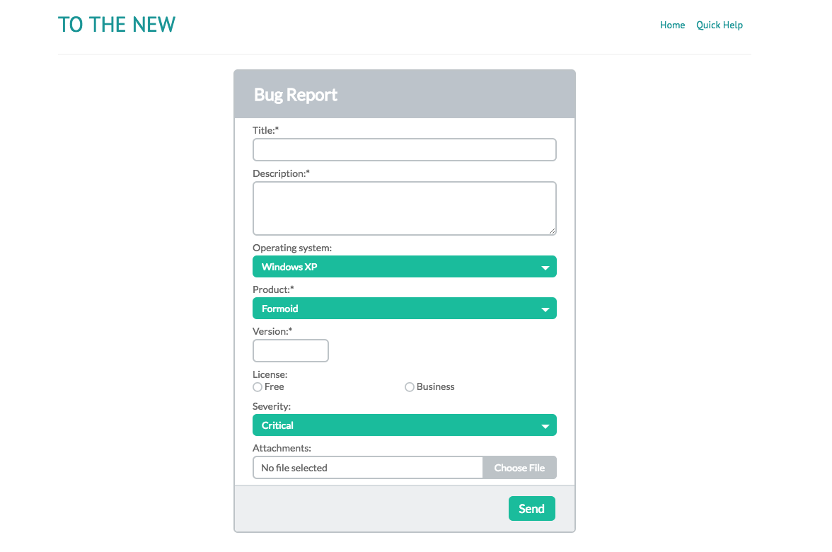

Ans:

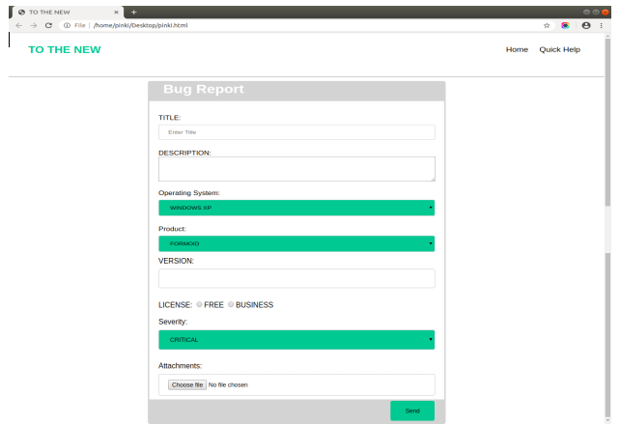

12. Create HTML for form.png
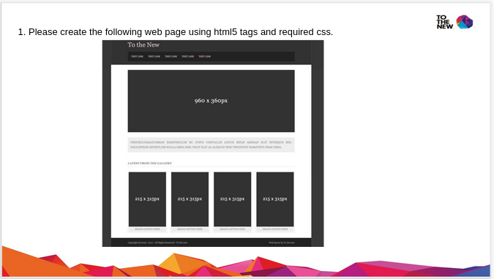

ANS:

