Table of Contents
Oracle ELT Pipeline — Engineering Standard & Runbook 1
Purpose, scope and principles 1
Pipeline flow 2
Repository structure 3
Naming conventions 4
Ingestion standard 5
dbt image lifecycle 6
Transformation and publishing 6
Data quality standard 7
Freshness and refresh banner 8
Tableau Server extract refresh 9
Failure alerting 10
Standards enforcement 12
Change and release process 13
Operational runbook 14
Open items 15

Oracle ELT Pipeline — Engineering Standard & Runbook
Engineering Standard & Runbook — version 1.0, 23 September 2026

Purpose, scope and principles
This standard defines how the Oracle ELT pipeline is built, run and maintained. One Composer DAG extracts 15 Oracle views into the BigQuery raw zone, then runs a dbt image to build staging and curated, in sequence.
In scope: ingestion, the dbt image, the orchestration DAG, data quality, freshness and the Tableau refresh banner. Other sources follow the same pattern but are documented separately.
Design principles:
- All-or-nothing. If any of the 15 views fails to ingest, the pipeline alerts and dbt does not run. Consumers never see partial data.
- Write-audit-publish. Curated data is built and tested in a hidden copy, and published only when every test passes.
- Config over code. Adding or changing a view is a configuration change, not a DAG change.
- Pinned artefacts. The dbt image is referenced by digest and the ingestion package by version. Nothing floats.
- Enforced, not reviewed. Standards are checked automatically in CI and at runtime.
- Evidence by default. Every run, quality check and refresh is written to control tables in BigQuery.

Pipeline flow
The DAG runs in four stages: ingest, gate, transform and publish. Each stage starts only if the previous one fully succeeded.
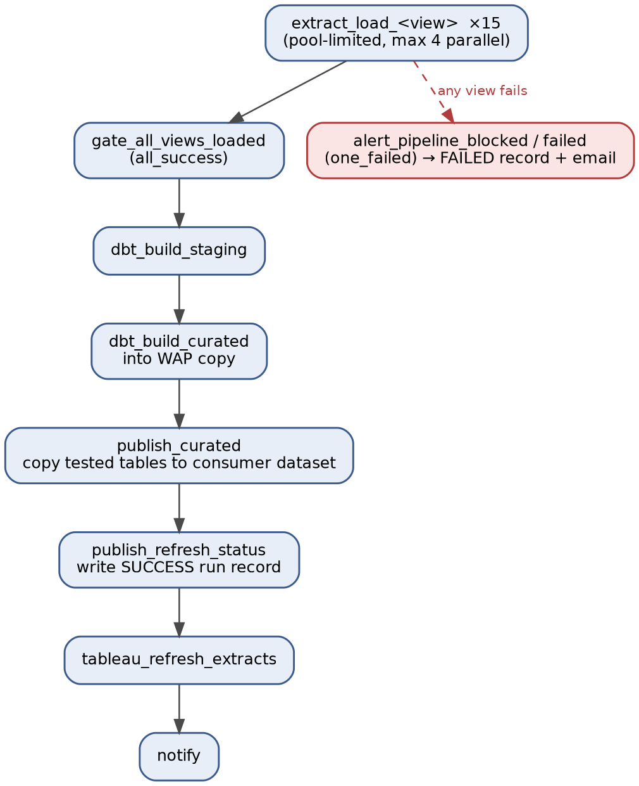
Figure 1: Pipeline DAG flow — sequential stages with the all-or-nothing failure path.
The dotted line is the failure path: any failed extract blocks the gate, and alert_pipeline_blocked sends one summary alert and writes a FAILED run record.
Task | Trigger rule | Purpose
extract_load_<view> | default | Extract one view, validate, load to raw
gate_all_views_loaded | all_success | Block dbt unless all 15 views loaded
alert_pipeline_blocked | one_failed | Summary alert, FAILED run record
dbt_build_staging | all_success | Build and test staging models
dbt_build_curated | all_success | Build and test curated in the WAP copy
publish_curated | all_success | Copy tested tables to the consumer dataset
publish_refresh_status | all_success | Write SUCCESS run record
tableau_refresh_extracts | all_success | Refresh registered Tableau extracts
notify | all_done | Run summary to the support channel
DAG settings: catchup=False, max_active_runs=1, retries=2 with exponential backoff, and an on_failure_callback on every task. The Airflow run_id is passed to ingestion logs and dbt --vars as the correlation_id.

Repository structure
Code is split across four repositories, one per service. Each has its own CI pipeline and owners.
edp-composer/ # DAGs only
├── dags/
│ ├── edp_oracle_<sys>_elt_daily.py
│ └── edp_platform_freshness_monitor_hourly.py
├── config/
│ ├── dev/
│ │ ├── oracle_<sys>_views.yaml
│ │ └── tableau_extracts.yaml
│ ├── uat/
│ └── prd/
├── plugins/airflow_local_settings.py # cluster policies
├── tests/ # DAG integrity tests
├── docs/standards.md
└── .github/workflows/
edp-ingestion/ # Python package, published to the private package repository
├── src/edp_ingestion/
│ ├── extract/oracle.py
│ ├── load/bigquery.py
│ ├── quality/checks.py
│ ├── control/watermark.py
│ └── tableau/refresh.py
├── tests/
└── pyproject.toml
edp-dbt-<sys>/ # dbt project and image
├── models/
│ ├── staging/<sys>/
│ │ ├── _<sys>__sources.yml
│ │ └── stg_<sys>__<entity>.sql
│ └── curated/<subject>/
│ ├── dim_<entity>.sql
│ └── fct_<event>.sql
├── macros/ tests/ seeds/
├── profiles/profiles.yml # env-var driven, no secrets
├── dbt_project.yml
├── Dockerfile
└── .github/workflows/
edp-bigquery/ # Terraform: datasets, IAM, control tables, views
The environment is chosen by the GCP project and the config/<env>/ folder, never by the DAG code. The same DAG file is promoted unchanged from dev to UAT to prod.

Naming conventions
All names are lowercase with underscores, except GCP projects and buckets, which use hyphens. Environment never appears in a DAG ID or model name.
Object | Convention | Example
DAG ID (= file name) | <programme>_<source>_<sys>_<purpose>_<frequency> | edp_oracle_<sys>_elt_daily
Extract task | extract_load_<view> | extract_load_v_trades
Gate / dbt / publish tasks | gate_<check>, dbt_build_<zone>, publish_<target> | dbt_build_curated
GCP project | <org>-edp-<env> | <org>-edp-prd
Raw dataset / table | raw_<source>_<sys> / source view name | raw_oracle_<sys>.v_trades
Staging dataset / model | stg_<sys> / stg_<sys>__<entity> | stg_<sys>__trades
Curated WAP dataset | cur_<subject>__wap | cur_markets__wap
Curated dataset / model | cur_<subject> / dim_<entity>, fct_<event> | cur_markets.fct_trade
Control dataset | ctl_edp | ctl_edp.pipeline_run_log
Archive path | gs://<org>-edp-<env>-archive/oracle/<sys>/<view>/load_date=YYYY-MM-DD/ | —
dbt artefacts path | gs://<org>-edp-<env>-artifacts/dbt/<dag_id>/<run_id>/ | —
dbt image | <region>-docker.pkg.dev/<project>/edp-dbt/dbt-<sys>:<semver>-<sha> | dbt-<sys>:1.4.0-a1b2c3d
Airflow Variable | edp_<sys>_<purpose> | edp_<sys>_dbt_image_digest
Airflow pool | pool_<target>_<sys> | pool_oracle_<sys>, pool_tableau
The double underscore in staging model names separates the source system from the entity, following the dbt convention.

Ingestion standard
Each view is extracted and loaded by a Composer worker task that calls the versioned edp-ingestion package. The DAG file holds no extraction logic.
Configuration. Every view is declared in config/<env>/oracle_<sys>_views.yaml:
- view: v_trades
target_table: raw_oracle_<sys>.v_trades
load_type: incremental # or full
watermark_column: last_updated_date
primary_key: [trade_id]
partition_field: last_updated_date
expected_schema:
- {name: trade_id, type: NUMERIC}
- {name: last_updated_date, type: TIMESTAMP}
Loading rules:
- Load into a temporary table, then MERGE (incremental) or overwrite the partition (full). Reruns never duplicate rows.
- Update the watermark in ctl_edp.ingestion_watermark only after the load succeeds.
- Write a byte-faithful Parquet copy to the archive path before loading to BigQuery.
- Credentials come from the enterprise secrets vault at task run time. Nothing is stored in Composer.
- Extract tasks run in pool_oracle_<sys> (default 4 slots, so at most 4 views extract in parallel) to protect the source. Set the pool to 1 for strict view-by-view execution.
Failure behaviour. All 15 extract tasks always attempt to run, so a rerun only repeats the failed views. Each retries twice with backoff before it is marked failed. Any failed view blocks the gate.

dbt image lifecycle
The dbt project is packaged as a container image, built once in CI and promoted unchanged across environments. It runs on GKE through KubernetesPodOperator.
- Build. Pin the base image, Python and dbt-bigquery versions. Run dbt deps at build time so packages are baked into the image.
- Tag. Tag each image <semver>-<git sha>, push it to Artifact Registry and sign it for Binary Authorization.
- Reference. The DAG reads the image digest from the Airflow Variable edp_<sys>_dbt_image_digest. Never use :latest.
- Promote. Moving to UAT or prod means updating that Variable to the same digest. Images are never rebuilt for promotion.
- Refresh. Rebuild monthly, or when a security vulnerability is reported, even with no code change.
- Profiles. profiles.yml reads project, dataset and location from environment variables. No credentials are in the image; the pod uses Workload Identity.

Transformation and publishing
Curated tables are built and tested in a hidden copy, then published only if every test passes. Consumers never see untested data.
- dbt_build_staging runs dbt build --select staging. Tests run as each model is built; any error test stops the run.
- dbt_build_curated runs dbt build --select curated with the target dataset set to cur_<subject>__wap.
- publish_curated copies each tested table from the WAP dataset to cur_<subject>. Table copy within BigQuery is fast and cheap.
- If any curated test fails, publishing is skipped and cur_<subject> keeps the last good version.
Staging and curated are separate tasks so a failed curated run can be restarted without rebuilding staging. After every run, dbt’s run_results.json and manifest.json are copied to the artefacts path in GCS.

Data quality standard
Every zone has mandatory checks. A check at error severity stops the pipeline; warn alerts and continues.
Zone | Check | Where it runs | Severity
Raw | Source row count equals loaded row count (same filter) | Ingestion package | error
Raw | Dropped column or changed type vs expected_schema | Ingestion package | error
Raw | New column not in expected_schema | Ingestion package | warn
Raw | Watermark moves forward, never backwards | Ingestion package | error
Raw | No nulls in key or watermark columns | Ingestion package | error
Raw | No duplicate primary keys in the batch | Ingestion package | error
Raw | Source freshness (warn_after, error_after) | dbt source freshness | warn / error
Staging | unique and not_null on primary keys | dbt test | error
Staging | accepted_values, relationships | dbt test | error
Staging | Enforced model contracts (names and types) | dbt contract | error
Curated | Totals reconcile to staging | dbt test | error
Curated | Row count change vs previous run beyond ±20% | dbt test | warn
Curated | Row count change vs previous run beyond ±50% | dbt test | error
Curated | Business rules agreed with the data owner | dbt test | error
Curated | Enforced model contracts on consumer-facing models | dbt contract | error
The schema check matters because a dropped source column does not break a BigQuery load. The column just stops being populated, with no error.
Evidence. Every check result is written to ctl_edp.dq_check_results with the correlation_id. dbt results are loaded from run_results.json after each run. The open-source Elementary package can do this and adds reports, if adopted.
Ownership. Each of the 15 views has a named data owner who signs off its thresholds and business rules.

Freshness and refresh banner
Freshness is checked at every layer, and every Tableau dashboard shows how current its data is.
Layer | Measure | Alert when
Source | Latest last_updated_date in Oracle | Source itself is behind (upstream issue)
Raw | dbt source freshness on load time | warn_after / error_after exceeded
Published | data_as_of_ts in the run log | Not published by the agreed deadline (e.g. 07:00)
Serving | Tableau banner and extract refresh log | Extract refresh fails or is late
Control table. ctl_edp.pipeline_run_log, partitioned by run date and clustered by dag_id:
dag_id STRING, run_id STRING, status STRING, -- SUCCESS | FAILED
run_start_ts TIMESTAMP, run_end_ts TIMESTAMP,
data_as_of_ts TIMESTAMP, -- max watermark loaded
failed_tasks ARRAY<STRING>, dbt_image_digest STRING
run_end_ts is when the pipeline finished; data_as_of_ts is how current the data is. The banner shows data_as_of_ts.
Status view (authorised view for Tableau):
CREATE OR REPLACE VIEW ctl_edp.v_refresh_status AS
SELECT
dag_id,
MAX(IF(status = 'SUCCESS', data_as_of_ts, NULL)) AS data_as_of_ts,
MAX(IF(status = 'SUCCESS', run_end_ts, NULL)) AS last_success_ts,
ARRAY_AGG(status ORDER BY run_end_ts DESC LIMIT 1)[OFFSET(0)] AS latest_status
FROM ctl_edp.pipeline_run_log
WHERE dag_id = 'edp_oracle_<sys>_elt_daily'
GROUP BY dag_id;
Tableau banner. Publish the view as a certified shared data source and place a one-row banner sheet at the top of every dashboard.
IF [latest_status] = "FAILED" THEN
"Latest refresh failed. Showing data as of " + STR([data_as_of_ts])
ELSEIF DATEDIFF('hour', [last_success_ts], NOW()) > 26 THEN
"Data may be out of date. Last refreshed " + STR([last_success_ts])
ELSE
"Data as of " + STR([data_as_of_ts])
END
- Colour the banner by state: neutral (OK), amber (stale), red (failed).
- Staleness is calculated in Tableau with NOW(), not in BigQuery, so it stays correct inside extracts. Convert UTC timestamps to the server’s timezone before comparing.
- Live dashboards read the view live.
- Extract dashboards include the view in the same extract as their charts, so the banner and data always change together.
Independent monitor. edp_platform_freshness_monitor_hourly checks v_refresh_status against the deadline. It catches a main DAG that never started, which that DAG cannot report itself.

Tableau Server extract refresh
Extract dashboards are refreshed by the pipeline, not by Tableau schedules. This stops an extract from capturing half-loaded data.
How it works:
- tableau_refresh_extracts reads config/<env>/tableau_extracts.yaml, the register of extract data sources this DAG feeds. Live dashboards are not registered.
- It triggers each refresh through the Tableau REST API (tableauserverclient, from the private package repository), with at most 3 at a time via pool_tableau.
- It polls each job with sensors in mode="reschedule", so waiting does not hold a worker slot. Each refresh has a timeout.
- Each refresh is logged to ctl_edp.tableau_extract_refresh_log (datasource ID, job ID, status, timestamps).
- A failed extract refresh alerts but does not fail the pipeline run, because the BigQuery data is correct.
- Tableau’s own time-based schedules for these extracts are removed.
Prerequisites (Tableau Server on-premises):
Item | Owner | Detail
Firewall | Network team | HTTPS 443 from the Composer worker subnet to Tableau Server over the private hybrid link, both directions of the firewall
DNS | Network team | Cloud DNS forwarding zone to on-premises DNS; needs review against the current DNS zone design
TLS | Platform team | Internal CA certificate trusted by Composer via REQUESTS_CA_BUNDLE; verification stays on
Service account | Tableau admins | Dedicated account, refresh rights on the relevant projects only
Access token | Tableau admins | Personal Access Token in the secrets vault, used by this DAG only; rotation before maximum lifetime
API version | Engineering | Pinned in DAG config
BigQuery access | Engineering | Tableau Server’s BigQuery account can read ctl_edp.v_refresh_status (Terraform)

Failure alerting
Every failure produces two things: a detailed alert to the people who fix it, and a run record that turns the Tableau banner red. Consumers keep the last good data because publishing is skipped. Follow these steps in order.
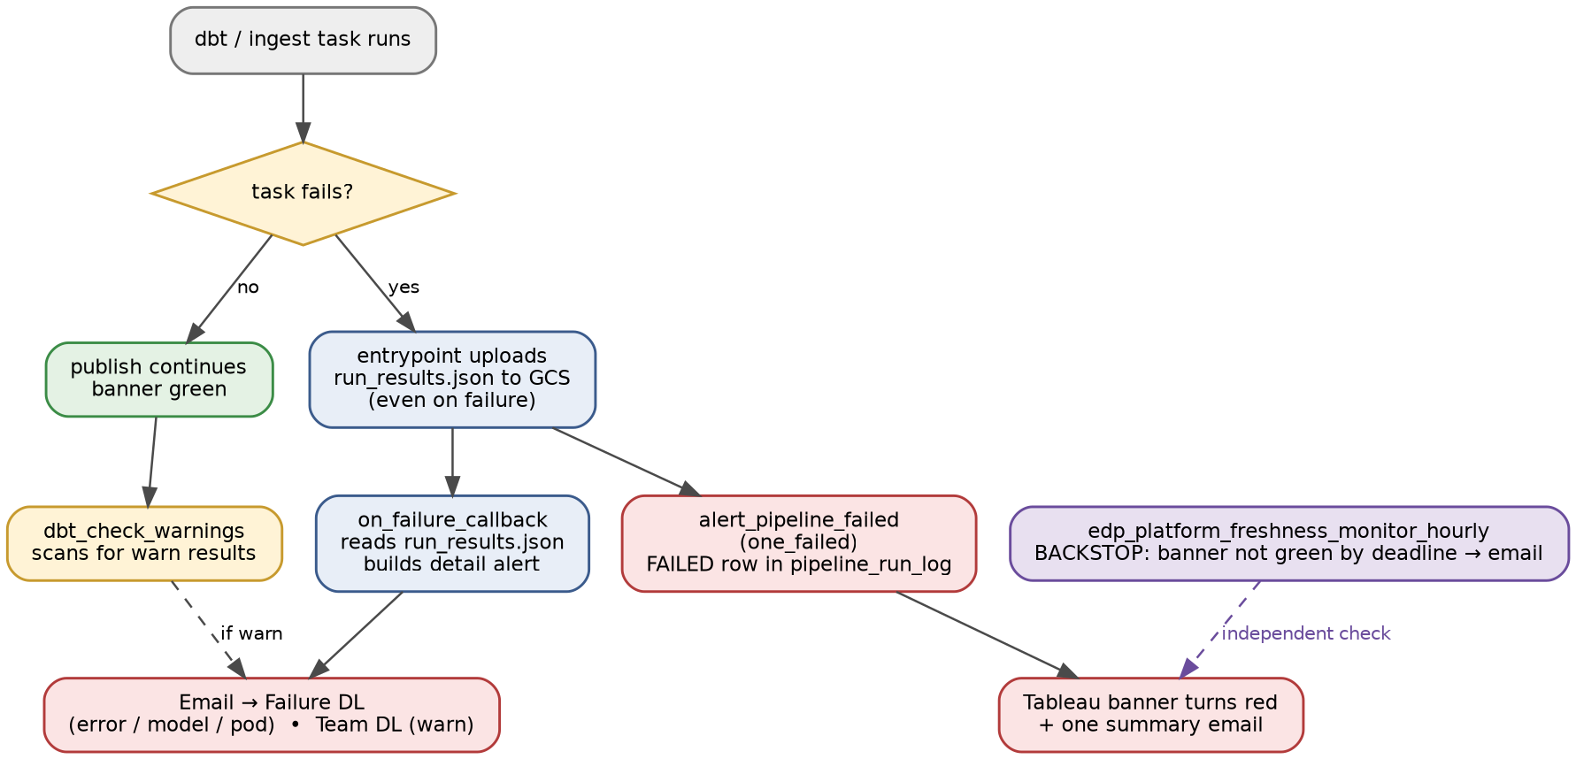
Figure 2: Failure alerting flow — detail alert, run-level record, warn path, and the independent backstop.
Step 1 — Make dbt emit machine-readable results. dbt writes run_results.json (per-node status, error message, failing row count) and manifest.json on every run. Confirm these are produced and not disabled.
Step 2 — Upload results even on failure. The image entrypoint must upload the artefacts before it exits, or a failed run leaves nothing to alert on:
dbt build --select "$SELECTOR" --vars "{correlation_id: $RUN_ID}"
rc=$?
gsutil cp target/run_results.json target/manifest.json \
"gs://<org>-edp-<env>-artifacts/dbt/$DAG_ID/$RUN_ID/"
exit $rc
The non-zero exit from dbt build is what makes KubernetesPodOperator mark the task failed, so preserve rc and exit with it.
Step 3 — Classify the severity in dbt, not in code. Set test severity in the dbt project so routing is declarative and reviewed:
- Critical tests (primary keys, reconciliation, contracts): severity: error — fails the build, stops the pipeline.
- Advisory tests (volume drift ±20%): severity: warn — recorded and alerted, run continues.
Step 4 — Task-level alert (the detail). Attach one shared on_failure_callback to every dbt task. It reads run_results.json from GCS and sends an alert containing: the zone, DAG, run ID and correlation_id; each failed model or test with dbt’s message and failing row count; links to the Airflow log and the artefacts folder; and a line stating that curated was not published. If the pod failed before dbt ran (image pull, out of memory), no results file exists — the callback falls back to the pod exit reason and a log link.
Step 5 — Warn-level alert. Add a dbt_check_warnings task after publish_curated. It scans run_results.json for warn results and sends a low-priority alert if any are present. Warnings never block publishing, so they need their own path or they are silently lost.
Step 6 — Run-level record (the banner). A single alert_pipeline_failed task, downstream of every task with trigger_rule=one_failed, writes a FAILED row to ctl_edp.pipeline_run_log with failed_tasks, and sends one summary message. This is what drives the Tableau banner and it covers ingestion and dbt failures in one place.
Step 7 — Route by severity, by email. Alerts are sent as email through the enterprise SMTP relay configured as an Airflow connection, never from personal accounts or ad-hoc webhooks. Send to role-based distribution lists, not individuals, so alerting survives staff changes. Use a fixed subject convention so recipients can filter and rule on it: [EDP][<ENV>][<STATUS>] <dag_id> — <task>, e.g. [EDP][PRD][FAILED] edp_oracle_<sys>_elt_daily — dbt_build_curated. Email has no built-in escalation, which is why the Step 9 backstop is mandatory, not optional.
Outcome | Priority | Email destination
error test or model error | High | Failure distribution list (e.g. <failure-dl>), monitored and actioned same day
Pod or infrastructure failure | High | Failure distribution list, with pod log link
warn test failure | Low | Team distribution list (e.g. <team-dl>)
Whole run blocked | High | Failure distribution list, one summary via alert_pipeline_failed
Step 8 — Set retries deliberately. One retry on dbt tasks, to absorb pod start-up problems. A failing data test will fail again, so extra retries only delay the alert.
Step 9 — Guarantee the alert cannot be missed. The on_failure_callback itself can fail (channel outage). The independent edp_platform_freshness_monitor_hourly DAG is the backstop: if the banner has not gone green by the deadline, it alerts regardless of whether the main DAG’s callbacks fired.
Step 10 — Verify before go-live. Prove each path in dev: force a model error, force an error test, force a warn test, and kill a pod. Confirm each produces the expected alert, the correct run record, and a red banner where applicable. Add these as a recurring pre-release check.

Standards enforcement
Standards in this document are enforced by automated checks. A pull request that breaks one cannot merge.
Repository | Check | Tool
edp-composer | DAG ID pattern, file name = DAG ID, owner, tags | pytest DAG integrity tests
edp-composer | retries >= 2, catchup=False, max_active_runs=1, failure callback | pytest DAG integrity tests
edp-composer | dbt image referenced by digest, never a tag | pytest DAG integrity tests
edp-composer | Same rules at runtime, so non-compliant DAGs cannot load | Airflow cluster policies (airflow_local_settings.py)
edp-ingestion | Unit tests, type checks, linting | pytest, mypy, ruff
edp-dbt-<sys> | Naming, layering, test and documentation coverage | dbt-project-evaluator
edp-dbt-<sys> | Primary-key test and description on every model | dbt-checkpoint pre-commit hooks
edp-dbt-<sys> | SQL style; dbt parse and compile succeed | sqlfluff, dbt
edp-dbt-<sys> | Image vulnerability scan | CI image scan
edp-bigquery | Dataset naming, CMEK, labels | Terraform validation, Conftest policies
All | Review required before merge to main | Branch protection, CODEOWNERS
Confirm that the Composer version in use supports cluster policies. If not, the pytest checks are the only enforcement.
Exceptions are recorded as a decision record (ADR) in docs/standards.md, each with an owner and an expiry date.

Change and release process
Every change goes through a pull request, automated checks and a promotion path of dev, UAT, then prod with an approval gate.
- Open a pull request. CI runs every check in the enforcement table.
- On merge, GitHub Actions deploys to dev: DAGs and config sync to the Composer bucket, the ingestion package is published, and the dbt image is built and its digest set in dev.
- Run the DAG in dev and review the data quality results.
- Promote to UAT with the same package version and image digest.
- Promote to prod after approval. Manual uploads to the Composer bucket are not permitted.
Changes that span repositories. When a new raw column feeds dbt, release ingestion first and dbt second. dbt source freshness and contracts surface any mismatch.
Version upgrades. Upgrade dbt, Airflow providers and the base image on a planned schedule, through the same path.

Operational runbook
These procedures cover the common support situations. Each starts from the alert or the control tables, not from guesswork.
Situation | Procedure
One or more views failed | Check dq_check_results and task logs for the cause. Fix, then clear only the failed extract_load_<view> tasks. Gate and dbt resume automatically.
dbt test failed | Find the failing test in run_results.json in the artefacts path. Consumers still see the last good data. Fix and clear dbt_build_<zone>.
Schema drift alert | Confirm the change with the source owner. Update expected_schema and the dbt models together, then rerun.
Source is late | Source freshness alert fires. Contact the source owner; do not rerun until the source has caught up.
Extract refresh failed | Check tableau_extract_refresh_log. Retry from the DAG task, not from Tableau, so the log stays complete.
Backfill a date range | Trigger the DAG with the required logical dates. Loads are idempotent, so reruns are safe.
Add a new view | Add it to the views config with its schema and owner, add staging models and tests, and release through the normal path.
dbt version upgrade | Update the Dockerfile, run the full test suite in dev, then promote the new digest.
Credential rotation | Rotate in the secrets vault. Tasks fetch credentials at run time, so no Composer change is needed.
Ongoing assurance:
- A data quality and freshness dashboard over the ctl_edp tables: pass rates, failures by view, freshness against the deadline.
- Monthly review of warnings and thresholds with data owners.
- Quarterly review of this standard and the exceptions register.

Open items
These must be resolved before the pipeline goes to production.
- ☐ Confirm secrets vault gateway is reachable from the Composer VPC, and the authentication method.
- ☐ Confirm the Oracle wallet format and how it is seeded into the vault.
- ☐ Agree the publish deadline and staleness threshold with consumers.
- ☐ Name a data owner for each of the 15 views and sign off thresholds.
- ☐ Raise firewall and DNS changes for Composer to Tableau Server.
- ☐ Confirm Personal Access Tokens are enabled on Tableau Server and their expiry settings.
- ☐ Confirm Composer version support for cluster policies.
- ☐ Build the register of Tableau extract data sources and remove their time-based schedules.

