**Kyngacell Online Community: An Assessment of its Overall Performance**

**GROUP 6**

11/24/2019

BAX 401 Business Analytics

# Zunfeng Huang

# Mitesh Jain

# John Elmar Loretizo

# Mayank Mani

# Shalini Mishra

Prakriti Rastogi

**Executive Summary**

KyngaCell, one of the leaders in mobile gaming, introduced a new online community feature for their latest game, *Nicht-Soporific*. To test the effectiveness and impact of the online community, we sought to determine and quantify if it improved user revenue and retention within the game along with an increase in customer lifetime value (CLV). The data provided details of individuals who play the game, who participate in the community, spending by gamers one month prior and subsequent to the release of the online community, customer age, and acquisition method (Campaign/Organic) for each user.

Upon analyzing the data, we concluded that:

* *The online community resulted in increased revenue.* The mean revenue for users who joined the online community increased by $29 as compared to the ones who did not join.
* *The online community did not lead to increased retention.* The retention rate for users who joined the community was less than that for those who did not join.
* *The online community feature had a positive effect on CLV.* The average CLV for users who joined the program increased by $9 in contrast to the ones who did not.
* *The effect of the customer acquisition method on CLV is inconclusive.* There was no significant difference in the CLV between the users who joined the program organically and those who joined as a result of the campaign.

In the end, the success of a new feature does not depend on how well it is marketed but on how well it addresses a user’s needs. Even though findings suggest a review of marketing & customer retention strategies, a more comprehensive approach to collecting data pertaining to acquisition cost and user demographics is required to arrive at more meaningful conclusions.

## Introduction

KyngaCell, a mobile gaming company, introduced a new online community feature that enables a player to connect and interact within and outside the game, *Nicht-Soporific*. The team believes that the online community feature had positive impacts on revenue and retention. This report looks into how the launch of this community feature has affected customer engagement in the game. Our goal is to quantify this impact as well as to enable upper management to take necessary actions

## 

## Problem Formulation

To assess if Kygnacell’s launch of the online community channel was a success, we will be looking into its general effect in terms of revenue for the community. We aim to specifically answer the following questions:

* Has the online community increased user revenue?
* Has the online community led to increased user retention?
* Has the online community led to an increase in CLV?[1]

To answer these questions, we will be using statistical tests that can assess whether their exist differences between those who joined and did not join, and if the differences are significant enough for a conclusive recommendation. User retention will be derived from a logistic regression model that predicts whether a customer will churn three months after the online community was introduced which will then be used to arrive at a value for CLV.

The CLV[2] formula relies on the assumption that both discount rate and acquisition cost is 0 and margin 50% of the customer spend. The discount rate assumption comes from the fact that there was no timeline given as to when the online community was launched. Thus, no reference for the computation of the relevant discount rate. The acquisition cost variable wasn’t provided in the dataset given.

We will also be assessing its direct quantitative effect, discuss any underlying assumption we have in answering questions, and any limitations that accompany it. Lastly, we will also be looking at whether the type of customer acquisition affects the metrics described above.

## 

## Data Description

We have been provided with three datasets for 199 customers of the game *Nicht Saporific* who chose to join the community and who didn’t.

* Customer spending before and after the launch of the online community.
* Customer age, their 3 months spend before churn and churn flag for these customers
* Customer acquisition channel, i.e. organic or promotion. We don’t have any visibility on the acquisition costs, user frequency or segment type which could have reduced heterogeneity in our data

## Model Results

To gauge the effect of the introduction of the online community on revenue, we carried out a “Diff-in-Diff” analysis[3]. For the users who joined the community, the estimated user revenue would have been $119.01 had the community not been launched. The online community feature resulted in the user revenue for the same group to be $148.02, an increase of $29 which can be attributed to the introduction of the community feature.

We computed the retention rate using a logistic regression model trained on the given data. With 95% confidence level, we can affirm that there is no significant increase in the retention of people who joined against those who did not. With the launch of this feature, the users tend to spend more, but it doesn’t improve retention.

CLV for users who joined the community was found to be higher than those who didn’t by approximately $9. Statistically, there is overwhelming evidence to support the claim that, on average, users who joined have higher CLV than those who didn’t.

To dig deeper, we compared the users who joined organically and those who joined through promotions assuming that there is no acquisition cost for either. There is not much difference between the CLV of those who came organically ($58.53) and those who joined via campaigns ($57.82). The retention rate for users that joined organically was 41.03% while those who joined via campaigns was 40.2%. Since acquisition cost in realistic scenarios will always be greater than 0, CLV for non-organic customers will be less than CLV for organic customers[4]

**Recommendations**

* *Review of marketing strategies:* Our results suggest that although the organization is spending more on marketing, users do not stay loyal for long. Hence, there is a need to review retention strategies by identifying and addressing user pain points.
* *Customization of community features:* Providing customized features that meet different expectations of various customer segments can be a step towards increased retention.
* *Enriching the dataset*: To provide more accurate results and avoid overestimation of CLV, additional data on acquisition costs is required.
* *Tackle data limitations*: Components of CLV have been computed using limited variables. More information on costs, customer segments and their service and usage patterns will give us a more accurate estimation of CLV. In the present scenario, aggregation bias might be seeping in which can be dealt with by collecting and using more customer information.

**Conclusion**

Adoption of a new feature by customers does not depend solely on marketing strategies. A company has to invest time and resources on eliminating issues faced by new and existing customers alike in order to facilitate higher customer engagement. Repeated modifications and improvements, addressing customer complaints, personalization, etc. play an important role in determining customer satisfaction which in turn increases retention and drives revenue.

## 

## References

1. Hubspot: Lower Churn through greater CHI, by F. Asis Martinez-Jerez; Thomas Steenburgh; Jill Avery; Lisa Brem (110052-PDF-ENG)
2. Predicting Customer Churn at QWE Inc., by Anton Ovchinnikov (UV6694-PDF-ENG)

## Appendix

## Table 1.1 Difference-in-Difference Table

|  |  |  |  |  |  |
| --- | --- | --- | --- | --- | --- |
|  |  | Period |  |  |  |
|  |  | Control | Treatment | Change / Diff | Diff-in-diff |
| Group | Joined | 88.1341 | 148.0244 | 59.8903 |  |
|  | Did Not Join | 70.3761 | 101.2479 | 30.8718 | 29.0185 |

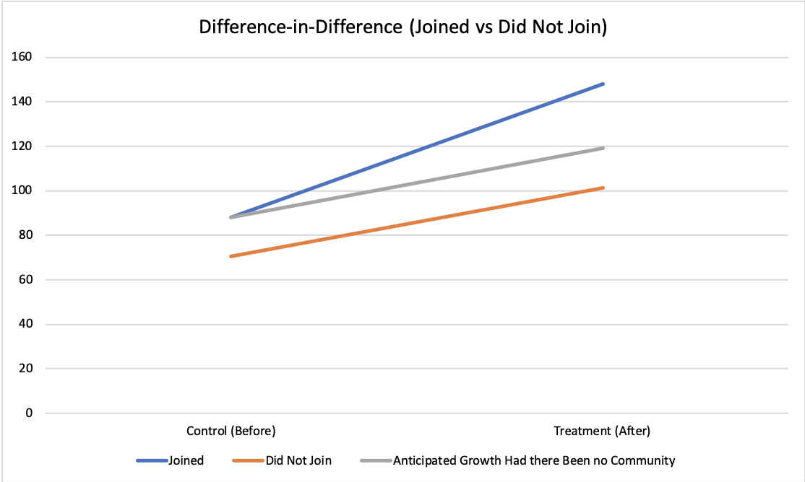

Question 2:

Comparison of Two Means with Normality Assumption

$H_{0}:μ_{joined}≤μ_{did not join}$

$H_{1}:μ_{joined}>μ_{did not join}$

Welch Two Sample t-Test

$t=-2.983 df = 178.41 p=0.9984$

Test for Q3:

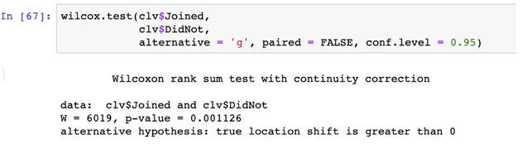

Comparison of customer lifetime value difference, assume normality:

$H_{0}:μ_{joined} =μ_{did not join}$

$H_{1}:μ_{joined }≠ μ_{did not join}$

|  |  |  |  |  |
| --- | --- | --- | --- | --- |
| Coefficients | Estimate | Std. Error | z value | Pr(>|z|) |
| (Intercept) | 0.474797 | 0.523983 | 0.906 | 0.36487 |
| Joined | 0.91654 | 0.355287 | 2.580 | 0.00988 ** |
| AgeWithFirm | -0.055849 | 0.071598 | -0.780 | 0.43537 |
| AveSpend | -0.002819 | 0.005655 | -0.498 | 0.61815 |

Significance Level: ** 0.01

Formula for CLV

$CLV=\sum_{t=0}^{T}{}\frac{mr^{t}}{{(1+i)}^{t}}-AC$

Where:

AC: acquisition cost

m: margin

r: retention rate

i : cash discount rate

t: time period

If T = 1 then the customer lifetime is within 1 three month window

If T = 2 then the customer lifetime is within 2 three month windows

Q4

|  |  |  |  |
| --- | --- | --- | --- |
|  | Revenue After Launch | Retention Rate | CLV |
| Did Not Join | 101.2479 | 0.4872 | 54.243 |
| Joined | 148.0244 | 0.2927 | 63.995 |

Q5

|  |  |  |
| --- | --- | --- |
| 0.4015343 | Non Organic | 57.816331 |
| 0.4103623 | Organic | 58.530718 |

1. CLV-Customer Lifetime Value
2. CLV-Customer Lifetime Value
3. See Appendix for diff-in-diff analysis, statistical tests
4. CLV -Customer Lifetime Value