> # CS544 HW3
> # Date: Jan 27-31, 2026
> # R Version: 4.5.2
>
> # Part 1 ======================================================================
> # init dataset
> forbes <- read.csv("https://people.bu.edu/kalathur/datasets/forbes_10_14_2025.csv")
> head(forbes)
name rank gender worth country category source
1 Elon Musk 1 M 477956 United States Technology Tesla, SpaceX
2 Larry Ellison 2 M 356345 United States Technology Oracle
3 Mark Zuckerberg 3 M 243081 United States Technology Facebook
4 Jeff Bezos 4 M 228925 United States Technology Amazon
5 Larry Page 5 M 202424 United States Technology Google
6 Sergey Brin 6 M 187836 United States Technology Google

> # a) barplot ------------------------------------------------------------------
>
> # find count of billionaires by country
> bln_by_country <- table(forbes$country)
> head(bln_by_country)

Albania Algeria Argentina Armenia Australia Austria
1 1 4 1 48 9
>
> # find rich countries
> rich_countries <- bln_by_country[bln_by_country >= 10]
> head(rich_countries)

Australia Belgium Brazil Canada China Cyprus
48 17 62 77 493 10
>
> # sort by count descending
> sorted_countries <- sort(rich_countries, decreasing = TRUE)
>
> # find a suitable y limit
> (y_max_1a <- ceiling(max(sorted_countries) / 100) * 100)
[1] 1000
>
> # store default margin & modify margin
> (default_mar <- par()$mar)
[1] 5.1 4.1 4.1 2.1
> par(mar = c(9,7,4,4))
>
> # barplot
> barplot(
+ sorted_countries,
+ ylim = c(0, y_max_1a), # avoid hard coding
+ las = 2, # par: labels perpendicular to axis
+ col = "rosybrown", # define color
+ ylab = "Count of Billionaires", # y label
+ main = "Barplot for Count of Billionaires in Rich Countries"
+ )
>
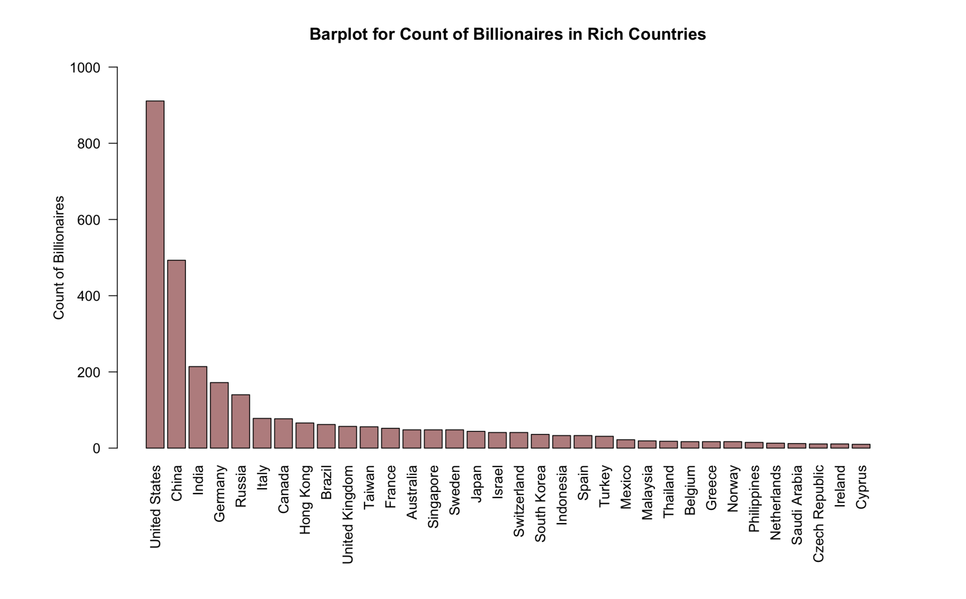
Figure 1 Barplot for Count of Billionaires in Rich Countries
>
> # restore defualt margin
> par(mar = default_mar)
>
>
>
> # b) distribution of f/m ------------------------------------------------------
>
> # find counts of billionaires by gender
> (table_gender <- table(forbes$gender))

F M
408 2700
>
> # change column names
> (slice_labels <- c("Female", "Male"))
[1] "Female" "Male"
>
> # find percentages
> (pct_gender <- round(table_gender/sum(table_gender), digits = 2)*100)

F M
13 87
>
> # join labels
> (slice_labels <- paste0(slice_labels, " ", pct_gender, "%"))
[1] "Female 13%" "Male 87%"
>
> # pie chart
> pie(table_gender,
+ labels = slice_labels,
+ col = c("wheat", "lightblue"), # color
+ main = "Pie Chart of Gender Distribution in Forbes Dataset" # title
+ )
>
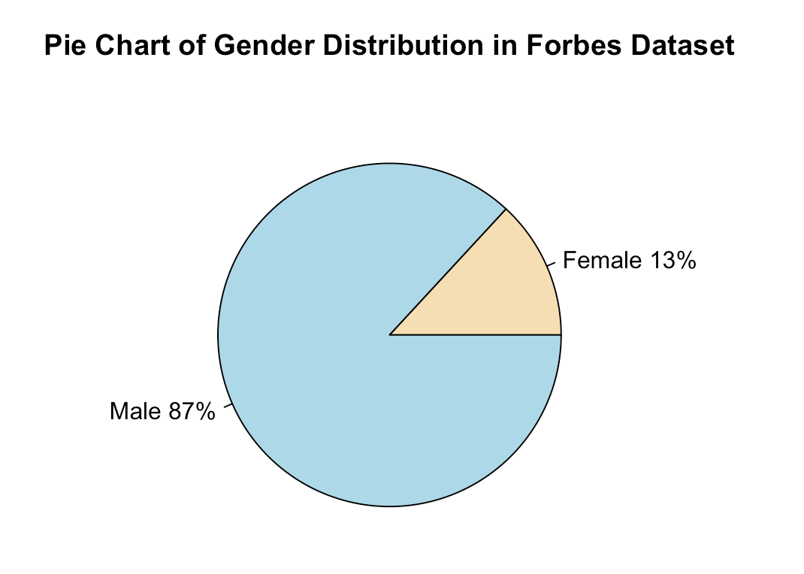
Figure 2 Pie Chart of Gender Distribution in Forbes Dataset

> # c) f/m across top 5 categories (bivariate) ----------------------------------
>
> # find counts of unique categories
> table_category <- table(forbes$category)
>
> # sort by count descending
> (table_category <- sort(table_category, decreasing = TRUE))

Finance & Investments Technology Manufacturing
472 423 371
Fashion & Retail Healthcare Food & Beverage
296 233 223
Diversified Real Estate Media & Entertainment
216 209 119
Energy Metals & Mining Automotive
107 82 76
Logistics Service Construction & Engineering
61 56 55
Sports Telecom Gambling & Casinos
51 33 21
>
> # find top 5 categories
> (top5cats <- names(table_category[1:5]))
[1] "Finance & Investments" "Technology" "Manufacturing"
[4] "Fashion & Retail" "Healthcare"
>
> # find subset of rows in top 5 categories
> top5cats_data <- subset(forbes, category %in% top5cats)
> head(top5cats_data)
name rank gender worth country category source
1 Elon Musk 1 M 477956 United States Technology Tesla, SpaceX
2 Larry Ellison 2 M 356345 United States Technology Oracle
3 Mark Zuckerberg 3 M 243081 United States Technology Facebook
4 Jeff Bezos 4 M 228925 United States Technology Amazon
5 Larry Page 5 M 202424 United States Technology Google
6 Sergey Brin 6 M 187836 United States Technology Google
>
> # create bivariate table gender*categories
> (table_gender_cats <- table(top5cats_data$gender, top5cats_data$category))

Fashion & Retail Finance & Investments Healthcare Manufacturing Technology
F 47 39 35 56 40
M 249 433 198 315 383
>
> # change level names for gender variable
> rownames(table_gender_cats)
[1] "F" "M"
> (rownames(table_gender_cats) <- c("Female", "Male"))
[1] "Female" "Male"
>
> # find max of pretty y ticks
> y_max_1c <- max(pretty(table_gender_cats))
> # pretty function returns numeric vector of n increasing numbers
> # which are "pretty" in decimal notation (eg. for axes ticks)
>
> # barplot
> barplot(
+ table_gender_cats,
+ beside = TRUE, # show gender groups beside each other
+ legend.text = TRUE, # show legend
+ args.legend = list(
+ x = "topright", # legend position
+ horiz = TRUE, # horizontally arrange legend labels
+ bty = "n" # box type of the box surrounding legend, "n" means none
+ ),
+ ylim = c(0, y_max_1c), # avoid hard coding
+ col = c("wheat", "lightblue"),
+ ylab = "Frequency",
+ main = "Barplot of Gender Distribution Across Top 5 Categories"
+ )
>

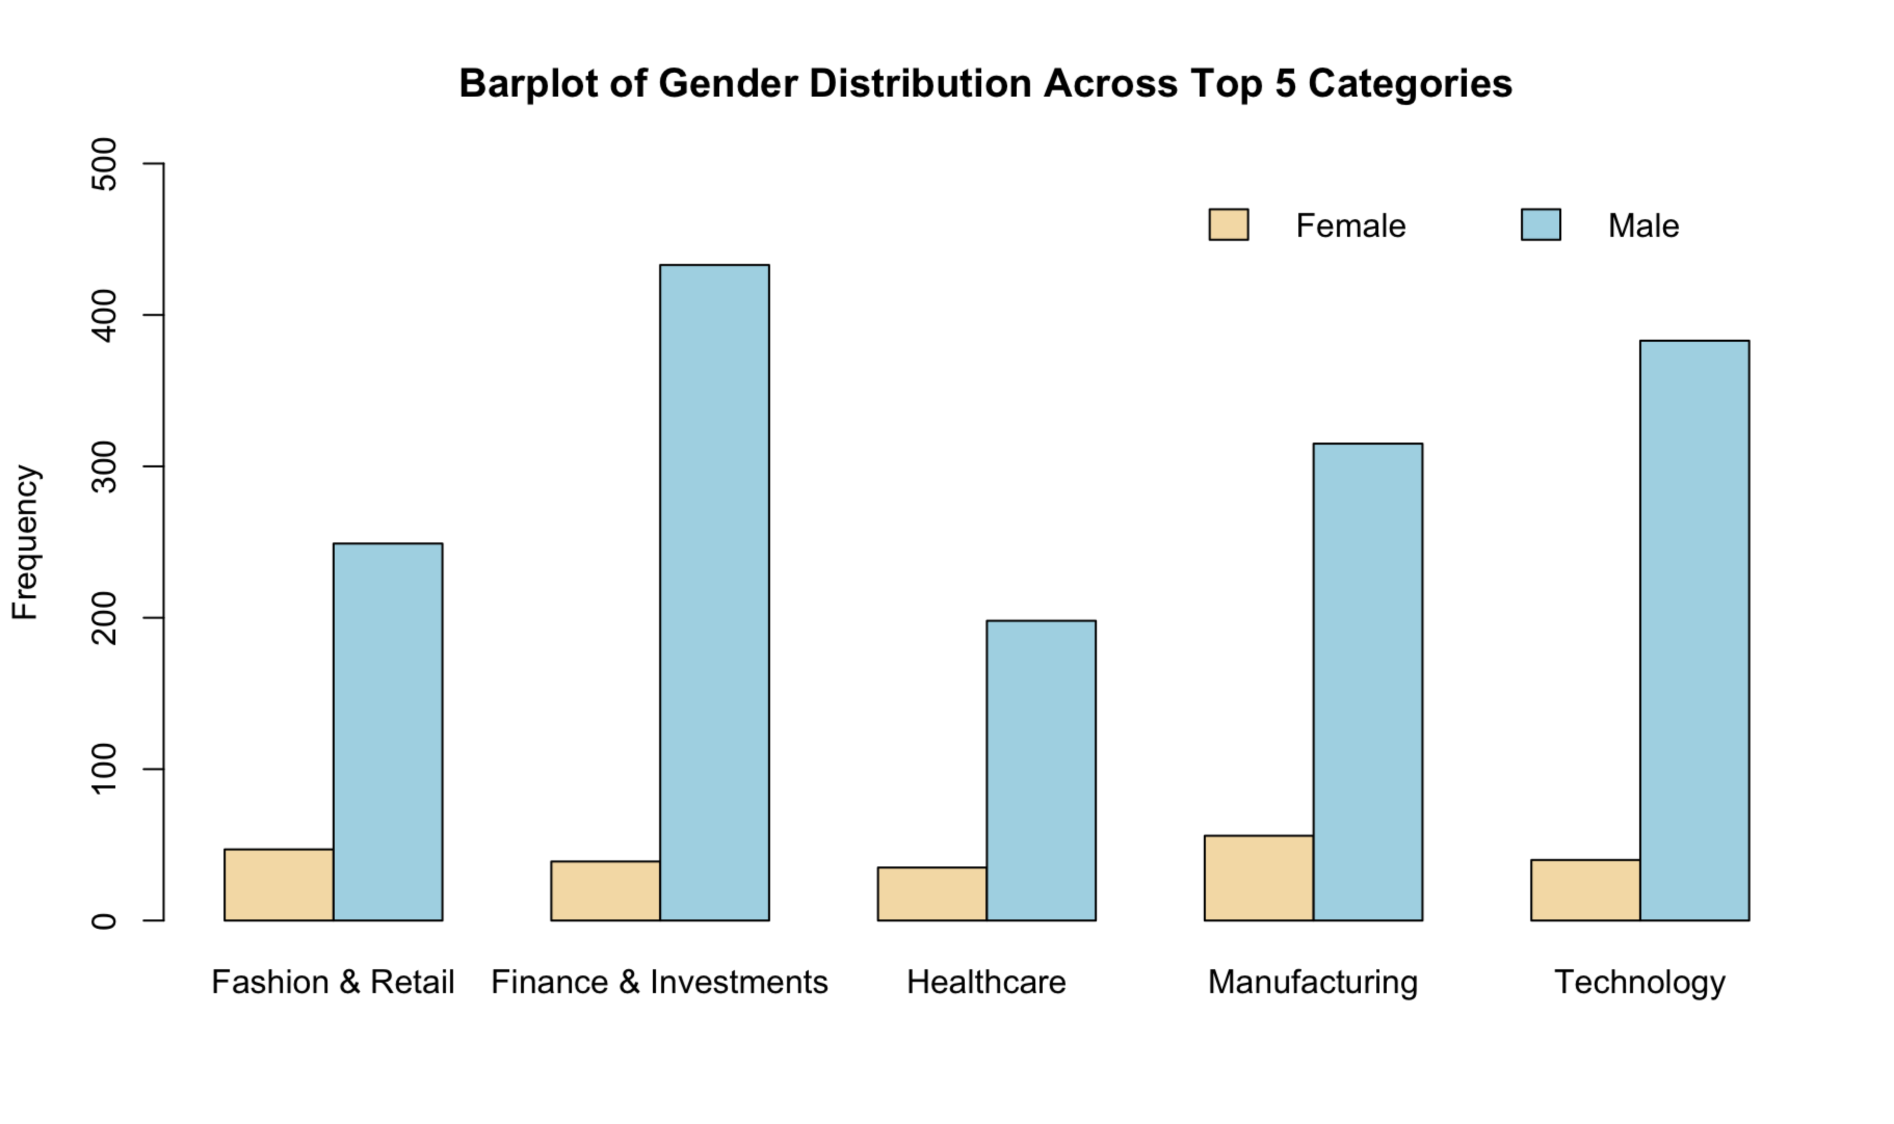
Figure 3 Barplot of Gender Distribution Across Top 5 Categories

> # d) inferences -------------------------------------------------------------

According to Figure 1, the United States stands out significantly with a far greater count of billionaires (about 9 hundred) than all other countries, demonstrating its dominant possession of billionaire and worth among the world. China ranks second following the US with a significant number of billionaires (about 5 hundred) as well.
As for Figure 2, 87% percent of these billionaires are male, which is more than 6 times that of female, showing male’s dominant status in the top-ranking rich people, as well as indicating a great gender unbalance regarding possessing huge amount of worth.
Moving on to Figure 3, Finance and Investments field shows the greatest number of billionaires. In the meantime, this figure also shows a huge gap between the number of male and female billionaires, where men account for the majority in all top 5 categories.

> # Part2 =======================================================================
>
> # init dataset
> us_quarters <- read.csv("https://people.bu.edu/kalathur/datasets/us_quarters.csv")
> head(us_quarters)
State DenverMint PhillyMint
1 Delaware 401424 373400
2 Pennsylvania 358332 349000
3 New Jersey 299028 363200
4 Georgia 488744 451188
5 Connecticut 657880 688744
6 Massachusetts 535184 628600
>
>
> # a) state with min/max num of quarters by each mint --------------------------
>
> # find states with highest/lowest number by each mint
> (min_Denver <- us_quarters[which.min(us_quarters$DenverMint),"State"])
[1] "Oklahoma"
> (max_Denver <- us_quarters[which.max(us_quarters$DenverMint),"State"])
[1] "Connecticut"
>
> (min_Philly <- us_quarters[which.min(us_quarters$PhillyMint),"State"])
[1] "Iowa"
> (max_Philly <- us_quarters[which.max(us_quarters$PhillyMint),"State"])
[1] "Virginia"
>
> # print out results
> paste(
+ sprintf(
+ "DenverMint produced most quarters for %s and least for %s.",
+ max_Denver, min_Denver
+ ),
+ sprintf(
+ "PhillyMint produced most quarters for %s and least for %s.",
+ max_Philly, min_Philly
+ )
+ )
[1] "DenverMint produced most quarters for Connecticut and least for Oklahoma. PhillyMint produced most quarters for Virginia and least for Iowa."
>
>
> # b) barplot: matrix for the two mints ----------------------------------------
>
> # store the data into a matrix
> m <- as.matrix(us_quarters[-1]) # exclude the 1st column
>
> # find suitable y limit
> y_max_2b <- max(pretty(m))
>
> # adjust parameters
> par(
+ mai=c(2, 1, 1, 0.5), # margin in inches
+ cex=0.8 # all text size become 80% of original
+ )
>
> # asjust global option to avoid scientific notation
> options(scipen = 999)
>
> # barplot
> barplot(
+ t(m), # transpose matrix
+ beside = TRUE, # let bar groups beside each other
+ ylim = c(0,y_max_2b), # y limits
+ names.arg = us_quarters$State, # category names
+ las = 2, # let labels perpendicular to axis
+ col = c('blue', 'grey'), # colors
+
+ legend.text = T, # show legend
+ args.legend = list(
+ text.width = 17, # legend width
+ x = "topright", # legend position
+ x.intersp = 1, # inter space
+ y.intersp = 0.7, # line space
+ cex = 0.8 # text size becomes 80% of original
+ )
+ )
>

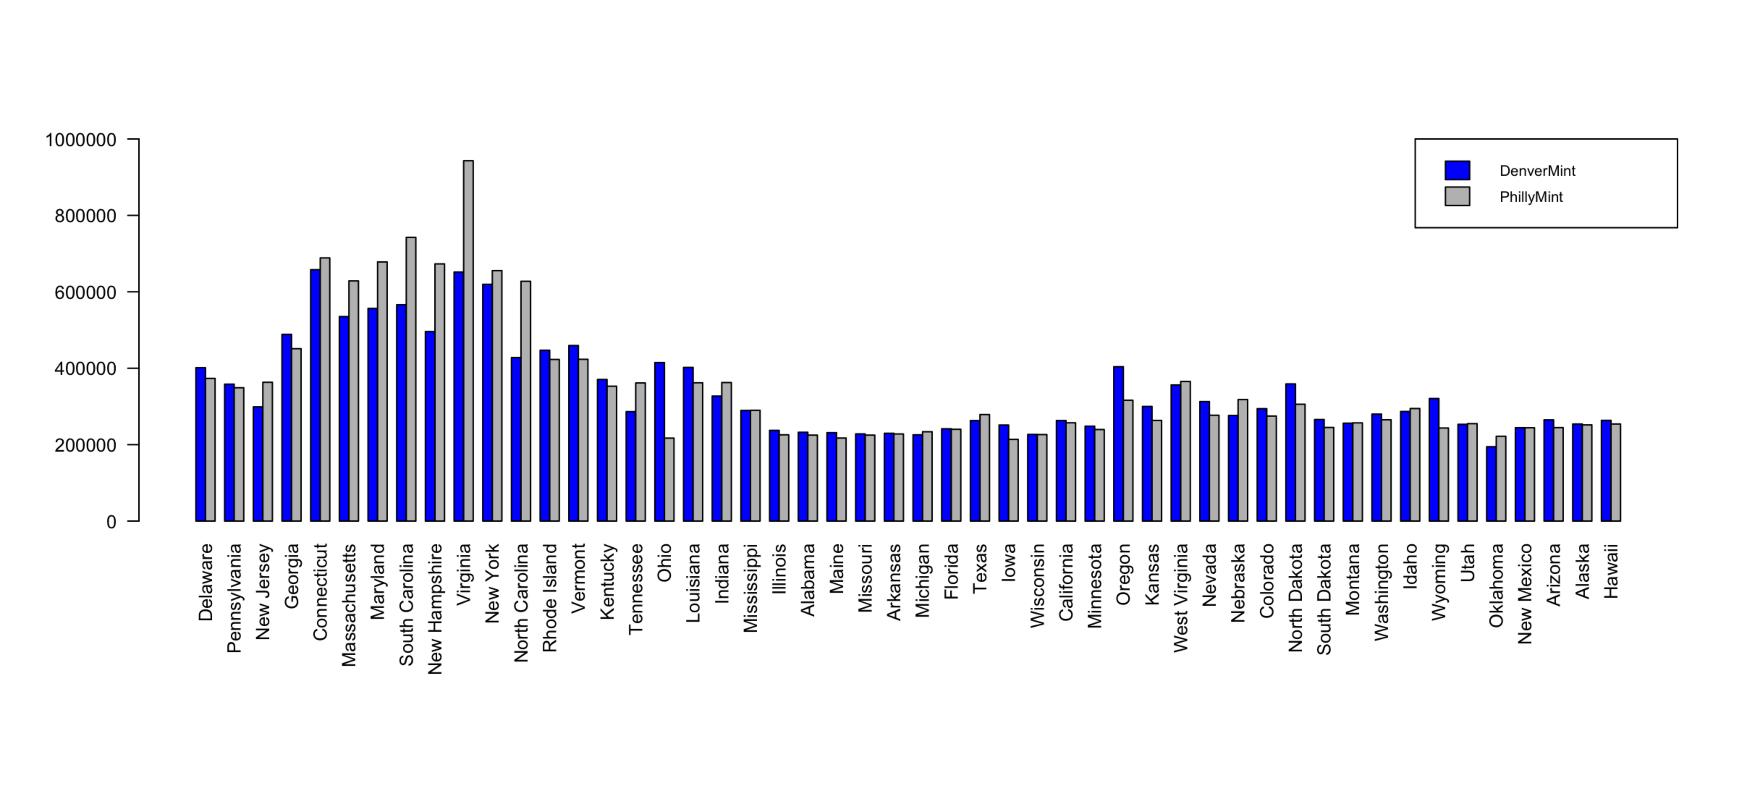
Figure 4 Barplot of Number (in thousands) of Quarters Minted for States by Mints
>
> # two striking inferences

According to Figure 4, the PhillyMint shows a dominant production volume for state Virginia, reaching a billion units, which is far more than that of DenverMint in Virginia (less than 700 million). This is also the highest peak in the entire dataset.
In addition, Connecticut is the state for which the largest production volume by DenverMint was (about 700 million).

> # c) side-by-side box plots for the two mints ---------------------------------
>
> # set parameters
> par(
+ mar=c(4, 8, 4, 6), cex=0.8, # margin and general text size
+ mgp = c(5, 1, 0) # move y axis title left to avoid overlap with y ticks
+ )
>
> # Drawing the side-by-side boxplot
> boxplot(
+ us_quarters$DenverMint, us_quarters$PhillyMint,
+ col = c("blue", "grey"), # colors
+ las = 1, # keep y labels horizontal
+ outline = TRUE, # show outliers if exist
+ names = c("Denver Mint", "Philly Mint"), # category names
+ ylab = "Number of Quarters", # y label
+ main = "Comparison of Quarters Produced by Mint" # title
+ )

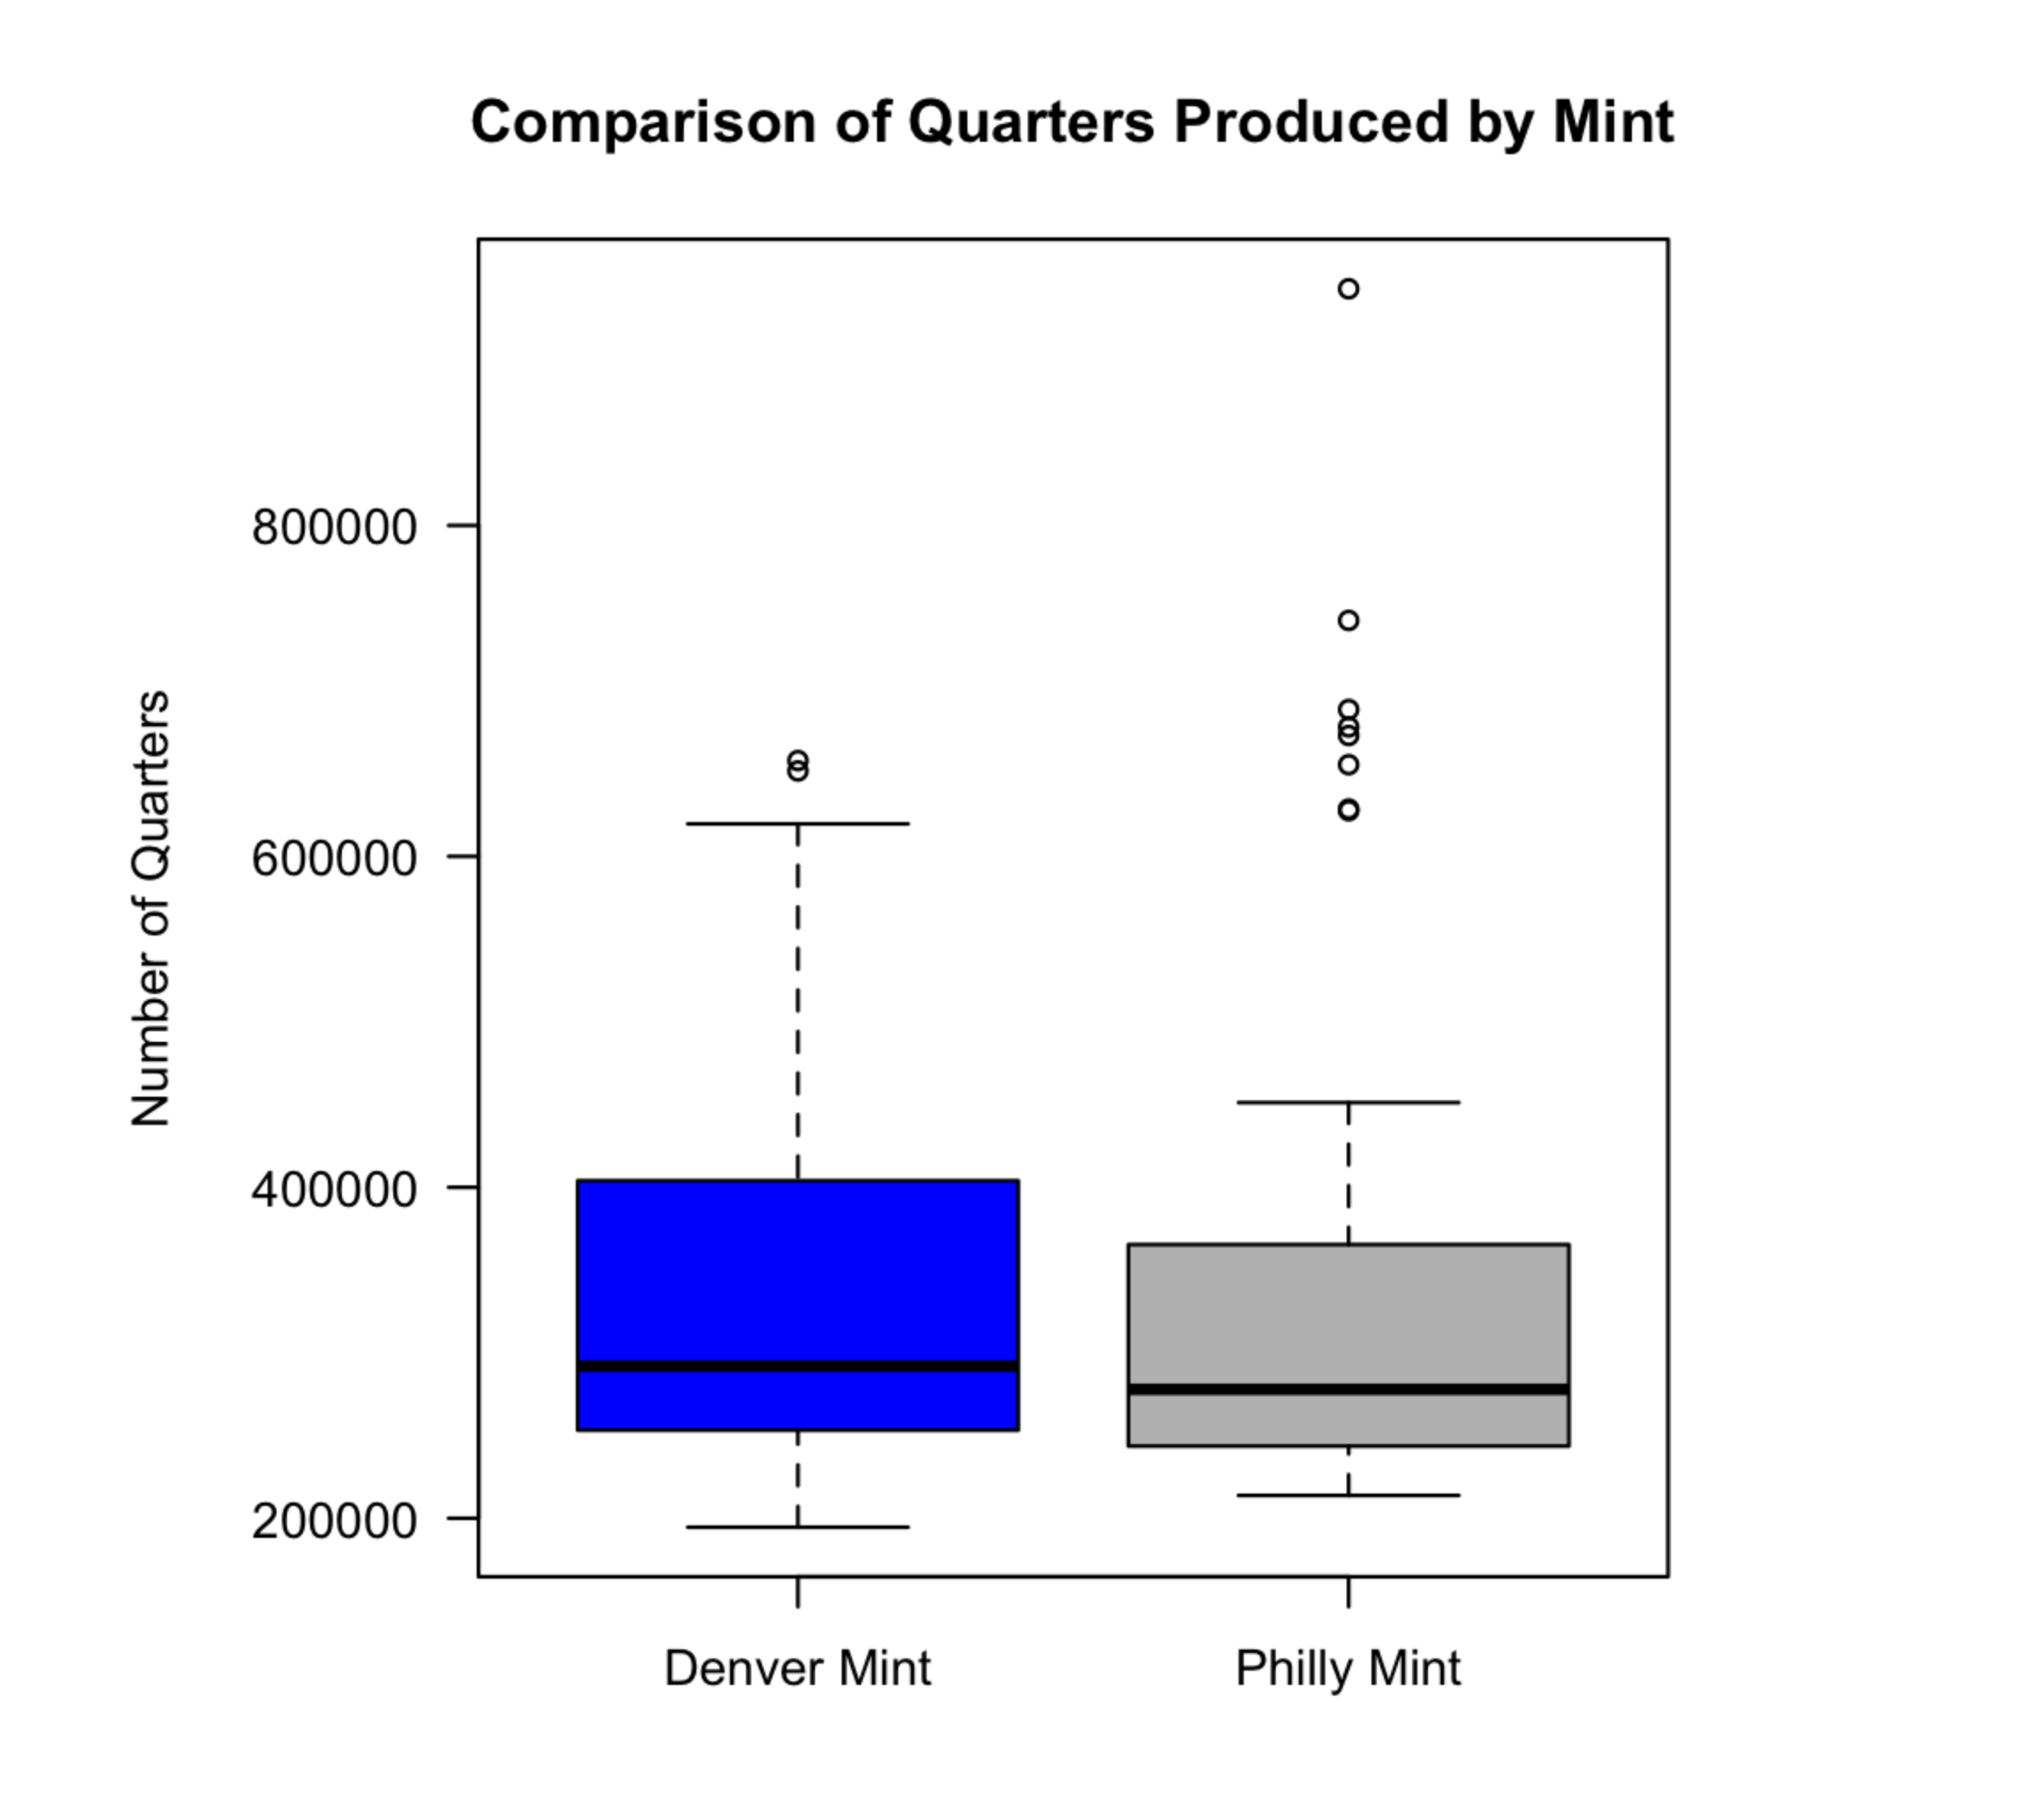
Figure 5 Comparison of Quarters Produced by Mints
>
>
> # two striking inferences for each of the box plots

🔴According to Figure 4, the PhillyMint shows a dominant production volume for state Virginia, reaching a billion units, which is far more than that of DenverMint in Virginia (less than 700 million). This is also the highest peak in the entire dataset.
In addition, Connecticut is the state for which the largest production volume by DenverMint was (about 700 million).


Print a message about the max / min

T == TRUE == true == 1
Plot: right values -> readable

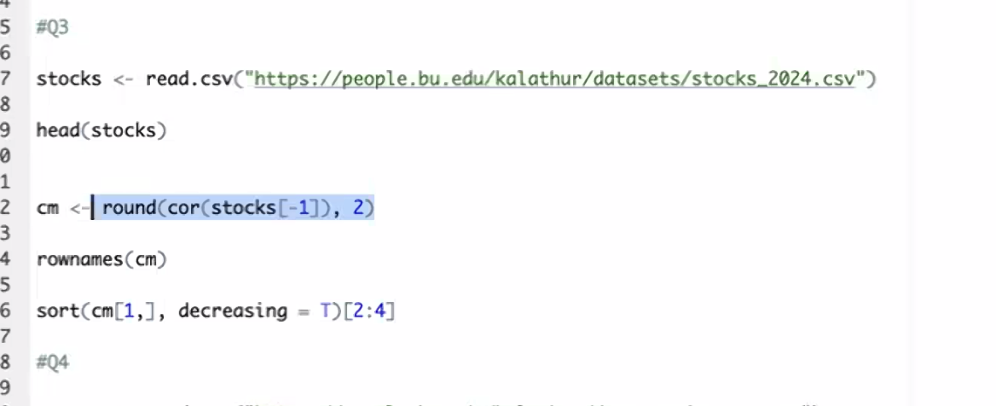
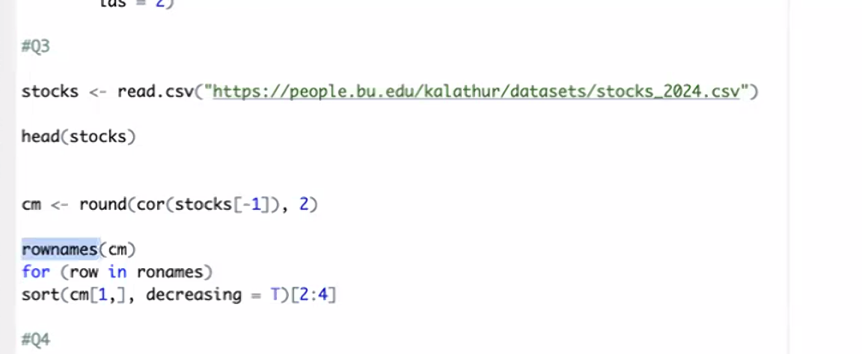

For loop for each row

Q4: histogram

y <- hist(...) also, print a message! Using loop
