EXCHANGE RATE POLICIES

Especially after WWII, the international trade in good and services has increased steadily. The expansion of the international trade brought the dependency of the countries to each other. When we look at U.S, -in terms of trade-, many Goods and services, including basic life supplies come from East Asian ( mostly China) also Most of the U.S products had traveled around world and been the inevitable goods of the all people around the world.

On the other hand, international trade may cause inappropriate situations when we checked goods and services sold to other countries. The economist mentioned about a n equivalence in international currencies during the trade.
This Equivalence is called Exchange rates.
In other words, Exchange rate between two countries is the price at which residents of the country trade with each other.
For example in finance part of newspapers we see the notes as 1 $= 120 yen
Or 1$= 0.9 Euro. This equalizations are called exchange rates.
Generally economists distinguish exchange rates as nominal exchange rates and real exchange rates.
Nominal Exchange rate:
Is the relative price of the currencies of two countries. Like the previous example
1$=120 Yen
We figure out that the exchange rate between U.S dollar and Japan yen is 120 Yen/Dollar

This is the nominal exchange rate.
For example
If a Japanese investor wants to buy 1 $ she/he will give 120 yen in order to buy 1$.

The nominal exchange rates are generally used in financial markets
On the other hand, unlike nominal exchange rates, Real Exchange rate is the relative price of currencies. This rate also explains the rate at which countries can trade goods and services of one country for the goods and services of other one.

For example
Let say 1 American Car ( Ford Taurus,) costs 25000 $ for a single consumer and 1 German Car ( BMW ) costs 10000 Euro for a consumer. If we think there are not tariffs for exports and imports and transportation cost are negligible
And alos we know the exchange rate
E=0.8 Euro/Dollar
Then 1 American Car is cost 25000 $*0.8Euro/Dollar=20.000 Euro
On the other hand 1 german car is 10000 Euro
We can compare and say that 1 American car is twice expensive as 12 German car when we equalize the
Real Exchange rate= 2*German Car /American Car
This ratio gives us exchange rate.
Also
We can write in other ways
Real Exchange rate= 0.8 Euro/Dollar*25000 Dollar/American Car
10.000 Euro/German Car

= 2 German Car/American Car
This is the real Exchange rate
The general Formula for real exchange rate is
R=E*P/P×
E stands for the nominal Exchange rate
P stands for the price price of the good in demoestic country
P× stands for the price level of the good and services in foreign country

Determinants of The Exchange rates
In open economies exchange rate is determined by the market through basic supply and demand model.

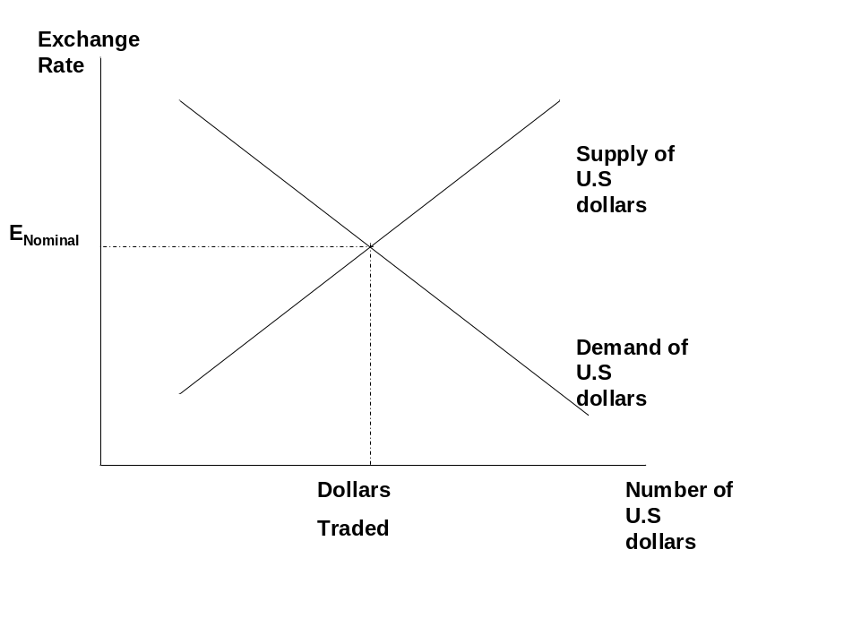
This figure shows the determination of the value of the dollar in the foreign exchange market. The supply curve indicates the number of Dollars that people try to sell in the market, The demand for dollar is indicate the number of dollars demanded in the international market.

What Factors can effect the exchange rates?
There are several factors effecting Exchange rates
- The Effect of the increase in Output
When the domestic output of a country increases, holding other factors constant, What happens to exchange rates?
When domestic income increases, consumers will spend more on Goods and services which will increase the demand for foreign currency . People have willing to exchange their money with foreign currency and so that domestic currency supply will increase
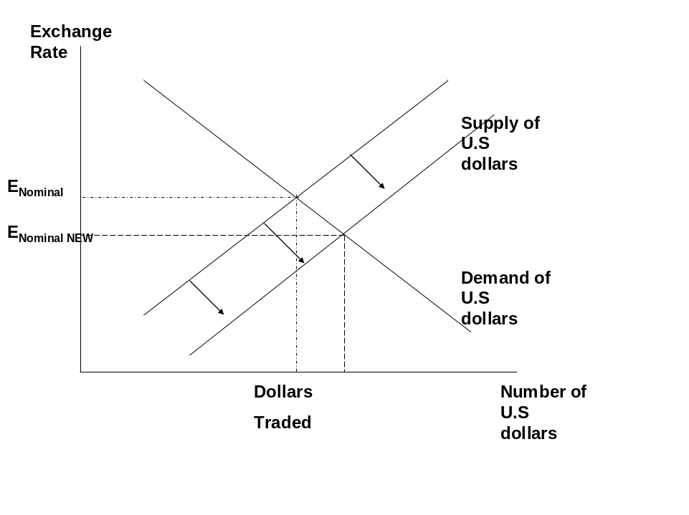
So that the number of Dollars traded in the market will increase and the exchange rate will fall.
Other factors are
- The change in Foreign Income
As Higher foreign output raises, demand for exports ( as well as dollar) increase this will increasse the demand for domestic currency and will increase the Exchange rates
- World Demand for Domestic goods
Higher world demand for domestic goods, means high demand for Dollar and increase demand for dollar and increase the Exchange rates.
- Domestic interest rates
As the domestic interest rates increase, the return of dollar investment will increase so that demand for dollar increases. This will lead to an increase in Exchange rates.

Quizes / Short Questions

1)
The price of one Hamburger in Houston is 2 Dollars
On the other hand the pce of an Hamburger in Tokyo is 2200 Yen
The the exchange rate is
E=110yen per dollar
According to givens
- The nominal Exchange rate is ________
- The formula for Real Exchange Rate is _________
- The Real Exchange Rate is ___________________

2)
In international Markets 1 $=0.55 British Sterling
And we know that 1 T.V set in England is 1000 pounds
Same set in U.S costs 400 dollars
Then
- The Nominal Exchange Rate is _______________
- The real Exchange rate is _____________
Choose the correct one
- The tv Sets in Manchester England is Cheaper/more expensinve than T.V sets in New York City.

3)
As the quality of the goods in U.S increases, the demand for U.S goods will ________, the demand for Euro will ______, and the exchange rate for Euro in international markets will _____

4)
What happens when the world demand for domestic goods decrease ?

Show graphically the conclusions

Answers
1)
- Nominal Exchange rate is given relative price of two currencies
It is E=110yen per dollar

- The formula for real Exchange rate is R=E*P/P×
E: nominal Exchange rate
P price level in U.S
P× price level in Japan

- =110 Yen/Dollar*(2$ /U.S hamburger)
R=
2200 /Japanese Hamburger
Then R=0.1 Japanese Hamburgers per U.S hamburger

2)
- Nominal Exchange rate is 0.55 pound/dollar
Real Exchange rate is
R= 0.55 pound/dolar*(400dollar/U.S TV Sets)

1000( pound/ England TV sets)
R=0.22 England TV sets/ U.S TV sets

- We see that 1 England TV set is 0.55*1000=550 dollar
- And 1 U.S Tv set is 400 dollar so that
The T.V. Sets in England is more expensive than T.V sets in U.S.

3)
As the quality of the goods in U.S increases the demand for that goods in all over the world increases so that people need Dollar in order to buy that goods, The demand of dollar in inernatinal Markets increases and the exchange rate will increase

4)
When the demand for domestic goods decrease people seek less dollar to buy the domestic goods so that demand for dollar decreases
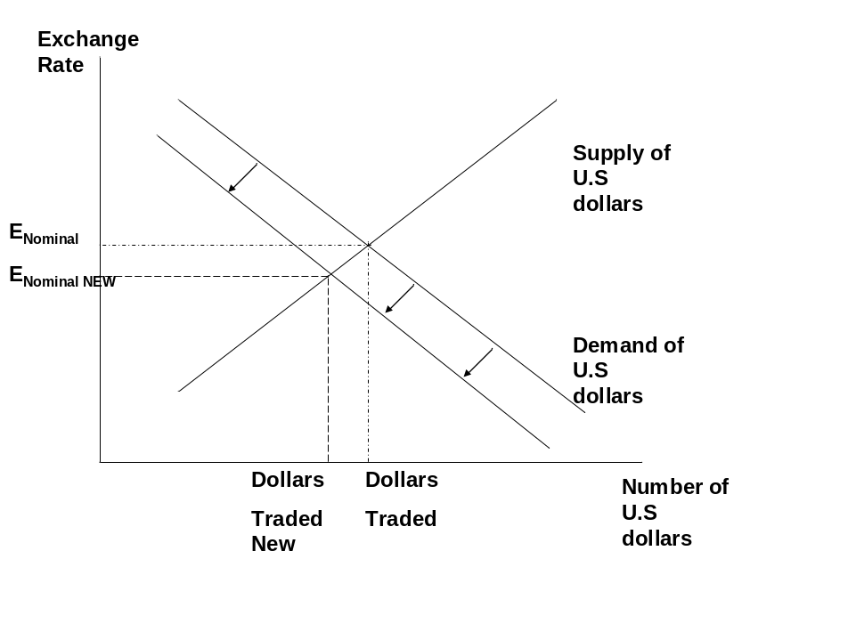
The new exchange rate after shifting demand curve is seen in the figure, it decreases and also the number of dollars traded decreases.

