Super Jungle Hunt

User manual

# Installation

After downloading the game, it is ready to be run from SuperJungleHunt.exe.

# User interface

The game starts with the start menu screen where you need to input your player name. In the next screen you get to choose the difficulty with the slider.

During the levels the player can see the points scored in the level, time left for time bonus and remaining lives.

A yellow heart means two lives, a red heart means one life and a transparent heart means no life.

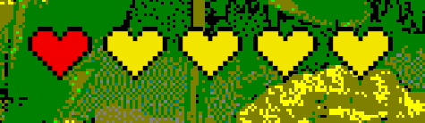

# Controls

The player can be controlled in the game by using the keyboard.

**Action Key**

Running / swimming Arrowkeys

Jump Space

Crouch Ctrl

# Goal

The goal of the game is to get to your wife who has been kidnapped by a cannibal tribe.

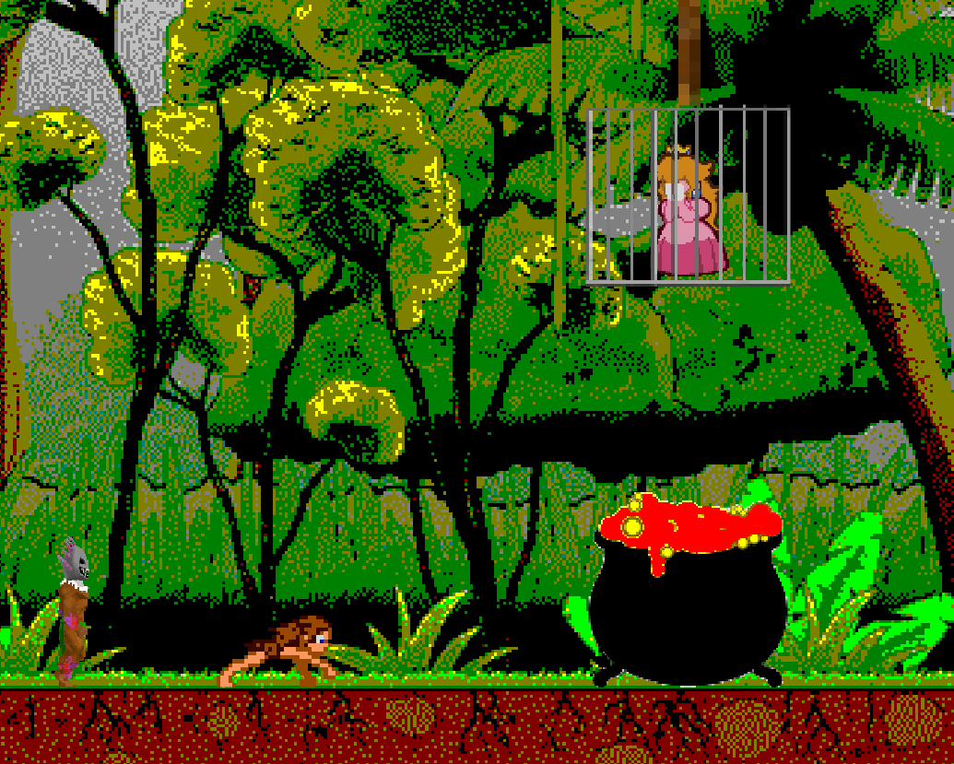

During the game you will also earn points by avoiding hazards and after the game you will get your name to the high-score list.

# Score

The more dangerously you play and the faster you complete the level, the more score you will get.

# Hazards

The game is filled with deadly hazards you should avoid.

**Level Hazards**

1. You should avoid hitting the ground by jumping from rope to rope, and to the water at the end of the level.
2. You should avoid touching the crocodiles by swimming and diving to various directions. The bubbles can catch you inside them and you’ll be unable to move until you hit the surface. Also you should go every now and then to the surface to get more air.

 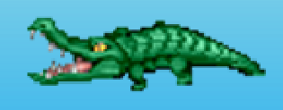

1. You should avoid contact with the boulders by jumping over the rolling boulders and running below the bouncing boulders.

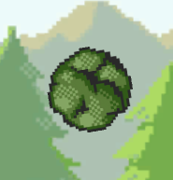 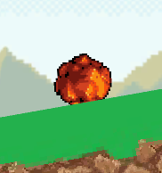

1. You should avoid touching the cannibals by jumping over them.

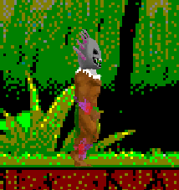

1. You should avoid hitting the pillars by jumping between them.

