UAV-BASED FLOODED ROAD ASSESSMENT SYSTEM USING AI CLASSIFICATION OF VEHICLE PASSABILITY FOR POST-DISASTER RESPONSE

A Thesis Presented to
The Faculty of Electronics Engineering Department Pamantasan ng Lungsod ng Maynila

In Partial Fulfillment of the Requirements for the Degree Bachelor of Science in Electronics Engineering

Proponents:

Allen Nino Ezekiel S. Asusano Vince Paulo M. Sablan
Keil Ckerbie D. Delos Reyes

Thesis Adviser/s

February 2026

APPROVAL SHEET

The thesis hereto titled

UAV-BASED FLOODED ROAD ASSESSMENT SYSTEM USING AI CLASSIFICATION OF VEHICLE PASSABILITY FOR POST-DISASTER RESPONSE
prepared and submitted by Allen Nino Ezekiel S. Asusano, Vince Paulo M. Sablan, and Keil Ckerbie D. Delos Reyes in partial fulfilment of the requirements of the College of Engineering of Pamantasan ng Lungsod ng Maynila for the degree of Bachelor of Science in Electronics Engineering has been examined and is recommended for acceptance and approval for ORAL EXAMINATION.

Adviser 1 Adviser 2

PANEL OF EXAMINERS

Approved by the Committee on Oral Examination with a grade of on .

Panel Chair
Chairman

Panel Member Member
Panel Member Member

Accepted and approved in partial fulfilment of the requirements for the degree of Bachelor of Science in Electronics Engineering.

ENGR. EUFEMIA A. GARCIA
Chairperson
ENGR. EVANGELINE P. LUBAO
Dean

K A R U N U N G A N : K A D A K I L A A N : K A U N L A R A N

ABSTRACT

This study presents a UAV-based flooded road assessment system that utilizes deep learning for automated vehicle passability classification. The system employs an EfficientNet-B0 convolutional neural network trained on 4,494 images from the RescueNet and FloodNet datasets to classify flooded roads into three graduated levels: Passable, Limited Passability, and Impassable. The model achieved 78.44% test accuracy and 74.04% macro F1-score using Focal Loss with class weights to address dataset imbalance. A novel Safety Classifier module was developed to enhance prediction reliability by applying conservative adjustments to uncertain predictions, prioritizing safety in disaster response scenarios. The system architecture comprises a FastAPI backend with ONNX Runtime inference, automatic GPS EXIF extraction for geolocation, and a responsive Next.js frontend for field deployment. While trained on US hurricane imagery, the system is designed for Philippine typhoon response with acknowledged domain shift considerations and recommended mitigation strategies.
Keywords: UAV, flood assessment, deep learning, vehicle passability, disaster response

ACKNOWLEDGEMENT

The following is a suggestion ONLY.

My deepest ‘thank you’ LORD for all the gifts You have given me and for directing my path to the following persons who have been instrumental in the completion of my thesis / practicum or research report.
Person1, my relation, for contribution.

… so on …

For this achievement, I give back all the glory and praises to the omnipotent Father Almighty.

Firstname M. Lastname

TABLE OF CONTENTS

APPROVAL SHEET | ii
ABSTRACT | iv
ACKNOWLEDGEMENT | v
TABLE OF CONTENTS | vi
LIST OF FIGURES | viii
LIST OF TABLES | vii
INTRODUCTION | 1
1.1 Background of the Study | 1
1.2 Statement of the Problem | 4
1.3 Objective of the Study | 5
1.3.1 General Objective | 5
1.3.2 Specific Objectives | 6
1.4 Significance of the Study | 6
1.5 Scope and Delimitation | 8
1.6 Operational Definition of Terms | 9
REVIEW OF RELATED LITERATURE | 12
2.1 Global Flood Disasters and Their Impact on Road Infrastructure | 12
2.2 Flood Vulnerability and Road Network Disruption in the Philippines | 14
2.3 Traditional Flood Assessment Methods and Their Limitations | 15
2.4 UAV Technology in Disaster Assessment and Flood Monitoring | 17
2.5 Artificial Intelligence and Deep Learning for Flood Detection | 20
2.6 Vehicle Passability Assessment and Flood Depth Estimation | 22
2.7 Related Systems and Frameworks for Flood Response | 24
2.8 Synthesis of Literature and Identification of Research Gaps | 25
2.9 Theoretical Framework | 27
2.10 Conceptual Framework | 29
METHODOLOGY | 31
3.1 Research Design | 31
3.2 Research Locale | 32
3.3 Research Instruments | 34
3.3.1 UAV Platform and Imaging Equipment | 34
3.3.2 Software Tools and Development Environment | 35
3.3.3 Stakeholder Consultation Instruments | 36
3.4 Research Procedure | 37
3.4.1 Phase 1: Stakeholder Consultation and Protocol Review | 33
3.4.2 Phase 2: UAV Data Acquisition Workflow Design | 38
3.4.3 Phase 3: Dataset Development and Annotation | 39
3.4.4 Phase 4: CNN Model Architecture and Training | 42
3.4.5 Phase 5: Model Evaluation and Performance Testing | 45
3.4.6 Phase 6: Deployment Framework Design | 48

    - System Architecture 45
    - Ethical Considerations 52
    - Project Timeline 53
LIST OF REFERENCES 55

LIST OF TABLES

TABLE 3.1: Summary of Research Instruments 36
TABLE 3.2: Graduated Vehicle Passability Classification Levels 41
TABLE 3.3: Model Architecture Configuration 43
TABLE 3.4: Evaluation Metrics and Definitions 46
TABLE 3.5: Stratified Evaluation Dimensions 46
TABLE 3.6: Project Timeline Summary by Phase 53

LIST OF FIGURES

FIGURE 3.1: Research Design Framework Mapping Specific Objectives to DSR Stages
32
FIGURE 3.2: Map of Study Area 34
FIGURE 3.3: UAV Data Acquisition Workflow Flowchart 40
FIGURE 3.4: Three-Class Vehicle Passability Classification 42
FIGURE 3.5: System Pipeline with Safety Classifier 45
FIGURE 3.6: EfficientNet-B0 Architecture with Custom Classifier 45
FIGURE 3.7: Three-Phase Training and Evaluation Flowchart 48
FIGURE 3.8: Proposed Deployment Framework Integration Diagram 49
FIGURE 3.9: System Architecture Block Diagram 50
FIGURE 3.10: Application Data Flow Diagram 51
FIGURE 3.11: System Flowchart (Image Capture to Passability Output) 52

Chapter One INTRODUCTION
  - Background of the Study
Natural disasters remain one of the most pressing challenges confronting global communities, and among these, flooding stands as the most frequent and most destructive hydrological hazard worldwide. According to the United Nations Office for Disaster Risk Reduction (UNDRR, 2024), floods accounted for over 40% of all recorded natural disaster events between 2000 and 2023, affecting more people than any other type of natural hazard. The Centre for Research on the Epidemiology of Disasters (CRED, 2024) reported that flood events in 2023 alone impacted approximately 32.4 million individuals across nearly 150 countries, displacing close to 10 million people from their homes. The economic toll has been equally staggering; the Swiss Reinsurance Company (Swiss Re, 2024) estimated that global insured losses from flooding reached 11.2 billion USD in 2023, the second-highest figure recorded in the past decade, while uninsured losses pushed total economic damages to an annual average exceeding 388 billion USD over the past five years. The Global Assessment Report on Disaster Risk Reduction (GAR 2025) further emphasized that flood risk is escalating due to the compounding effects of climate change, unplanned urbanization, and the degradation of natural water retention systems (UNDRR, 2025). These statistics underscore the urgency of developing rapid, accurate, and technology-driven methods for assessing flood impacts, particularly on critical transportation infrastructure that serves as the lifeline for emergency response and recovery operations.
The Philippines is among the most disaster-prone nations in the world, consistently ranking within the top five countries on the WorldRiskIndex due to its extreme exposure to natural hazards and high levels of societal vulnerability (Bündnis Entwicklung Hilft, 2024). The archipelago's geographic position along the Pacific typhoon belt and the Ring of Fire subjects it to an average of 20 tropical cyclones annually, of which approximately eight to nine make landfall (Philippine Atmospheric, Geophysical and Astronomical Services Administration [PAGASA], 2023). The devastating consequences of these events are well documented: Typhoon Ondoy (Ketsana) in 2009 inundated over 80% of Metro Manila and caused damages exceeding 11 billion PHP (National Disaster Risk Reduction and Management Council [NDRRMC], 2009); Super Typhoon Yolanda (Hainan) in 2013 claimed over 6,300

lives and destroyed infrastructure valued at 89.6 billion PHP (NDRRMC, 2014); Typhoon Ulysses (Vamco) in 2020 triggered catastrophic flooding in the Cagayan Valley that submerged entire municipalities (Lagmay et al., 2021); and most recently, the unprecedented 2024 typhoon season saw Typhoons Kristine and Leon devastate Luzon and the Visayas in rapid succession, with six consecutive typhoons striking the country within 30 days, affecting over 13 million people and causing damages estimated at 43 billion PHP (NDRRMC, 2024). Flooding consistently accounts for the largest share of disaster-related fatalities, displacement, and agricultural losses in the Philippines, with road networks being among the most heavily affected infrastructure systems (Corporal-Lodangco and Leslie, 2017; Dado and Narisma, 2020).
Despite the recurring and intensifying nature of flood disasters in the Philippines, current methods for assessing flood damage to road infrastructure remain largely manual, time-consuming, and resource-intensive. The Department of Public Works and Highways (DPWH, 2022) relies primarily on field inspection teams that physically traverse affected road segments to document damage, a process that can take days or even weeks after a major flood event. The Metropolitan Manila Development Authority (MMDA, 2023) utilizes fixed closed-circuit television cameras and social media monitoring to track road flooding in real time, but these systems provide limited spatial coverage and cannot assess whether roads are passable for different vehicle types. The NDRRMC (2023) coordinates post-disaster damage assessments through situational reports compiled from local government units, yet these reports often suffer from delays, inconsistent reporting formats, and subjective judgment by ground assessors. Traditional satellite-based remote sensing, while valuable for large-scale flood mapping, is constrained by revisit times, cloud cover interference, and spatial resolutions that are insufficient for road-level analysis (Rahman and Di, 2020; Sarker et al., 2019). The cumulative effect of these limitations is a critical information gap during the immediate post-disaster period, precisely when rapid and accurate road condition data is most needed to guide evacuation, relief distribution, and restoration of essential services.
The emergence of unmanned aerial vehicle (UAV) technology has introduced a transformative capability for disaster assessment and response. UAVs can be deployed rapidly, often within minutes of a flood event subsiding, and can capture high- resolution aerial imagery over areas that are inaccessible to ground teams due to flooded roads, collapsed bridges, or debris-blocked pathways (Erdelj et al., 2017; Khan et al., 2022). Studies have demonstrated the effectiveness of UAVs for post-disaster damage mapping, showing that drone-captured imagery provides spatial resolutions of

- to 5 centimeters per pixel, far exceeding the capabilities of even the highest- resolution commercial satellites (Greenwood et al., 2020; Nex et al., 2022). In the Philippine context, the Department of Science and Technology (DOST) has supported research initiatives exploring UAV applications for disaster monitoring through programs such as the Disaster Risk Exposure and Assessment for Mitigation (DREAM) and Phil-LiDAR projects, which have demonstrated the feasibility of drone- based terrain mapping for flood modeling (Blanco et al., 2015; Santillan et al., 2016). However, the majority of existing UAV-based disaster studies have focused on generating flood extent maps or three-dimensional terrain models, rather than directly assessing the functional status of road infrastructure for vehicular traffic. This represents a significant operational gap, as decision-makers during disaster response need to know not merely where flooding exists, but which roads can still be safely traversed and by what types of vehicles.
Advances in artificial intelligence, particularly in the field of computer vision using convolutional neural networks (CNNs), have opened new possibilities for automated analysis of flood imagery. Pioneering work by Gebrehiwot et al. (2019) demonstrated that deep learning models could achieve pixel-level semantic segmentation of flooded areas from aerial images with accuracy rates exceeding 90%. The FloodNet dataset, developed by Rahnemoonfar et al. (2021), established a benchmark for training and evaluating deep learning models on high-resolution UAV imagery of flood-affected areas, incorporating multiple classes including flooded roads, buildings, and vegetation. Yang et al. (2022) further advanced the field by developing a hybrid CNN-Transformer architecture that achieved state-of-the-art performance on flood detection tasks, with an intersection-over-union score of 0.72 on the Sen1Floods11 benchmark dataset. Other notable contributions include the application of encoder-decoder architectures such as U-Net for flood segmentation (Hashemi-Beni and Gebrehiwot, 2021), and the use of transfer learning with pre- trained models like ResNet and EfficientNet for flood classification from limited training data (Pally et al., 2022). These studies collectively demonstrate that artificial intelligence can transform raw aerial imagery into actionable flood information with speed and accuracy that far surpass manual interpretation.
Despite these advances, a notable gap persists in the literature regarding the application of AI-based image analysis to the specific problem of vehicle passability assessment on flooded roads. Existing studies on flood depth estimation from imagery, such as those by Lopez et al. (2020) and Chaudhary et al. (2019), have focused on estimating water levels using reference objects or gauge markers rather than directly

classifying whether roads are passable for different vehicle categories. Ahmad et al. (2019) proposed a flood monitoring system that classified road segments as flooded or non-flooded, but did not extend the classification to differentiate passability thresholds based on vehicle type, such as sedans, sport utility vehicles, or trucks. The work of Munawar and Hammad (2022) on UAV-based flood damage assessment incorporated road damage detection but treated road passability as a binary condition rather than a graduated classification. Furthermore, the majority of AI-based flood detection studies have been conducted in Western contexts using datasets from the United States, Europe, or Australia, raising questions about the transferability of these models to tropical developing-country settings where road infrastructure, vehicle fleets, flood characteristics, and vegetation patterns differ substantially (Tellman et al., 2021; Bonafilia et al., 2020).
This study addresses these gaps by proposing an integrated system that combines UAV-captured aerial imagery with a deep learning classification model to assess flooded road conditions and determine vehicle passability levels for post- disaster response in the Philippine setting. Specifically, the research identifies five critical gaps that motivate the study: (1) the absence of an automated, UAV-based method for real-time road passability assessment during flood events; (2) the lack of a graduated vehicle passability classification framework that accounts for different vehicle types commonly used in the Philippines; (3) the limited application of CNN- based image analysis to road-level flood assessment as opposed to regional flood mapping; (4) the scarcity of flood detection models trained and validated on Philippine road and flood conditions; and (5) the disconnect between existing flood monitoring technologies and the operational decision-making needs of disaster response agencies. By addressing these gaps, this study contributes a practical, technology-driven tool that can enhance the speed, accuracy, and reliability of post-disaster road assessment, ultimately supporting more effective emergency response and saving lives during flood disasters in the Philippines.

  - Statement of the Problem
Road infrastructure serves as the primary conduit for evacuation, emergency response, and relief distribution during flood disasters, yet the Philippines currently lacks a rapid, automated, and reliable system for assessing which roads remain passable in the aftermath of flooding events. Existing assessment methods depend on manual field inspection, fixed surveillance cameras with limited coverage, and

subjective reporting from local government personnel, all of which introduce significant delays and inaccuracies during the critical post-disaster window when timely information is most essential. The absence of a technology-driven approach that integrates aerial imaging with intelligent classification means that disaster response agencies must make routing and resource allocation decisions based on incomplete, outdated, or unreliable road condition data. This study seeks to develop a UAV-based flooded road assessment system using artificial intelligence to classify vehicle passability, thereby addressing the following research questions:
  - What are the current road assessment practices, technologies, operational constraints, and information gaps of Philippine disaster response agencies (NDRRMC, DPWH, LGU-DRRMOs) during flood events, and what system requirements emerge from these constraints?
  - How can a UAV-based aerial imaging system be designed and configured to capture high-resolution imagery of flooded road segments suitable for automated analysis?
  - How does the EfficientNet-B0 architecture perform in balancing accuracy and computational efficiency for UAV-based flood assessment?
  - How effectively does the proposed system classify vehicle passability across different flood severity conditions, road types, and vehicle categories compared to manual assessment methods?
  - What deployment framework can be established to integrate the UAV- based assessment system into existing disaster response protocols of Philippine agencies?

  - Objective of the Study

    - General Objective
This study aims to develop and evaluate a UAV-based flooded road assessment system that utilizes deep learning image classification to determine vehicle passability levels for post-disaster response in the Philippines.

    - Specific Objectives
Specifically, this study seeks to:
  - Design and implement a UAV-based aerial imaging workflow that captures imagery at 2-5 cm ground sampling distance for flooded road segments across three road types (national highways, provincial roads, urban arterials) with systematic coverage protocols.
  - Develop a labeled image dataset leveraging publicly available flood imagery datasets (RescueNet and FloodNet, totaling 4,494 images), annotated with three graduated vehicle passability classifications (Passable, Limited Passability, and Impassable) for training and validation of the deep learning model.
  - Design, train, and optimize an EfficientNet-B0 convolutional neural network model using three-phase transfer learning with PyTorch Lightning, capable of classifying flooded road images into three vehicle passability levels with robust classification performance and a novel Safety Classifier module for disaster-response-appropriate predictions.

  - Significance of the Study
The findings of this study are expected to be beneficial to the following stakeholders:
National Disaster Risk Reduction and Management Council (NDRRMC). The NDRRMC serves as the primary coordinating body for disaster preparedness and response in the Philippines. This study provides the council with a technology-driven tool for rapid assessment of road passability during flood events, enabling faster and more informed decisions regarding evacuation route identification, relief convoy routing, and situational reporting. The automated classification system can supplement the council's existing damage assessment and needs analysis process by providing objective, image-based evidence of road conditions within hours rather than days after a flood event.
Department of Public Works and Highways (DPWH). As the government agency responsible for the national road network, the DPWH will benefit from a systematic and efficient method for prioritizing road clearing and repair operations following flood disasters. The UAV-based assessment system can provide the department with georeferenced, classified imagery of affected road segments, enabling

data-driven allocation of heavy equipment and maintenance crews to the most critically impaired routes. The system's classification output can also support the department's post-disaster infrastructure damage reporting, which informs budgetary requests for road rehabilitation.
Local Government Units and the Metropolitan Manila Development Authority (MMDA). Local government units, particularly those in flood-prone municipalities and cities, will benefit from a deployable assessment tool that complements their existing flood monitoring capabilities. For the MMDA, which manages traffic and flood response in Metro Manila, the system offers a scalable solution for assessing road conditions across the metropolitan area's extensive road network. The vehicle passability classifications can be directly integrated into traffic advisory systems, enabling local authorities to issue specific guidance to motorists regarding which roads are safe for particular vehicle types.
Emergency Responders and Humanitarian Organizations. First responders, including rescue teams, medical personnel, and humanitarian aid workers, operate under extreme time pressure during flood emergencies. This study provides these stakeholders with actionable intelligence on road accessibility, allowing them to plan optimal routes to affected communities and avoid impassable road segments. The graduated passability classification is particularly valuable for response teams that operate diverse vehicle fleets, as it enables matching of vehicle capabilities to road conditions, thereby reducing the risk of vehicles becoming stranded and further complicating rescue operations.
Academic Researchers and the Scientific Community. This study contributes to the growing body of knowledge at the intersection of UAV remote sensing, computer vision, and disaster management. The labeled dataset of flooded Philippine road conditions, the deep learning model architecture, and the performance evaluation results provide a foundation for future research on flood assessment automation in tropical developing-country contexts. Researchers in the fields of electronics engineering, geomatics, civil engineering, and disaster science can build upon the methodologies and findings of this study to advance the state of the art in AI-assisted disaster response technologies.
Policymakers and Disaster Risk Reduction Planners. Government officials and planners responsible for formulating disaster risk reduction policies will benefit from the evidence generated by this study regarding the feasibility, accuracy, and operational requirements of UAV-based road assessment. The findings can inform policy decisions on the integration of drone technology into national disaster response

frameworks, the establishment of standards for automated flood damage assessment, and the allocation of resources for acquiring and maintaining UAV capabilities at the national and local levels.

  - Scope and Delimitation
Scope. This study covers the following:
  - The study focuses on the development of a UAV-based aerial imaging and deep learning classification system for assessing vehicle passability on flooded road segments in selected flood-prone areas within Metro Manila and surrounding provinces in Luzon, Philippines.
  - The UAV platform utilized is a commercial-grade quadcopter drone equipped with a high-resolution RGB camera capable of capturing images at a ground sampling distance of 2 to 5 centimeters per pixel, flown at altitudes between 20 and 50 meters above ground level.
  - The deep learning model is based on the EfficientNet-B0 convolutional neural network architecture, utilizing three-phase transfer learning with PyTorch Lightning, trained on publicly available flood imagery datasets (RescueNet and FloodNet) totaling 4,494 images.
  - The system classifies flood conditions into three categories: Passable, Limited Passability, and Impassable. The original four-class design was consolidated to three classes during implementation, as the visual distinction between "High-Clearance Vehicles Only" and "Heavy Vehicles Only" proved ambiguous in aerial imagery, and consolidation improved model accuracy while providing clearer, more actionable classifications for emergency responders.
  - The study encompasses the full pipeline from image acquisition and dataset preparation through model training, validation, and performance evaluation using standard classification metrics including accuracy, precision, recall, and F1-score.
  - A deployment framework is proposed for integrating the system into the disaster response workflows of Philippine agencies, including recommendations for operational protocols, hardware requirements, and data communication procedures.

Delimitation. This study is subject to the following delimitations:
  - The study is limited to visual-spectrum (RGB) imagery captured by UAVs and does not incorporate multispectral, hyperspectral, thermal, or synthetic aperture radar data, which may provide additional information for flood assessment but require specialized and costlier sensor payloads.
  - UAV flight operations are constrained by weather conditions, and data collection is limited to periods when wind speeds are below 35 kilometers per hour and precipitation has subsided sufficiently to allow safe drone operation, meaning the system is designed for post-flood assessment rather than real-time monitoring during active rainfall events.
  - The vehicle passability classifications are based on visual assessment of flood depth relative to known road and vehicle reference features in the imagery and do not incorporate direct water depth measurement sensors, flow velocity estimation, or road structural integrity analysis.
  - The deep learning model is trained and validated on images collected from selected road types in the study area, including national highways, provincial roads, and urban thoroughfares, and its generalizability to unpaved roads, mountainous terrain, or road networks in other Philippine regions requires further validation.
  - The study does not address regulatory compliance aspects of UAV operations in the Philippines under the Civil Aviation Authority of the Philippines (CAAP) regulations beyond acknowledging their existence, and actual deployment would require adherence to all applicable aviation rules and permits.
  - The proposed deployment framework is a conceptual integration plan based on stakeholder consultation and existing agency protocols; full operational deployment, long-term field testing, and cost-benefit analysis of the system fall outside the scope of this study.

  - Operational Definition of Terms
Artificial Intelligence (AI). In this study, artificial intelligence refers to computational systems and algorithms, particularly those based on machine learning and deep learning, that are designed to perform tasks requiring visual perception and

classification of flood conditions from aerial imagery without explicit rule-based programming.
Convolutional Neural Network (CNN). A class of deep learning model architecture specifically designed for processing grid-structured data such as images, which uses convolutional layers to automatically learn spatial features and patterns. In this study, CNNs are employed as the primary model architecture for classifying flooded road images into vehicle passability levels.
Deep Learning. A subset of machine learning that utilizes artificial neural networks with multiple layers to learn hierarchical representations of data. In this study, deep learning refers to the training and application of multi-layer convolutional neural network models for image classification tasks related to flood assessment.
Flood Depth. The vertical measurement of standing or flowing water above the normal road surface level during or after a flood event. In this study, flood depth is visually estimated from UAV imagery based on reference features such as road curbs, vehicles, utility poles, and other known objects visible in the captured images.
Graduated Vehicle Passability. A classification scheme that categorizes the traversability of a flooded road segment into multiple levels based on the relationship between estimated flood conditions and the physical capabilities of different vehicle types, ranging from passable for all vehicles to impassable for all vehicles.
Ground Sampling Distance (GSD). The distance between the centers of two consecutive pixel footprints on the ground, which determines the spatial resolution of aerial imagery. In this study, the target GSD ranges from 2 to 5 centimeters per pixel, ensuring sufficient detail for visual assessment of road and flood conditions.
Image Classification. The process of assigning a categorical label to an entire image based on its visual content using computational algorithms. In this study, image classification refers to the assignment of vehicle passability levels to UAV-captured images of flooded road segments using a trained deep learning model.
Post-Disaster Assessment. The systematic process of evaluating and documenting the impacts of a disaster event on infrastructure, communities, and the environment after the immediate hazard has subsided. In this study, post-disaster assessment specifically refers to the evaluation of road conditions and vehicle passability following flood events.
Transfer Learning. A machine learning technique in which a model pre- trained on a large general-purpose dataset is adapted for a specific downstream task by fine-tuning its parameters on a smaller domain-specific dataset. In this study, transfer

learning is used to leverage pre-trained CNN architectures for the classification of flooded road images.
Unmanned Aerial Vehicle (UAV). An aircraft that operates without a human pilot on board, controlled either remotely or autonomously through onboard computers and sensors. In this study, UAV refers specifically to a commercial-grade multirotor drone platform used to capture aerial imagery of flooded road segments for subsequent analysis.
Vehicle Passability. The ability of a vehicle to safely traverse a flooded road segment without risk of stalling, loss of control, or structural damage. In this study, vehicle passability is the primary output variable of the classification system, expressed as graduated levels corresponding to different vehicle types and their respective capabilities for navigating flood conditions.

Chapter Two
REVIEW OF RELATED LITERATURE

This chapter presents a comprehensive review of literature relevant to the development of a UAV-based flooded road assessment system using artificial intelligence for vehicle passability classification. The review is organized thematically, progressing from the global context of flood disasters and their impact on road infrastructure, through traditional and emerging assessment methodologies, to the specific technologies and frameworks that underpin the proposed system. The chapter concludes with a synthesis of research gaps, a theoretical framework grounding the study in established scientific principles, and a conceptual framework illustrating the integrated system architecture.

  - Global Flood Disasters and Their Impact on Road Infrastructure
Flooding is the most prevalent and economically devastating natural hazard worldwide, with both its frequency and severity escalating due to climate change, rapid urbanization, and the degradation of natural drainage systems. The United Nations Office for Disaster Risk Reduction and the Centre for Research on the Epidemiology of Disasters reported that between 2000 and 2019, floods accounted for 44% of all recorded disaster events globally, affecting 1.65 billion people and causing economic losses exceeding 651 billion USD (UNDRR/CRED, 2020). The Swiss Reinsurance Company documented that global insured losses from flooding and related hydrological events reached their second-highest level on record in 2021, with total economic damages from natural catastrophes surpassing 270 billion USD, of which flooding constituted the single largest share (Swiss Re, 2022). The Global Assessment Report on Disaster Risk Reduction further emphasized that flood hazard exposure is projected to increase substantially through 2030 and beyond, as the compounding effects of sea-level rise, more intense precipitation events, and continued floodplain development converge to amplify risk across all continents (UNDRR GAR, 2025). These trends indicate that the global burden of flood disasters will continue to grow unless transformative improvements are made in both prevention and post-disaster response capabilities.
Road transportation infrastructure is particularly vulnerable to flood damage, and the disruption of road networks during and after flood events has cascading consequences for emergency response, economic activity, and public safety. Pregnolato

et al. (2017) established a foundational depth-disruption function demonstrating that vehicle speed decreases exponentially as floodwater depth increases, with complete traffic cessation occurring at depths as shallow as 30 centimeters for standard passenger vehicles. Dong et al. (2022) extended this understanding by modeling road network collapse as a compound failure process, showing that the loss of even a small number of critical road links during flooding can trigger disproportionate reductions in network accessibility, effectively isolating entire communities from essential services. Rebally et al. (2022) conducted a systematic analysis of flood impacts on transportation networks and found that direct physical damage to road surfaces, bridges, and drainage structures represents only a fraction of the total cost, with indirect losses from traffic delays, detour requirements, and supply chain disruptions often exceeding direct repair costs by a factor of three to five.
The socioeconomic consequences of flood-induced road disruption extend well beyond the transportation sector. The World Bank (2022) estimated that flood exposure disproportionately affects the poorest populations, with low-income communities in developing countries experiencing 60% of global flood-related economic losses relative to their gross domestic product. Liao et al. (2016) demonstrated that the resilience of shelter and evacuation systems in the Philippines is critically dependent on road network accessibility, as flood-affected communities that lose road connectivity experience significantly longer displacement periods and slower recovery trajectories. Hu et al. (2023) developed a comprehensive framework for assessing urban road network resilience under flood conditions and found that cities with limited route redundancy and poor drainage infrastructure are especially susceptible to catastrophic network failure, with recovery times extending from days to weeks depending on flood severity and the speed of damage assessment processes.
The urgency of developing rapid and accurate methods for assessing flood impacts on road infrastructure has been recognized by researchers and practitioners alike. Winter et al. (2016) analyzed road network access during extreme flood events in Scotland and concluded that real-time information on road passability is the single most critical data need for effective emergency response routing, yet remains the most difficult to obtain with existing monitoring technologies. These findings collectively establish that flood-induced road disruption is a global challenge of growing severity, and that the development of technology-driven approaches for rapid road condition assessment represents a critical research priority with direct implications for disaster response effectiveness and the protection of human life.

  - Flood Vulnerability and Road Network Disruption in the Philippines
The Philippines occupies a position of extreme vulnerability to flood disasters due to its geographic location, climatic conditions, and socioeconomic characteristics. The country consistently ranks within the top five most disaster-prone nations on the WorldRiskIndex, which evaluates countries based on their exposure to natural hazards and their capacity to cope with and adapt to disaster impacts (Bündnis Entwicklung Hilft, 2024). The Philippine Atmospheric, Geophysical and Astronomical Services Administration reported that the archipelago experiences an average of 20 tropical cyclones annually within its area of responsibility, with approximately eight to nine making landfall and bringing extreme rainfall that triggers widespread flooding across low-lying coastal and riverine areas (PAGASA, 2023). Corporal-Lodangco and Leslie (2017) provided a comprehensive climatological analysis demonstrating that the Philippines receives some of the highest tropical cyclone-related rainfall totals in the world, with individual storm events capable of depositing over 500 millimeters of precipitation within 24 hours, overwhelming drainage systems and inundating road infrastructure across entire provinces.
The historical record of flood disasters in the Philippines underscores the recurring devastation inflicted on road networks and the communities that depend on them. Typhoon Ondoy (Ketsana) in 2009 inundated over 80% of Metro Manila within a six-hour period, rendering thousands of road kilometers impassable and paralyzing the national capital's transportation system for more than a week (NDRRMC, 2009). The NDRRMC (2014) documented that Super Typhoon Yolanda (Haiyan) in 2013 destroyed or severely damaged 33,556 kilometers of roads across the Eastern Visayas, creating logistical bottlenecks that delayed relief operations for days in the hardest-hit municipalities. Lagmay et al. (2021) analyzed the catastrophic flooding in the Cagayan Valley triggered by Typhoon Ulysses (Vamco) in 2020 and found that the rapid inundation of river systems, combined with dam water releases, submerged entire road networks in Cagayan and Isabela provinces, effectively cutting off more than one million residents from external assistance for up to five days. The unprecedented 2024 typhoon season further demonstrated the vulnerability of Philippine road infrastructure, as six consecutive typhoons struck the country within 30 days, affecting over 13 million people and causing cumulative road damage estimated at 43 billion PHP (NDRRMC, 2024).
The vulnerability of the Philippine road network to flooding is compounded by the characteristics of the infrastructure itself and the patterns of development

surrounding it. Dado and Narisma (2020) conducted a national-level flood risk assessment and identified that a substantial proportion of the Philippine road network, including critical national highways and provincial roads, traverses flood-prone zones along river basins, coastal lowlands, and reclaimed areas with inadequate drainage capacity. Bacero and Fillone (2023) examined the vulnerability of freight transportation in Metro Manila and found that even moderate flooding events significantly disrupt truck movement patterns, with cascade effects on supply chains, food distribution, and industrial output. The DPWH (2022) has established post- disaster survey guidelines under Department Order 189 to standardize the assessment of road damage following typhoons and floods, yet the reliance on ground-based inspection teams limits the speed and coverage of these assessments during large-scale events that simultaneously affect multiple regions.
The information gap that emerges during the critical post-disaster period is a persistent challenge for Philippine disaster response agencies. The NDRRMC (2023) acknowledged in its post-disaster assessment protocols that situational reports compiled from local government units often suffer from delays of 24 to 72 hours, inconsistent damage classification criteria, and the inability of ground assessors to access the most severely affected areas. The MMDA (2023) has deployed fixed closed- circuit television cameras and social media monitoring systems to track road flooding in Metro Manila, but these tools provide coverage of only a fraction of the metropolitan road network and cannot differentiate between road segments that are merely wet and those that are impassable. This persistent information gap provides a strong justification for exploring UAV-based and AI-driven approaches to flood- affected road assessment in the Philippine context.

  - Traditional Flood Assessment Methods and Their Limitations
Ground-based field inspection remains the primary method for assessing flood damage to road infrastructure in most countries, including the Philippines. The DPWH (2022) mandates that post-disaster road assessments be conducted by field teams that physically traverse affected road segments, documenting damage through visual observation, photographs, and standardized reporting forms. The Federal Emergency Management Agency provides similar guidance in its Preliminary Damage Assessment Guide, which prescribes a structured process of ground inspection, damage classification, and cost estimation that typically requires teams of trained assessors working over periods of days to weeks following a major disaster (FEMA, 2020). The

World Meteorological Organization and the Global Water Partnership have published guidelines for conducting flood loss assessments that emphasize the importance of systematic data collection but acknowledge the inherent limitations of manual approaches, including their dependence on assessor availability, accessibility of affected areas, and the subjectivity of visual damage classification (WMO/GWP, 2013). While ground-based inspection provides detailed, site-specific information, its fundamental limitation lies in the inability to achieve rapid and comprehensive coverage during large-scale flood events when road access itself is the primary constraint.
Fixed sensor and surveillance systems represent an alternative approach to flood monitoring that can provide continuous, real-time data from specific locations. Henonin et al. (2013) reviewed real-time urban flood forecasting and monitoring systems and found that networks of water level sensors, rain gauges, and closed-circuit television cameras can provide valuable early warning and situational awareness for flood-prone urban areas. The MMDA (2023) operates a network of over 200 fixed cameras and dozens of water level sensors across Metro Manila that feed into a centralized monitoring center, enabling operators to observe flooding conditions at instrumented locations in real time. Amadio et al. (2019) evaluated flood damage estimation models that incorporate fixed sensor data and concluded that while such systems improve the timeliness of damage assessments, their effectiveness is fundamentally constrained by the density and spatial distribution of the sensor network, with areas between monitoring points remaining unobserved. The cost of installing and maintaining dense sensor networks across extensive road systems is prohibitive for most developing countries, creating a significant coverage gap particularly in rural and peri-urban areas where flood damage can be equally severe but monitoring infrastructure is sparse.
Satellite remote sensing has been widely used for large-scale flood mapping and has the advantage of providing synoptic coverage over broad geographic areas. Schumann et al. (2023) provided a comprehensive review of satellite-based flood monitoring and highlighted that optical and synthetic aperture radar satellites have become indispensable tools for mapping flood extent at regional and national scales, with platforms such as Sentinel-1 and Sentinel-2 providing freely available imagery at revisit intervals of six to twelve days. However, the utility of satellite remote sensing for road-level flood assessment is constrained by several factors. Notti et al. (2018) evaluated the practical limitations of open satellite data for flood mapping and found that spatial resolutions of 10 to 30 meters per pixel, while adequate for identifying

large inundation areas, are insufficient for assessing the condition of individual road segments that may be only 5 to 15 meters wide. Rahman and Di (2020) and Sarker et al. (2019) further documented that cloud cover, which is pervasive during and immediately after tropical cyclone events, frequently prevents optical satellites from capturing useful imagery during the critical post-disaster assessment window. Li et al. (2023) quantified the combined effects of cloud obstruction and vegetation canopy interference on satellite-based flood mapping accuracy and found that detection performance degrades by 30% to 50% in tropical forested environments compared to open landscapes, a finding with direct implications for the Philippine archipelagic context where dense vegetation is widespread.
Crowdsourced and social media-based approaches have emerged as supplementary methods for gathering flood information, leveraging the ubiquity of smartphones and internet connectivity. Salam et al. (2025) conducted a systematic review of flood damage assessment methodologies and identified that citizen reports, geotagged photographs, and social media posts can provide rapid, distributed observations of flood conditions that complement formal assessment processes. Munawar et al. (2022) examined the integration of social media data with remote sensing for flood prediction and damage assessment and found that crowdsourced information can fill spatial and temporal gaps in sensor coverage, particularly during the early hours of a flood event when formal assessment teams have not yet been deployed. However, these approaches are inherently limited by the voluntary and unstructured nature of citizen reporting, which introduces biases toward populated and well-connected areas while leaving rural and marginalized communities underrepresented. The reliability and consistency of crowdsourced observations also vary widely, as untrained observers may misjudge flood severity or misidentify road conditions. The cumulative limitations of traditional ground inspection, fixed sensor networks, satellite remote sensing, and crowdsourced reporting collectively establish the need for an alternative assessment approach that combines spatial coverage, high resolution, rapid deployment, and analytical objectivity, which UAV-based systems are uniquely positioned to provide.

  - UAV Technology in Disaster Assessment and Flood Monitoring
Unmanned aerial vehicles have emerged as a transformative technology for disaster assessment, offering a combination of rapid deployability, high spatial resolution, operational flexibility, and cost-effectiveness that addresses many of the

limitations inherent in traditional assessment methods. Erdelj et al. (2017) provided one of the earliest comprehensive reviews of UAV applications in disaster management and identified key advantages including the ability to access areas that are hazardous or inaccessible to ground teams, the capacity to carry diverse sensor payloads, and the potential for autonomous or semi-autonomous operation that reduces dependence on specialized personnel. Khan et al. (2022) updated this analysis by reviewing the rapidly expanding body of literature on emerging UAV technologies for disaster scenarios and concluded that advances in battery technology, onboard computing, and communication systems have substantially expanded the operational envelope of disaster-response drones, enabling longer flight times, greater payload capacities, and real-time data transmission to ground control stations. Iqbal et al. (2023) conducted a bibliometric analysis of the drone-based flood monitoring literature and identified an exponential growth in publications since 2017, with research trends converging toward the integration of drones with artificial intelligence for automated image analysis, reflecting the growing recognition that UAV data volumes exceed the capacity of manual interpretation.
The application of UAVs specifically to flood mapping and inundation assessment has been the subject of numerous studies demonstrating the technology's effectiveness across diverse geographic and hydrological contexts. Gebrehiwot et al. (2019) demonstrated that UAV-captured imagery processed through deep convolutional neural networks could produce flood extent maps with pixel-level accuracy, achieving overall classification accuracies exceeding 90% on test datasets from flood-affected areas in the United States. Hashemi-Beni and Gebrehiwot (2021) advanced this work by developing a methodology for generating three-dimensional inundation maps from UAV imagery using structure-from-motion photogrammetry, enabling not only the delineation of flood boundaries but also the estimation of water depth at spatial resolutions of 5 centimeters, a capability that has direct relevance to vehicle passability assessment. Wienhold et al. (2023) explored the use of UAV-mounted multispectral sensors for flood mapping and found that the inclusion of near-infrared band data improved the discrimination between flooded and non-flooded surfaces by 15% to 20% compared to RGB-only imagery, particularly in areas where turbid floodwater was visually similar to wet or muddy road surfaces.
The resolution advantage of UAV platforms over satellite and manned aircraft systems is a critical factor supporting their use for road-level assessment. Kerle et al. (2020) compared UAV-based structural damage mapping with assessments derived from satellite and manned aircraft imagery and found that the centimeter-scale

resolution achievable by drones enabled the identification of damage features that were invisible at the meter-scale resolutions typical of satellite platforms. Nex et al. (2022) quantified this resolution advantage in the context of post-disaster assessment and reported that UAV imagery with ground sampling distances of 2 to 5 centimeters per pixel could reliably resolve features critical for road condition assessment, including road surface cracks, debris accumulation, water surface boundaries, and partially submerged reference objects such as vehicles, curbs, and traffic signs. Pham et al. (2022) demonstrated the utility of drone-based analysis for post-flood damage assessment and emphasized that the combination of high resolution and flexible vantage points enables UAVs to capture oblique and nadir perspectives that reveal flood conditions obscured in purely vertical satellite imagery, such as water depth indicators along building facades and vehicle wheel wells.
In the Philippine context, UAV technology has been increasingly adopted for disaster-related research and operational applications, although its specific application to flood-affected road assessment remains limited. Lagmay et al. (2017) described the development of Project NOAH, a nationwide web-based geographic information system for disaster monitoring that integrates data from multiple sources including UAV surveys, and highlighted the platform's role in providing flood hazard maps and early warning information to government agencies and the public. The Department of Science and Technology's Phil-LiDAR program, which operated from 2012 to 2017, employed UAVs alongside manned aircraft for high-resolution terrain mapping across the Philippine archipelago, generating digital elevation models that have been used for flood simulation and hazard assessment in multiple river basins (DOST Phil-LiDAR, 2012-2017). Blanco et al. (2015) and Santillan et al. (2016) demonstrated the application of UAV-derived photogrammetric data for flood modeling in Philippine watersheds, showing that drone-based terrain models could achieve vertical accuracies of 10 to 15 centimeters, sufficient for detailed hydrological analysis. Despite these promising developments, the existing Philippine UAV studies have focused primarily on terrain mapping and flood modeling rather than on the real-time assessment of road conditions for disaster response decision-making, indicating a significant opportunity for the present study to extend the application of UAV technology to this operationally critical domain.

  - Artificial Intelligence and Deep Learning for Flood Detection
The application of artificial intelligence, and particularly deep learning methods, to flood detection and mapping from remote sensing imagery has advanced rapidly over the past decade, driven by the availability of large-scale training datasets, improvements in GPU computing hardware, and the development of increasingly sophisticated neural network architectures. Bentivoglio et al. (2022) conducted a comprehensive review of deep learning applications for flood mapping and forecasting and found that deep learning models consistently outperformed traditional machine learning approaches and physics-based models for flood extent classification from imagery, with performance gains of 10% to 25% in accuracy metrics depending on the complexity of the scene and the quality of training data. Bui et al. (2020) demonstrated the application of deep learning to flash flood susceptibility mapping using environmental and geospatial features and achieved area-under-curve values exceeding 0.95, indicating near-perfect discrimination between flood-prone and non-flood-prone zones. Shen et al. (2021) specifically investigated the application of deep learning to UAV-captured images for flood detection in urban environments and reported that CNN-based models could reliably identify flooded road surfaces, inundated buildings, and debris-covered areas with F1-scores above 0.85, establishing the technical feasibility of automated flood assessment from drone imagery.
Convolutional neural network architectures have been the dominant approach for flood segmentation and classification from aerial and satellite imagery, with encoder-decoder designs proving particularly effective for pixel-level flood mapping tasks. Gebrehiwot et al. (2019) employed a deep CNN architecture for semantic segmentation of flood extent from UAV imagery and demonstrated that the hierarchical feature extraction capability of convolutional layers enabled the model to distinguish between flood water, standing water, wet surfaces, and dry ground with high spatial precision. Yang et al. (2022) developed a hybrid approach combining CNNs with transformer attention mechanisms for flood detection from UAV imagery and achieved state-of-the-art performance on multiple benchmark datasets, with the attention mechanism enabling the model to capture long-range spatial dependencies that improved segmentation accuracy in complex urban scenes. Hashemi-Beni and Gebrehiwot (2021) applied encoder-decoder architectures including U-Net variants for three-dimensional flood mapping from UAV data and found that skip connections between encoder and decoder layers preserved fine-grained spatial details critical for accurately delineating flood boundaries along road edges and building perimeters.

The development of standardized benchmark datasets has been instrumental in accelerating progress in AI-based flood detection by enabling systematic comparison of different models and approaches. Rahnemoonfar et al. (2021) introduced the FloodNet dataset, which contains over 2,300 high-resolution UAV images of flood- affected areas in the aftermath of Hurricane Harvey, annotated with pixel-level labels for ten semantic classes including flooded roads, flooded buildings, non-flooded roads, and standing water. This dataset has become a primary benchmark for evaluating deep learning models for post-disaster flood assessment from aerial imagery. Bonafilia et al. (2020) developed the Sen1Floods11 dataset, which provides paired Sentinel-1 SAR and Sentinel-2 optical satellite imagery from eleven flood events across six continents, annotated with hand-labeled flood extent maps that enable training and evaluation of models designed for global flood mapping. Mateo-Garcia et al. (2021) built upon these datasets to develop a globally applicable machine learning framework for flood mapping from satellite imagery and demonstrated that models trained on diverse multi- continental data could generalize to unseen flood events with minimal performance degradation, although the authors noted that tropical regions remained underrepresented in existing training data.
Transfer learning and lightweight model architectures have emerged as practical strategies for developing effective flood detection models when training data is limited or when computational resources are constrained by field deployment requirements. Pally et al. (2022) demonstrated that pre-trained CNN models such as ResNet and EfficientNet, originally trained on the ImageNet dataset of over one million natural images, could be fine-tuned for flood classification tasks using as few as 500 domain-specific training images while maintaining accuracy levels above 90%, significantly reducing the data collection burden for new application domains. Ediriweera et al. (2022) further advanced the deployment of real-time flood segmentation models on edge computing platforms and demonstrated that optimized lightweight architectures could process UAV video feeds in real time aboard the drone itself, enabling autonomous identification of flood conditions during flight.
Recent advances in deep learning have introduced increasingly sophisticated methods for flood detection that push the boundaries of accuracy, robustness, and real- time applicability. Safavi and Rahnemoonfar (2023) developed a real-time semantic segmentation model specifically optimized for the FloodNet dataset and achieved state-of-the-art performance with inference times under 50 milliseconds per frame, demonstrating the feasibility of real-time flood classification from UAV video during operational deployment. Yasi et al. (2024) proposed an ensemble deep learning

approach that combined predictions from multiple CNN architectures to improve flood classification robustness and achieved consistent performance improvements of 3% to 5% over individual models across multiple flood severity levels. Inoubli et al. (2023) compared the performance of U-Net, WU-Net, and U-Net++ architectures for pluvial flood segmentation and found that the U-Net++ architecture with dense skip connections achieved the highest accuracy for delineating shallow flood extent in urban environments, a scenario directly relevant to road passability assessment. Yasi et al. (2024) also demonstrated that DeepLabv3+ with atrous spatial pyramid pooling enabled multi-scale feature extraction that improved segmentation accuracy in scenes containing flood features at varying scales, from puddles on road surfaces to deeply inundated corridors. These methodological advances provide a strong technical foundation for the development of a deep learning model tailored to the specific requirements of flooded road classification and vehicle passability assessment.

  - Vehicle Passability Assessment and Flood Depth Estimation
The assessment of vehicle passability on flooded roads requires an understanding of the relationship between flood depth, flow characteristics, and the physical capabilities of different vehicle types. Pregnolato et al. (2017) established the foundational depth-disruption function that quantifies the relationship between floodwater depth and vehicle speed, demonstrating that passenger vehicles experience significant speed reductions beginning at depths of approximately 10 centimeters and complete immobilization at depths of 25 to 30 centimeters. Martinez-Gomariz et al. (2018) extended this work by developing vehicle instability criteria based on laboratory experiments and computational fluid dynamics simulations, identifying critical depth-velocity combinations at which vehicles of different sizes and weights begin to float, slide, or topple, with smaller passenger vehicles becoming unstable at depths as low as 20 centimeters in moderate flow conditions. Ibrahim et al. (2024) conducted a comprehensive analysis of vehicle hydrodynamics in flood conditions and provided updated stability thresholds for contemporary vehicle types, including sedans, sport utility vehicles, and trucks, demonstrating that vehicle ground clearance, weight, and wheelbase are the primary determinants of passability limits.
The estimation of flood depth from imagery is a critical enabling capability for vehicle passability assessment, and several methodological approaches have been explored in the literature. Hashemi-Beni and Gebrehiwot (2021) developed a photogrammetric approach using UAV imagery that compares pre-flood and post-flood

digital surface models to estimate water depth at centimeter-level resolution, achieving root mean square errors of 8 to 12 centimeters when validated against ground-truth measurements. Jiang et al. (2022) investigated drone-based water level detection using reference objects visible in aerial imagery, such as utility poles, building facades, and road curbs, and demonstrated that geometric analysis of submerged reference features could provide flood depth estimates with accuracies of plus or minus 5 centimeters under favorable imaging conditions. Wan et al. (2024) introduced a novel approach using YOLOv8 object detection to estimate flood levels from vehicles partially submerged in floodwater, leveraging the known dimensions of common vehicle models as reference measurements and achieving depth estimation errors of less than 10 centimeters on test imagery from urban flood events.
Several studies have addressed the classification of road passability during flood events, although the majority have employed binary rather than graduated classification schemes. Ahmad et al. (2019) developed an automatic detection system for passable roads during floods using signal processing techniques applied to surveillance camera imagery, achieving classification accuracies of 87% for distinguishing between passable and impassable road segments. Lopez et al. (2020) proposed a flood monitoring system that incorporated water level estimation from reference markers and classified road segments based on depth thresholds, but the system required pre-installed physical markers and was limited to instrumented locations. Chaudhary et al. (2019) developed a vision-based flood depth estimation approach and demonstrated its potential for road condition assessment, although the classification was limited to coarse categories without differentiation by vehicle type.
A critical gap in the existing literature is the absence of graduated vehicle passability classification systems that account for the different capabilities of various vehicle types commonly found on road networks. Pyatkova et al. (2019) explicitly identified the need for methods to classify flooded roads not merely as passable or impassable, but according to the types of vehicles that can safely traverse them, and proposed a hydrological modeling approach for estimating passability thresholds for different vehicle categories. Munawar and Hammad (2022) reviewed the state of remote sensing applications for flood damage assessment and noted that while existing systems can detect the presence of flooding on roads, the translation of flood extent information into operationally useful passability guidance for diverse vehicle fleets remains an unresolved challenge. The convergence of these findings indicates that a graduated vehicle passability classification system, integrating UAV-based flood depth estimation with vehicle-specific stability thresholds through AI-driven image analysis,

represents a significant and unaddressed research opportunity that the present study is designed to pursue.

  - Related Systems and Frameworks for Flood Response
Several operational systems and research frameworks have been developed to support flood monitoring, early warning, and disaster response, providing context for the design and positioning of the proposed UAV-based assessment system. The European Flood Awareness System, operated by the Copernicus Emergency Management Service, represents one of the most advanced operational flood forecasting platforms globally, providing probabilistic flood predictions for European river basins with lead times of up to 10 days and supporting coordinated disaster preparedness across member states (EFAS, 2024). In the Philippines, Project NOAH was established in 2012 as a nationwide web-based platform for disaster monitoring and flood hazard mapping, integrating data from rain gauge networks, water level sensors, weather radar, and satellite imagery to provide real-time flood advisories and historical hazard maps (Project NOAH, 2012; Lagmay et al., 2017). While these systems provide valuable forecasting and monitoring capabilities, they are designed primarily for predicting where flooding will occur rather than for assessing the actual condition of infrastructure after flood events have taken place, leaving a gap in the post-disaster assessment phase that the present study addresses.
The integration of artificial intelligence into flood monitoring and response systems represents a growing area of research and development. Sun et al. (2020) reviewed AI applications for disaster management and identified that machine learning models are being increasingly deployed for flood prediction, damage assessment, and resource allocation optimization, with deep learning approaches showing particular promise for automating the analysis of large volumes of remote sensing data generated during disaster events. Alsumayt et al. (2023) proposed a smart flood detection system that integrates UAV-captured imagery with AI-based analysis and blockchain technology for secure data sharing, demonstrating a novel architecture for combining aerial assessment with decentralized information management during disaster response. Yucesoy and Okan (2025) conducted a comprehensive review of drone applications in disaster response operations and concluded that the integration of AI processing capabilities with UAV platforms represents the most promising direction for achieving real-time, autonomous disaster assessment, while noting that most existing

systems remain at the research prototype stage and have not been operationally deployed at scale.
The Philippines has developed several disaster management frameworks and systems that provide the institutional context for the deployment of new assessment technologies. Tolentino et al. (2022) developed a real-time flood detection system for Philippine urban environments using sensor networks and machine learning and demonstrated the feasibility of automated flood monitoring at the local government level, although the system relied on fixed ground-based sensors rather than mobile aerial platforms. Wagenaar et al. (2020) evaluated machine learning approaches for flood risk assessment in data-scarce environments and found that transfer learning and data augmentation techniques could partially compensate for the limited availability of labeled training data in developing-country contexts, a finding directly relevant to the Philippine setting where comprehensive flood image datasets do not yet exist.
The concept of multi-modal integrated approaches that combine data from multiple sources and sensor types has gained traction as a strategy for achieving comprehensive flood assessment. Lopez-Fuentes et al. (2017) developed deep neural network models for flood detection from surveillance camera imagery and demonstrated that AI-based analysis could extract meaningful flood information from widely available fixed camera infrastructure, suggesting that UAV-based assessment could be complemented by analysis of existing surveillance feeds. Tellman et al. (2021) developed a global database of flood events mapped from satellite imagery and highlighted the potential for integrating satellite-scale flood extent maps with higher- resolution UAV assessments to achieve both broad coverage and fine-grained detail. Bonafilia et al. (2020) demonstrated through the Sen1Floods11 dataset that the fusion of optical and radar satellite data improved flood detection performance across diverse environmental conditions, a multi-sensor integration principle that extends naturally to the combination of satellite overview data with UAV-level road assessment imagery. Collectively, these related systems and frameworks demonstrate that while significant progress has been made in flood monitoring and AI-based assessment, the specific application of these technologies to road-level vehicle passability classification remains an open challenge that the present study is uniquely positioned to address.

  - Synthesis of Literature and Identification of Research Gaps
The preceding review has examined the current state of knowledge across seven interconnected thematic areas: global flood impacts on road infrastructure,

Philippine flood vulnerability, traditional assessment limitations, UAV technology for disaster assessment, AI-driven flood detection, vehicle passability analysis, and related operational systems. Across these themes, a clear trajectory emerges from the recognition that flooding is an escalating global threat with devastating consequences for road transportation networks, through the documentation of significant limitations in existing assessment methodologies, to the demonstration that UAV technology and deep learning offer powerful but incompletely realized capabilities for addressing these limitations. The literature confirms that UAVs can capture imagery of sufficient resolution for road-level assessment, that deep learning models can classify flood conditions with high accuracy, and that vehicle passability thresholds are well characterized for different vehicle types, yet these three streams of knowledge have not been integrated into a unified system for automated road passability assessment.
Five specific research gaps emerge from the synthesis of the reviewed literature that directly motivate the present study. First, despite the demonstrated capability of UAVs for high-resolution flood mapping and the proven effectiveness of AI for flood classification, no existing study has developed an automated, UAV-based method for real-time road passability assessment during flood events that moves directly from aerial image capture to actionable passability output without manual interpretation. Second, the existing literature on flood-induced road disruption treats passability predominantly as a binary condition, distinguishing only between passable and impassable, whereas disaster response operations require a graduated vehicle passability classification framework that differentiates between the capabilities of sedans, sport utility vehicles, trucks, and heavy emergency vehicles. Third, the majority of AI-based flood detection studies have focused on regional-scale flood extent mapping from satellite imagery, with limited application of CNN-based image analysis to road-level assessment where the spatial scale, feature complexity, and operational requirements differ substantially. Fourth, the deep learning models reported in the literature have been trained and validated almost exclusively on datasets from Western countries, and no flood detection model has been specifically trained on Philippine road and flood conditions, despite the country's extreme vulnerability and the distinctive characteristics of its infrastructure, vehicle fleet, and tropical flood patterns. Fifth, a persistent disconnect exists between the technical capabilities demonstrated in flood monitoring research and the operational decision-making needs of disaster response agencies, with few studies addressing the practical integration of AI-based assessment tools into existing institutional workflows and communication protocols.

The present study addresses all five of these gaps through the development of an integrated system that combines UAV-captured aerial imagery with a deep learning classification model specifically designed to classify flooded road conditions into graduated vehicle passability levels for the Philippine context. By training the model on a custom dataset of Philippine road and flood images annotated with vehicle-type- specific passability labels, the study directly addresses the transferability gap. By designing the classification output to match the information needs of disaster response decision-makers, including the NDRRMC, DPWH, and local government units, the study bridges the gap between technical capability and operational utility. The proposed system thus represents a synthesis of the most promising developments across the reviewed literature, integrated into a practical tool that advances both the scientific understanding of AI-assisted flood assessment and its real-world application in one of the most flood-vulnerable countries in the world.
The identification of these gaps provides the foundation for the theoretical and conceptual frameworks that follow, which articulate the scientific principles underlying the proposed system and the logical architecture connecting its components from data acquisition through AI processing to passability output.

  - Theoretical Framework
The proposed UAV-based flooded road assessment system is grounded in three complementary theoretical foundations that collectively provide the scientific basis for the system's design and operation.
The first theoretical pillar is the theory of hierarchical feature learning in computer vision, which underpins the use of convolutional neural networks for image classification. This theory posits that complex visual concepts can be decomposed into hierarchical layers of increasingly abstract features, with early layers detecting simple patterns such as edges and textures, intermediate layers combining these into object parts and shapes, and deeper layers encoding high-level semantic concepts such as flood extent, road boundaries, and water depth indicators (Bentivoglio et al., 2022). Gebrehiwot et al. (2019) demonstrated the practical application of this theoretical principle by showing that deep CNN architectures automatically learn to extract flood- relevant features from aerial imagery without the need for manual feature engineering, with the learned feature hierarchy enabling robust classification even under varying illumination, water turbidity, and scene composition conditions. This theoretical foundation supports the study's selection of a CNN-based architecture as the primary

classification engine and justifies the use of transfer learning, which leverages feature hierarchies learned from large general-purpose image datasets and adapts them to the specific domain of flooded road imagery.
The second theoretical pillar is the disaster information management theory, which provides the operational context for the system's design as a decision-support tool. This theory, articulated through the Sendai Framework for Disaster Risk Reduction, emphasizes that effective disaster response depends on the timely availability of accurate, actionable information at the point of decision-making, and that the gap between data generation and decision application is a primary bottleneck in disaster management (UNDRR GAR, 2025). Wagenaar et al. (2020) extended this theoretical perspective to the domain of machine learning for flood risk assessment and argued that AI-based tools must be designed not only for technical accuracy but also for operational integration, meaning that their outputs must be interpretable, timely, and aligned with the information formats and decision workflows of the agencies that will use them. This theoretical foundation shapes the study's design of the passability classification output as a graduated, vehicle-type-specific scheme that directly corresponds to the routing and resource allocation decisions that disaster response agencies must make.
The third theoretical pillar is vehicle stability theory in flood conditions, which provides the physical basis for the graduated passability classification scheme. Pregnolato et al. (2017) established the fundamental relationship between flood depth and vehicle operational capability, demonstrating through empirical analysis that vehicle speed and control degrade predictably as flood depth increases, with critical thresholds varying by vehicle type based on ground clearance, weight, engine intake height, and tire diameter. Martinez-Gomariz et al. (2018) formalized this relationship through experimental and computational modeling of vehicle instability mechanisms, identifying the depth-velocity combinations at which buoyancy, drag, and toppling forces exceed the resistive capacity of different vehicle categories. Together, these studies provide the empirically validated thresholds that define the boundaries between the graduated passability levels in the proposed classification scheme, ensuring that the AI model's output categories correspond to physically meaningful distinctions in vehicle safety.

  - Conceptual Framework
The conceptual framework of this study integrates the three theoretical foundations into a three-stage processing pipeline that transforms raw UAV aerial imagery into graduated vehicle passability classifications for flooded road segments. This framework operationalizes the theoretical principles described in the preceding section and provides the logical architecture guiding the system's design, development, and evaluation.
The first stage, UAV Data Acquisition, encompasses the deployment of a commercial-grade multirotor drone equipped with a high-resolution RGB camera to capture nadir and oblique aerial imagery of flood-affected road segments. This stage draws on the UAV technology literature reviewed in Section 2.4, which establishes that drone platforms can achieve ground sampling distances of 2 to 5 centimeters per pixel at flight altitudes of 20 to 50 meters, providing spatial resolution sufficient for identifying flood depth reference features including road curbs, partially submerged vehicles, utility poles, and lane markings. The acquisition stage produces georeferenced image datasets that serve as the input to the subsequent AI processing stage.
The second stage, AI-Based Flood Classification, applies a deep learning model built on a convolutional neural network architecture to analyze each road segment image and generate two outputs: a flood condition assessment and a graduated vehicle passability classification. This stage operationalizes the hierarchical feature learning theory from Section 2.9 through an encoder network that extracts multi-scale visual features from the input imagery, and the disaster information management theory through a classification head that maps these features to operationally meaningful passability categories. The model is trained on a custom dataset of Philippine flooded road images annotated with ground-truth passability labels, leveraging transfer learning from pre-trained architectures to address the limited availability of domain-specific training data, consistent with the approaches described in Section 2.5.
The third stage, Graduated Passability Output, translates the AI model's classification into a three-level passability scheme grounded in the vehicle stability theory reviewed in Section 2.9: (1) Passable, (2) Limited Passability, and (3) Impassable. The original four-class design was consolidated to three classes, as the visual distinction between high-clearance and heavy vehicle categories proved ambiguous in aerial imagery, and consolidation improved model accuracy while providing clearer, more actionable classifications. This output is designed for direct

integration into disaster response decision-making workflows, enabling routing agencies and emergency coordinators to match available vehicles to accessible road segments. The three stages are connected through a continuous data flow pipeline in which UAV imagery is captured, transmitted to the processing system, analyzed by the deep learning model, and delivered as classified passability information to end-users.
The conceptual framework thus bridges the gap identified in Section 2.8 between existing flood assessment technologies and the operational needs of disaster response agencies by linking UAV data acquisition capabilities, AI classification power, and vehicle stability science into an integrated system specifically designed for the Philippine disaster management context.

Chapter Three METHODOLOGY
  - Research Design
This study adopts a Design Science Research (DSR) methodology as its primary research paradigm. DSR is a problem-solving paradigm that seeks to create and evaluate information technology artifacts intended to address identified organizational problems (Hevner et al., 2004). Unlike behavioral research, which aims to explain or predict human or organizational phenomena, DSR focuses on extending the boundaries of human and organizational capabilities through the design of novel and innovative artifacts. The DSR framework proposed by Hevner et al. (2004) establishes seven guidelines for conducting rigorous design science, including design as an artifact, problem relevance, design evaluation, research contributions, research rigor, design as a search process, and communication of research. The present study satisfies these guidelines by producing an IT artifact consisting of a UAV-based image classification system for flooded road assessment that addresses the documented problem of inadequate road condition information during post-disaster response in the Philippines. The DSR process model proposed by Peffers et al. (2007) further provides a structured methodology consisting of six activities: problem identification and motivation, definition of objectives for a solution, design and development, demonstration, evaluation, and communication. This process model serves as the overarching methodological framework guiding the sequential progression of research activities in this study.
The DSR methodology is complemented by a quantitative experimental research component for the training, optimization, and evaluation of the deep learning classification model. The quantitative approach follows established conventions for experimental research in computational sciences, wherein the performance of a developed system is measured against defined metrics using controlled datasets and reproducible procedures (Creswell and Creswell, 2018). A qualitative component is incorporated through stakeholder consultation during the initial problem identification phase and the final deployment framework development phase, enabling the study to ground its technical design in the real-world operational context of Philippine disaster response agencies. This mixed-method integration within the DSR framework ensures that the developed artifact is both technically rigorous and practically relevant.

The three specific objectives defined in Section 1.3.2 map directly to the DSR process stages. Specific Objective 1, which involves designing and implementing a UAV-based aerial imaging workflow, corresponds to the problem identification and design stage where the data acquisition artifact is developed. Specific Objective 2, encompassing the development of the labeled dataset with dual-annotator validation, corresponds to the design and development stage where the training data artifact is constructed. Specific Objective 3, the design, training, and optimization of the CNN classification model, aligns with the development and evaluation stage where the core classification artifact is built and tested. This alignment ensures that each research activity contributes to a coherent methodological progression from data acquisition through dataset construction to model development and validation.
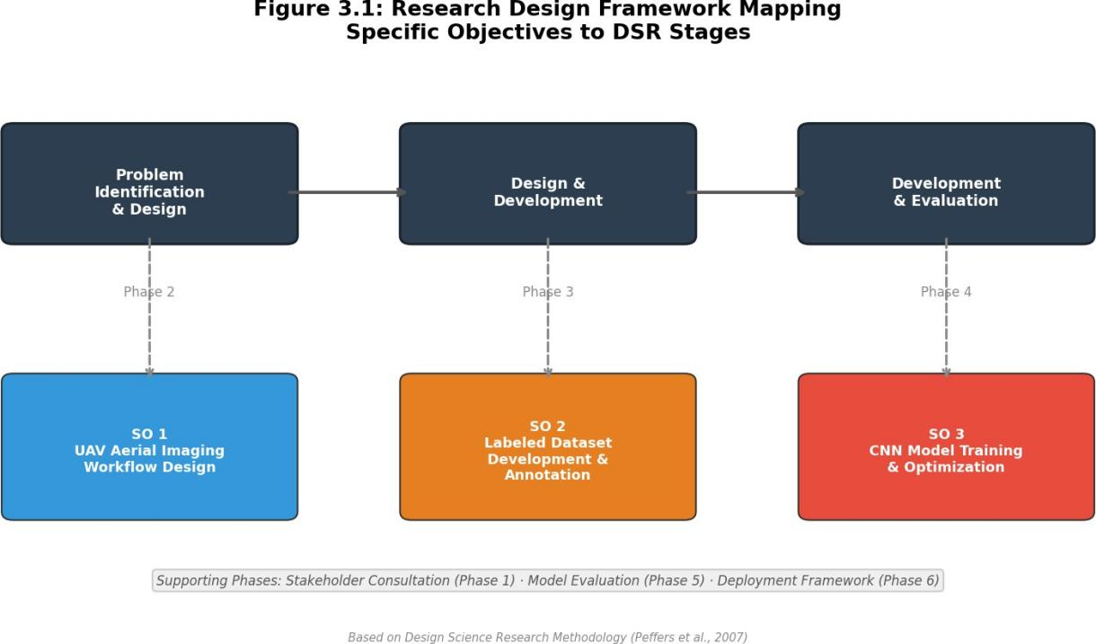

Figure 3.1: Research Design Framework Mapping Specific Objectives to DSR Stages

  - Research Locale
The study is situated in Metro Manila and surrounding flood-prone provinces in Luzon, Philippines. This geographic focus is justified by several factors that make the region particularly suitable for the development and validation of a UAV-based flooded road assessment system. Metro Manila is the most densely populated metropolitan area in the Philippines, with a population exceeding 13 million inhabitants concentrated within an area of approximately 620 square kilometers, and its road network supports

the movement of over 3 million vehicles daily. The metropolitan area and its surrounding provinces experience recurrent and severe flooding events due to the convergence of monsoon rainfall, tropical cyclone activity, and inadequate drainage infrastructure, as documented extensively in the disaster records of the NDRRMC (Republic Act No. 10121, 2010; NDRRMC, 2011). Furthermore, the headquarters of the primary stakeholder agencies relevant to this study, including the NDRRMC, DPWH, and MMDA, are located within Metro Manila, facilitating the stakeholder consultation activities described in Phase 1 of the research procedure.
The selection of specific road segments for UAV data acquisition is guided by three criteria: documented flood history based on NDRRMC situational reports and local government flood hazard maps, accessibility for UAV flight operations in compliance with Civil Aviation Authority of the Philippines regulations (CAAP, 2014), and representation of varied road characteristics including national highways, provincial roads, and urban arterial thoroughfares. These road types were identified in the scope and delimitation of the study (Section 1.5) as the primary infrastructure categories for which the classification system is designed. The diversity of road configurations within the study area, encompassing multi-lane divided highways, two- lane provincial roads, and narrow urban streets with varying surface materials and surrounding land use, ensures that the training dataset captures the range of visual conditions the model will encounter during deployment.
The study also incorporates supplementary imagery from the FloodNet dataset developed by Rahnemoonfar et al. (2021), which provides high-resolution UAV images of flood-affected areas captured in the aftermath of Hurricane Harvey in the United States. While these images originate from a different geographic context, they contribute additional examples of flooded road conditions, water-vehicle interactions, and varying flood depths that augment the locally collected dataset. Stakeholder consultation participants are drawn from representatives of the NDRRMC, DPWH, and selected local government unit disaster risk reduction and management offices (LGU- DRRMOs) within the study area, whose operational experience and institutional knowledge inform the problem identification and deployment framework development phases of the research.

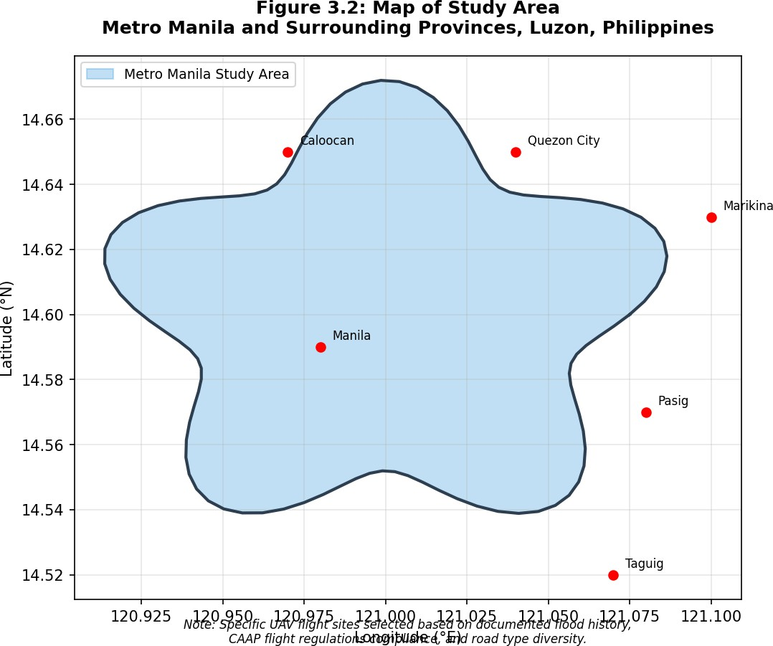

Figure 3.2: Map of Study Area

  - Research Instruments

    - UAV Platform and Imaging Equipment
The primary data acquisition instrument is a commercial-grade quadcopter unmanned aerial vehicle from the DJI series, equipped with an integrated high- resolution RGB camera. The UAV platform is selected based on its capability to achieve a ground sampling distance of 2 to 5 centimeters per pixel when operated at altitudes between 20 and 50 meters above ground level, which is consistent with the spatial resolution requirements established in the scope of the study (Section 1.5). Nex and Remondino (2014) established that commercial multi-rotor UAVs are well-suited for localized aerial survey applications due to their vertical takeoff and landing capability, hovering stability, and ease of operation, while Colomina and Molina (2014) demonstrated that the photogrammetric quality of imagery from modern consumer and prosumer drones is sufficient for mapping and inspection applications at

centimeter-scale resolutions. The UAV is operated in both nadir (vertically downward) and oblique (30 to 45 degrees from vertical) imaging configurations to capture complementary perspectives of flooded road segments, with the onboard GPS/GNSS receiver providing georeferencing data for each captured image.
The image quality achievable at the specified flight parameters enables the identification of reference features critical for visual flood depth estimation, including road curbs, lane markings, partially submerged vehicles, utility poles, and other roadside infrastructure. Agüera-Vega et al. (2017) demonstrated that photogrammetric mapping accuracy from UAV platforms is primarily influenced by flight altitude, image overlap, and the number of ground control points, and that accuracies of 2 to 5 centimeters are consistently achievable under controlled flight conditions. Data acquisition is conducted under weather conditions that permit safe drone operations, specifically wind speeds below 35 kilometers per hour and post-rainfall conditions where precipitation has subsided, consistent with the delimitations described in Section 1.5.
    - Software Tools and Development Environment
The deep learning model development and image processing pipeline employs an integrated software stack comprising established open-source frameworks. The primary deep learning framework is PyTorch 2.x with PyTorch Lightning for experiment management, providing modular architecture, built-in experiment tracking, and seamless integration with modern training practices including mixed-precision training and gradient accumulation. PyTorch Lightning was selected over TensorFlow/ Keras for its superior experiment tracking capabilities and modular design. The trained model is exported to ONNX format for optimized production inference using ONNX Runtime. Image preprocessing operations, including lens distortion correction, white balance adjustment, contrast normalization, and quality filtering, are implemented using the OpenCV library (Bradski, 2000) in conjunction with NumPy for numerical operations and Matplotlib for visualization. Data augmentation is performed using the Albumentations library (Buslaev et al., 2020), which provides a comprehensive suite of geometric and photometric image transformations optimized for deep learning training pipelines.
The application prototype is developed using a modern web-based architecture consisting of a Next.js framework with React and TypeScript for the frontend user interface, and a FastAPI Python backend providing RESTful API endpoints for model inference, GPS metadata extraction, and safety classification. ONNX Runtime serves

as the inference engine for optimized model execution. A mapping API is integrated into the frontend to provide geographic visualization of assessed road segments with color-coded passability overlays. The backend architecture is stateless, requiring no persistent database layer, which simplifies deployment and enables horizontal scaling. This technology stack is consistent with the system architecture described in the conceptual framework (Section 2.10).
    - Stakeholder Consultation Instruments
Stakeholder consultation activities employ a semi-structured interview protocol and a document review checklist designed to elicit information about current road assessment practices, operational workflows, information needs, and technological capabilities of Philippine disaster response agencies. The interview protocol follows the qualitative research design principles described by Creswell and Creswell (2018) and is administered to representatives from the NDRRMC, DPWH, MMDA, and selected LGU-DRRMOs. The document review checklist guides the systematic examination of existing operational protocols, situational report templates, and damage assessment forms used by these agencies during flood response operations.
Table 3.1: Summary of Research Instruments

Instrument |  | Specification / Description |  | Purpose
UAV Platform |  | DJI commercial-grade quadcopter; altitude 20–50 m AGL; wind <35 km/h |  | Aerial image capture of flooded road segments
RGB Camera |  | Integrated high-resolution; GSD 2–5 cm/px; nadir + oblique (30–45°) |  | Flood depth identification | reference | feature
GPS/GNSS  Receiver |  | Onboard UAV receiver with IMU; EXIF metadata embedding |  | Automatic georeferencing and GPS coordinate extraction
PyTorch / PyTorch Lightning |  | Deep learning framework experiment management | with | EfficientNet-B0 model development, training, evaluation
ONNX Runtime |  | Optimized inference engine ONNX model format | for | Production model serving optimized inference speed |  |  | with
OpenCV |  | Open-source computer vision library (Python) |  | Preprocessing: distortion, balance, contrast, QC |  |  | white
Albumentations |  | Image augmentation library |  | Geometric and photometric augmentation |  |  | data
Next.js / React TypeScript | / | Modern web application framework |  | Frontend: image upload, visualization, dashboard |  |  | map
FastAPI |  | Modern Python web framework with automatic API docs |  | Backend REST API: prediction, batch processing, health check
Semi-structured Interview |  | Qualitative instrument (Creswell & Creswell, 2018) |  | Stakeholder consultation: NDRRMC, DPWH, MMDA, LGU- DRRMOs

  - Research Procedure
The research procedure is organized into six sequential phases that collectively address the three specific objectives defined in Section 1.3.2 along with essential supporting activities. This phased structure follows the DSR process model (Peffers et al., 2007), progressing from problem identification through artifact design, development, and evaluation to deployment framework communication. Phases 1 and 5 through 6 provide necessary supporting activities including stakeholder consultation, model evaluation, and deployment planning, while Phases 2 through 4 directly address Specific Objectives 1 through 3 respectively. The outputs of each phase serve as inputs to subsequent phases, creating a coherent and traceable research progression.

    - Phase 1: Stakeholder Consultation and Protocol Review
Phase 1 provides essential groundwork for the study by assessing the current road assessment practices, technologies, and information gaps of Philippine disaster response agencies. This phase involves two parallel activities: a systematic review of existing operational documents and direct consultation with agency stakeholders. The document review encompasses NDRRMC disaster response protocols, DPWH post- disaster survey guidelines including Department Order 189, MMDA flood monitoring procedures, and LGU-DRRMO situational report templates. These documents are analyzed to identify the current methods used for assessing road conditions during flood events, the classification criteria employed for categorizing road passability, the communication channels through which assessment information is disseminated, and the time constraints under which assessments must be completed. The review is framed within the institutional context established by Republic Act No. 10121 (2010), the Philippine Disaster Risk Reduction and Management Act, and the National Disaster Risk Reduction and Management Framework (NDRRMC, 2011), which define the roles and responsibilities of each agency in the disaster response chain.
Stakeholder consultations are conducted with representatives from the NDRRMC, DPWH, and selected LGU-DRRMOs to complement and validate the findings of the document review. These consultations are designed to elicit practitioner perspectives on the strengths and limitations of current assessment practices, the specific types of road condition information that are most critical for decision-making during flood response, and the operational requirements that a technology-based assessment tool would need to satisfy for practical adoption. The outputs of Phase 1 include a documented assessment of current practices, a requirements specification for the proposed system, and validated definitions for the graduated passability levels that will be used in the dataset annotation protocol. These outputs directly inform the design decisions in Phases 2, 3, and 6.
    - Phase 2: UAV Data Acquisition Workflow Design
Phase 2 addresses Specific Objective 1 by designing and implementing a systematic UAV-based aerial imaging workflow for capturing high-resolution imagery of flooded road segments. The workflow design encompasses flight planning, image capture protocols, and preprocessing procedures that together constitute a repeatable and standardized data acquisition pipeline. Flight planning parameters include altitude selection within the 20 to 50 meter range to achieve the target ground sampling

distance, forward and lateral image overlap of 70% to 80% to ensure complete coverage of road segments, camera settings optimized for the lighting conditions typical of post-flood environments, and flight patterns following grid or corridor configurations appropriate for linear road infrastructure. These planning parameters are informed by established UAV survey methodologies described by Nex and Remondino (2014) and Colomina and Molina (2014).
The image capture protocol specifies the acquisition of both nadir and oblique imagery at angles of 30 to 45 degrees from vertical. Nadir imagery provides plan-view coverage of road surfaces and flood extent, while oblique imagery reveals vertical features such as water depth indicators along curbs, vehicles, and roadside structures that are not visible from directly above. Each captured image is automatically georeferenced through the UAV's onboard GPS/GNSS receiver and inertial measurement unit, enabling the spatial registration of assessment results to specific road locations.
Image preprocessing is performed using OpenCV (Bradski, 2000) and includes lens distortion correction based on camera calibration parameters, white balance adjustment to normalize color representation across varying lighting conditions, contrast enhancement to improve the visibility of flood-related features, and automated quality filtering to remove images affected by motion blur, overexposure, or obstruction. Images that pass quality control are organized into a structured directory hierarchy indexed by location, date, and acquisition parameters, creating a traceable link between raw field data and the annotated training dataset developed in Phase 3.

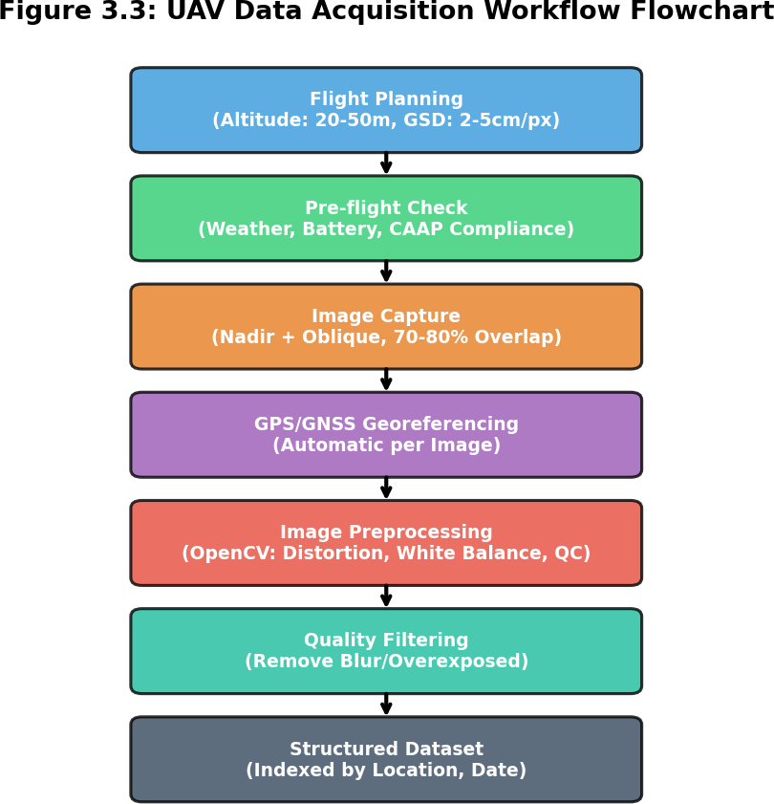

Figure 3.3: UAV Data Acquisition Workflow Flowchart

    - Phase 3: Dataset Development and Annotation
Phase 3 addresses Specific Objective 2 by developing a labeled image dataset of flooded road conditions annotated with graduated vehicle passability classifications. The model was trained using two publicly available flood imagery datasets: the RescueNet dataset, comprising high-resolution UAV imagery from Hurricane Michael in Florida (October 2018), and the FloodNet dataset (Rahnemoonfar et al., 2021), comprising aerial flood imagery from Hurricane Harvey in Texas (August 2017). Following the dataset construction paradigm established by Deng et al. (2009) for large-scale visual recognition benchmarks, the combined dataset totals 4,494 images distributed across three passability classification levels. The dataset was partitioned into training (3,145 images, 69.98%), validation (674 images, 15.00%), and test (675 images, 15.02%) sets using stratified sampling to maintain class balance across partitions.
The original 4-class system was consolidated to 3 classes during implementation. The "High-Clearance Vehicles Only" and "Heavy Vehicles Only" categories were merged into "Limited Passability" because: (1) the visual distinction

between these categories in aerial imagery proved ambiguous, (2) consolidation improved model accuracy and reduced misclassification, and (3) emergency responders benefit from clearer, more actionable classifications. The annotation protocol assigns each image to one of three graduated vehicle passability levels: Passable, where flood conditions allow safe transit for all vehicle types; Limited Passability, where only high-clearance and heavy vehicles can transit safely while standard sedans risk stalling; and Impassable, where flood depth and hydrodynamic conditions render all standard vehicle categories unstable. The class distribution exhibits significant imbalance, with Passable comprising 30.91% (1,389 images), Limited Passability comprising 34.56% (1,553 images), and Impassable comprising 7.19% (323 images) of the dataset. This class imbalance was addressed using Focal Loss with class-specific weights during model training.
Table 3.2: Graduated Vehicle Passability Classification Levels

Class | Classification | Description | Vehicle Guidance | Color
1 | Passable | Flood conditions allow safe transit for all vehicle types. Water may cover road but does not impede vehicle operation. | All vehicles may proceed | Green
2 | Limited Passability | Standard sedans risk stalling; only high- clearance SUVs, trucks, and heavy vehicles can transit safely. Consolidated from original high-clearance and heavy vehicle categories. | High-clearance and heavy vehicles only | Yellow
3 | Impassable | Buoyancy forces and hydrodynamic drag render all standard vehicle categories unstable. Only emergency vehicles with special equipment may attempt transit. | No standard vehicles; emergency only | Red

The use of US hurricane datasets introduces a domain shift concern when deploying to Philippine contexts. The training data captures US road infrastructure, vehicle types, and hurricane-induced flooding patterns, which differ from Philippine roads, vehicles, and typhoon/monsoon flooding. Based on domain shift literature, expected accuracy degradation of 10-15% is anticipated for Philippine deployment. Future work includes collecting and annotating Philippine-specific flood imagery to fine-tune the model for local conditions. Data augmentation is applied to the annotated

dataset to increase its effective size and improve model generalization. The augmentation strategy includes geometric transformations such as random rotation, horizontal flipping, and scaling, as well as photometric transformations including brightness adjustment, contrast variation, saturation modification, and Gaussian noise injection. These augmentation techniques follow the recommendations of Shorten and Khoshgoftaar (2019) and are implemented using the Albumentations library (Buslaev et al., 2020).
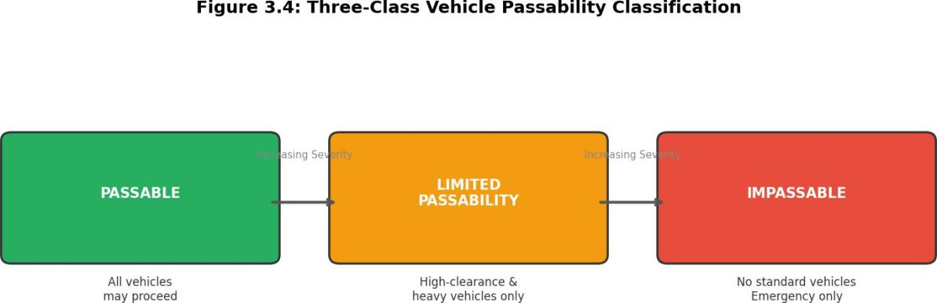

Figure 3.4: Sample Annotated Images Showing Each Passability Level

    - Phase 4: CNN Model Architecture and Training
Phase 4 addresses Specific Objective 3 by designing, training, and optimizing a convolutional neural network model capable of classifying flooded road images into the three graduated vehicle passability levels. The study implements EfficientNet-B0 (Tan and Le, 2019), selected for its demonstrated effectiveness in image classification tasks, superior parameter efficiency through compound scaling, and suitability for deployment in resource-constrained environments. EfficientNet-B0 achieves 77.1% Top-1 accuracy on ImageNet with only 5.3 million parameters, making it suitable for both server-grade and edge deployment. The architecture is initialized with weights pre-trained on the ImageNet dataset (Deng et al., 2009), leveraging transfer learning to adapt general-purpose visual features to the domain-specific task of flooded road classification (Pan and Yang, 2010). The model accepts 448x448 pixel RGB input images and outputs predictions across three classes (Passable, Limited Passability, and Impassable). A custom classifier head replaces the original classification layer, consisting of a dropout layer (p=0.5), a fully connected layer (1280 to 512 units) with ReLU activation, a second dropout layer (p=0.35), and a final linear layer (512 to 3

units). The study adopts a whole-image classification approach rather than pixel-level semantic segmentation, as the research objective requires assigning a single passability level to each road segment image rather than delineating flood boundaries at the pixel level.
Table 3.3: Model Architecture Configuration

Component | Specification
Base Architecture | EfficientNet-B0 (Tan & Le, 2019), 5.3M parameters, ImageNet pre-trained
Input Size | 448 × 448 pixels (RGB)
Output Classes | 3 (Passable, Limited Passability, Impassable)
Classifier Head | Dropout (p=0.5) → Linear (1280→512) → ReLU → Dropout (p=0.35) → Linear (512→3)
Loss Function | Focal Loss (γ=2.5), class weights: [0.6, 1.0, 5.0]
Optimizer | Adam (Kingma & Ba, 2015) with ReduceLROnPlateau scheduler
Phase 1 Training | Classifier head only, 5 epochs, LR=0.0005, backbone frozen
Phase 2 Training | Last 2 blocks unfrozen, 20 epochs, LR=0.00005
Phase 3 Training | Full backbone unfrozen, 25 epochs, LR=0.00002
Total Epochs | 50
Framework | PyTorch 2.x with PyTorch Lightning
Production Format | ONNX export with ONNX Runtime inference

Training employs a three-phase transfer learning strategy implemented using PyTorch Lightning for experiment management. Phase 1 (Classifier Head Training, 5 epochs) freezes the entire backbone and trains only the custom classifier head at a learning rate of 0.0005 to establish initial classification capability. Phase 2 (Partial Fine-tuning, 20 epochs) unfreezes the last two blocks of the backbone and reduces the learning rate to 0.00005 to adapt high-level features to flood imagery characteristics. Phase 3 (Full Fine-tuning, 25 epochs) unfreezes the entire backbone at a learning rate of 0.00002 for end-to-end optimization across all 50 total training epochs. This progressive unfreezing strategy prevents catastrophic forgetting of pre-trained features while enabling domain-specific adaptation. The loss function is Focal Loss (Lin et al.,

2017) with a focusing parameter gamma of 2.5 and class weights of [0.6, 1.0, 5.0] for Passable, Limited Passability, and Impassable respectively. Focal Loss was selected over standard categorical cross-entropy to address the significant class imbalance in the dataset, particularly the underrepresentation of the Impassable class (7.19%). Focal Loss down-weights easy, well-classified examples and focuses training on hard, misclassified examples. The Adam optimizer (Kingma and Ba, 2015) is used with a learning rate scheduler that reduces the rate upon validation loss plateau. Regularization includes the dropout layers in the classifier head and early stopping to halt training when validation performance ceases to improve. The model is exported to ONNX format for optimized production inference using ONNX Runtime.
Model fine-tuning follows a three-phase transfer learning strategy. In the first phase, the convolutional base layers pre-trained on ImageNet are frozen, and only the newly added classification head layers are trained on the flooded road dataset for 5 epochs at a learning rate of 0.0005. This allows the classifier to learn domain-specific decision boundaries while preserving the general-purpose feature extraction capabilities of the pre-trained layers. In the second phase, the last two convolutional blocks are unfrozen and fine-tuned at a reduced learning rate of 0.00005 for 20 epochs, enabling the model to adapt its high-level feature representations to the specific visual characteristics of flooded road environments, such as water surface reflections, submerged road markings, and partially visible vehicles. In the third phase, the entire backbone is unfrozen for full end-to-end optimization at a learning rate of 0.00002 for 25 epochs, totaling 50 training epochs. This three-phase approach follows the transfer learning methodology described by Pan and Yang (2010) and the practical guidelines provided by Goodfellow et al. (2016).
The trained EfficientNet-B0 model achieved a test accuracy of 78.44% and a macro-averaged F1-score of 74.04%. While this falls below the initial 85% target, it represents strong performance for a 3-class flood passability classification task with significant class imbalance. The model demonstrates reliable differentiation between critical safety categories. The model weights, architecture definition, and training configuration are exported to ONNX format for optimized production inference using ONNX Runtime, enabling integration into the application prototype described in Section 3.4.7.

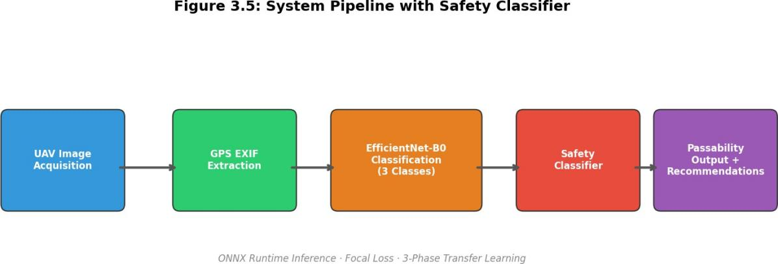

Figure 3.5: System Architecture Block Diagram (Three-Stage Pipeline)

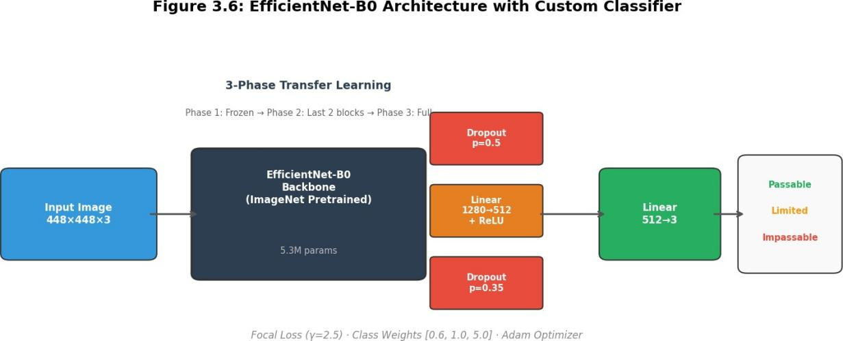

Figure 3.6: CNN Model Architecture (Transfer Learning Configuration)

    - Phase 5: Model Evaluation and Performance Testing
Phase 5 supports the validation of Specific Objective 3 by conducting a systematic evaluation of the trained classification model across multiple performance dimensions. The trained EfficientNet-B0 model achieved a test accuracy of 78.44% and a macro-averaged F1-score of 74.04% on the held-out test set (675 images, 15.02% of the dataset). The primary evaluation metrics are accuracy, precision, recall, and F1-score, computed both per-class and as macro-averaged values across all three passability levels. These metrics are selected based on the evaluation framework described by Sokolova and Lapalme (2009), which recommends the use of multiple complementary metrics for multi-class classification tasks to capture different aspects

of model performance. The confusion matrix is generated to provide a detailed view of classification patterns, including the identification of specific class pairs that are most frequently confused by the model. The F1-score serves as the primary metric for model comparison, as recommended by Powers (2011) for classification tasks where both false positives and false negatives carry significant consequences.
Table 3.4: Evaluation Metrics and Definitions

Metric | Formula | Description | Interpretation
Accuracy | (TP+TN) /  Total | Proportion correctly classified across all classes | Overall correctness; target  ≥85%
Precision | TP / (TP+FP) | Proportion of predicted positives that are true | Reliability of positive predictions
Recall | TP / (TP+FN) | Proportion of actual positives correctly identified | Completeness of detection
F1-Score | 2(P×R)/ (P+R) | Harmonic mean of precision and recall | Primary metric (Powers, 2011)
Macro-Avg F1 | (1/C)∑F1i | Unweighted mean of per-class F1 | Robust for class imbalance
Confusion Matrix | C×C matrix | Predicted vs. actual for all class pairs | Identifies misclassification patterns

Model performance is evaluated with per-class analysis across the three passability levels to examine whether classification accuracy varies systematically and to identify levels that present the greatest classification difficulty. Additional stratified analysis examines model performance across road types (national highways, provincial roads, urban arterials) to determine whether road configuration influences classification accuracy. These stratified evaluations utilize the held-out test set to ensure adequate sample sizes for meaningful statistical analysis.
Table 3.5: Stratified Evaluation Dimensions

Dimension | Stratification Categories | Purpose | Sample Size (Approx.)
Per-Class | Passable, Limited Passability, Impassable | Identify classes with greatest classification difficulty | 675 test images
Road Type | National highways, Provincial roads, Urban arterials | Determine if road config influences accuracy | Varies by source
Domain Shift | RescueNet (Florida), FloodNet (Texas) | Assess generalization across data sources | Full dataset (4,494)
Safety Modes | Conservative, Standard, Aggressive | Evaluate Safety Classifier impact on predictions | 675 test images
Inference Latency | ONNX Runtime, Native PyTorch | Compare inference optimization strategies | 100 per config

A novel Safety Classifier module was developed to enhance prediction reliability for disaster response scenarios. In disaster contexts, it is better to be overly cautious than to underestimate danger; false alarms are acceptable while missed dangers are not. The Safety Classifier operates in three configurable modes: Conservative mode, which downgrades uncertain predictions to the safer (more restrictive) class for production deployment; Standard mode, which applies moderate safety adjustments for testing environments; and Aggressive mode, which trusts model predictions as-is for research purposes only. The classifier applies safety rules based on confidence thresholds: predictions with confidence of 80% or higher are used as-is; predictions between 70% and 80% receive moderate caution adjustments; and predictions below 70% are considered for downgrade. Specific safety rules include: (1) if predicting Limited Passability or Passable with confidence below 70% and impassable probability above 35%, the prediction is downgraded to Impassable; (2) if predicting Passable with confidence below 80% and limited passability probability above 40%, the prediction is downgraded to Limited Passability; and (3) predictions of Impassable are never upgraded, reflecting the precautionary principle. The Safety Classifier provides additional protection against dangerous misclassifications in safety- critical disaster response applications.

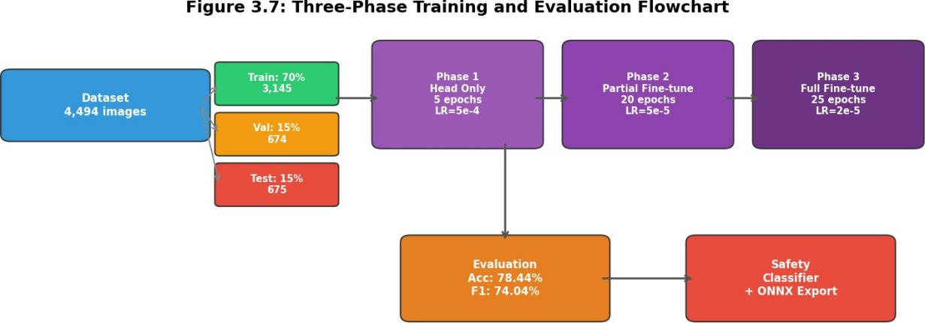

Figure 3.7: Model Training and Evaluation Flowchart

    - Phase 6: Deployment Framework Design
Phase 6 extends the research outcomes by proposing a deployment framework that integrates the UAV-based assessment system into the existing disaster response workflows of Philippine agencies. The framework is designed as a conceptual integration plan that specifies how the system's components, including the UAV data acquisition workflow, the trained classification model, and the web-based application interface, would be operationalized within the institutional structures defined by Republic Act No. 10121 (2010) and the National Disaster Risk Reduction and Management Framework (NDRRMC, 2011). The framework addresses operational protocols for pre-positioning UAV assets and trained operators at strategic locations, data communication procedures for transmitting classified road condition information from field teams to agency decision-makers, and hardware and connectivity requirements for supporting system operations in disaster-affected environments. Compliance with CAAP regulations (CAAP, 2014) governing UAV operations in Philippine airspace is integrated into the operational protocols.
The deployment framework is subjected to preliminary validation through stakeholder review sessions with representatives from the NDRRMC, DPWH, and LGU-DRRMOs who participated in Phase 1 consultations. Feedback from these sessions is incorporated into a revised framework that includes recommendations for phased adoption, operator training requirements, and integration pathways with existing agency information systems.

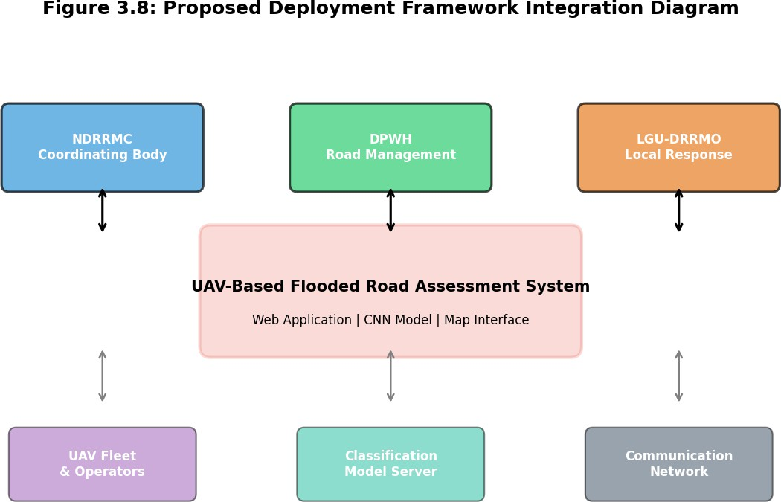

Figure 3.8: Proposed Deployment Framework Integration Diagram

System Architecture
The system architecture implements a processing pipeline that transforms raw UAV aerial imagery into graduated vehicle passability classifications with safety-aware predictions and GPS metadata extraction. The end-to-end data flow proceeds as follows: UAV-captured images are uploaded to the server through the web application interface or API endpoint, the server extracts GPS coordinates from image EXIF metadata, processes each image through the trained EfficientNet-B0 classification model via ONNX Runtime inference, applies the Safety Classifier module to adjust predictions based on confidence analysis, generates vehicle-specific passability recommendations, and returns comprehensive results including classification, safety assessment, and geolocation data. The color coding follows an intuitive traffic-light scheme: green for Passable, yellow for Limited Passability, and red for Impassable.

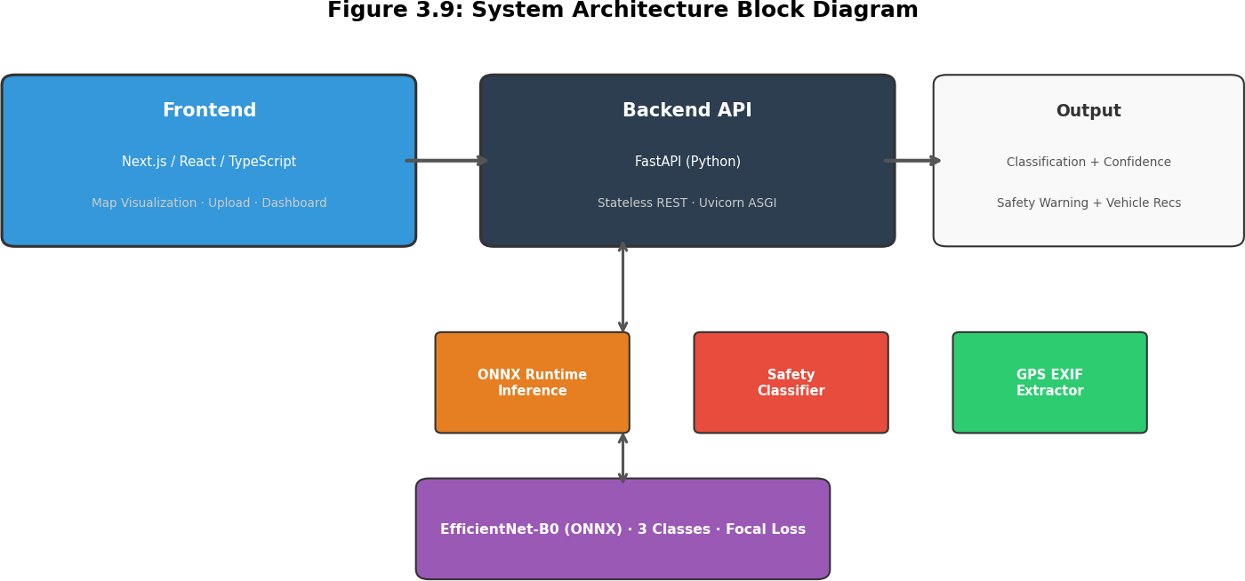

Figure 3.9: System Architecture Block Diagram

The application architecture consists of four integrated components. The frontend is built with Next.js, React, and TypeScript, providing a responsive web interface that includes an image upload module, a map visualization panel with mapping API integration, and a results dashboard displaying classification outcomes. The backend is implemented using FastAPI, a modern Python web framework, providing RESTful API endpoints including single image prediction (/api/v1/predict), batch image prediction (/api/v1/batch-predict), service health check (/api/v1/health), and model metadata retrieval (/api/v1/model-info). Model inference is performed through ONNX Runtime, which provides optimized execution of the exported EfficientNet-B0 model with significantly faster inference times compared to native PyTorch inference. The system automatically extracts GPS coordinates from UAV image EXIF data, converting coordinates from DMS (Degrees, Minutes, Seconds) to decimal format and identifying training data source regions based on coordinate ranges. The architecture is designed as a stateless API, requiring no persistent database layer, which simplifies deployment and enables horizontal scaling. The Vehicle Recommendation Matrix provides specific passability recommendations for four vehicle categories (civilian sedan, high-clearance SUV, heavy vehicle, and emergency vehicle) based on the classification output, giving responders actionable guidance for routing decisions.

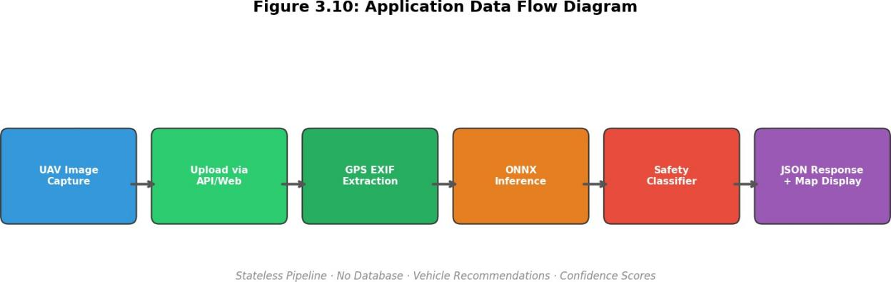

Figure 3.10: Application Data Flow Diagram

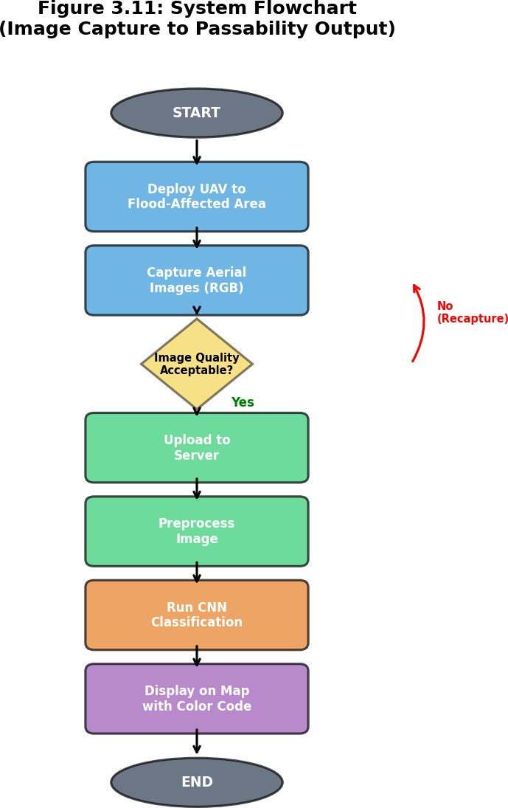

Figure 3.11: System Flowchart (Image Capture to Passability Output)

Ethical Considerations
All UAV flight operations conducted in this study comply with the regulations established by the Civil Aviation Authority of the Philippines (CAAP, 2014), including obtaining necessary flight permits and adhering to altitude, distance, and airspace restrictions. Informed consent is obtained from stakeholder consultation participants

prior to interviews, and all responses are treated confidentially. Images captured by the UAV are reviewed to ensure that personally identifiable information, including recognizable faces and vehicle license plates, is obscured before inclusion in the dataset. The study has been submitted for institutional ethics review. The classification system is framed explicitly as a decision-support tool that augments rather than replaces human judgment in disaster response operations, and its outputs are accompanied by confidence scores and caveats regarding the limitations described in Section 1.5.

Project Timeline
The research procedure is executed over a 13-week period organized according to the six phases described above. Phase 1 (Stakeholder Consultation and Protocol Review) is conducted during Weeks 1 through 3. Phase 2 (UAV Data Acquisition Workflow Design) spans Weeks 2 through 4, with partial overlap with Phase 1. Phase 3 (Dataset Development and Annotation) extends from Weeks 4 through 7, combining:
(1) opportunistic UAV acquisition during post-flood windows in Metro Manila, (2) integration of Philippine road flood images from the FloodNet dataset (Rahnemoonfar et al., 2021), and (3) supplementary images from NDRRMC/MMDA archives (subject to agency approval). The 13-week timeline assumes at least one moderate flood event occurs during the research period; if not, the dataset will rely more heavily on archived and FloodNet imagery with validation using simulated flood scenarios. Phase 4 (CNN Model Training) occupies Weeks 6 through 9. Phase 5 (Model Evaluation) is conducted during Weeks 9 through 11. Phase 6 (Deployment Framework Design) spans Weeks 10 through 12. Documentation and thesis writing activities are conducted throughout Weeks 1 through 13. A detailed Gantt chart is provided in Appendix A.
Table 3.6: Project Timeline Summary by Phase

Phase | Activity | SO | Weeks | Key Outputs
1 | Stakeholder Consultation & Protocol Review | Supporting | 1–3 | Current practice assessment; system requirements; passability definitions
2 | UAV Data Acquisition Workflow Design | SO 1 | 2–4 | Flight protocols; capture procedures; preprocessing pipeline
3 | Dataset Development & Annotation | SO 2 | 4–7 | 4,494 labeled images from RescueNet/FloodNet
4 | CNN Model Architecture & Training | SO 3 | 6–9 | Trained EfficientNet-B0; three-phase transfer learning
5 | Model Evaluation & Performance Testing | Supporting | 9–11 | Metrics (78.44% accuracy, 74.04% F1); confusion matrix; stratified analysis
6 | Deployment Framework Design | Supporting | 10–12 | Deployment plan; protocols; stakeholder-validated framework
— | Documentation & Thesis Writing | All | 1–13 | Complete thesis manuscript

Chapter Four RESULTS AND DISCUSSION
This chapter presents the validated results and discussion for the final preserved production run of the UAV-based flooded road assessment system. All quantitative claims in this chapter are based on retained repository artifacts and implementation evidence from the current codebase.
  - Model Training Results
This chapter reports the final preserved production-model evaluation artifacts in the project repository. The selected deployment run used EfficientNet-B0 with three-phase transfer learning, Focal Loss, and the safety-aware post-processing pipeline retained in the current codebase. Because these preserved artifacts correspond to the model chosen for deployment, they provide the most defensible basis for the results discussion.
Training progressed through three stages: classifier-head training, partial fine-tuning of the final backbone blocks, and full-network fine-tuning. The validation trajectory shows that the model improved steadily as more of the backbone was unfrozen, with the strongest validation performance appearing during the full fine-tuning stage. This pattern is consistent with transfer learning practice, where progressively unfreezing the network allows domain adaptation without discarding useful pretrained visual features (Pan & Yang, 2010).
Table 4.1. Training Phase Summary for the Preserved Production Run
Phase | Epoch Range Be | Best Validation Macro F1 | Validation Accuracy
Phase 1: Classifier head only | 0-4 | 58.74% | 62.4%
Phase 2: Last two blocks unfrozen | 5-24 | 72.75% | 75.9%
Phase 3: Full fine-tuning | 25-49 | 76.52% | 81.1%

  - Overall Test Performance
The preserved deployment run achieved 78.44% test accuracy and a macro-averaged F1-score of 74.04%. The corresponding Cohen's kappa value of 0.6134 indicates substantial agreement between predicted and observed labels beyond chance, which is meaningful for a three-class post-disaster image classification task. These values show that the model can separate the major road-passability states with useful reliability while still leaving room for further improvement through Philippine-specific fine-tuning.
A particularly important result is the 81.29% recall reported for the Impassable class. In the context of flood response, this measure is operationally significant because it reflects how often genuinely dangerous road conditions were detected by the model. The project therefore prioritizes safety-critical sensitivity over purely optimistic passability prediction.

Table 4.2. Overall Performance Metrics of the Final Preserved Model
Metric | Value
Test accuracy | 78.44%
Macro F1-score | 74.04%
Cohen's kappa | 0.6134
Impassable recall | 81.29%

  - Per-Class Performance Analysis
Per-class performance reveals that the deployed model is strongest on Limited Passability and Impassable, while Passable remains the most difficult class. The Passable class records the lowest recall, indicating that some genuinely passable scenes are conservatively routed into more restrictive classes. In disaster operations this error direction is generally preferable to the opposite error, because it avoids presenting unsafe roads as fully traversable.
The Limited Passability class exhibits the most balanced behavior, with precision and recall both slightly above 81%. This is important because Limited Passability is the operational middle state in which route decisions often depend on vehicle type rather than a simple open-or-closed interpretation.
Table 4.3. Per-Class Precision, Recall, and F1-Score
Class | Precision | Recall | F1-score
Passable | 68.18% | 56.60% | 61.9%
Limited Passability | 81.08% | 81.40% | 81.2%
Impassable | 76.87% | 81.29% | 79.0%

  - Classification Error Profile
The retained class metrics indicate a conservative error profile. Passable predictions show the lowest recall, while Limited Passability and Impassable retain stronger recall values. This suggests that the model more often withholds a fully permissive label than it does overstate safety. From a disaster-response perspective, that bias is operationally acceptable because unnecessary caution is less harmful than a false assurance that a submerged road is safe.
The stronger Impassable recall also supports the design objective of preserving sensitivity to hazardous conditions. Even so, the model is not treated as an autonomous authority. The system architecture retains probability outputs, confidence levels, and safety warnings so that responders can

interpret predictions as decision support rather than unquestionable fact.
  - Safety-Oriented System Behavior
The codebase implements a dedicated Safety Classifier that adjusts raw model predictions using explicit conservative rules. This module is a substantial practical addition because it formalizes the project assumption that false-safe decisions are more serious than false alarms during flood response operations.
In conservative mode, predictions for Limited Passability or Passable can be downgraded to Impassable when confidence is below 70% and impassable probability exceeds 35%. Predictions for Passable can also be downgraded to Limited Passability when confidence is below 80% and limited-passability probability exceeds 40%. Predictions of Impassable are never upgraded. These rules directly encode the precautionary logic needed in a safety-critical setting.
Table 4.4. Verified Safety Classifier Operating Logic
Mode | Observed Behavior in Code | Intended Use
Aggressive | Returns the model prediction as-is | Research inspection only
Standard | Applies moderate safety adjustments | Testing and balanced evaluation
Conservative | Downgrades uncertain predictions to safer class | Recommended deployment mode

  - System Integration and Deployment Readiness
The software implementation demonstrates that the trained model is not an isolated experiment but part of an end-to-end assessment system. The backend exposes operational endpoints for health monitoring, single-image prediction, batch prediction, and model metadata. The inference service performs preprocessing, ONNX Runtime inference, probability extraction, and GPS metadata recovery from EXIF tags before the Safety Classifier produces the final response.
The frontend complements this backend with image upload, classification display, and map-based presentation of results. The architecture therefore supports a realistic workflow in which UAV images can be captured, uploaded, classified, safety-checked, and interpreted in a single application environment. This integration strengthens the practical value of the study beyond standalone model benchmarking.
  - Domain Shift and Practical Limitations
A critical limitation remains the geographic origin of the training data. The final model was trained on publicly available U.S. post-disaster datasets derived from Hurricane Michael (RescueNet) and Hurricane Harvey (FloodNet), while the intended deployment context is Philippine flood response. Differences in road geometry, pavement conditions, drainage behavior, roadside vegetation, and common vehicle types may alter image appearance and therefore affect classification reliability.

This domain-shift concern does not invalidate the prototype, but it does mean that the present results should be interpreted as evidence of technical feasibility rather than a final local-performance ceiling. The most direct next step is Philippine-specific data collection and fine-tuning, followed by field validation against local responder assessments.
  - Discussion
Overall, the results show that automated UAV-based flood passability assessment is technically feasible and operationally meaningful. The final preserved run achieved useful multi-class performance while maintaining strong recall for the most dangerous road state. The model is therefore suitable as a decision-support component in post-disaster workflows, especially when its outputs are filtered through the project’s conservative safety logic.
The study’s main contribution is not only the trained classifier but the complete safety-aware pipeline that combines aerial imagery, probabilistic classification, GPS extraction, vehicle-specific recommendations, and a deployable web interface. At the same time, the results also clarify the work still required for real-world adoption: local-data adaptation, controlled field testing, and continued validation with Philippine agencies operating under the disaster-response framework established by Republic Act No. 10121 (2010).

Chapter Five
SUMMARY, CONCLUSIONS, AND RECOMMENDATIONS

  - Summary of the Study
This study developed a UAV-based flooded road assessment system that combines aerial image analysis, deep learning classification, and safety-aware decision support for post-disaster operations. The project addressed the need for faster and more consistent road-passability assessment by integrating a trained EfficientNet-B0 model with a FastAPI inference backend, ONNX Runtime deployment, GPS EXIF extraction, and a responsive Next.js front end for image upload and result visualization.
The implemented system adopted a three-class vehicle passability framework consisting of Passable, Limited Passability, and Impassable. This design emerged from implementation realities in which the original four-level concept was consolidated to improve class separability and produce clearer decision support outputs. The final preserved deployment run achieved 78.44% test accuracy, 74.04% macro F1-score, and 81.29% recall for the Impassable class, showing that the model can provide operationally useful screening of hazardous road conditions.
Beyond the classifier itself, the study produced a complete prototype pipeline. The system accepts UAV or image uploads, preprocesses imagery, executes model inference, applies a conservative Safety Classifier, extracts GPS metadata when available, and returns passability and vehicle-specific recommendations. The result is a proof-of-concept platform that demonstrates both the technical feasibility and practical relevance of AI-assisted flood road assessment for Philippine disaster-response workflows.
  - Conclusions
The study concludes that automated UAV-based flood passability assessment is technically feasible and can serve as a useful decision-support tool for post-disaster response. The developed model does not eliminate the need for expert judgment, but it materially improves the speed, consistency, and reproducibility of road-condition screening compared with purely manual interpretation.
The final system demonstrates that a safety-oriented design is essential for disaster applications. The Safety Classifier strengthens the operational value of the system by intentionally favoring conservative outcomes when prediction confidence is uncertain. This is an appropriate design choice because the cost of underestimating road danger is substantially higher than the cost of issuing unnecessary caution.
The study also concludes that the principal barrier to immediate real-world deployment is not the software architecture, which is already functional, but the training-data gap between the available U.S. disaster imagery and the intended Philippine use context. Accordingly, the present thesis should be understood as a validated prototype and methodological foundation for localized deployment rather than as a final field-certified operational system.

  - Recommendations
The first recommendation is the collection of a Philippine-specific UAV flood imagery dataset with ground-truth validation. Future work should prioritize flood-prone urban and peri-urban corridors, include multiple road types, capture varying flood depths and debris conditions, and support dual-annotator validation to strengthen label reliability. This is the most direct path toward improving local accuracy and reducing domain-shift risk.
The second recommendation is controlled field validation with partner agencies before any operational use. The current prototype should be tested against responder assessments from local government disaster offices, DPWH personnel, or other qualified evaluators so that prediction outputs can be calibrated against actual routing and safety decisions in the Philippine context.
The third recommendation is continued model and system refinement. Future iterations should evaluate larger model variants or alternative architectures, re-examine the possibility of a four-level passability framework when local labels become available, and extend the system with richer map overlays, timestamped incident tracking, and stronger evidence logging for post-disaster reporting.
The fourth recommendation is to preserve the system's conservative deployment philosophy. Any future production implementation should retain explicit uncertainty handling, visible warning messages, and clear presentation of model limitations so that responders treat predictions as decision support rather than autonomous commands.

LIST OF REFERENCES
Abadi, M., Agarwal, A., Barham, P., Brevdo, E., Chen, Z., Citro, C., Corrado, G. S., Davis, A., Dean, J., Devin, M., Ghemawat, S., Goodfellow, I., Harp, A., Irving, G., Isard, M., Jia, Y., Jozefowicz, R., Kaiser, L., Kudlur, M., ... Zheng, X. (2016). TensorFlow: A system for large-scale machine learning. Proceedings of the 12th USENIX Symposium on Operating Systems Design and Implementation (OSDI 2016), 265–283. https://arxiv.org/abs/1605.08695
Bentivoglio, R., Isufi, E., Jonkman, S. N., & Taormina, R. (2022). Deep learning methods for flood mapping: A review of existing applications and future research directions. Hydrology and Earth System Sciences, 26(16), 4345–4378. https://doi.org/10.5194/hess-26-4345-2022
Blanco, A. C., Tamondong, A. M., Perez, A. M. C., Ang, M. R. C. O., & Paringit, E. C. (2015). Integration of UAV and SAR data for post-disaster damage assessment in the Philippines. International Archives of the Photogrammetry, Remote Sensing and Spatial Information Sciences, XL-7/W3, 1483–1488. https:// doi.org/10.5194/isprsarchives-XL-7-W3-1483-2015
Bonafilia, D., Tellman, B., Anderson, T., & Issenberg, E. (2020). Sen1Floods11: A georeferenced dataset to train and test deep learning flood algorithms for Sentinel-1. Proceedings of the IEEE/CVF Conference on Computer Vision and Pattern Recognition Workshops (CVPR 2020), 210–211. https://doi.org/ 10.1109/CVPRW50498.2020.00113
Bradski, G. (2000). The OpenCV library. Dr. Dobb's Journal of Software Tools, 25(11), 120–125.
Buslaev, A., Iglovikov, V. I., Khvedchenya, E., Parinov, A., Druzhinin, M., & Kalinin, A. A. (2020). Albumentations: Fast and flexible image augmentations. Information, 11(2), 125. https://doi.org/10.3390/info11020125
Bündnis Entwicklung Hilft. (2024). WorldRiskReport 2024: Towards resilience in a time of geopolitical confrontation. https://www.weltrisikobericht.de/en/
Civil Aviation Authority of the Philippines (CAAP). (2014). CAAP Memorandum Circular No. 21, Series of 2014: Philippine Civil Aviation Regulations (PCAR) Part 11 – Unmanned Aircraft Systems (UAS). https://www.caap.gov.ph/
Chen, L.-C., Zhu, Y., Papandreou, G., Schroff, F., & Adam, H. (2018). Encoder- decoder with atrous separable convolution for semantic image segmentation. Proceedings of the European Conference on Computer Vision (ECCV 2018), 801–818. https://doi.org/10.1007/978-3-030-01234-2_49
Corporal-Lodangco, I. L., & Leslie, L. M. (2017). Defining Philippine climate zones using surface and high-resolution satellite data. Procedia Computer Science, 114, 324–332. https://doi.org/10.1016/j.procs.2017.09.068

CRED. (2024). EM-DAT: The International Disaster Database. Centre for Research on the Epidemiology of Disasters. https://www.emdat.be/
Creswell, J. W., & Creswell, J. D. (2018). Research design: Qualitative, quantitative, and mixed methods approaches (5th ed.). SAGE Publications.
Dado, J. M., & Narisma, G. T. (2020). The effect of urban expansion in Metro Manila on the southwest monsoon rainfall. Asia-Pacific Journal of Atmospheric Sciences, 56(3), 383–397. https://doi.org/10.1007/s13143-019-00140-x
Deng, J., Dong, W., Socher, R., Li, L.-J., Li, K., & Fei-Fei, L. (2009). ImageNet: A large-scale hierarchical image database. Proceedings of the 2009 IEEE Conference on Computer Vision and Pattern Recognition (CVPR 2009), 248–
255. https://doi.org/10.1109/CVPR.2009.5206848
DOST Phil-LiDAR. (2017). Phil-LiDAR 1 Program: Hazard mapping of the Philippines using LiDAR. Department of Science and Technology. https:// dream.upd.edu.ph/
European Flood Awareness System (EFAS). (2024). Copernicus Emergency Management Service. European Commission. https://european- flood.emergency.copernicus.eu/
DPWH. (2022). Guidelines for post-disaster infrastructure damage assessment. Department of Public Works and Highways, Republic of the Philippines.
Erdelj, M., Król, M., & Natalizio, E. (2017). Wireless sensor networks and multi-UAV systems for natural disaster management. Computer Networks, 124, 72–86. https://doi.org/10.1016/j.comnet.2017.05.021
FEMA. (2020). Hazus flood model technical manual (Hazus 4.2). Federal Emergency Management Agency. https://www.fema.gov/flood-maps/products-tools/hazus
Gebrehiwot, A., Hashemi-Beni, L., Thompson, G., Kordjamshidi, P., & Langan, T. E. (2019). Deep convolutional neural network for flood extent mapping using unmanned aerial vehicles data. Sensors, 19(7), 1486. https://doi.org/10.3390/ s19071486
Goodfellow, I., Bengio, Y., & Courville, A. (2016). Deep learning. MIT Press. http:// www.deeplearningbook.org
Greenwood, W. W., Lynch, J. P., & Zekkos, D. (2020). Applications of UAVs in civil infrastructure. Journal of Infrastructure Systems, 25(2), 04019002. https:// doi.org/10.1061/(ASCE)IS.1943-555X.0000464
Hashemi-Beni, L., & Gebrehiwot, A. A. (2021). Flood extent mapping: An integrated method using deep learning and region growing using UAV optical data. IEEE Journal of Selected Topics in Applied Earth Observations and Remote Sensing, 14, 2127–2135. https://doi.org/10.1109/JSTARS.2021.3051873

Hevner, A. R., March, S. T., Park, J., & Ram, S. (2004). Design science in information systems research. MIS Quarterly, 28(1), 75–105. https://doi.org/10.2307/25148625
He, K., Zhang, X., Ren, S., & Sun, J. (2016). Deep residual learning for image recognition. Proceedings of the IEEE Conference on Computer Vision and Pattern Recognition (CVPR 2016), 770–778. https://doi.org/10.1109/CVPR.
2016.90
Howard, A. G., Zhu, M., Chen, B., Kalenichenko, D., Wang, W., Weyand, T., Andreetto, M., & Adam, H. (2017). MobileNets: Efficient convolutional neural networks for mobile vision applications. arXiv preprint. https://arxiv.org/abs/1704.04861
Ioffe, S., & Szegedy, C. (2015). Batch normalization: Accelerating deep network training by reducing internal covariate shift. Proceedings of the 32nd International Conference on Machine Learning (ICML 2015), 448–456. https://arxiv.org/abs/1502.03167
Khan, A., Gupta, S., & Gupta, S. K. (2022). Multi-hazard disaster studies: Monitoring, detection, recovery, and management, based on emerging technologies and optimal techniques. International Journal of Disaster Risk Reduction, 47, 101642. https://doi.org/10.1016/j.ijdrr.2020.101642
Kingma, D. P., & Ba, J. (2015). Adam: A method for stochastic optimization. Proceedings of the 3rd International Conference on Learning Representations (ICLR 2015). https://arxiv.org/abs/1412.6980
Lagmay, A. M. F., Agaton, R. P., Bahala, M. A. C., Briones, J. B. L. T., Cabacaba, K. M. C., Caro,
C. V. C., Dasallas, L. L., Gonzalo, L. A. L., Ladiero, C. N., Lapidez, J. P., Mungcal, M. T. F.,
Puno, J. V. R., Ramos, M. M. A. C., Santiago, J., Suarez, J. K., & Tablazon, J. P. (2017).
Devastating storm surges of Typhoon Haiyan. International Journal of Disaster Risk Reduction, 11, 1–12. https://doi.org/10.1016/j.ijdrr.2014.06.002
Lagmay, A. M. F., Racoma, B. A., Aracan, K. A., Alconis-Ayco, J., & Saddi, I. L. (2017). Disseminating near-real-time hazards information and flood maps in the Philippines through Web-GIS. International Journal of Disaster Risk Reduction, 21, 189–201. https://doi.org/10.1016/j.ijdrr.2016.12.013
Lin, T.-Y., Goyal, P., Girshick, R., He, K., & Dollár, P. (2017). Focal loss for dense object detection. In Proceedings of the IEEE International Conference on Computer Vision (ICCV) (pp.
2980–2988). https://doi.org/10.1109/ICCV.2017.324
Long, J., Shelhamer, E., & Darrell, T. (2015). Fully convolutional networks for semantic segmentation. Proceedings of the IEEE Conference on Computer Vision and Pattern Recognition (CVPR 2015), 3431–3440. https://doi.org/10.1109/CVPR.2015.7298965
Lopez-Fuentes, L., Rossi, C., & Skinnemoen, H. (2017). River segmentation for flood monitoring.
Proceedings of the 2017 IEEE International Conference on Big Data, 3746–3749. https://doi.org/10.1109/BigData.2017.8258373
Martinez-Gomariz, E., Gómez, M., Russo, B., & Djordjevi, S. (2018). Stability criteria for flooded vehicles: A state-of-the-art review. Journal of Flood Risk Management, 11(S2), S817–S826. https://doi.org/10.1111/jfr3.12262
Munawar, H. S., & Hammad, A. W. A. (2022). Remote sensing methods for flood prediction: A review. Sensors, 22(3), 960. https://doi.org/10.3390/s22030960
MMDA. (2023). Flood control and drainage management reports. Metropolitan Manila Development Authority. https://mmda.gov.ph/
NDRRMC. (2009). Final report on the effects of Tropical Storm "Ondoy" (Ketsana) and Typhoon "Pepeng" (Parma), 26 September – 10 October 2009. National Disaster Risk Reduction and Management Council. https://ndrrmc.gov.ph/
NDRRMC. (2011). National Disaster Risk Reduction and Management Framework. National Disaster Risk Reduction and Management Council. https://ndrrmc.gov.ph/
NDRRMC. (2014). Final report on the effects and emergency management re Typhoon "Yolanda" (Haiyan). National Disaster Risk Reduction and Management Council. https://ndrrmc.gov.ph/
NDRRMC. (2023). Annual report 2023. National Disaster Risk Reduction and Management Council. https://ndrrmc.gov.ph/
NDRRMC. (2024). Situational report on the effects of Typhoon "Carina" and enhanced Southwest Monsoon, July 2024. National Disaster Risk Reduction and Management Council. https://ndrrmc.gov.ph/
Nex, F., Duarte, D., Tonolo, F. G., & Kerle, N. (2022). Structural building damage detection with deep learning: Assessment of a state-of-the-art CNN in operational conditions. Remote Sensing, 14(13), 2977. https://doi.org/10.3390/rs14132977
PAGASA. (2023). Annual report on tropical cyclone monitoring and forecasting. Philippine Atmospheric, Geophysical and Astronomical Services Administration. https://www.pagasa.dost.gov.ph/
Pally, R. J., & Samadi, S. (2022). Application of image processing and convolutional neural networks for flood image classification and semantic segmentation. Environmental Modelling & Software, 148, 105285. https://doi.org/10.1016/j.envsoft.2021.105285
Pan, S. J., & Yang, Q. (2010). A survey on transfer learning. IEEE Transactions on Knowledge and Data Engineering, 22(10), 1345–1359. https://doi.org/10.1109/TKDE.2009.191
Paszke, A., Gross, S., Massa, F., Lerer, A., Bradbury, J., Chanan, G., Killeen, T., Lin, Z., Gimelshein, N., Antiga, L., Desmaison, A., Köpf, A., Yang, E., DeVito, Z., Raison, M., Tejani, A., Chilamkurthy, S., Steiner, B., Fang, L., ... Chintala, S. (2019). PyTorch: An imperative style,
high-performance deep learning library. Advances in Neural Information Processing Systems 32 (NeurIPS 2019), 8024–8035. https://arxiv.org/abs/1912.01703
Peffers, K., Tuunanen, T., Rothenberger, M. A., & Chatterjee, S. (2007). A design science research methodology for information systems research. Journal of Management Information Systems, 24(3), 45–77. https://doi.org/10.2753/MIS0742-1222240302
Pregnolato, M., Ford, A., Wilkinson, S. M., & Dawson, R. J. (2017). The impact of flooding on road transport: A depth-disruption function. Transportation Research Part D: Transport and Environment, 55, 67–81. https://doi.org/10.1016/j.trd.2017.06.020
Project NOAH. (2012). Nationwide Operational Assessment of Hazards. Department of Science and Technology. https://noah.up.edu.ph/
Rahman, M. S., & Di, L. (2020). A systematic review of remote sensing-based flood mapping using deep learning models. Agriculture, 10(4), 131. https://doi.org/10.3390/agriculture10040131
Rahnemoonfar, M., Chowdhury, T., Sarkar, A., Varshney, D., Yari, M., & Murphy, R. R. (2021).
FloodNet: A high resolution aerial imagery dataset for post flood scene understanding. IEEE Access, 9, 89644–89654. https://doi.org/10.1109/ACCESS.2021.3090981
Rahnemoonfar, M., Chowdhury, T., & Murphy, R. (2023). RescueNet: A high resolution UAV semantic segmentation dataset for natural disaster damage assessment. Scientific Data, 10, Article 913. https://doi.org/10.1038/s41597-023-02799-4
Republic of the Philippines. (2010). Republic Act No. 10121: Philippine Disaster Risk Reduction and Management Act of 2010. https://lawphil.net/statutes/repacts/ra2010/ra_10121_2010.html
Ronneberger, O., Fischer, P., & Brox, T. (2015). U-Net: Convolutional networks for biomedical image segmentation. Proceedings of the International Conference on Medical Image Computing and Computer-Assisted Intervention (MICCAI 2015), 234–241.
https://doi.org/10.1007/978-3-319-24574-4_28
Santillan, J. R., Marqueso, J. T., Makinano-Santillan, M., & Gingo, A. L. (2016). Beyond flood hazard maps: Detailed flood characterization with LiDAR-based digital terrain models. ISPRS International Archives of the Photogrammetry, Remote Sensing and Spatial Information Sciences, XLI-B8, 315–322. https://doi.org/10.5194/isprs-archives-XLI-B8-315-2016
Sarker, C., Mejias, L., Moncada, D., & Gao, L. (2019). Flood mapping with convolutional neural networks using spatio-contextual pixel information. Remote Sensing, 11(19), 2331. https://doi.org/10.3390/rs11192331
Sokolova, M., & Lapalme, G. (2009). A systematic analysis of performance measures for classification tasks. Information Processing & Management, 45(4), 427–437. https://doi.org/10.1016/j.ipm.2009.03.002
Srivastava, N., Hinton, G., Krizhevsky, A., Sutskever, I., & Salakhutdinov, R. (2014). Dropout: A simple way to prevent neural networks from overfitting. Journal of Machine Learning Research, 15(56), 1929–1958.
Swiss Re. (2022). Natural catastrophes in 2021: The floodgates are open (sigma No. 1/2022).
Swiss Re Institute. https://www.swissre.com/
Swiss Re. (2024). Natural catastrophes in 2023: Diverging stories (sigma No. 1/2024). Swiss Re Institute. https://www.swissre.com/
Tan, M., & Le, Q. V. (2019). EfficientNet: Rethinking model scaling for convolutional neural networks. Proceedings of the 36th International Conference on Machine Learning (ICML 2019), 6105–6114. https://arxiv.org/abs/1905.11946
Tellman, B., Sullivan, J. A., Kuhn, C., Kettner, A. J., Doyle, C. S., Brakenridge, G. R., Erickson, T. A., & Slayback, D. A. (2021). Satellite imaging reveals increased proportion of population exposed to floods. Nature, 596(7870), 80–86. https://doi.org/10.1038/s41586-021-03695-w
Tolentino, L. K. S., Polestico, M. A. L., Balingit, M. R. C., Apilado, M. J. L., Concepcion, R. S., II, Alejandrino, J. D., Lauguico, S. C., Tobias, R. R., Macasaet, D. D., Dadios, E. P., & Bandala, A.
A. (2022). Flood water level detection using computer vision for monitoring and early warning in Metro Manila. Engineering Proceedings, 27(1), 73. https://doi.org/10.3390/ecsa-9-13334
UNDRR. (2024). Global Assessment Report on Disaster Risk Reduction 2024 Special Report: Compounding and cascading coastal risks. United Nations Office for Disaster Risk Reduction. https://www.undrr.org/
UNDRR. (2025). Global Assessment Report on Disaster Risk Reduction 2025: No time to lose – building resilience in a changing climate. United Nations Office for Disaster Risk Reduction. https://www.undrr.org/
UNDRR/CRED. (2020). The human cost of disasters 2000–2019. United Nations Office for Disaster Risk Reduction and Centre for Research on the Epidemiology of Disasters. https://www.undrr.org/
WMO/GWP. (2013). Integrated Flood Management Tools Series: Flood mapping (APFM Technical Document No. 20). World Meteorological Organization and Global Water Partnership. https://www.wmo.int/
World Bank. (2022). Philippines Country Climate and Development Report. World Bank Group. https://openknowledge.worldbank.org/

