Project Sprint #4

The Solitaire game is described in CS449HomeworkOverview.docx. You should read the description very carefully.

Your submission must include the GitHub link to your project and you must ensure that the instructor has the proper access to your project. You will receive no points otherwise.

GitHub link: https://github.com/Pintized/CS449-Spring-Project

This sprint assumes that all the features that support a human player to play a manual or automated Solitaire game is already implemented. The minimum features include choosing the game mode (manual or automated), choosing the board size, setting up a new game, making a move (in a manual or automated game), randomize the state of the board and determining if a manual or automated game is over.

The main task of this assignment is adding the feature of recording a game into a text file (or a lightweight database) and replaying from text file. The following is the complete GUI layout.

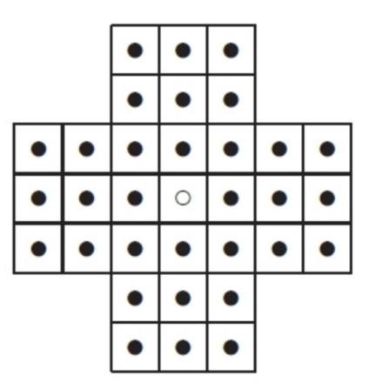

Sample GUI of Solitaire

Board size

Board Type

English

Hexagon

Diamond

Record game

New Game

7

Repla
y

Randomize

Autoplay

Figure 1: Sample GUI Layout of the Complete Solitaire Game

1

- Demonstration (10 points)

Submit a link to a video of approximately 5 minutes, clearly demonstrating that you have implemented all the features in the following table. In the video, you must explain what is being demonstrated. No points will be given without a video link.
YouTube/Panopto link: https://youtu.be/rWxxJPmn3eg

 | Feature
1 | A complete manual game without using the “randomize” function is recorded
2 | A complete manual game without using the “randomize” function is replayed
3 | A complete manual game that sporadically uses the “randomize” function is recorded
4 | A complete manual game that sporadically uses the “randomize” function is replayed
5 | A complete automated game is recorded
6 | A complete automated game is replayed

- User Stories and Acceptance Criteria for the Record/Replay Requirements (5 points)

 User Story Template: As a <role>, I want <goal> [so that <benefit>] Add or delete rows as needed.
ID | User Story  Name | User Story Description | Priority | Estimated effort (hours)
20 | Record Game | Recording the game so I can save and replay it. | High | 4
21 | Replay Recorded Game | Replay a recorded game to review the moves made. | High | 5

User Story ID and Name | AC  ID | Description of Acceptance Criterion | Status (completed, toDo, inPprogress)
20 story | 20.1 | Given that the GUI is open, when user checks “record game”, then system records successful moves. | completed
 | 20.2 | Given that recording is enabled, user makes a move, then only valid moves are safely stored in file. | completed
21 story | 21.1 | Given that a record game file does exist, when the user clicks on “replay”, then the system looks and loads the saved file. | completed
 | 21.2 | Given that the file is loaded, when replay is started, then the system shows each move in chronological order. | completed

2

