Project Sprint #1

The Solitaire game is described in CS449HomeworkOverview. You should read the description very carefully.

In this assignment, you aim to specify the requirements (i.e., user stories and acceptance criteria) of the target software that allows a human player to play a Solitaire game. These requirements will be fully implemented by the end of sprint 3. The minimum features include choosing the board size and type, starting a new game, making a move, determining if a game is over. The following is a sample GUI layout.

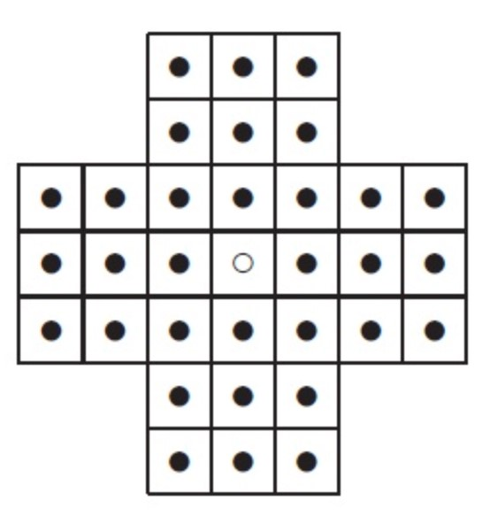

Board size

Board Type

English

Hexagon

Diamond

New Game

7

Figure 1. Sample GUI layout of the first working program by the end of Sprint 3

Use the following tables to document your user stories and acceptance criteria.

You are required to use the free ChatGPT or another LLM to complete two user stories and two of their respective acceptance criteria. You must ensure that the generated user stories are correct and fix them if not. At the end of the submission, provide screenshots of your LLM prompts and answers, along with the description of errors the LLM made that you had to correct. Points will be deducted if no screenshots/description are provided.

For the other user stories and acceptance criteria, you are not required to use LLM.

- User Stories (3 points)

 User Story Template: As a <role>, I want <goal> [so that <benefit>]
ID | User Story Name | User Story Description | Priority | Estimated effort (hours)
1 | Choose a board size | As a player,  I want to choose the board size before starting the game,  so that I can control the difficulty and layout of the game. | 1 | 0.25
2 | Choose the board type | As a player,  I want to choose the board type (English, European, Triangle),  so that I can play different variations of solitaire. | 2 | 0.25
3 | Start a new game of the chosen board size and type | As a player,  I want to start a new game using my selected size and type,  so that I can begin playing with my chosen configuration. | 3 | 0.25

4 | Make a move in a game | As a player,  I want to make valid moves by selecting and jumping pegs,  so that I can progress toward solving the puzzle. | 4 | 0.25
5 | A game is over | As a player,  I want the game to detect when no valid moves remain,  so that I know when the game has ended. | 5 | 0.25

- Acceptance Criteria (AC) (12 points): Add/delete rows as needed.

User Story ID and Name | AC ID | Description of Acceptance Criterion | Status (completed, toDo, inPprogress)
1. Choose a board size | 1.1 | AC 1.1 – Valid size selection  - Given the application is open  - When I select a board size within the allowed range  - Then the selected board size is stored for the next game | completed
 | 1.2 | AC 1.2 – Invalid size prevention  - Given the board size control has minimum and maximum values  - When I attempt to enter a value outside the allowed range  - Then the system prevents or corrects the invalid value  AC 1.3 – Size applied to game  - Given I have selected a board size  - When I click “Start New Game”  - Then the game board renders visually using the selected size  AC 1.4 – Default size  - Given I do not change the board size  - When I start a new game  - Then the default board size is used | completed
 | …
2. Choose the board type |  | AC 2.1 – Board type selection  - Given the board type radio buttons are displayed  - When I select a board type  - Then that board type becomes the active configuration  AC 2.2 – Single selection enforcement  - Given multiple board type options exist  - When I select a new option  - Then the previous option is automatically deselected  AC 2.3 – Type applied to board  - Given I selected a board type  - When I start a new game  - Then the board renders using that board type layout  AC 2.4 – Default board type  - Given I do not change the board type  - When I start a new game  - Then the default board type is used | completed
3. Start a New Game |  | AC 3.1 – Game initialization  - Given I have selected a board size and type  - When I click “Start New Game”  - Then the game board is rendered visually  AC 3.2 – Move counter reset  - Given a game is in progress  - When I click “Start New Game”  - Then the move counter resets to zero  AC 3.3 – Replace active game  - Given a game is already running  - When I click “Start New Game”  - Then the previous game state is cleared and replaced  AC 3.4 – Record setting stored  - Given the “Record Game” option is selected  - When I start a new game  - Then the recording preference is stored for that session | completed
4. Make a Move |  | AC 4.1 – Select peg  - Given a game is running  - When I click on a peg  - Then the peg becomes selected visually  AC 4.2 – Valid jump  - Given a peg is selected  - When I click on a valid empty hole two spaces away  - Then the peg moves, and the jumped peg is removed  AC 4.3 – Invalid move prevention  - Given a peg is selected  - When I attempt an invalid move  - Then the system rejects the move and displays feedback  AC 4.4 – Move counter update  - Given a valid move is made  - When the move completes  - Then the move counter increments by one | completed
5. Game Over |  | AC 5.1 – Game over detection  - Given a game is running  - When no valid moves exist  - Then the game state changes to “Game Over”  AC 5.2 – Prevent further moves  - Given the game is over  - When I attempt to make a move  - Then the system prevents the action  AC 5.3 – Visual feedback  - Given the game has ended  - When the game over condition occurs  - Then the UI displays a clear “Game Over” message  AC 5.4 – Replay  - Given the game is over  - When I click “Replay”  - Then a new game starts using the current configuration | completed

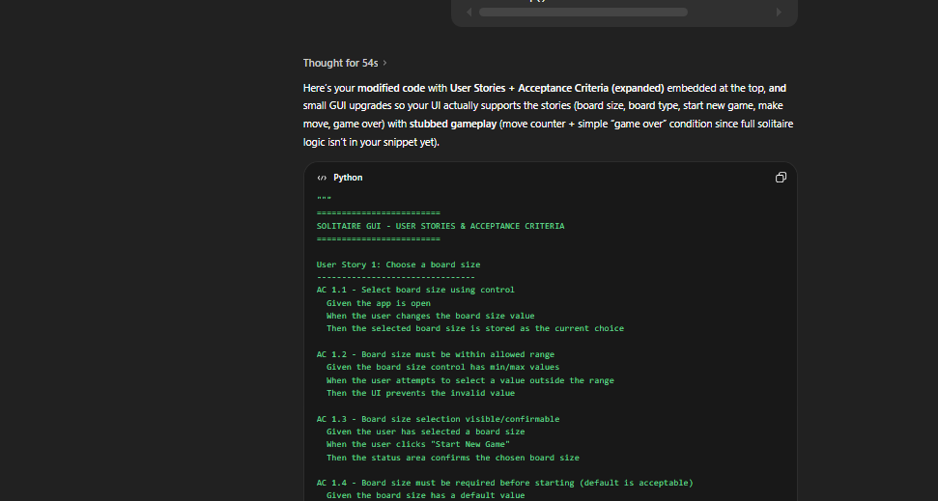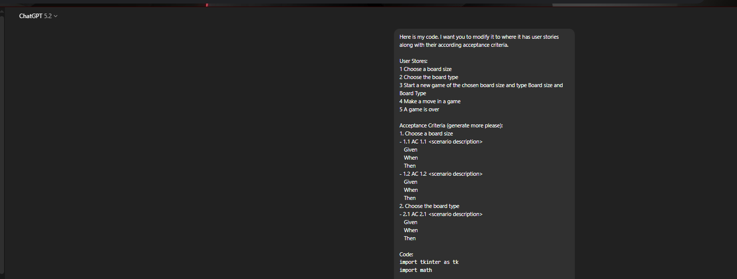
One thing I had to fix was that AI did not generate the user stories along with the acceptance criteria. That, I had to go do and fix with another prompt. As shown in the picture below. All the pictures above are my previous prompts on how I would handle it with AI.
