Project Sprint #2

The Solitaire game is described in CS449HomeworkOverview.docx. You should read the description very carefully.

Your submission must include the GitHub link to your project, and you must ensure that the instructor has the proper access to your project. You will receive no points otherwise.

GitHub link: https://github.com/Pintized/CS449-Spring-Project

In this assignment, you aim to implement the minimum features including choosing the board size and type, starting a new game, making a move, determining if a game is over. The following is a sample GUI layout.

The implementation of a GUI is required. You should make every attempt to make your code easy to extend. It is required to separate the user interface code and the game logic code into different classes (refer to the TicTacToe example). xUnit tests are required.

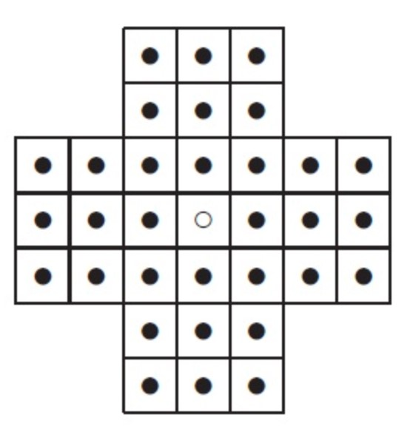

Board size

Board Type

English

Hexagon

Diamond

New Game

7

Figure 1. Sample GUI layout of the Sprint 2 program

Deliverables:

Demonstration (8 points)

Submit a link to a video of no more than three minutes, clearly demonstrating that you have implemented the required features and written some automated unit tests. In the video, you must explain what is being demonstrated. No points will be given without a video link.
YouTube/Panopto link: https://youtu.be/uIeqj1YBFJE

 | Feature
1 | Choose board size and type
2 | Start a new game of the chosen board size and type
3 | Making a move
4 | Checking the end of game
5 | Automated unit tests

Summary of Source Code (1 points)
Source code file name | Production code or test code? | # lines of code
 | Total

You must submit all source code to get any credit for this assignment.

Production Code vs User stories/Acceptance Criteria (3 points)

Update your user stories and acceptance criteria from the previous assignment (if required) and ensure they adequately capture the requirements. Summarize how each of the following user story/acceptance criteria is implemented in your production code (class name and method name etc.). If you are not using an OOP, then adapt the tables accordingly.

User Story ID | User Story
1 | Choose board size and type
2 | Start a new game of the chosen board size and type
3 | Making a move
4 | Checking the end of game

User Story ID and Name | AC ID | Class Name(s) | Method Name(s) | Status (complete or not) | Notes (optional)
1 | 1.1 | PegSolitaireApp | Start_new_game | Complete | Spinbox stores size
 | 1.2 | PegSolitaireGame | Init | Complete | Size corrected if invalid
 | 1.3 | PegSolitaireGame | _build_board | Complete | Board renders with size
 | 1.4 | PegSolitaireApp | Board_size_var | Complete | Default = 7
2 | 2.1 | PegSolitaireApp | Board_type_var | Complete | Radio buttons store type
 | 2.2 | Tkinter | Radiobutton | Complete | Enforced by Tkinker
 | 2.3 | PegSolitaireGame | _build_board | Complete | Layout changes by type
 | 2.4 | PegSolitaireApp | Board_type_var | Complete | Default = English
3 | 3.1 | PegSolitaireApp | Start_new_game | Complete | Create new PegSolitaireGame
 | 3.2 | PegSolitaireGame | Init | Complete | Move count reset
 | 3.3 | PegSolitaireApp | Start_new_game | Complete | Replace previous game
 | 3.4 | PegSolitaireApp | Start_new_game | Complete | Configuration
4 | 4.1 | PegSolitaireApp | on_canvas_click | Complete | Selection storing
 | 4.2 | PegSolitaireGame | Try_move | Complete | Jump logic
 | 4.3 | PegSolitaireApp | on_canvas_click | Complete | Invalid move rejection
 | 4.4 | PegSolitaireGame | Try_move | Complete | Move count incrementation
5 | 5.1 | PegSolitaireGame | Is_game_over | Complete | Check no valid move
 | 5.2 | PegSolitaireApp | on_canvas_click | Complete | Prevent move over
 | 5.3 | PegSolitaireApp | Status_var | Complete | Display game over
 | 5.4 | PegSolitaireApp | Start_new_game | Complete | Replaying resets game

Tests vs User stories/Acceptance Criteria (3 points)

Summarize how each of the user story/acceptance criteria is tested by your test code (class name and method name) or manually performed tests.

User Story ID | User Story
1 | Choose board size and type
2 | Start a new game of the chosen board size and type
3 | Making a move
4 | Checking the end of game

4.1 Automated tests directly corresponding to the acceptance criteria of the above user stories
You are required to use ChatGPT to create at least 2 unit tests. You also need to ensure that the generated test cases are correct and refine them if not. At the end of the submission, provide the screenshots of your ChatGPT prompts and answers, along with errors ChatGPT made and you fixed. You may also use another LLM, including hosted locally. Points will be deducted if no screenshots are provided.

User Story ID and Name | Acceptance Criterion ID | Class Name (s) of the Test Code | Method Name(s) of the Test Code | Status (Pass/Fail/In Progress)
3 | 3.1 | Test_peg_game | Test_initial_center_empty | Pass
4 | 4.2 | Test_peg_game | Test_valid_move_updattes_board | Pass
5 | 5.1 | Test_peg_game | Test_game_over_detection | Pass

4.2 Manual tests directly corresponding to the acceptance criteria of the above user stories (if any)

User Story ID and Name | Acceptance Criterion ID | Test Case Input | Test Oracle  (Expected Output) | Notes
1 | 1.1 | Select size 9 | Board size = 9 | Verified visually
2 | 2.1 | Select Triangle | Triangle board renders | Verified visually
3 | 3.2 | Start new game mid-play | Move counter resets | Verified
4 | 4.3 | Attempt diagonal move on English board | Move rejected | Status message shown
5 | 5.3 | Play until no moves remain | Game over displayed | Verified

4.3 Other automated or manual tests not corresponding to the acceptance criteria of the above user stories (if any)

Number | Test Input | Expected Result | Class Name of the Test Code | Method Name of the Test Code
1 | Invalid size | Auto-correction to odd | PegSolitaireGame | init
2 | Move from empty cell | Rejected | PegSolitaireGame | Try_move

Acceptance Criterion:
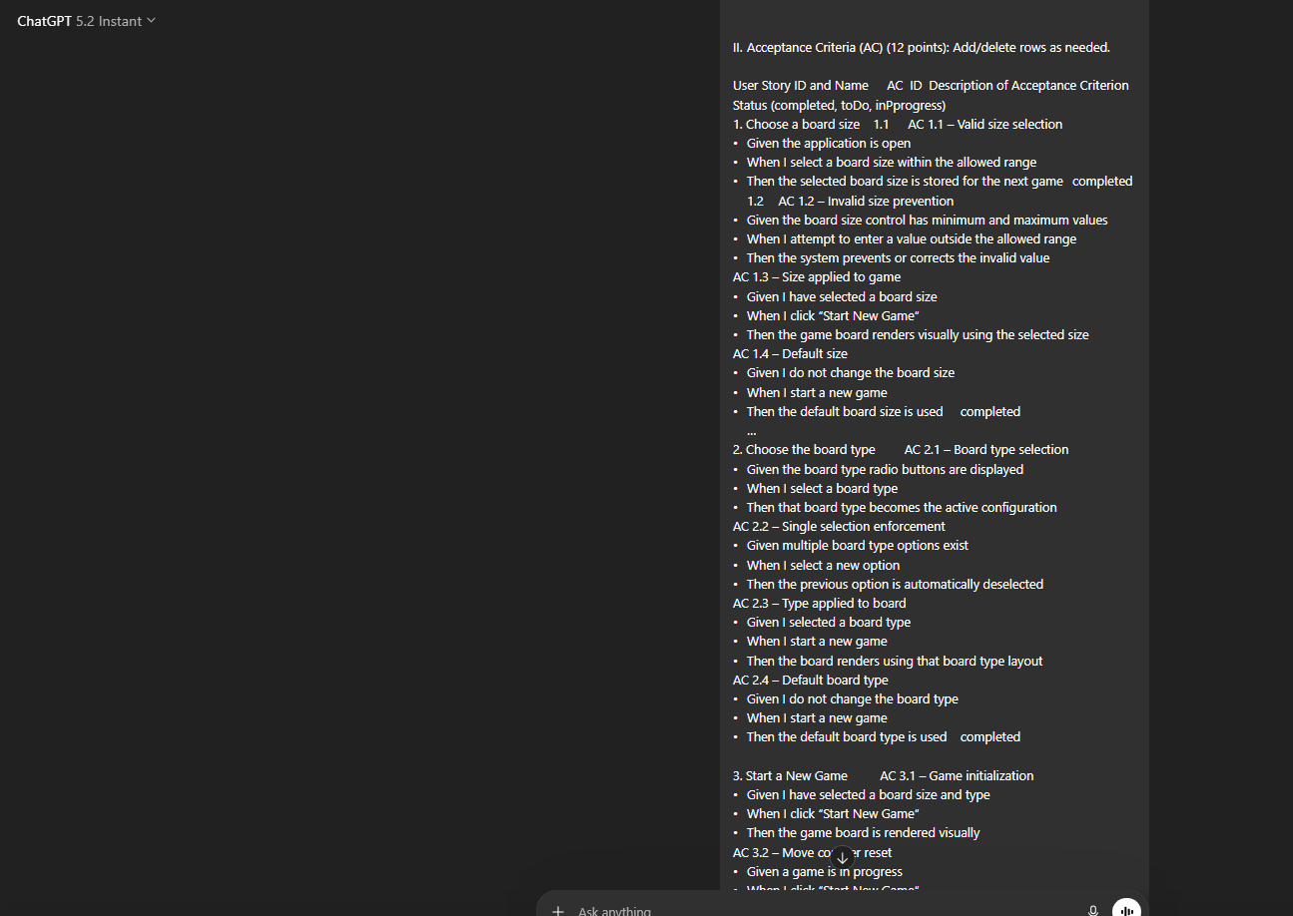

3 Unit Tests:
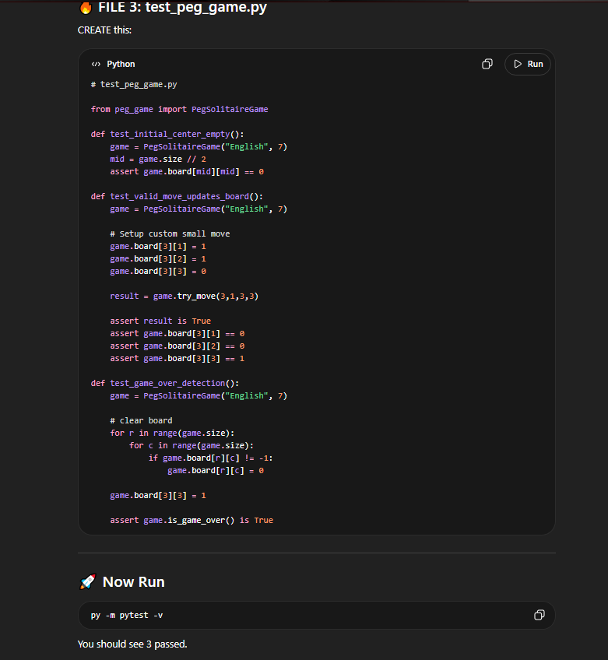
Test Passed:
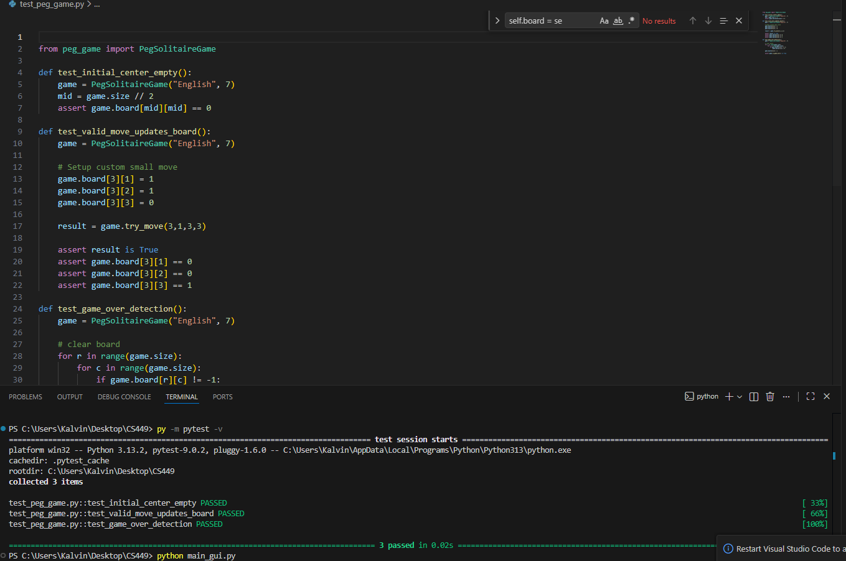

Errors:
- Didn’t increment move_count
- Invalid board setup
Corrections:
- Updated try_move implementation
- Adjusted board in test

