

Grupo 1, Lab 3

Lucas Pinto

Carlos Vidal

Assignment 1 – Hadamard codes

The challenge is to design a solution for an encoder and a decorder that implements a combinatorial algorithm for message transmission with the error correcting properties developed by Richard Hamming using Hadamard codes of class [8, 4, 4]­2, described as [n, k, d], were n=blocklength, k=message length and d=minimum distance, or [2k­, K, 2k-1].

An additional requirement stipulates that either one, the encoder or the decoder, should implement a serial(series) input, and the other one a parallel input, so our choice was to implement a serial input encoder and a parallel input decoder.

1. Serial input encoder:

1.1. Data flow and serial-parallel control unit implementation

1.2. Circuit interface and schematics of the internal organization:

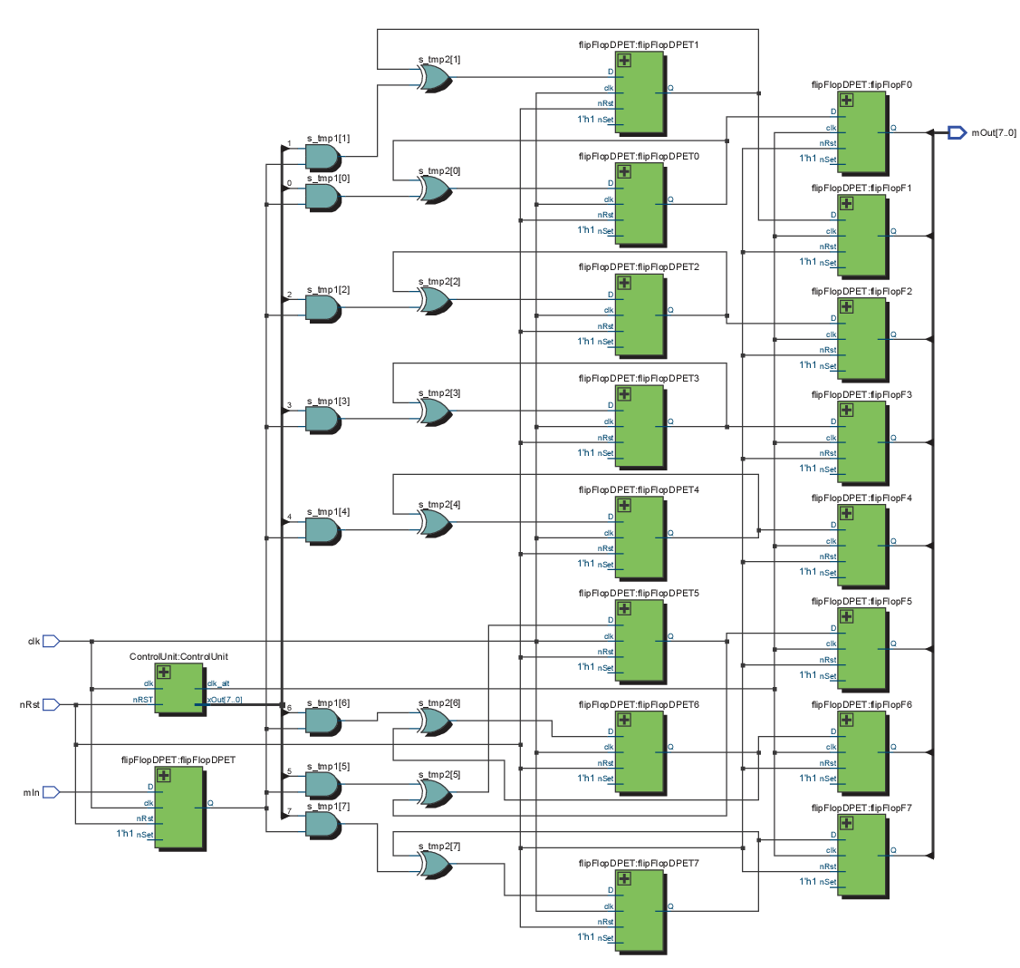

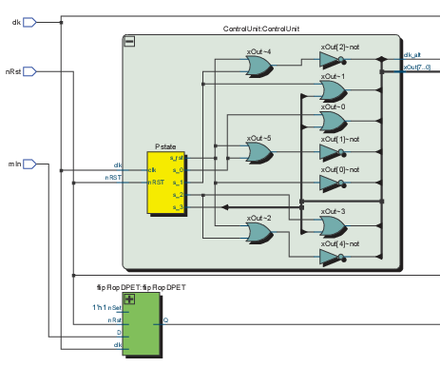 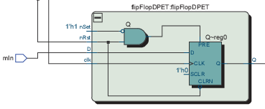

1.3. Implementation cost:

1. AND gates, 8 XOR gates, 4 NOT gates and 17 D Flip-Flop PET.

1.4. Quartus project and operation simulation:

1. Parallel input decoder:
   1. 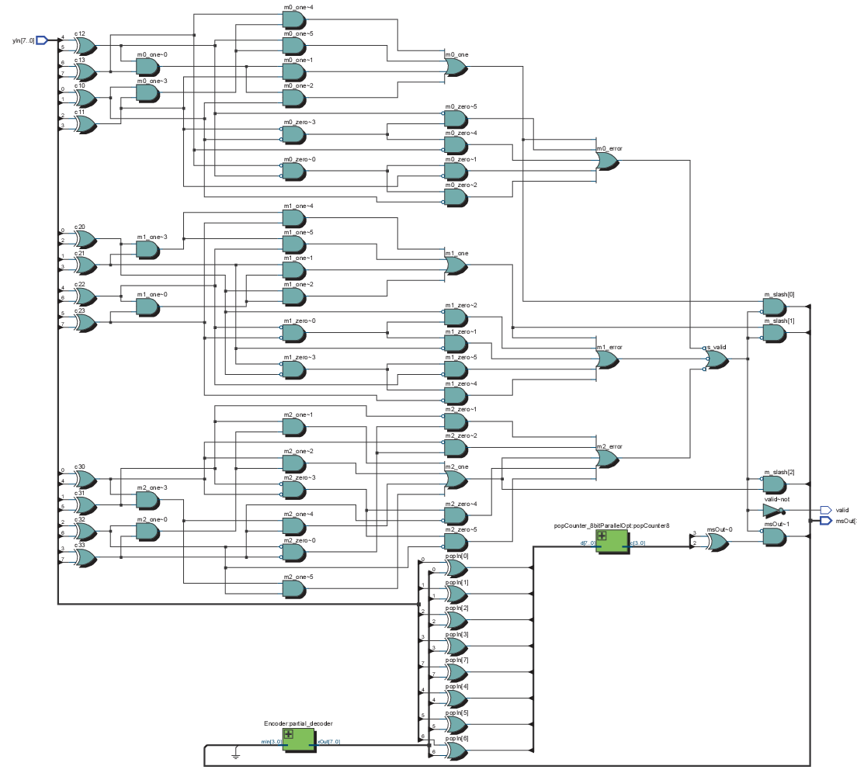Circuit interface and schematics of the internal organization:

2.2. Implementation cost:

20 XOR, 40 AND, 23 OR, 29 NOT and 1 8-bit POPCounter.

8-bit POPCounter =

4x(1XOR + 1AND) +

2x[(1XOR + 1AND) + (2XOR + 1AND)] +

(1XOR + 1AND) + (2XOR + 2AND + 1OR) + (2XOR + 1AND) =

= 15XOR + 12AND + 1OR

8-bit POPCounter Propagation Delay =

Stage 0: 1XOR gate

Stage 1: 2XOR gates

Stage 2: 2XOR gates + 1AND gate + 1OR gate

Total: 5XOR gates + 1AND gate + 1OR gate

TOTAL COST = 35XOR, 52AND, 24OR, 29NOT

Total Propagation Delay =

m’3 path :

Stage 0: 1XOR gate

Stage 1: 5XOR gates + 1AND gate + 1OR gate (8-bit POPCounter)

Stage 2: 1XOR gates + 1AND gate

Total: 7XOR gates + 2AND gates + 1OR gate

m’0, m’1 and m’2 path worst case:

Stage 0: 1XOR gate + 1AND gate

Stage 1: 1NOT gate + 1AND gate (inverted input AND gate)

Stage 2: 1NOT gate + 1AND gate (inverted input AND gate)

Stage 3: 1OR gate

Stage 4: 1NOT gate + 1OR gate (inverted input OR gate)

Stage 5: 1NOT gate + 1AND gate (inverted input AND gate)

Total: 4NOT gates + 1XOR gate + 4AND gates + 2OR gates

2.3. Quartus project and operation simulation:

Simulation1



Simulation2

