Stowger Switching System Presented by Pintu Hossain

In this chapter, we will discuss how the Strowger Switching system works. The first ever automatic telephone switching was developed by Almon B Strowger. As the operator at the Manual telephone exchange was the wife of his competitor and was diverting all the business, Strowger thought of developing a switching system, which does not require an operator. This led to the invention of the automatic switching system developed by Strowger.

The **Strowger Switching system** is also called the step-by-step switching system as the connections are established in a **step-by-step** manner.

Automatic Switching System

The Manual Switching system requires an operator who after receiving a request, places a call. Here, the operator is the sole in-charge for establishing or releasing the connections. The privacy of the calls and the details of the called and the calling subscribers are at stake.

Overcoming the disadvantages of Manual Switching systems, the Automatic Switching systems come with the following advantages −

* Language barriers will not affect the request for connection.
* Higher degree of privacy is maintained.
* Faster establishment and release of calls is done.
* Number of calls made in a given period can be increased.
* Calls can be made irrespective of the load on the system or the time of the day.

Let us now throw some light on how a call is made and how dialing is done without the help of an operator.

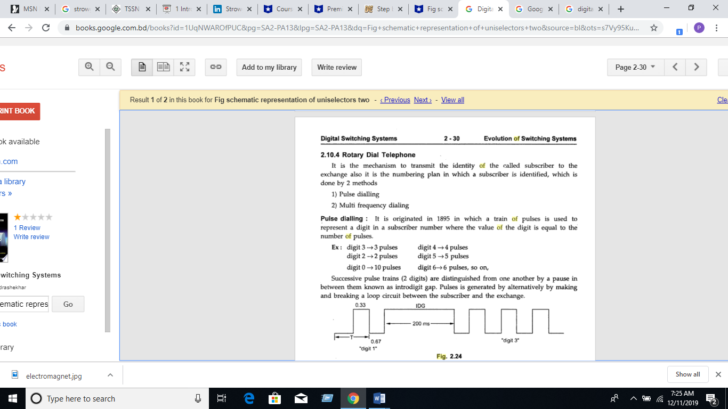

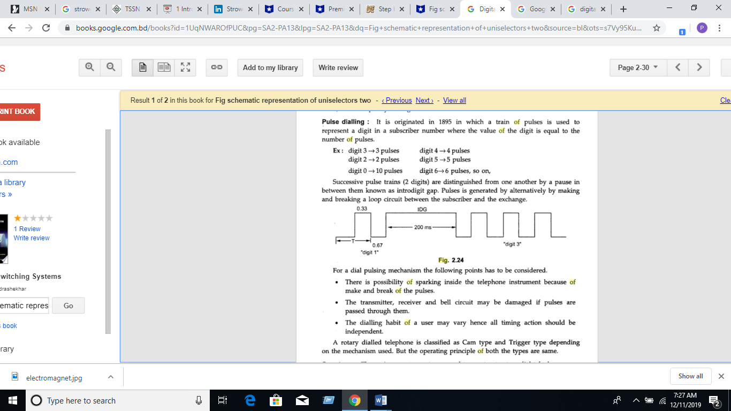

Finger plate arrangement

The dial is operated by placing the finger in the hole appropriate to the digit to be dialed. Now, drawing the fingerplate round in the clockwise direction to the finger stop position and letting the dial free by withdrawing the finger, makes a number dialed. The fingerplate and the associated mechanism now return to the rest position under the influence of a spring. The dial is ready for the next number.

The dial pulses are produced during the return travel of the fingerplate, thus eliminating the human element in pulse timings. The following figure shows the dial holes and finger stop.

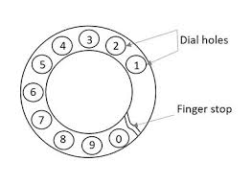

A rotary dial phone uses the following for implementing pulse dialing −

* Finger plate and spring
* Shaft, gear and Pinion wheel
* Pawl and ratchet mechanism
* Impulsing cam and suppressor cam or a trigger mechanism
* Impulsing contact
* Centrifugal governor and worm gear
* Transmitter, Receiver and bell by-pass circuits

## Impulsing Mechanism or Internal Mechanism of Rotary Dial Telephone Part

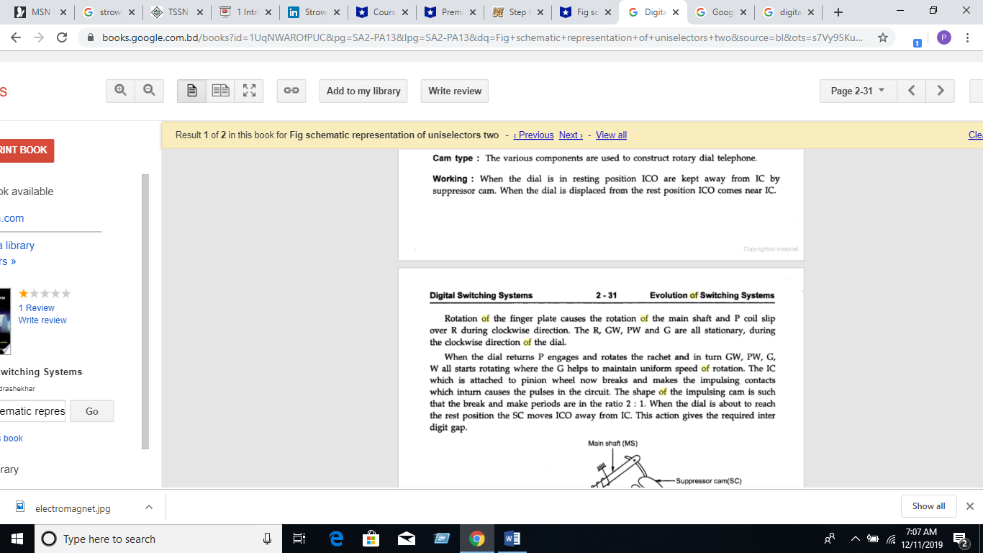

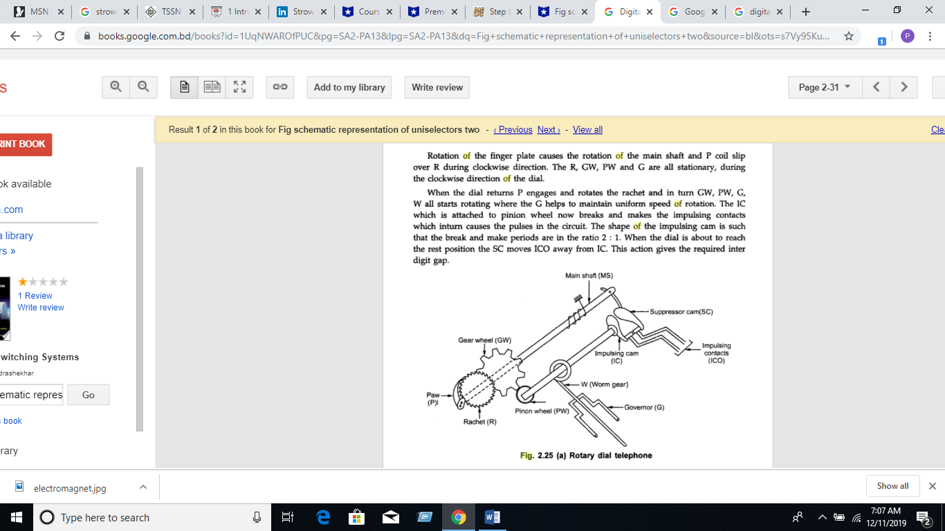

Impulsing circuit of a rotary dial telephone

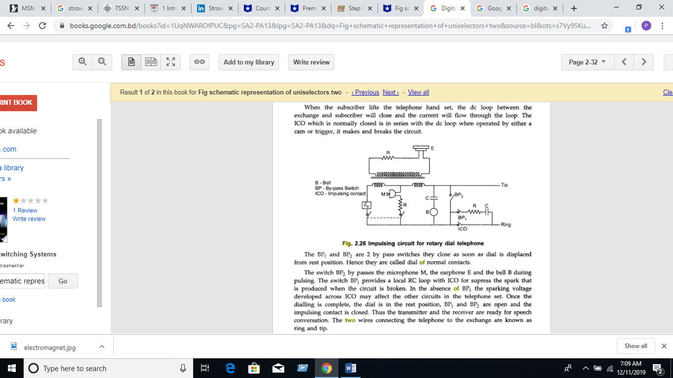

**SIGNALLING  IN THE SUBSCRIBER NETWORK**

 A number of signalling functions are involved in establishing, maintaining and releasing a telephone conversation. These functions are performed by an operator in a manual exchange. In automatic switching systems, the verbal signalling of the operator is replaced by a series of distinctive tones. Five subscriber related signalling functions which were performed by the operator:

 1. Respond to the calling subscriber to obtain the identification of the called party.

2. Inform the calling subscriber that the call is being established.

3. Ring the bell of the called party.

4. Inform the calling subscriber, if the called party is busy.

5. Inform the calling subscriber, if the called party line is unobtainable for some reason.

 Distinctive signalling tones ere provided in all automatic switching systems for functions 1,3,4 and 5. A signalling tone for function 2 is usually not available in Strowger exchanges. However, most of the modem exchanges provide a call-in-progress or routing tone for function 2. Although attempts have been made to standardise the tones for various signals, many variations are in vogue in different parts of the world and even in different systems installed in the same country. Variations are mainly due to different capabilities and technologies of the switching systems used.

**What are the different tones used in strowger telephony? Explain with the help of waveforms and the timings.**

1. **DIAL TONE**

The dial tone is the signaling tone, which indicates that the exchange is ready to accept the dialed digits from the subscriber. The number should be dialed only when this signal is heard. Otherwise, the digits dialed before this signal will not be considered. This will lead to the dialing of a wrong number.

The dial tone is generally a 33 Hz or 50 Hz or 400 Hz continuous tone as shown below.

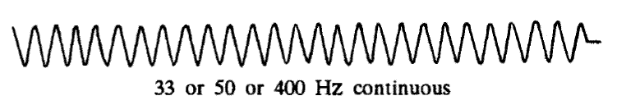

**2. RINGING CURRENT**

 When the called party line is obtained, the exchange control equipment sends out the ringing current to the telephone set of the called party.

**2. RINGING TONE**

As the ringing current is transmitted to the called subscribe, the control equipment sends out a ringing tone to the calling subscriber, which has a pattern similar to that of the ringing current as shown in Figure 3.

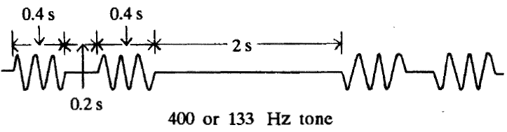

**BUSY TONE**

After dialing the required number, if the called subscriber or the lines at the exchange are not free to place a call, the calling subscriber is sent a busy tone indicating that the lines or the subscriber is busy; this is called a busy tone.

A busty tone of 400Hz signal with silence period in between. The burst and silence durations have the same value of 0.75s or 0.75s.

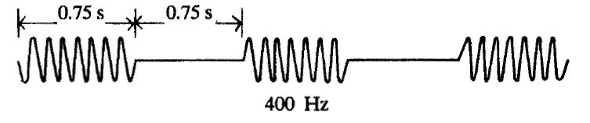

**ROUTING TONE**OR **CALL-IN-PROGRESS TONE**

When a subscriber call is routed through a number of different types of exchanges, one hears different call-in-progress tones as the call progresses through different exchanges. Such a signal is a 400Hz or 800Hz intermittent pattern. This signal has different patterns in different systems.

* In electromechanical systems, it is usually 800Hz with 50 percent duty ratio and 0.5s ON/OFF period.
* In analog electronic exchanges, it is a 400Hz pattern with 0.5s ON period and 2.5s OFF period.
* In digital exchanges, it is 400Hz signal with 0.1s ON/OFF periods.

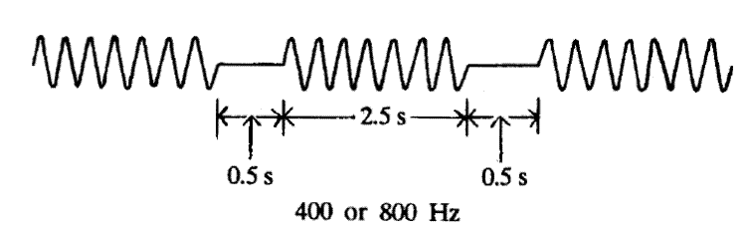

**NUMBER UNOBTAINABLE TONE**

If the called party is out of order or disconnected or if an error in dialing leads to the selection of a spare line, such a situation is indicated using a continuous 400Hz signal, called as Number Unobtainable tone. The following illustration shows a continuous 400Hz signal.

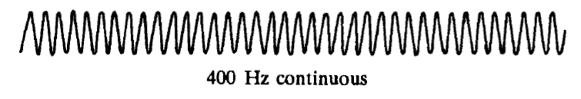

In the Strowger switching system, there are two types of selectors; these selectors form the building blocks for the switching systems.

* Uni-selector
* Two-motion selector

Both of these selectors are constructed using electro-mechanical rotary switches

UNISELECTOR: The Uni-selector has a single selector pole and multiple throws to reach the bank of contacts for each number dialed.

Two Motion Selector:

The two-motion selector has two rotary switches for vertical and horizontal stepping movement, to reach the bank of contacts.

**Uni-selector Switching(Drive mechanism of a rotary switch)**

The following figure 2.9 shows the drive mechanism of the Uni-selector Strowger switching system.

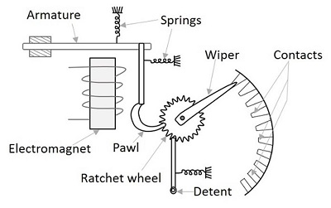

.

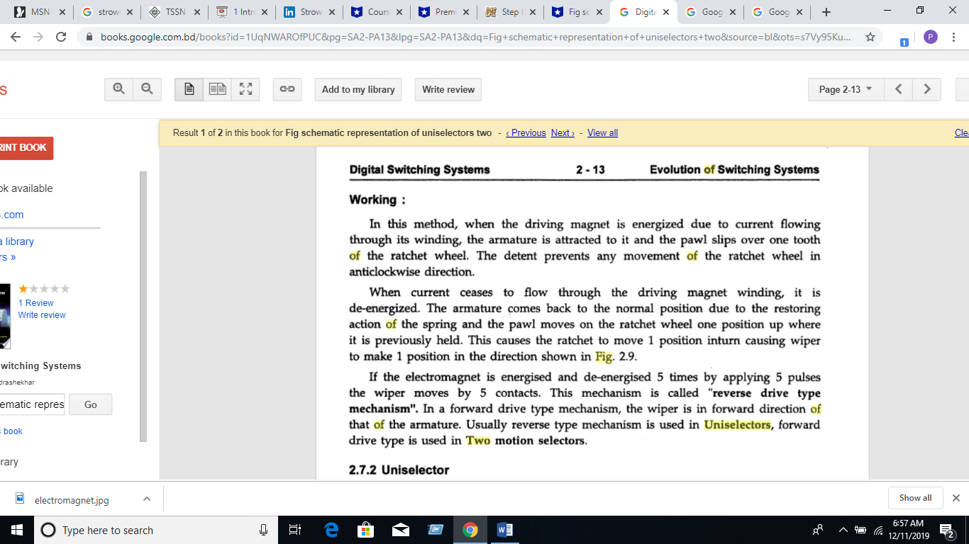

Schematic representation of uniselectors

