Computer Repair Appointment and Service Management System

RDBMS and CRUD Operations Documentation

1. Database Tables (RDBMS)
The system uses a relational database structure where tables are connected through primary keys and foreign keys.
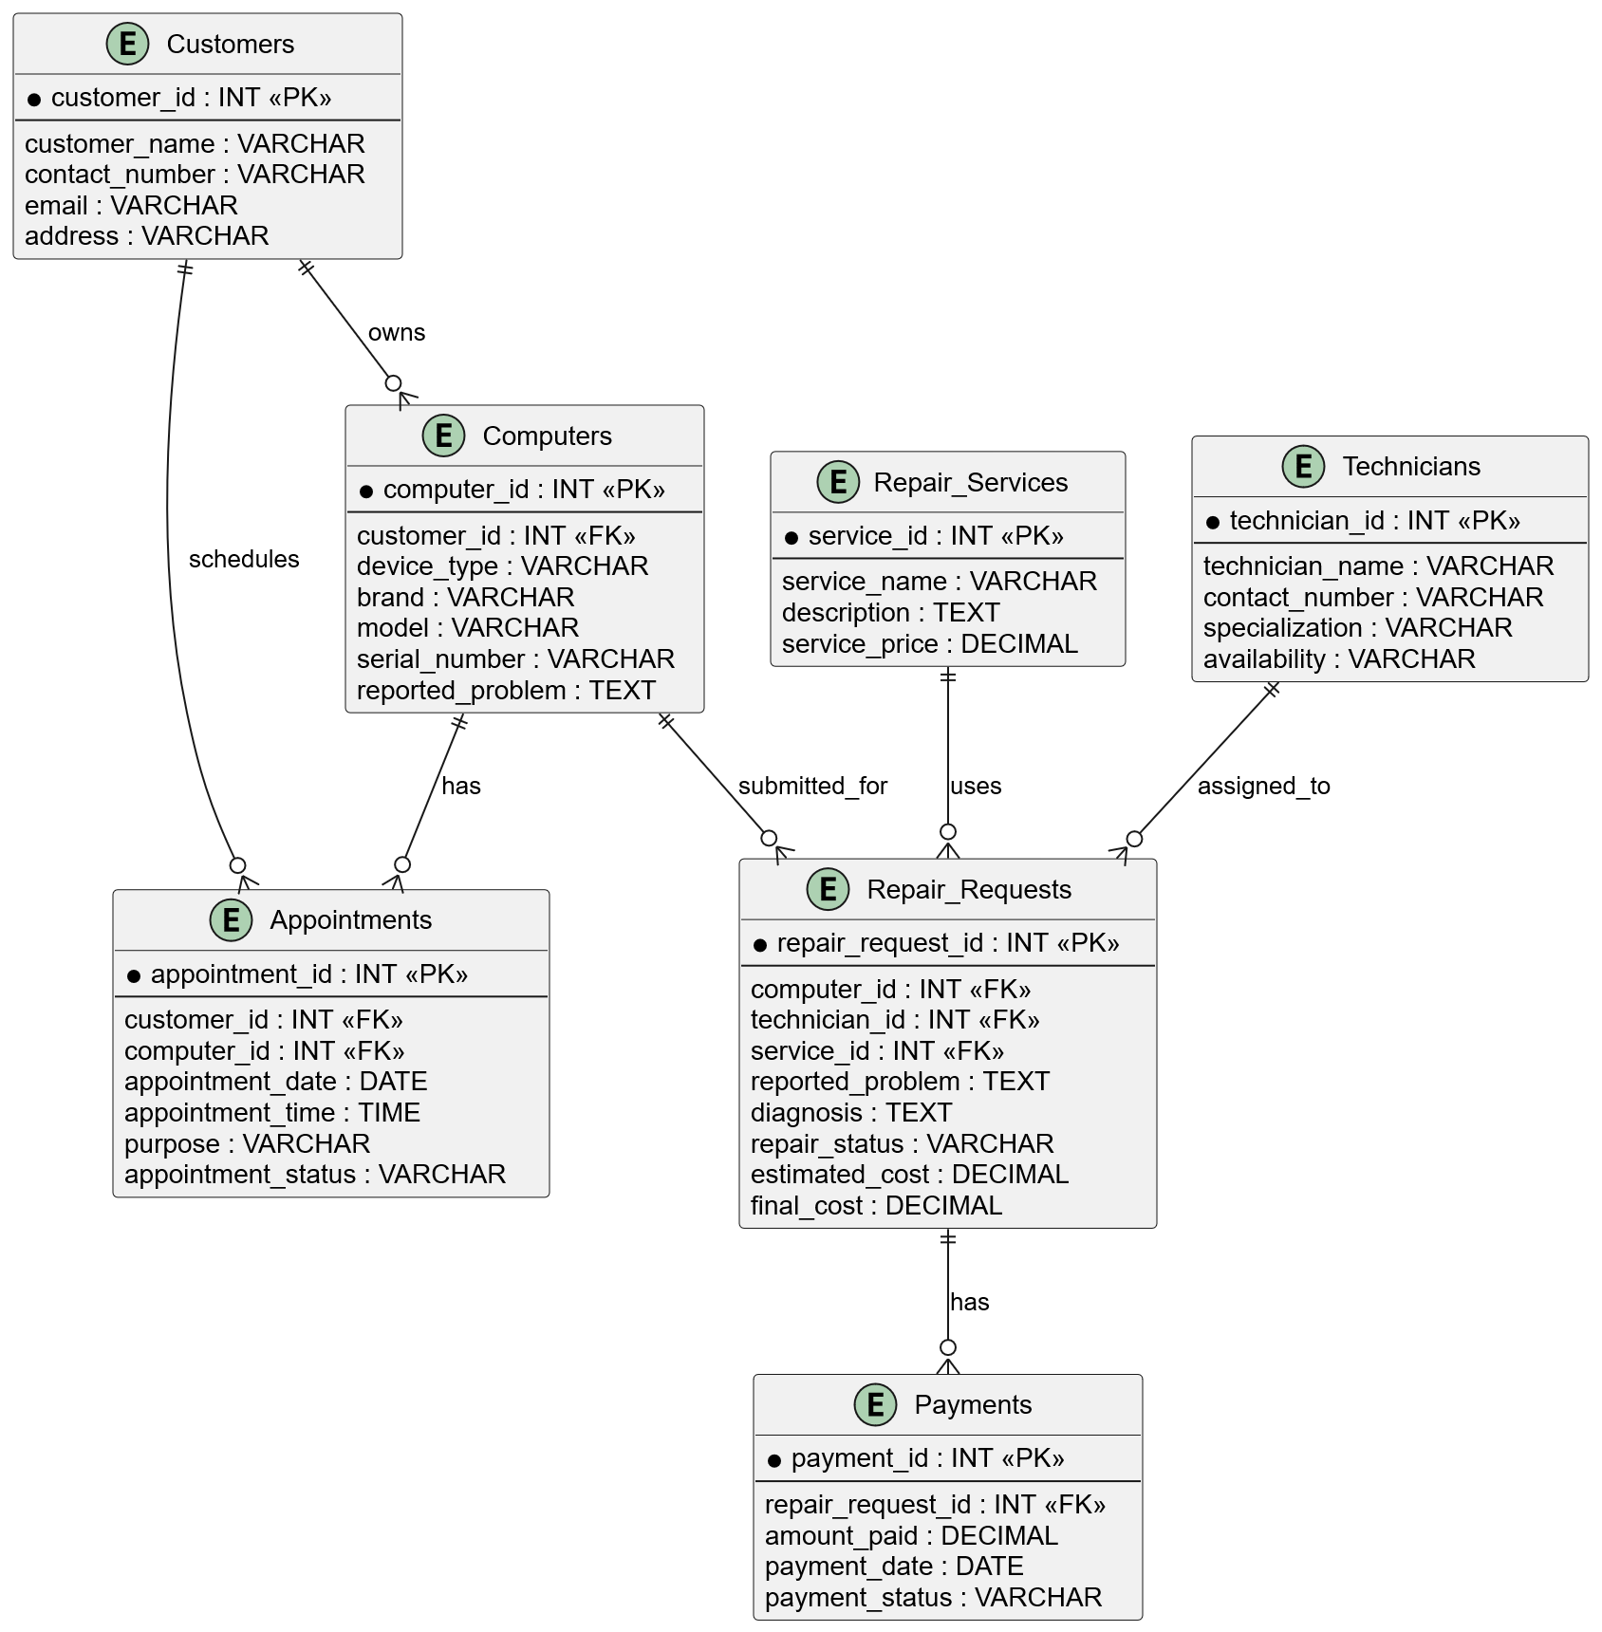
CUSTOMERS - Stores customer information.
COMPUTERS - Stores customer computer/device information.
APPOINTMENTS - Stores repair appointment schedules.
REPAIR_REQUESTS - Stores repair transactions, diagnosis, and repair status.
TECHNICIANS - Stores technician information.
REPAIR_SERVICES - Stores available repair services and prices.
PAYMENTS - Stores payment records.

CREATE Operations (INSERT)

CUSTOMERS
INSERT INTO customers (customer_name, contact_number, email, address)
VALUES ('Juan Dela Cruz','09123456789','juan@gmail.com','Batac');

COMPUTERS
INSERT INTO computers (customer_id, device_type, brand, model, serial_number, reported_problem)
VALUES (1,'Laptop','Acer','Aspire 5','SN001','No display');

APPOINTMENTS
INSERT INTO appointments (customer_id, computer_id, appointment_date, appointment_time, purpose, appointment_status)
VALUES (1,1,'2026-10-01','10:00 AM','Computer repair','Pending');

REPAIR_REQUESTS
INSERT INTO repair_requests (computer_id, technician_id, service_id, reported_problem, diagnosis, repair_status)
VALUES (1,1,1,'No display','Faulty RAM','Under Diagnosis');

TECHNICIANS
INSERT INTO technicians (technician_name, contact_number, specialization, availability) VALUES ('Mark Santos','09123456789','Hardware Repair','Available');

REPAIR_SERVICES
INSERT INTO repair_services (service_name, description, service_price) VALUES ('Hardware Diagnostics','Checking hardware problems',300);

PAYMENTS
INSERT INTO payments (repair_request_id, amount_paid, payment_date, payment_status) VALUES (1,300,'2026-10-01','Paid');

READ Operations (SELECT)

Display Customers
SELECT * FROM customers;

Display Computers with Owner
SELECT customers.customer_name, computers.brand, computers.model
FROM computers JOIN customers ON computers.customer_id = customers.customer_id;

View Repair Requests
SELECT * FROM repair_requests;

UPDATE Operations

Update Customer Information
UPDATE customers SET contact_number='09999999999' WHERE customer_id=1;

Update Appointment Status
UPDATE appointments SET appointment_status='Confirmed' WHERE appointment_id=1;

Update Repair Status
UPDATE repair_requests SET repair_status='Under Repair' WHERE repair_request_id=1;

DELETE Operations

Delete Appointment
DELETE FROM appointments WHERE appointment_id=1;

Delete Payment Record
DELETE FROM payments WHERE payment_id=1;

Delete Repair Request
DELETE FROM repair_requests WHERE repair_request_id=1;

CRUD Summary
Operation | SQL Command | Purpose
CREATE | INSERT | Adds new records.
READ | SELECT | Retrieves stored data.
UPDATE | UPDATE | Modifies existing records.
DELETE | DELETE | Removes records.

