Faculty of Computing, Engineering & Media (CEM)
Coursework Brief 2023/24

Module name: |  | Mobile Games & Ai for Simulation
Module code: |  | GAMR2520
Title of the Assessment: |  | Assignment 2: Mobile Game
This coursework item is: (delete as appropriate) |  |  |  | Summative
This summative coursework will be marked anonymously: (delete as appropriate) |  |  |  |  |  |  |  |  | No
The learning outcomes that are assessed by this coursework are:
- Effectively communicate the requirements for portability and usability for games developed for the mobile platform.

- Demonstrate the ability to create, design, implement and deploy a game suitable for the mobile platform.
This coursework is: |  |  | Group
This coursework constitutes 50% of the overall module mark.
Date Set: | Thursday 11th January 2024
Date & Time Due (the deadline): | Wednesday 31st January 2024 at 12:00pm (Midday)
In accordance with the University Assessment and Feedback Policy, your marked coursework and feedback will be available to you on: |  |  |  |  | Monday 21st February 2024
You should normally receive feedback on your coursework no later than 15 University working days after the formal hand-in date, provided that you have met the submission deadline

If for any reason this is not forthcoming by the due date your module leader will let you know why and when it can be expected. The Associate Professor Student Experience (CEMstudentexperience@dmu.ac.uk) should be informed of any issues relating to the return of marked coursework and feedback.
When completed you are required to submit your coursework via:
These are TEAM (80%) components:
- Unity Game Project files, to be submitted on LearningZone by Wednesday 31st January at 12:00pm (midday).

- Executable (.apk) of the project by Wednesday 31st January at 12:00pm (midday).

- A 5-slide Presentation submitted via Turnitin due Wednesday 31st January at 12:00pm (midday), to be delivered during Presentation and Demonstration (either F2F or online).

- A face-to-face Presentation and Demonstration of the project during your Lab on Wednesday 31st January.

OR

An ONLINE Presentation and Demonstration of the project during Online Session on Thursday 1st February, 9am-11am.
(subject to prior agreement).
These are INIDVIDUAL (20%) components:
- FIVE Journal entries in Discussion section, reviewing mobile games. Entries to be completed on LearningZone by Wednesday 31st January at 12:00pm (midday).

- A Peer Mark Allocation grid due Friday 2nd February at 12:00pm (midday)

See below for more details
If you need any support or advice on completing this coursework please visit the Student Matters tab on the CEM LearningZone shell.

Late submission of coursework policy:

Late submissions will be processed in accordance with current University regulations.

Please check the regulations carefully to determine what late submission period is allowed for your programme.
Academic Offences and Bad Academic Practices:

Please ensure you read the section entitled “Academic Offences and Bad Academic Practice” in the module handbook or the relevant sections in this link: BaseCamp Link: Overview: Assessment and Good Academic Practices
Tasks to be undertaken:
See below for more details
Deliverables to be submitted for assessment:
See below for more details
How the work will be marked:
See below for more details and matrix

Module leader/tutor name: |  | Salim Hasshu
Contact details: |  | salim.hasshu@dmu.ac.uk

Should you need any further information or advice please email cemadvicecentre@dmu.ac.uk

Assignment – Develop a Game for Mobile
Your task
In this module you will have learned design and implementation of games using the Unity3D game engine for a mobile platform (Android). As part of this, we looked at the unique considerations and techniques for the development of games for mobile platforms.

In teams of 3 – 4, you must think about the game that you want to implement in Unity3D version 2022.3.4, there is no theme, it can be either 2D, 3D or even 2.5D. The target audience for your game will be ‘Casual Gamers’. Games designed for ‘Casual Gamers’ are for everyone and anyone to play, have simple rules, shorter sessions, and a low barrier to entry. Development of the game should be structured around Advanced Techniques employed in mobile games.

Advanced Techniques:
MUST HAVE
- Interface Design.
- User Inputs.
Choose at least ONE of:
- Camera Techniques.
- Lighting.
- Saving.
- Object Pooling.

The assignment divided into two parts, the TEAM (80%) components and the INDIVIDUAL (20%) components.

The following are TEAM components (80%):
As a team, your task for this assignment will be to develop a casual game that is appropriately designed and implemented for mobile platforms. As part of the submission, you should incorporate at least three Advanced Techniques (from the list above), with an appropriate level of complexity that reflects engagement with the module. Due to the nature of the implementation, optimisation is a key factor which you must consider when creating your mobile game.

You must build your game as an APK, and deploy it on the Android Virtual Device. This is how your submission will be tested.

You are also required to submit a 5-slide presentation (title and references do not count) (PowerPoint, etc), to be presented during your demonstration. It should address the key themes of your game and discuss how you developed your work. It must refer to the implementation the advanced techniques as well as optimisation and appropriateness for mobile. You may want to have a slide for design (reflecting on journal entries, see below), one slide for each advanced techniques and one slide for optimisation and appropriateness for mobile.

You must demonstrate your game and implementation of advanced techniques. The demonstration must also include your presentation slides and at least 3 minutes of gameplay showing the implementation of advanced techniques, optimisation and other important areas, such as your Unity3D Project – highlighting key areas.

The Team:
This is a team assignment. You will need to organise yourselves into teams of between 3 – 4 (ideal is 4). If you are in a larger team, it is expected that your team will have to do more work; If you are adamant that you want to work on your own, this too may be acceptable but only after you have been given approval by the module tutor. You must email in the first instance to see if you request can be granted, however, this is designed as a team project and as such will only be considered in special circumstances, with evidence to support why you are unable to work in a team. It is not required for team members to be in the same lab group.

You must set yourselves into teams by Monday 15th Jan.

Marks:
You will receive an individual grade within the context of you team. Your grade will be broken down into the following components (see mark scheme):
- Implementation and integration of Advanced Techniques (25)
- Consideration and Appropriation for Mobile (20)
- APK Build and Deploy (20)
- Presentation Slides & Demonstration (15)

For each component, your team will be given an overall grade. This grade will be shared between individuals based on peer evaluation. You will be required to allocate 100 points (%) between your other team members based on the amount you believe they contributed to the submission; this will be done confidentially. These peer evaluation scores will then be used to allocate final marks to individuals, unless the tutor has reason to believe peer evaluations have not been done confidentially or the process has not been wholly above board in any way. In this case the tutor will allocate marks.

An example of mark allocation:
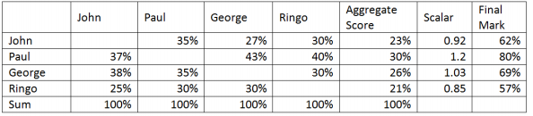
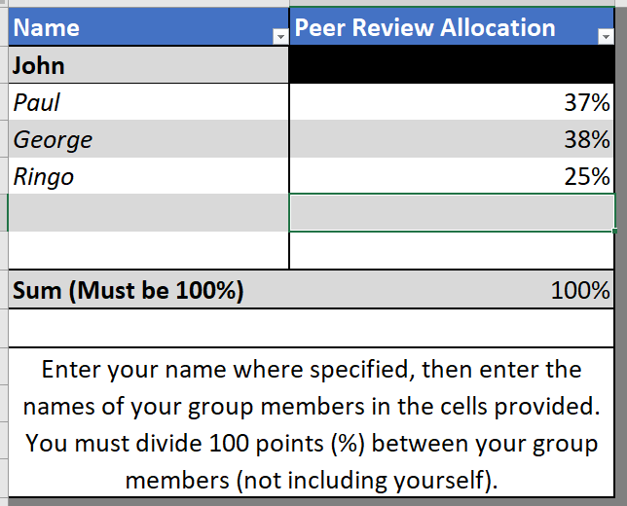
On the left is an example of how each individual will complete the Peer Evaluation spreadsheet. A total of 100 points (%) is divided between the other members of the team (John example). Below is an example of how the scale is calculated of a submission worth 67% (of the TEAM component). YOU DO NOT GRADE YOURSELF.

Individual marks will not exceed +10 marks for the team score. For example, if the team project was scored at 67% (of the TEAM component), and the matrix used to calculate the individual mark for a member was given as 80% (Paul). The individual mark would be capped at 77% (of the TEAM component). However, there is no minimum cap. This means no contribution can still lead to a failure.

Teamwork:
Your ability to work within a team is critical to the success of all aspects of this coursework. As an individual you need to be able to provide technical contributions, negotiate, compromise and be willing to accept contributions and constructive criticism from your peers. It is your responsibility to contribute to your team and it is the responsibility of your peers to allow you to make that contribution.

Assets:
Unity is the course tool; however, you can use models from other courses, or those from the Unity Asset Store, or TurboSquid, as part of your submission. You must clearly state in your slides any assets used from Asset Store or elsewhere. Remember :-

Components/Assets/Code of the project will only be marked if it’s your own.

The following are INDIVIDUAL component (20%):
As part of your development, you must investigate what sorts of casual games are currently available on mobile. This can provide you a better understanding of the standard typically expected of this genre. You must enter at least 5 Journal Entries in the Discussion section on LearningZone, critically analysing 5 different casual mobile games. We will be looking at a range of different games during the labs, or you may choose your own. The journal entries should be a minimum of 50 words, but can include screenshots and images.


To do this, go to LearningZone, and to the Module Shell, then click on Discussions.
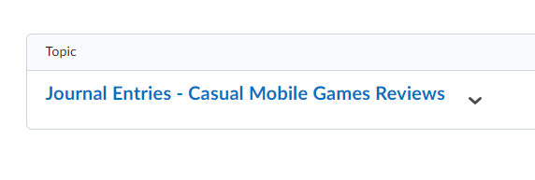
Then click on the Journal Entries.

You must create only ONE thread, and review your 5 games in there.


Deliverables:
The following are TEAM components:
Zipped Unity3D Project file:
- Wednesday 31st January 2024 at 12:00 (midday). Unity Project, submission through project submission link via LearningZone.
- (if there are issues uploading to LearningZone, upload the zip folder to OneDrive, and submit a link)

Mobile Game APK file:
- Wednesday 31st January 2024 at 12:00 (midday). APK, submission through APK submission link via LearningZone.

Presentation Slides:
- Wednesday 31st January 2024 at 12:00 (midday). 5 slides, submission through TurnItIn link via LearningZone.

Presentation & Demonstration (10 minutes):
- A face-to-face Presentation and Demonstration of the project during your Lab on Wednesday 31st January.

OR

- An ONLINE Presentation and Demonstration of the project during Online Session on Thursday 1st February, 9am-11am.
(subject to prior agreement).

The following are INDIVIDUAL components:
5 Journal Entries:
- Wednesday 31st January 2024 at 12:00 (midday). Submission through journal entries on the Discussion section on LearningZone.

Peer Mark Allocations:
- Friday 2nd February 2024 at 12:00 (midday). Template can be found on LearningZone.

 | 0 - 29% | 30 - 39% | 40 - 49% | 50 - 59% | 60-69% | 70 – 89% | 90 - 100%
Team Component (80%) (your mark scaled based on peer review).
Implementation and integration of Advanced Techniques  (25) | No explicit use of Advanced Techniques. | Minor and limited use of the Advanced Techniques | Some limited use of the Advanced Techniques (less than three). | Overall decent use of Advanced Techniques (at least three implemented effectively). . | Good use of Advanced Techniques (at least three), but limited integration. | Excellent use of Advanced Techniques, including effective synthesis of Techniques, with vision outlined in the presentation.
Consideration and Appropriation for Mobile  (20) | No or little consideration and appropriation for mobile. No or Very little Optimisation Techniques implemented. | Minor consideration and appropriation for mobile, but unclear. Minor attempt to include Optimisation, very incomplete implementation. | Limited consideration and appropriation for mobile, not very obvious. Some attempt to include Optimisation, but incomplete implementation. | Overall decent consideration and appropriation for mobile clearly visible in implementation. Overall decent Optimisation, but generic implementation | Good overall consideration and appropriation for mobile. Good Optimisation, however, a lack of innovation, or integration with Mobile format, prevented obtaining a higher mark. | Excellent consideration and appropriation for mobile, immersive experience. Excellent use of Optimisation. Excellent integration with Mobile format.
APK Build and Deploy  (20) | APK was not provided, or was provided and does not install. | APK provided but does not load, or exhibits fatal errors causing crashing. | APK installs and runs but exhibiting major errors in the game, some which lead to fatal errors. | APK installs and runs but exhibiting some errors in the game, however, minimal fatal errors. | APK installs and runs but exhibiting minor errors in the game, however, no fatal errors. | APK installs and runs and functions almost flawlessly, with only minor issues or room for improvement.
Presentation Slides  & Demonstration  (15) | No or very poor presentation. No Demonstration | No clear vision or incorporation of the presentation. No/Poor Demonstration. | A minor attempt however lacks descriptions, critical analysis of implantation and structure. Poor grammar and/or expression problems. Poor Demonstration. | A reasonable attempt at a presentation with some descriptions, critical analysis of implantation and structure. Some grammar and/or expression problems. Reasonable Demonstration. | Overall, a good attempt at a presentation with good descriptions, critical analysis of implantation and structure but minor grammar and/or expression problems. Very good Demonstration. | Excellent presentation with excellent descriptions, critical analysis of implantation and structure with excellent use of grammar, formatting and clarity of expression. Excellent Demonstration.
Individual Component (20%)
Journal Entries  (20) | No or very limited journal entries | Limited number of journal entries with poor analysis and reflection. No more than 2. | Some journal entries with reasonable level of analysis and reflection. No more than 3. | Good journal entries with good level of analysis and reflection. No more than 4. | Very good and descriptive journal entries with a very good level of analysis and reflection. Up to 5 entries. | Excellent descriptive journal entries with a very high level of analysis and reflection. Minimum of 5 entries.
Mark Scheme
Innovation, going above and beyond the specification

