The code for all three problems is in a single python file. The functions for each problem can be separated as:

1. **Problem 1:** a) DOP(polyList),

b) PolyDivide(polys, divisor),

c) Divide().

Divide() is the main function for this problem.

1. **Problem 2:** a) PolyMultiply(rootsList),

b) Multiply().

Multiply() is the main function for this problem.

1. **Problem 3:** a) ScalarMultiply(xList, exIndex),

b) LagrangeInterpolation().

LagrangeInterpolation() is the main function for this problem.

In addition, there is a Main() function that uses all the function. It is the main function that can perform three operations: divide, multiply and interpolate. Main() function is called by default which provides options for the user to choose between these three operations.

**To run this program, the user should just compile the PA1_UtsavShrestha.py file and follow the on-screen options. Sample of them are attached here as screenshot.**

When the program prompts for the user to select an option, to perform divide operation (**Problem 1**), the user must input **1.** Its screenshot is:

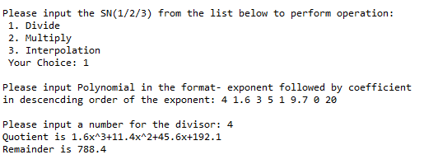

Similarly, to perform multiply operation (**Problem 2**), the user must input **2.** Its screenshot is:

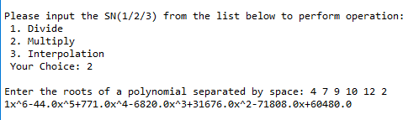

Finally, to perform interpolation (**Problem 3**), the user must input **3.** Its screenshot is:

