**Batch Processing**

Instead of executing a single query, we can execute a batch (group) of queries using **batch processing**.

**Why need of Batch Processing**

In a Jdbc program if multiple sql operations are there, then each operation is individually transferred to the database. This approach will increase the number of round trips between java program (application) and database. If the number of round trips is increased between an application and database, then it will reduce the performance of an application. To overcome these problems we use Batch Processing.

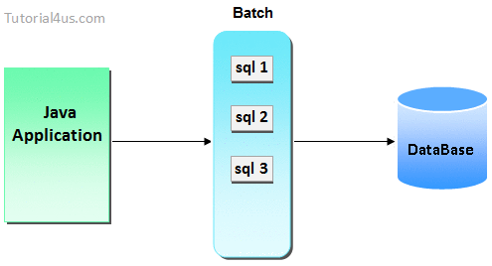

## Advantage of Batch Processing

Increase the performance of an application.

### Method of Batch Processing

The following two methods are used for performing Batch Processing. These methods are given by Statement Interface.

|  |  |
| --- | --- |
| **Method** | **Description** |
| 1 | void addBatch(String query) | It adds query into batch. |
| 2 | int[] executeBatch() | It executes the batch of queries. |

Note: In Batch Processing only non-select operations are allowed select operation is not allowed

If any operation failed in batch processing then java.sql.BatchUpdate Exception will be thrown

When we want to cancel all the operation of the batch when one operation failed then apply batch processing with transaction management.