This is my Project:

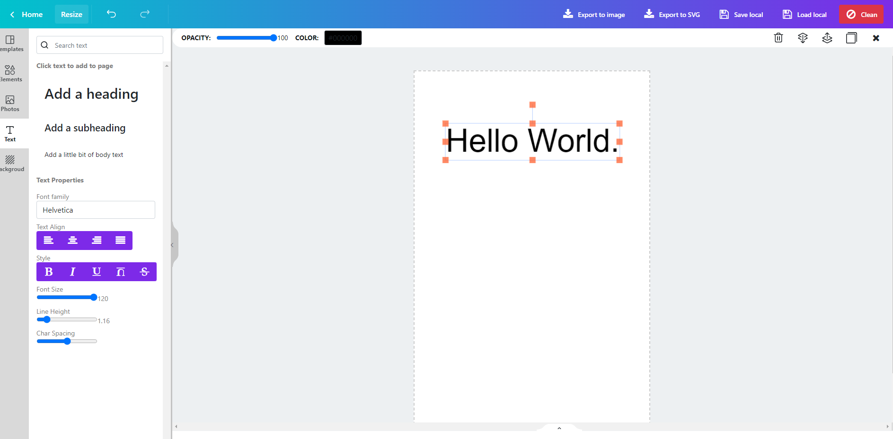

1º I need to put in this red area all the options available

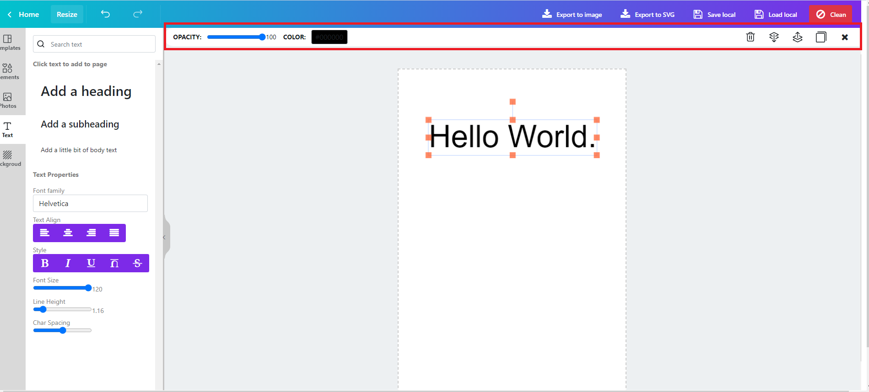

The options are only the green ones (delete the red ones):

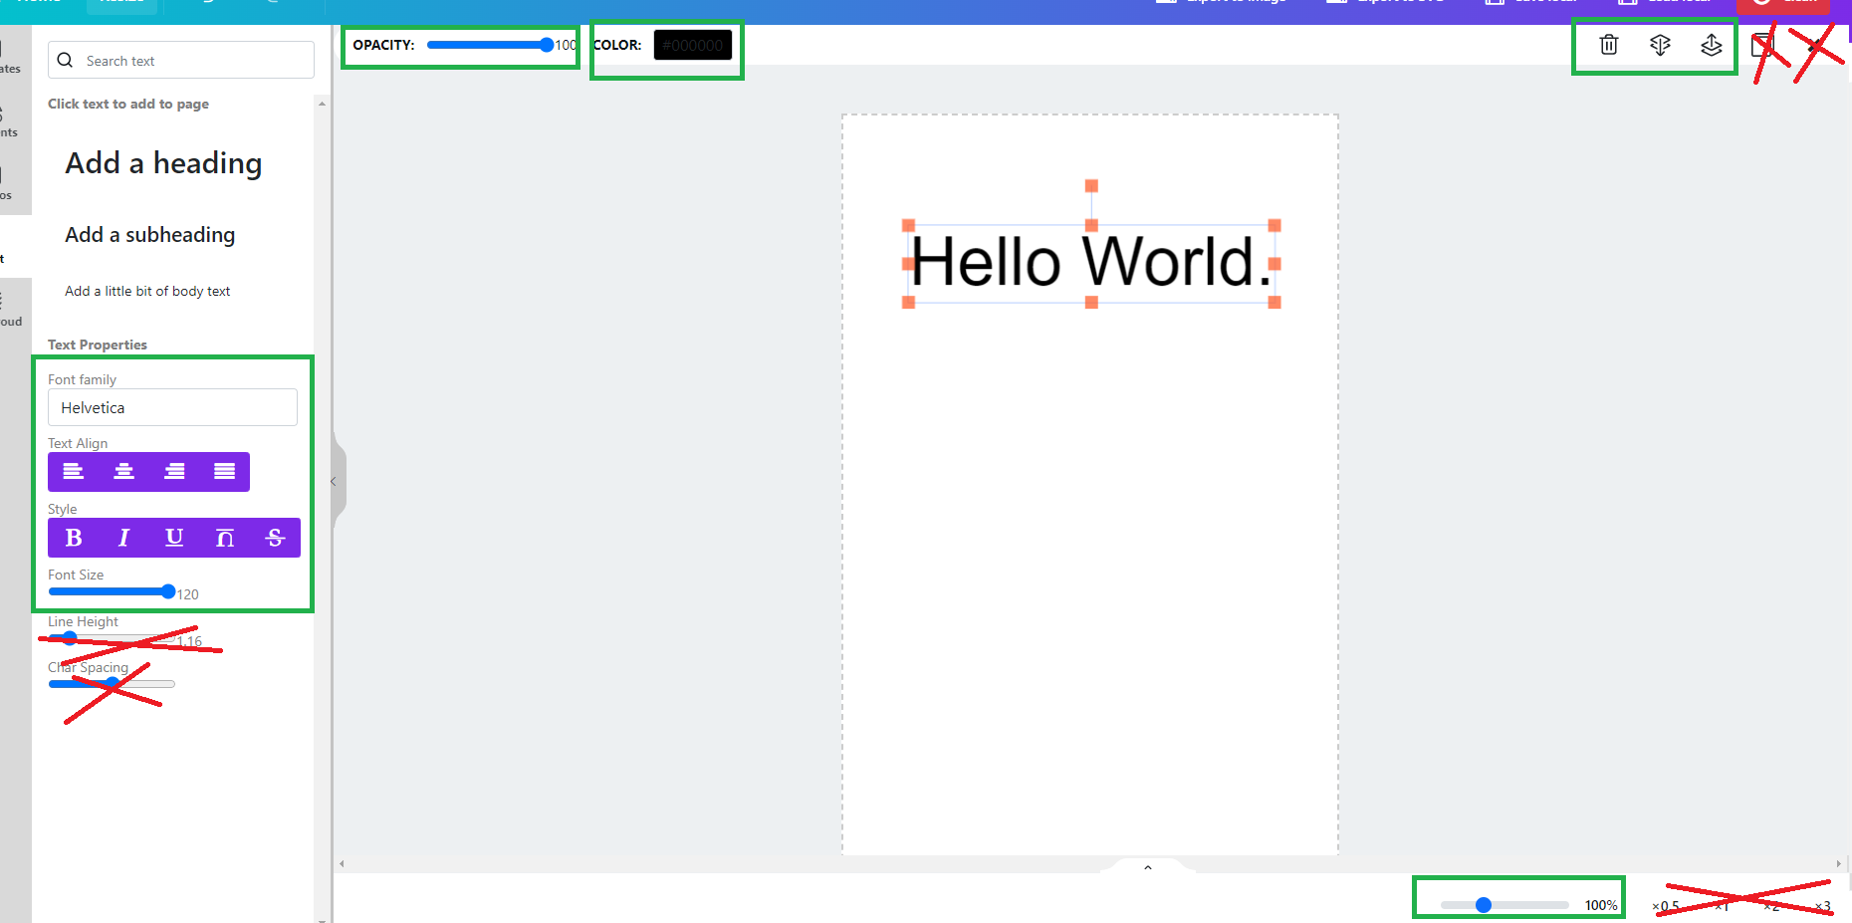

And the layout should be like this:

**Opacity** should be a combo with min: 0% and max:100%



With pre default values but the user can enter a different one. Just like in Microsoft Word.

The **color pallete** button should be like this :



The **Font Size** should be a combo:



With pre default values but the user can enter a different one. Just like in Microsoft Word.

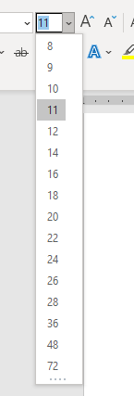

**In this cases:**

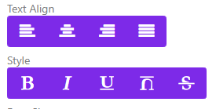

Remove the titles , the background too to look like this:





The zoom, instead tof this:



Put like this:



So everything of this options should be in this red area, just in one row.

2º I need I tooltip in every shape, could be Text or images.

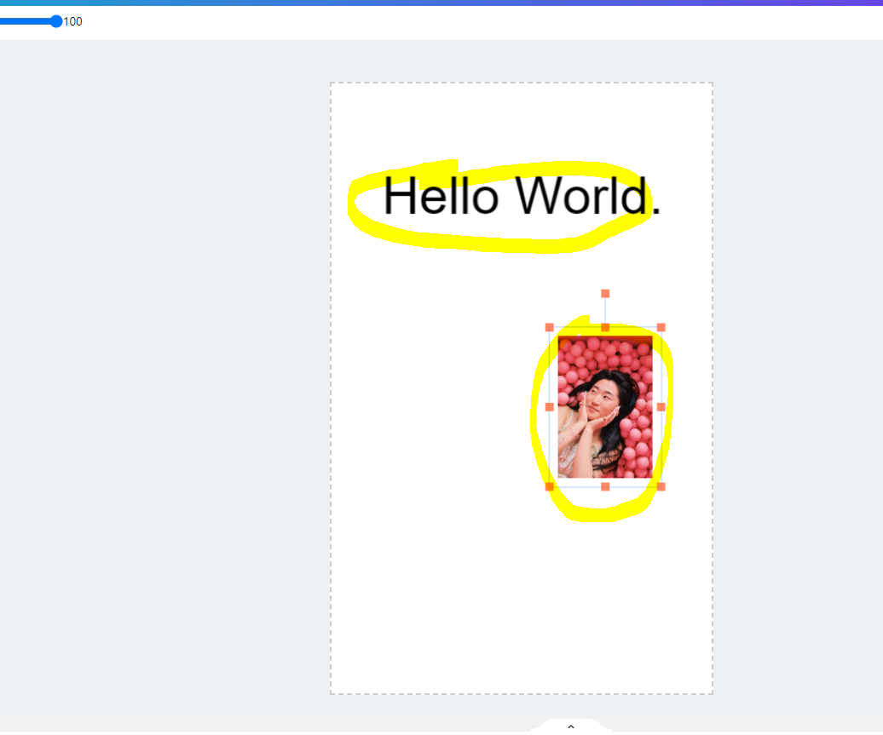

The tooltip should be something like this:



With white text in the middle.

The content in the tooltip will be in the object type: Image, Itext, rect, circle,etc…

3º Bug to fix:

If I increase the text, the Font Size should be update too.

