1. Consider the following ε-NFA.
 | ε | a | b | c
→p | {q,r} | φ | {q} | {r}
q | φ | {p} | {r} | {p,q}
∗r | φ | φ | φ | φ
(1) Compute the ε-closure of each state.
(2) Give all the strings of length three or less accepted by the automaton.
Give regular expressions for following languages.
2. L = { 0^{n}1^{m} | n < 4, m ≤ 3}.
3. The set of all strings of 0's and 1's not containing 101 as a substring.
4. L = { w∈{0,1}* | w contains both 01 and 10 as substrings }.
5. The set of all strings with an equal number of 0's and 1's, such that no prefix has two more 0's than 1's, nor two more 1's than 0's.
6. Let L={ w | w∈{0,1}* and if there are two 0s of w, they must be separated by 1 or 11 }.
7. The set of all strings of 0's and 1's except the string 001.
8. { w | w corresponds to the binary encoding, without leading 0s, of natural numbers that are evenly divisible by 4 }.
9. Write a regular expression for the language which is accepted by following finite automaton. You are required to do your work step by step as hint below.
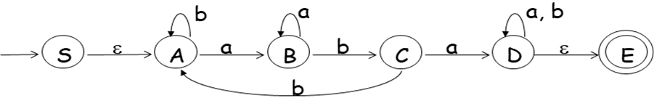
First step: eliminate(remove) state B
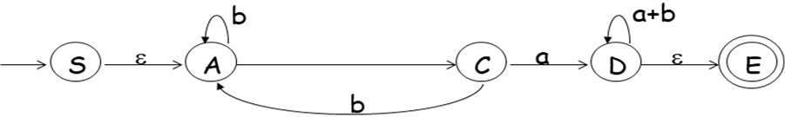
Second step: eliminate(remove) state C
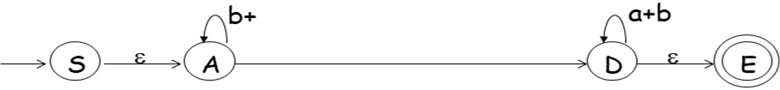

Third step: eliminate(remove) state D
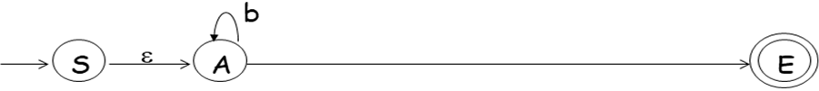

Final step: eliminate(remove) state A

10. Prove that L = {0^{m}1^{n} | m/n is an integer} is not regular with pumping lemma.

