

Fast Device Discovery for Remote Device Management
in Lighting Control Networks

Sang-Il Choi¹, Sanghun Lee², Seok-Joo Koh³,
Insu Kim¹, and Tae-Gyu Kang¹

Abstract
The Remote Device Management (RDM) protocol is used to manage the devices in the lighting control networks. RDM provides bi-directional communications between a controller and many lighting devices over the DMX512-A network. In RDM, using a simple binary search scheme, which is based on the 48-bit unique ID (UID) of each device, discovers the lighting devices. However, the existing binary search scheme tends to require a large delay in the device discovery process. In this paper, we propose a novel partition-based discovery scheme for fast device discovery in RDM. In the proposed scheme, all devices are divided into several partitions as per the device UID, and the controller performs device discovery for each partition by configuring a response timer that each device will use. From numerical simulations, we can see that there is an optimal number of partitions to minimize the device discovery time for a given number of devices in the proposed scheme, and also that the proposed partition-based scheme can reduce the device discovery time, as compared to the existing binary search scheme.

Keywords
Device Discovery, Partition-Based, RDM

1. Introduction
One of the primary issues in the lighting control network is how to effectively manage a lot of devices within the network. Some protocols for device management have so far been made in the PLASA Technical Standards Program (TSP) [1], which includes the Digital Multiplex 512-A (DMX512-A) [2] and Remote Device Management (RDM) [3].
The RDM protocol is performed based on the polling system, in which a controller initiates communication and the devices will respond to the request of controller. RDM is used for the discovery and management of devices that are connected through the DMX512-A link. For device discovery, the controller uses a simple binary search scheme, based on the 48-bit unique ID (UID). However, this device discovery scheme tends to require a lengthy discovery time due to exploring the 2⁴⁸ theoretically
This paper is organized as follows: Section 2 discusses the existing device discovery scheme. In Section 3, we propose the fast device discovery scheme for RDM. In Section 4, we analyze and compare the existing and proposed schemes in terms of device discovery times. Section 5 concludes this paper.

※ This is an Open Access article distributed under the terms of the Creative Commons Attribution Non-Commercial License (http://creativecommons.org/licenses/by-nc/3.0/) which permits unrestricted non-commercial use, distribution, and reproduction in any medium, provided the original work is properly cited.
Manuscript received Month 06, 20XX; first revision Month 08, 20XX; accepted Month 06, 20XX.
Corresponding Author: Seok-Joo Koh (sjkoh@knu.ac.kr)
¹ School of Computer Science and Engineering, Kyungpook National University, Daegu, Korea (jips@kips.or.kr, jips1@kips.or.kr, jips2@kips.or.kr)
² Dept. of Computer Science, Zhejiang Wanli University, Ningbo, China (jips3@kips.or.kr)
³ LED Communication Research Team, Electronics and Telecommunications Research Institute, Daejeon, Korea (jips3@kips.or.kr)

2. Existing Device Discovery Scheme

In RDM [3], a simple binary search scheme is used for device discovery, which is based on the 48-bit UID of each device. Fig. 1 shows the existing device discovery scheme, in which a controller performs a binary search for devices with the UIDs ranging from 0 to 2⁴⁸.

2.1 Wavelet Filterbank

Initially, the controller sets the UID search range with (lower, upper) and sends a discovery message to all of the devices in the RDM network. If the controller responds to a single response message, the corresponding device will be successfully found. Otherwise, if two or more devices have responded at the same time, the controller cannot process the multiple response messages due to the characteristics of the DMX512-A link [2]. This is because the DMX512-A link does not use the packet scheduling functionality and thus, multiple response messages will be simply corrupted and discarded by the controller. In this case, the controller will further divide the UID search range into the two parts.

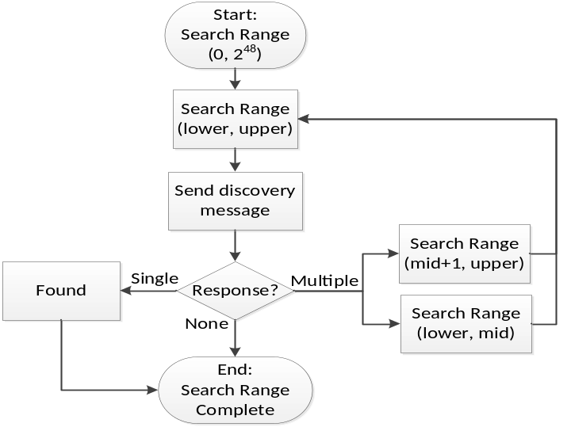
Fig. 1. Existing device discovery in Remote Device Management (RDM).

2.1.1 Wavelet theory

One of the primary issues in the lighting control network is how to effectively manage a lot of devices within the network.

3. Proposed Device Discovery Scheme

The existing device discovery scheme gives a lengthy device discovery time because the 48-bit UID search range (2⁴⁸) tends to induce very deep tree levels along the binary search tree. Thus, we propose a new device discovery scheme, called partition-based device discovery.
In the proposed scheme, all devices in the network will be grouped into N_{p} partitions, as shown in Fig. 2.

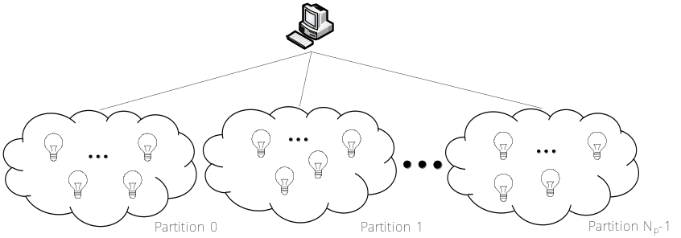
Fig. 2. Partitions of devices in Remote Device Management (RDM).

Given the number of partitions (N_{p}), the partition of a device (0, 1, .., N_{p}-1) is determined by using the modulo (%) operator and the device UID, as follows:

Partition of device UID = UID % N_{p}.

4. Performance Analysis

To evaluate the performance of the proposed scheme, we compared the device discovery time for the existing binary search scheme and the proposed partition-based scheme in a variety of network conditions. For numerical analysis, we used MATLAB (MathWorks, Natick, MA, USA), and we performed five test instances and obtained the averaged values in simulations.

$S=201\log_{10}\left(\frac{256}{ε}\right)$$S=201\log_{10}\left(\frac{256}{ε}\right)$$S=201\log_{10}\left(\frac{256}{ε}\right)$, $ε= \sqrt{\frac{1}{N^{2}}{(S_{k}-D_{k})}^{2}}$ (1)

$S=201\log_{10}\left(\frac{256}{ε}\right)$, $ε= \sqrt{\frac{1}{N^{2}}{(S_{k}-D_{k})}^{2}}$ (2)

In our analysis, we first examined an optimal configuration of the parameters that are used in the proposed scheme, such as the Delay Increase Interval (DII) and the number of partitions (N_{p}). After that, we compared the proposed scheme with the existing scheme in terms of device discovery time.
Fig. 4 shows the impacts of both N_{p} and the number of devices on the device discovery time, in which DII is set to 10 time slots. It is noted in the figure that the device discovery time is plotted in the time unit of seconds, whereas, the basic operational time unit is 0.0028 seconds in each simulation. From this figure, we can see that the device discovery time tends go higher, as the number of devices increases. From the results, it is noted that there may be an optimal number of N_{p} for a given number of devices. For example, for 2¹⁰ devices, N_{p} = 3 gives the best performance, whereas, the device discovery time can be minimized at N_{p} = 6 when there are 2¹² devices in the network. In our analysis, we first examined an optimal configuration of the parameters that are used in the proposed scheme, such as the Delay Increase Interval (DII) and the number of partitions (N_{p}). After that, we compared the proposed scheme with the existing scheme in terms of device discovery time. Fig. 4 shows the impacts of both N_{p} and the number of devices on the device discovery time, in which DII is set to 10 time slots. It is noted in the figure that the device discovery time is plotted in the time unit of seconds, whereas, the basic operational time unit is 0.0028 seconds in each simulation. From this figure, we can see that the device discovery time tends go higher, as the number of devices increases. From the results, it is noted that there may be an optimal number of N_{p} for a given number of devices. For example, for 2¹⁰ devices, N_{p} = 3 gives the best performance, whereas, the device discovery time can be minimized at N_{p} = 6 when there are 2¹² devices in the network.

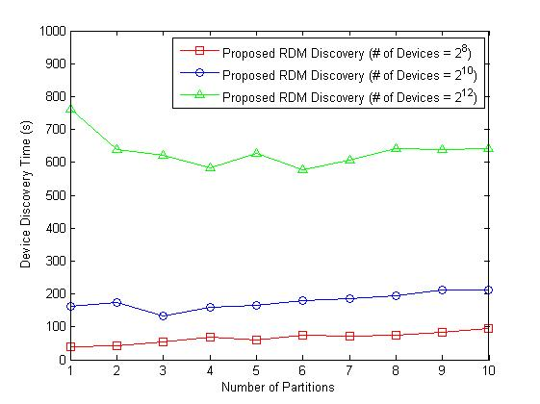
Fig. 4. The impacts of both N_{p} and the number of devices on the discovery time.

With this obtained optimal configuration, we compared the overall device discovery time for the existing binary search scheme and the proposed partition-based scheme, as shown in Table 1. From this figure, we can see that the proposed scheme gives a much smaller device discovery time than the existing scheme does.
Table 1. PSNR results [dB] for various test images and δ value
 | δ | Visu-shrink | Sure-shrink | Bayes- shrink | Sendur’s method | Oracle- shrink | Wiener | Normal shrink
Lena | 10 | 28.76 | 33.28 | 33.32 | 33.94 | 33.61 | 33.53 | 33.57
Lena | 20 | 26.46 | 30.22 | 30.17 | 30.73 | 30.38 | 30.35 | 28.98
Lena | 30 | 25.14 | 28.38 | 28.48 | 28.94 | 28.60 | 28.53 | 25.69
Barbara | 10 | 24.81 | 30.21 | 30.86 | 31.13 | 31.50 | 31.37 | 29.81
Barbara | 20 | 22.81 | 25.91 | 27.13 | 27.25 | 27.40 | 27.32 | 26.79
Barbara | 30 | 22.00 | 24.33 | 25.16 | 25.21 | 25.32 | 25.22 | 24.29
Boat | 10 | 26.49 | 31.19 | 31.80 | 32.25 | N/A | N/A | N/A
Boat | 20 | 24.43 | 28.14 | 28.48 | 28.93 | N/A | N/A | N/A
Boat | 30 | 23.33 | 26.52 | 26.60 | 27.11 | N/A | N/A | N/A
Goldhill | 10 | N/A | 31.87 | 31.90 | N/A | 31.97 | 31.71 | 31.80
Goldhill | 20 | N/A | 28.43 | 28.65 | N/A | 28.76 | 28.65 | 28.26
Goldhill | 30 | N/A | 27.02 | 27.11 | N/A | 27.16 | 27.09 | 27.09

5. Conclusion

In this paper, we have proposed a new partition-based device discovery scheme in lighting control networks. In the proposed scheme, all devices are divided into several partitions. In addition, to avoid collisions occurring due to multiple responses, each device sends a response message based on a response timer that is configured by the controller.
From the numerical analysis, we can see that the proposed scheme can provide a much lower device discovery time than the existing scheme. Moreover, the performance gaps between the existing and proposed schemes become lager, as the number of devices increase.

Conflict of Interest

Funding
Please describe the sources of funding that have supported the work.

Acknowledgments (optional)

References

- B. Wang, “Analysis on the current situation and prospect of green mine construction in nonferrous metals industry,” World Nonferrous Metals, vol. 2020, no. 23, pp. 163-164+167, 2020. https://doi.org/10.3969/j.issn.1002-5065.2020.23.082
- J. Lee, J. G. Andrews, and D. Hong, "Spectrum-sharing transmission capacity," IEEE Transactions on Wireless Communications, vol. 10, no. 9, pp. 3053-3063, 2011. https://doi.org/10.1109/TWC.2011.070511.101941
- D. C. Broadstock, R. Matousek, M. Meyer, and N. G. Tzeremes, “Does corporate social responsibility impact firms' innovation capacity? The indirect link between environmental & social governance implementation and innovation performance,” Journal of Business Research, vol. 119, pp. 99-110, 2020. https://doi.org/10.1016/j.jbusres.2019.07.014
- Q. Cao and S. Fujita, "Cost-effective replication schemes for query load balancing in DHT-based peer-to-peer file searches," Journal of Information Processing Systems, vol. 10, no, 4, pp. 628-645, 2014. https://doi.org/10.3745/JIPS.03.0020
- V. Kolici, A. Herrero, and F. Xhafa, "On the performance of Oracle grid engine queuing system for computing intensive applications," Journal of Information Processing Systems, vol. 10, no, 4, pp. 491-502, 2014. http://doi.org/10.3745/JIPS.01.0004


Sang-Il Choi https://orcid.org/0000-0002-4510-0385

He received B.S. and M.S. degrees in School of Computer Science and Engineering from Kyungpook National University in 2010 and 2012, respectively. Since March 2018, he is with the School of Computer Science and Engineering from Kyungpook National University as a Ph.D. candidate. His current research interests include mobile communication and lighting control network.

Sanghun Lee https://orcid.org/0000-0002-4510-0385

She received B.S. degree in computer science from Duksung Women’s University in 1995, M.S. degree in computer science from Yonsei University in 2000, and Ph.D. degree in computer sciences from the University of Iowa, Iowa City, in 2005. She is currently a professor in the Department of Computer Science, Ewha Women’s University, Seoul, Korea. Her research interests include communication and lighting control network.
When you make your profile, Please kindly include your current Position, Department (Division), and Affiliation.

Remark :

1. Before submission, You should read the policy of publication charge
and select the right submission track. http://jips-k.org/static/submission

2. Figures and Tables need to be provided as high resolution
(original file).

3. References should be cited in numerical order as they appear in text.

4. When you make your profile, Please kindly include your current position or title as well as your affiliation in your profile.

5. We need all author's ORCID ID. Please visit website.
https://orcid.org/signin (This takes around 2 minutes to complete.)
You can put it beside author's biography of last pages.

6. Manuscripts that are not properly formatted and prepared will be returned to the authors for revision and resubmission.

