The **Object.freeze()** method **freezes** an object. A frozen object can no longer be changed; freezing an object prevents new properties from being added to it, existing properties from being removed, prevents changing the enumerability, configurability, or writability of existing properties, and prevents the values of existing properties from being changed. In addition, freezing an object also prevents its prototype from being changed. freeze() returns the same object that was passed in.

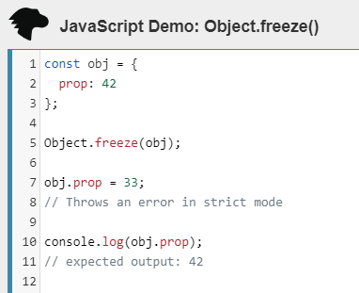

# **JavaScript Array reduce() Method**

<https://www.w3schools.com/jsref/jsref_reduce.asp>

## **Definition and Usage**

The reduce() method reduces the array to a single value.

The reduce() method executes a provided function for each value of the array (from left-to-right).

The return value of the function is stored in an accumulator (result/total).

**Note:** reduce() does not execute the function for array elements without values.

**Note:** This method does not change the original array.

### **Example**

Subtract the numbers in the array, starting from the beginning:

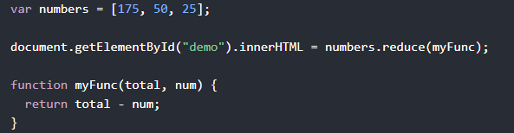

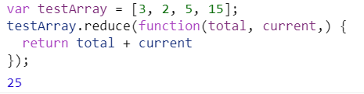

# **JavaScript String charAt() Method**

### **Example**

Return the first character of a string:



## Definition and Usage

The charAt() method returns the character at the specified index in a string.

The index of the first character is 0, the second character is 1, and so on.

**Tip:** The index of the last character in a string is string.length-1, the second last character is string.length-2, and so on (See "More Examples").

JavaScript Array sort() Method

### **Example**

Sort an array:

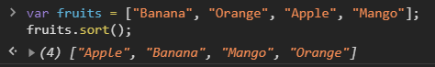

The sort() method sorts the items of an array.

The sort order can be either alphabetic or numeric, and either ascending (up) or descending (down).

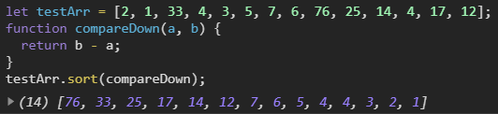

By default, the sort() method sorts the values as strings in alphabetical and ascending order.

This works well for strings ("Apple" comes before "Banana"). However, if numbers are sorted as strings, "25" is bigger than "100", because "2" is bigger than "1".

Because of this, the sort() method will produce an incorrect result when sorting numbers.

You can fix this by providing a "compare function" (See "Parameter Values" below).

**Note:** This method changes the original array.

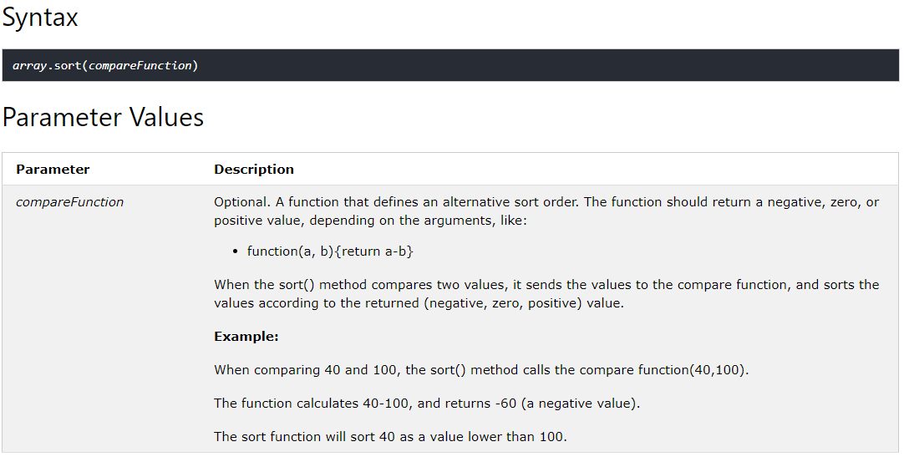

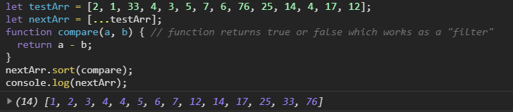

The **Object.values()** method returns an array of a given object's own enumerable property values, in the same order as that provided by a [for...in](https://developer.mozilla.org/en-US/docs/Web/JavaScript/Reference/Statements/for...in) loop. (The only difference is that a for...in loop enumerates properties in the prototype chain as well.)

Syntax:

**Object.values(obj)**

Object.values() returns an array whose elements are the enumerable property values found on the object. The ordering of the properties is the same as that given by looping over the property values of the object manually.

JavaScript **Array map()**Method

<https://www.w3schools.com/jsref/jsref_map.asp#:~:text=The%20map()%20method%20creates,for%20array%20elements%20without%20values>.

The map() method creates a new array with the results of calling a function for every array element.

The map() method calls the provided function once for each element in an array, in order.

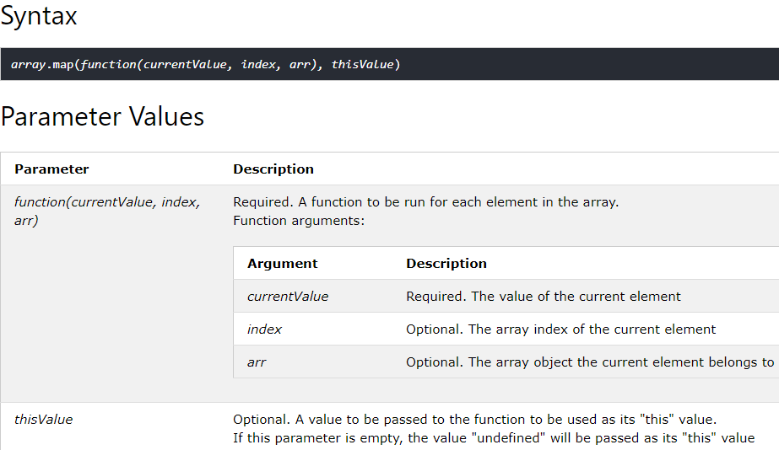

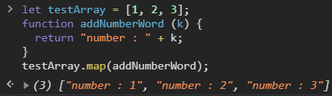

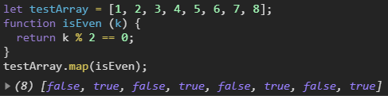

# **JavaScript Array join() Method**

<https://www.w3schools.com/jsref/jsref_join.asp>

The join() method returns the array as a string.

The elements will be separated by a specified separator. The default separator is comma (,).

**Note:** this method will not change the original array.

## **Syntax**



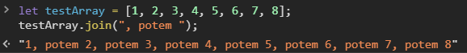

The **padStart()** method pads the current string with another string (multiple times, if needed) until the resulting string reaches the given length. The padding is applied from the start of the current string.



**Syntax:**

**str.padStart(targetLength [, padString])**

# JavaScript **String split()**Method

<https://www.w3schools.com/jsref/jsref_split.asp>

## **Definition and Usage**

The split() method is used to split a string into an array of substrings, and returns the new array.

**Tip:** If an empty string ("") is used as the separator, the string is split between each character.

**Note:** The split() method does not change the original string.



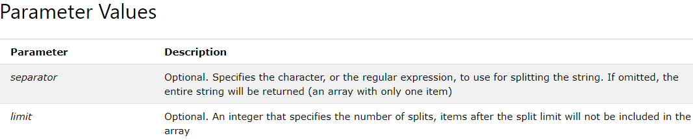



# JavaScript **Array reverse()**Method

<https://www.w3schools.com/jsref/jsref_reverse.asp>

## **Definition and Usage**

The reverse() method reverses the order of the elements in an array.

**Note:** this method will change the original array.

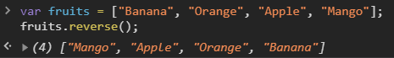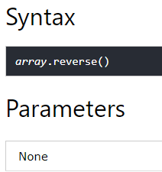

# JavaScript **String replace()**Method

<https://www.w3schools.com/jsref/jsref_replace.asp>

## **Definition and Usage**

The replace() method searches a string for a specified value, or a regular expression, and returns a new string where the specified values are replaced.

**Note:** If you are replacing a value (and not a regular expression), only the first instance of the value will be replaced. To replace all occurrences of a specified value, use the global (g) modifier (see "More Examples" below).

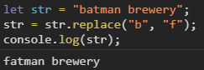 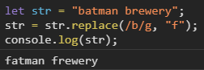

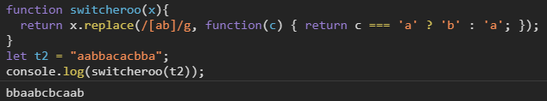

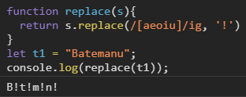

# JavaScript**round()**Method

<https://www.w3schools.com/jsref/jsref_round.asp>

## **Definition and Usage**

The round() method rounds a number to the nearest integer.

**Note:** 2.49 will be rounded down (2), and 2.5 will be rounded up (3).



# JavaScript **Array filter()**Method

<https://www.w3schools.com/jsref/jsref_filter.asp>

## **Definition and Usage**

The filter() method creates an array filled with all array elements that pass a test (provided as a function).

**Note:** filter() does not execute the function for array elements without values.

**Note:** filter() does not change the original array.

**Syntax:**

**array.filter(function(currentValue, index, arr), thisValue)**

|  |  |
| --- | --- |
| **Parameter** | **Description** |
| *function(currentValue, index,arr)* | Required. A function to be run for each element in the array. Function arguments:   |  |  | | --- | --- | | **Argument** | **Description** | | *currentValue* | Required. The value of the current element | | *index* | Optional. The array index of the current element | | *arr* | Optional. The array object the current element belongs to | |
| *thisValue* | Optional. A value to be passed to the function to be used as its "this"  value. If this parameter is empty, the value "undefined" will be passed  as its "this" value |

# JavaScript **Array concat()**Method

## **Definition and Usage**

The concat() method is used to join two or more arrays.

This method does not change the existing arrays, but returns a new array, containing the values of the joined arrays.

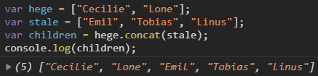

**Syntax:**

**array1.concat(array2, array3, ..., arrayX)**

|  |  |
| --- | --- |
| **Parameter** | **Description** |
| *array2*, *array3*, ..., *arrayX* | Required. The arrays to be joined |

# JavaScript **Array every()**Method

<https://www.w3schools.com/jsref/jsref_every.asp>

## **Definition and Usage**

The every() method checks if all elements in an array pass a test (provided as a function).

The every() method executes the function once for each element present in the array:

* If it finds an array element where the function returns a false value, every() returns false (and does not check the remaining values)
* If no false occur, every() returns true

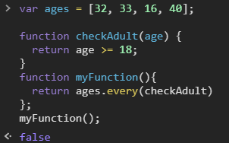

# **Array.prototype.flat()**