***Roll & Play board games spot - Data warehouse design***Business process

The Data warehouse is designed for organizing tournaments. We described this process in a detailed way in the document Specification of business processes.  
  
Relational Database schema  
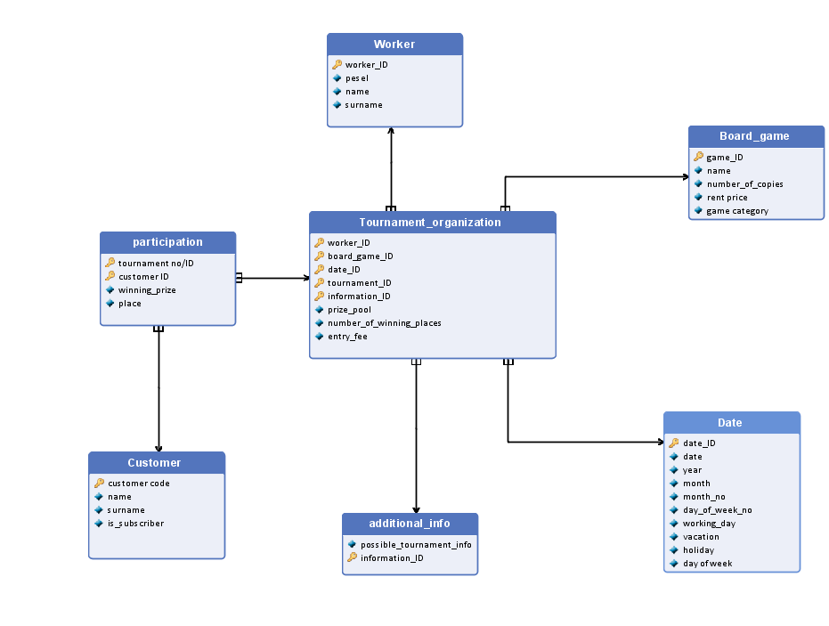

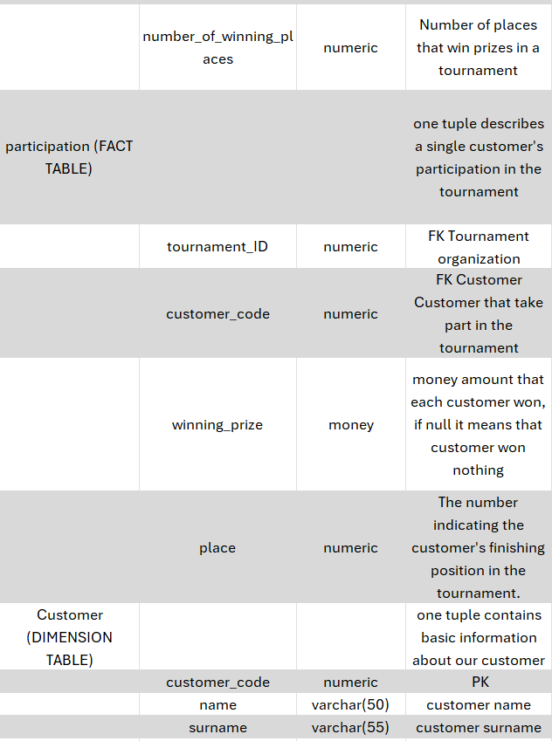

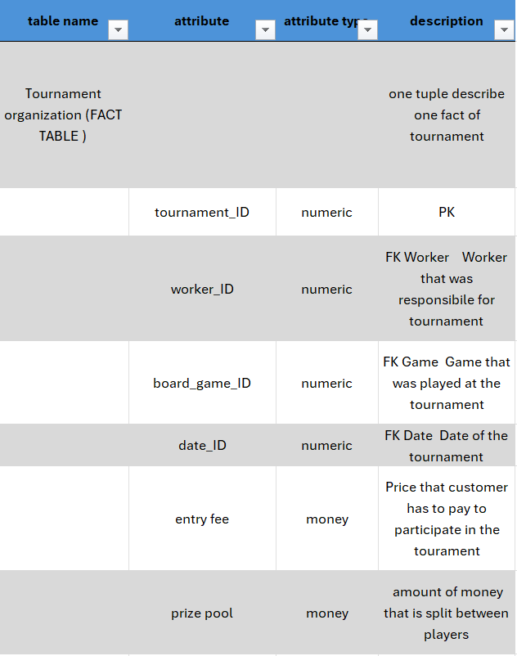

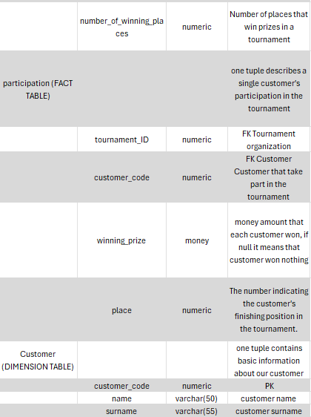

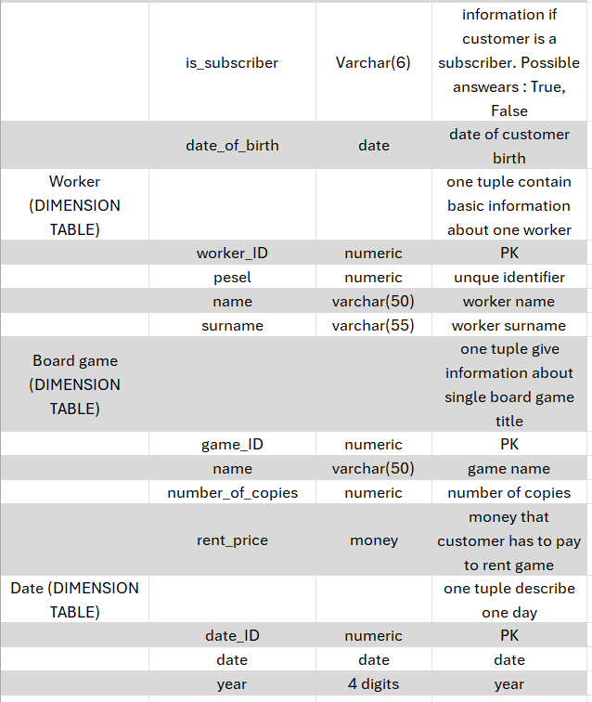

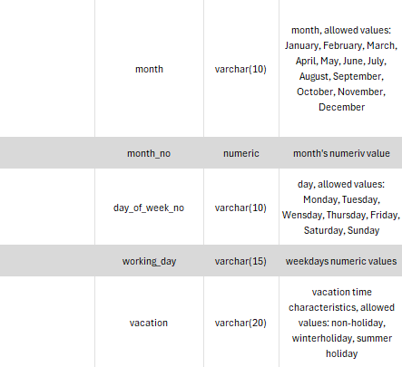

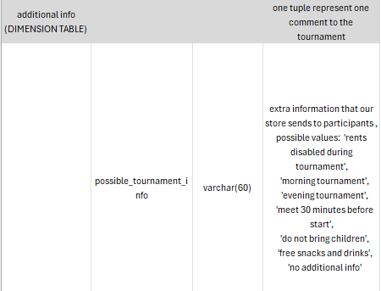

Dimensional model

Fact definitions

**Fact 1 Tournament organization fact:**

Dimension definitions  
**Dimensions for Fact 1 Tournament organization fact:**  
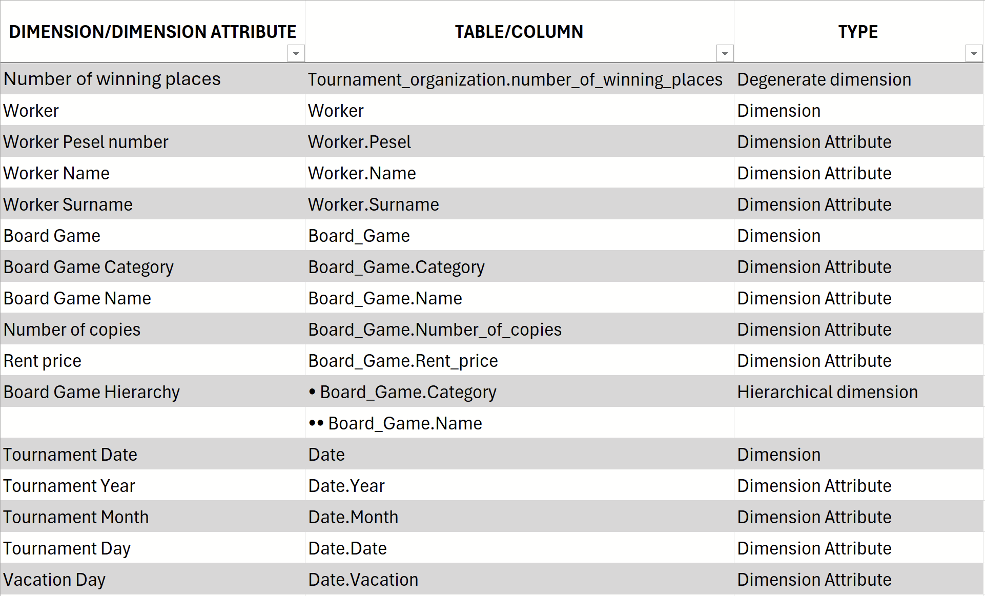

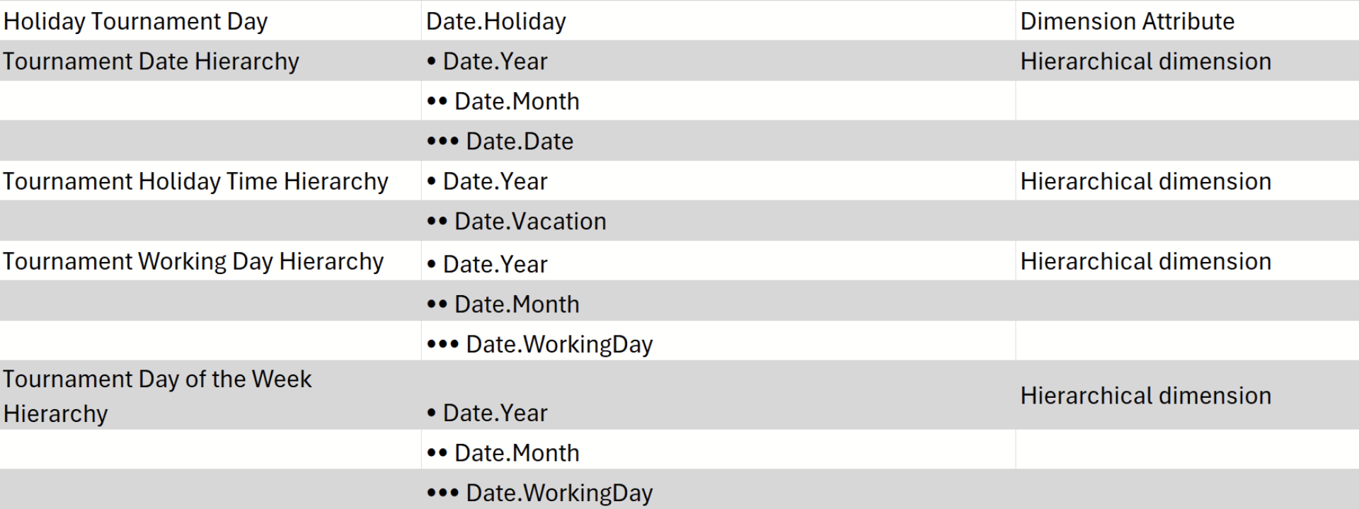

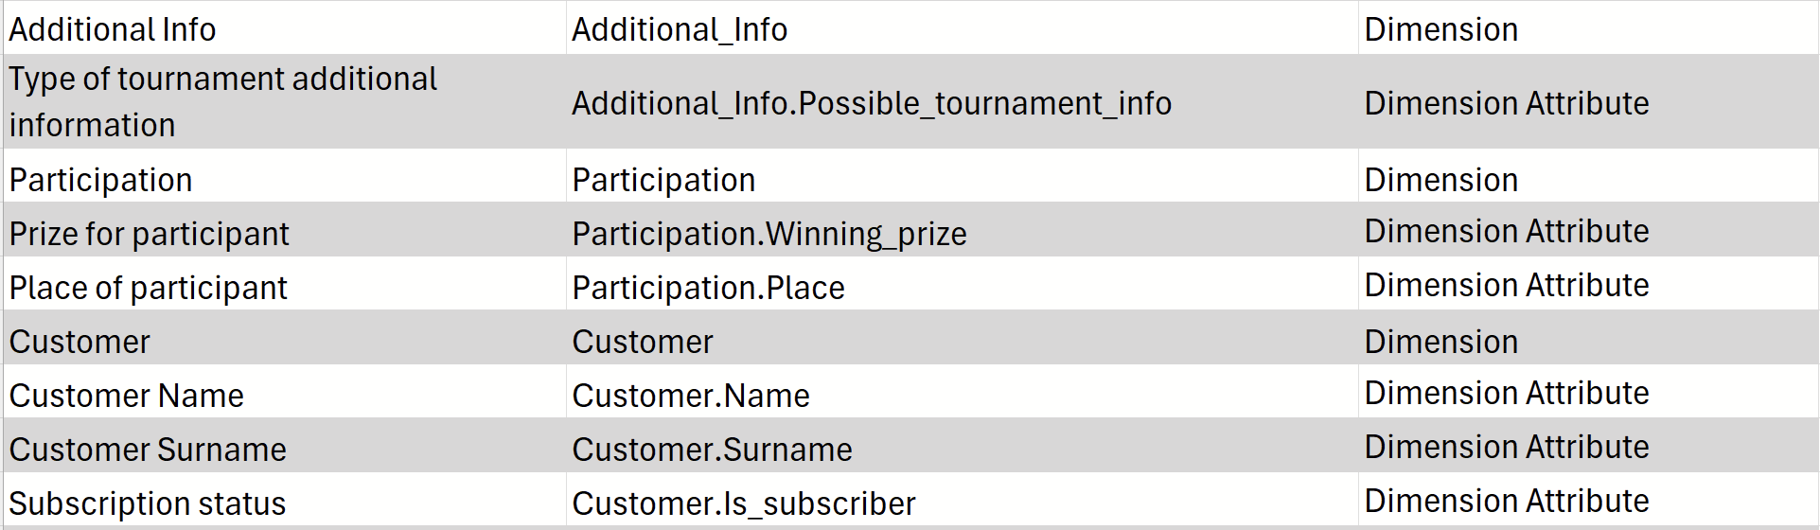

Dimensions for Fact 2 Participation in the tournament fact:

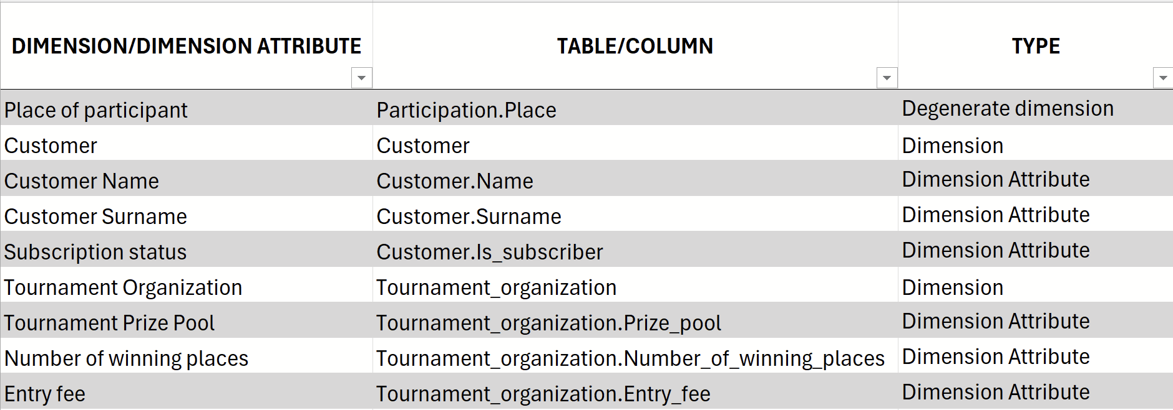

Checking the feasibility of queries based on the multidimensional model  
1. What is the impact of the prize pool on the number of participants?

Measure: Prize pool of the tournament

Dimension: Tournament Participants (Dimension Attributes: Prize pool)

Dimension: Participation (Dimension Attributes: Customer ID)

2. What is the impact of entry price on the number of participants?

Measure: Entry fee for the tournament

Dimension: Tournament Participants (Dimension Attributes: Entry fee)

Dimension: Participation (Dimension Attributes: Customer ID)

3. What is the impact of the number of places with money reward on the number of participants?

Measure: Number of winning places  
 Dimension: Tournament Participants (Dimension Attributes: Number of  
 winning places)

Dimension: Participation (Dimension Attributes: Customer ID)

4. Which game has the most tournament players?

Measure: Number of tournament players

Dimension: Participation (Dimension Attributes: Customer ID)

Dimension: Board game (Dimension Attributes: Name)

5. Are tournaments hosted on the weekends more popular?

Measure: Number of tournament players

Dimension: Participation (Dimension Attributes: Customer ID)  
 Dimension: Date (Dimension Attributes: Day of week No)  
6. Do tournaments with free snacks and drinks are more popular?  
 Measure: Number of tournament players  
 Dimension: Participation (Dimension Attributes: Customer ID)  
 Dimension: Additional info (Dimension Attributes: Possible tournament info)  
7. Are tournaments only for adult players less popular?  
 Measure: Number of tournament players  
 Dimension: Participation (Dimension Attributes: Customer ID)  
 Dimension: Additional info (Dimension Attributes: Possible tournament info)  
8. Does the time of tournament (morning/evening) influence the attendance?  
 Measure: Number of tournament players  
 Dimension: Participation (Dimension Attributes: Customer ID)  
 Dimension: Additional info (Dimension Attributes: Possible tournament info)  
9. What age group is the biggest percentage of tournament players?  
 Measure: Number of tournament players  
 Dimension: Participation (Dimension Attributes: Customer ID)  
 Dimension: Customer (Dimension Attributes: Customer Code)  
10. Do months with more tournaments result in more subscriptions?

Measure: Number of subscriptions

Dimension: Customer (Dimension Attributes: Is subscriber)

Dimension: Date (Dimension Attributes: Month)

Dimension: Tournament organization (Dimension Attributes: Tournament ID)