CUDA_examples REPOSITORY TUTORIAL:
Author do recommend such logical sequence at development of CUDA program:
- get familiar with C programming language,
- read https://en.wikipedia.org/wiki/CUDA
- buy book „CUDA by examples” et. al. Sanders,
- write few dozens of your own programs,
- get an online Youtube course „Udacity: intro to parallel programming”,
- write few dozens of your own programs,
- buy book „Profesional CUDA programming” et. al. Cheng.

This step by step tutorial is intendent for executing repository CUDA programs. It consist of tip dashes:
1) obtain computer/laptop/tablet/phone with included NVidia GPU graphics ( programs are written in Nvidia corporation C extensions language with some C++11 capabilities - Compute Unified Device Architecture CUDA ). If you have not any, I will provide you some new-parts proposition in 2018y:
- CPU: Intel Celeron G3900
- MB: Gigabyte GA-B150-HD3 ( note PCIe 3.0 x16 bandwidth ~12.6GBps )
- RAM: 1x GOODRAM PLAY Blue 2 / 4GB,
- HDD: 120GB SSD GOODRAM, or two pendrives 16GB with Lubuntu desktop 64bit live session on first pendrive, power supply,
- GPU: Nvidia GT730 4GB GDDR5 / GT 1030 2GB
  - tip: consider operating system distribution booting to RAM ( f.e. modified Ubuntu ),
  - tip: consider good quality monitors, chair and keyboard ( for my best knowledge mouse is unnecessary and slows work ),
  - tip: for parallel cluster consider adding SSD RAID 0 ( #mdadm are not so computationally expensive, as you think, especially for multicore CPU ) and sufficient network connection,
  - tip: theoretical lower price – any used Personal Computer with PCIe1.0x16 ( f.e. Core2Duo s775 + 1x1GB RAM + NVS300 + 2xpendrive 16GB ). I did not check that configuration by myself, but should work,
  - tip: if you disable graphical server ( #sudo service lightdm stop ), you will get additional free space of +0.5GB RAM +0.34GB GPU memory, ( author do recommend vim + screen in two windows ), additionally some programs might execute faster,
  - tip: making software RAID 0 on hardware SSD RAID 0 disk array controller for big-data efficient streaming processing.

via .DEB PACKAGE
2) download cudaXX.deb package ( if you have at least 6.x cuda-computation capable device - newer than GT1030):
https://developer.nvidia.com/cuda-toolkit
othercase (GTX 2/4/5/6/7/9xx) download CUDA-Toolkit 8.0 from:
https://developer.nvidia.com/cuda-80-ga2-download-archive
3) in terminal:
- switch to terminal view:
#Ctr+Alt+F1 ( to switch on terminal view )
#Ctr+Alt+F7 ( to switch from terminal view to graphical server )
- at terminal view ( Ctr+Alt+F1 ) log in:
#login: admin
#pass: admin1
#sudo chmod +x cudaXX.deb
#sudo dpkg -i cudaXX.deb
#sudo apt-get update
4) enable GPU driver at: System Settings->Additional Drivers-> Nvidia Driver xx
5) install CUDA Toolkit:
#sudo aptitude install cuda g++-4.9 gcc-4.9
#sudo ln -s /usr/bin/g++-4.9 /usr/local/cuda/bin/g++
#sudo ln -s /usr/bin/gcc-4.9 /usr/local/cuda/bin/gcc
6) restart PC, check whether CUDA programs are working properly – start with CUDA_examples/02_deviceFeatures
#./RUN_COMMANDS.sh

7) if something went wrong, you can reinstall cuda package:
#dpkg -l | grep cuda- | awk '{print $2}' | xargs -n1 sudo dpkg --purge
#dpkg -i cuda**.deb
#sudo apt-get update
#sudo apt-get install cuda-X-X

Post Scriptum: Mostly I have been developing it on Dell Inspiron 7746 with i7 5500U, 16GB RAM 1666MHz, Nvidia GM108M GeForce 845M PCIe 3.0x4 2GB and SSD 1TB ( OS: LINUX Ubuntu Desktop 16.04 64bit; LINUX Ubuntu Desktop 16.10 64bit ). Also it was checked on PC’s: Intel i7 2660k, 16GB 2 channel RAM 1333MHz, Nvidia GK110 GTX780 3GB PCIe 2.0x16, SSD 0.24TB ( OS: LINUX Ubuntu 16.04 64bit ) and Intel Celeron G3900, 12GB 2 channel RAM DDR3 1333MHz, Nvidia GK110 GTX780 3GB PCIe 3.0x16, Nvidia GP108 GT1030 2GB PCIe 3.0x4.
Post Post Scriptum: If one will use customized liveCD from LINUX_tips repo, he or she should take into consideration that minimal recommended RAM size should be 8GB.
Please do consider registers amount for some hardware:
GPR – General Purpose Register
FPR – Floating Point Register
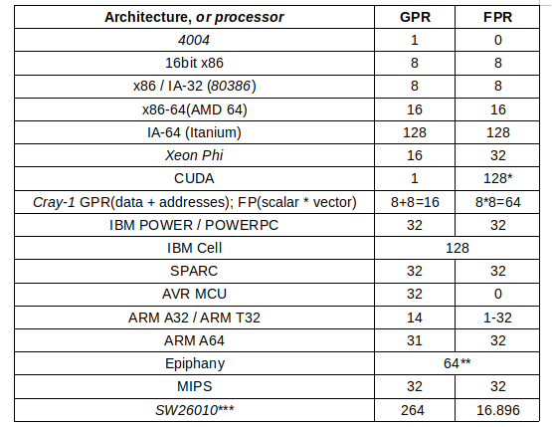
*3584 CUDA cores at 2nd Maxwell generation GP102 processor (GTX1080ti) – there are 1.835.008 FPR’s
**64 cores at E64G401 – there is 4096 register acting as GPR’s or FPR’s,
*** amount approximated

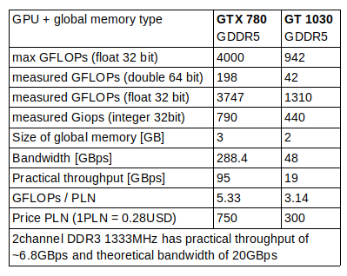

for your RAM details please refer to:
http://manpages.ubuntu.com/manpages/xenial/man1/mbw.1.html

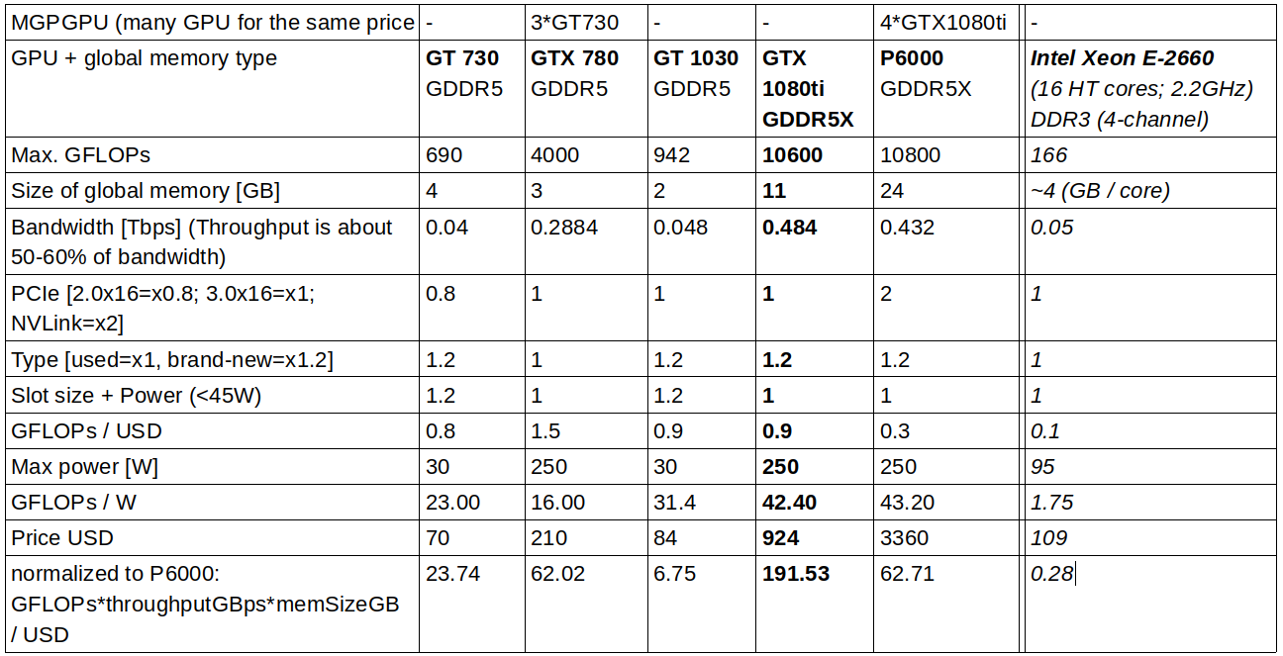

Please do refer to:
https://asteroidsathome.net/boinc/cpu_list.php
http://cuda-z.sourceforge.net/
https://github.com/PiotrLenarczyk/CPlusPlus_examples/tree/master/78_linpackGFLOPS

