# Create Tournament

* 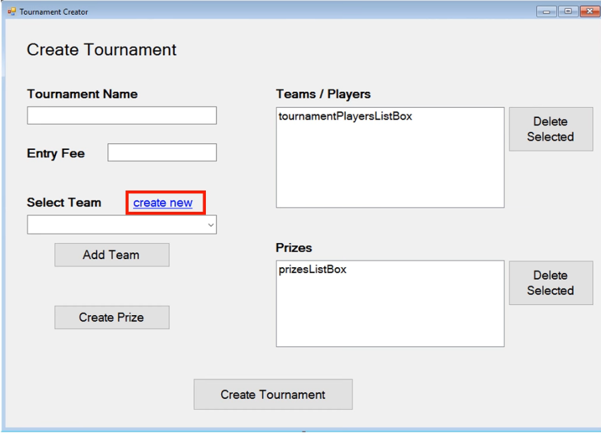Create new – it should open a form to create a new team. Once when the new team is created, the form to create team should close out the new team form. Come back to tournament creator and return a new team. This is good place to use interface, because the create team form not even have to know about the tournament creator form.
* Add Team – take the selected team and put it in Teams list
* Create Prize – it will works very similar to Create new button. The difference is, this will open create prize form
* Delete Selected – it will allow to delete selected team or prizes from the lists.
* Create Tournament – this button is going to create a tournament. It should validate if the information about tournament is as expected (if prizes is not negative number, if there are any teams etc.)

# Create Team

* Add Member – adding existing member to a team and deleting him from a list of players without team.
* Create Member – it creates member, should validate if every information was according to expected, like email with @ etc.
* Create Team – return a team.

# Create Prize

* Create Prize – returns prize and validate information about it

# Tournament Dashboard

* Create Tournament – open a Create Tournament form and return a new tournament
* Load Tournament – load existing tournament and open a Tournament Viewer

# Tournament Viewer

* <name> - change according to loaded tournament
* Round – allows to select round from the tournament
* Unplayed Only – filtering to view only unplayed matchup
* Score – after select unplayed matchup in actual round, we can write a score to team 1 and 2. After click the Score button it will save the scores, change matchup to played one and save the winner of the matchup. **If it’s the last game in round, next round should be started and every player should be notified about it. If it’s the last game in tournament it should end it, make a prizes etc.**