Notes from udemy course: Multithreading, Concurrency & Parallel programming in Java, with strong emphasis on high performance
Saved examples and stuff: /home/piotr/git/javaMultiThreading (github)

Thread creation:
- Create Thread object and pass a Runnable object to it (anonymous inner class or lambda or reference) – Thread thread = new Thread(); - it is empty by default and expects an object which implements Runnable interface to be passed as argument.

Anonymous inner class
Thread thread = new Thread(new Runnable(){
public void run() {
// Code which will run in the thread
}
});

Lambda:
Thread thread = new Thread(() → {
public void run() {
// Code which will run in the thread
}
});

Start Thread: thread.start();

Thread methods:
Thread.currentThread() - get thread object
Thread.currentThread().getName() - name
Thread.sleep(millis: 1000) - sleep – not spinning on CPU but instructs OS not to
schedule it for given time.
thread.setName - set thread name
thread.setPriority(Thread.MAX_PRIORITY) – set priority - takes param of type int – 1-10 or use predefined.
Thread.getCurrentThread().getPriority() - get priority

Create thread by using Inheritance – extending thread class:
class NewThread extends Thread {
public void run() {
// Thread work
// Direct access to thread methods with this:
this.getName()
this.setPriority()
}
}

Debugging
If unhandled exception is thrown inside thread it will terminate it. To be able to log some more data or clean resources we can define uncaught exception handler:
thread.setUncaughtExceptionHandler(new Thread.UncaughtExceptionHandler(){
public void uncaughtException(Thread t, Throwable e) {
// clean up and log data about the exception
}

});

We set this exception on the thread before starting it.

Thread termination:
- Consumes resources – if thread done its work we want to terminate it to release resources.
- If it is misbehaving
- The application will not stop as long as at least one (non demon) thread is still running. Need to stop all threads before closing the application.

Termination:
- thread.interrupt()
  - thread is executing a method that throws InterruptedException
  - the threads code is handling the interrupted signal explicitly – inside a long running code like a loop we need to define if statement which checks if thread is interrupted:
  - if(Thread.currentThread().isInterrupted()){
return;
}
- Demon threads (thread.setDemon(true)) – background tasks which should not block our application from terminating – if main thread finishes, application finishes no matter if demon thread is still doing something.
  - Background tasks - Example: File saving thread in text editor – saves every so often our work in background.
  - Code we do not have control of like 3rd party library, and we do not want it to block our app from terminating.

Joining threads (coordinating):
When 2 or more threads are running at the same time they are completely independent and we cannot know if thread 1 or thread 2 will finish first, will they run concurrent or in parallel or one after the other we cannot know that.

Concurrent:
Thread 1
Thread 2
Thread 1

Parallel:
Thread 1
Thread 2

If thread 2 depends on input from thread 1 then we need to coordinate them:
- Busy wait: thread 2 runs in a loop and keeps checking if thread 1 result is ready:
void waitForThread1(){
while(! Thread1.isFinished())
//burn CPU cycles
}

That will waist CPU cycles and especially in single CPU machine it will be very inefficient because the busy wait loop will take CPU from the thread on which it is waiting, slowing it down.
- What we want is for thread 2 to sleep and get out of the way so that thread 1 can finish as quick as possible.
  - Join:
    - public final void join()
    - public final void join(long millis, int nanos)
    - public final void join(long millis)

Example:
/**
* Joining Threads
* https://www.udemy.com/java-multithreading-concurrency-performance-optimization
*/
public class Main {
public static void main(String[] args) throws InterruptedException {
List<Long> inputNumbers = Arrays.asList(100000000L, 3435L, 35435L, 2324L, 4656L, 23L, 5556L);

List<FactorialThread> threads = new ArrayList<>();

for (long inputNumber : inputNumbers) {
threads.add(new FactorialThread(inputNumber));
}

for (Thread thread : threads) {
thread.setDaemon(true);
thread.start();
}

/*After starting threads and before checking in main thread if each thread finished
we need to run join method on each one. Join method will only return when a thread has finished.
If we did not do it, we would have a race condition scenario where the FactorialThreads are racing with main thread
If main thread finishes faster than some FactorialThreads then we will not have the result ready.*/
for (Thread thread : threads) {
thread.join(2000);
/*We set the parameter to 2000 millis, that means that join method will return even if this thread did not finish, this thread will be still running and the application will not finish until its done. We can use the thread termination technics to stop it by interrupting it or setting it to be daemon. This ensures that our application will not hang for long time if we get a very long running thread.*/
}

for (int i = 0; i < inputNumbers.size(); i++) {
FactorialThread factorialThread = threads.get(i);
if (factorialThread.isFinished()) {
System.out.println("Factorial of " + inputNumbers.get(i) + " is " + factorialThread.getResult());
} else {
System.out.println("The calculation for " + inputNumbers.get(i) + " is still in progress");
}
}
}

- Do not rely on the order of execution
- Always use thread coordination
- Threads may take unreasonable long time. Always use Thread.join(…) with time limit
- Stop long running thread if we joined based on time-out.

Optimisation

Latency
- Increasing performance by partitioning a task into smaller tasks and running each chunk in separate thread.
- More threads than cores is counter-productive for computational problem which does not include blocking calls like IO
- There is inherent cost for running an algorithm by multiple threads – problem we want to partition needs to be large enough to be worthwhile.

Throughput – number of tasks completed in a given period – task/time unit
In situation where we have large number of concurrent tasks (unrelated and independent) and we want to be able to process as many as possible in given period of time.
We have 2 approaches:
Split each task into sub-tasks and process in multiple threads – like in latency optimisation. Splitting task into subtasks has initial cost (braking task in to multiple tasks, scheduling threads and aggregation of sub-results) and in case where we have unrelated tasks it is unnecessary.
Schedule each task on separate thread (Throughput N/T, where: N- number of task, T – time ) Better performance in practice than splitting into sub-tasks as we do not have the additional cost of splitting and then aggregating.

Thread pooling
Crating threads once and reusing for future tasks. Threads are created and are waiting in pool. Tasks are distributed among the threads through a queue. Each thread is taking tasks from that queue whenever that thread is available. – We can use thread pools available in Java like Fixed Thread Pool executor.
Example:
int numOfThreads = 4;
Executor executor = Executors.newFixedThreadPool(
Runnable task = …;
Executor.execute(task) - adds task to a thread pool queue.

Apache JMeter - performance testing (throughput)

Data sharing between threads

Stack and Heap memory

Stack – memory region where methods are executed. Arguments passed to a function are stored on the stack as well as all local variables.
At any given point of time each thread may be executing different line of code of given method. Stack and instruction pointer (points to currently executed instruction on the stack) defines a state of each thread’s execution.
Stack consists of frames. There will be a frame created for each function. Each method only has access to variables from its own frame.
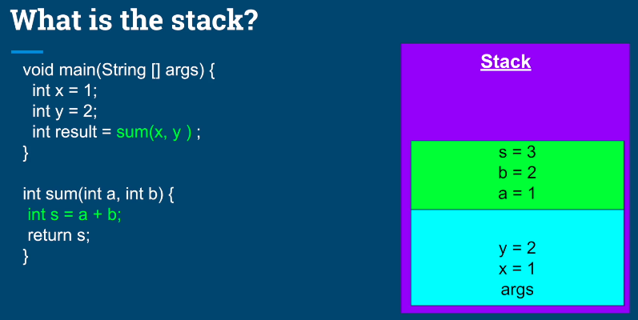
In above example main method (frame with blue background on the stack) has only access to variables x,y and args. When main method calls sum method a new frame is created (green background) and arguments a and b are passed. This are copies of x and y from main and are completely independent and unrelated. Once sum method finished and returns s, it will be saved in CPU register and sum method frame is removed from stack. Then instruction pointer goes back to caller method and the sum calculated in sum method is assigned to local variable result which is pushed on the stack as well:
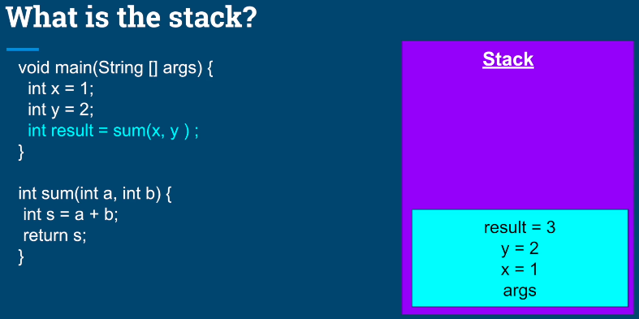

Stack’s properties
- All variables belong to the thread executing on that stack.
- Stack is statically allocated when the thread is created.
- Stack’s size is fixed, and relatively small (platform specific).
- If calling hierarchy is too deep we may get StackOverflow Exception (Risky with recursive calls).

Heap – shared memory region that belongs to the process.
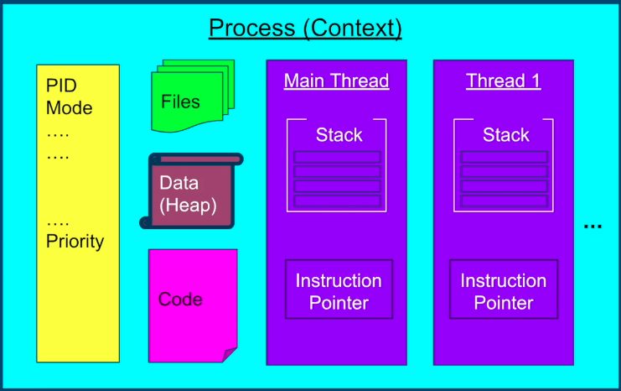

What is allocated on the Heap:
- Objects (anything created with new operator).
- Members of classes - anything defined inside the object (including primitives).
- Static variables – they belong to class object so are members of class as well.

Heap Memory Management:
- Managed by JVM Garbage Collector
- Objects – stay as long as we have reference to them.
- Members of classes – exist as long as their parent objects exist.
- Static variables - stay throughout entire application’s lifetime.

Objects vs References
References are not Objects.
References are variables which give us access to an object they point to (it’s a memory address of the location of given object).
Objects are the instances of given class allocated on the Heap.
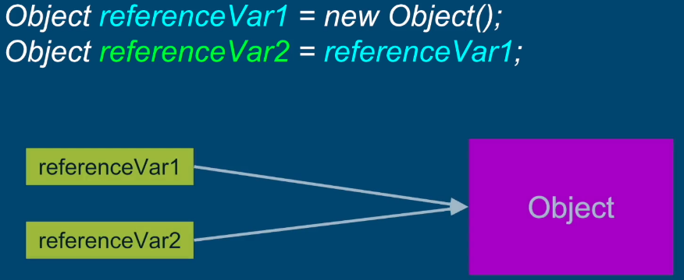
Above we have one object called Object and two references pointing to the same object called referenceVar1 and referenceVar2. This are 3 separate entities.
Allocation of References:
- can be allocated on the stack if they are created as local variables inside a method
- can be allocated on the heap if they are members of the class
Objects are always allocated on the heap (stack is statically allocated and has static size which cannot change during app runtime, objects are allocated dynamically during runtime and are incompatible with the design of stack).

Summary
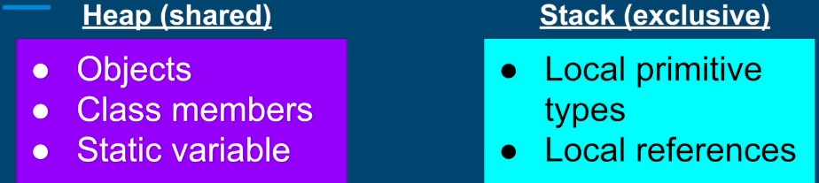

Resource Sharing
Example:
* Copyright (c) 2019 Michael Pogrebinsky
* Resource Sharing & Introduction to Critical Sections
* https://www.udemy.com/java-multithreading-concurrency-performance-optimization

public class Main {
public static void main(String[] args) throws InterruptedException {
InventoryCounter inventoryCounter = new InventoryCounter();
IncrementingThread incrementingThread = new IncrementingThread(inventoryCounter);
DecrementingThread decrementingThread = new DecrementingThread(inventoryCounter);

incrementingThread.start();
decrementingThread.start();

incrementingThread.join();
decrementingThread.join();

System.out.println("We currently have " + inventoryCounter.getItems() + " items");
}

public static class DecrementingThread extends Thread {
private InventoryCounter inventoryCounter;

public DecrementingThread(InventoryCounter inventoryCounter) {
this.inventoryCounter = inventoryCounter;
}

@Override
public void run() {
for (int i = 0; i < 10000; i++) {
inventoryCounter.decrement();
}
}
}

public static class IncrementingThread extends Thread {
private InventoryCounter inventoryCounter;

public IncrementingThread(InventoryCounter inventoryCounter) {
this.inventoryCounter = inventoryCounter;
}

@Override
public void run() {
for (int i = 0; i < 10000; i++) {
inventoryCounter.increment();
}
}
}

private static class InventoryCounter {
private int items = 0;

public void increment() {
items++;
}

public void decrement() {
items--;
}

public int getItems() {
return items;
}
}
}

InventoryCounter is a shared object and items member variable is shared between 2 threads.
items++ and items-- are happening at the same time and are not atomic.

Atomic Operation:
Operation or set of operations is considered atomic, if it appears to the rest of system as if it occurred at once, single step, no intermediate states.

Concurrency issues (not atomic operations – race condition):
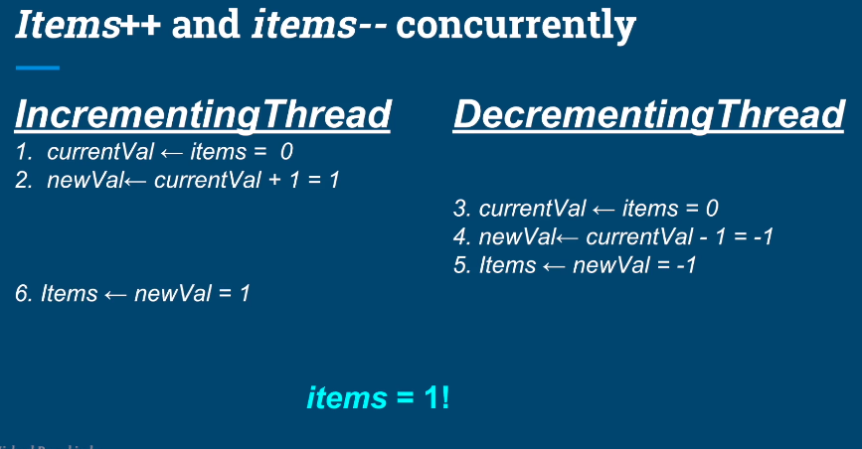

Critical section
Section of code which needs to be protected from concurrent execution.
Locking mechanism:
Synchronized keyword provides locking mechanism in Java. It shields critical section of code from concurrent execution and allows to surround any number of operations to be executed atomically. It can be added to method declaration and will lock whole method on current object, that means if 2 methods in a class have synchronized keyword than if one thread enters one of this methods it will lock both of them and other threads will have to wait, that is because the lock happened on same object (this kind of lock is called monitor):
public synchronized method1 () {…}
public synchronized method2 () {…}

The other way is to create synchronized section and surround only the part of the method which is critical which does not lock whole method:
public method1 () {
Object locking object = new Object();
…
synchronized(lockingObject){
critical section
}
...
}
This way we only restrict a part of a method and as well we lock on individual object created inside method so it will lock only critical section of this method. This allows a lot more flexibility and will allow to write code more efficient. Critical section should be minimized to include only bare minimum allowing to execute our logic correctly in multi-threaded situation. This way more code can be executed concurrently and this will allow to achieve best performance.
Synchronized block is re-entrant which means that if thread1 is in one critical section and is trying to enter another one then it will not be blocked. A thread cannot prevent itself from entering critical section.

Atomic operations and Volatile keyword
Identifying atomic operations:
- All reference assignments are atomic (getters and setters are atomic)
- All assignments to primitive types are safe except long and double – volatile keyword provides solution to this. If used with long or double writes and reads are atomic and thread safe.
  - long and double are exception because they are 64 bit long, Java does not make guarantees even on 64bit computer, assignment may be done in 2 operations. One write to lower 32 bits and one to upper 32 bits.
- Java provides classes in java.util.concurrent.atomic package which provides lock free atomic operations.

Race Condition and Data Race – volatile keyword
Race Condition:
- 2 or more threads are racing to access shared resource.
- At least one thread is modifying the resource.
- Timing of threads scheduling may cause incorrect results.
- The core of the issue is non atomic operations performed on the shared resource.
Data Race:
Compiler and CPU may execute the instructions out of order to optimize performance. If we have 2 or more threads executing and accessing shared resource even if there is no race condition data race may cause incorrect behaviour.
- Re-ordering of operations will only be done if it is possible to maintain logical correctness.
- Compiler re-arranges instructions for better branch prediction (if statements and loops), vectorization (parallel instruction execution), prefetching instructions (better cache performance)
To prevent data race:
- Synchronization of methods which modify shared variables. It will not prevent re-ordering but because only one thread will execute it at a time it will never be an issue.
- If we do not have race condition and we want to allow threads to execute in parallel than we need to declare shared variables as volatile to prevent operation re-ordering (memory fence).
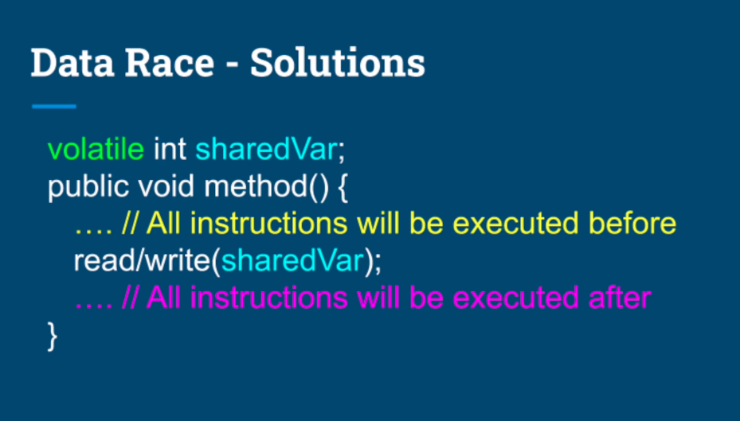

Rule of Thumb:
Every shared variable modified by at least one thread should be either synchronized or declared volatile.

Locking strategies and deadlock
Locking Strategies:
- Coarse-grained locking – limited parallelism, contention but no deadlocks.
  - Locking operation which do not interfere with each other with same lock so that if thread A executes method 1 than thread B cannot access method 2.
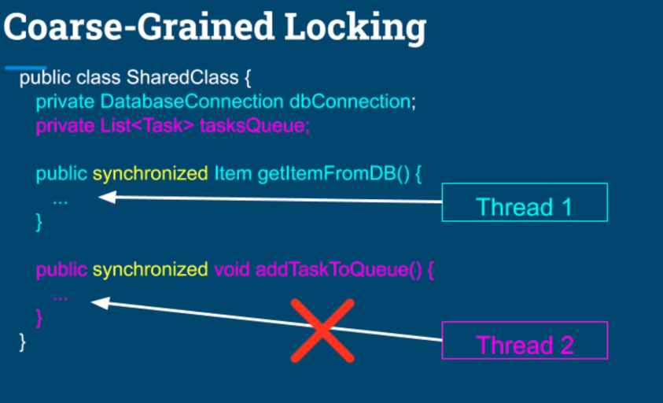
- Fine-grained locking – better parallelism – deadlock may occur.
  - Locking operation which do not interfere with each other with different locks so that if thread A executes method 1 than thread B can access and execute method 2.

Deadlocks
- Lock in white - acquired by thread.
- Lock in red – thread is waiting to acquire it.
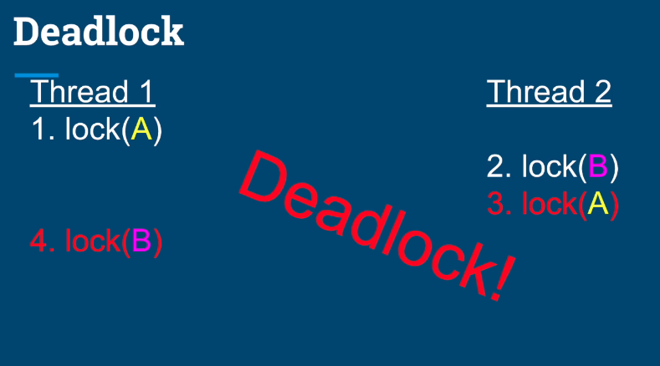
Deadlock definition:
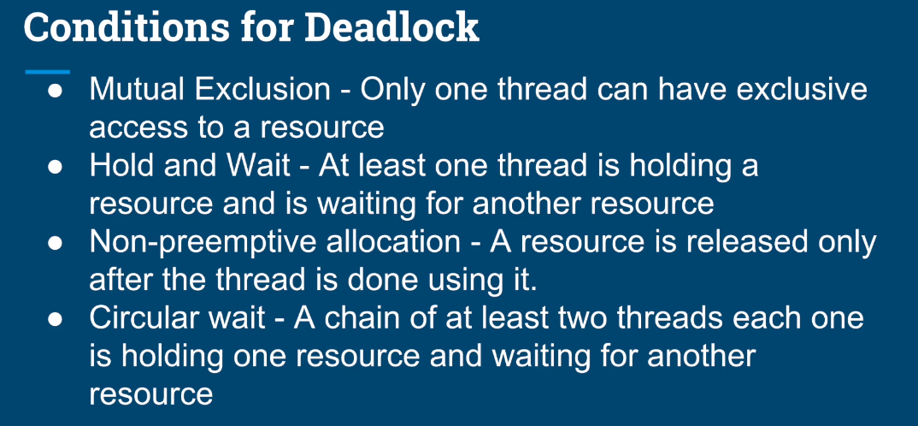
Solution:
Make sure that one of above conditions is not true.
Easiest solution is to avoid circular wait by enforcing strict order in lock acquisition – acquire locks on shared resources in same order in all threads (releasing order does not matter).
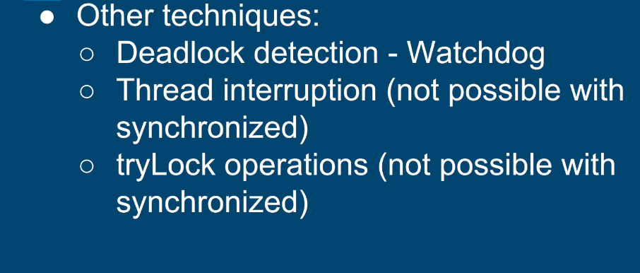

ReentrantLock, lockInerruptibly, tryLock
To use re-entrant lock we need to create object of RentrantLock type and we need to explicitly lock and unlock resource.
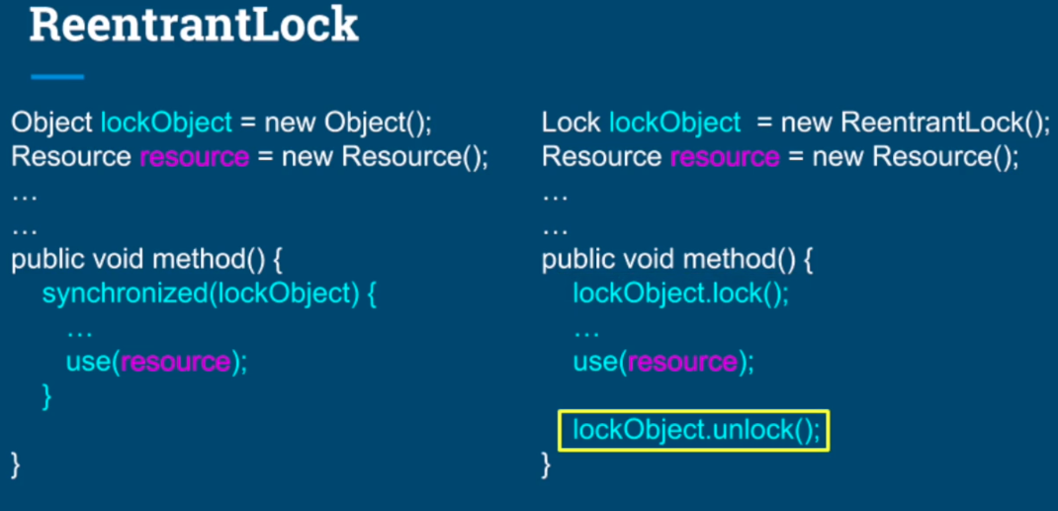
If exception is thrown before we unlock than it will stay locked forever. We need to surround critical section in try / finally block and unlock in finally clause. This will as well take care of the case if we need to return in critical section, finally clause will always execute.
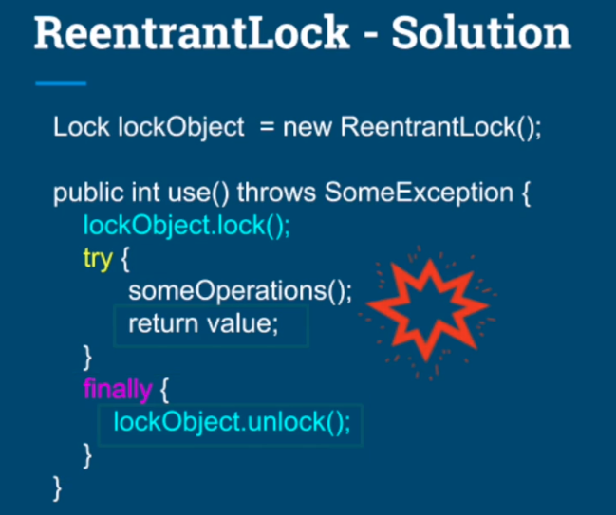
Re-entrant locks provides extra functionality:
- getQueuedThreads() - list of threads waiting to acquire a lock.
- getOwner() - Returns the thread that currently owns the lock.
- IsHeldByCurrentThread() - Queries if the lock is held by current thread.
- IsLocked() – checks if the lock is held by any thread.

Lock fairness (one thread gets much more resources than others)
- ReentrantLock allows to pass true to constructor to enforce fairness ReemtrantLock(true)
- Enforcing fairness comes at a cost (acquiring lock may take longer) and may reduce the throughput of the application.
LockInterruptibly
If a thread is trying to acquire a lock which is held by another thread, it will be suspended and will not wake up until the lock is released. In this case calling interrupt method would not do anything.
If we use lockInterruptibly instead while another thread is already holding the lock than we can still get out of this suspension. LockInterruptibly method forces us to surround it with try / catch block and handle InterruptedException. We can call interrupt method from another thread and cause the thread to go to catch block where we can do clean-up and shut down the thread.
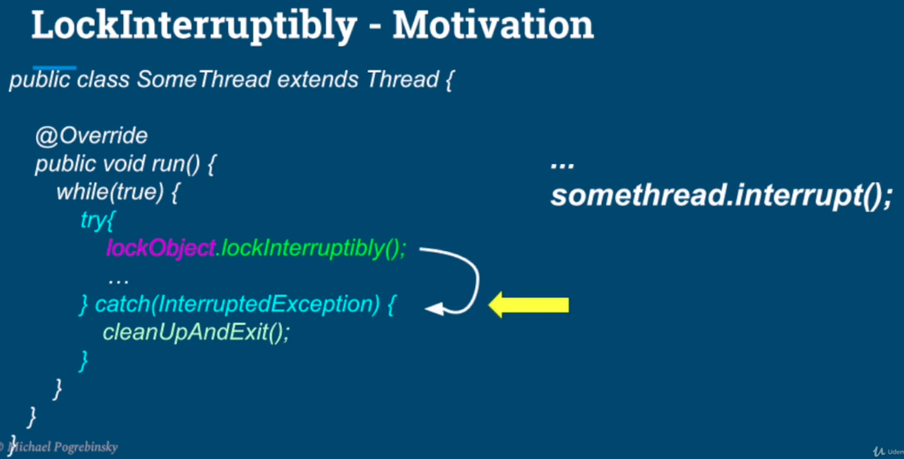
LockInterruptibly is useful to:
- Creating watchdog for deadlock detection and recovery – where watchdog can interrupt threads which are in deadlock.
- Waking up threads, do clean-up and close the application

TryLock
boolean tryLock();
boolean tryLock(long timeout, TimeUnit unit);
TryLock tries to acquire a lock and
- if the lock is available it acquires it and returns true.
- If it is not available it will return false and thread will not get suspended it will go to next instruction.
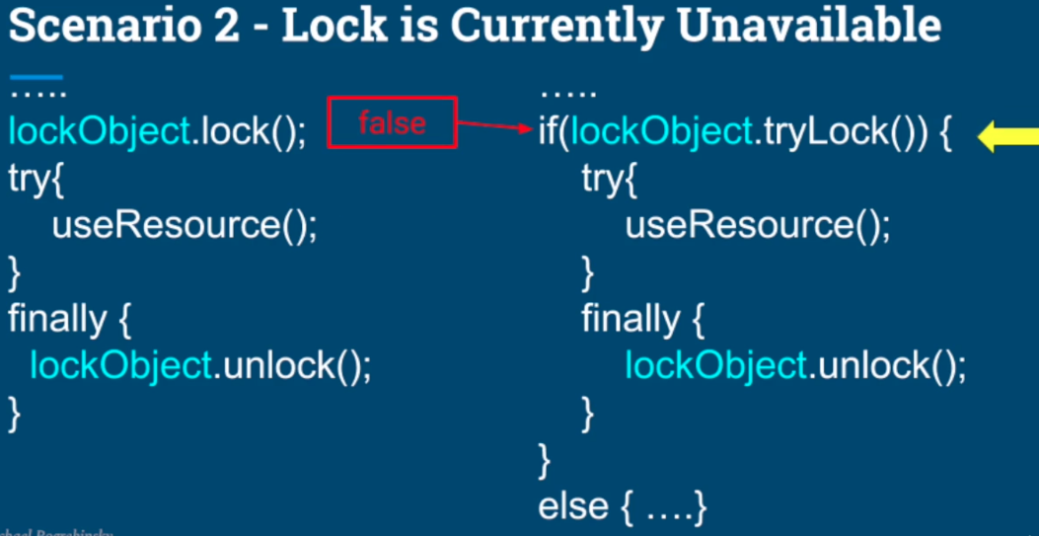
TryLock qualities:
- Never blocks
- Regardless of the state of the lock it always return immediately.
Use Cases:
- Real time applications (video and image processing, low latency trading systems, user interface) where suspending a thread on a lock is unacceptable.
- TryLock would typically be used in an infinite loop (like user interface thread which is rendering screen) if we need to access shared resource and it is locked we would need to block user interface thread which would be unresponsive for that amount of time we are waiting for lock. Instead we can use TryLock inside if statement and if it returns false we may not update the resource at this time but we will keep going refreshing the screen and keep retrying to access TryLock and update shared resource.
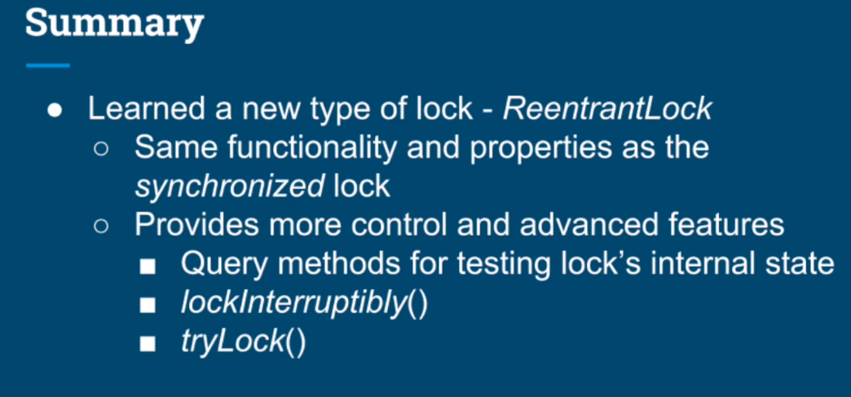

Read / Write lock – ReentrantReadWriteLock
I case where read operations are predominant or are not very fast, mutual exclusion of reading threads will slow down the application.
ReentrantReadWriteLock comes with 2 locks: readLock and write lock.
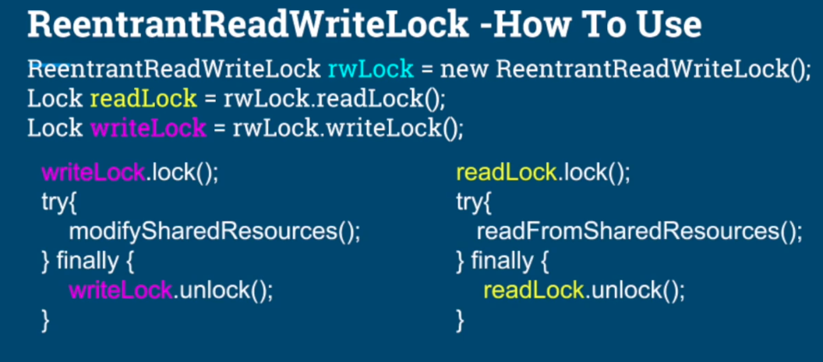
Multiple threads can acquire the readLock meaning that multiple reading threads can get into critical section at the same time. ReadLock is holding internal count of how many threads are holding the lock.
Only single thread is allowed to lock writeLock.
There is mutual exclusion between readers and writers.
If writeLock is acquired by one thread, no other thread can acquire read or write lock.
If at least one thread is holding readLock than no thread can acquire writeLock.
In situation where read operations are not predominant or slow ReentrantReadWriteLock may perform worse than conventional lock. Always make sure it is right lock to use in given situation and measure results.

Semaphore and producer – consumer scenario

