EPAM Data Basics – Homework Assignment 2

Logical Data Model for Subway Management System

Contents
1.1 Business background 3
1.2 Problems. Current Situation 3
1.3 the Benefits of implementing a database. Project Vision 3
2.1 Definitions & Acronyms 3
2.2 Step-by-step approach to modeling 3
2.3 Logical Scheme 4
2.4 Objects 4

Business Description

Business background
The metro management system is designed to centralize and organize all operational data related to subway lines, stations, trains, ticket sales, employees, and infrastructure maintenance.
This system provides a single source of truth for the daily operations of the subway network, improving efficiency in scheduling, maintenance, and passenger service.

Problems. Current Situation
Currently, operational information about the metro is often stored in separate systems or spreadsheets: schedules, ticketing, maintenance records, and staff assignments are not connected.
This separation causes inefficiencies such as inconsistent data, delays in reporting, and difficulties in tracking the performance of stations, trains, and maintenance tasks.

the Benefits of implementing a database. Project Vision
The new database will integrate all information in one structured relational system.
It will allow metro management to:
- Monitor station and line schedules in real time.
- Manage staff assignments, roles, and train operations.
- Track ticket pricing, discounts, and promotions.
- Record and analyse maintenance tasks for all infrastructure elements.

This centralized database will ensure data integrity, support operational decisions, and enable long-term analytics and optimization of metro performance.

Model description

Definitions & Acronyms
PK – Primary Key – a unique identifier for each record in a table.
FK – Foreign Key – a reference linking records between two related tables.
INT – Integer – numeric data type used for whole numbers.
VARCHAR(n) - Variable Character – text data type that stores up to n characters.
NOT NULL - Constraint that ensures a column must always have a value (no empty entries).
NUMERIC(p,s) - Fixed-point number with p total digits and s digits after the decimal point.
3NF - Third Normal Form

Step-by-step approach to modeling
The design process started with analyzing the business requirements of the metro system.
First, the main functional areas were identified: Transportation, Ticketing, and Maintenance.
For each area, core entities were defined (e.g., Stations, Lines, Tickets, Infrastructure) and relationships between them were mapped.
Then, supporting entities were added to ensure proper normalization and eliminate redundancy, such as bridge tables (Station_Line, Station_Employee).
All tables were structured to meet the principles of 3NF, ensuring that each non-key attribute depends only on the primary key.
Finally, data types, primary and foreign keys, and example data were assigned (with the exception of bridge tables) to demonstrate how the model can be used in practice.

Logical Scheme
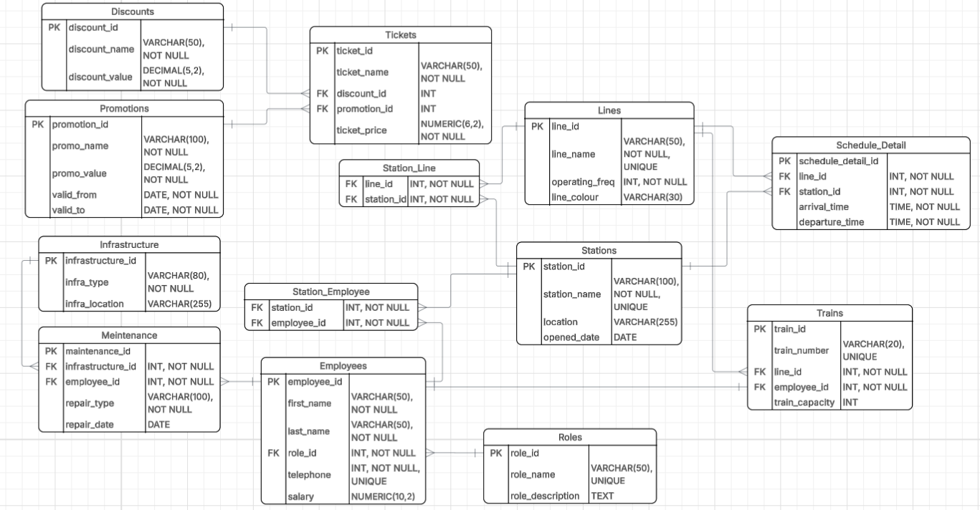

Objects

Stations
Stores information about metro stations.

Table Name | Field name | Field Description | Data Type
Stations | station_id | PK, Unique identifier of the station | INT
 | station_name | Name of the metro station | VARCHAR(100)
 | location | Location or address of the station | VARCHAR(255)
 | opened_date | Date when the station was opened | DATE

Each station can belong to multiple lines through the Station_Line table and can have many employees assigned.

Example with data

station_id | station_name | location | opened_date
1 | Central Station | Al. Jerozolimskie 10, 00-019 Warsaw | 1998-03-12

Lines
Defines each subway line, its name, operating frequency, and color code.

Table Name | Field name | Field Description | Data Type
Lines | line_id | PK, Unique identifier of the metro line | INT
 | line_name | Name of the metro line | VARCHAR(50)
 | operating_freq | Operating frequency or number of trains per day | INT
 | line_colour | Visual color code representing the line | VARCHAR(30)

Each line has multiple stations and trains assigned.
Example with data

line_id | line_name | operating_freq | line_colour
1 | Line A | 20 | Red

Station_Line
Associative table defining which stations belong to which lines (many-to-many).

Table Name | Field name | Field Description | Data Type
Station_Line | station_id | PK/FK, Station associated with the line | INT
 | line_id | PK/FK, Line that includes the station | INT

Resolves the many-to-many relationship between stations and lines.

Schedule_Detail
Contains information about train arrivals and departures at each station.

Table Name | Field name | Field Description | Data Type
Schedule_Detail | schedule_detail_id | PK, Unique schedule entry | INT
 | line_id | FK, Line on which the train operates | INT
 | station_id | FK, Station included in the schedule | INT
 | arrival_time | Time of train arrival at the station | TIME
 | departure_time | Time of train departure from the station | TIME

Example with data

schedule_detail_id | line_id | station_id | arrival_time | departure_time
1 | 1 | 1 | 07:30:00 | 07:32:00

Trains
Represents the rolling stock (train units) used on specific lines.

Table Name | Field name | Field Description | Data Type
Trains | train_id | PK, Unique identifier of the train | INT
 | train_number | Official train number | VARCHAR(20)
 | line_id | FK, Line to which the train belongs | INT
 | employee_id | FK, Driver or employee responsible for the train | INT
 | train_capacity | Maximum passenger capacity | INT

Each train belongs to one line and is operated by one employee.
Example with data

train_id | train_number | line_id | employee_id | train_capacity
1 | A001 | 1 | 10 | 220
Employees
Contains all staff members working in the metro system.

Table Name | Field name | Field Description | Data Type
Employees | employee_id | PK, Unique identifier of the employee | INT
 | first_name | Employee's first name | VARCHAR(50)
 | last_name | Employee's last name | VARCHAR(50)
 | role_id | FK, Role assigned to the employee | INT
 | telephone | Employee's telephone number | INT
 | salary | Employee’s monthly salary | NUMERIC(10,2)

Employees can be assigned to stations or maintenance tasks.
Each employee can be assigned to one role only.

Example with data

employee_id | first_name | last_name | role_id | telephone | salary
1 | Steve | Kowalski | 1 | 501123456 | 4500.00

Roles
Defines the function of each employee, e.g., driver, technician, or station manager.

Table Name | Field name | Field Description | Data Type
Roles | role_id | PK, Unique identifier of the role | INT
 | role_name | Name of the role | VARCHAR(50)
 | description | Short description of responsibilities | TEXT

Example with data

role_id | role_name | description
1 | Technician | Handles maintenance and repairs

Station_Employee
Resolves the many-to-many relationship between stations and employees.

Table Name | Field name | Field Description | Data Type
Station_Employee | station_id | PK, FK, Station where the employee works | INT
 | employee_id | PK, FK , Assigned employee | INT

Connects stations and employees in a many-to-many relationship.

Tickets
Holds details about available ticket types and prices.

Table Name | Field name | Field Description | Data Type
Tickets | ticket_id | PK, Unique identifier of the ticket | INT
 | ticket_name | Type of ticket | VARCHAR(50)
 | FK, discount_id | FK, Linked discount  (if applicable) | INT
 | FK, promotion_id | FK, Linked promotion (if applicable) | INT
 | ticket_price | Price of the ticket | NUMERIC(6,2)

Each ticket can have one discount and one promotion applied, while a single discount or promotion can apply to multiple ticket types.

Example with data

ticket_id | ticket_name | discount_id | promotion_id | ticket_price
1 | Single Ride | 1 | NULL | 3.50

Discounts
Defines discount programs such as student or senior discounts.

Table Name | Field name | Field Description | Data Type
Discounts | discount_id | PK, Unique identifier of the discount | INT
 | discount_name | Name of the discount | VARCHAR(50)
 | discount_value | Discount value in percentage | DECIMAL(5,2)

Example with data

discount_id | discount_name | discount_value
1 | Student | 20.00

Promotions
Stores temporary promotional offers.

Table Name | Field name | Field Description | Data Type
Promotions | promotion_id | PK, Unique identifier of the promotion | INT
 | promo_name | Name of the promotion | VARCHAR(100)
 | promo_value | Promotion value in percentage | DECIMAL(5,2)
 | valid_from | Promotion start date | DATE
 | valid_to | Promotion end date | DATE

Example with data

promotion_id | promo_name | promo_value | valid_from | valid_to
1 | Spring Offer | 15.00 | 2025-03-01 | 2025-05-31

Infrastructure
Lists all infrastructure elements that require maintenance (e.g., tunnels, tracks, trains, stations).

Table Name | Field name | Field Description | Data Type
Infrastructure | infrastructure_id | PK, Unique infrastructure identifier | INT
 | infra_type | Type of infrastructure | VARCHAR(80)
 | infra_location | Location of the infrastructure | VARCHAR(255)

Example with data

infrastructure_id | infra_type | infra_location
1 | Track | Line A – North Section

Maintenance
Tracks maintenance operations performed on the infrastructure.

Table Name | Field name | Field Description | Data Type
Maintenance | maintenance_id | PK, Unique maintenance record | INT
 | infrastructure_id | FK, Infrastructure element under maintenance | INT
 | employee_id | FK, Employee who performed the maintenance | INT
 | repair_type | Type of repair performed | VARCHAR(100)
 | repair_date | Date of maintenance | DATE

Each record represents one completed repair or maintenance action.
Example with data

maintenance_id | infrastructure_id | employee_id | repair_type | repair_date
1 | 3 | 12 | Electrical repair | 2025-01-15

