Edgeworth series distribution
PDF of the Edgeworth series (ES) with parameters $γ_{1}$ and ${\overline{γ}}_{2}$ is given by (Kendal and Stuart 1958)
$f_{ES}\left(x;γ_{1,},{\overline{γ}}_{2}\right)=ϕ\left(x;0,1\right)\left(1+\frac{1}{3!}γ_{1,}\left(x^{3}-3x\right)+\frac{1}{4!}{\overline{γ}}_{2}\left(x^{4}-6x^{2}+3\right)\right) \left(x∈R\right)$,
where$γ_{1,}∈R, {\overline{γ}}_{2}≥-2$. We have $ϕ\left(x;0,1\right)=f_{ES}\left(x;0,0\right)$, obviously.
Table 1A Vectors of ES parameter $θ$ and similarity measure M. Groups A-H
Group | $$θ=\left(γ_{1,},{\overline{γ}}_{2}\right)$$ | $$M\left(θ;0,1\right)$$ | Group | $$θ=\left(γ_{1,},{\overline{γ}}_{2}\right)$$ | $$M\left(θ;0,1\right)$$
A | 0.4,3.33 | 0.8 | E | 1.39,-0.067 | 0.825
 | 0.3,2.499 | 0.85 |  | 1.175,-0.46 | 0.85
 | 0.2,1.666 | 0.9 |  | 0.775,-0.408 | 0.9
B | -0.4,3.33 | 0.8 | F | -1.39,-0.067 | 0.825
 | -0.3,2.499 | 0.85 |  | -1.175,-0.46 | 0.85
 | -0.2,1.666 | 0.9 |  | -0.775,-0.408 | 0.9
C | 0,3.428 | 0.8 | G | 1.391,0 | 0.825
 | 0,2.571 | 0.85 |  | 1.19,0 | 0.85
 | 0,1.71 | 0.9 |  | 0.795,0 | 0.9
D | 0,-3.428 | 0.8 | H | -1.391,0 | 0.825
 | 0,-2.571 | 0.85 |  | -1.19,0 | 0.85
 | 0,-1.71 | 0.9 |  | -0.795,0 | 0.9
Source: own material

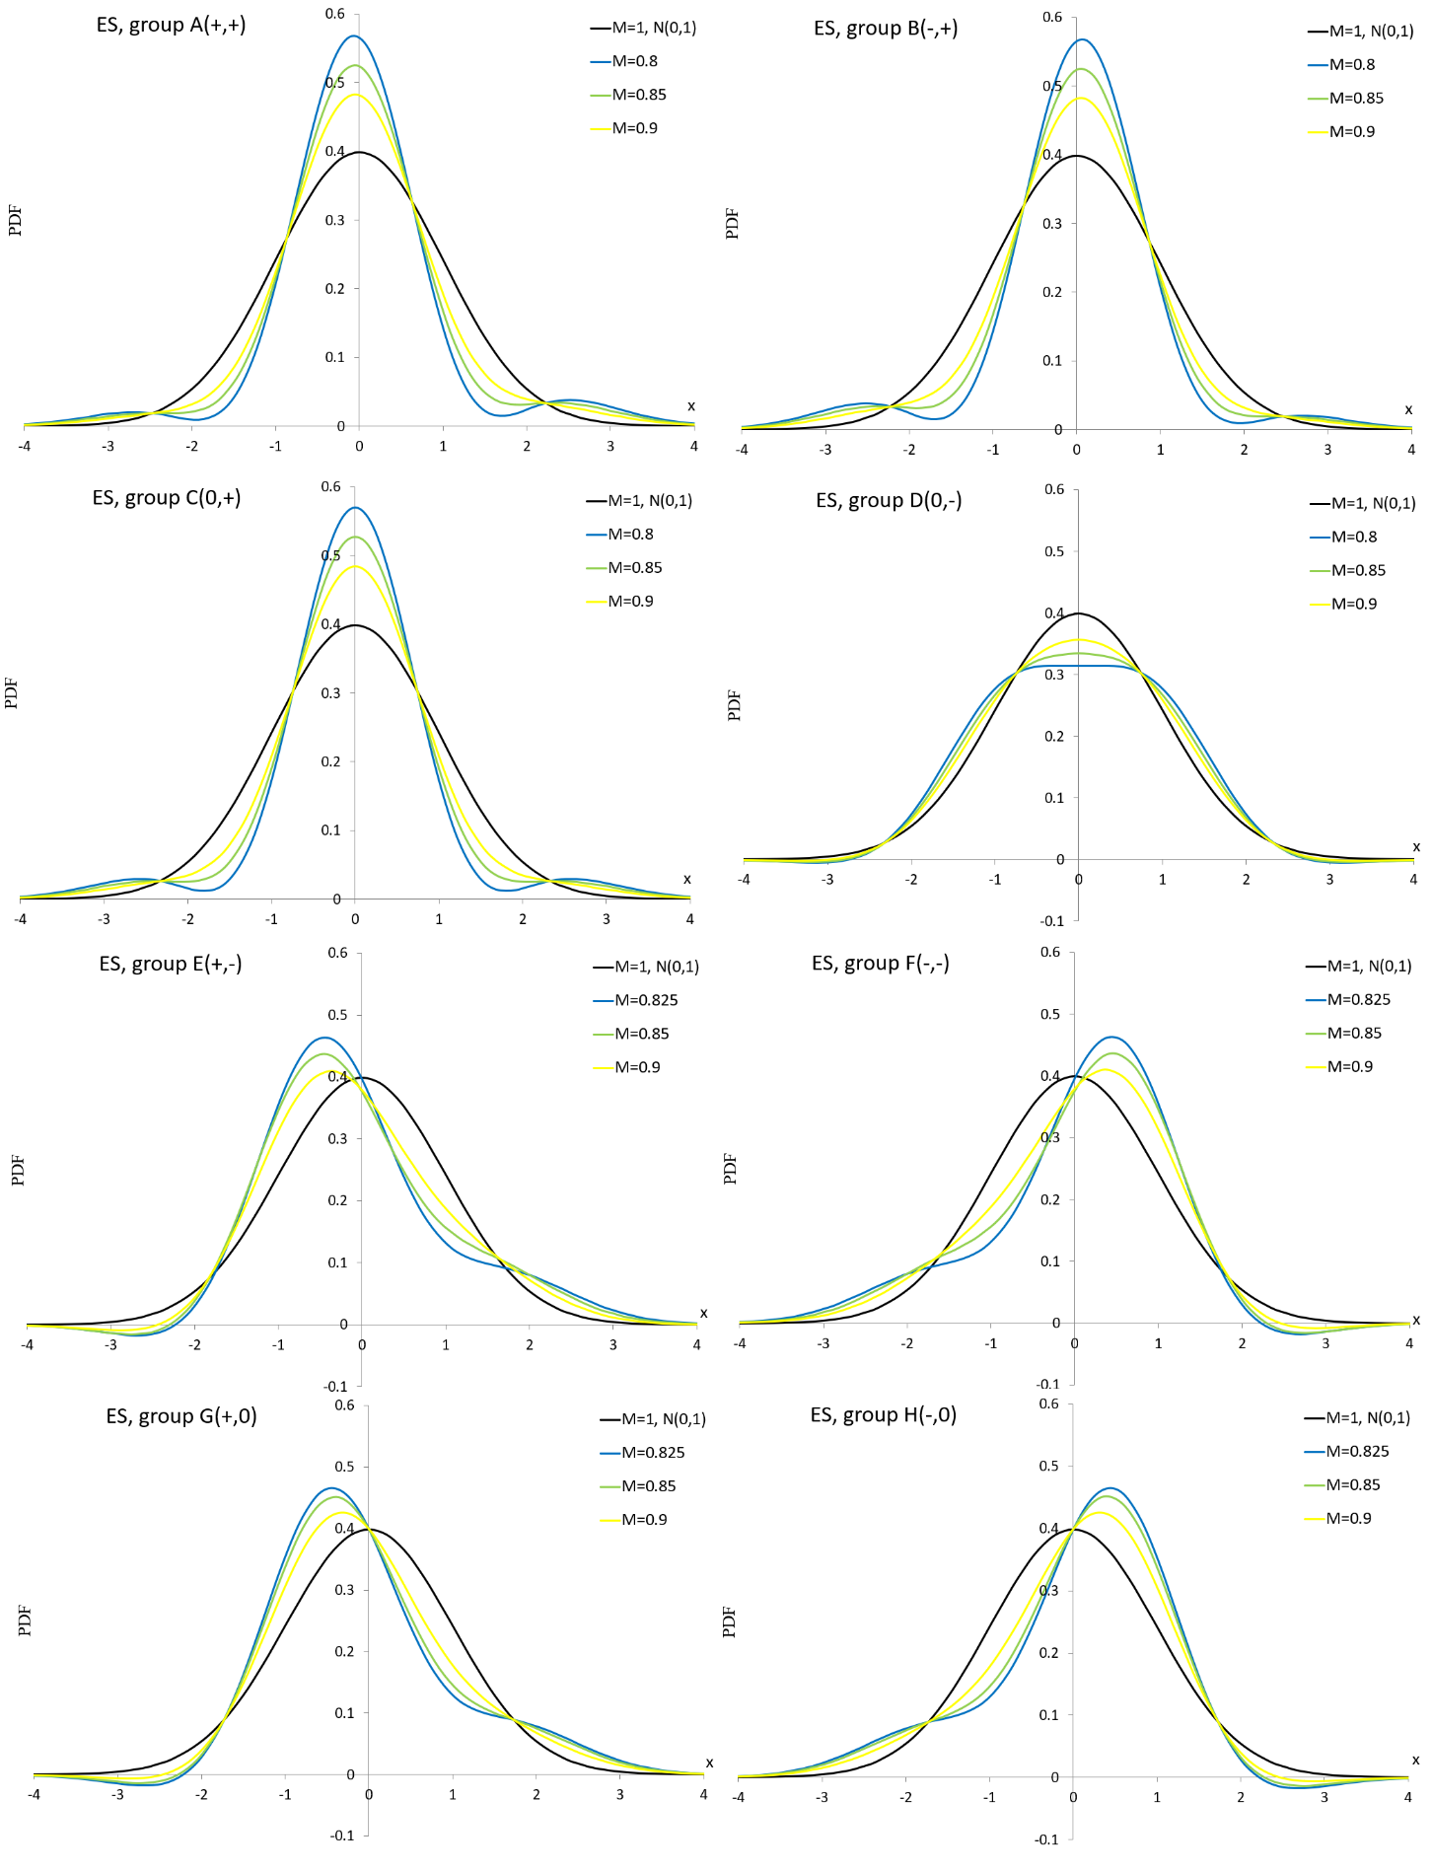
Source: own material
Figure 1A PDF curves of the ES distribution for parameter values presented in Table 1A

Pearson distribution
Let
$a=\frac{2{\overline{γ}}_{2}-3γ_{1}^{2}}{10{\overline{γ}}_{2}-5γ_{1}^{2}+12}, b=\frac{\left|γ_{1}\right|\left({\overline{γ}}_{2}+6\right)}{10{\overline{γ}}_{2}-5γ_{1}^{2}+12}, c=\frac{4{\overline{γ}}_{2}-3γ_{1}^{2}+12}{10{\overline{γ}}_{2}-5γ_{1}^{2}+12}, Δ=b^{2}-4ac$,
then the PDF of the Pearson P distribution is given by (Pearson 1985)
$$f_{P}\left(x;γ_{1,},{\overline{γ}}_{2}\right)=\left\{\begin{matrix}\frac{exp\left[\frac{2ab-b}{a\left(2ax+b\right)}\right]}{C_{1}{\left(2ax+b\right)}^{1/a}} & ∆=0 \\ \frac{exp\left[\frac{b-2ab}{a\sqrt{4ac-b^{2}}}\tan^{-1}\left(\frac{2ax+b}{\sqrt{4ac-b^{2}}}\right)\right]}{C_{2}{\left(ax^{2}+bx+c\right)}^{1/2a}} & ∆<0 \\ \frac{{\left(\frac{2ax+b-\sqrt{b^{2}-4ac}}{2ax+b+\sqrt{b^{2}-4ac}}\right)}^{\frac{b-2ab}{2a\sqrt{b^{2}-4ac}}}}{C_{3}{\left(ax^{2}+bx+c\right)}^{1/2a}} & ∆>0\end{matrix}\right.$$
where $x∈R, γ_{1,}∈R, {\overline{γ}}_{2}≥-2$ and $C_{1}$, $C_{2}$, $C_{3}$ are normalizing constants defined as
$C_{1}=\int_{-∞}^{∞}{\frac{exp\left[\frac{2ab-b}{a\left(2ax+b\right)}\right]}{{\left(2ax+b\right)}^{1/a}}dx}$, $C_{2}=\int_{-∞}^{∞}{\frac{exp\left[\frac{b-2ab}{a\sqrt{4ac-b^{2}}}\tan^{-1}\left(\frac{2ax+b}{\sqrt{4ac-b^{2}}}\right)\right]}{{\left(ax^{2}+bx+c\right)}^{1/2a}}dx}$, $C_{3}=\int_{-∞}^{∞}{\frac{{\left(\frac{2ax+b-\sqrt{∆}}{2ax+b+\sqrt{∆}}\right)}^{\frac{b-2ab}{2a\sqrt{∆}}}}{C_{8}{\left(ax^{2}+bx+c\right)}^{1/2a}}dx}$.
A special case of the P distribution is the normal $N\left(0,1\right)$ for $γ_{1}={\overline{γ}}_{2}=0$.

Table 2A Vectors of the P parameter $θ$ and similarity measure M. Groups A-H
Group | $$θ=\left(γ_{1,},{\overline{γ}}_{2}\right)$$ | $$M\left(θ;0,1\right)$$ | Group | $$θ=\left(γ_{1,},{\overline{γ}}_{2}\right)$$ | $$M\left(θ;0,1\right)$$
A | 2.04,4.1 | 0.5 | E | 0.985,-0.5 | 0.5
 | 1.62,3.845 | 0.75 |  | 0.715,-0.475 | 0.75
 | 0.9,2 | 0.9 |  | 0.515,-0.2 | 0.9
B | -2.04,4.1 | 0.5 | F | -0.985,-0.5 | 0.5
 | -1.62,3.845 | 0.75 |  | -0.715,-0.475 | 0.75
 | -0.9,2 | 0.9 |  | -0.515,-0.2 | 0.9
C | 0,11.2 | 0.9 | G | 1.164,0 | 0.5
 | 0,3.65 | 0.925 |  | 0.879,0 | 0.75
 | 0,1.521 | 0.95 |  | 0.578,0 | 0.9
D | 0,-1.695 | 0.5 | H | -1.164,0 | 0.5
 | 0,-1.315 | 0.75 |  | -0.879,0 | 0.75
 | 0,-0.89 | 0.9 |  | -0.578,0 | 0.9
Source: own material

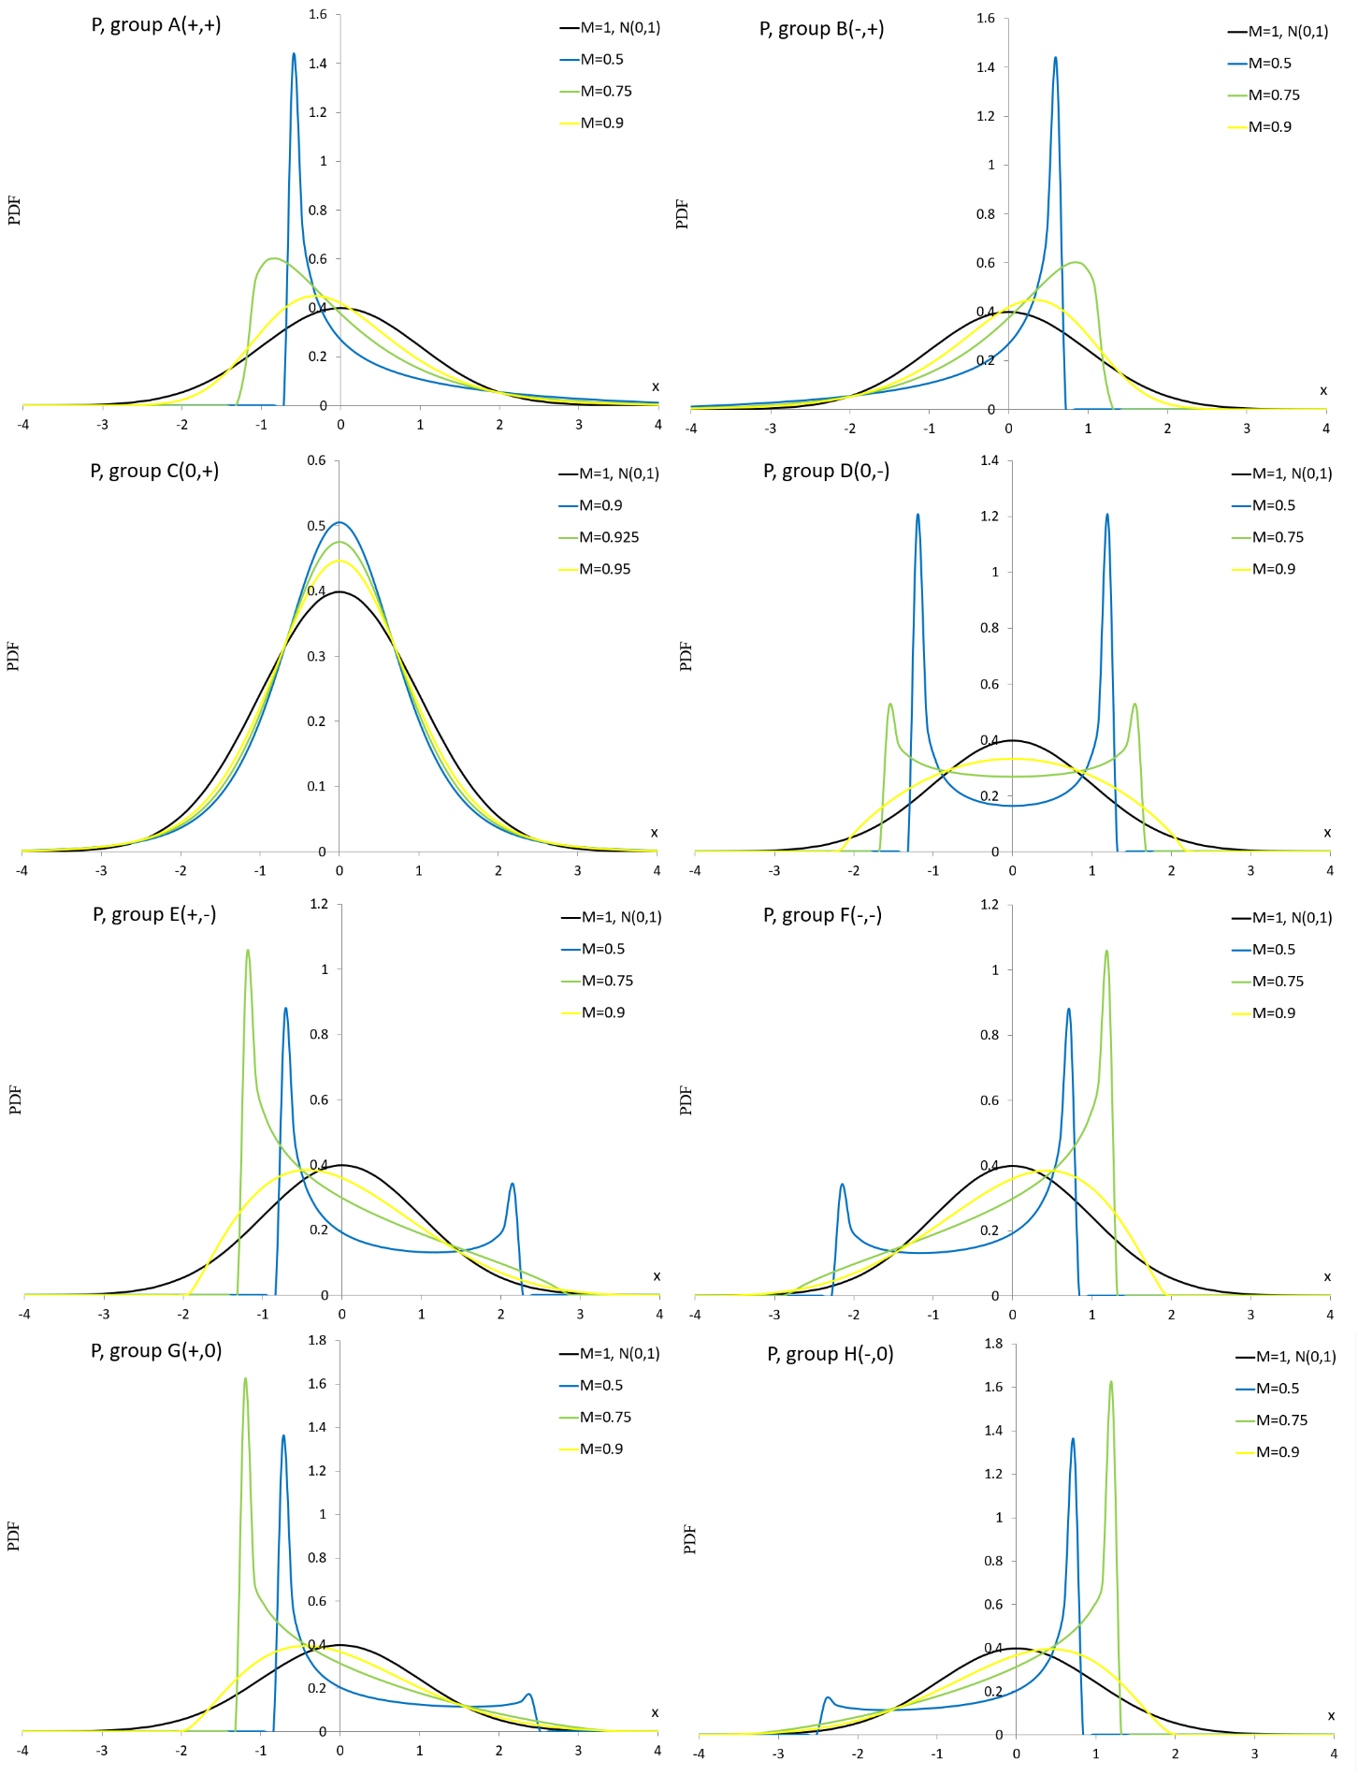
Source: own material
Figure 2A PDF curves of the P distribution for parameter values presented in Table 2A

Normal mixture distribution
PDF of the normal mixture NM distribution is given by
$f_{NM}\left(x;θ\right)=ωϕ\left(x;μ_{1},σ_{1}\right)+\left(1-ω\right)ϕ\left(x;μ_{2},σ_{2}\right) \left(x∈R\right)$,
where $θ=\left(μ_{1},σ_{1},μ_{2},σ_{2},ω\right)$ and $μ_{1},μ_{2}∈R, σ_{1},σ_{2}>0, ω∈\left[0,1\right]$. Special cases of the NM distribution are:
- normal $N\left(μ_{1},σ_{1}\right)$ for $ω=1$, $N\left(μ_{2},σ_{2}\right)$ for $ω=0$,
- location contaminated normal LCN $f_{LCM}\left(x;μ_{1},ω\right)=f_{NM}\left(x;μ_{1},1,0,1,ω\right)$,
- scale contaminated normal SCN $f_{SCN}\left(x; σ_{1},ω\right)=f_{NM}\left(x;0,σ_{1},0,1,ω\right)$.
Table 3A Vectors of the NM parameter $θ$ and similarity measure M. Groups A-H
Group | $$θ=\left(μ_{1},σ_{1},μ_{2},σ_{2},ω\right)$$ | $$M\left(θ;0,1\right)$$
A | 0.572,2.472,5.614,3.454,0.787 | 0.5
 | -0.215,1.254,1.979,1.99,0.639 | 0.75
 | 0.497,1.376,-0.268,0.884,0.612 | 0.9
B | 0.502,2.019,1.708,0.953,0.36 | 0.5
 | 0.06,1.437,1.004,0.609,0.634 | 0.75
 | 0.709,0.368,-0.072,1.115,0.193 | 0.9
C | 0.519,6.599,0.519,1.058,0.665 | 0.5
 | 0.137,0.581,0.137,2.391,0.294 | 0.75
 | 0.1,0.988,0.1,1.543,0.532 | 0.9
D | -0.511,1.353,4.293,1.021,0.551 | 0.5
 | 2.707,0.013,0.017,1.125,0.238 | 0.75
 | 1.243,0.621,-0.39,0.811,0.347 | 0.9
E | -0.475,2.22,5.318,2.427,0.721 | 0.5
 | -0.019,1.369,2.979,1.15,0.829 | 0.75
 | 2.635,0.35,-0.015,1.166,0.038 | 0.9
F | -0.692,0.705,2.1,0.679,0.324 | 0.5
 | -0.055,1.277,1.781,0.443,0.775 | 0.75
 | -0.09,1.08,-1.581,0.92,0.9 | 0.9
G | 2.686,3.099,-0.964,2.217,0.471 | 0.5
 | -0.56,1.465,1.411,1.45,0.8 | 0.75
 | -0.286,1.114,0.984,1.105,0.801 | 0.9
H | 2.425,1.101,0.272,1.693,0.526 | 0.5
 | 0.864,1.125,-1.339,1.241,0.735 | 0.75
 | 0.429,1.078,-0.364,1.228,0.434 | 0.9
Source: own material

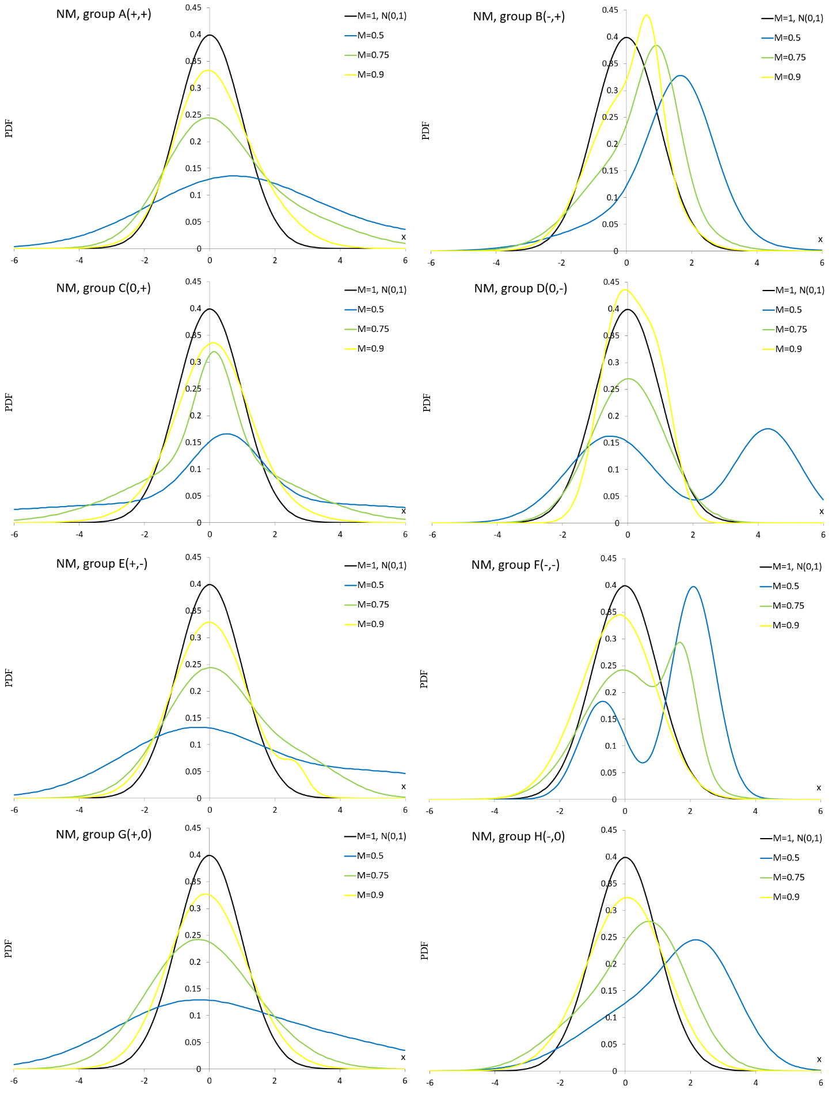
Source: own material
Figure 3A PDF curves of the NM distribution for parameter values presented in Table 3A

Normal distribution with plasticizing component
PDF of the normal distribution with plasticizing component NDPC is given by (Sulewski 2022)
$f_{NDPC}\left(x;θ\right)=ωϕ\left(x;μ_{1},σ_{1}\right)+\left(1-ω\right)\frac{c_{2}}{σ_{2}}{\left|\frac{x-μ_{2}}{σ_{2}}\right|}^{c_{2}-1}ϕ\left({\left|\frac{x-μ_{2}}{σ_{2}}\right|}^{c_{2}};0,1\right) \left(x∈R\right)$,
where $θ=\left(μ_{1},σ_{1},μ_{2},σ_{2},c_{2},ω\right)$ and $μ_{1},μ_{2}∈R, σ_{1},σ_{2}>0, c_{2}≥1, ω∈\left[0,1\right]$. Special cases of the NDPC distribution are: $N\left(μ_{1},σ_{1}\right)$ for $ω=1$; $N\left(μ_{2},σ_{2}\right)$ for $c_{2}=1, ω=0$ and plasticizing component for $ω=0$.
Table 4A Vectors of NDPC parameter $θ$ and similarity measure M. Groups A-H
Group | $$θ=\left(μ_{1},σ_{1},μ_{2},σ_{2},c_{2},ω\right)$$ | $$M\left(θ;0,1\right)$$
A | 1.194,0.601,2.186,2.592,2,0.666 | 0.5
 | 0.265,0.415,0.996,1.541,1.16,0.313 | 0.75
 | 0.173,0.358,0.289,1.268,1.132,0.198 | 0.9
B | -1.321,1.842,0.741,0.459,2.56,0.287 | 0.5
 | 0.539,0.632,-1.078,2.061,1.174,0.741 | 0.75
 | -0.966,1.824,0.259,0.889,1.1,0.26 | 0.9
C | 1.308,0.656,1.308,3.261,2,0.613 | 0.5
 | 0.571,1.023,0.571,1.962,1.15,0.505 | 0.75
 | -0.097,1.332,-0.097,1.058,1.1,0.614 | 0.9
D | -0.692,2.203,-0.692,2.544,1.759,0.25 | 0.5
 | 0.323,1.312,0.605,1.335,1.2,0.01 | 0.75
 | 0.179,0.494,0.179,1.163,1.426,0.443 | 0.9
E | 0.675,0.284,2.122,1.968,2.104,0.374 | 0.5
 | 0.423,1.032,1.058,2.077,1.815,0.494 | 0.75
 | -0.134,0.993,0.671,1.211,1.479,0.583 | 0.9
F | 1.609,0.59,0.322,2.194,1.609,0.309 | 0.5
 | 0.617,0.737,0.129,1.752,1.465,0.332 | 0.75
 | -0.046,1.156,1.261,0.799,1.87,0.876 | 0.9
G | 1.88,2.736,-0.848,1.122,6.437,0.679 | 0.5
 | 2.419,1.56,0.237,1.384,1.476,0.074 | 0.75
 | 0.055,0.702,0.474,1.586,1.328,0.473 | 0.9
H | 1.642,1.247,0.202,2.681,1.428,0.554 | 0.5
 | -1.246,1.326,0.858,1.103,1.242,0.313 | 0.75
 | -0.115,1.286,0.306,1.091,1.093,0.465 | 0.9
Source: own material

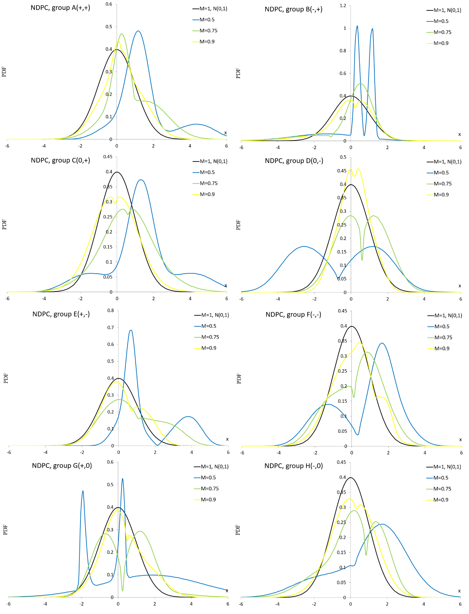
Source: own material
Figure 4A PDF curves of the NDPC for parameter values presented in Table 4A

Plasticizing component mixture distribution
PDF of the plasticizing component mixture distribution PCM is given by (Sulewski 2020)
$f_{PCM}\left(x;θ\right)=ωf_{PC}\left(x;μ_{1},σ_{1},c_{1}\right)+\left(1-ω\right)f_{PC}\left(x;μ_{2},σ_{2},c_{2}\right) \left(x∈R\right)$,
where $f_{PC}\left(x;μ,σ,c\right)=\frac{c}{σ}{\left|\frac{x-μ}{σ}\right|}^{c-1}ϕ\left({\left|\frac{x-μ}{σ}\right|}^{c};0,1\right) \left(x∈R\right)$ and $θ=\left(μ_{1},σ_{1},c_{1}, μ_{2},σ_{2},c_{2},ω\right)$,
$μ_{1},μ_{2}∈R, σ_{1},σ_{2}>0, c_{1},c_{2}≥1, ω∈\left[0,1\right]$. Special cases of the PCM distribution are: $N\left(μ_{1},σ_{1}\right)$ for $c_{1}=1, ω=1$; $N\left(μ_{2},σ_{2}\right)$ for $c_{2}=1, ω=0$; plasticizing components $PC\left(μ_{1},σ_{1},c_{1}\right),$ and $PC\left(μ_{2},σ_{2},c_{2}\right)$ for $ω=0, ω=1$, respectively.
Table 5A Vectors of PCM parameter $θ$ and similarity measure M. Groups A-H
Group | $$θ=\left(μ_{1},σ_{1},c_{1}, μ_{2},σ_{2},c_{2},ω\right)$$ | $$M\left(θ;0,1\right)$$
A | 1.415,1.684,2.194,11.252,5.474,2.331,0.9 | 0.5
 | 0.444,0.899,1.602,1.653,2.506,1.876,0.64 | 0.75
 | -0.076,1.056,1.1,0.701,1.646,1.095,0.71 | 0.9
B | 1.366,0.572,1.11,0.502,1.669,1.253,0.658 | 0.5
 | 0.67,0.425,1.576,-0.323,1.696,1.05,0.349 | 0.75
 | -0.204,2.209,1.205,0.133,1.139,1.05,0.076 | 0.9
C | 1.597,2.518,1.263,1.596,0.856,1.285,0.526 | 0.5
 | 0.012,0.274,1.256,0.012,2.046,1.01,0.183 | 0.75
 | 0.127,1.089,1.01,0.127,0.183,1.01,0.863 | 0.9
D | 1.631,0.893,1.05,1.632,2.104,1.554,0.498 | 0.5
 | 0.639,1.576,1.167,0.64,1.085,1.199,0.163 | 0.75
 | 0.666,1.123,4.041,0.233,1.069,1.05,0.01 | 0.9
E | 1.472,0.782,1.11,0.236,0.291,3.203,0.692 | 0.5
 | -0.196,0.341,1.064,0.613,0.758,1.204,0.153 | 0.75
 | 0.722,0.703,1.304,-0.57,0.598,1.05,0.455 | 0.9
 | 0.584,1.171,9.804,-0.016,1.024,1.076,0.05 | 0.5
F | 0.261,1.419,1.909,3.099,0.744,1.567,0.57 | 0.75
 | 0.037,1.295,1.076,1.316,1.171,1.654,0.485 | 0.9
 | 0.201,0.121,1.573,0.184,1.177,1.161,0.066 | 0.5
G | 1.088,0.894,3.782,1.969,2.71,1.792,0.55 | 0.75
 | 1.515,2.553,3.55,0.07,1.328,1.619,0.07 | 0.9
 | -0.034,1.072,1.159,1.146,1.51,1.301,0.756 | 0.5
H | 0.816,1.867,1.24,1.787,1.272,1.05,0.278 | 0.75
 | -0.364,1.889,1.057,0.29,1.413,1.05,0.527 | 0.9
 | 0.286,0.405,1.27,-0.263,1.261,1.05,0.112 | 0.5
Source: own material

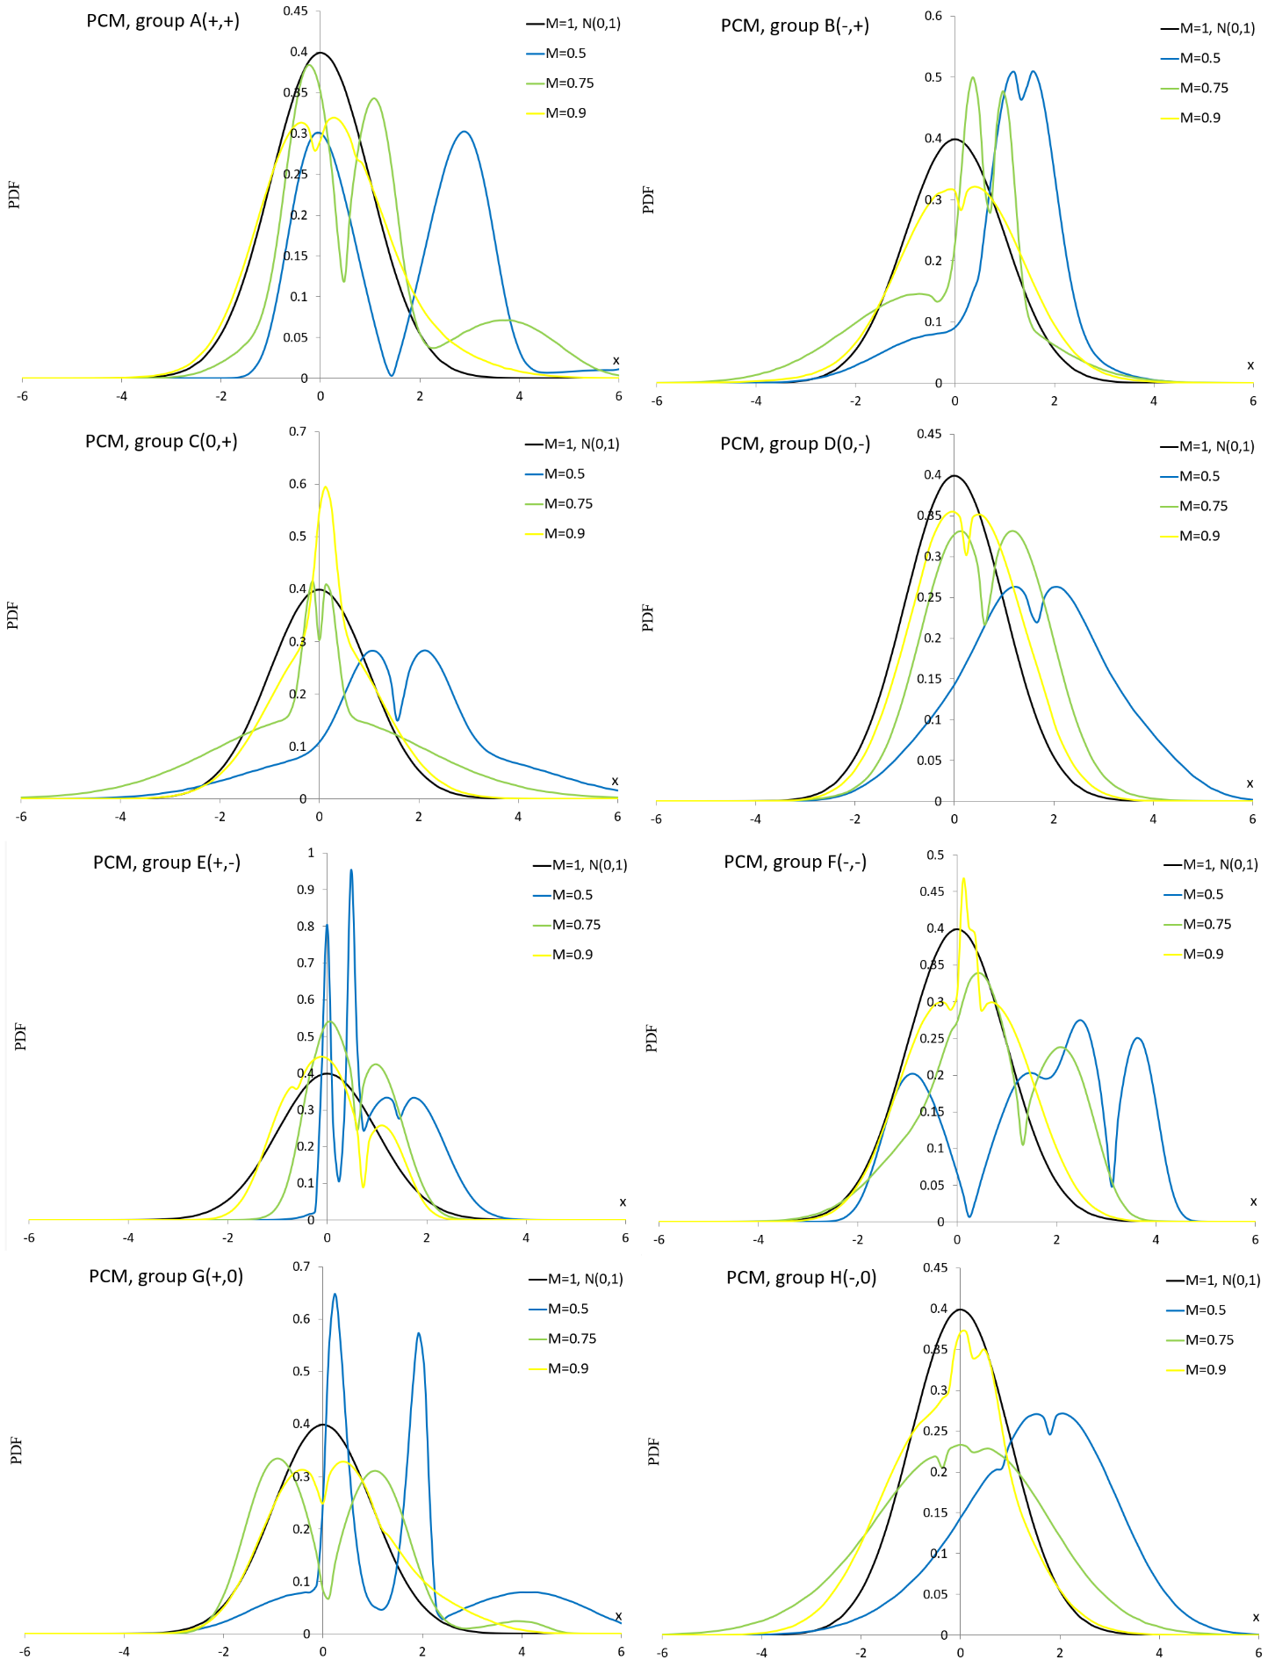
Source: own material
Figure 5A PDF curves of the PCM distribution for parameter values presented in Table 5A

Laplace mixture distribution
PDF of the Laplace mixture LM distribution is given by
$f_{LM}\left(x;θ\right)=ω\frac{1}{2σ_{1}}exp\left(-\frac{\left|x-μ_{1}\right|}{σ_{1}}\right)+\left(1-ω\right)\frac{1}{2σ_{2}}exp\left(-\frac{\left|x-μ_{2}\right|}{σ_{2}}\right)$,
where $θ=\left(μ_{1},σ_{1}, μ_{2},σ_{2},ω\right)$ and $x∈R, μ_{1},μ_{2}∈R, σ_{1},σ_{2}>0, ω∈\left[0,1\right]$. Special cases of the LM distribution are Laplace L $L\left(μ_{1},σ_{1}\right)$ for $ω=1$ and $L\left(μ_{2},σ_{2}\right)$ for $ω=0$.
Table 6A Vectors of LM parameter $θ$ and similarity measure M. Groups A-H
Group | $$θ=\left(μ_{1},σ_{1}, μ_{2},σ_{2},ω\right)$$ | $$M\left(θ;0,1\right)$$
A | 4.521,7.174,-0.757,1.959,0.313 | 0.5
 | 1.169,1.491,-0.019,0.849,0.56 | 0.75
 | 0.452,0.818,-0.947,0.482,0.762 | 0.9
B | -0.358,0.405,-2.549,2.309,0.234 | 0.5
 | 0.94,0.335,-0.571,1.585,0.122 | 0.75
 | -0.736,0.911,0.04,0.878,0.132 | 0.9
C | 1.445,1.571,-2.516,1.87,1 | 0.5
 | 0.246,0.844,-0.59,0.905,0.043 | 0.75
 | 0.319,0.86,-0.21,0.874,0.222 | 0.9
D | -6.131,0.945,-0.386,1.54,0.366 | 0.5
 | -4.898,0.343,-0.415,1.234,0.29 | 0.6
 | 2.115,0.07,-0.512,0.822,0.208 | 0.7
E | 7.186,1.509,-0.869,0.58,0.309 | 0.5
 | -1.711,0.177,0.773,0.823,0.421 | 0.6
 | 1.023,0.358,-0.118,0.348,0.428 | 0.75
F | -3.863,0.348,1.522,1.359,0.248 | 0.4
 | 0.006,0.065,0.703,0.189,0.227 | 0.45
 | -0.466,0.161,0.08,0.159,0.48 | 0.5
G | 2.309,1.022,-1.1,0.418,0.391 | 0.5
 | -0.208,1.335,7.917,1.899,0.712 | 0.6
 | 0.679,0.702,-1.434,0.642,0.532 | 0.75
H | -9.234,0.124,1.581,2.321,0.161 | 0.4
 | -1.322,0.83,2.398,1.181,0.291 | 0.45
 | 0.81,0.479,2.254,0.229,0.736 | 0.5
Source: own material

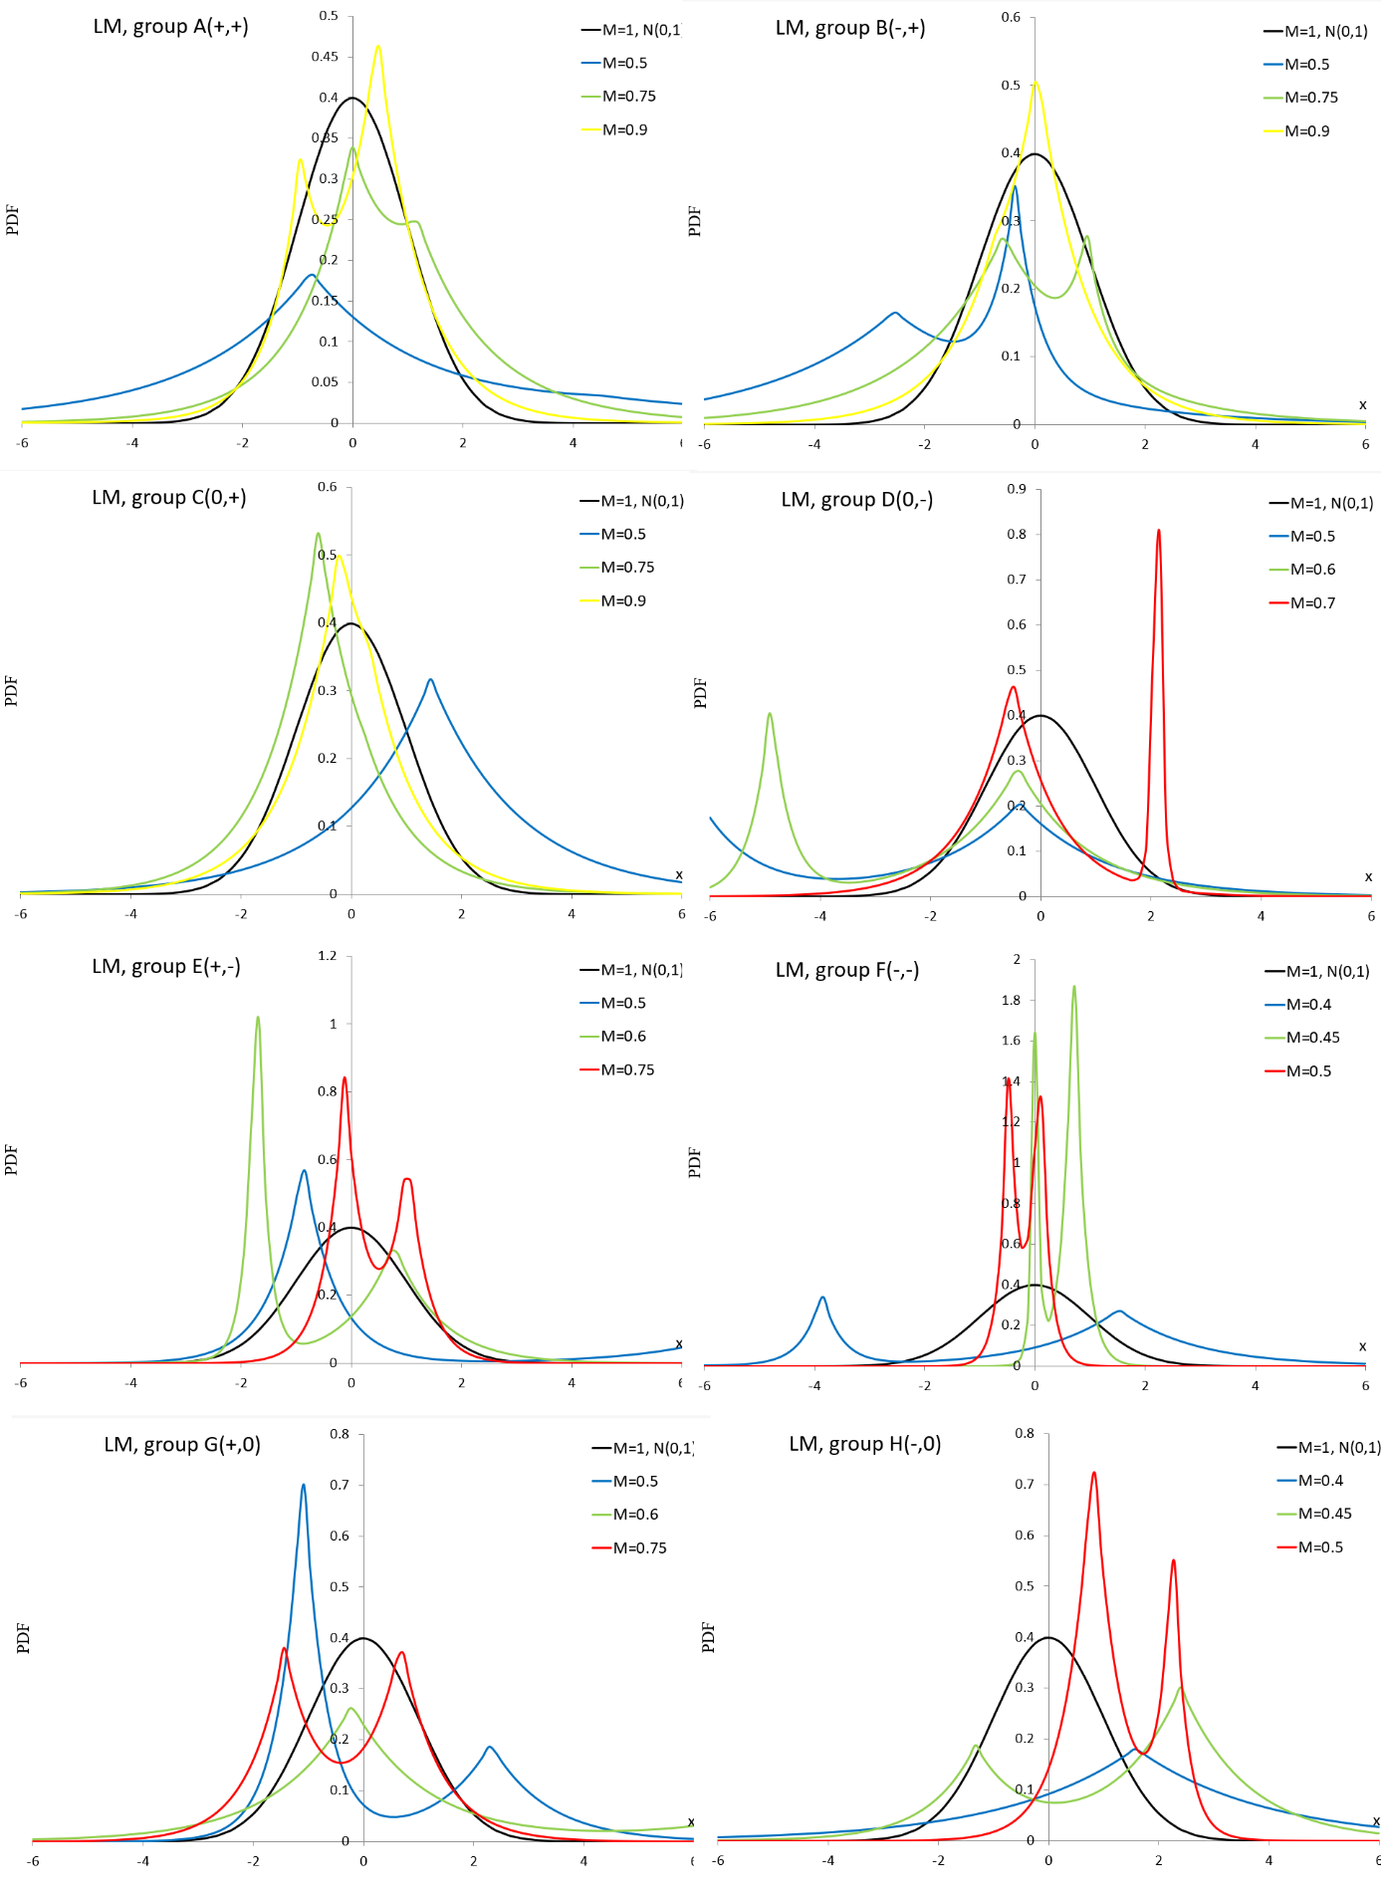
Source: own material
Figure 6A PDF curves of the LM distribution for parameter values presented in Table 6A

Johnson SB distribution
PDF of the Johnson SB SB distribution is given by (Johnson, 1949)
$$f_{SB}\left(x;a,b,c,d\right)=\frac{bd}{\left(x-c\right)\left(c+d-x\right)}ϕ\left[a+bln\left(\frac{x-c}{c+d-x}\right);0,1\right], x∈\left[c,c+d\right]$$
where$a,c∈R; b,d>0$.
Table 7A Vectors of the SB parameter $θ$ and similarity measure M. Groups A – B, D – H
Group | $$θ=\left(μ_{1},σ_{1}, μ_{2},σ_{2},ω\right)$$ | $$M\left(θ;0,1\right)$$
A | 1.972,1.819,-0.45,4 | 0.5
 | 2.482,2.23,-1.665,7.423 | 0.75
 | 3.092,2.702,-2.908,12.271 | 0.9
B | -4.086,2.097,-5.424,6.348 | 0.5
 | -2.614,2.258,-5.722,7.58 | 0.75
 | -1.992,2.198,-6.446,8.974 | 0.9
D | 0,3.149,-2.116,4.115 | 0.5
 | 0,3.958,-4.707,9.414 | 0.75
 | 0,4.304,-8.154,15.856 | 0.9
E | 0.664,0.45,-0.027,4.679 | 0.5
 | 0.834,0.754,-0.727,3.258 | 0.75
 | 0.867,2.297,-4.627,10.828 | 0.9
F | -0.716,0.448,-0.622,1.618 | 0.5
 | -1.044,1.22,-4.394,5.493 | 0.75
 | -1.202,1.515,-4.252,6.217 | 0.9
G | 1.64,2.044,-3.761,8.045 | 0.5
 | 1.825,2.345,-1.984,6.623 | 0.75
 | 2.952,4.082,-5.487,16.27 | 0.9
H | -1.357;1.565;-1.601;3.202 | 0.5
 | -2.046;2.695;-5.081;7.468 | 0.75
 | -2.068;2.73;-7.098;10.398 | 0.9
Source: own material

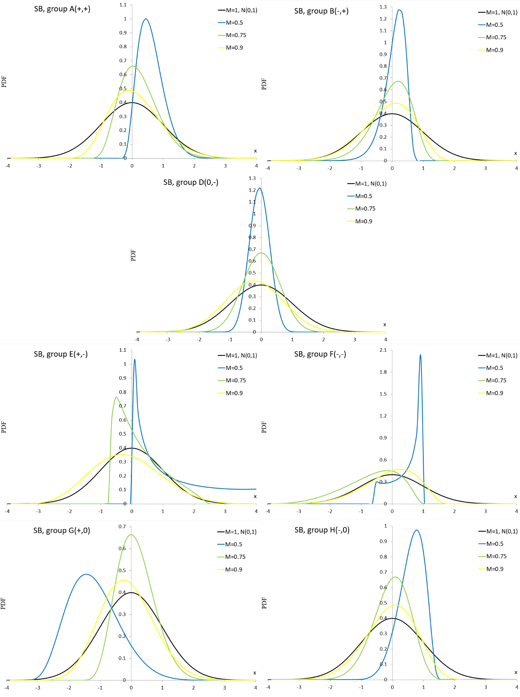
Source: own material
Figure 7A PDF curves of the SB distribution for parameter values presented in Table 7A

Johnson SU distribution
PDF of the Johnson SU SU distribution is given by (Johnson, 1949)
$$f_{SU}\left(x;a,b,c,d\right)=\frac{b}{\sqrt{{\left(x-c\right)}^{2}+d^{2}}}ϕ\left[a+b\sinh^{-1}\left(\frac{x-c}{d}\right);0,1\right]\left(x∈R\right)$$
where $b>0,a,c∈R,d≠0$.
Table 8A Vectors of the SU parameter $θ$ and similarity measure M. Groups A – C, E – H
Group | $$θ=\left(a,b,c,d\right)$$ | $$M\left(θ;0,1\right)$$
A | -1.246,2.021,0.257,0.731 | 0.5
 | -0.569,2.063,-1.301,2.625 | 0.75
 | -0.11,2.762,-0.069,3.319 | 0.9
B | 2.502,2.889,2.029,3.828 | 0.5
 | 2.564,3.308,2.137,1.902 | 0.75
 | 2.296,5.558,2.36,6.031 | 0.9
C | 0,1.821,-1.617,3.096 | 0.5
 | 0,1.829,-0.205,2.967 | 0.75
 | 0,3.372,0.204,2.935 | 0.9
E | -22.518,45.262,-11.095,19.766 | 0.5
 | 1.29,40.539,-0.294,-17.564 | 0.6
 | 0.244,21.027,-0.134,-12.383 | 0.75
F | 0.861,18.997,-1.158,14.674 | 0.3
 | 0.756,3.676,0.166,0.819 | 0.4
 | 13.843,36.36,4.174,11.623 | 0.5
G | -9.342,11.021,-1.575,1.981 | 0.4
 | -23.944,18.041,-8.486,5.409 | 0.5
 | -9.349,85.071,-3.763,35.754 | 0.6
H | 0.738,49.723,3.6,73.029 | 0.3
 | 2.547,7.276,0.835,1.65 | 0.4
 | 4.211,10.507,1.959,3.55 | 0.5
Source: own material

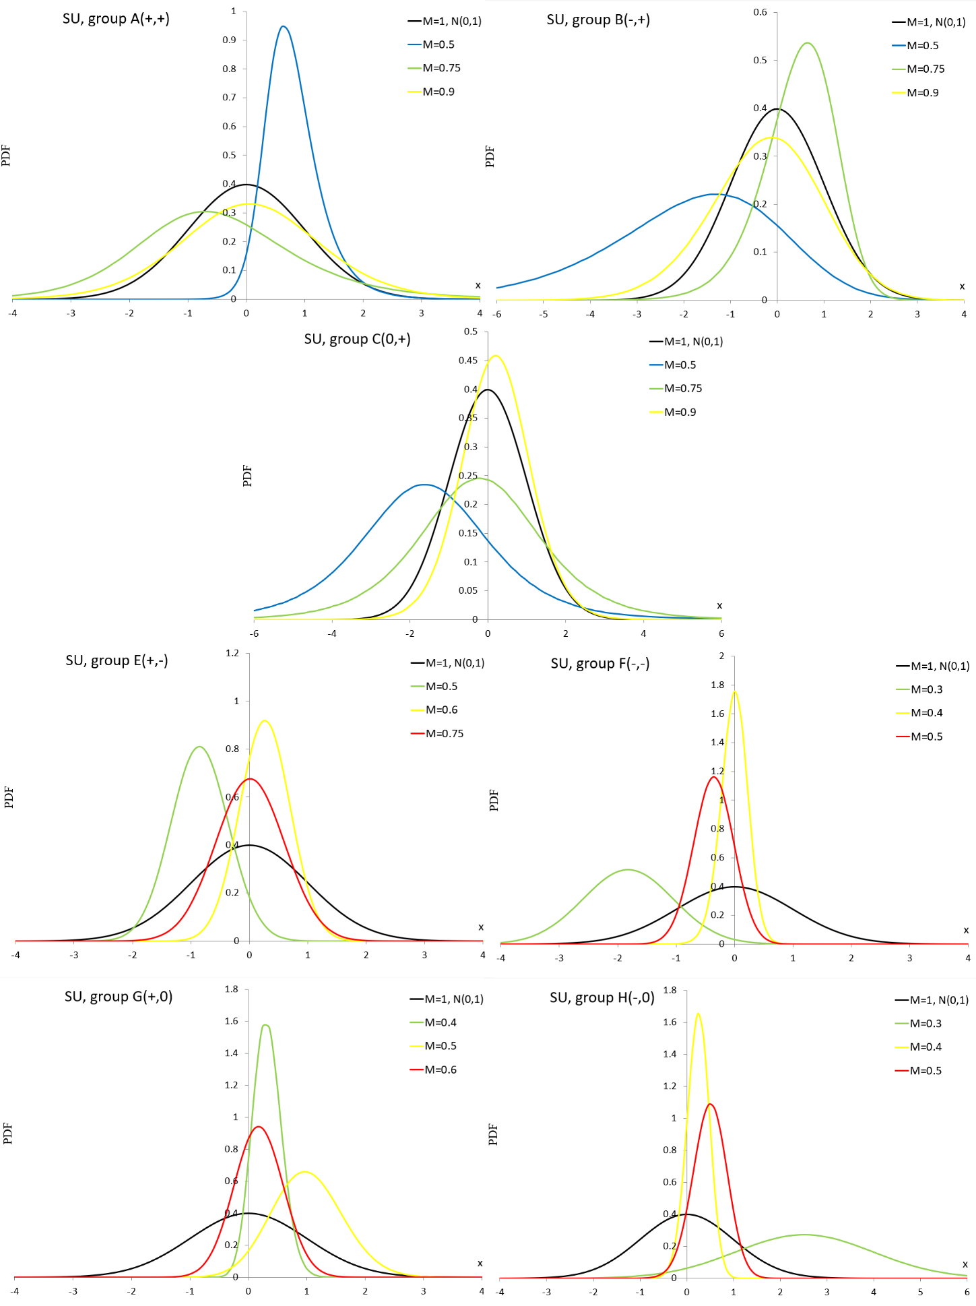
Source: own material
Figure 8A PDF curves of the SU distribution for parameter values presented in Table 8A

Extended easily changeable kurtosis distribution
PDF of the extended easily changeable kurtosis EECK distribution is given by (Sulewski, 2023)
$f_{EECK}\left(x;a,b\right)=\frac{{\left(1-{\left|x\right|}^{b}\right)}^{a}Γ\left(a+\frac{1}{b}+1\right)}{2Γ\left(a+1\right)Γ\left(\frac{1}{b}+1\right)} \left(x∈\left[-1,1\right]\left(a≥0\right),x∈\left(-1,1\right)\left(1<a<0\right)\right)$,
where $a>-1,b>0$. Special cases of the EECK distribution are: uniform $U\left(-1,1\right)=EECK\left(0,b\right)$, triangle $\left(a=b=1\right)$ and easily changeable kurtosis $\left(b=2\right)$ distributions.
Table 9A Vectors of the EECK parameter $θ$ and similarity measure M. Groups C-D
Group | $$θ=\left(a,b\right)$$ | $$M\left(θ;0,0.096\right)$$
C | 46.018,1.043 | 0.5
 | 40.914,1.366 | 0.75
 | 10.676,1.184 | 0.9
D | 60.495,4.846 | 0.5
 | 48.76,2.738 | 0.75
 | 48.76,2.211 | 0.9
Source: own material
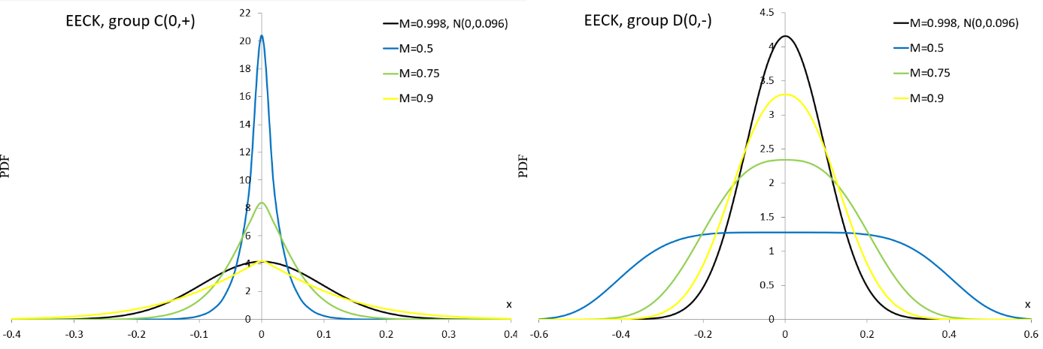
Source: own material
Figure 9A PDF curves of the EECK distribution for parameter values presented in Table 9A

Exponential power distribution
PDF of the exponential power EP distribution is given by (Subbotin, 1923; Lunetta, 1963)
$f_{EP}\left(x;a,b,c\right)= \frac{1}{2c\sqrt[c]{c}Γ\left(1+\frac{1}{c}\right)}exp\left[-\frac{1}{c}{\left(\left|\frac{x-a}{b}\right|\right)}^{c}\right], x∈R \left(a∈R,b,c>0\right)$.
Special case of the EP distribution is the $N\left(a,b\right)$ for $c=2$.
Table 10A Vectors of the EP parameter $θ$ and similarity measure M. Groups C-D
Group | $$θ=\left(a,b,c\right)$$ | $$M\left(θ;0,1\right)$$
C | -0.796,2.985,1.609 | 0.5
 | 90.611,1.385,1.695 | 0.75
 | 90.251,1.033,1.785 | 0.9
D | -0.611,3.71,28.792 | 0.5
 | -0.673,1.198,3.828 | 0.75
 | -0.05,1.272,3.117 | 0.9
Source: own material
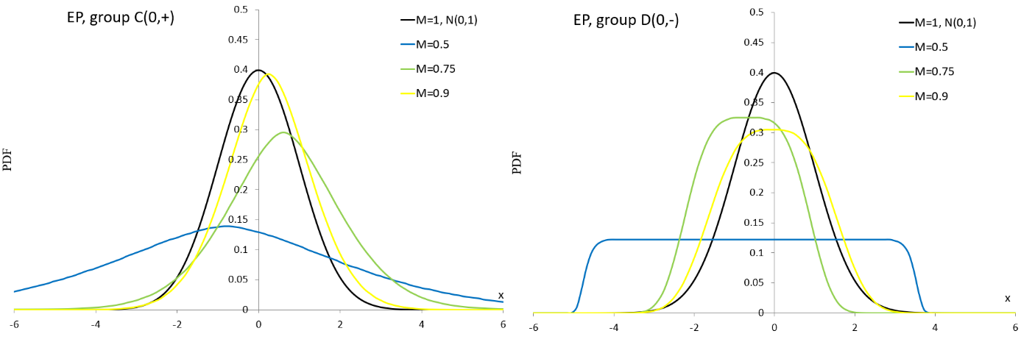
Source: own material
Figure 10A PDF curves of the EP distribution for parameter values presented in Table 10A

.

