Expression of CXCL9 orchestrates cytotoxic and regulatory T cell infiltration in renal cell carcinoma

Methods, Figures and Tables

Uro study team

2022-10-18

# Methods

Detailed description of analysis procedures is provided in **Supplementary Methods**.

## Ethics

No ethics committee approval was needed for publicly available anonymous expression and clinical information data sets. Donors of tissue for flow cytometry measurements provided written consent. The study was conducted in accordance with the Declaration of Helsinki and its protocol was approved by the ethical committee of the University Hospital Regensburg (approval number: …to be filled in…)

## Software

The analysis was done with R version 4.2.0. Basic data transformation tasks were accomplished with the *tidyverse* package bundle (1). Results were visualized with the packages *ggplot2* (bubble plots) (2), *ExDA* (violin plots; <https://github.com/PiotrTymoszuk/ExDA>), *microViz* (Forest plots, bar plots of regulation estimates and p values; <https://github.com/PiotrTymoszuk/microViz>) and *survminer* (Kaplan-Meier plots) (3). Exploratory data analysis and hypothesis testing was done with the *rstatix* (4) and *ExDA* packages.

## Data import and transformation

The following publicly available RCC data sets were re-analyzed: TCGA Clear Cell Carcinoma (KIRC) project (5), whole-genome subsets of the CheckMate 010 (CM 010) and CheckMate 025 (CM 025) studies (6), GSE73731 (7), GSE167093 (8), RECA-EU (9) and E-MTAB 1980 (10). Author-provided expression data and clinical information for the TCGA cohort were extracted from the GDC Data Portal with the TCGA-Assembler script (<https://github.com/compgenome365/TCGA-Assembler-2/blob/master/TCGA-Assembler/>). Author-provided expression and clinical data for GSE73731 and GSE167093 were fetched with the *GEOquery* package (11). E-MTAB 1980 and RECA-EU data sets were imported from the ArrayExpress and ICGC Data Portal repositories, respectively, with in-house developed R scripts. To investigate possible effects of therapy with immune checkpoint inhibitors, the CheckMate 025 everolimus (CM 025 EVER) and nivolumab (CM 025 NIVO) treatment arms were analyzed separately.

For the microarray expression studies (GSE73731, GSE167093, E-MTAB 1980), integration of multiple probes targeting the same gene was accomplished by geometric mean. Expression values were transformed with (RNA sequencing: TCGA, CM 010, CM 025, RECA-EU) of . Immune infiltration estimates were calculated using the QuanTIseq algorithm (*immunedeconv* package) (12,13).

The following genes were investigated: *CXCL9* (Entrez ID: 4283), *CXCL10* (3627), *CXCL11* (6373) and *CXCR3* (2833).

## Descriptive statistic and hypothesis testing

Numeric variables are presented as median values with interquartile ranges. Categorical variables are presented as percentages and total numbers within the complete observation set. Comparison of log2-transformed expression between donor-matched normal kidney and RCC samples was done with two-tailed paired T test. Differences in log2-transformed expression levels between tumor grades, tumor stages, individuals with our without distant metastases at diagnosis, MSKCC (Memorial Sloan Kettering Cancer Center) risk groups and patients with or without overall clinical response to therapy were investigated by Mann-Whitney test with r effect size statistic or Kruskal-Wallis test with effect size statistic, as appropriate. Pair-wise correlation of log2-transformed expression in RCC and correlations of log2-transformed *CXCL9* and *CXCR3* expression with infiltration estimates were analyzed with Spearman’s test. Statistical significance in differences in overall and relapse-free survival between *CXCL9*high and *CXCL9*low expressors was determined by Mentel-Henszel test. P values were corrected for multiple testing for each analysis step separately with the Benjamini-Hochberg method (14).

## Survival stratification and differential gene expression

Cancer samples in the cohorts with survival data available (TCGA, CM 010, CM 025, RECA-EU, E-MTAB 1980) were stratified into low and high expressors of *CXCL9* with the cutoff corresponding to the largest difference in overall or relapse-free survival determined by Mentel-Henszel test (packages *survival* and *kmOptimizer*, <https://github.com/PiotrTymoszuk/kmOptimizer>) (15–17). Samples in the cohorts without survival data (GSE73731, GSE167093) were dichotomized by the median *CXCL9* expression.

Differential gene expression in the *CXCL9* expression strata defined by overall survival or median split was investigated by Benjamini-Hochberg-corrected two-tailed T test (package *microViz*) (14). The differentially regulated genes were defined by the adjusted significance cutoff (pFDR < 0.05) and the 1.5-fold regulation cutoff.

## GO enrichment analysis, signaling pathway modulation, gene set variation analysis

Biological process (BP) gene ontology (GO) term enrichment for the differentially regulated genes was analyzed with the *goana()* tool (package *limma*) (18). Differential modulation of KEGG-listed pathways based on the differential gene expression was investigated with SPIA with the combined significance for gene set enrichment and net pathway regulation (pG) as a significance metric and tA as an estimate of magnitude of pathway modulation (19). Regulation of particular signaling pathway components was visualized with the *pathview* package (20).

Signatures of CD8+ T cells, cytotoxicity, exhaustion and regulatory T cells were retrieved from the MSig Database, release 7.5.1. Gene set variation analysis (GSVA) scores for the gene signature were calculated with the *GSVA* (21)and *gseaTools* packages (<https://github.com/PiotrTymoszuk/gseaTools>). GSVA scores were compared between the *CXCL9* expression strata by two-tailed T test with Benjamini-Hochberg correction for multiple testing (package *microViz*) (14).

## Biochemical reaction modulation

Rules of assignment of genes to biochemical reactions were retrieved from the Recon2 human metabolism model available via the BiGG database (22).

Regulation of biochemical reactions in the *CXCL9* expression strata based on whole-genome estimates of differential gene expression and their standard errors was done by evaluation of the gene assignment rules with the ‘gene - protein - reaction’ (GPR) principle (23). Standard deviation, 95% confidence intervals and p values for the predicted reaction regulation estimates were obtained by a Monte Carlo simulation (n = 1000 draws). The analysis was done with the package *BiGGR* (23) and the development package *biggrExtra* (<https://github.com/PiotrTymoszuk/biggrExtra>).

## Flow cytometry

Donor-matched peripheral blood mononuclear cells (PBMC), healthy kidney tissues, tissues from the center and periphery of RCC were obtained freshly at the day of surgery (n = 4, **Supplementary Table S1**). The donors were recruited at the Department of Urology of the University Hospital Regensburg between 2019 and 2020 prior to the pharmacological cancer treatment. Single cell suspensions of kidney and RCC samples were obtained as described previously (24). PBMC were purified by Ficoll density gradient centrifugation. The cell suspensions were permeabilized using the Cytofix/Cytoperm kit (BD) and stained with anti-CD3, CD14, CD56, CD19, CD25, CD4 (all BD), CD8 (BioLegend) and CXCL9 antibodies (Biotechne). Viable cells were identified by staining with Fixable Viability Dye eFluor 708 (eBioscience).

## Data and code availability

Data analyzed within the study are publicly available. The study pipeline is available at … to be filled in ….

# Tables

Table 1: Characteristic of the study cohorts. Numeric variables are presented as medians with interquartile ranges and ranges. Categorical variables are presented as percentage and total number within the complete observation set.

| **Variable** | **TCGA** | **E-MTAB 1980** | **GSE73731** | **GSE167093** | **RECA-EU** | **CM 010** | **CM 025 EVER** | **CM 025 NIVO** |
| --- | --- | --- | --- | --- | --- | --- | --- | --- |
| Sex | Female: 35% (n = 188) Male: 65% (n = 345) complete: n = 533 | Female: 24% (n = 24) Male: 76% (n = 77) complete: n = 101 | Female: 39% (n = 102) Male: 61% (n = 160) complete: n = 262 | Female: 41% (n = 247) Male: 59% (n = 357) complete: n = 604 | Female: 43% (n = 39) Male: 57% (n = 52) complete: n = 91 | Female: 33% (n = 15) Male: 67% (n = 30) complete: n = 45 | Female: 27% (n = 25) Male: 73% (n = 67) complete: n = 92 | Female: 24% (n = 21) Male: 76% (n = 67) complete: n = 88 |
| Age, years | 61 [IQR: 52 - 70] range: 26 - 90 complete: n = 533 | 64 [IQR: 56 - 72] range: 35 - 91 complete: n = 101 |  | 62 [IQR: 55 - 68] range: 23 - 85 complete: n = 602 | 60 [IQR: 54 - 67] range: 35 - 83 complete: n = 91 | 61 [IQR: 55 - 67] range: 46 - 81 complete: n = 45 | 62 [IQR: 56 - 68] range: 31 - 86 complete: n = 92 | 62 [IQR: 53 - 68] range: 30 - 88 complete: n = 88 |
| Tumor grade | G1: 2.6% (n = 14) G2: 43% (n = 229) G3: 39% (n = 206) G4: 14% (n = 76) GX: 0.94% (n = 5) complete: n = 530 | G1: 13% (n = 13) G2: 60% (n = 59) G3: 22% (n = 22) G4: 5.1% (n = 5) complete: n = 99 | G1: 8.6% (n = 22) G2: 35% (n = 90) G3: 37% (n = 95) G4: 19% (n = 49) complete: n = 256 | G1: 19% (n = 100) G2: 57% (n = 304) G3: 20% (n = 105) G4: 4.5% (n = 24) complete: n = 533 | G1: 14% (n = 13) G2: 53% (n = 48) G3: 17% (n = 15) G4: 16% (n = 14) complete: n = 90 |  |  |  |
| Tumor stage, pt | T1: 51% (n = 273) T2: 13% (n = 69) T3: 34% (n = 180) T4: 2.1% (n = 11) complete: n = 533 | T1: 67% (n = 68) T2: 11% (n = 11) T3: 21% (n = 21) T4: 0.99% (n = 1) complete: n = 101 | T1: 33% (n = 41) T2: 9.6% (n = 12) T3: 22% (n = 28) T4: 35% (n = 44) complete: n = 125 | T1: 51% (n = 306) T2: 16% (n = 98) T3: 23% (n = 138) T4: 10% (n = 62) complete: n = 604 | T1: 59% (n = 54) T2: 14% (n = 13) T3: 24% (n = 22) T4: 2.2% (n = 2) complete: n = 91 |  |  |  |
| Metastasis stage, pm | M0: 79% (n = 422) M1: 15% (n = 79) MX: 5.6% (n = 30) complete: n = 531 | M0: 88% (n = 89) M1: 12% (n = 12) complete: n = 101 |  |  | M0: 89% (n = 81) M1: 9.9% (n = 9) MX: 1.1% (n = 1) complete: n = 91 |  |  |  |
| Node stage, pn | N0: 45% (n = 240) N1: 3% (n = 16) NX: 52% (n = 277) complete: n = 533 | N0: 93% (n = 94) N1: 3% (n = 3) N2: 4% (n = 4) complete: n = 101 |  |  | N0: 87% (n = 79) N1: 2.2% (n = 2) NX: 11% (n = 10) complete: n = 91 |  |  |  |
| Relapse | 26% (n = 115) complete: n = 435 | 32% (n = 32) complete: n = 101 |  |  | 6.6% (n = 6) complete: n = 91 | 91% (n = 41) complete: n = 45 | 89% (n = 82) complete: n = 92 | 88% (n = 77) complete: n = 88 |
| Death | 30% (n = 160) complete: n = 530 | 23% (n = 23) complete: n = 101 |  |  | 33% (n = 30) complete: n = 91 | 78% (n = 35) complete: n = 45 | 83% (n = 76) complete: n = 92 | 70% (n = 62) complete: n = 88 |
| Observation time, days | 1000 [IQR: 330 - 1700] range: 0 - 3800 complete: n = 529 | 1600 [IQR: 1000 - 2500] range: 30 - 4400 complete: n = 101 |  |  | 1800 [IQR: 1100 - 2000] range: 2 - 2300 complete: n = 91 | 770 [IQR: 240 - 1500] range: 36 - 2200 complete: n = 45 | 600 [IQR: 250 - 1100] range: 21 - 1900 complete: n = 92 | 680 [IQR: 350 - 1500] range: 25 - 2000 complete: n = 88 |
| MSKCC risk group |  |  |  |  |  | favorable: 36% (n = 16) intermediate: 38% (n = 17) poor: 27% (n = 12) complete: n = 45 | favorable: 36% (n = 33) intermediate: 47% (n = 43) poor: 17% (n = 16) complete: n = 92 | favorable: 27% (n = 24) intermediate: 50% (n = 44) poor: 23% (n = 20) complete: n = 88 |
| Therapy response |  |  |  |  |  | PD: 44% (n = 20) SD: 31% (n = 14) PR: 22% (n = 10) CRPR: 0% (n = 0) CR: 2.2% (n = 1) complete: n = 45 | PD: 30% (n = 24) SD: 65% (n = 51) PR: 0% (n = 0) CRPR: 5.1% (n = 4) CR: 0% (n = 0) complete: n = 79 | PD: 34% (n = 28) SD: 41% (n = 34) PR: 0% (n = 0) CRPR: 25% (n = 21) CR: 0% (n = 0) complete: n = 83 |

# Figures

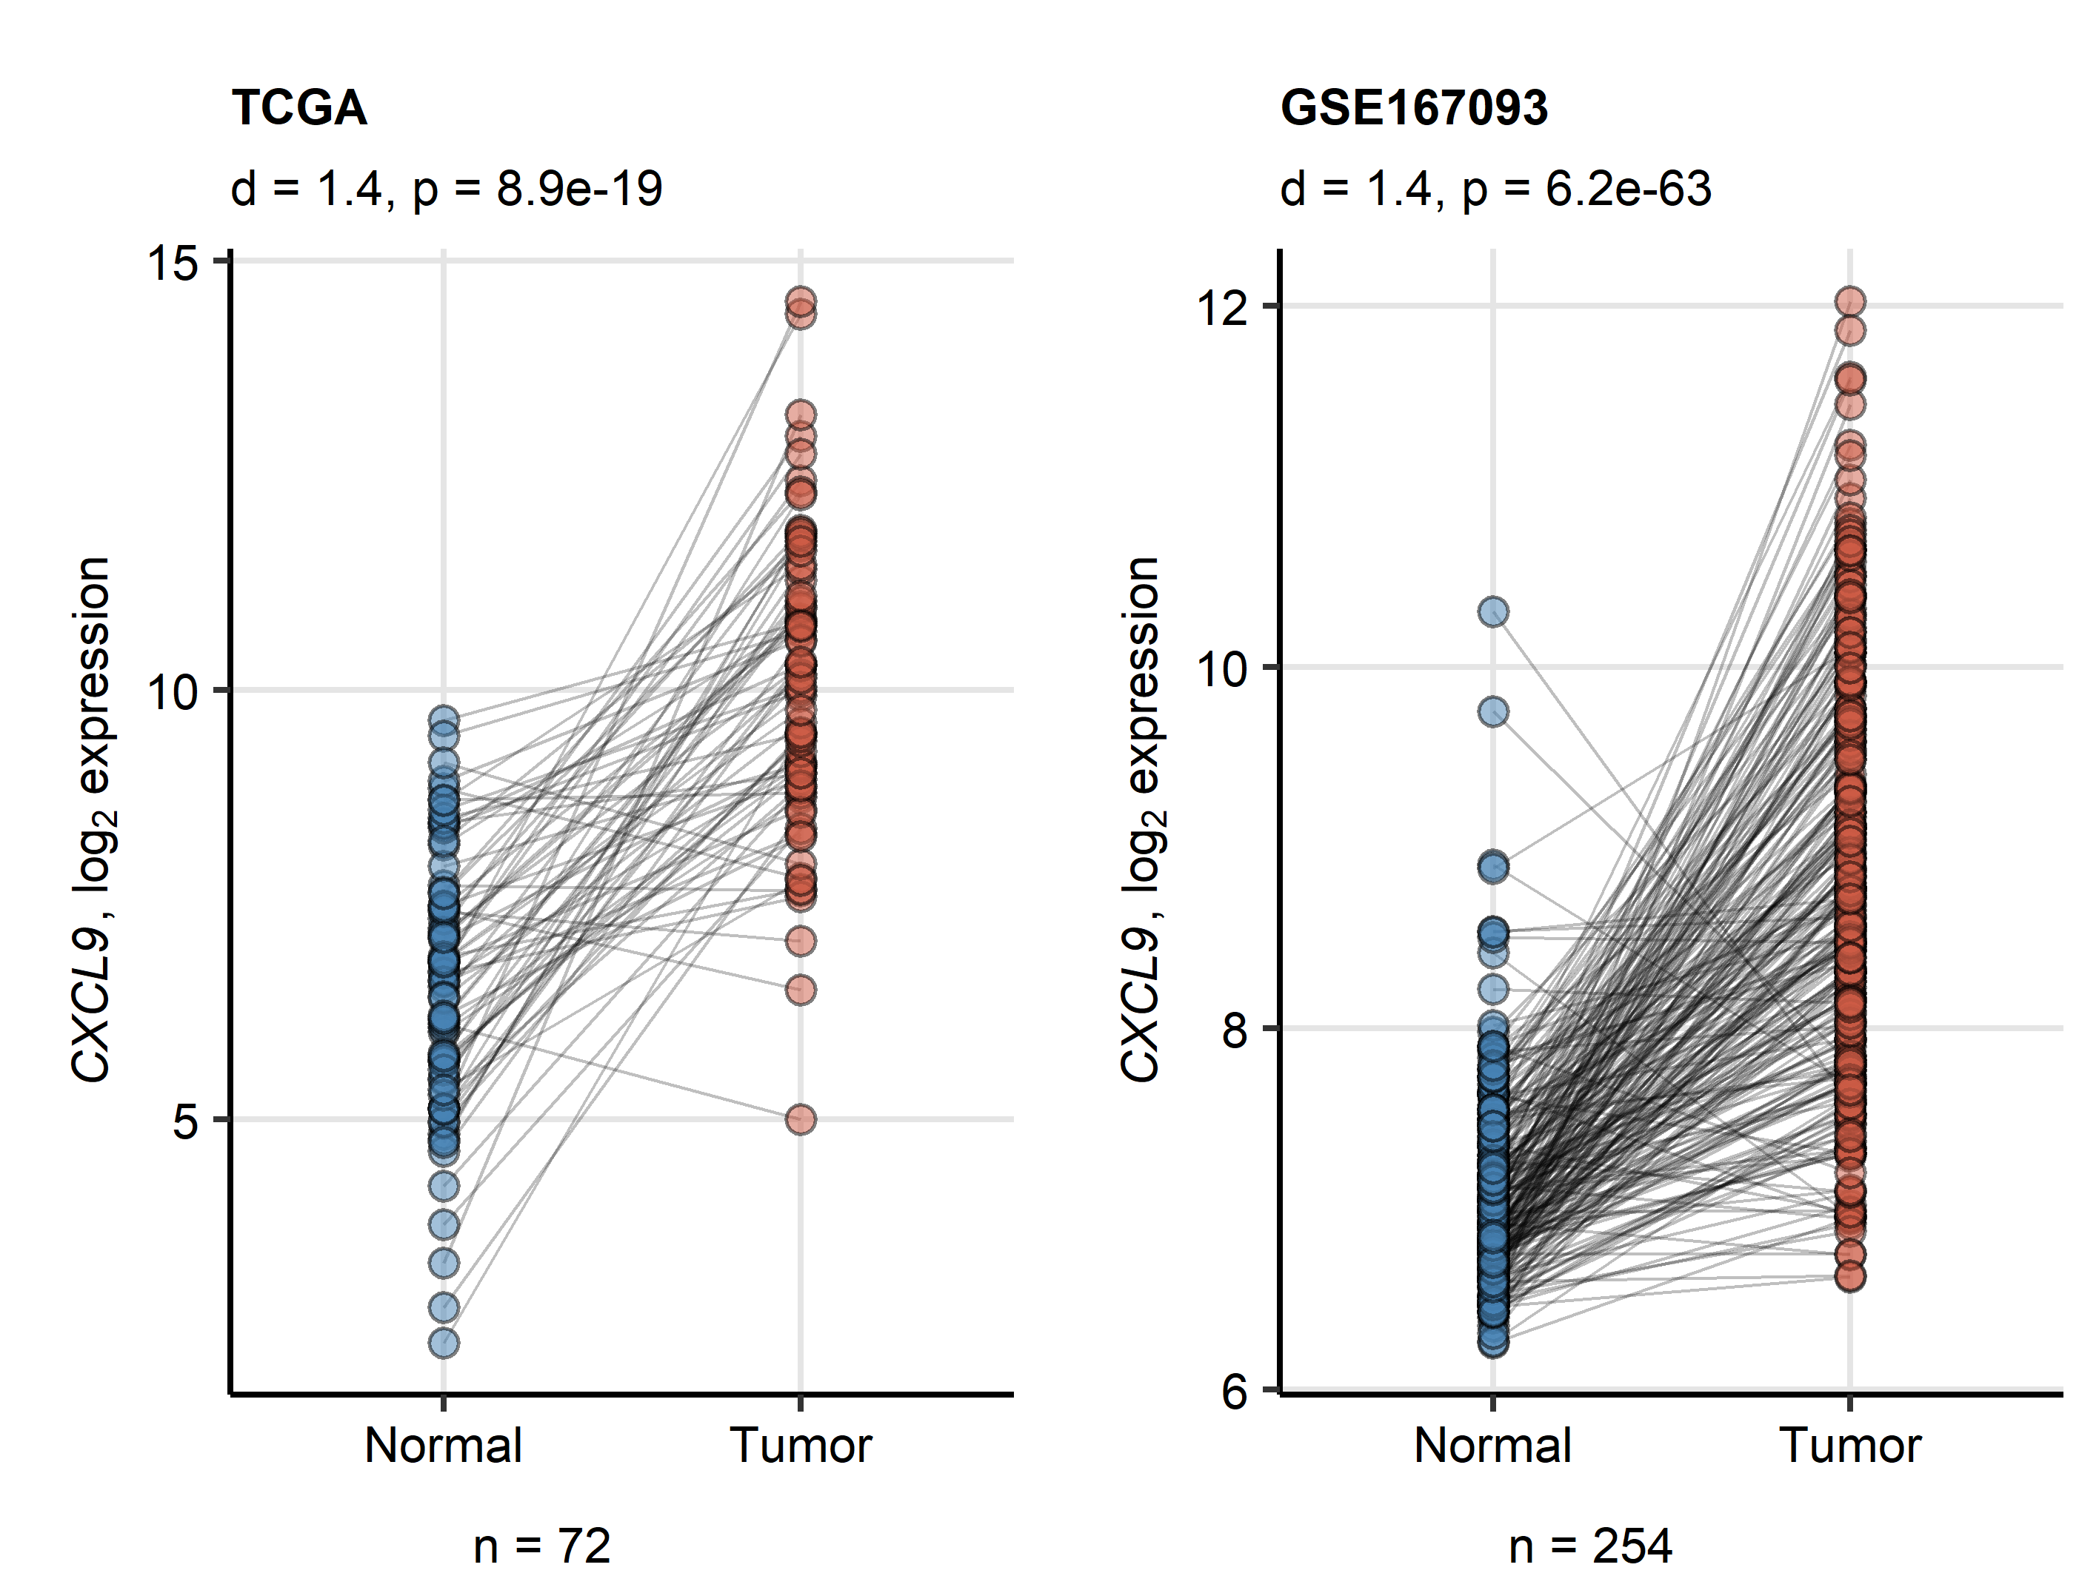

**Figure 1. Expression of CXCL9 in the normal kidney and RCC.** *Differences in log2-transformed expression of CXCL9 between the matched normal kidney and RCC samples in the TCGA and GSE73731 cohorts were investigated by two-tailed paired T test with Cohen’s d effect size statistic. P values were corrected for multiple testing with Benjamini-Hochberg method. Points represent single samples, samples from the same tissue donors are connected with lines. Effect size statistic and p values are displayed in the plot captions. Numbers of tissue donors are indicated under the plots.*

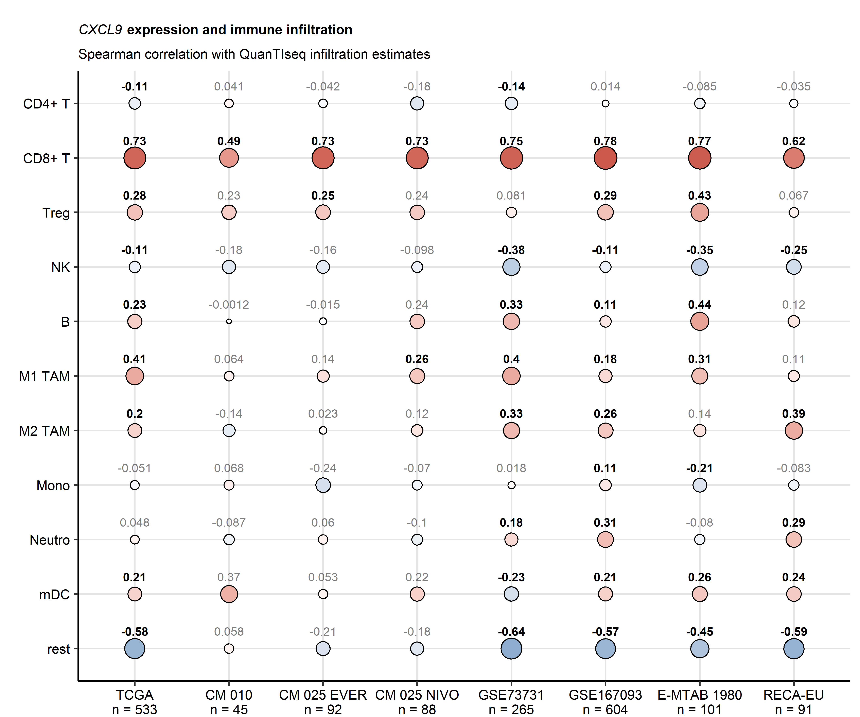

**Figure 2. Correlation of CXCL9 expression in RCC with immune cell infiltration.** *Levels of immune cells in cancer samples were predicted with the QuanTIseq algorithm. Correlation of the immune infiltration estimates and log2-transformed levels of CXCL9 expression was investigated by Spearman’s test corrected for multiple testing with Benjamini-Hochberg method. Correlation coefficients are presented in a bubble plot. Point size corresponds to the absolute value, point color corresponds to the value. Points are labeled with the values, significant correlations are highlighted in bold. Numbers of complete observations are indicated in the X axis. CM: CheckMate, EVER: everolimus, NIVO: nivolumab, Treg: regulatory T cells, NK: natural killer cells, TAM: tumor-associated macrophages, Mono: monocytes, Neutro: neutrophils, mDC: myeloid dendritic cells.*



**Figure 3. CXCL9 is predominantly expressed in CD14+ myeloid cells infiltrating ccRCC tumors and correlates with intratumoral immune cell frequencies (placeholder).** *Legend*

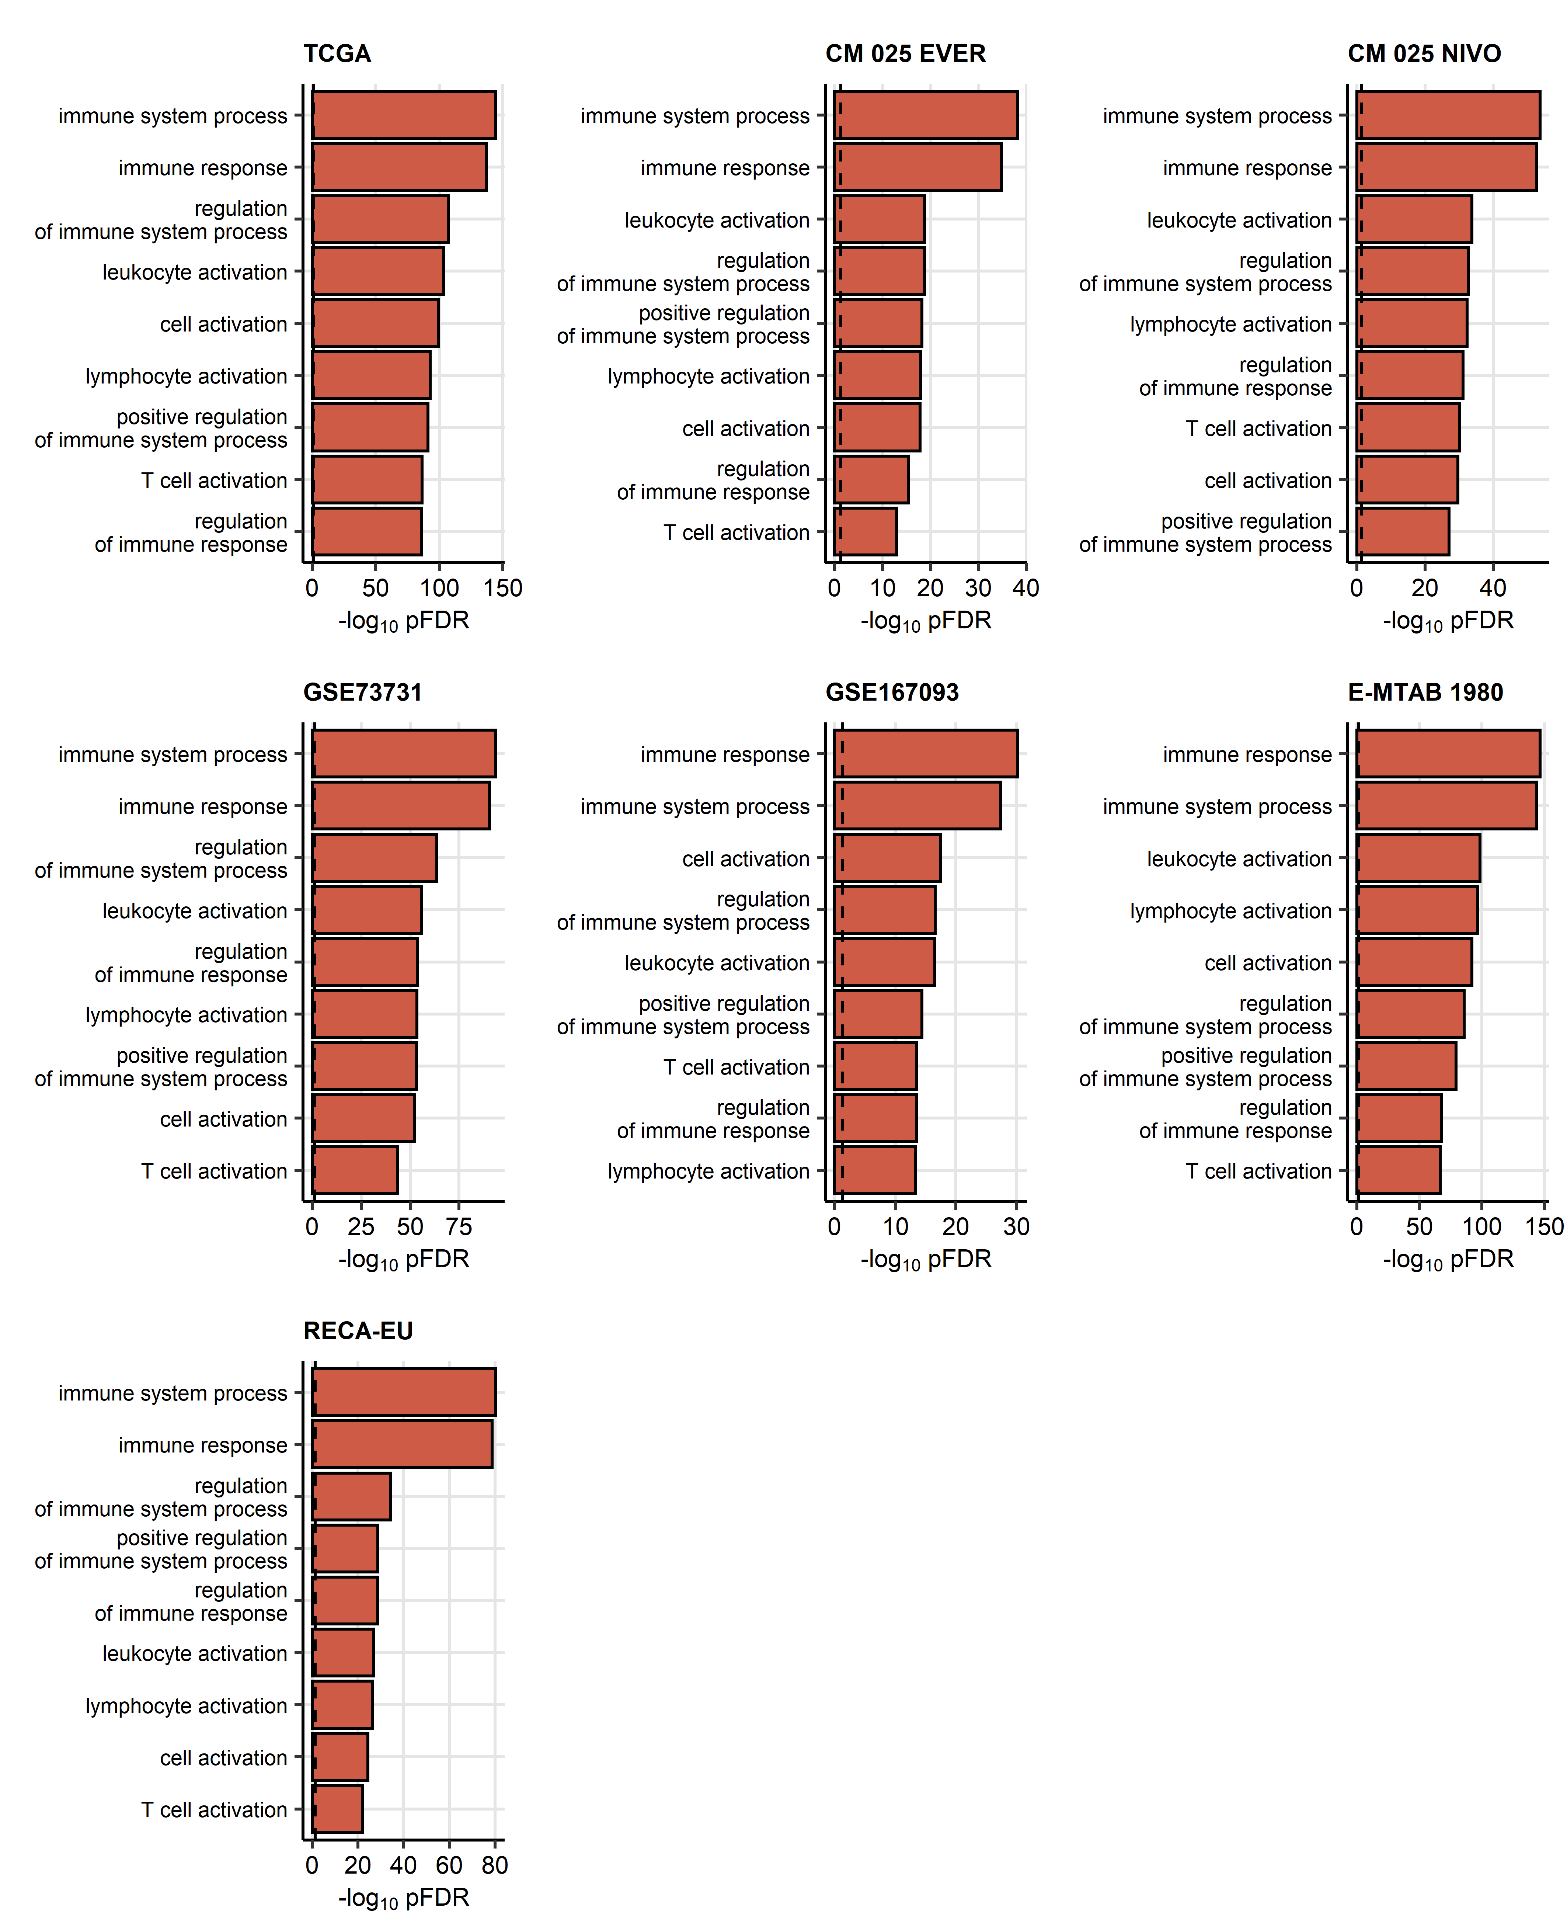

**Figure 4. Biological process GO term enrichment within the genes differentially regulated between CXCL9high and CXCL9low tumors.** *Cancers samples were classified as CXCL9high and CXCL9low with the cutoffs corresponding to the largest difference in overall survival (TCGA, CM 010, CM 025, E-MTAB 1980 and EU RECA) or by the median CXCL9 expression (GSE73731, GSE167093). Genes differentially regulated between the CXCL9 expression strata were identified by Benjamini-Hochberg-corrected two-tailed T test and the 1.5-fold regulation cutoff. Biological process gene ontology (GO) term enrichment within the differentially regulated gene sets was determined by the goana tool. No significantly enriched GO terms were identified in the CheckMate 010 cohort. p values for significant GO terms shared by all cohorts except for the CheckMate 010 collective are presented in bar plots. CM: CheckMate, EVER: everolimus, NIVO: nivolumab.*

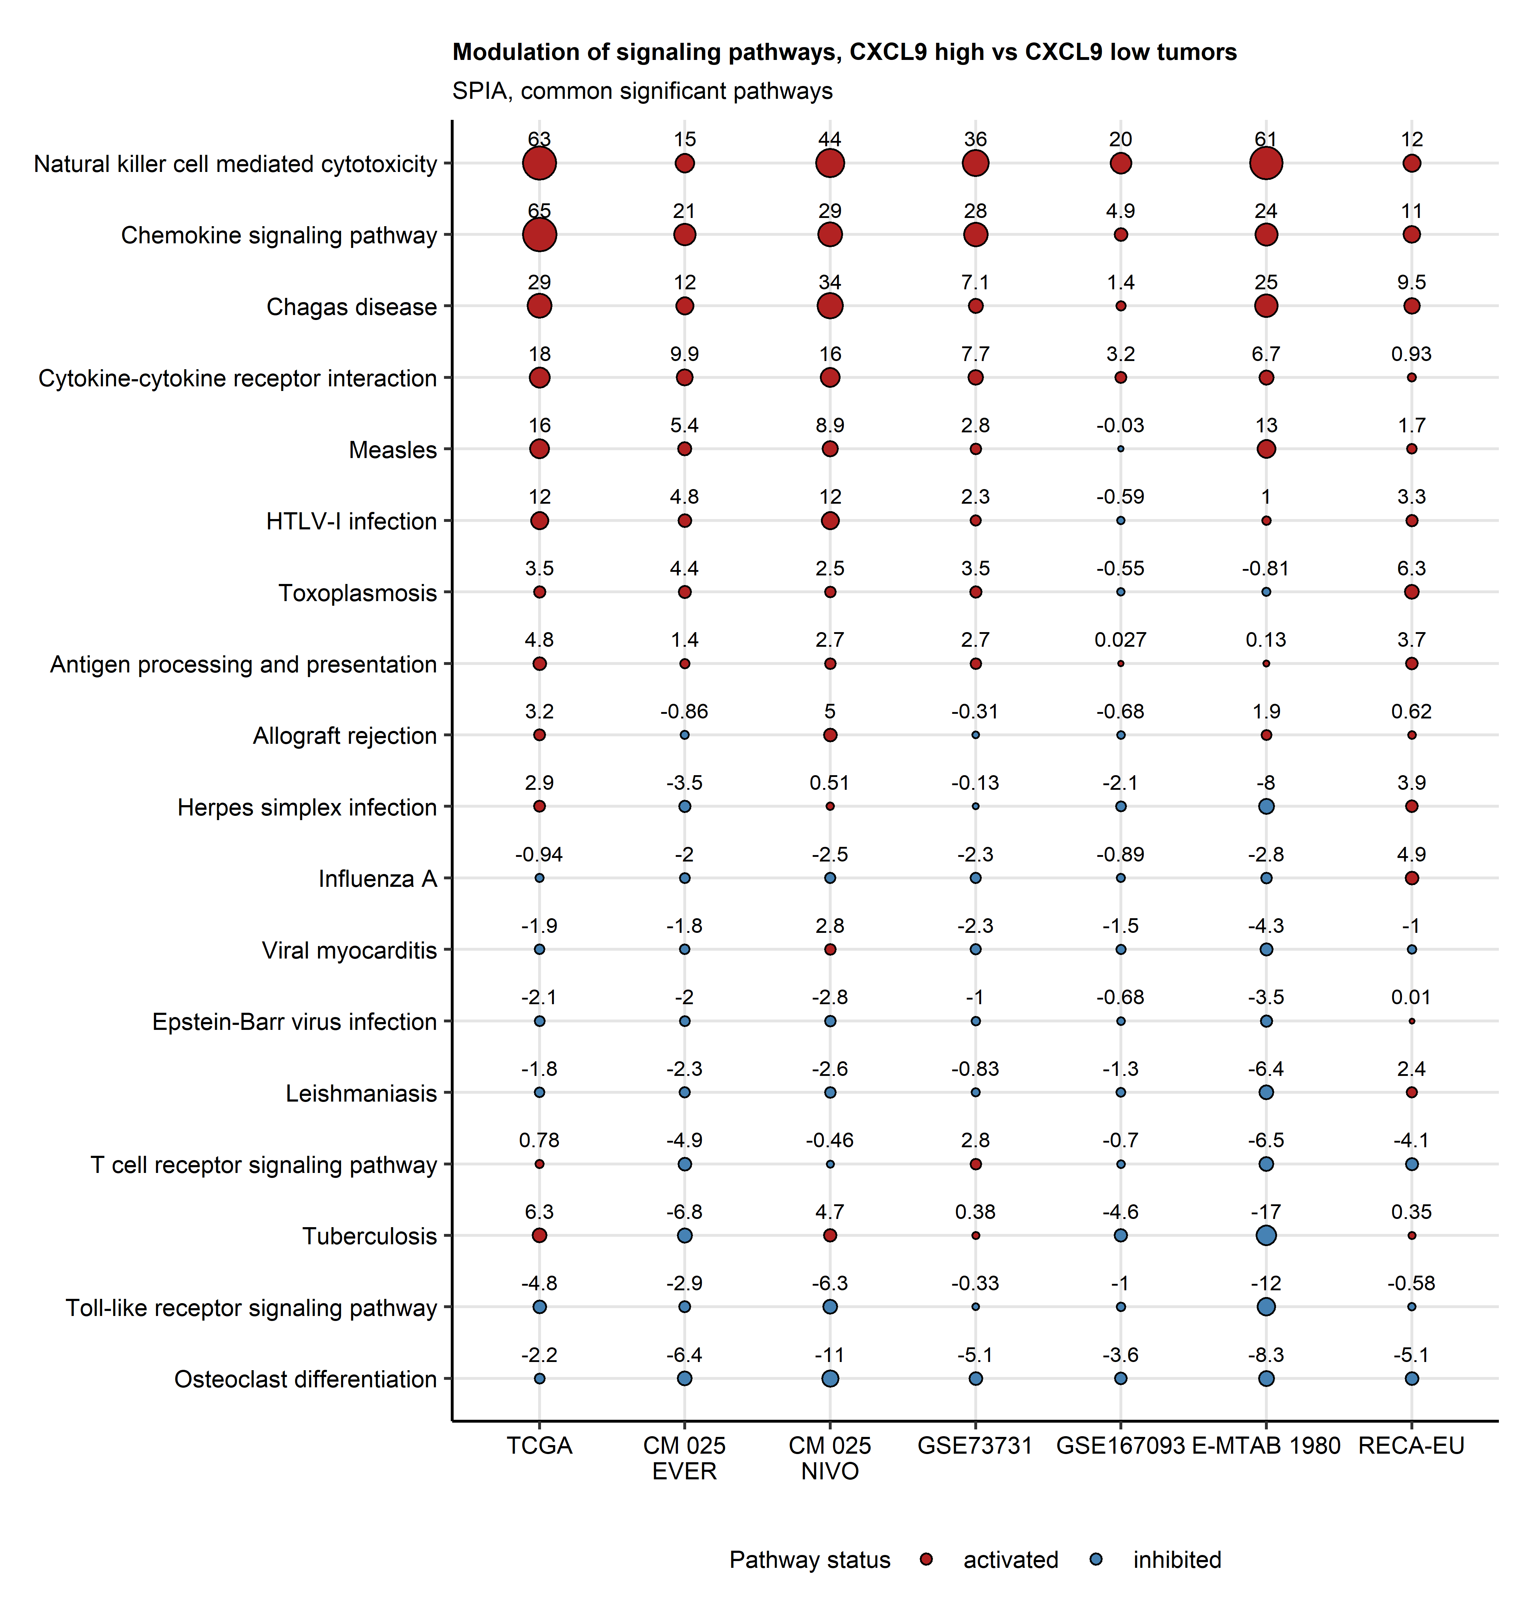

**Figure 5. Predicted modulation of signaling pathways in CXCL9high tumors.** *Modulation of KEGG-listed signaling pathways in CXCL9high versus CXCL9low cancers based on fold-regulation expression estimates for differentially regulated genes was predicted with the SPIA tool. Values of the pathway modulation metric tA for signaling pathways found significantly regulated in all study cohorts are presented in a bubble plot. Point size corresponds to the tA value, point color codes for the regulation status as compared with CXCL9low cancers. Points are labeled with the tA values.*

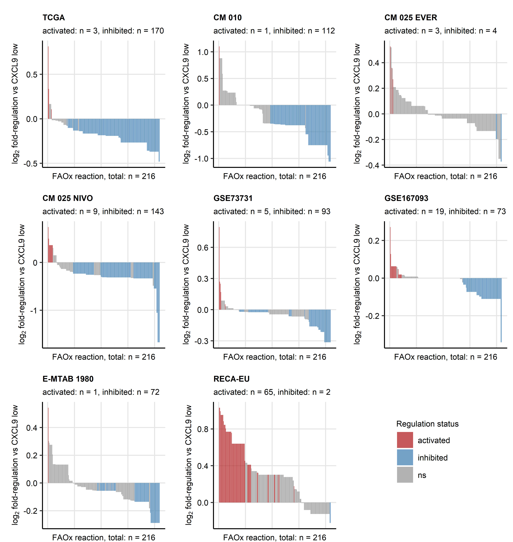

**Figure 6. Predicted regulation of fatty acid oxidation reactions in CXCL9high tumors.** *Regulation of metabolic reactions in CXCL9high versus CXCL9low cancer based on estimates of differential gene expression was predicted with the BiGGR and biggrExtra tools. Fold-regulation estimates for fatty acid oxidation (FAOx) are presented in as bar plots. Each bar represents a single reaction, bar color codes for significance and activation status. Total numbers of reactions are indicated in the X axis. Numbers of significantly activated and inhibited reactions are displayed in the plot captions. CM: CheckMate, EVER: everolimus, NIVO: nivolumab.*

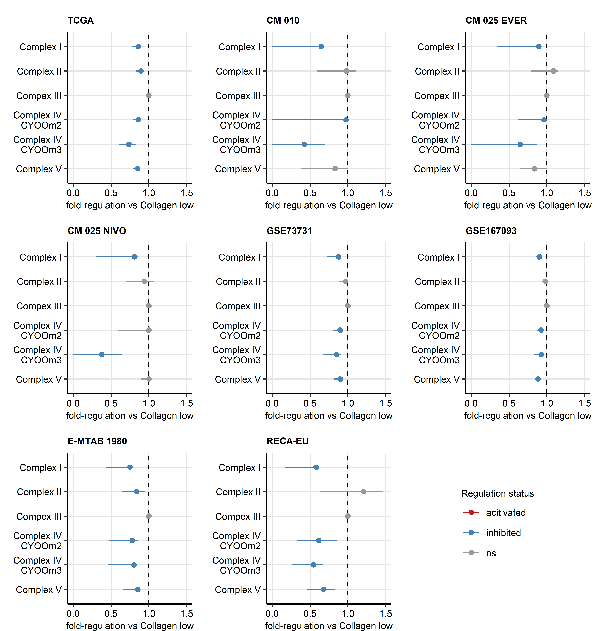

**Figure 7. Predicted regulation of oxidative phosphorylation reactions in CXCL9high tumors.** *Regulation of metabolic reactions in CXCL9high versus CXCL9low cancer based on estimates of differential gene expression was predicted with the BiGGR and biggrExtra tools. Fold-regulation estimates for oxidative phosphorylation (OxPhos) with 95% confidence intervals are presented in as Forest plots. Point color codes for significance and activation status.*

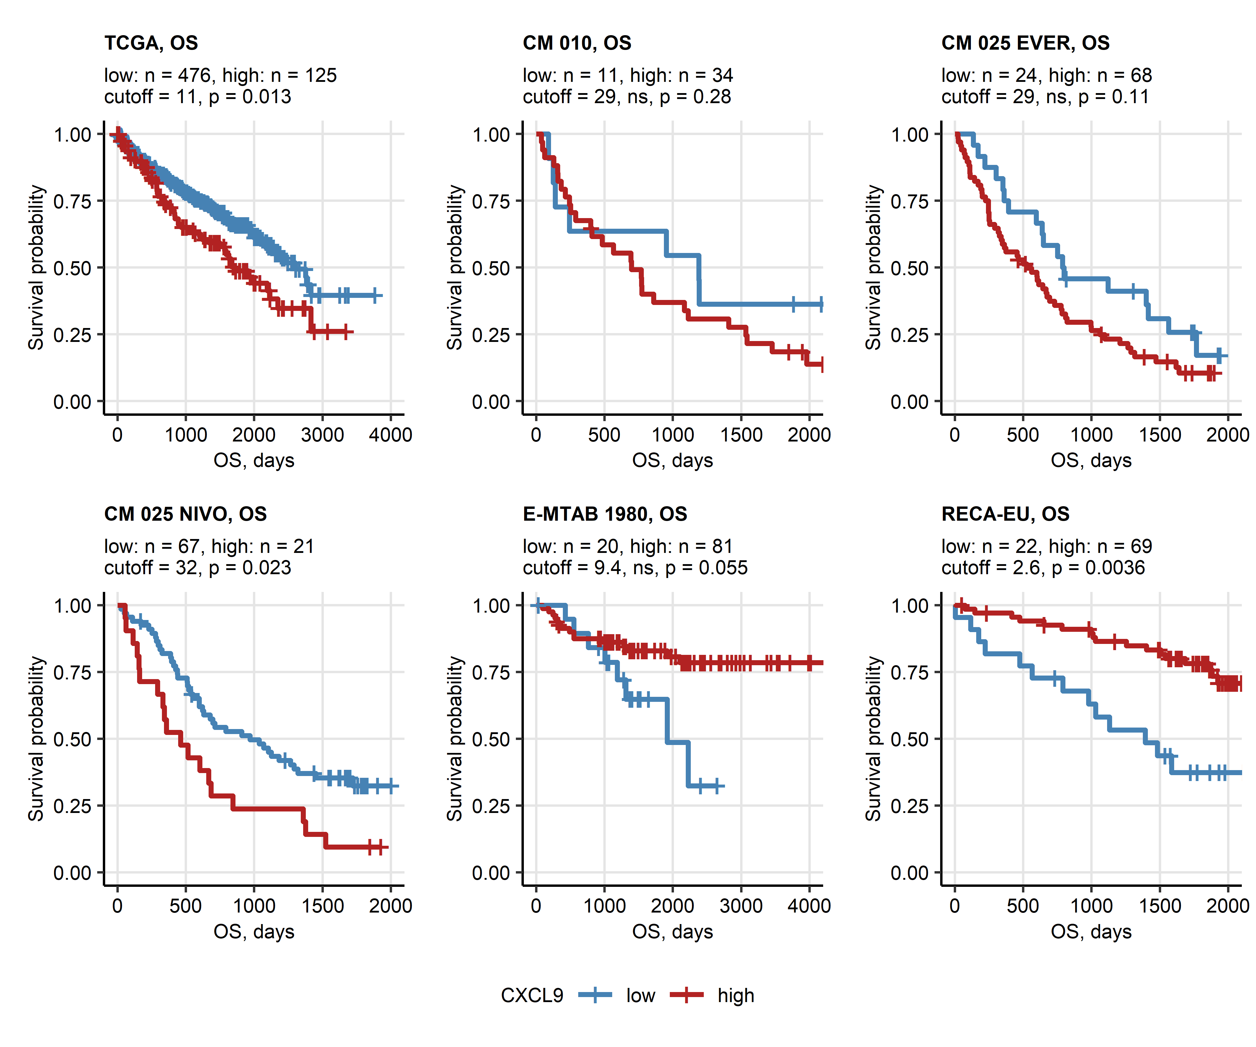

**Figure 8. Overall survival of patients bearing CXCL9high and CXCL9low RCC.** *Cancer samples were classified as CXCL9low and CXCL9high with the cutoffs corresponding to the largest differences in overall survival (OS). Differences in OS between the CXCL9 expression strata were investigated with Mentel-Henszel test corrected for multiple testing with Benjamini-Hochberg method. Fractions of surviving patients are presented in Kaplan-Meier plots. Numbers of low and high expressors, cutoff and p values are displayed in the plot captions.*

# References

1. Wickham H, Averick M, Bryan J, Chang W, McGowan L, François R, Grolemund G, Hayes A, Henry L, Hester J, et al. Welcome to the Tidyverse. *Journal of Open Source Software* (2019) 4:1686. doi: [10.21105/joss.01686](https://doi.org/10.21105/joss.01686)

2. Wickham Hadley. *ggplot2: Elegant Graphics for Data Analysis*. 1st ed. New York: Springer-Verlag (2016). [https://ggplot2.tidyverse.org](https://ggplot2.tidyverse.org/)

3. Kassambara A, Kosinski M, Biecek P. survminer: Drawing Survival Curves using ’ggplot2’. (2016) <https://cran.r-project.org/package=survminer>

4. Kassambara A. rstatix: Pipe-Friendly Framework for Basic Statistical Tests. (2021) <https://cran.r-project.org/package=rstatix>

5. Creighton CJ, Morgan M, Gunaratne PH, Wheeler DA, Gibbs RA, Robertson G, Chu A, Beroukhim R, Cibulskis K, Signoretti S, et al. Comprehensive molecular characterization of clear cell renal cell carcinoma. *Nature 2013 499:7456* (2013) 499:43–49. doi: [10.1038/nature12222](https://doi.org/10.1038/nature12222)

6. Braun DA, Hou Y, Bakouny Z, Ficial M, Sant’ Angelo M, Forman J, Ross-Macdonald P, Berger AC, Jegede OA, Elagina L, et al. Interplay of somatic alterations and immune infiltration modulates response to PD-1 blockade in advanced clear cell renal cell carcinoma. *Nature medicine* (2020) 26:909. doi: [10.1038/S41591-020-0839-Y](https://doi.org/10.1038/S41591-020-0839-Y)

7. Wei X, Choudhury Y, Lim WK, Anema J, Kahnoski RJ, Lane B, Ludlow J, Takahashi M, Kanayama HO, Belldegrun A, et al. Recognizing the Continuous Nature of Expression Heterogeneity and Clinical Outcomes in Clear Cell Renal Cell Carcinoma. *Scientific reports* (2017) 7: doi: [10.1038/S41598-017-07191-Y](https://doi.org/10.1038/S41598-017-07191-Y)

8. Laskar RS, Li P, Ecsedi S, Abedi-Ardekani B, Durand G, Robinot N, Hubert JN, Janout V, Zaridze D, Mukeria A, et al. Sexual dimorphism in cancer: insights from transcriptional signatures in kidney tissue and renal cell carcinoma. *Human molecular genetics* (2021) 30:343–355. doi: [10.1093/HMG/DDAB031](https://doi.org/10.1093/HMG/DDAB031)

9. RECA. RECA-EU, ICGC Data Portal. <https://dcc.icgc.org/projects/RECA-EU> [Accessed August 16, 2022]

10. Sato Y, Yoshizato T, Shiraishi Y, Maekawa S, Okuno Y, Kamura T, Shimamura T, Sato-Otsubo A, Nagae G, Suzuki H, et al. Integrated molecular analysis of clear-cell renal cell carcinoma. *Nature Genetics 2013 45:8* (2013) 45:860–867. doi: [10.1038/ng.2699](https://doi.org/10.1038/ng.2699)

11. Sean D, Meltzer PS. GEOquery: a bridge between the Gene Expression Omnibus (GEO) and BioConductor. *Bioinformatics (Oxford, England)* (2007) 23:1846–1847. doi: [10.1093/BIOINFORMATICS/BTM254](https://doi.org/10.1093/BIOINFORMATICS/BTM254)

12. Finotello F, Mayer C, Plattner C, Laschober G, Rieder Di, Hackl H, Krogsdam A, Loncova Z, Posch W, Wilflingseder D, et al. Molecular and pharmacological modulators of the tumor immune contexture revealed by deconvolution of RNA-seq data. *Genome Medicine* (2019) 11:34. doi: [10.1186/s13073-019-0638-6](https://doi.org/10.1186/s13073-019-0638-6)

13. Sturm G, Finotello F, List M. Immunedeconv: An R Package for Unified Access to Computational Methods for Estimating Immune Cell Fractions from Bulk RNA-Sequencing Data. *Methods in molecular biology (Clifton, NJ)* (2020) 2120:223–232. doi: [10.1007/978-1-0716-0327-7_16](https://doi.org/10.1007/978-1-0716-0327-7_16)

14. Benjamini Y, Hochberg Y. Controlling the False Discovery Rate: A Practical and Powerful Approach to Multiple Testing. *Journal of the Royal Statistical Society: Series B (Methodological)* (1995) 57:289–300. doi: [10.1111/j.2517-6161.1995.tb02031.x](https://doi.org/10.1111/j.2517-6161.1995.tb02031.x)

15. Therneau TM, Grambsch PM. *Modeling Survival Data: Extending the Cox Model*. 1st ed. New York: Springer Verlag (2000).

16. Kocher F, Tymoszuk P, Amann A, Sprung S, Salcher S, Daum S, Haybaeck J, Rinnerthaler G, Huemer F, Kauffmann-Guerrero D, et al. Deregulated glutamate to pro-collagen conversion is associated with adverse outcome in lung cancer and may be targeted by renin-angiotensin-aldosterone system (RAS) inhibition. *Lung Cancer* (2021) 159:84–95. doi: [10.1016/j.lungcan.2021.06.020](https://doi.org/10.1016/j.lungcan.2021.06.020)

17. Eigentler A, Tymoszuk P, Zwick J, Schmitz AA, Pircher A, Kocher F, Schlicker A, Lesche R, Schäfer G, Theurl I, et al. The Impact of Cand1 in Prostate Cancer. *Cancers* (2020) 12: doi: [10.3390/cancers12020428](https://doi.org/10.3390/cancers12020428)

18. Young MD, Wakefield MJ, Smyth GK, Oshlack A. Gene ontology analysis for RNA-seq: accounting for selection bias. *Genome Biology* (2010) 11:R14. doi: [10.1186/gb-2010-11-2-r14](https://doi.org/10.1186/gb-2010-11-2-r14)

19. Tarca AL, Draghici S, Khatri P, Hassan SS, Mittal P, Kim JS, Kim CJ, Kusanovic JP, Romero R. A novel signaling pathway impact analysis. *Bioinformatics* (2009) 25:75–82. doi: [10.1093/bioinformatics/btn577](https://doi.org/10.1093/bioinformatics/btn577)

20. Luo W, Brouwer C. Pathview: An R/Bioconductor package for pathway-based data integration and visualization. *Bioinformatics* (2013) 29:1830–1831. doi: [10.1093/bioinformatics/btt285](https://doi.org/10.1093/bioinformatics/btt285)

21. Hänzelmann S, Castelo R, Guinney J. GSVA: Gene set variation analysis for microarray and RNA-Seq data. *BMC Bioinformatics* (2013) 14:7. doi: [10.1186/1471-2105-14-7](https://doi.org/10.1186/1471-2105-14-7)

22. King ZA, Lu J, Dräger A, Miller P, Federowicz S, Lerman JA, Ebrahim A, Palsson BO, Lewis NE. BiGG Models: A platform for integrating, standardizing and sharing genome-scale models. *Nucleic Acids Research* (2016) 44:D515–D522. doi: [10.1093/NAR/GKV1049](https://doi.org/10.1093/NAR/GKV1049)

23. Gavai AK, Supandi F, Hettling H, Murrell P, Leunissen JAM, Van Beek JHGM. Using Bioconductor Package BiGGR for Metabolic Flux Estimation Based on Gene Expression Changes in Brain. *PLOS ONE* (2015) 10:e0119016. doi: [10.1371/JOURNAL.PONE.0119016](https://doi.org/10.1371/JOURNAL.PONE.0119016)

24. Siska PJ, Beckermann KE, Mason FM, Andrejeva G, Greenplate AR, Sendor AB, Chiang YCJ, Corona AL, Gemta LF, Vincent BG, et al. Mitochondrial dysregulation and glycolytic insufficiency functionally impair CD8 T cells infiltrating human renal cell carcinoma. *JCI Insight* (2017) 2: doi: [10.1172/JCI.INSIGHT.93411](https://doi.org/10.1172/JCI.INSIGHT.93411)