Persistent somatic symptoms are key to individual illness perception at one year after COVID-19 in a cross-sectional prospective cohort study

Figures for Reviewers

CovILD study team

2023-03-20

# Figures for Reviewers

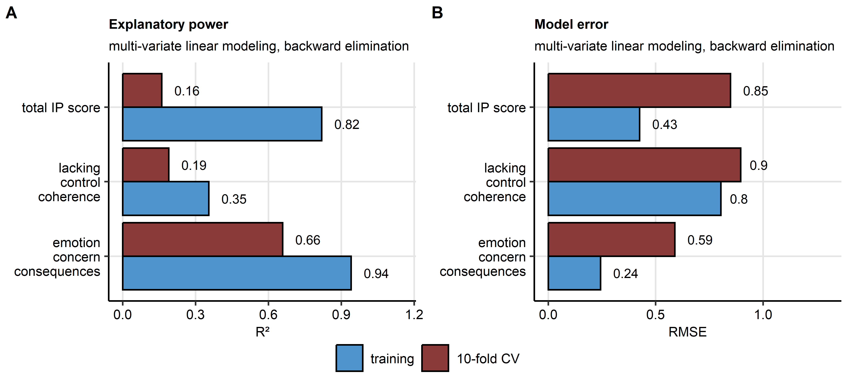

Figure 1: Performance and reproducibility of backward elimination multi-parameter models.

**Supplementary Figure S1. Performance and reproducibility of backward elimination multi-parameter models.**

*The total illness perception (IP) score, the emotion/concern/consequences and the lacking control/coherence sub-scores at the one-year follow-up were modeled by linear regression with Akaike information criterion-driven backwards elimination of model terms.*

*(A) Fraction of variance explained by the model in the training data set and 10-repeats 10-fold cross-validation (CV) was estimated by the $R^{2}$ statistic.*

*(B) Model error expressed as root mean squared error (RMSE) in the training and CV data sets.*