A short introduction to celltrax pre-processing tools

What the app does and what doesn’t
The celltrax pre-processing tools Shiny app is an interactive version of two R packages for pre-processing of microscopy cell tracing data: the celltrackR and celltrax, offering basic tools with their most common settings to non-programmers. It enables for correction for cell recognition errors, filtering of the track lengths, gap repair, elimination of cell multiplets, non-specific drift correction and selection of actively motile cells. The user may adjust some of the settings and, finally, download the raw and processed track table along with some diagnostic plots.
Due to limitations of external computation power, the app allows for processing of maximal 1000 tracks or 40000 steps in total. For larger samples or macroscopic object analysis or any highly customized analysis setup, switching to R programming environment is recommended.

Importing track data
Raw data in two formats are accepted:
- Recommended: Single, tab-delimited file with the id, t, x, y and, optionally, z columns is the preferred format. Note: data processed by the app are returned in this format.
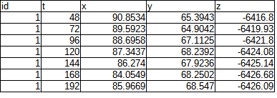
- Deprecated: Separate files for X, Y and, optionally, Z coordinates each are accepted as well. The first column must define the time variable, the remaining must be named after the track IDs.
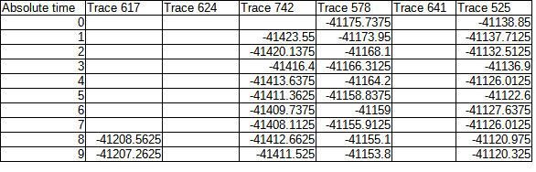

Analysis and results
The data processing is started by pressing the ‘Launch’ button. In case of any errors, you may simply re-fresh the page by pressing F5. You may adjust the setting for each pre-processing task at the corresponding tabs. The default settings are supposed to work fine for most input human cell samples scaled in µm – please check out the output units in your sample!
Especially at adjusting non-specific drift or selecting actively motile cells, be sure to include proper controls in your experiment. The drift adjustment and motile cell selection are omitted during pre-processing by default and require user’s action.
The processed or raw data may be downloaded as tab-delimited text files in the recommended format described above along with some diagnostic plots of cell tracks and displacement vectors in .pdf format.

New analysis
To start a new analysis, refresh the page (F5) or click the ‘Reset form’ button in the side panel.

