Distinct smell and taste disorder phenotype of post-acute COVID-19 sequelae

Tables and figures

Health after COVID-19 in Tyrol and CovILD study team

2023-05-30

# Tables

Table 1: Baseline characteristic of the Austria (AT) and Italy (IT) survey study cohorts. Numeric variables are presented as medians with interquartile ranges (IQR) and ranges. Categorical variables are presented as percentages and counts within the complete observation set.

| **Variablea** | **AT** | **IT** | **Significanceb** | **Effect sizeb** |
| --- | --- | --- | --- | --- |
| Sex | female: 67% (n = 320) male: 33% (n = 159) | female: 70% (n = 300) male: 30% (n = 127) | ns (p = 0.46) | V = 0.037 |
| Education | non-tertiary: 63% (n = 302) tertiary: 37% (n = 176) | non-tertiary: 59% (n = 250) tertiary: 41% (n = 177) | ns (p = 0.35) | V = 0.047 |
| Age, years | 43 [IQR: 32 - 53] range: 18 - 80 | 45 [IQR: 34 - 54] range: 18 - 95 | ns (p = 0.31) | r = 0.048 |
| BMI before COVID-19 | normal: 54% (n = 257) overweight: 28% (n = 135) obesity: 18% (n = 84) | normal: 66% (n = 278) overweight: 25% (n = 104) obesity: 8.8% (n = 37) | p = 0.0011 | V = 0.15 |
| Employment status | employed: 83% (n = 398) unemployed: 8.4% (n = 40) leave: 1.7% (n = 8) retired: 6.9% (n = 33) | employed: 81% (n = 348) unemployed: 9.4% (n = 40) leave: 1.9% (n = 8) retired: 7.3% (n = 31) | ns (p = 1) | V = 0.022 |
| Autoimmunity | 6.7% (n = 32) | 6.3% (n = 27) | ns (p = 1) | V = 0.0072 |
| Hypertension | 11% (n = 51) | 8.4% (n = 36) | ns (p = 0.46) | V = 0.038 |
| Pre-CoV depression/anxiety | 5.4% (n = 26) | 5.2% (n = 22) | ns (p = 1) | V = 0.0061 |
| Diabetes | 1.5% (n = 7) | 0.23% (n = 1) | ns (p = 0.26) | V = 0.065 |
| Freq. resp. infections | 6.7% (n = 32) | 3.3% (n = 14) | ns (p = 0.1) | V = 0.077 |
| Cardiovascular disease | 2.1% (n = 10) | 3% (n = 13) | ns (p = 0.62) | V = 0.03 |
| Hay fever/allergy | 18% (n = 88) | 12% (n = 51) | p = 0.045 | V = 0.089 |
| Malignancy | 2.1% (n = 10) | 4% (n = 17) | ns (p = 0.31) | V = 0.056 |
| Gastrointestinal disease | 1.7% (n = 8) | 0.7% (n = 3) | ns (p = 0.46) | V = 0.044 |
| Pulmonary disease | 3.8% (n = 18) | 2.8% (n = 12) | ns (p = 0.67) | V = 0.026 |
| Freq. bact. Infections | 4.8% (n = 23) | 1.2% (n = 5) | p = 0.016 | V = 0.1 |
| Pre-CoV sleep disorders | 3.5% (n = 17) | 4.7% (n = 20) | ns (p = 0.62) | V = 0.029 |
| Daily medication | absent: 62% (n = 295) 1 - 4 drugs: 37% (n = 175) 5 drugs and more: 1.9% (n = 9) | absent: 74% (n = 317) 1 - 4 drugs: 25% (n = 106) 5 drugs and more: 0.94% (n = 4) | p = 0.0024 | V = 0.14 |
| Observation time | 180 [IQR: 130 - 220] range: 90 - 400 | 140 [IQR: 120 - 270] range: 90 - 390 | p = 0.0036 | r = 0.12 |
| Comorbidity | 49% (n = 237) | 43% (n = 185) | ns (p = 0.22) | V = 0.062 |
| aBMI: body mass index, normal: BMI < 25 kg/m², overweight: BMI 25 - 30 kg/m², obesity: BMI > 30 kg/m²; Pre-CoV depression/anxiety: depression or anxiety before COVID-19; Freq. resp. infections: frequent (> 2 per year) respiratory infections; Freq. bact. Infections: frequent (> two per year) bacterial infections with antibiotic therapy; Pre-CoV sleep disorders: sleep disorders before COVID-19. | | | | |
| bCategorical variables: χ² test with Cramer V effect size statistic. Numeric variables: Mann-Whitney U test with wilcoxon r effect size statistic. P values corrected form multiple testing with Benjamini-Hochberg method. | | | | |

Table 2: Baseline characteristic of the CovILD study cohort and the study participants stratified by COVID-19 severity. Numeric variables are presented as medians with interquartile ranges (IQR) and ranges. Categorical variables are presented as percentages and counts within the complete observation set.

| **Variablea** | **Entire cohort** | **Ambulatory CoV subset** | **Moderate CoV subset** | **Severe CoV subset** | **Significanceb** | **Effect sizeb** |
| --- | --- | --- | --- | --- | --- | --- |
| Sex | female: 41% (n = 44) male: 59% (n = 64) | female: 67% (n = 18) male: 33% (n = 9) | female: 35% (n = 19) male: 65% (n = 36) | female: 27% (n = 7) male: 73% (n = 19) | p < 0.001 | V = 0.31 |
| Age, years | 56 [IQR: 49 - 68] range: 19 - 87 | 47 [IQR: 38 - 55] range: 19 - 70 | 62 [IQR: 53 - 72] range: 27 - 87 | 56 [IQR: 52 - 64] range: 44 - 79 | p < 0.001 | η² = 0.21 |
| BMI at CoV onset | normal: 39% (n = 42) overweight: 43% (n = 46) obesity: 19% (n = 20) | normal: 56% (n = 15) overweight: 33% (n = 9) obesity: 11% (n = 3) | normal: 29% (n = 16) overweight: 51% (n = 28) obesity: 20% (n = 11) | normal: 42% (n = 11) overweight: 35% (n = 9) obesity: 23% (n = 6) | p < 0.001 | V = 0.17 |
| Comorbidity present | 75% (n = 81) | 41% (n = 11) | 85% (n = 47) | 88% (n = 23) | p < 0.001 | V = 0.46 |
| Cardiovascular disease | 40% (n = 43) | 7.4% (n = 2) | 47% (n = 26) | 58% (n = 15) | p < 0.001 | V = 0.39 |
| Hypertension | 27% (n = 29) | 7.4% (n = 2) | 27% (n = 15) | 46% (n = 12) | p < 0.001 | V = 0.31 |
| Pulmonary disease | 19% (n = 20) | 11% (n = 3) | 22% (n = 12) | 19% (n = 5) | p = 0.031 | V = 0.11 |
| Metabolic disease | 42% (n = 45) | 19% (n = 5) | 49% (n = 27) | 50% (n = 13) | p < 0.001 | V = 0.27 |
| Diabetes | 15% (n = 16) | 3.7% (n = 1) | 15% (n = 8) | 27% (n = 7) | p < 0.001 | V = 0.23 |
| Gastrointestinal disease | 13% (n = 14) | 0% (n = 0) | 20% (n = 11) | 12% (n = 3) | p < 0.001 | V = 0.24 |
| Malignancy | 9.3% (n = 10) | 3.7% (n = 1) | 15% (n = 8) | 3.8% (n = 1) | p < 0.001 | V = 0.19 |
| Immune deficiency | 5.6% (n = 6) | 0% (n = 0) | 3.6% (n = 2) | 15% (n = 4) | p < 0.001 | V = 0.25 |
| aBMI at CoV onset: body mass index at COVID-19 onset, normal: BMI < 25 kg/m², overweight: BMI 25 - 30 kg/m², obesity: BMI > 30 kg/m². | | | | | | |
| bComparison of ambulatory, moderate and severe COVID-19 individuals. Categorical variables: χ² test with Cramer V effect size statistic. Numeric variables: Kruskal-Wallis test with η² effect size statistic. P values corrected form multiple testing with Benjamini-Hochberg method. | | | | | | |

# Figures

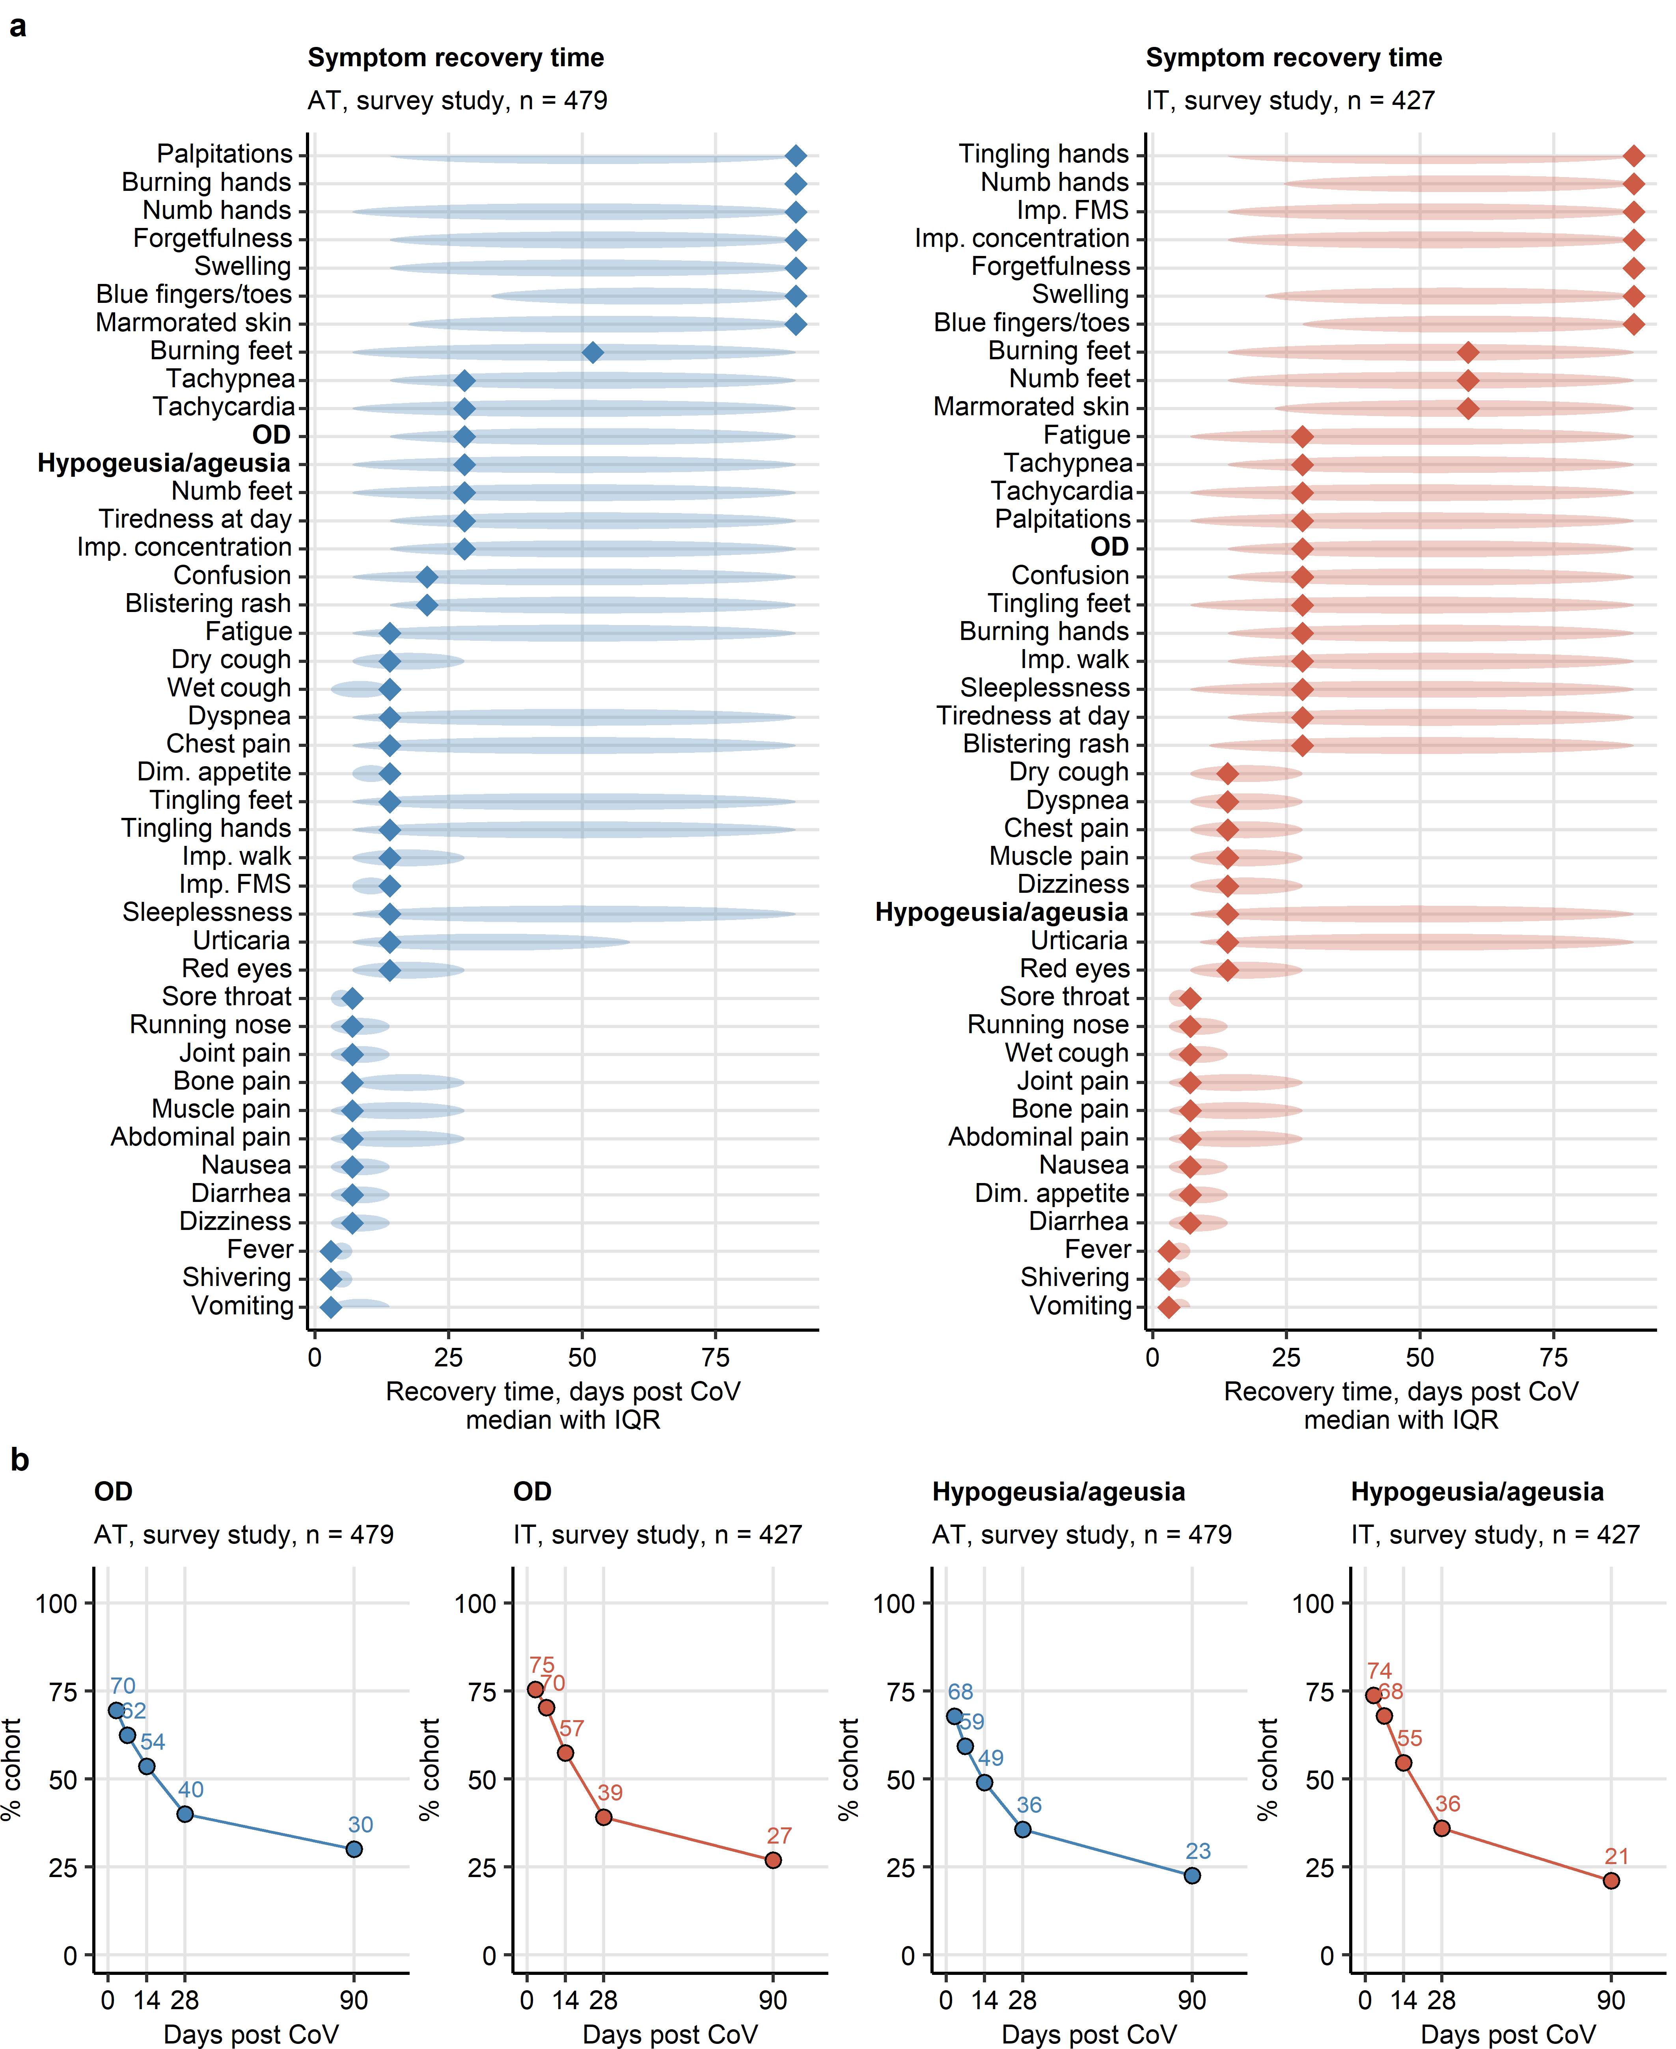

Figure 1: Symptom-specific recovery times in the ambulatory COVID-19 survey study.

**Figure 1. Symptom-specific recovery times in the ambulatory COVID-19 survey study.**

*Symptom-specific recovery times were calculated for each participant of the survey study cohorts (Austria: AT, Italy: IT).*

*(a) Distribution of the recovery times in the individuals with the indicated symptoms present during acute COVID-19 (first 14 days after clinical onset). Diamonds represent median recovery times, tinted ellipses code for interquartile ranges. Numbers of complete observations are indicated in the plot captions.*

*(b) Percentages of individuals with self-reported olfactory dysfunction and taste disorders in the AT and IT survey study cohorts at particular time points after clinical onset. Numbers of complete observations are indicated under the plots.*

*OD: self-reported olfactory dysfunction; Imp. concentration: impaired concentration; Dim. appetite: diminished appetite; Imp. walk: impaired walk; Imp. FMS: impaired fine-motor skills.*

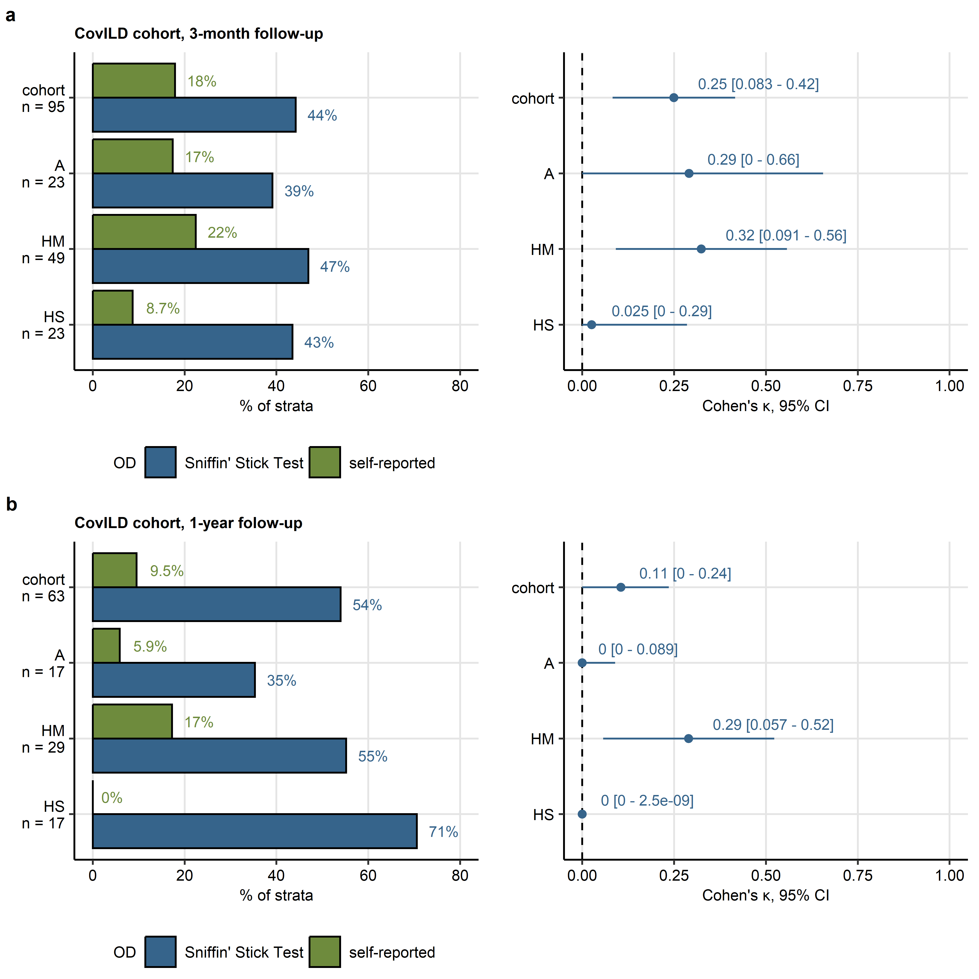

Figure 2: Rates of subjective and objective hyposmia in the CovILD cohort two months and one year after COVID-19.

**Figure 2. Rates of subjective and objective hyposmia in the CovILD cohort two months and one year after COVID-19.**

*Objective olfactory dysfunction (OD) was diagnosed in CovILD study participants with < 13 correctly identified odorants in the 16-item Sniffin’ Sticks Identification Test. Frequencies of objective and self-reported olfactory dysfunction were compared at the three-month (a) and one-year follow-up (b) after COVID-19 in the entire cohort and the ambulatory (A), hospitalized moderate COVID-19 (HM) and hospitalized severe COVID-19 (HS) subset of the cohort. Concordance between the self-reported and objective olfactory dysfunction was assessed by Cohen’s inter-rater reliability statistic. Percentages of individuals with self-reported and objective hyposmia within the cohort or COVID-19 severity strata are presented in bar plots. Cohen’s with 95% confidence intervals (CI) are displayed in Forest plots.*

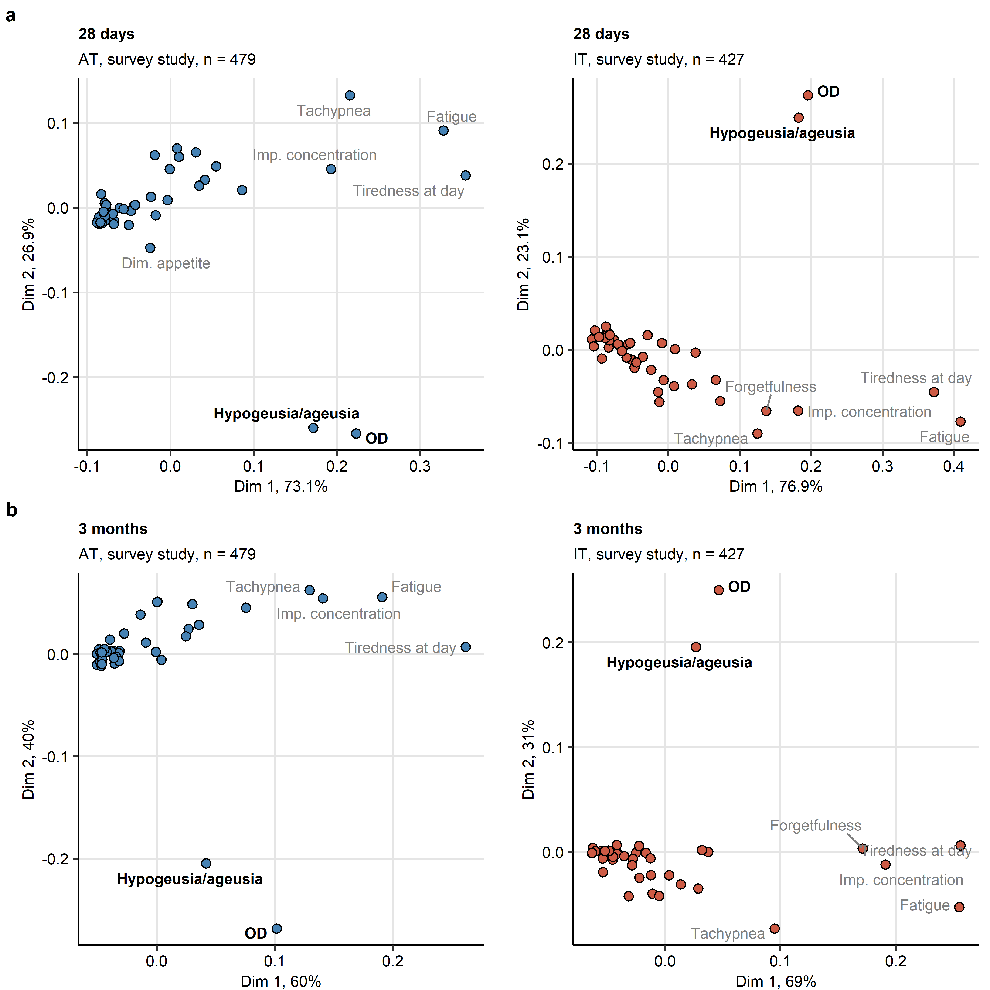

Figure 3: Self-reported olfactory dysfunction and taste disorders are isolated persistent symptoms of COVID-19.

**Figure 3. Self-reported olfactory dysfunction and taste disorders are isolated persistent symptoms of COVID-19.**

*Symptom data during at 28 days (a) and 3 months (b) after clinical onset in the Austria (AT) and Italy (IT) survey study cohorts were subjected to two-dimensional multi-dimensional scaling (MDS) with simple matching distance (SMD) between the symptoms. MDS coordinates are presented in scatter plots. Selected data points are labeled with the symptom names. Percentages of the data set variance associated with the MDS dimensions are indicated in the plot axes. Numbers of complete observations are indicated in the plot captions.*

*OD: self-reported olfactory dysfunction; Imp. concentration: impaired concentration.*

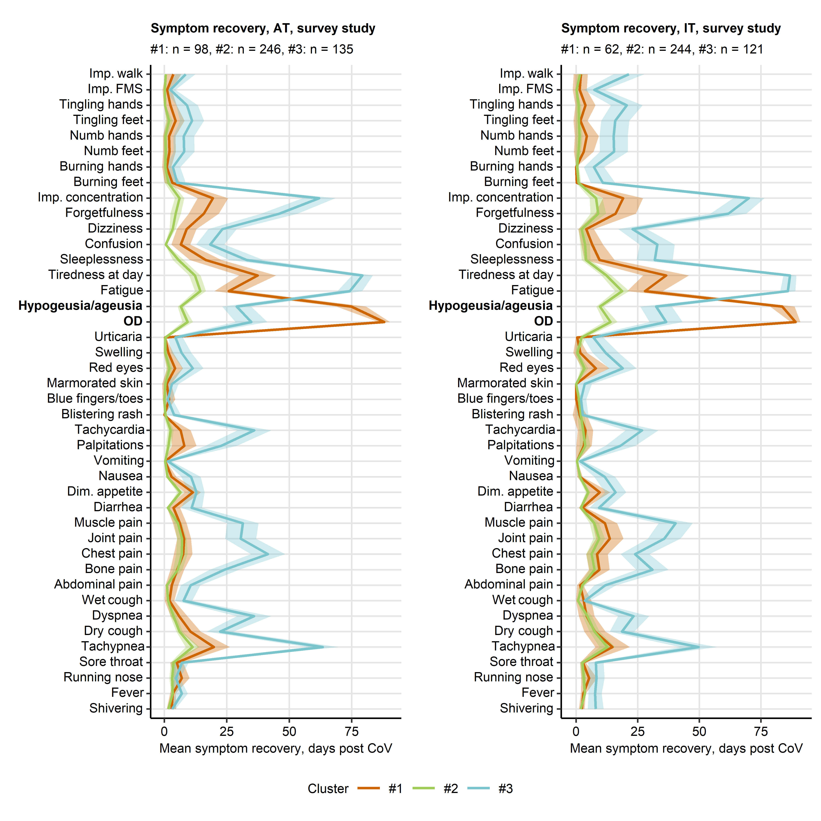

Figure 4: Differing duration of neurocognitive and respiratory symptoms, fatigue, olfactory dysfunction and taste disorders defines the COVID-19 recovery clusters.

**Figure 4. Differing duration of neurocognitive and respiratory symptoms, fatigue, olfactory dysfunction and taste disorders defines the COVID-19 recovery clusters.**

*Clustering of the survey study participants in respect to symptom-specific recovery times was done by semi-supervised PAM algorithm (partitioning around medoids, Euclidean distance, training cohort: Austria [AT], test cohort: Italy [IT]). Mean recovery times in the recovery clusters are presented as lines, 2 SEM intervals are displayed as tinted regions. Numbers of individuals assigned to the recovery clusters are indicated in the plot captions.*

*OD: self-reported olfactory dysfunction; Dim. appetite: diminished appetite; Imp. concentration: impaired concentration; Imp. walk: impaired walk; Imp. FMS: impaired fine motor skills.*

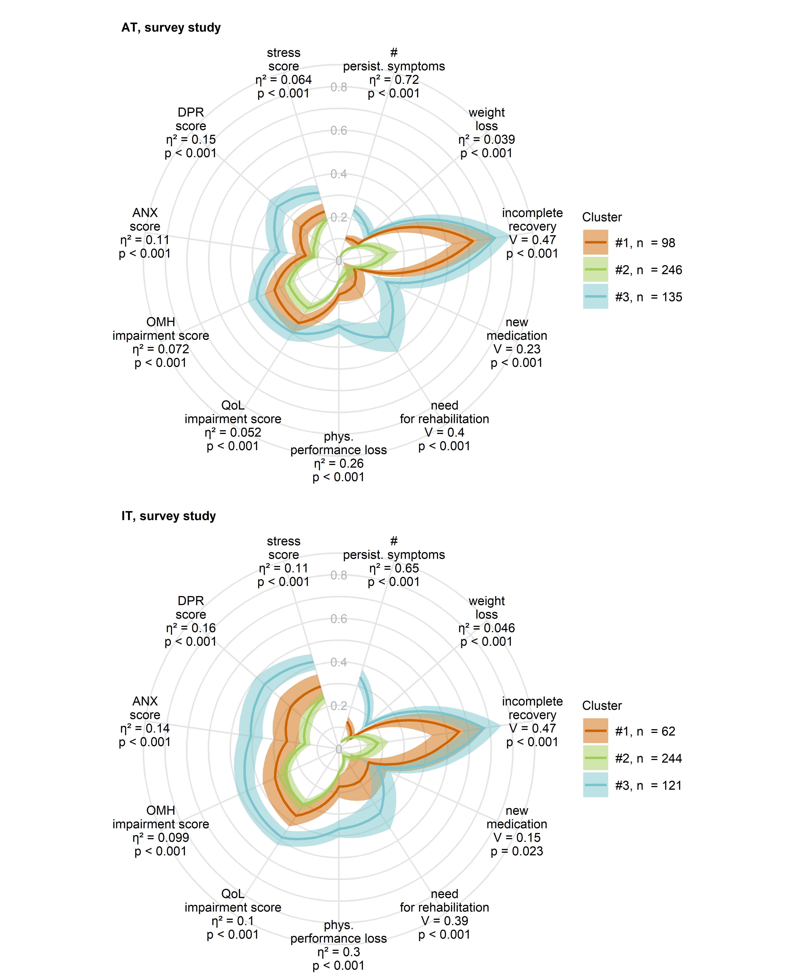

Figure 5: Physical and mental health, and quality of life in the COVID-19 recovery clusters

**Figure 5. Physical and mental health, and quality of life in the COVID-19 recovery clusters**

*Clustering of the survey study participants in respect to symptom-specific recovery times was done by the semi-supervised PAM algorithm (partitioning around medoids, Euclidean distance, training cohort: Austria [AT], test cohort: Italy [IT]). Minimum/maximum scaled readouts of clinical and physical recovery, mental health and quality of life at the time of survey completion in the clusters in the Austria (AT) and Italy (IT) survey study cohorts are presented. Dichotomous items (incomplete convalescence, weight loss, new medication and need for rehabilitation) were binarized (yes: 1, no: 0) prior to visualization. Statistical significance for differences between the clusters was assessed by Kruskal-Wallis with effect size statistic (numeric variables) or test with Cramer V effect size statistic (categorical variables). P values were corrected for multiple testing with Benjamini-Hochberg method. Lines represent mean values, 2 SEM intervals are displayed as tinted regions. Effect sizes and p values are shown in the plots. Numbers of individuals assigned to the recovery clusters are indicated in the plot legends.*

*incomplete recovery: self-reported incomplete recovery; # persist. symptoms: number of symptoms at 28 days after clinical onset; phys. performance loss: physical performance loss as compared with the time before COVID-19; QoL impairment score: score of impaired quality of life; OMH impairment score: overall mental health impairment score; ANX score: anxiety score, Patient Health Questionnaire, PHQ-4; DPR: depression score, Patient Health Questionnaire, PHQ-4; stress score: mental stress score, 7 item PHQ stress module.*