Three distinct patterns of mental response after mountain sport accidents

Supplementary Material

Psychiatry Study Team

2023-03-30

# Supplementary Methods

## Software

Data analysis and transformation was accomplished with R version 4.2.0. The study dataset was imported from an SPSS file with the *foreign* package (1). Tabular data were handled with the *tidyverse* package bundle (2) and the packages *rlang* (3) and [*trafo*](https://github.com/PiotrTymoszuk/trafo). Test variables were handled with *stringi* (4).

For distribution testing (normality, variance, Gini index), the packages [*ExDA*](https://github.com/PiotrTymoszuk/ExDA), *rstatix* (5) and *DescTools* (6) were utilized. Consistency of psychometric tools was assessed with the packages *psych* (7), [*ExDA*](https://github.com/PiotrTymoszuk/ExDA) and [*clustTools*](https://github.com/PiotrTymoszuk/clustTools). Clustering tendency was investigated with *factoextra* (8) and [*clustTools*](https://github.com/PiotrTymoszuk/clustTools). Statistical hypothesis testing and correlation analyses were accomplished with [*ExDA*](https://github.com/PiotrTymoszuk/ExDA), *rstatix* (5).

For clustering, the package [*clustTools*](https://github.com/PiotrTymoszuk/clustTools) with implementation of algorithms and distance measures from *factoextra*, *cluster* and *philentropy* (8–10) was utilized. UMAP (uniform manifold approximation and projection) was done with the *umap* package (11,12). Univariable mental cluster assignment classifiers were developed with the *OneR* (13,14). A multi-variable classifier for mental cluster assignment was developed with the conditional random forest algorithm (15,16) implemented in the *party* package (17). Accuracy of the classifiers was assessed with the packages *caret* (18) and [*caretExtra*](https://github.com/PiotrTymoszuk/caretExtra).

Results were visualized with *ggplot* (bar plots, box plots and heat maps of confusion matrices) (19), [*ExDA*](https://github.com/PiotrTymoszuk/ExDA) (violin, stack and ribbon plots) and [*clustTools*](https://github.com/PiotrTymoszuk/clustTools) (cluster quality control plots, clustering features heat maps, distance heat maps, scatter plots of UMAP layouts). Figures were created with the package *cowplot* (20). Tables were generated with *flextable* (21). The manuscript and Supplementary Material were written in *rmarkdown* (22) with the package *bookdown* (23). Figures, tables and R expressions in the markdown documents were managed with the development package [*figur*](https://github.com/PiotrTymoszuk/figur). The markdown documents were rendered with *knitr* (24), *bookdown* (23) with author-info-blocks.lua and scholarly-metadata.lua scripts by Albert Krewinkel and Jörn Krenzer.

## Data import and transformation

The study data set was imported from an SPSS file with raw study data (function read.spss(), package *foreign*). The list of extracted variables with their description is available in **Supplementary Table S1**. A total of 307 participants with the complete set of psychometric battery variables (**Supplementary Table S2**) were included in the analysis (**Figure 1**).

The psychometric battery (**Supplementary Table S2**) consisted of German versions of assessment tools for anxiety (GAD-7: 7-item general anxiety disorder scale) (25), depression (PHQ: patient health questionnaire, PHQ-9) (26,27), panic (PHQ-panic module) (26,27), persistent somatic symptoms (PHQ-15) (28), resilient coping (RS13: 13-item resilience scale) (29), loss of sense of coherence (SOC-9L: Leipzig 9-item sense of coherence questionnaire) (30), loss of quality of life (EUROHIS-QOL 8: 8-item EUROHIS project quality of life scale) (31), post-traumatic growth (PTGI: post-traumatic growth inventory) (32) and post-traumatic stress disorder (PCL-5 DSM-5: PTSD checklist for DSM-5) (33).

Symptoms of anxiety were defined as GAD-7 10, symptoms of depression were defined as PHQ-9 11 (34), significant somatization/persistent somatic symptoms were defined as PHQ-15 11 (28). Resilient coping classes were defined as follows: low: RS-13 0 - 65, moderate: 66 - 72, high: 73 (29).

Items of the EUROHIS QOL 8 tool were scores as with 1 - 5 likert scales (1: extreme concerns, no satisfaction at all, 5: no concerns/full satisfaction, ) with each item representing a single domain of quality of life (quality of life, health, energy, finances, activity, self-esteem, relationship and housing). The total EUROHIS QOL score was defined as the arithmetic mean of all items (31).

Separate scores were computed for each domain of the PTGI tool (I: relations, II: possibilities, III: personal strength, IV: spiritual strength, V: life appreciation) with each item scores as 0: none, 1: very little, 2: little, 3: moderate, 4: great, 5: extremely great. In addition, the total PTGI score was calculated as the sum of all items (32).

Separate scores were calculated for domains B, C, D and E of the PCL-5 DSM-5 tool along with the total score being the sum of all items. Each PCL-5 DSM-5 item was scored as 0: not at all, 1: a little bit, 2: moderate, 3: quite a bit and 4: extremely. Participants positive for the B domain or C domain were identified by at least one item scored with ‘moderate’, participants positive for the D or E domain were identified by at least two item scored with ‘moderate’. Significant PTSD symptoms where assumed in participants screened positive for at least one of the B, C, D or E PCL-5 DSM-5 domains (33).

Traumatic events prior to the sport accident were assessed with the DIA-X tool (Diagnostic Expert System) (35). Direct personal experience or being a witness of a traumatic event specified by the DIA-X questionnaire or by an additional yes/no item (‘other traumatic events’) was scored as 1. Prior traumatic event was assumed with at least one DIA-X item scored with 1. Prior sport accidents, flashbacks during sport activity, confusion during sport activity, subjective need for psychological support, presence of psychological/psychiatric support/therapy post accident and presence of somatic health consequences after the accident were surveyed as single yes/no items. Flashbacks frequency was assessed in the following categories: none, more than one per month and more than one per year. Smoking was surveyed as a single yes/no question. Alcohol abuse was investigated with the CAGE tool with 2 points indicative of substantial addiction (36). Data on hospital treatment and surgery were extracted from electronic patient’s records. Injury severity was assessed with the abbreviated injury scale (AIS) (37).

Additional information on study variables and their stratification schemes are presented in **Supplementary Table S1**.

## Consistency of psychometric tools and power analysis

Consistency of psychometric tools was assessed by factor analysis and McDonald’s (function omega(), package *psych*) (7,38). The number of latent factors for calculation of was identified by inspection of loadings determined by factor analysis (function reduce_data(), [*clustTools*](https://github.com/PiotrTymoszuk/clustTools)). All psychometric tools used in the study except for the stress PSS-4 scale (39) and the BRCS resilience tool (40) exhibited good-to-excellent consistency with > 0.8 (**Supplementary Table S3**). The poorly performing PSS-4 and BRCS scales were excluded from the further analysis.

To find the optimal size of a training subset of the study cohort, random subsamples of the study dataset of varying sizes were investigated (50, 100, 150, 200, 250, 300 observations, 50 random draws per subsample size). For each random subsample, clustering tendency was assessed by Hopkins statistic (function get_clust_tendency(), package [*clustTools*](https://github.com/PiotrTymoszuk/clustTools)). For n = 200 observations, the median Hopkins statistic was 0.72 (interquartile range: 0.72 - 0.73) indicative of good clustering tendency. The Hopkins statistic value for this subset was comparable with the value for the entire subset (0.74). For these reasons, 2/3 of the entire dataset or n = 204 was considered as the size of the training subset of the study cohort.

## Training/test subset definition

The study participants were assigned to the training and test subsets with the 2:1 size ratio (**Figure 1**). To this end, 1000 random splits of the datasets were generated. The subset assignment scheme was chosen with possibly small differences in accident year, age, gender, pre-existing somatic and pre-existing mental illness rates, frequencies of prior traumatic events (DIA-X) (35) and distribution of injury severity grades (AIS: abbreviated injury scale) (37) as investigated by and Mann-Whitney test, as appropriate (functions chisq_test() and wilcox_test(), package *rstatix*).

## Assessment of selection bias

To assess possible selection bias, demographic, socioeconomic, clinical and accident-related parameters were compared between individuals excluded due to missingness of psychometric data or denying survey participation and participants included in he analysis (**Figure 1**). Categorical variables were compared by test with Cramer V effect size statistic and numeric variables were compared by Mann-Whitney test with r effect size statistic (function compare_variables(), package [*ExDA*](https://github.com/PiotrTymoszuk/ExDA)). Potential differences between the training and test subset of the study cohort (**Figure 1**) were analyzed in an analogical way. Significant (p < 0.05) differences between the included/excluded participants are presented in **Supplementary Tables S4**.

## Semi-supervised clustering

Observations of the training subset of the study cohort were subjected to clustering in respect to the numeric psychometric scores (**Supplementary Table S2**). The score values were normalized and median-centered (function center_data(), package [*clustTools*](https://github.com/PiotrTymoszuk/clustTools)). For clustering, the PAM (partition around medoids) algorithm (9) with the cosine distance measure between observations (10) was employed. The clustering object was constructed with the function kcluster() from the [*clustTools*](https://github.com/PiotrTymoszuk/clustTools) package. The choice of the clustering algorithm was motivated by its good explanatory performance measured by the fraction of explained clustering variance (ratio of between-cluster sum of squares to total sum of squares, method var(), [*clustTools*](https://github.com/PiotrTymoszuk/clustTools)) and superior stability in 10-fold cross-validation (41) (cluster assignment in the folds by an inverse distance weighted 7-nearest neighbors classifier, method cv(), [*clustTools*](https://github.com/PiotrTymoszuk/clustTools)) in a comparison with several other clustering algorithms presented in **Supplementary Figure S2A**. The number of cluster was chosen based on the bend of the curve of within-cluster sum of squares and the peak of mean silhouette statistic (method plot(), package [*ExDA*](https://github.com/PiotrTymoszuk/ExDA)). By this means, three mental clusters were defined: the neutral, PTG (post-traumatic growth) and PTB (post-traumatic burden) clusters (**Supplementary Figure S2B**). Assignment of the training subset observations to the mental clusters was accomplished with an inverse distance weighted 7-nearest neighbor classifier. This semi-supervised procedure yielded clustering structures with similar fractions of explained variance in the training (V = 0.54) and test subset (V = 0.54). In addition, comparable separation between the clusters could be discerned in the training and test subsets by a visual analysis of UMAP layouts, pairwise distance heat maps (**Supplementary Figure S3**) and heat maps of normalized levels of the clustering variables (**Supplementary Figure S4**).

Differences in clustering variables, frequencies of mental disorder symptoms as well as demographic, socioeconomic, clinical and accident-related factors between the mental clusters were assessed separately in the training and test subset by test with Cramer V effect size statistic and Kruskal-Wallis test with effect size statistic for categorical and numeric variables, respectively (**Supplementary Tables S5** and **S6**).

## Uni- and multi-variable cluster assignment classifiers

Univariable classifiers of the mental cluster assignment for demographic, socioeconomic, clinical and accident-related parameters (**Supplementary Table S7**) were trained in the training subset of the study cohort by the one-rule (oneR) algorithm (function OneR(), package _OneR__) (13,14). The cluster assignment was subsequently predicted for the test subset observations (method predict(), package *OneR*).

Two multi-parameter classifiers of the mental cluster assignment were developed in the training subset:

1. a model employing candidate early predictors of cluster assignment, i.e. demographic, socioeconomic, medical history and accident related explanatory factors
2. a model including additionally late consequences of the accident such as somatic health aftermath, flashbacks or cautious behavior during sport

The multi-parameter classifiers (**Supplementary Table S7**) were trained in the training subset with the conditional random forest algorithm (15–17) with n = 1000 random trees and the splitting rule corresponding to the maximum test statistic. In the model 1, the mtry parameter was set to 7, minsplit to 10 and mincriterion to 1.28 (function cforest() with the cforest_control(teststat = 'max', testtype = 'Teststatistic', mtry = 7, mincriterion = qnorm(0.9), minsplit = 10, ntree = 1000) control object, package *party*). In the model 2, the mtry parameter was set to 6, minsplit to 20 and mincriterion to 0 (function cforest() with the cforest_control(teststat = 'max', testtype = 'Teststatistic', mtry = 6, mincriterion = 0, minsplit = 20, ntree = 1000) control object, package *party*). The optimal parameter sets were obtained by optimization (tuning) employing the out-of-bag predictions in the training subsets (not shown). The cluster assignment was subsequently predicted for the test subset observations (method predict(), package *party*).

Accuracy and statistic for the classifiers’ mental cluster assignment predictions in the training and test subsets were computed with the function multiClassSummary() from the package *caret* (18). Conditional importance for explanatory variables expressed as accuracy loss (42) was obtained for the conditional random forest algorithm with the function ’varimp()` from the *party* package.

## Data and code availability

An R data (RData) file with anonymized patient data will be made available upon request to the corresponding author. The study analysis pipeline is available at <https://github.com/PiotrTymoszuk/mental_accident>.

# Supplementary Tables

Supplementary Table S1: Variables used in the analysis pipeline. The table is available in a supplementary Excel file.

Supplementary Table S2: Mental health assessment battery.

| **Variable** | **Description** |
| --- | --- |
| PCL-5 DSM-5 score | PTSD total score, PCL-5 DSM-5, sum of all items |
| PTSD+ (at least one domain) | At least one PCL-5 DSM-5 domain positive |
| PCL-5 DSM-5 domain B score | PTSD rating, PCL-5 DSM-5 domain B |
| PTSD domain B symptoms | PTSD symptoms, PCL-5 DSM-5 domain B positive |
| PCL-5 DSM-5 domain C score | PTSD rating, PCL-5 DSM-5 domain C |
| PTSD domain C symptoms | PTSD symptoms, PCL-5 DSM-5 domain C positive |
| PCL-5 DSM-5 domain D score | PTSD rating, PCL-5 DSM-5 domain D |
| PTSD domain D symptoms | PTSD symptoms, PCL-5 DSM-5 domain D positive |
| PCL-5 DSM-5 domain E score | PTSD rating, PCL-5 DSM-5 domain E |
| PTSD domain E symptoms | PTSD symptoms, PCL-5 DSM-5 domain E positive |
| PTGI score | Post-traumatic growth, PTGI total score, sum of all items |
| PTGI I relations score | Post-traumatic growth, PTGI scoring, domain I, relations |
| PTGI II possibilities score | Post-traumatic growth, PTGI scoring, domain II, new possibilities |
| PTGI III personal strength score | Post-traumatic growth, PTGI scoring, domain III, personal strength |
| PTGI IV spiritual score | Post-traumatic growth, PTGI scoring, domain IV, spiritual |
| PTGI V life appreciation score | Post-traumatic growth, PTGI scoring, domain V, appreciation of life |
| RS13 score | Resilient coping, RS13 score |
| RS13 coping class | Resilient coping, RS13 coping class |
| SOC-9L score | Loss of sense of coherence, SOC-9L score |
| PHQ-9 score | PHQ-9 score, depression |
| Depression symptoms (PHQ-9 ≥11) | PHQ-9 score, depression signs |
| GAD-7 score | GAD-7 score, anxiety |
| Anxiety symptoms (GAD-7 ≥10) | GAD-7 score, anxiety signs |
| PHQ-panic score | PHQ panic 4 item score |
| Panic symptoms (PHQ-panic) | PHQ panic positivity |
| PHQ-15 score | PHQ-15 health problems, somatization |
| Somatization symptoms (PHQ-15 ≥11) | PHQ-15 health problems, moderate-severe symptoms |
| EUROHIS-QOL 8 score | Quality of life, EUROHIS-QOL 8 score |
| EUROHIS-QOL 8 QoL score | Quality of life, EUROHIS-QOL 8 score QoL |
| EUROHIS-QOL 8 health score | Quality of life, EUROHIS-QOL 8 score health |
| EUROHIS-QOL 8 energy score | Quality of life, EUROHIS-QOL 8 score energy |
| EUROHIS-QOL 8 finances score | Quality of life, EUROHIS-QOL 8 score financial aspects |
| EUROHIS-QOL 8 activity score | Quality of life, EUROHIS-QOL 8 score activity |
| EUROHIS-QOL 8 self-esteem score | Quality of life, EUROHIS-QOL 8 score self-esteem |
| EUROHIS-QOL 8 relationship score | Quality of life, EUROHIS-QOL 8 score relationship |
| EUROHIS-QOL 8 housing score | Quality of life, EUROHIS-QOL 8 score housing |

Supplementary Table S3: Consistency of the psychometric tools used in the study measured by McDonald's omega.

| **Scalea** | **Number of latent factors** | **Total omega** |
| --- | --- | --- |
| RS13 | 2 | 0.94 |
| PTGI | 2 | 0.93 |
| GAD-7 | 3 | 0.89 |
| PHQ-panic | 1 | 0.88 |
| EUROHIS-QOL 8 | 4 | 0.88 |
| PHQ-9 | 4 | 0.87 |
| PHQ-15 | 4 | 0.84 |
| PCL-5 DSM-5 | 1 | 0.81 |
| aGAD-7: 7-item general anxiety disorder scale; PHQ: patient health questionnaire; EUROHIS-QOL 8: 8-item EUROHIS project quality of life scale; SOC-9L: Leipzig 9-item sense of coherence questionnaire; RS13: 13-item resilience scale; BRCS: brief resilent coping scale; PCL-5 DSM-5: PTSD checklist for DSM-5; PTGI: post-traumatic growth inventory | | |

Supplementary Table S4: Significant (p < 0.05) differences between individuals excluded from analysis and analyzed study participants. Numeric variables are presented as medians with interquartile ranges (IQR). Categorical variables are presented as percentages and counts within the complete observation set.

| **Variablea** | **Included** | **Excluded** | **Significanceb** | **Effect sizeb** |
| --- | --- | --- | --- | --- |
| income/year | no income: 21% (n = 63) < 30000 EUR: 18% (n = 56) 30000 - 45000 EUR: 19% (n = 59) ≥ 45000 EUR: 42% (n = 129) n = 307 | no income: 44% (n = 35) < 30000 EUR: 14% (n = 11) 30000 - 45000 EUR: 16% (n = 13) ≥ 45000 EUR: 26% (n = 21) n = 80 | p < 0.001 | V = 0.22 |
| income ≥ 45K EUR/year | 42% (n = 129) n = 307 | 26% (n = 21) n = 80 | p = 0.014 | V = 0.13 |
| sport type | ski/snowboard: 64% (n = 197) sledding: 3.9% (n = 12) climbing/hiking/mountaineering: 14% (n = 42) biking: 16% (n = 48) other: 2.6% (n = 8) n = 307 | ski/snowboard: 52% (n = 2224) sledding: 5% (n = 212) climbing/hiking/mountaineering: 11% (n = 467) biking: 27% (n = 1144) other: 4.8% (n = 205) n = 4252 | p < 0.001 | V = 0.077 |
| injury severity class, AIS | 1: 37% (n = 108) 2: 35% (n = 103) 3+: 28% (n = 83) 0: 0% (n = 0) n = 294 | 1: 46% (n = 156) 2: 36% (n = 121) 3+: 17% (n = 56) 0: 1.2% (n = 4) n = 337 | p < 0.001 | V = 0.16 |
| injury severity, AIS | 2 [IQR: 1 - 3], range: 1 - 5 n = 294 | 2 [IQR: 1 - 2], range: 0 - 4 n = 337 | p < 0.001 | r = 0.15 |
| hospitalized | 26% (n = 80) n = 307 | 9.5% (n = 404) n = 4252 | p < 0.001 | V = 0.13 |
| surgery | 14% (n = 43) n = 307 | 4.2% (n = 179) n = 4252 | p < 0.001 | V = 0.11 |
| surgery diagnoses | 0 [IQR: 0 - 0], range: 0 - 9 n = 307 | 0 [IQR: 0 - 0], range: 0 - 9 n = 4252 | p < 0.001 | r = 0.11 |
| somatic accident aftermath | 37% (n = 115) n = 307 | 22% (n = 12) n = 55 | p = 0.037 | V = 0.12 |
| PTGI score | 32 [IQR: 16 - 48], range: 0 - 100 n = 307 | 8.5 [IQR: 3 - 41], range: 0 - 78 n = 18 | p = 0.026 | r = 0.12 |
| PTGI I relations score | 12 [IQR: 6 - 18], range: 0 - 35 n = 307 | 2.5 [IQR: 0 - 13], range: 0 - 28 n = 18 | p = 0.0071 | r = 0.15 |
| PTGI III personal strength score | 8 [IQR: 4 - 11], range: 0 - 20 n = 307 | 4.5 [IQR: 0 - 8.8], range: 0 - 16 n = 18 | p = 0.028 | r = 0.12 |
| PTGI V life appreciation score | 6 [IQR: 2 - 9], range: 0 - 15 n = 307 | 1.5 [IQR: 0.25 - 6.8], range: 0 - 12 n = 18 | p = 0.049 | r = 0.11 |
| SOC-9L score | 19 [IQR: 16 - 25], range: 10 - 49 n = 307 | 27 [IQR: 20 - 35], range: 17 - 50 n = 11 | p = 0.0062 | r = 0.15 |
| aAIS: abbreviated injury scale; PTGI: post-traumatic growth inventory; SOC-9L: Leipzig 9-item sense of coherence scale; K: 1000 Euro; EUR: Euro. | | | | |
| bNumeric variables: Mann-Whitney test with r effect size statistic; categorical variables: χ² test with Cramer V effect size statistic, | | | | |

Supplementary Table S5: Differences in psychometric clustering factors between the mental clusters. Numeric variables are presented as medians with interquartile ranges (IQR). The table is available in a supplementary Excel file.

Supplementary Table S6: Significant (p < 0.05) differences in demographic, socioeconomic, clinical and accident-related factors between the mental clusters. Numeric variables are presented as medians with interquartile ranges (IQR). Categorical variables are presented as percentages and counts within the complete observation set.

| **Cohort subset** | **Variablea** | **Neutral cluster** | **PTG cluster** | **PTB cluster** | **Significanceb** | **Effect sizeb** |
| --- | --- | --- | --- | --- | --- | --- |
| training | Participants, n | 63 | 77 | 64 |  |  |
| sex | female: 30% (n = 19) male: 70% (n = 44) | female: 55% (n = 42) male: 45% (n = 35) | female: 48% (n = 31) male: 52% (n = 33) | p = 0.013 | V = 0.21 |
| trauma-risk profession | 3.2% (n = 2) | 12% (n = 9) | 1.6% (n = 1) | p = 0.021 | V = 0.19 |
| income/year | no income: 16% (n = 10) < 30000 EUR: 13% (n = 8) 30000 - 45000 EUR: 16% (n = 10) ≥ 45000 EUR: 56% (n = 35) | no income: 30% (n = 23) < 30000 EUR: 22% (n = 17) 30000 - 45000 EUR: 12% (n = 9) ≥ 45000 EUR: 36% (n = 28) | no income: 17% (n = 11) < 30000 EUR: 19% (n = 12) 30000 - 45000 EUR: 25% (n = 16) ≥ 45000 EUR: 39% (n = 25) | p = 0.048 | V = 0.18 |
| pre-existing somatic illness | 6.3% (n = 4) | 19% (n = 15) | 20% (n = 13) | p = 0.049 | V = 0.17 |
| pre-existing mental illness | 0% (n = 0) | 1.3% (n = 1) | 14% (n = 9) | p < 0.001 | V = 0.29 |
| alcohol abuse (CAGE ≥2) | 3.2% (n = 2) | 5.2% (n = 4) | 14% (n = 9) | p = 0.041 | V = 0.18 |
| rescue | self: 65% (n = 41) partner/third party: 22% (n = 14) rescue team: 13% (n = 8) | self: 47% (n = 36) partner/third party: 21% (n = 16) rescue team: 32% (n = 25) | self: 41% (n = 26) partner/third party: 20% (n = 13) rescue team: 39% (n = 25) | p = 0.013 | V = 0.18 |
| psychological support | 1.6% (n = 1) | 16% (n = 12) | 9.4% (n = 6) | p = 0.018 | V = 0.2 |
| psychological support need | 0% (n = 0) | 9.1% (n = 7) | 16% (n = 10) | p = 0.006 | V = 0.22 |
| somatic accident aftermath | 27% (n = 17) | 27% (n = 21) | 53% (n = 34) | p = 0.0015 | V = 0.25 |
| caution post accident | no change: 56% (n = 35) more cautious: 44% (n = 28) less cautious: 0% (n = 0) | no change: 31% (n = 24) more cautious: 68% (n = 52) less cautious: 1.3% (n = 1) | no change: 17% (n = 11) more cautious: 83% (n = 53) less cautious: 0% (n = 0) | p < 0.001 | V = 0.24 |
| flashbacks during sport | 25% (n = 16) | 30% (n = 23) | 59% (n = 38) | p < 0.001 | V = 0.3 |
| flashback frequency | none: 75% (n = 47) > 1/month: 7.9% (n = 5) > 1/year: 17% (n = 11) | none: 70% (n = 54) > 1/month: 13% (n = 10) > 1/year: 17% (n = 13) | none: 41% (n = 26) > 1/month: 34% (n = 22) > 1/year: 25% (n = 16) | p < 0.001 | V = 0.24 |
| test | Participants, n | 36 | 33 | 34 |  |  |
| pre-existing mental illness | 0% (n = 0) | 3% (n = 1) | 15% (n = 5) | p = 0.023 | V = 0.27 |
| injury severity, AIS | 2 [IQR: 1 - 3] range: 1 - 4 | 2 [IQR: 2 - 3] range: 1 - 4 | 2 [IQR: 1 - 2] range: 1 - 3 | p = 0.046 | η² = 0.042 |
| psychological support need | 0% (n = 0) | 0% (n = 0) | 18% (n = 6) | p = 0.0016 | V = 0.35 |
| somatic accident aftermath | 22% (n = 8) | 45% (n = 15) | 59% (n = 20) | p = 0.0071 | V = 0.31 |
| flashbacks during sport | 22% (n = 8) | 45% (n = 15) | 65% (n = 22) | p = 0.0016 | V = 0.35 |
| flashback frequency | none: 78% (n = 28) > 1/month: 5.6% (n = 2) > 1/year: 17% (n = 6) | none: 55% (n = 18) > 1/month: 18% (n = 6) > 1/year: 27% (n = 9) | none: 35% (n = 12) > 1/month: 26% (n = 9) > 1/year: 38% (n = 13) | p = 0.0097 | V = 0.25 |
| aCAGE: Cut, Annoyed, Guilty, and Eye scale; AIS: abbreviated injury score. | | | | | | |
| bNumeric variables: Kruskal-Wallis test with η² effect size statistic. Categorical variables: χ² test with Cramer V effect size statistic. | | | | | | |

Supplementary Table S7: Sets of explanatory factors (early: available during acute medical management of the accident) used for modeling of the mental cluster assignment.

| **Classifier type** | **Explanatory variables** |
| --- | --- |
| early predictor model | age, age class, accident season, accident daytime, sex, education, employment, sport profession, trauma-risk profession, healthcare profession, income/year, income ≥ 45K EUR/year, residence in the Alps, smoking, pre-existing somatic illness, pre-existing mental illness, prior traumatic event/DIA-X, alcohol abuse (CAGE ≥2), prior sport accidents, sport type, alone during the accident, accident culprit, rescue, rescue mode, injury severity class, injury severity, head injury, face injury, neck injury, chest injury, abdomen injury, spine region injury, upper limb injury, lower limb injury, other injury, number of injured body parts, hospitalized, surgery, surgery diagnoses |
| full set predictor model | age, age class, accident season, accident daytime, sex, education, employment, sport profession, trauma-risk profession, healthcare profession, income/year, income ≥ 45K EUR/year, residence in the Alps, smoking, pre-existing somatic illness, pre-existing mental illness, prior traumatic event/DIA-X, alcohol abuse (CAGE ≥2), prior sport accidents, sport type, alone during the accident, accident culprit, rescue, rescue mode, injury severity class, injury severity, head injury, face injury, neck injury, chest injury, abdomen injury, spine region injury, upper limb injury, lower limb injury, other injury, number of injured body parts, hospitalized, surgery, surgery diagnoses, psychological support, psychological support need, somatic accident aftermath, returned to same sport, caution post accident, flashbacks during sport, flashback frequency, confusion during sport |

# Supplementary Figures

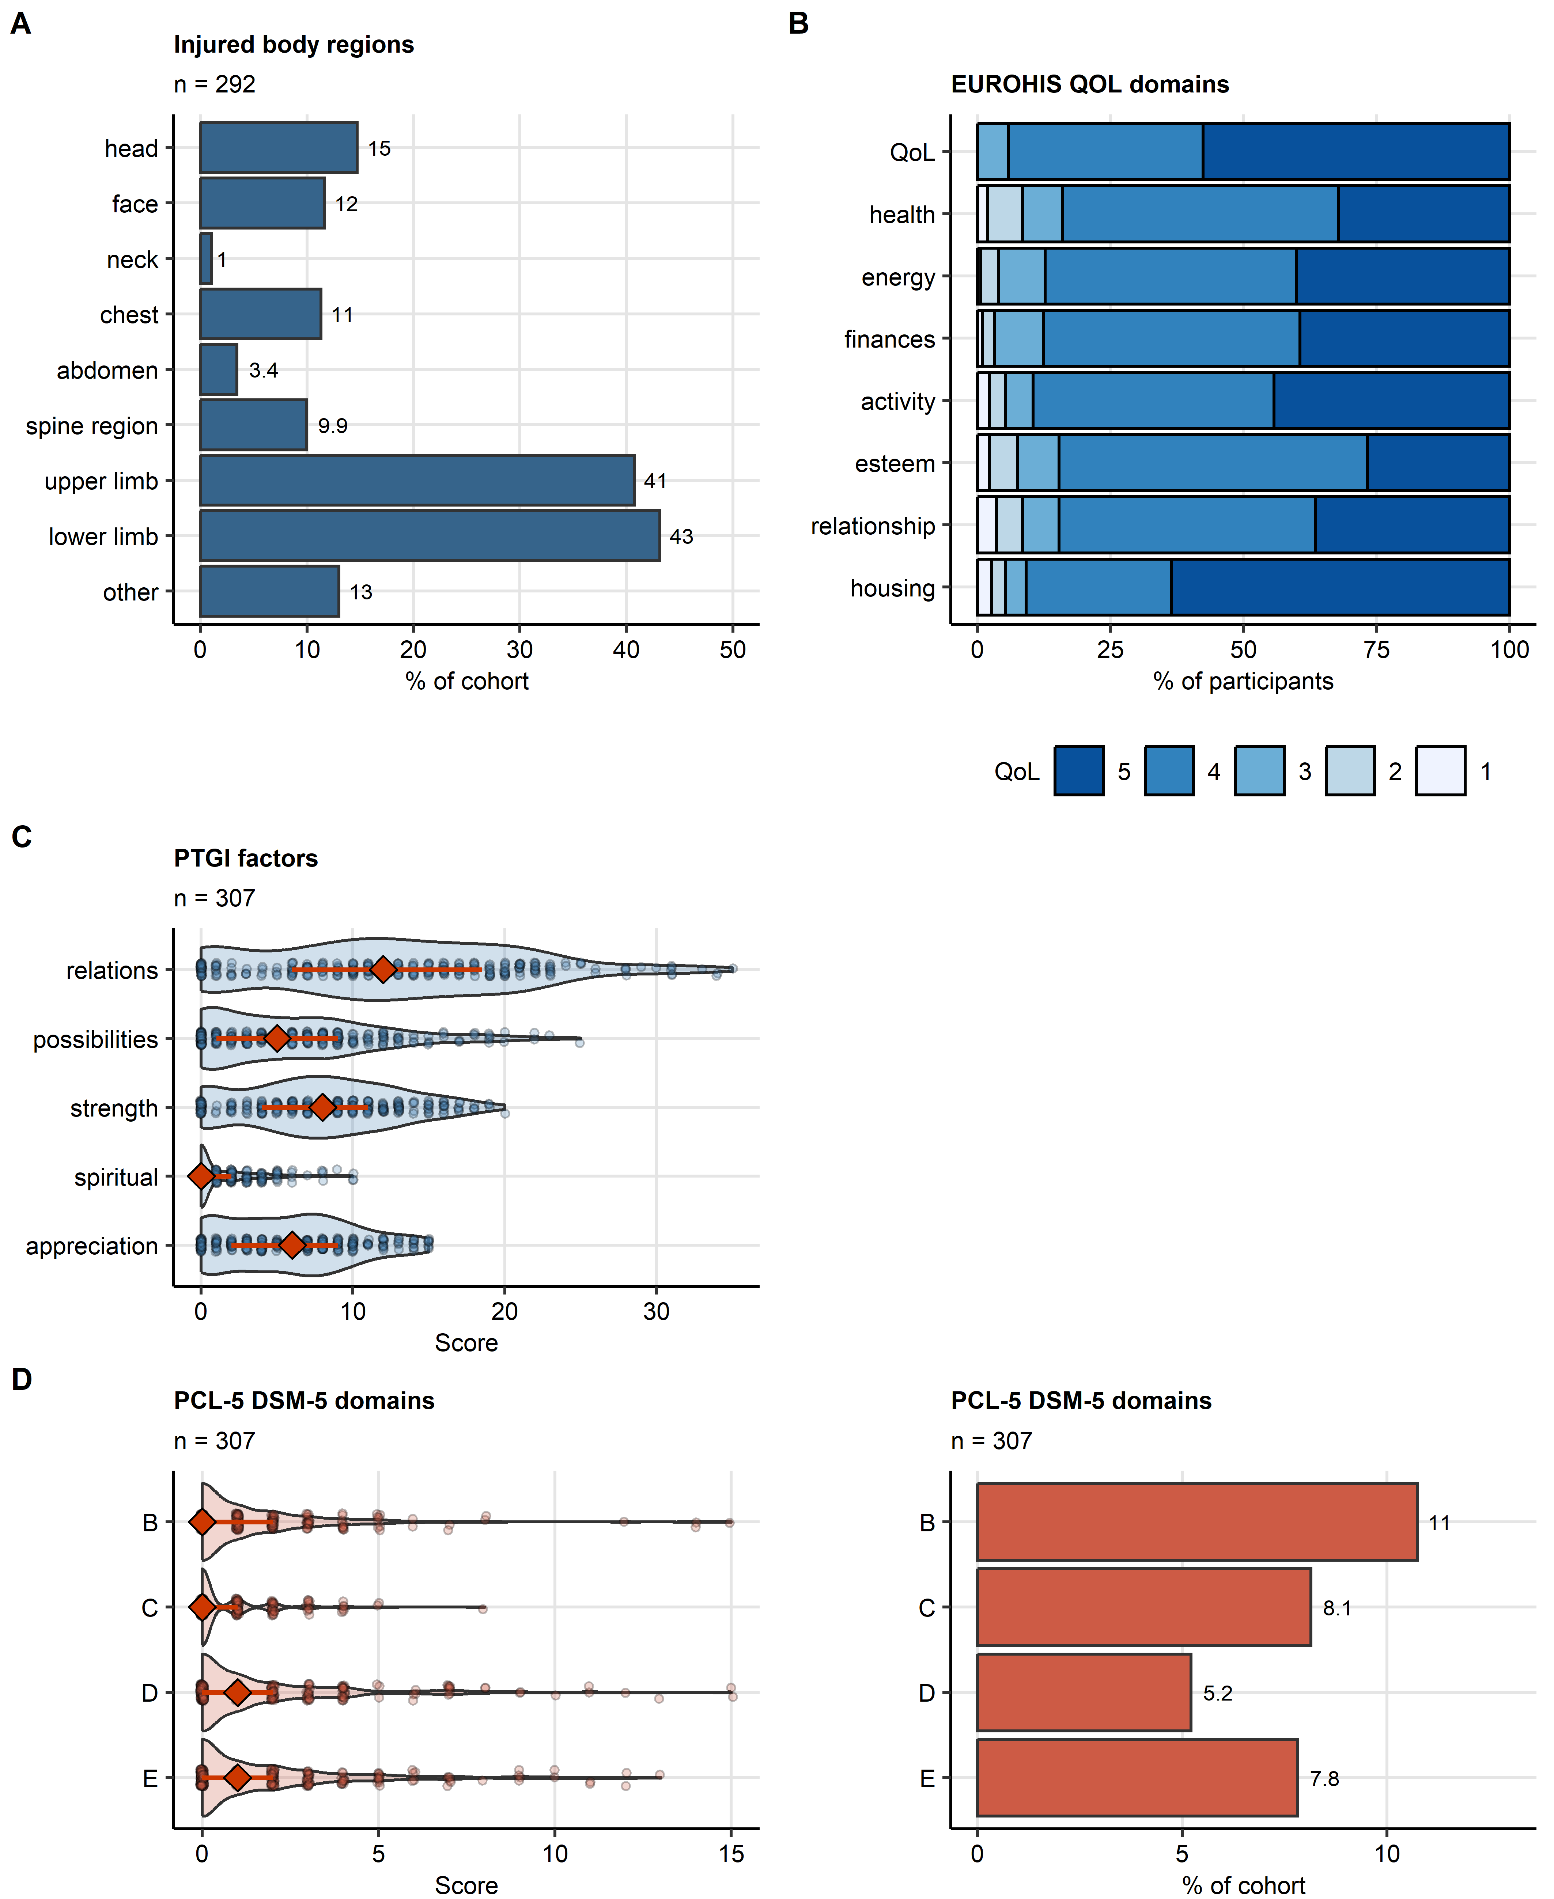

**Supplementary Figure S1. Injured body regions and detailed scoring of quality of life, post-traumatic stress disorder and post-traumatic growth in the study cohort.**

*For categorical variables, percentages of complete observations are presented as bars. Numeric variables are presented in violin plots with red diamonds denoting medians, interquartile ranges presented as red whiskers and single observations depicted as points. Quality of life scores are expressed as categorical variables and presented as percentages of participants in stack plots. The number of complete cases is displayed in the plot captions.* *(A) Distribution of injured body regions. (B) Scoring of the domains of the EUROHIS project 8-item quality of life scale (EUROHIS-QOL 8). (C) Scoring of the post-traumatic stress disorder (PTSD) domains with the PCL-5 DSM-5 tool and percentages of participants screened positive for the PTSD domains. (E) Scoring of the factors of the post-traumatic growth with the post-traumatic growth inventory (PTGI) tool.*

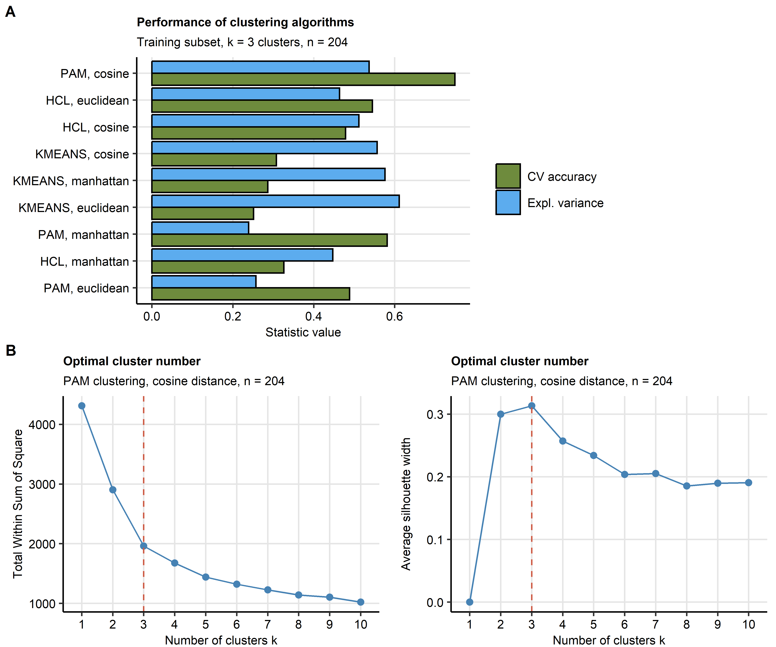

**Supplementary Figure S2. Definition of the mental clusters in the training subset of the study cohort.**

*The mental clusters were defined in respect to psychometric scoring in the training subset of the study cohort by PAM (partition around medoids) with cosine distance between the observations.*

*(A) Comparison of explanatory performance and stability of various clustering algorithms in the training subset. The explanatory performance was measured as a fraction of explained clustering variance (ratio of between-cluster sum of squares to total sum of squares). The stability was assessed by a rate of correct cluster assignment in 10-fold cross-validation (CV) with cluster assignment in the folds by an inverse distance weighted 7-nearest neighbors classifier. Note the superior stability of the PAM/cosine distance algorithm.*

*(B) Determination of the cluster number by the bend of the within-cluster sum of squares curve and the peak mean silhouette statistic.*

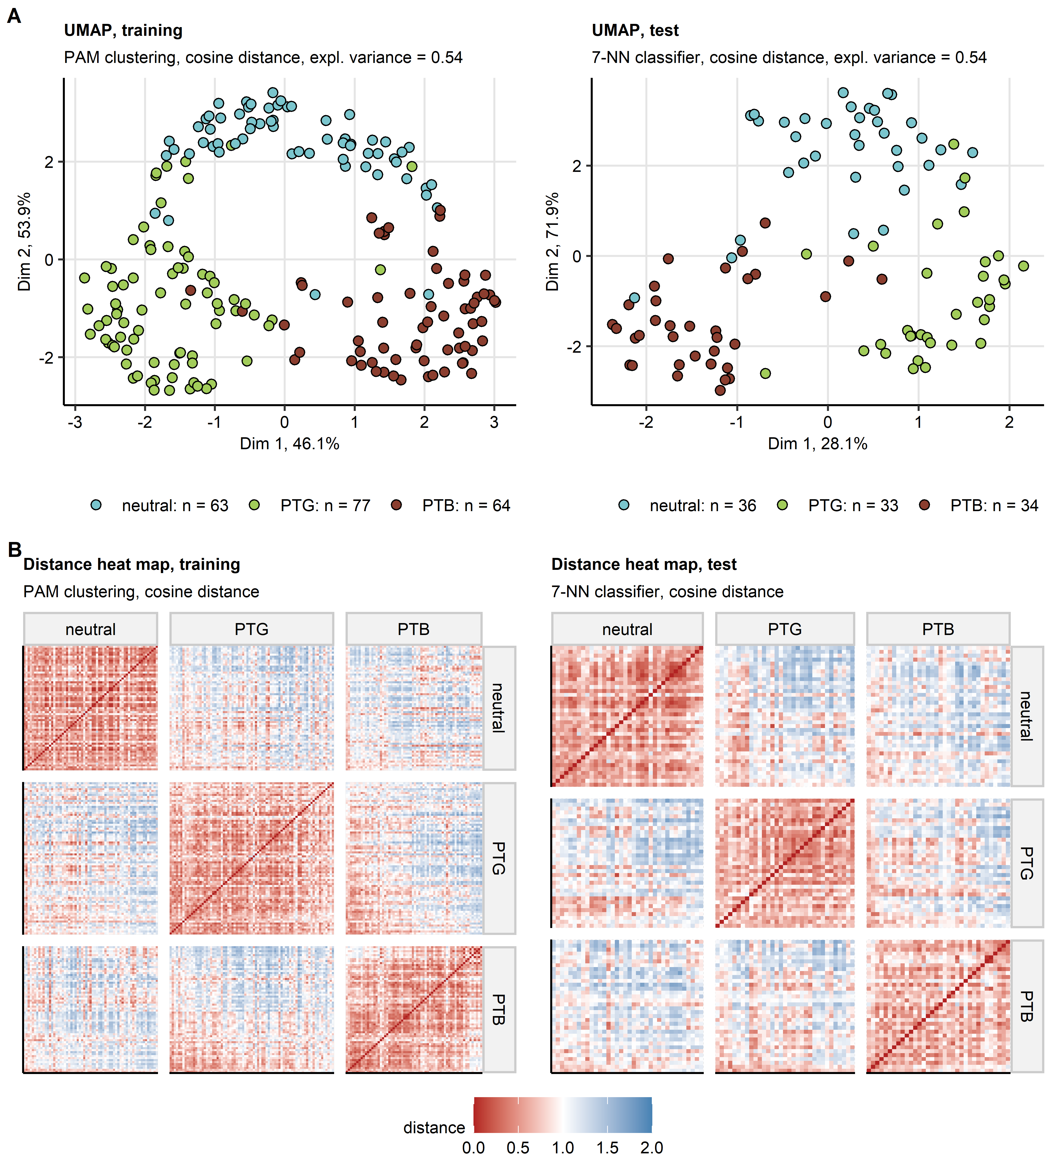

**Supplementary Figure S3. Semi-supervised clustering.**

*The mental clusters were defined in respect to psychometric scoring in the training subset of the study cohort by PAM (partition around medoids) with cosine distance between the observations. Assignment of the test subset observations to the mental clusters was done with the inverse distance weighted 7-nearest neighbors classifier. By this procedure, three mental clusters were identified: neutral, PTG (post-traumatic growth) and PTB (post-traumatic burden). Numbers of observations in the mental clusters are shown in the plot legend in (A).*

*(A) Observations in the training and test subsets of the study cohorts were subjected to two-dimensional UMAP (uniform manifold approximation and projection) in respect to the psychometric scores. UMAP layouts are shown in scatter plots. Points represent single samples. Point color codes for the cluster assignment.*

*(B) Pairwise cosine distances between observations in the mental clusters of the training and test subsets presented in heat maps.*

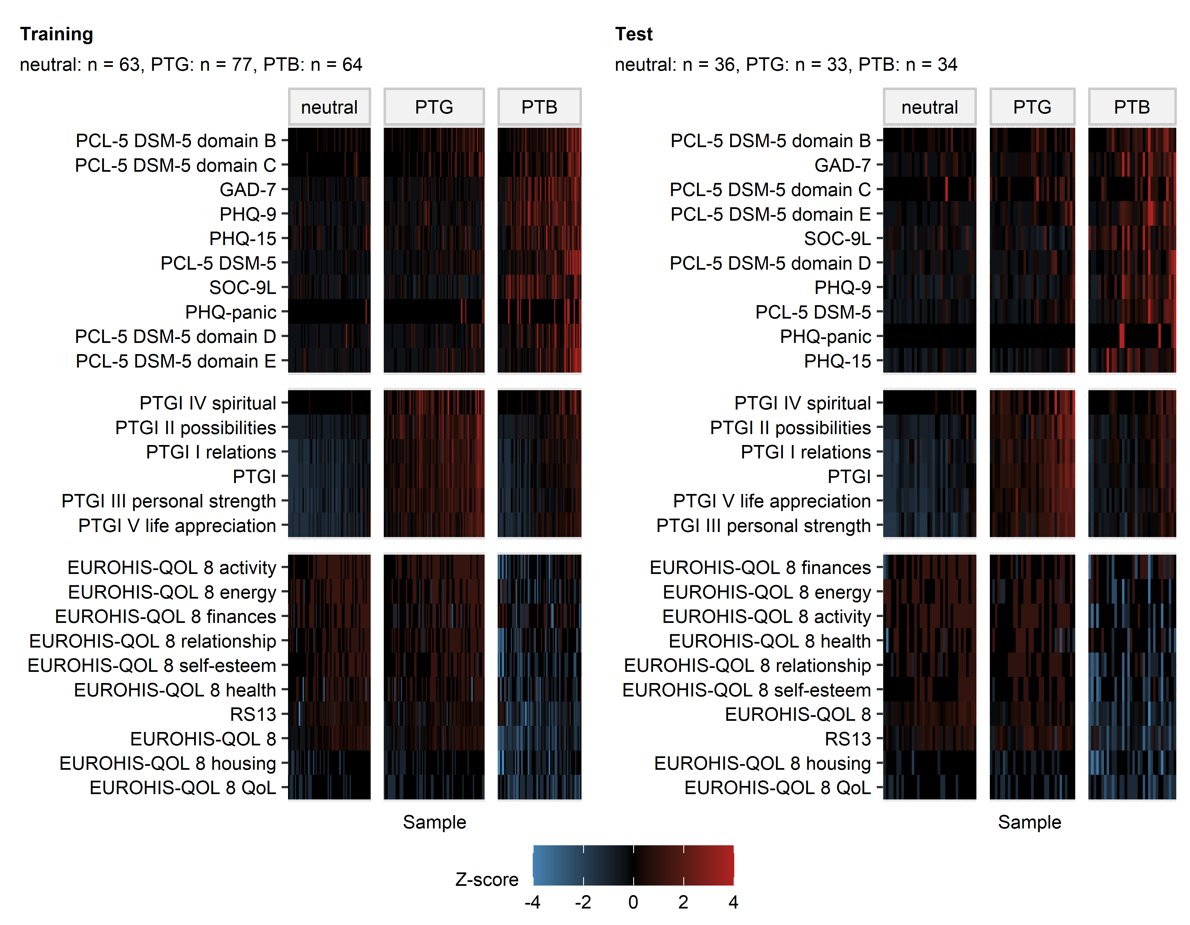

**Supplementary Figure S4. Levels of psychometric clustering scores in the mental clusters.**

*Levels of psychometric scores used in clustering in the mental clusters. Normalized, median-centered score values (Z scores) are presented as heat maps. Numbers of observations in the clusters are displayed in the plot captions. PSS4: 4-item perceived stress scale; GAD-7: 7-item general anxiety disorder scale; PHQ: patient health questionnaire; EUROHIS-QOL 8: 8-item EUROHIS project quality of life scale; SOC-9L: Leipzig 9-item sense of coherence questionnaire; RS13: 13-item resilience scale; PCL-5 DSM-5: PTSD checklist for DSM-5; PTGI: post-traumatic growth inventory; PTSD: post-traumatic stress disorder.*

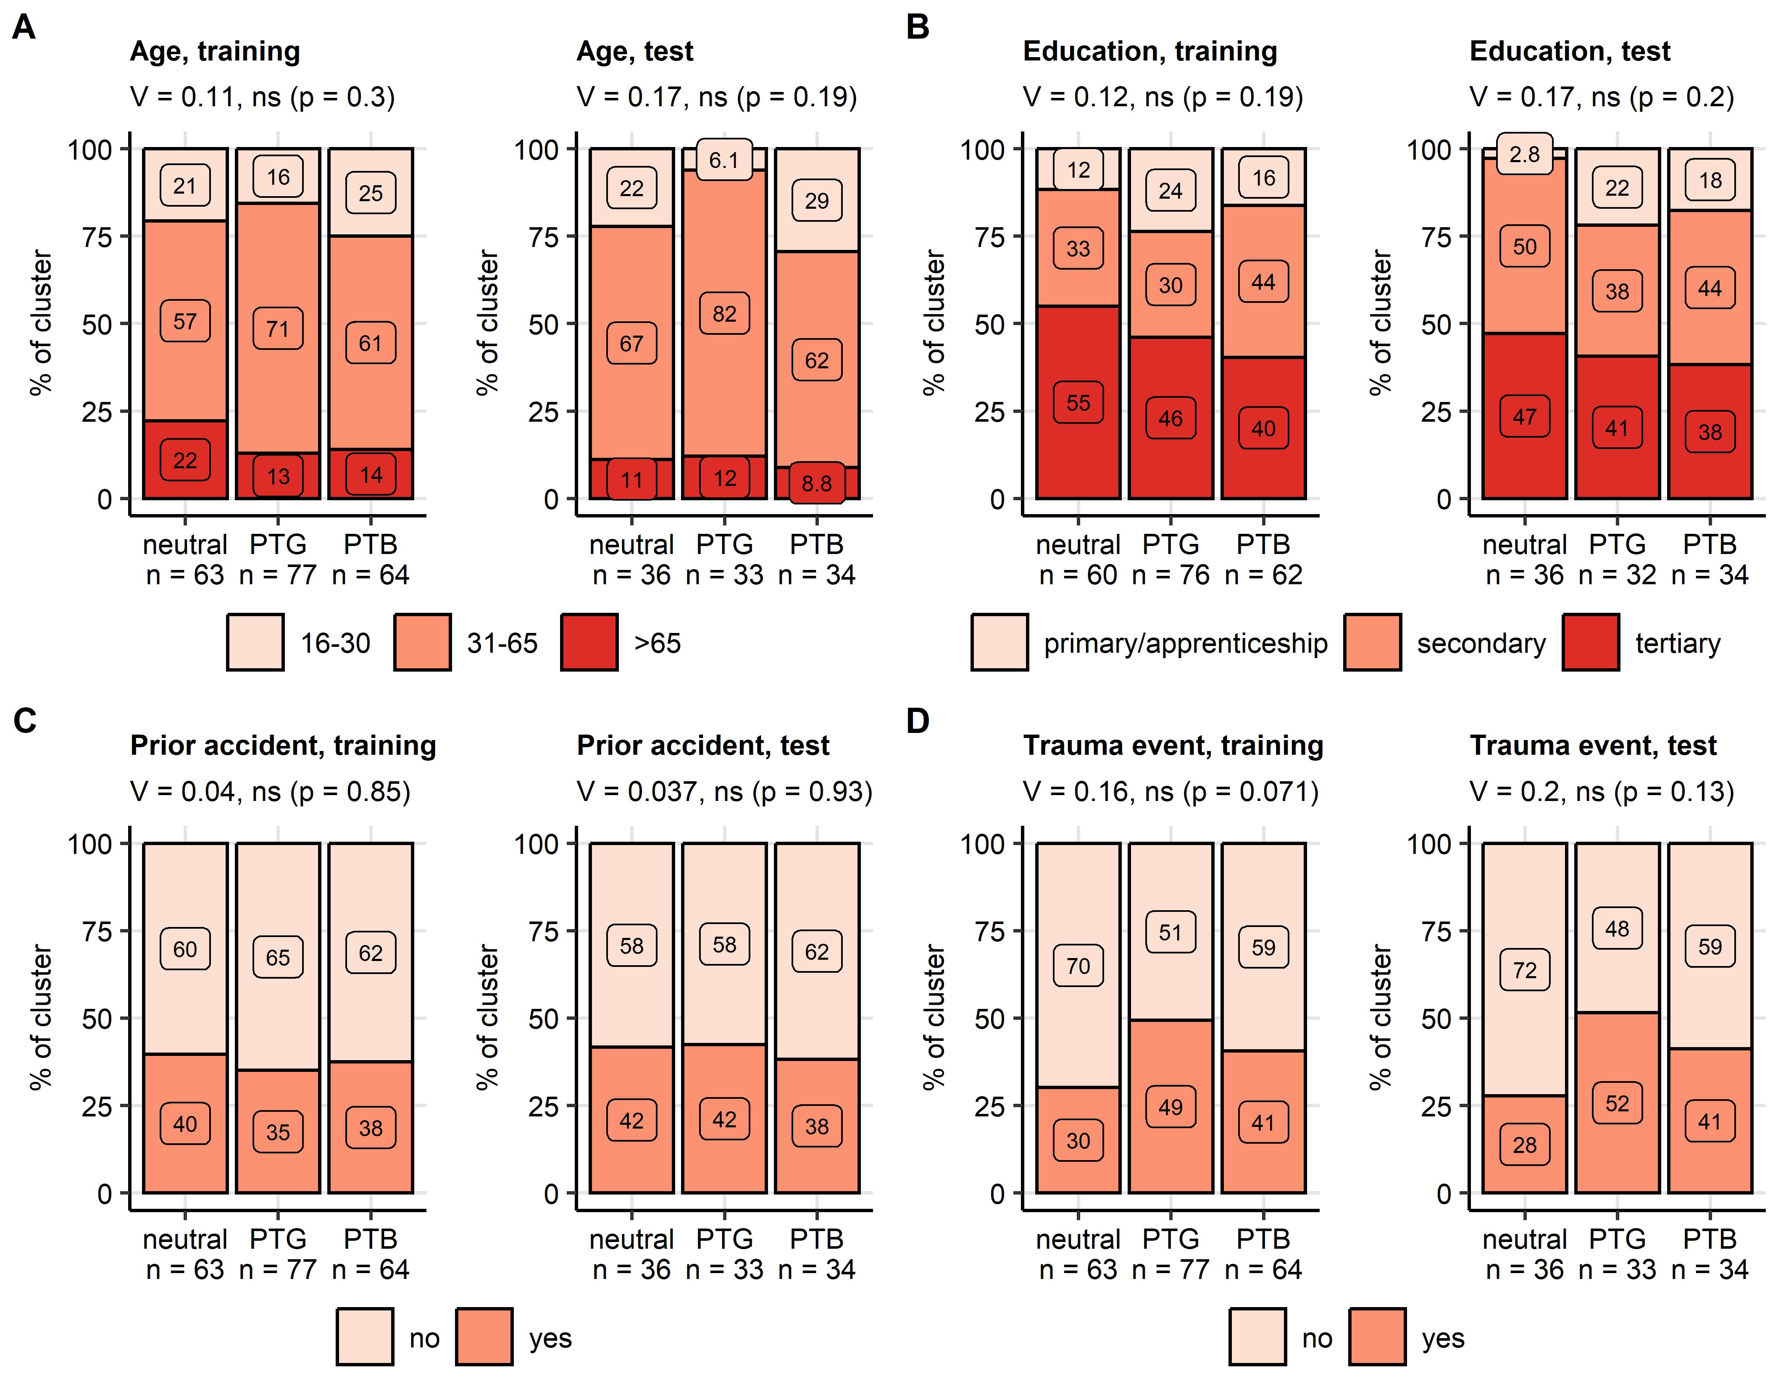

**Supplementary Figure S5. Age, education, household income, prior accidents and traumatic events in the mental clusters.**

*Distribution of age classes (A, young: < 30, middle: 30 - 65, elderly > 65 years), education grades (B), frequencies of prior sport accidents (D) and prior traumatic events (E, measured by the DIA-X tool) in the mental clusters. Statistical significance was determined by test with Cramer V effect size statistic. Percentages in the mental clusters in the training and test subset of the study cohort are presented in stack plots. Effect sizes and p-values are displayed in the plot captions. Numbers of observations in the clusters are presented in the X axes.*

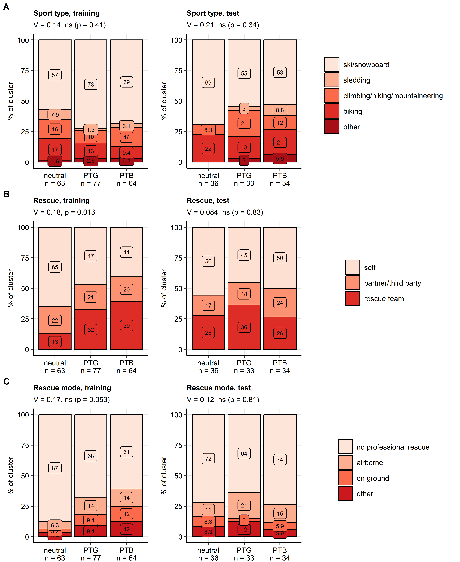

**Supplementary Figure S6. Accident sport type and accident rescue in the mental clusters.**

*Distribution of sport types (A) and rescue modes (B, C) in the mental clusters. Statistical significance was determined by test with Cramer V effect size statistic. Percentages in the mental clusters in the training and test subset of the study cohort are presented in stack plots. Effect sizes and p-values are displayed in the plot captions. Numbers of observations in the clusters are presented in the X axes.*

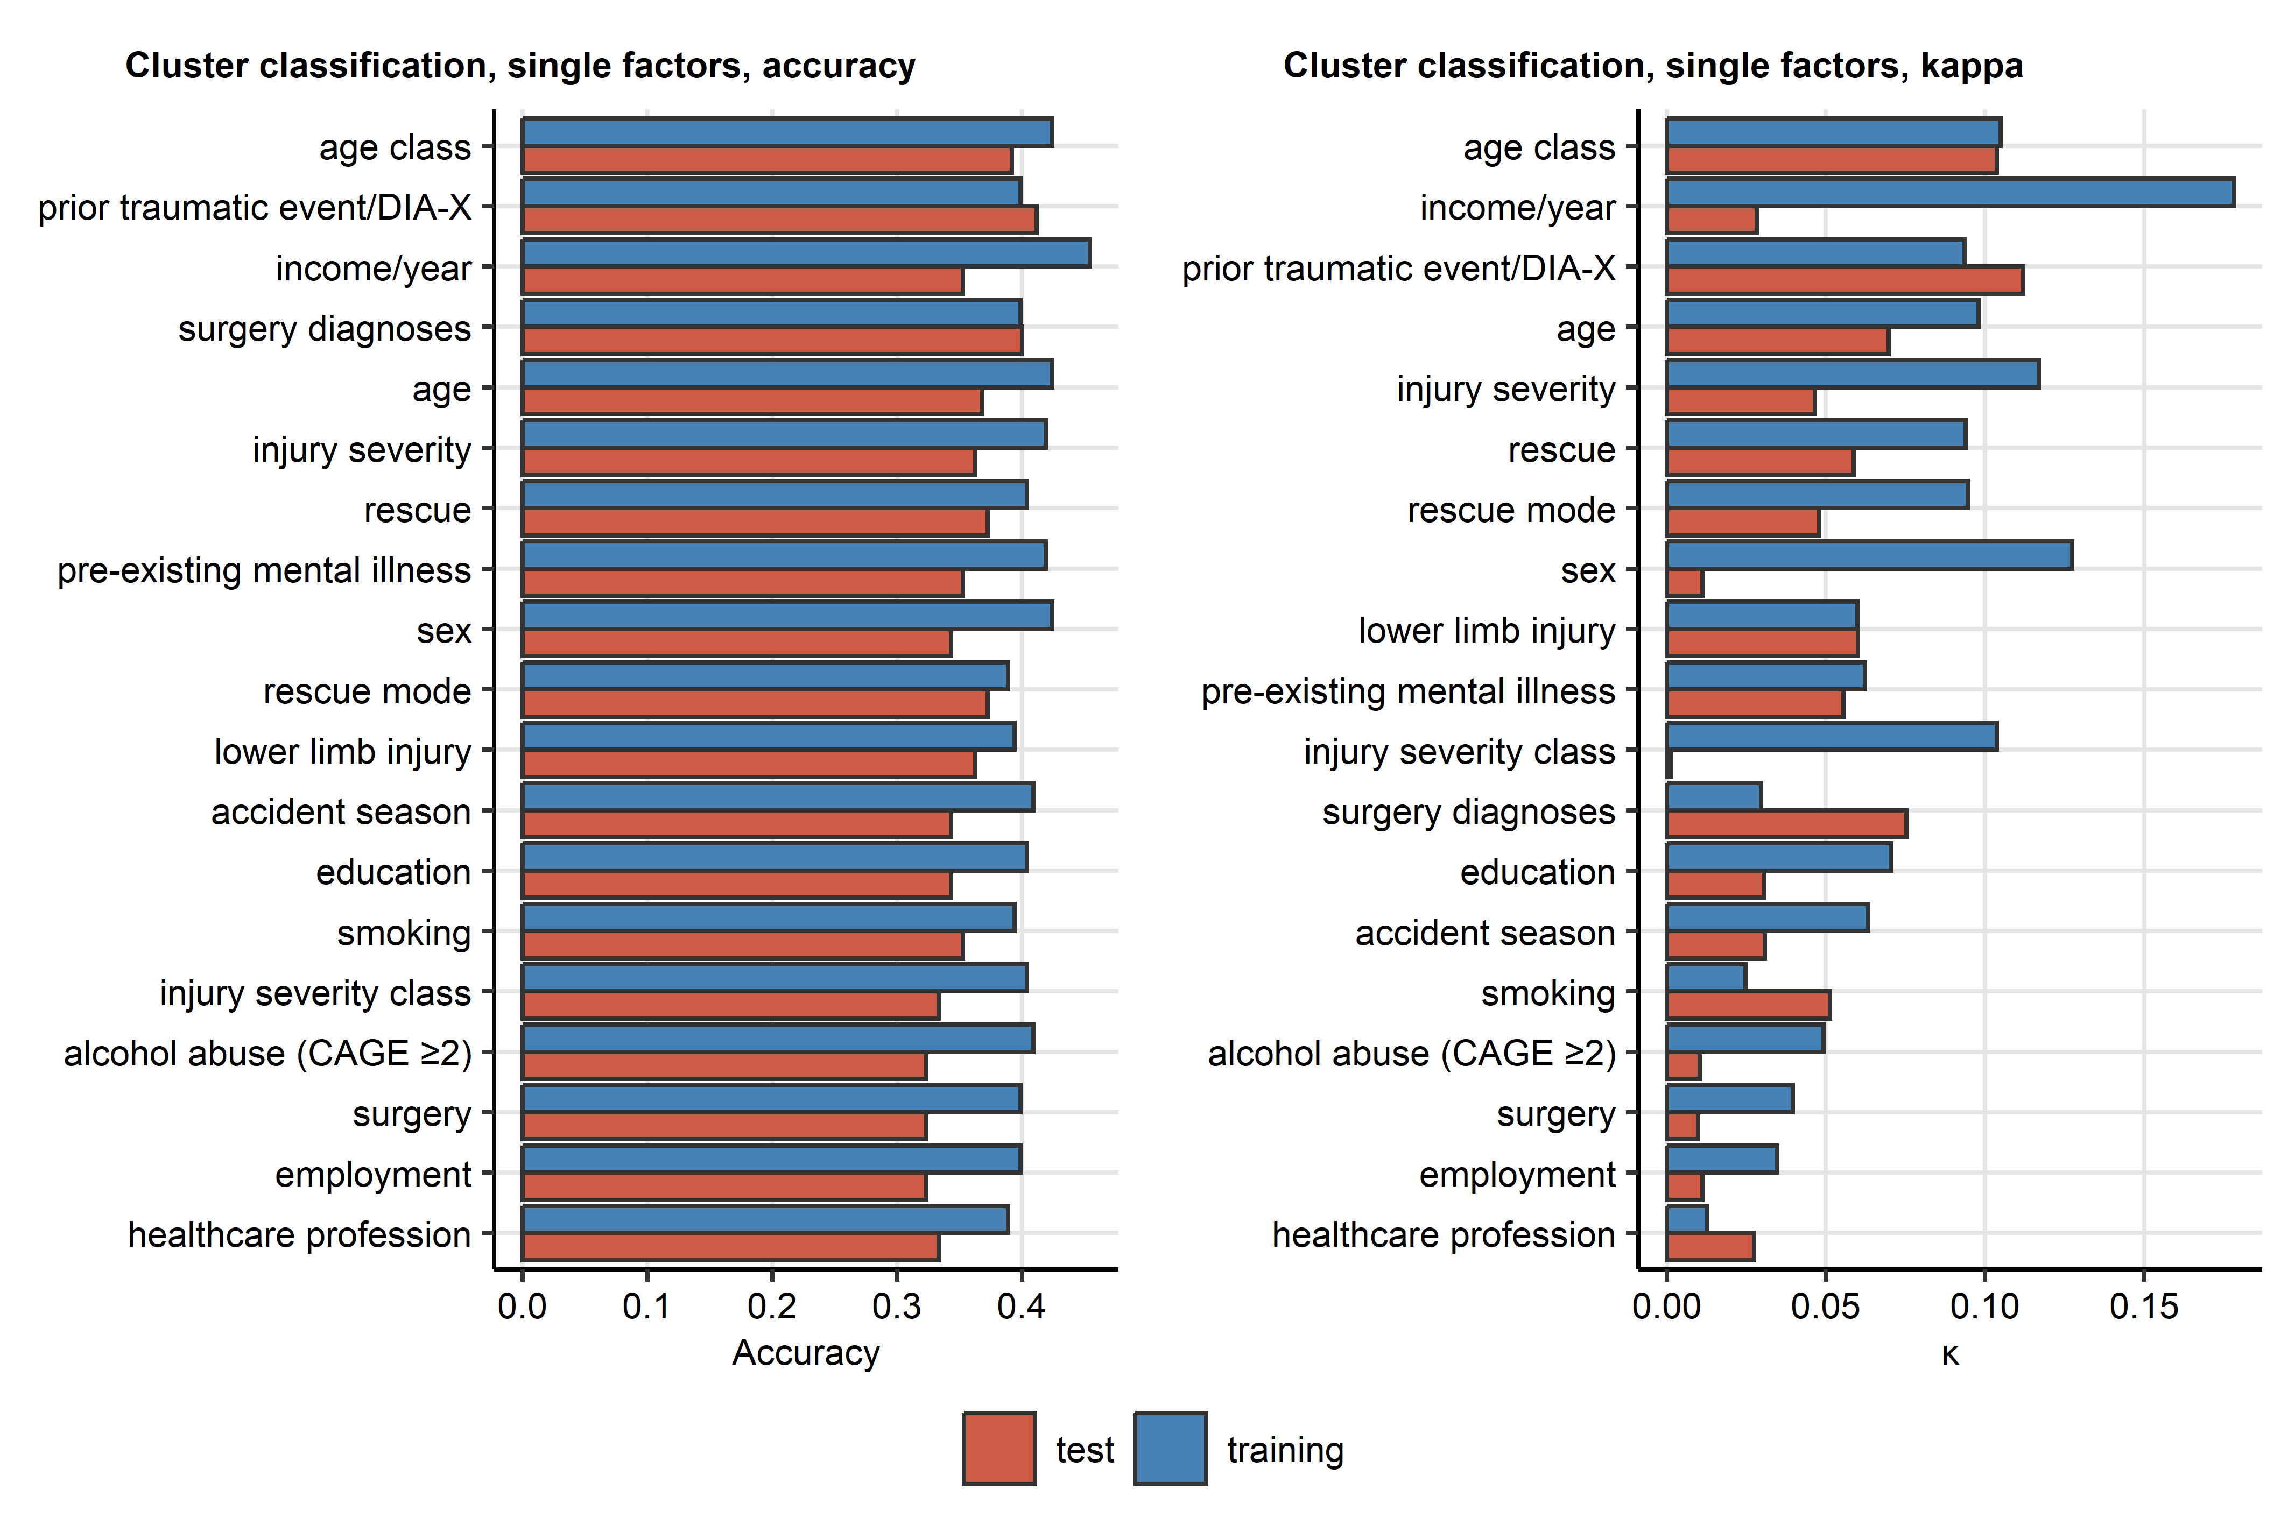

**Supplementary Figure S7. Prediction of the mental cluster assignment by single demographic, socioeconomic, clinical and accident-related factors available during acute medical management of the accident.**

*Univariable classifiers of the mental cluster assignment for demographic, socioeconomic, clinical and accident-related parameters available during acute medical management of the mountain sport accident were trained in the training subset of the study cohort by the one-rule (oneR) algorithm. The cluster assignment was subsequently predicted for the test subset observations. Accuracy and of the classifiers with any predictive value ( > 0 in both subsets) are shown in bar plots.*

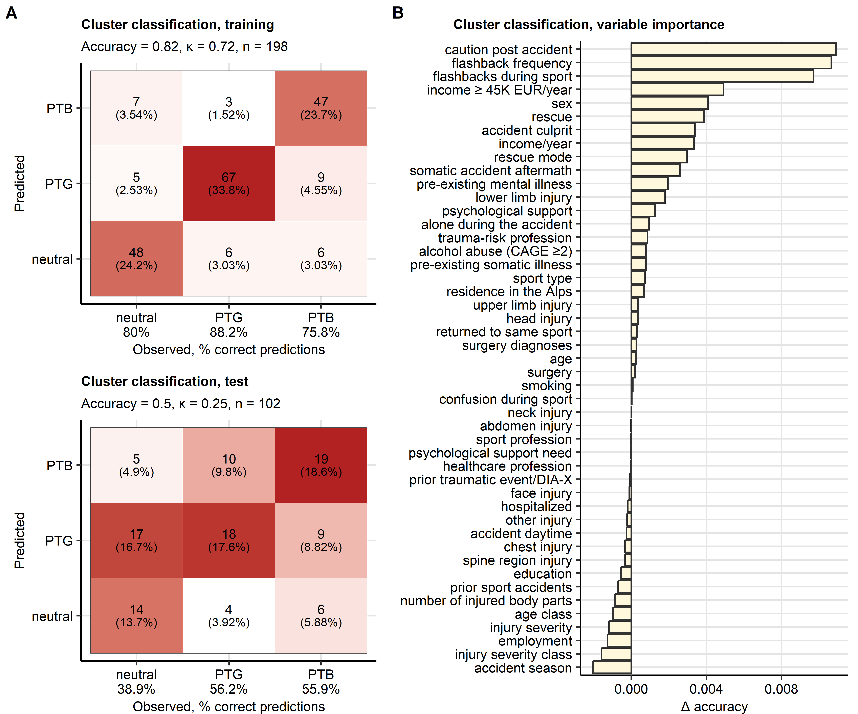

**Supplementary Figure S8. Assignment of accident victims to the mental clusters based on demographic, socioeconomic, clinical, accident- and accident consequence-related factors by the random forest algorithm.**

*A conditional random forest classifier for the mental cluster assignment based on demographic, socioeconomic, clinical and accident- and accident consequence-related factors was trained in the training subset of the study cohort.*

*(A) Prediction accuracy of the classifier in the training and test subset of the study cohort presented in a heat map plot of the confusion matrices. Color codes for number of cases. The overall prediction accuracy, and observation numbers are displayed in the plot caption. Prediction accuracy for particular clusters is shown in the X axis.*

*(B) Conditional importance of the explanatory variables for prediction of the mental cluster assignment expressed as accuracy loss ( accuracy).*

# References

1. R Core Team, Bivand R, Carey VJ, DebRoy S, Eglen S, Guha R, Herbrandt S, Lewin-Koh N, Myatt M, Nelson M, et al. foreign: Read Data Stored by ’Minitab’, ’S’, ’SAS’, ’SPSS’, ’Stata’, ’Systat’, ’Weka’, ’dBase’, ... (2022) <https://cran.r-project.org/web/packages/foreign/index.html>

2. Wickham H, Averick M, Bryan J, Chang W, McGowan L, François R, Grolemund G, Hayes A, Henry L, Hester J, et al. Welcome to the Tidyverse. *Journal of Open Source Software* (2019) 4:1686. doi: [10.21105/joss.01686](https://doi.org/10.21105/joss.01686)

3. Henry L, Wickham Hadley. rlang: Functions for Base Types and Core R and ’Tidyverse’ Features. (2022) <https://cran.r-project.org/web/packages/rlang/index.html>

4. Gagolewski M, Tartanus B. Package ’stringi’. (2021) <https://cran.r-project.org/web/packages/stringi/index.html http://cran.ism.ac.jp/web/packages/stringi/stringi.pdf>

5. Kassambara A. rstatix: Pipe-Friendly Framework for Basic Statistical Tests. (2021) <https://cran.r-project.org/package=rstatix>

6. Signorell A. DescTools: Tools for Descriptive Statistics. (2022) <https://cran.r-project.org/package=DescTools>

7. Revelle W. Package ’psych’ - Procedures for Psychological, Psychometric and Personality Research. *R Package* (2015)1–358. <https://cran.r-project.org/web/packages/psych/index.html http://personality-project.org/r/psych-manual.pdf>

8. Kassambara A, Mundt F. factoextra: Extract and Visualize the Results of Multivariate Data Analyses. (2020) <https://cran.r-project.org/web/packages/factoextra/index.html>

9. Schubert E, Rousseeuw PJ. Faster k-Medoids Clustering: Improving the PAM, CLARA, and CLARANS Algorithms. *Lecture notes in computer science (including subseries lecture notes in artificial intelligence and lecture notes in bioinformatics)*. Springer (2019). p. 171–187 doi: [10.1007/978-3-030-32047-8_16](https://doi.org/10.1007/978-3-030-32047-8_16)

10. Drost H-G. Philentropy: Information Theory and Distance Quantification with R. *Journal of Open Source Software* (2018) 3:765. doi: [10.21105/joss.00765](https://doi.org/10.21105/joss.00765)

11. Konopka T. umap: Uniform Manifold Approximation and Projection. (2022) <https://cran.r-project.org/web/packages/umap/index.html>

12. McInnes L, Healy J, Melville J. UMAP: Uniform Manifold Approximation and Projection for Dimension Reduction. (2018) <https://arxiv.org/abs/1802.03426v3 http://arxiv.org/abs/1802.03426>

13. Jouanne-Diedrich H von. OneR: One Rule Machine Learning Classification Algorithm with Enhancements. (2017) <https://cran.r-project.org/web/packages/OneR/index.html>

14. Holte RC. Very Simple Classification Rules Perform Well on Most Commonly Used Datasets. *Machine Learning* (1993) 11:63–90. doi: [10.1023/A:1022631118932/METRICS](https://doi.org/10.1023/A:1022631118932/METRICS)

15. Hothorn T, Hornik K, Zeileis A. Unbiased recursive partitioning: A conditional inference framework. *Journal of Computational and Graphical Statistics* (2006) 15:651–674. doi: [10.1198/106186006X133933](https://doi.org/10.1198/106186006X133933)

16. Strobl C, Boulesteix AL, Zeileis A, Hothorn T. Bias in random forest variable importance measures: Illustrations, sources and a solution. *BMC Bioinformatics* (2007) 8:1–21. doi: [10.1186/1471-2105-8-25/FIGURES/11](https://doi.org/10.1186/1471-2105-8-25/FIGURES/11)

17. Hothorn T, Hornik K, Strobl C, Zeileis A. party: A Laboratory for Recursive Partytioning. (2022) <https://cran.r-project.org/web/packages/party/index.html>

18. Kuhn M. Building predictive models in R using the caret package. *Journal of Statistical Software* (2008) 28:1–26. doi: [10.18637/jss.v028.i05](https://doi.org/10.18637/jss.v028.i05)

19. Wickham Hadley. *ggplot2: Elegant Graphics for Data Analysis*. 1st ed. New York: Springer-Verlag (2016). [https://ggplot2.tidyverse.org](https://ggplot2.tidyverse.org/)

20. Wilke CO. *Fundamentals of Data Visualization: A Primer on Making Informative and Compelling Figures*. 1st ed. Sebastopol: O’Reilly Media (2019).

21. Gohel D. flextable: Functions for Tabular Reporting. (2022) <https://cran.r-project.org/web/packages/flextable/index.html>

22. Allaire J, Xie Y, McPherson J, Luraschi J, Ushey K, Atkins A, Wickham H, Cheng J. rmarkdown: Dynamic Documents for R. (2022) <https://cran.r-project.org/web/packages/rmarkdown/index.html>

23. Xie Y. *Bookdown: Authoring books and technical documents with R Markdown*. (2016). doi: [10.1201/9781315204963](https://doi.org/10.1201/9781315204963)

24. Xie Y. knitr: A General-Purpose Package for Dynamic Report Generation in R. (2022) <https://cran.r-project.org/web/packages/knitr/index.html>

25. Spitzer RL, Kroenke K, Williams JBW, Löwe B. A Brief Measure for Assessing Generalized Anxiety Disorder: The GAD-7. *Archives of Internal Medicine* (2006) 166:1092–1097. doi: [10.1001/ARCHINTE.166.10.1092](https://doi.org/10.1001/ARCHINTE.166.10.1092)

26. Löwe B, Spitzer RL, Zipfel S, Herzog W. Auflage Manual 17.07. (2002).

27. Gräfe K, Zipfel S, Herzog W, Löwe B. Screening psychischer störungen mit dem "Gesundheitsfragebogen für Patienten (PHQ-D)". Ergebnisse der Deutschen validierungsstudie. *Diagnostica* (2004) 50:171–181. doi: [10.1026/0012-1924.50.4.171](https://doi.org/10.1026/0012-1924.50.4.171)

28. Kroenke K, Spitzer RL, Williams JBW. The PHQ-15: validity of a new measure for evaluating the severity of somatic symptoms. *Psychosomatic medicine* (2002) 64:258–266. doi: [10.1097/00006842-200203000-00008](https://doi.org/10.1097/00006842-200203000-00008)

29. Leppert K, Koch B, Brähler E, Und BS-KD, 2008 U. Die Resilienzskala (RS)–Überprüfung der Langform RS-25 und einer Kurzform RS-13. *Klinische Diagnostik und Evaluation* (2008) 1:226–243. <https://www.academia.edu/download/44388154/A_406.pdf>

30. Schumacher J, Wilz G, Gunzelmann T, Brähler E. Die sense of coherence scale von antonovsky: Teststatische überprüfung in einer repräsentativen bevölkerungsstichprobe und konstruktion einer kurzskala. *PPmP Psychotherapie Psychosomatik Medizinische Psychologie* (2000) 50:472–482. doi: [10.1055/s-2000-9207](https://doi.org/10.1055/s-2000-9207)

31. Schmidt S, Mühlan H, Power M. The EUROHIS-QOL 8-item index: psychometric results of a cross-cultural field study. *European Journal of Public Health* (2006) 16:420–428. doi: [10.1093/EURPUB/CKI155](https://doi.org/10.1093/EURPUB/CKI155)

32. Tedeschi RG, Calhoun LG. The Posttraumatic Growth Inventory: measuring the positive legacy of trauma. *Journal of traumatic stress* (1996) 9:455–471. doi: [10.1007/BF02103658](https://doi.org/10.1007/BF02103658)

33. Bovin MJ, Marx BP, Weathers FW, Gallagher MW, Rodriguez P, Schnurr PP, Keane TM. Psychometric properties of the PTSD Checklist for Diagnostic and Statistical Manual of Mental Disorders-Fifth Edition (PCL-5) in veterans. *Psychological assessment* (2016) 28:1379–1391. doi: [10.1037/PAS0000254](https://doi.org/10.1037/PAS0000254)

34. Manea L, Gilbody S, McMillan D. Optimal cut-off score for diagnosing depression with the Patient Health Questionnaire (PHQ-9): A meta-analysis. *CMAJ* (2012) 184:E191. doi: [10.1503/CMAJ.110829/-/DC1](https://doi.org/10.1503/CMAJ.110829/-/DC1)

35. Maercker A, Bromberger F. Checklisten und Fragebogen zur Erfassung traumatischer Ereignisse in deutscher Sprache. *Trierer Psychologische Berichte* (2005) 32:

36. O’Brien CP. The CAGE Questionnaire for Detection of Alcoholism. *JAMA* (2008) 300:2054–2056. doi: [10.1001/JAMA.2008.570](https://doi.org/10.1001/JAMA.2008.570)

37. Gennarelli TA, Wodzin E. AIS 2005: A contemporary injury scale. *Injury* (2006) 37:1083–1091. doi: [10.1016/j.injury.2006.07.009](https://doi.org/10.1016/j.injury.2006.07.009)

38. McDonald RP. *Test theory: A unified treatment*. 1st Editio. New Yor: Psychology Press (1999). doi: [10.4324/9781410601087](https://doi.org/10.4324/9781410601087)

39. Cohen S, Kamarck T, Mermelstein R. A global measure of perceived stress. *Journal of health and social behavior* (1983) 24:385–396. doi: [10.2307/2136404](https://doi.org/10.2307/2136404)

40. Sinclair VG, Wallston KA. The development and psychometric evaluation of the Brief Resilient Coping Scale. *Assessment* (2004) 11:94–101. doi: [10.1177/1073191103258144](https://doi.org/10.1177/1073191103258144)

41. Lange T, Roth V, Braun ML, Buhmann JM. Stability-based validation of clustering solutions. *Neural Computation* (2004) 16:1299–1323. doi: [10.1162/089976604773717621](https://doi.org/10.1162/089976604773717621)

42. Strobl C, Boulesteix AL, Kneib T, Augustin T, Zeileis A. Conditional variable importance for random forests. *BMC Bioinformatics* (2008) 9:1–11. doi: [10.1186/1471-2105-9-307/FIGURES/4](https://doi.org/10.1186/1471-2105-9-307/FIGURES/4)