The effect of inflammation, SARS-CoV-2 infection, age and mental health on serotonin, and kynurenine and catecholamine pathway metabolites

Manuscript

Katharina Hüfner1,✉, Sophia Vedova1, Piotr Tymoszuk2, Philipp Nelles1, Tobias Bruckner1, Eberhard A. Deisenhammer1,3, Jonas Egeter1, Matyas Galffy1, Johannes Giesinger1, Jens Lehmann1, Maria Oberhammer2, Joachim Rockenschaub1, Magdalena Sacher4, Bernhard Holzner1, Johanna M. Gostner5, Barbara Sperner-Unterweger1

2023-06-08

1 University Hospital of Psychiatry II, Department of Psychiatry, Psychotherapy, Psychosomatics and Medical Psychology, Medical University Innsbruck, Innsbruck, Austria.  
2 Data Analytics As a Service Tirol, Innsbruck, Austria.  
3 University Hospital of Psychiatry I, Department of Psychiatry, Psychotherapy, Psychosomatics and Medical Psychology, Medical University Innsbruck, Innsbruck, Austria.  
4 Department of Visceral, Transplant and Thoracic Surgery (VTT), Medical University Innsbruck, Innsbruck, Austria

5Insitute of Medical Biochemistry, Medical University Innsbruck, Innsbruck, Austria

Corresponding author:

Katharina Hüfner

University Hospital of Psychiatry II, Department of Psychiatry, Psychotherapy, Psychosomatics and Medical Psychology

Anichstrasse 35

6020 Innsbruck

Austria

✉ Correspondence: [Katharina Hüfner <katharina.huefner@tirol-kliniken.at>](mailto:katharina.huefner@tirol-kliniken.at)

Running title: Activity of the serotonin, kynurenine, and catecholamine metabolic pathways and COVID-19

# Keywords

serotonin and dopamine availability, COVID-19, kynurenine, tryptophan, inflammation, mental health

# Abstract

**Background:** A high prevalence of mental disorders following COVID-19 has been described. It is therefore essential to elucidate underlying biological mechanisms linking SARS-CoV-2 infection and mental health. Activity in the kynurenine and catecholamine pathways could be a link between mental and physical health, with inflammation playing a major role in this relationship. We investigated factors that affect the different pathway activities in SARS-CoV-2 infection and recovery.

**Methods:** The cross-sectional SIMMUN (n = 165) and longitudinal INCOV cohort (n = 167, Su et al. 2022) were analyzed. Demographic and clinical characteristic, inflammatory markers, SARS-CoV-2 infection, symptoms of depression and anxiety (HADS), and mental stress (PSS-4) served as explanatory variables. Serum serotonin and markers of the kynurenine (kynurenine/tryptophan ratio), and catecholamine pathway activity (dopamine 3-O-sulfate, phenylalanine/tyrosine ratio) were modeled by multi-parameter linear regression.

**Results:** In the SIMMUN cohort, the inflammatory marker neopterin ( = 0.47 [95% CI: 0.34-0.61]), SARS-CoV-2-positivity (0.42 [0.16-0.68]), mental stress (0.18 [0.055-0.31]) and age were positively associated with the kynurenine/tryptophan ratio. The phenylalanine/tyrosine ratio was lower in SARS-CoV-2-positive participants (-0.38 [-0.68–0.08]) compared to uninfected. In the INCOV cohort, inflammation markers were associated with lower serotonin (IL6: -0.22 [-0.38–0.053]) and dopamine 3-O-sulfate (interferon-gamma: -0.15 [-0.26–0.036]). Serotonin (0.76 [0.34-1.2]) and dopamine 3-O-sulfate levels (0.63 [0.28-0.99]) were higher during recovery than in acute SARS-CoV-2 infection.

**Conclusion:** SARS-CoV-2 infection, inflammation, age and mental stress are the key independent predictors of high kynurenine pathway activity, which might also be associated with serotonin availability. The catecholamine pathway was also affected in SARS-CoV-2 infection. These pathways could thus be a biological link between COVID-19 and mental health.

# Introduction

The immune system and the brain interact at multiple levels with influences on one system having consequences on the other (Dantzer et al., 2008). Physical disorders such as infections, cardiovascular disease, frailty, autoimmune illness or malignancy are often accompanied by symptoms of depression, anxiety and mental stress (Dickens and Creed, 2001; Hüfner et al., 2022; Hüfner et al., 2015; Mayerl et al., 2020; Mitchell et al., 2011; Rajan et al., 2020; Renault et al., 1987). Inflammation interferes with key metabolic processes controlling serotonin and dopamine availability, such as the kynurenine pathway (affecting potentially also serotonin availability) and the catecholamine pathway. Inflammation was thus proposed as an important link between mental and physical health (Bonaccorso et al., 2002; Brown et al., 2021; Dantzer et al., 2008; Gostner et al., 2020; Hüfner et al., 2015; Valdiglesias et al., 2018).

Serotonin is synthesized from the essential aminoacid tryptophan (TRP) by tryptophan hydroxylase (TPH) and aromatic L-amino acid decarboxylase. Most systemic TRP is catabolized along the kynurenine pathway. The conversion of TRP to kynurenine (KYN) by tryptophan 2,3-dioxygenase (TDO) or indoleamine 2,3-dioxygenases (IDO1, IDO2) is the rate limiting step of the kynurenine pathway and might thereby control TRP levels subsequently available for serotonin synthesis (Badawy, 2017; Lukić et al., 2022). Importantly, IDO1 is stimulated by inflammatory signals (Badawy, 2017; Robinson et al., 2003) and TDO activity is increased by glucocorticoids which are also released as a reaction to mental stress (Knox, 1951; Maes et al., 1990). Kynurenine pathway metabolites such as KYN or quinolinic acid [QUIN] can additionally pass the blood-brain barrier, interfere e.g. glutamatergic signaling and exert neurotoxicity (Brown et al., 2021; Schwarcz et al., 2012). Hence, the kynurenine pathway, whose activity can be assessed by the ratio of blood KYN to TRP (KYN/TRP) is an activation marker of IDO and TDO activity and thereby reflects inflammatory and hypothalamic–pituitary–adrenal axis signals (Badawy, 2017; Brown et al., 2021; Schwarcz et al., 2012). Consequently, elevated levels of circulating kynurenine pathway metabolites, high KYN/TRP, decreased TRP as well as lowered levels of associated neurotransmitter serotonin were reported for numerous physical disorders and associated with symptoms of mental disorders (Capuron et al., 2011; Cervenka et al., 2017; Fellendorf et al., 2022; Hüfner et al., 2021, 2019; Hüfner et al., 2015; Hunt et al., 2020; Marx et al., 2020).

The synthesis of neurotransmitters such has dopamine via the catecholamine pathway involves the conversion of phenylalanine (PHE) to tyrosine (TYR) catalyzed by phenylalanine hydroxylase (PAH) followed by hydroxylation of TYR by tyrosine 5-hydroxylase (TH). PAH, TH and enzyme TPH important for serotonin synthesis rely on tetrahydrobiopterin (BH4) as an essential cofactor (Meiser et al., 2013; Neurauter et al., 2008). During inflammation, BH4 is oxidized to its inactive derivative and consumed in a competitor reaction of nitric oxide formation (Neurauter et al., 2008; Rahimian et al., 2022). As a result of such functional BH4 deficiency, reflected e.g. by an elevated blood PHE to TYR ratio, biosynthesis of dopamine and serotonin is reduced (Capuron et al., 2011; Geisler et al., 2013; Vancassel et al., 2018). Accordingly, changes in PHE and TYR levels have been reported in different physical disorders such as cancer, infections and inflammatory conditions and associated with depression and anxiety (Capuron et al., 2011; Geisler et al., 2013; Hüfner et al., 2015; Vancassel et al., 2018).

SARS-CoV-2 virus is the causal pathogen of coronavirus disease 2019 (COVID-19). Apart from sustained physical disability, mental disorders in millions of patients amount to the persistent burden of the COVID-19 pandemic (Al-Aly et al., 2021; Huang et al., 2021; Hüfner et al., 2022; Sahanic et al., 2023; Staudt et al., 2022). Increased kynurenine pathway activity has recently been identified in acute COVID-19 and during COVID-19 recovery and associated with infection severity (Bizjak et al., 2022; Dewulf et al., 2022; Lionetto et al., 2021; Santiago-Mujika et al., 2022). Theoretical considerations (Bower et al., 2022) and preliminary experimental data suggest that a highly active kynurenine pathway as well as reduced levels of serotonin and catecholamine biosynthesis may contribute to symptoms of mental stress, anxiety and depression in COVID-19 patients (Kucukkarapinar et al., 2022; Matits et al., 2023).

Clinical and experimental evidence for an interaction of mental health with inflammation, kynurenine and catecholamine pathway activity and systemic availability of serotonin and dopamine in COVID-19 is scarce. To address this question, we analyzed the effects of demographic, clinical, psychometric (anxiety, depression, mental stress), inflammation- and SARS-CoV-2-related factors on the kynurenine pathway activity and associated serotonin levels as well as the catecholamine pathway in two cohorts of SARS-CoV-2 patients: the cross-sectional SIMMUN cohort and the published longitudinal INCOV cohort (Su et al., 2022).

# Materials and Methods

Details on study cohorts, procedures and analysis are provided in **Supplementary Methods**.

## Ethics statement

The SIMMUN study was conducted in accordance with the Declaration of Helsinki and European Data Policy. All participants gave written informed consent prior to enrollment. Participants’ data were stored and analyzed in anonymized form. This study was approved by the ethics committee of the Medical University Innsbruck (Austria, approval number: 1132/2020). No approval by the ethics committee was required for the published INCOV dataset (Su et al., 2022).

## Study cohorts

### SIMMUN study

Individuals tested for SARS-CoV-2 via PCR at the University Hospital of Innsbruck and patients of the University Clinic for Psychiatry I and II (Innsbruck, Austria) undergoing routine SARS-CoV-2 PCR were invited to participate. The study was conducted between June 2020 and May 2021. The inclusion criteria were age of 18 - 70 years, proficiency in German, residence in the study region (Tyrol, Austria), and a SARS-CoV-2 PCR conducted at the study site. The exclusion criteria were active SARS-CoV-2 infection (< 14 days after diagnosis), pregnancy, active malignancy, organ transplantation, surgery in the past 3 months, inflammatory illness and oral corticosteroid treatment. Only individuals with complete explanatory and response variables presented in **Supplementary Table S1** and **Supplementary Figure S1** were analyzed. Significant differences between the analyzed and excluded participants are listed in **Supplementary Table S2**.

### INCOV study

Proteome, metabolome and clinical data are [publicly available](https://data.mendeley.com/datasets/96v329bg7g/1) (Su et al., 2022). Samples with complete explanatory and response variables presented in **Supplementary Figure S1** and **Supplementary Table S3** were analyzed.

## Procedures

### SIMMUN study

The SIMMUN data were collected during a single on-site visit at median 139 days after the SARS-CoV-2 PCR (interquartile range: 119 - 157) and extracted from electronic patient records (**Supplementary Table S1**). Demographic and clinical characteristics included age, sex, body mass index (BMI), mental disorders diagnosed by a physician, self-reported physical disorders, smoking and alcohol consumption, result and date of the SARS-CoV-2 PCR. Inflammatory markers and neutrophil/lymphocyte ratio (NLR) were determined by a certified laboratory at the University Hospital of Innsbruck. Neopterin (NEO) concentrations were measured by enzyme-linked immunosorbent assay (BRAHMS Diagnostics, Berlin, Germany). Serum TRP, KYN, PHE and TYR were determined by high-performance liquid chromatography (Neurauter et al., 2008; Widner et al., 1997). Immunoglobulin gamma against receptor binding domain S1/S2 protein (anti-RBD IgG) was quantified by ELISA (Deisenhammer et al., 2021). Laboratory measurements beyond the detection limits were substituted with the respective detection limit value. Mental stress was scored with the 4-item perceived stress scale (PSS-4) (Cohen et al., 1983). Clinically relevant symptoms of anxiety and depression were defined as 8 points in the hospital anxiety and depression scale (HADS) (Bjelland et al., 2002; Zigmond and Snaith, 1983).

### INCOV cohort

Plasma proteomes and metabolomes in the INCOV cohort were measured by proximity extension assay (Olink, Sweden) and liquid chromatography/tandem mass spectrometry (Metabolon, USA), respectively, and expressed as age- and sex-adjusted, log2-transformed concentrations (Su et al., 2022, 2020). Serotonin (Lukić et al., 2022), markers of the kynurenine (TRP, KYN, quinolinic acid [QUIN]) (Badawy, 2017) and catecholamine pathway (PHE, TYR, and dopamine 3-O-sulfate [DA sulfate]) (Goldstein et al., 1999; Meiser et al., 2013; Suominen et al., 2013), cytokine markers of inflammation (interleukin-6 [IL6], interleukin-10 [IL10], tumor necrosis factor-alpha [TNF] and interferon-gamma [IFNG]), age, sex and BMI were analyzed (**Supplementary Table S3**).

Plasma samples were collected during acute and sub-acute infection, and recovery at median 10, 14, 64 days after diagnosis of SARS-CoV-2 infection via PCR, respectively (**Supplementary Table S4**).

## Analysis endpoints

The first endpoint was to determine demographic, clinical, psychometric, inflammation- and SARS-CoV-2-related factors influencing serum markers of kynurenine and catecholamine pathway activity (TRP, KYN, KYN/TRP, PHE, TYR, PHE/TYR) by multi-parameter modeling in the SIMMUN cohort. The second endpoint was to investigate how systemic serotonin and dopamine availability (DA sulfate), are influenced by age, sex, BMI, inflammatory cytokines, timepoint of SARS-CoV-2 infection, kynurenine pathway metabolites (TRP, KYN, QUIN) as well as catecholamine pathway metabolites (PHE, TYR). This endpoint was addressed by multi-parameter robust linear modeling, time course modeling and correlation analysis in the INCOV cohort (**Supplementary Figure S1**).

## Statistical analysis

R version 4.2.3 was used for statistical analysis.

Numeric variables were presented as medians with interquartile ranges and ranges. Categorical variables are presented as percentages and counts. Normality and variance homogeneity was assessed by Shapiro-Wilk and Levene test, respectively. In the SIMMUN cohort, non-normally distributed numeric variables were logarithm- or square root-transformed prior to modeling and parametric tests (**Supplementary Table S1**). Since most of the INCOV study variables were non-normally distributed, robust linear modeling and non-parametric testing were employed. Consistency of psychometric tools was investigated by global McDonald’s (McDonald, 1999). Except for multi-parameter modeling, p values were corrected for multiple testing with the false discovery rate method (Benjamini and Hochberg, 1995) separately for each analysis task. Effects with p < 0.05 were considered significant.

Significance was determined by Mann-Whitney test with r effect size, two-tailed T test with Cohen’s d effect size statistic or test with Cramer’s V effect size statistic. Correlation was assessed by Pearson’s or Spearman’s rank test and visualized as bubble or force-directed network plots (Csardi and Nepusz, 2006).

Responses and explanatory variables were normalized prior to modeling. In the SIMMUN cohort, effects of age, sex, body mass class, physical and psychiatric disorders, BMI, smoking and alcohol consumption, inflammation markers (NEO, NLR), SARS-CoV-2 infection, anti-RBD IgG titer, clinically relevant symptoms of depression and anxiety (HADS), mental stress (PSS-4) on kynurenine and catecholamine pathway activity markers were assessed by multi-parameter linear regression with backward elimination. In the INCOV cohort, effects of age, sex, BMI, cytokine markers of inflammation (IL6, IL10, TNF, IFNG), SARS-CoV-2 infection and timepoint (uninfected, acute, sub-acute, recovery), kynurenine (TRP, KYN, QUIN) and catecholamine pathway metabolites (PHE, TYR) and on plasma serotonin and DA sulfate were modeled by multi-parameter robust linear regression (Huber, 2011). Explanatory performance, reproducibility and proper parameterization of the multi-parameter models was investigated by R2 and root mean square error (RMSE) in 10-fold cross-validation. Differences in cytokines and metabolites between SARS-CoV-2 infection timepoints in the INCOV collective were investigated by robust linear modeling with uninfected subset or acute infection serving as baselines.

# Results

## Characteristic of the cohorts

Two cohorts of uninfected and SARS-CoV-2-infected individuals were analyzed (SIMMUN and INCOV). Out of 215 individuals enrolled in the SIMMUN study, 165 participants with complete study variables were analyzed (**Supplementary Figure S1**, **Supplementary Table S1**). The excluded individuals were characterized by more frequent mental disorders and more frequent clinically relevant symptoms of depression and anxiety (HADS), higher scores of mental stress (PSS-4) and less frequent SARS-CoV-2 infections than the analyzed participants (**Supplementary Table S2**). In the analyzed SIMMUN cohort, males represented 38% and the median age was 50 years. The SIMMUN study data were recorded at median 139 days after the SARS-CoV-2 PCR. None of the participants had received anti-SARS-CoV-2 vaccination prior to enrollment. SARS-CoV-2-positive individuals accounted for 39% of the analyzed participants. The gender and age structure of the SARS-CoV-2-negative and -positive subsets was comparable. ~~In the entire SIMMUN cohort, 47% of participants were overweight or obese, and 51% reported a physical disorder; these figures were comparable between SARS-CoV-2-negative and -positive individuals. Mental disorders diagnosed by a physician affected 41% of participants and were significantly more common in SARS-CoV-2-negative (50%) than in SARS-CoV-2-positive individuals (28%, p = 0.021, effect size: V = 0.21)~~ (**Table 1**). The psychometric tools for assessment of perceived mental stress (PSS-4) and depression and anxiety (HADS) displayed good-to-excellent internal consistency ( = 0.74 - 0.96) (McDonald, 1999) (**Supplementary Figure S2**). Clinically relevant symptoms of anxiety (HADS 8) were more frequent in SARS-CoV-2-negative (43%) than in SARS-CoV-2-positive participants (20%, p = 0.013, effect size: V = 0.23). Clinically relevant symptoms of depression (HADS 8) were more common in SARS-CoV-2-negative (31%) than in SARS-CoV-2-positive participants (16%), yet this effect was not statistically significant. Scores of mental stress were comparable in both SARS-CoV-2 subsets (negative: median 6, positive: median 5 points). ~~As expected, titer of antibodies against the S1/S2 SARS-CoV-2 protein (anti-RBD IgG) was significantly higher in the SARS-CoV-2-positive subset (median: 16 AU) as compared with uninfected individuals (median: 0.31 AU, p < 0.001, effect size: r = 0.84).~~ In 73% of SARS-CoV-2-infected SIMMUN study participants, the infection was mild and treated on an outpatient basis (**Table 1**).

Out of 225 individuals initially enrolled in the INCOV study (Su et al., 2022), 167 participants with complete study variables providing 354 metabolome and proteome samples were analyzed (**Supplementary Figure S1**, **Supplementary Tables S3 - S4**). In the analyzed INCOV cohort, the median age was 60 years and 56% of participants were male. SARS-CoV-2-positive individuals comprised 84% of the cohort. SARS-CoV-2-positive individuals (median age: 62 years) were significantly older than uninfected participants (median age: 56 years, p = 0.044, effect size: r = 0.17). ~~Percentages of overweight or obese individuals were higher among SARS-COV-2-positive (74%) than SARS-CoV-2-negative participants (55%), this effect was not statistically significant~~. Nearly all (97%) of SARS-CoV-2-positive participants of the INCOV study experienced moderate-to-critically severe infections and were hospitalized during COVID-19 (**Table 2**).

As compared with the SIMMUN cohort, the INCOV cohort had a significantly higher percentage of males (p = 0.0014, effect size: V = 0.18), higher age (p < 0.001, effect size: p < 0.001), higher rates of overweight or obese participants (p < 0.001, effect size: V = 0.28), more frequent SARS-CoV-2 infections (p < 0.001, effect size: V = 0.46), and higher hospitalization rates (p < 0.001, effect size: V = 0.72) (**Supplementary Table S5**).

## Inflammation, SARS-CoV-2 infection, age, mental stress and depression influence systemic activity of the kynurenine pathway

In the SIMMUN dataset, we initially searched for predictors of activity of the kynurenine and catecholamine pathways. TRP, KYN and KYN/TRP served as markers of the kynurenine pathway (Badawy, 2017), and PHE, TYR and PHE/TYR were investigated as markers of the catecholamine pathway activity (Meiser et al., 2013). The candidate explanatory variables were age, sex, BMI, the presence of physical and mental disorders, smoking, alcohol consumption, SARS-CoV-2 infection, anti-SARS-CoV-2 antibody titer, NEO and NLR as inflammatory markers, perceived mental stress, and symptoms of depression and anxiety (**Supplementary Table S1**).

Meaningful multi-parameter models optimized by backward elimination could be established for TRP, KYN, KYN/TRP, TYR and PHE/TYR. The PHE model had a negligible explanatory performance, proved non-significant as compared with the intercept-only null model and was hence not further analyzed (**Supplementary Table S6**). The remaining models were characterized by good reproducibility and proper parameterization as indicated by comparable fit errors (RMSE) in the training dataset and cross-validation. The KYN and KYN/TRP ratio models had the best, moderate-to-substantial explanatory performance, measured by cross-validated R2 of 0.21 and 0.3, respectively. The cross-validated R2 metric values for the TRP, TYR and PHE/TYR models ranged from 0.1% to 0.15 indicative of weak-to-moderate explanatory value (**Supplementary Figure S3**).

Regarding the kynurenine pathway, the inflammatory marker NEO ( = -0.19 [95% CI: -0.34–0.04]) and clinically relevant symptoms of depression (HADS depression 8, = -0.48 [95% CI: -0.83–0.14]) were independently associated with reduced serum TRP. KYN and KYN/TRP were significantly and positively associated with SARS-CoV-2 infection (KYN: = 0.48 [95% CI: 0.2-0.76], KYN/TRP: = 0.42 [95% CI: 0.16-0.68]), higher NEO (KYN: = 0.35 [95% CI: 0.2-0.49], KYN/TRP: = 0.47 [95% CI: 0.34-0.61]) and age (KYN: = 0.21 [95% CI: 0.067-0.35], KYN/TRP: = 0.26 [95% CI: 0.12-0.39]). Additionally, high perceived mental stress (PSS-4) was identified as a significant predictor of increased KYN/TRP ( = 0.18 [95% CI: 0.055-0.31]). High KYN concentrations were related to low NLR ( = -0.19 [95% CI: -0.32–0.051]) (**Figure 1A**).

Regarding the catecholamine pathway, serum TYR concentrations were negatively associated with NEO ( = -0.2 [95% CI: -0.35–0.048]) and positively with age ( = 0.37 [95% CI: 0.21-0.52]). SARS-CoV-2 infection ( = -0.38 [95% CI: -0.68–0.08]) and age ( = -0.27 [95% CI: -0.41–0.12]) were significant predictors of lower PHE/TYR (**Figure 1B**).

By analysis of single significant predictors identified by modeling, we could corroborate significant, positive, moderate-to-strong correlations of age and NEO with KYN and KYN/TRP in the SIMMUN cohort. This analysis revealed also a significant positive correlation of age with TYR and a significant negative correlation of age with PHE/TYR (**Supplementary Figure S4 - S5**, **Supplementary Tables S7 - S8**).

## Inflammatory cytokines, SARS-CoV-2 infection course, age and availability of biosynthesis precursors regulate systemic serotonin and dopamine levels

Next, we investigated factors affecting plasma levels of serotonin (Lukić et al., 2022) and a major circulating catabolite of dopamine, DA sulfate (Goldstein et al., 1999; Meiser et al., 2013), as direct markers of the serotonin and associated kynurenine pathway as well as the catecholamine pathway activity, respectively. This analysis was done in the INCOV cohort (Su et al., 2022) with age, sex, BMI, cytokine markers of inflammation (IL6, IL10, TNF, IFNG), timepoint of SARS-CoV-2 infection, concentrations of kynurenine pathway metabolite levels (TRP, KYN, QUIN) affecting also serotonin and catecholamine pathway metabolites (TRP, PHE, TYR) as candidate explanatory variables (**Supplementary Table S3**). Metabolites and cytokines were sampled in SARS-CoV-2-positive participants during acute and sub-acute infection, and recovery, at median 10, 14 and 64 days after infection diagnosis via PCR, respectively (**Supplementary Table S4**).

The multi-parameter robust regression model (Huber, 2011) for plasma serotonin was characterized by moderate explanatory performance (cross-validated R2 = 0.15). The explanatory performance of the DA sulfate model was weak (cross-validated R2 = 0.053). Comparable fit errors (RMSE) in the training dataset and cross-validation indicated good reproducibility and proper parameterization of the models (**Figure 2A**).

In the INCOV cohort, five significant predictors of plasma serotonin were identified. Age ( = -0.16 [95% CI: -0.27–0.055]), male sex ( = -0.24 [95% CI: -0.44–0.039]) and the inflammatory cytokine IL6 ( = -0.22 [95% CI: -0.38–0.053]) were associated with significantly lower serotonin levels, whereas TRP ( = 0.17 [95% CI: 0.047-0.29]) and recovery from SARS-CoV-2 infection ( = 0.76 [95% CI: 0.34-1.2] versus uninfected) were predictors of higher plasma serotonin. Significantly higher DA sulfate levels were identified for recovery from SARS-CoV-2 infection ( = 0.63 [95% CI: 0.28-0.99] versus uninfected) and high TNF concentrations ( = 0.18 [95% CI: 0.074-0.28]). In turn, obesity ( = -0.3 [95% CI: -0.52–0.085] versus normal weight) and IFNG ( = -0.15 [95% CI: -0.26–0.036]) were independently associated with significantly decreased DA sulfate levels (**Figure 2B**, **Supplementary Table S9**).

The association of serotonin and DA sulfate levels with inflammation was confirmed by time course modeling (**Figure 3**, **Supplementary Tables S10 - S11**). The maximum plasma concentrations of inflammation markers IL6, IL10, TNF and IFNG were observed during acute infection. They were paralleled by changes in metabolites of the kynurenine pathway with a significantly decreased TRP ( = -1.9 [95% CI: -2.7–1]), increased KYN ( = 1.5 [95% CI: 0.99-2]) and elevated QUIN ( = 1.8 [95% CI: 1.3-2.4]) during acute infection as compared with uninfected individuals. The inflammatory milieu of acute infection was also associated with significantly increased levels of the catecholamine pathway substrate PHE ( = 1.4 [95% CI: 0.97-1.9] versus uninfected). Resolution of systemic inflammation during sub-acute SARS-CoV-2 infection and recovery was reflected by decreasing plasma levels of IL6, IL10, TNF and INFG as compared with acute disease. This was paralleled by decreasing levels of KYN (sub-acute: = -0.31 [95% CI: -0.6–0.022], recovery: = -1.3 [95% CI: -1.6–0.9]) and QUIN (sub-acute: = -0.29 [95% CI: -0.61-0.022], recovery: = -1.4 [95% CI: -1.8–0.97]), and increasing TRP (sub-acute: = 0.75 [95% CI: 0.25-1.3], recovery: = 1.9 [95% CI: 1.2-2.5]) and serotonin levels (sub-acute: 0.22 [95% CI: -0.1-0.54], recovery: = 1.2 [95% CI: 0.81-1.6]) as compared with acute SARS-CoV-2 infection. Similarly, infection recovery was associated with significantly decreasing PHE (sub-acute: = -0.54 [95% CI: -0.81–0.27], recovery: = -1.2 [95% CI: -1.5–0.83]) and increasing DA sulfate (sub-acute: = 0.68 [95% CI: 0.34-1], recovery: = 1.5 [95% CI: 1.1-2]) as compared with acute infection.

In correlation analysis of inflammation-associated cytokines and metabolites (**Figure 4A**, **Supplementary Figure S6**), TRP was negatively associated with all investigated cytokines during acute (: -0.38 - -0.24) and sub-acute infection (: -0.51 - -0.33) with weak-to-moderate and moderate-to-large effect sizes. Plasma serotonin levels correlated negatively with IL6 concentrations during acute infection ( = -0.23, effect size: weak) and correlated negatively with IL6, IL10, TNF and IFNG in sub-acute infection (: -0.44 - -0.26, effect size: weak-to-moderate). By contrast, KYN (acute, : 0.42 - 0.58; sub-acute. : 0.56 - 0.65) and QUIN (acute, : 0.39 - 0.69; sub-acute, : 0.59 - 0.71) correlated positively with circulating IL6, IL10, TNF and IFNG with a moderate-to-large effect size. Serotonin levels correlated with TRP during acute ( = 0.2) and sub-acute infection ( = 0.3) with weak and moderate effect size, respectively.

Concerning the catecholamine pathway metabolites (**Figure 4B**, **Supplementary Figure S6**), positive correlations of PHE with IL6, IL10 and TNF were observed in acute infection (: 0.24 - 0.39, effect size: weak-to-moderate). PHE was weakly positively associated with IL10 in sub-acute SARS-CoV-2 infection ( = 0.29). In turn, TYR plasma concentrations correlated negatively with TNF and IFNG during acute ( = -0.23) and sub-acute infection (: -0.26 - -0.22) with weak effect size. DA sulfate correlated negatively with IFNG and IL6 in acute (IFNG, = -0.22) and sub-acute infection (IL6, = -0.23), respectively, with weak effect size.

# Discussion

## Result summary

We investigated factors affecting the kynurenine pathway activity and associated serotonin availability as well as catecholamine pathway activity in SARS-CoV-2 infection using two different cohorts. Our analysis underlines the pivotal role of SARS-CoV-2-dependent – and independent inflammation in systemic neurotransmitter metabolism. Combining the results from both cohorts we report higher levels of the kynurenine pathway markers, KYN, KYN/TRP and QUIN, and lower concentration of the serotonin precursor TRP, in the presence of inflammation reflected by NEO or IL6. This observation and the significant association of serotonin with TRP levels in the INCOV cohort suggest collectively that depletion of TRP via highly active kynurenine pathway could limit systemic serotonin availability during SARS-CoV-2 infection (Badawy, 2017). Age, male sex, mental stress and depression were proposed as infection-independent predictors of high kynurenine pathway activity, lowered TRP and, consequently, reduced serotonin production. Our data suggest inhibitory effects of inflammation on the first step of the catecholamine pathway, PHE - TYR conversion, and a reduced systemic dopamine availability reflected by lowered circulating DA sulfate (Meiser et al., 2013).

## General discussion

Overall we note that explanatory performance of analyses of serotonin availability and kynurenine pathway activity measured by R2 and correlation coefficients were generally higher than explanatory values of the catecholamine pathway analyses. This indicates that the predictors identified by our analysis, inflammation, SARS-CoV-2-positivity, and infection timepoint kynurenine pathway to a larger degree than catecholamine metabolism, which is in line with a recent metabolomic study in COVID-19 individuals (Thomas et al., 2020). Effects of inflammation on markers of the kynurenine and catecholamine pathway activity were stronger in the INCOV than in the SIMMUN cohort, which may reflect more severe infection in INCOV study participants. In the SIMMUN cohort, the inflammatory marker NLR was unexpectedly linked to lower KYN, which may be explained by a sustained low-grade neutropenia reported for up to 1 year after COVID-19 (Lin et al., 2022).

## Effects of inflammation and infection on the kynurenine pathways and systemic levels of serotonin

IDO1, together with TDO and IDO2, catalyzes the first reaction of the kynurenine pathway, the TRP - KYN conversion, which catabolizes >90% of TRP and might thereby limit serotonin availability (Badawy, 2017; Lukić et al., 2022). Expression and activity of IDO1 is induced by inflammatory stimuli such as IL6, TNF and IFNG (Badawy, 2017; Robinson et al., 2003). Consequently, increased kynurenine pathway activity was reported for multiple inflammatory conditions (Badawy, 2017). In COVID-19, metabolite levels of the kynurenine pathway in blood and urine were found to correlate positively with inflammatory markers (Dewulf et al., 2022; Santiago-Mujika et al., 2022), disease severity (Ceballos et al., 2022; Dewulf et al., 2022; Lionetto et al., 2021) and were implicated in persistent COVID-19 symptoms (Bizjak et al., 2022; Cysique et al., 2022; Matits et al., 2023). These findings were summarized in a recent metaanalysis demonstrating an increased KYN/TRP ratio in COVID-19, particularly in severe manifestations (Almulla et al., 2022). Using high-throughput metabolomics, tryptophan metabolism via serotonin and kynurenine pathways was identified as the most prominently affected metabolic system in acute COVID-19. In this study, TRP and serotonin were demonstrated to decrease and KYN was shown to increase in an IL6-dependent way (Thomas et al., 2020). Of note, IL6 was also identified in the present analysis as a predictor of lower plasma serotonin in the INCOV cohort. We demonstrated significant, positive associations of serotonin and TRP levels in acute and sub-acute infection in the INCOV cohort. This suggests that kynurenine pathway may especially efficiently compete for TRP with systemic serotonin synthesis in the highly inflammatory milieu of early COVID-19. In turn, increasing TRP and serotonin during infection recovery in the INCOV cohort may reflect decreasing IDO1 activity and re-routing of TRP to the serotonin biosynthesis (Badawy, 2017; Lukić et al., 2022). The multi-parameter modeling in the SIMMUN cohort revealed an additional, inflammation-independent effect of SARS-CoV-2-positivity at a median of 139 days after infection on KYN and KYN/TRP. While its mechanism remains unclear, an analogical sustained increase in KYN in the absence of the inflammatory marker C-reactive protein was described in long-term COVID-19 recovery (Bizjak et al., 2022). Age was identified in the present analysis as another predictor of high kynurenine pathway activity and also low serotonin availability, which may be a result of a chronic low-grade inflammation observed in elderly (Capuron et al., 2011; Sorgdrager et al., 2019). Furthermore, significantly lower levels of serotonin were observed in male participants of the INCOV cohort. This may reflect a generally stronger inflammatory response to SARS-CoV-2 in males (Ceballos et al., 2022), which was also evident in our data (INCOV, IL6: = 0.69 [95% CI: 0.073-1.3], male versus female, robust linear modeling).

## Effects of inflammation and infection on the catecholamine pathway and systemic dopamine availability

BH4 poses, another junction between neurotransmitter metabolism and inflammation. Activity of GTP cyclohydrolase I, the enzyme catalyzing the rate-limiting step of BH4 synthesis, is strongly stimulated by IFNG and other inflammatory stimuli. However, during inflammation, BH4 availability for catecholamine and serotonin synthesis enzymes is limited due to oxidation and depleted by nitric oxide synthesis (Geisler et al., 2013; Meiser et al., 2013; Neurauter et al., 2008). As previously reported (Luporini et al., 2021), we obsereved an higher plasma PHE during acute and sub-acute infection in the INCOV cohort. We also found an inverse association of parameters of catecholamine pathway activity such as PHE and PHE/TYR (increased), and TYR and DA sulfate levels (decreased) with inflammatory markers NEO, IL6, TNF and IFNG. Taken together, these observations are consistent with the inflammatory BH4 deficiency leading to reduced PHE - TYR conversion and impaired catecholamine biosynthesis during acute and sub-acute SARS-CoV-2 infection. By contrast, the increased DA sulfate during infection recovery in the INCOV cohort and the significantly lower PHE/TYR at median 139 days after SARS-CoV-2 infection in the SIMMUN cohort may indicate a restored BH4 homeostasis and efficient dopamine synthesis (Geisler et al., 2013; Goldstein et al., 1999; Meiser et al., 2013; Neurauter et al., 2008). Contrary to the reported suppression of catecholamine synthesis with age (Peters, 2006), we observed higher blood levels of TYR and lower PHE/TYR in older participants of the SIMMUN study. However, since we could not replicate this effect in the INCOV cohort, its significance remains questionable. Analogically, although low DA sulfate levels were associated with obesity in the INCOV cohort, we could not observe any significant effects of obesity on markers of catecholamine pathway activity in the SIMMUN cohort.

## Interaction of mental health with activity of the kynurenine and catecholamine pathways, and systemic serotonin and dopamine availability

Peripheral and central nervous system inflammation has been identified as a neuroimmune mechanism contributing to mental disorder such as depression or anxiety and mental stress (Brown et al., 2021; Schwarcz et al., 2012; Vancassel et al., 2018). Mechanistically, sickness behavior which accompanies acute inflammation and shares many similarities to depression, was postulated to involve the kynurenine and catecholamine pathway (Dantzer et al., 2008; Maes et al., 2012; Vancassel et al., 2018). Additionally, kynurenine pathway metabolites can exert there effects via interference with neuronal signaling, e.g.  with glutamatergic receptors (Brown et al., 2021; Schwarcz et al., 2012). Markers of kynurenine pathway activity such as TRP, KYN or KYN/TRP were associated with symptoms of depression in recent metaanalyses (Fellendorf et al., 2022; Hunt et al., 2020; Marx et al., 2020). Inflammatory markers were also associated with elevated PHE/TYR indicative of reduced dopamine availability and proposed to contribute to depression in cancer (Hüfner et al., 2015) and trauma (Hüfner et al., 2019). The potential role of persisting inflammation and TRP depletion in persistent somatic symptoms and mental disorders in COVID-19 convalescents was proposed in recent hypothesis papers (Bower et al., 2022; Eroğlu et al., 2021). There is first clinical evidence for concomitantly elevated markers of inflammation, kynurenine pathway activity and lowered TRP availability in COVID-19 patients suffering from persistent symptoms (Bizjak et al., 2022), cognitive impairment (Cysique et al., 2022), or symptoms of anxiety, depression and mental stress (Kucukkarapinar et al., 2022; Matits et al., 2023). In the SIMMUN cohort, clinically relevant symptoms of depression (HADS) and mental stress (PSS-4) along with the inflammatory marker NEO could were associated with lower TRP values and a higher KYN/TRP ratio, respectively. In the INCOV cohort, inflammation was also identified to affect circulating serotonin, TRP, as well as kynurenine pathway metabolites KYN and QUIN. Hence, the additive effects of inflammation, infection, mental stress and age may disrupt the homeostasis of the kynurenine and catecholamine pathways and predispose to depressive or anxious disorders in COVID-19 patients (Bower et al., 2022; Dantzer et al., 2008).

Most evidence on the relevance of the peripheral neurotransmitter levels in mental disorders is delivered by observational studies, whereas in vivo experimental reports are scarce (Brown et al., 2021). In the periphery, liver, mesenteric organs and vasculature are the main sites of TRP, serotonin and dopamine metabolism (Badawy, 2017; Goldstein et al., 1999; Lukić et al., 2022; Meiser et al., 2013). Although kynurenine pathway metabolites were postulated to pass the blood-brain barrier (Brown et al., 2021; Schwarcz et al., 2012; Vancassel et al., 2018), mental disorders are not consistently paralleled by uniform and reproducible changes in dopamine, serotonin, and kynurenine pathway metabolites in the central nervous system (Brown et al., 2021; Clark et al., 2016; Miller et al., 2008). Clinical evidence for the serotonin theory of depression was also questioned in a recent systematic review (Moncrieff et al., 2022). Whether there is a causal association of inflammatory and infection-related factors with mental disorders frequently observed in COVID-19 patients (Al-Aly et al., 2021; Huang et al., 2021; Hüfner et al., 2022; Sahanic et al., 2023), needs further validation.

## Limitations

Our study has limitations. First, incompatibility of study designs and variable sets of the SIMMUN and INCOV studies precluded direct comparison and validation of our findings in the classical training - test cohort analysis setting. In particular, we were not able to validate effects of early infection on the metabolic pathways of interest in the SIMMUN cohort. Conversely, we could not validate the effects of stress, depression and anxiety in the INCOV cohort due to unavailability of psychometric data.

Second, relevance of the systemic kynurenine and catecholamine pathway activity for the central nervous system and mental health is controversial. We give a balanced discussion of this controversy to account for this fact.

Third, the SIMMUN cohort had a limited sample size and a highly variable SARS-CoV-2 infection - sampling interval, which likely diminished effect sizes of the SARS-CoV-2 infection.

Fourth, a selection bias occurred in the SIMMUN cohort due to enrichment in patients with mental disorders. In the INCOV cohort there was a selection bias towards hospitalized COVID-19 patients. Hence, none of the cohorts is representative for the general population.

Fifth, both cohorts were recruited during initial phases of the pandemic and do not include vaccinated patients. Similarly, the analyzed cohorts were exposed to wild-type-like SARS-CoV-2 variants and do not allow to assess effects of infection with highly transmissible but less virulent omicron pathogens. For these reasons, validation studies with further cohorts are urgently needed.

## Conclusions

SARS-CoV-2-dependent and -independent inflammation is associated with changes in the activity of the kynurenine and catecholamine pathway which may lead to effects on systemic availability of serotonin and dopamine. Those effects can be further amplified by advanced age, mental stress and depression. Further research is needed to explore the mechanistic interplay of SARS-CoV-2 infection, inflammation and mental health parameters. It remains to be investigated, if and how this mechanism contribute to mental disorders following SARS-CoV-2 infection.

# Acknowledgements

We thank all participants and patients for the participation in the study.

# Funding

The study was supported by the Science Fund of the Land Tirol (grant number GZ71134 to Katharina Hüfner).

# Conflict of interest

Katharina Hüfner has received research grants from Austria Wirtchaftsservice (AWS) and the State of Tyrol as well as lecturer’s honoraria from Forum Medizinische Fortbildung (FOMF), the Anton Proksch Institute and the Hospital of Schwaz. Piotr Tymoszuk owns a data science company, Data Analytics as a Service Tirol, and receives payments from statistical data analysis, bioinformatic and scientific writing services. Other authors declare that no conflict of interest exists.

# Data and code availability

Anonymized patient data will be made available upon request to the corresponding author. The INCOV cohort data are publicly available at <https://data.mendeley.com/datasets/96v329bg7g/1>. The analysis pipeline code is available at <https://github.com/PiotrTymoszuk/simmun>.

# Tables

Table 1: Characteristic of the SIMMUN cohort. Numeric variables are presented as medians with interquartile ranges. Categorical variables are presented as percentages and counts within complete observation sets.

| **Variablea** | **Uninfected** | **SARS-CoV-2 infection** | **Test** | **Significanceb** | **Effect size** |
| --- | --- | --- | --- | --- | --- |
| Participants, n | 101 | 64 |  |  |  |
| Sex | female: 64% (65) male: 36% (36) | female: 58% (37) male: 42% (27) | χ² | ns (p = 0.54) | V = 0.066 |
| Age, years | 50 [IQR: 35 - 58] range: 18 - 69 | 50 [IQR: 32 - 56] range: 20 - 68 | Mann-Whitney | ns (p = 0.45) | r = 0.069 |
| Body mass indexc | normal: 53% (54) overweight: 32% (32) obesity: 15% (15) | normal: 53% (34) overweight: 27% (17) obesity: 20% (13) | χ² | ns (p = 0.6) | V = 0.079 |
| Physical disorder | 54% (55) | 45% (29) | χ² | ns (p = 0.43) | V = 0.089 |
| Mental disorder | 50% (50) | 28% (18) | χ² | p = 0.021 | V = 0.21 |
| HADS anxiety score | < 8: 57% (58) ≥ 8: 43% (43) | < 8: 80% (51) ≥ 8: 20% (13) | χ² | p = 0.013 | V = 0.23 |
| HADS depression score | < 8: 69% (70) ≥ 8: 31% (31) | < 8: 84% (54) ≥ 8: 16% (10) | χ² | ns (p = 0.078) | V = 0.17 |
| Clinically relevant symptoms of depression or anxiety, HADS ≥ 8 | 45% (45) | 20% (13) | χ² | p = 0.0078 | V = 0.25 |
| PSS-4 mental stress score | 6 [IQR: 3 - 9] range: 0 - 14 | 5 [IQR: 3 - 8] range: 1 - 13 | Mann-Whitney | ns (p = 0.33) | r = 0.095 |
| anti-RBD SARS-CoV-2, IgG, AU | 0.31 [IQR: 0.28 - 0.34] range: 0.21 - 0.99 | 16 [IQR: 14 - 17] range: 0.42 - 20 | Mann-Whitney | p < 0.001 | r = 0.84 |
| COVID-19 severity |  | ambulatory: 73% (47) hospitalized: 27% (17) |  |  |  |
| aHADS: hospital anxiety and depression scale; PSS-4: perceived stress scale, 4 item; RBD: receptor binding domain; IgG: immunoglobulin gamma; AU: arbitrary units. | | | | | |
| bCorrected for multiple testing with the false discovery rate method. | | | | | |
| coverweight: body mass index (BMI) 25 - 30 kg/m²; obesity: BMI > 30 kg/m² | | | | | |

|  |  |  |  |  |  |
| --- | --- | --- | --- | --- | --- |
|  |  |  |  |  |  |
|  |  |  |  |  |  |
|  |  |  |  |  |  |
|  |  |  |  |  |  |
|  |  |  |  |  |  |
|  |  |  |  |  |  |
|  |  |  |  |  |  |
|  |  |  |  |  |  |
|  |  |  |  |  |  |
|  |  |  |  |  |  |
|  |  |  |  |  |  |
|  | | | | | |
|  | | | | | |
|  | | | | | |

Table 2: Characteristic of the INCOV cohort. Numeric variables are presented as medians with interquartile ranges. Categorical variables are presented as percentages and counts within complete observation sets.

| **Variable** | **Uninfected** | **SARS-CoV-2 infection** | **Test** | **Significancea** | **Effect size** |
| --- | --- | --- | --- | --- | --- |
| Participants, n | 27 | 140 |  |  |  |
| Sex | female: 56% (15) male: 44% (12) | female: 41% (58) male: 59% (82) | χ² | ns (p = 0.25) | V = 0.1 |
| Age, years | 56 [IQR: 49 - 60] range: 32 - 70 | 62 [IQR: 48 - 73] range: 26 - 89 | Mann-Whitney | p = 0.044 | r = 0.17 |
| Body mass indexb | normal: 44% (12) overweight: 22% (6) obesity: 33% (9) | normal: 26% (36) overweight: 36% (51) obesity: 38% (53) | χ² | ns (p = 0.17) | V = 0.16 |
| Ethnics | Asian: 0% (0) Black or African-American: 12% (3) White: 88% (21) Other: 0% (0) | Asian: 16% (22) Black or African-American: 9.3% (13) White: 46% (65) Other: 29% (40) | χ² | p = 0.0013 | V = 0.33 |
| COVID-19 severityc |  | mild: 2.9% (4) moderate: 59% (83) severe: 25% (35) critical: 13% (18) |  |  |  |
| aCorrected for multiple testing with the false discovery rate method. | | | | | |
| boverweight: body mass index (BMI) 25 - 30 kg/mm², obesity: BMI > 30 kg/mm² | | | | | |
| cWHO ordinal scale for clinical improvement; mild: 1 - 2, moderate: 3 - 4, severe: 5 - 6, critical: 7; moderate, severe and critical infection patients were hospitalized during COVID-19. | | | | | |

# Figures

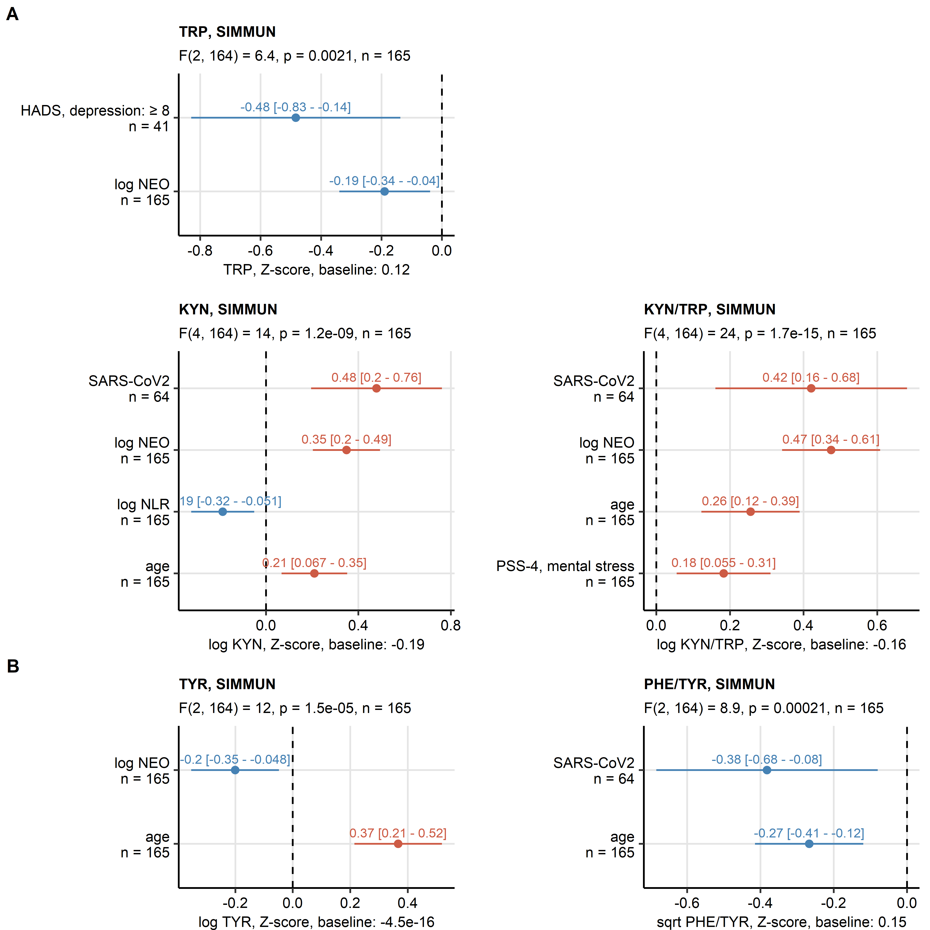

Figure 1: Results of multi-parameter linear modeling of tryptophan, kynurenine, kynurenine/tryptophan ratio, tyrosine and phenylalanine/tyrosine ratio in the SIMMUN cohort.

**Figure 1. Results of multi-parameter linear modeling of tryptophan, kynurenine, kynurenine/tryptophan ratio, tyrosine and phenylalanine/tyrosine ratio in the SIMMUN cohort.**

*Effects of markers of systemic inflammation (neopterin [NEO], neutrophil/lymphocyte ratio [NLR]), SARS-CoV-2 infection status, titer of immunoglobulin gamma against the receptor binding domain of the S1/S2 SARS-CoV-2 protein (anti-RBD IgG), clinically relevant symptoms of anxiety and depression (hospital depression and anxiety scale [HADS] 8 points), intensity of mental stress (perceived stress scale, 4 item [PSS-4]), age and sex on readouts of the kynurenine pathway (A, tryptophan [TRP], kynurenine [KYN], kynurenine/tryptophan ratio [KYN/TRP]) and the catecholamine pathway activity (B, phenylalanine [PHE], tyrosine [TYR], phenylalanine/tyrosine ratio [PHE/TYR]) were investigated by multi-parameter linear regression with backward elimination of non-significant terms. Numeric variables were normalized prior to modeling. Overall model validity was assessed by likelihood-ratio test (LRT) as compared with the respective null models. Coefficient estimates () with 95% confidence intervals are presented in Forest plots. LRT results (F values, degrees of freedom and p values) and total numbers of complete observations are indicated in the plot captions. Model intercepts (baseline) are indicated in the X axis titles.*

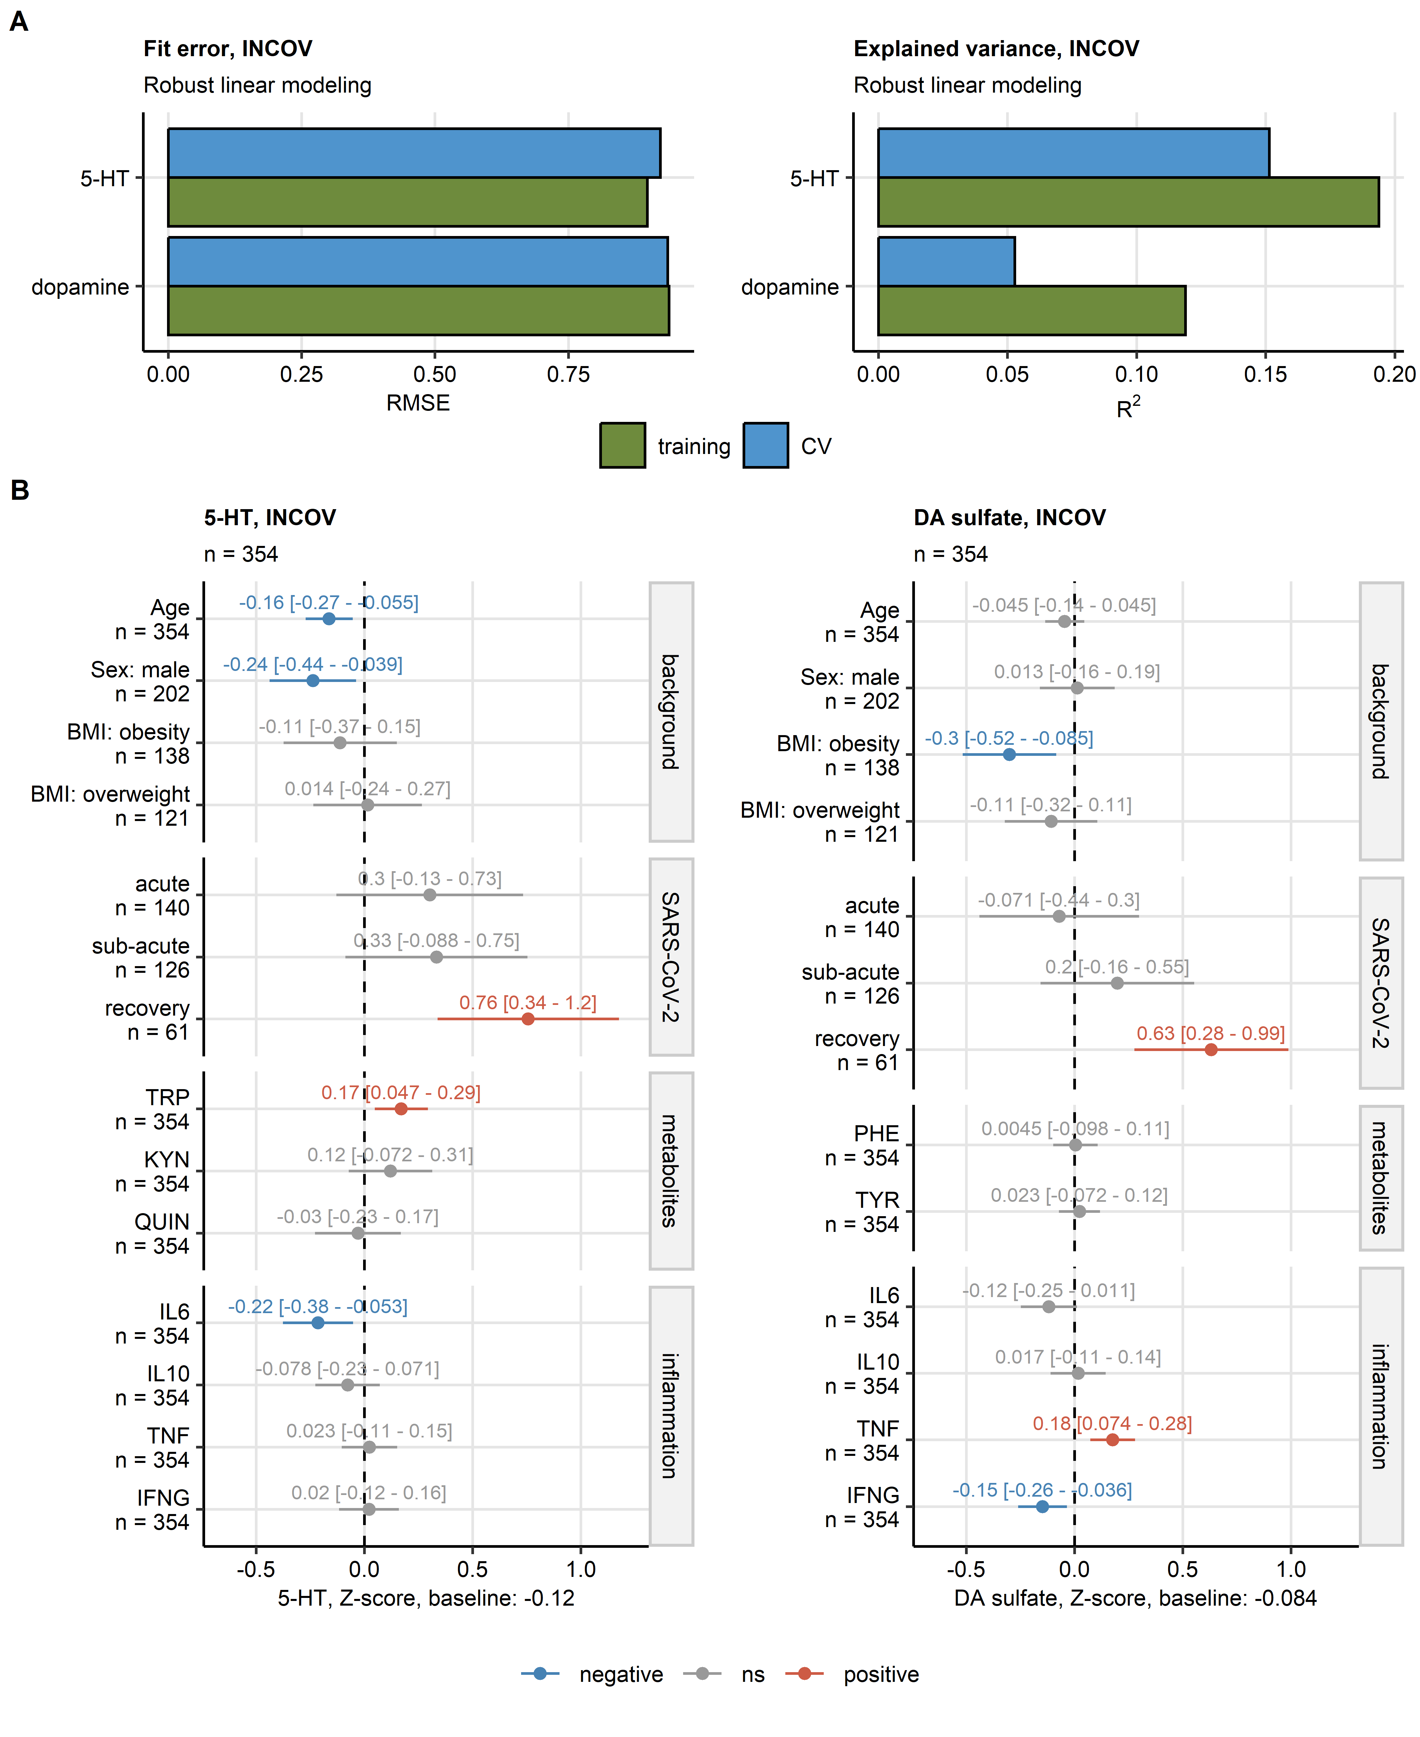

Figure 2: Results of multi-parameter robust linear modeling of plasma levels of serotonin and dopamine 3-O-sulfate in the INCOV cohort.

**Figure 2. Results of multi-parameter robust linear modeling of plasma levels of serotonin and dopamine 3-O-sulfate in the INCOV cohort.**

*Effects of age, timepoint of SARS-CoV-2 infection (acute: median 10 days, sub-acute: median 14 days, recovery: median 64 days after SARS-CoV-2 infection diagnosis via PCR), plasma levels of metabolites of the d kynurenine pathway (tryptophan [TRP], kynurenine [KYN], quinolinic acid [QUIN]), plasma levels of metabolites of the catecholamine pathway (phenylalanine [PHE], tyrosine [TYR]), and plasma concentrations of cytokine markers of inflammation (interleukin-6 [IL6], interleukin-10 [IL10], tumor necrosis factor-alpha [TNF] and interferon-gamma [IFNG]) on plasma concentrations of serotonin (5-hydroxy tryptamine [5-HT]) and dopamine 3-O-sulfate (DA sulfate) were modeled by multi-parameter robust linear regression.*

*(A) Model fit error (root mean square error [RMSE]) and fraction of explained variance (R2) of the robust linear models assessed in the training dataset and infection timepoint-stratified 10-fold cross-validation (CV).*

*(B) Estimates of model coefficients () with 95% confidence intervals presented in Forest plots. Numbers of complete observations are indicated in the plot captions. Model intercepts (baseline) are indicated in the X axis titles.*

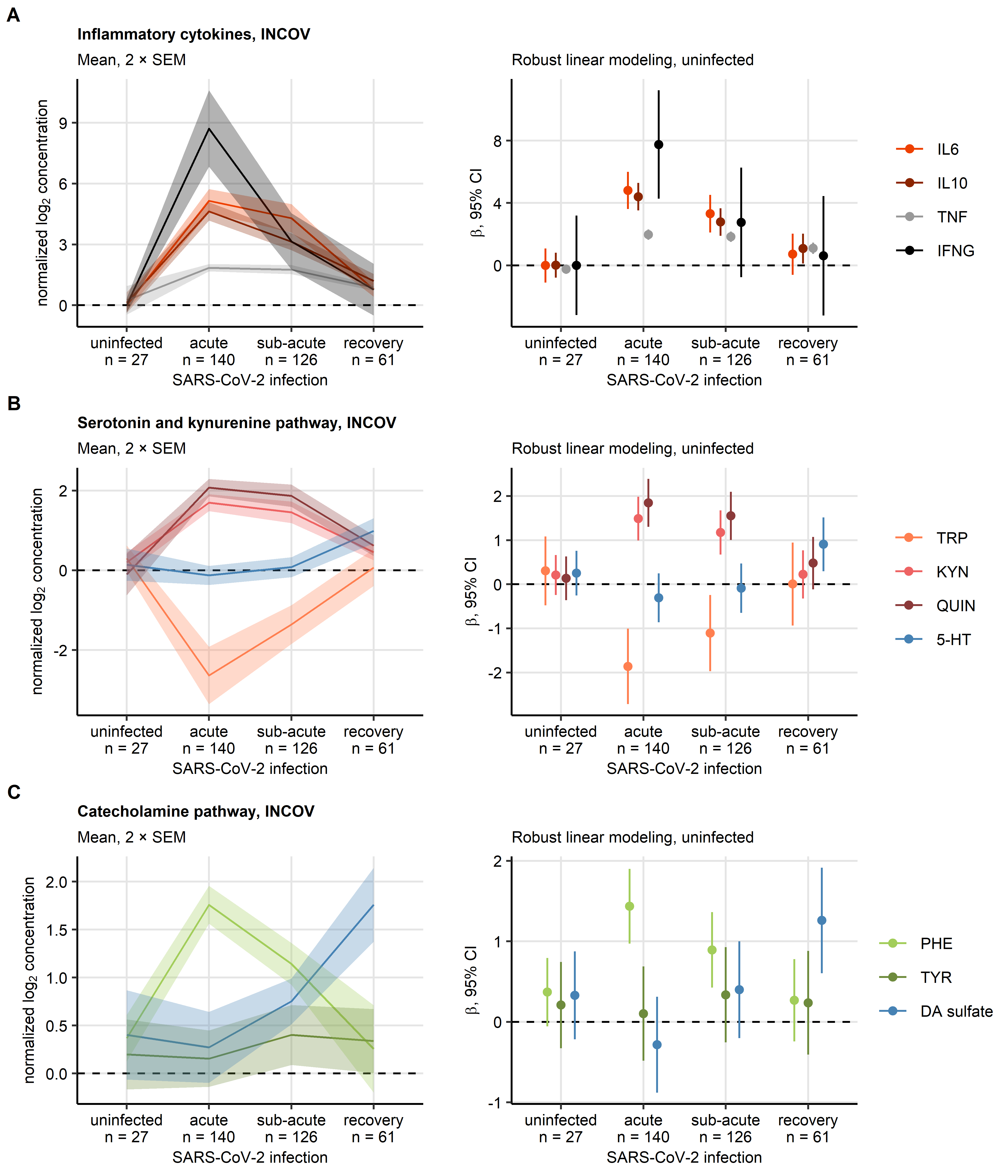

Figure 3: Time course of cytokine markers of inflammation, and metabolites of the kynurenine and catecholamine pathways during SARS-CoV-2 infection and recovery in the INCOV cohort.

**Figure 3. Time course of cytokine markers of inflammation, and metabolites of the kynurenine and catecholamine pathways during SARS-CoV-2 infection and recovery in the INCOV cohort.**

*Time courses of normalized log2-transformed plasma concentrations of cytokine markers of inflammation (A, interleukin-6 [IL6], interleukin-10 [IL-10], tumor necrosis factor-alpha [TNF], interferon gamma [INFG]), metabolites of the kynurenine pathways (B, tryptophan [TRP], kynurenine [KYN], quinolinic acid [QUIN], serotonin/5-hydroxy tryptamine [5-HT]), and metabolites of the catecholamine pathway (C, phenylalanine [PHE], tyrosine [TYR], dopamine 3-O-sulfate [DA sulfate]). Differences between uninfected controls and acute, sub-acute SARS-CoV-2 infection and recovery (median 10, 14 and 64 days after SARS-CoV-2 infection diagnosis via PCR, respectively) were modeled by robust linear regression with the uninfected controls as baseline. Mean normalized concentrations with 2 standard errors of the mean (2 SEM) are depicted as solid lines with tinted ribbons (plots on the left). Robust linear model coefficient estimates () with 95% confidence intervals are visualized in Forest plots (right). Numbers of complete observations per timepoint are indicated in the X axes.*

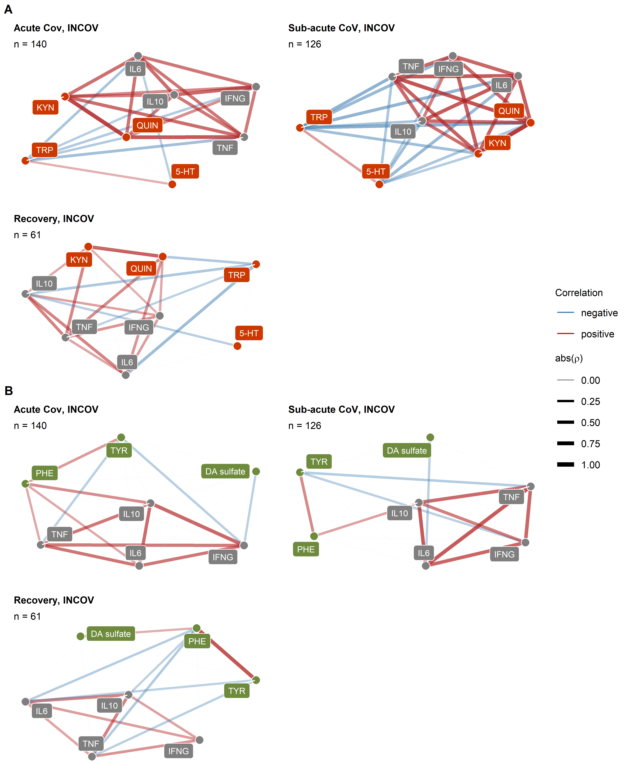

Figure 4: Correlation of plasma levels of cytokine markers of inflammation, and metabolites of the kynurenine and catecholamine pathways during SARS-CoV-2 infection in the INCOV cohort.

**Figure 4. Correlation of plasma levels of cytokine markers of inflammation, and metabolites of the kynurenine and catecholamine pathways during SARS-CoV-2 infection and recovery in the INCOV cohort.**

*Plasma levels of serotonin [5-hydroxy tryptamine, 5-HT], metabolites of the kynurenine pathway (tryptophan [TRP], kynurenine [KYN], quinolinic acid [QUIN]), metabolites of the catecholamine pathway (phenylalanine [PHE], tyrosine [TYR], dopamine 3-O-sulfate [DA sulfate]) and cytokine markers of inflammation (interleukin-6 [IL6], interleukin-10 [IL10], tumor necrosis factor-alpha [TNF], interferon-gamma [INFG]) were subjected to pairwise correlation analysis in SARS-CoV-2-infected individuals (acute: median 10 days, sub-acute: median 14 days, recovery: median 64 days after SARS-CoV-2 infection diagnosis via PCR). Correlation coefficient matrices for correlation coefficients > 0.2 were visualized as force-directed network plots. Node color codes for the variable type (gray: inflammatory markers, orange: serotonin and kynurenine pathway, green: catecholamine pathway), edge width and color codes for the value and sign of the correlation coefficient.*

# References

Al-Aly, Z., Xie, Y., Bowe, B., 2021. High-dimensional characterization of post-acute sequelae of COVID-19. Nature 594, 259–264. <https://doi.org/10.1038/s41586-021-03553-9>

Almulla, A.F., Supasitthumrong, T., Tunvirachaisakul, C., Algon, A.A.A., Al-Hakeim, H.K., Maes, M., 2022. The tryptophan catabolite or kynurenine pathway in COVID-19 and critical COVID-19: a systematic review and meta-analysis. BMC Infectious Diseases 22. <https://doi.org/10.1186/S12879-022-07582-1>

Badawy, A.A.B., 2017. Kynurenine pathway of tryptophan metabolism: Regulatory and functional aspects. International Journal of Tryptophan Research 10. <https://doi.org/10.1177/1178646917691938/ASSET/IMAGES/LARGE/10.1177_1178646917691938-FIG2.JPEG>

Benjamini, Y., Hochberg, Y., 1995. Controlling the False Discovery Rate: A Practical and Powerful Approach to Multiple Testing. Journal of the Royal Statistical Society: Series B (Methodological) 57, 289–300. <https://doi.org/10.1111/j.2517-6161.1995.tb02031.x>

Bizjak, D.A., Stangl, M., Börner, N., Bösch, F., Durner, J., Drunin, G., Buhl, J.L., Abendroth, D., 2022. Kynurenine serves as useful biomarker in acute, Long- and Post-COVID-19 diagnostics. Frontiers in immunology 13. <https://doi.org/10.3389/FIMMU.2022.1004545>

Bjelland, I., Dahl, A.A., Haug, T.T., Neckelmann, D., 2002. The validity of the Hospital Anxiety and Depression Scale: An updated literature review. Journal of Psychosomatic Research 52, 69–77. <https://doi.org/10.1016/S0022-3999(01)00296-3>

Bonaccorso, S., Marino, V., Puzella, A., Pasquini, M., Biondi, M., Artini, M., Almerighi, C., Verkerk, R., Meltzer, H., Maes, M., 2002. Increased depressive ratings in patients with hepatitis C receiving interferon-alpha-based immunotherapy are related to interferon-alpha-induced changes in the serotonergic system. Journal of clinical psychopharmacology 22, 86–90. <https://doi.org/10.1097/00004714-200202000-00014>

Bower, J.E., Radin, A., Kuhlman, K.R., 2022. Psychoneuroimmunology in the time of COVID-19: Why neuro-immune interactions matter for mental and physical health. Behaviour Research and Therapy 154, 104104. <https://doi.org/10.1016/J.BRAT.2022.104104>

Brown, S.J., Huang, X.F., Newell, K.A., 2021. The kynurenine pathway in major depression: What we know and where to next. Neuroscience & Biobehavioral Reviews 127, 917–927. <https://doi.org/10.1016/J.NEUBIOREV.2021.05.018>

Capuron, L., Schroecksnadel, S., Féart, C., Aubert, A., Higueret, D., Barberger-Gateau, P., Layé, S., Fuchs, D., 2011. Chronic low-grade inflammation in elderly persons is associated with altered tryptophan and tyrosine metabolism: role in neuropsychiatric symptoms. Biological psychiatry 70, 175–182. <https://doi.org/10.1016/J.BIOPSYCH.2010.12.006>

Ceballos, F.C., Virseda-Berdices, A., Resino, S., Ryan, P., Martínez-González, O., Peréz-García, F., Martin-Vicente, M., Brochado-Kith, O., Blancas, R., Bartolome-Sánchez, S., Vidal-Alcántara, E.J., Albóniga-Díez, O.E., Cuadros-González, J., Blanca-López, N., Martínez, I., Martinez-Acitores, I.R., Barbas, C., Fernández-Rodríguez, A., Jiménez-Sousa, M.Á., 2022. Metabolic Profiling at COVID-19 Onset Shows Disease Severity and Sex-Specific Dysregulation. Frontiers in Immunology 13, 3155. <https://doi.org/10.3389/FIMMU.2022.925558/BIBTEX>

Cervenka, I., Agudelo, L.Z., Ruas, J.L., 2017. Kynurenines: Tryptophan’s metabolites in exercise, inflammation, and mental health. Science (New York, N.Y.) 357. <https://doi.org/10.1126/SCIENCE.AAF9794>

Clark, S.M., Pocivavsek, A., Nicholson, J.D., Notarangelo, F.M., Langenberg, P., McMahon, R.P., Kleinman, J.E., Hyde, T.M., Stiller, J., Postolache, T.T., Schwarcz, R., Tonelli, L.H., 2016. Reduced kynurenine pathway metabolism and cytokine expression in the prefrontal cortex of depressed individuals. Journal of Psychiatry and Neuroscience 41, 386–394. <https://doi.org/10.1503/JPN.150226>

Cohen, S., Kamarck, T., Mermelstein, R., 1983. A global measure of perceived stress. Journal of health and social behavior 24, 385–396. <https://doi.org/10.2307/2136404>

Csardi, G., Nepusz, T., 2006. [The igraph software package for complex network research](https://igraph.org/). InterJournal Complex Sy, 1695.

Cysique, L.A., Jakabek, D., Bracken, S.G., Allen-Davidian, Y., Heng, B., Chow, S., Dehhaghi, M., Pires, A.S., Darley, D.R., Byrne, A., Phetsouphanh, C., Kelleher, A., Dore, G.J., Matthews, G.V., Guillemin, G.J., Brew, B.J., 2022. Post-acute COVID-19 cognitive impairment and decline uniquely associate with kynurenine pathway activation: a longitudinal observational study. medRxiv 2022.06.07.22276020. <https://doi.org/10.1101/2022.06.07.22276020>

Dantzer, R., O’Connor, J.C., Freund, G.G., Johnson, R.W., Kelley, K.W., 2008. From inflammation to sickness and depression: when the immune system subjugates the brain. Nature reviews. Neuroscience 9, 46–56. <https://doi.org/10.1038/NRN2297>

Deisenhammer, F., Bauer, A., Kavelar, C., Rudzki, D., Rössler, A., Kimpel, J., Borena, W., Reindl, M., 2021. 12-month SARS-CoV-2 antibody persistency in a Tyrolean COVID-19 cohort. Wiener klinische Wochenschrift 133, 1265–1271. <https://doi.org/10.1007/S00508-021-01985-X>

Dewulf, J.P., Martin, M., Marie, S., Oguz, F., Belkhir, L., De Greef, J., Yombi, J.C., Wittebole, X., Laterre, P.F., Jadoul, M., Gatto, L., Bommer, G.T., Morelle, J., 2022. Urine metabolomics links dysregulation of the tryptophan-kynurenine pathway to inflammation and severity of COVID-19. Scientific reports 12. <https://doi.org/10.1038/S41598-022-14292-W>

Dickens, C., Creed, F., 2001. The burden of depression in patients with rheumatoid arthritis. Rheumatology 40, 1327–1330. <https://doi.org/10.1093/RHEUMATOLOGY/40.12.1327>

Eroğlu, İ., Eroğlu, B.Ç., Güven, G.S., 2021. Altered tryptophan absorption and metabolism could underlie long-term symptoms in survivors of coronavirus disease 2019 (COVID-19). Nutrition (Burbank, Los Angeles County, Calif.) 90. <https://doi.org/10.1016/J.NUT.2021.111308>

Fellendorf, F.T., Bonkat, N., Dalkner, N., Schönthaler, E.M.D., Manchia, M., Fuchs, D., Reininghaus, E.Z., 2022. Indoleamine 2,3-dioxygenase (IDO)-activity in Severe Psychiatric Disorders: A Systemic Review. Current Topics in Medicinal Chemistry 22. <https://doi.org/10.2174/1568026622666220718155616>

Geisler, S., Gostner, J.M., Becker, K., Ueberall, F., Fuchs, D., 2013. Immune activation and inflammation increase the plasma phenylalanine-to- tyrosine ratio. Pteridines 24, 27–31. <https://doi.org/10.1515/PTERID-2013-0001/MACHINEREADABLECITATION/RIS>

Goldstein, D.S., Swoboda, K.J., Miles, J.M., Coppack, S.W., Aneman, A., Holmes, C., Lamensdorf, I., Eisenhofer, G., 1999. Sources and physiological significance of plasma dopamine sulfate. The Journal of clinical endocrinology and metabolism 84, 2523–2531. <https://doi.org/10.1210/JCEM.84.7.5864>

Gostner, J.M., Kurz, K., Fuchs, D., 2020. The significance of tryptophan metabolism and vitamin B-6 status in cardiovascular disease. The American Journal of Clinical Nutrition 111, 8–9. <https://doi.org/10.1093/AJCN/NQZ291>

Huang, C., Huang, L., Wang, Y., Li, X., Ren, L., Gu, X., Kang, L., Guo, L., Liu, M., Zhou, X., Luo, J., Huang, Z., Tu, S., Zhao, Y., Chen, L., Xu, D., Li, Y., Li, C., Peng, L., Li, Y., Xie, W., Cui, D., Shang, L., Fan, G., Xu, J., Wang, G., Wang, Y., Zhong, J., Wang, C., Wang, J., Zhang, D., Cao, B., 2021. 6-month consequences of COVID-19 in patients discharged from hospital: a cohort study. The Lancet 397, 220–232. <https://doi.org/10.1016/S0140-6736(20)32656-8>

Huber, P.J., 2011. Robust Statistics. International Encyclopedia of Statistical Science 1248–1251. <https://doi.org/10.1007/978-3-642-04898-2_594>

Hüfner, K., Fuchs, D., Blauth, M., Sperner-Unterweger, B., 2019. How acute and chronic physical disease may influence mental health – An Analysis of neurotransmitter precursor amino acid levels. Psychoneuroendocrinology 106, 95–101. <https://doi.org/10.1016/j.psyneuen.2019.03.028>

Hüfner, K., Giesinger, J.M., Gostner, J.M., Egeter, J., Koudouovoh-Tripp, P., Vill, T., Fuchs, D., Sperner-Unterweger, B., 2021. Neurotransmitter Precursor Amino Acid Ratios Show Differential, Inverse Correlations with Depression Severity in the Low and High Depression Score Range. International Journal of Tryptophan Research : IJTR 14. <https://doi.org/10.1177/11786469211039220>

Hüfner, K., Oberguggenberger, A., Kohl, C., Geisler, S., Gamper, E., Meraner, V., Egeter, J., Hubalek, M., Beer, B., Fuchs, D., Sperner-Unterweger, B., 2015. Levels in neurotransmitter precursor amino acids correlate with mental health in patients with breast cancer. Psychoneuroendocrinology 60, 28–38. <https://doi.org/10.1016/J.PSYNEUEN.2015.06.001>

Hüfner, K., Tymoszuk, P., Ausserhofer, D., Sahanic, S., Pizzini, A., Rass, V., Galffy, M., Böhm, A., Kurz, K., Sonnweber, T., Tancevski, I., Kiechl, S., Huber, A., Plagg, B., Wiedermann, C.J., Bellmann-Weiler, R., Bachler, H., Weiss, G., Piccoliori, G., Helbok, R., Loeffler-Ragg, J., Sperner-Unterweger, B., 2022. Who Is at Risk of Poor Mental Health Following Coronavirus Disease-19 Outpatient Management? Frontiers in Medicine 9. <https://doi.org/10.3389/fmed.2022.792881>

Hunt, C., Macedo e Cordeiro, T., Suchting, R., Dios, C. de, Cuellar Leal, V.A., Soares, J.C., Dantzer, R., Teixeira, A.L., Selvaraj, S., 2020. Effect of immune activation on the kynurenine pathway and depression symptoms – A systematic review and meta-analysis. <https://doi.org/10.1016/j.neubiorev.2020.08.010>

Knox, W.E., 1951. [Two mechanisms which increase in vivo the liver tryptophan peroxidase activity: specific enzyme adaptation and stimulation of the pituitary adrenal system.](https://www.ncbi.nlm.nih.gov/pubmed/14886511) British journal of experimental pathology 32, 462–469.

Kucukkarapinar, M., Yay-Pence, A., Yildiz, Y., Buyukkoruk, M., Yaz-Aydin, G., Deveci-Bulut, T.S., Gulbahar, O., Senol, E., Candansayar, S., 2022. Psychological outcomes of COVID-19 survivors at sixth months after diagnose: the role of kynurenine pathway metabolites in depression, anxiety, and stress. Journal of Neural Transmission 129. <https://doi.org/10.1007/s00702-022-02525-1>

Lin, H., Liu, X., Sun, H., Zhang, J., Dong, S., Liu, M., Li, L., Tian, J., Guo, Y., Gan, J., Chen, Z., Wang, X., Lin, Y., Zhang, D., Liu, Y., Zhang, X., Liu, P., Xu, K., Zhou, X., Liang, H., Gao, G.F., Liu, W.J., Wu, G., 2022. Sustained abnormality with recovery of COVID-19 convalescents: a 2-year follow-up study. Science Bulletin 67, 1556. <https://doi.org/10.1016/J.SCIB.2022.06.025>

Lionetto, L., Ulivieri, M., Capi, M., De Bernardini, D., Fazio, F., Petrucca, A., Pomes, L.M., De Luca, O., Gentile, G., Casolla, B., Curto, M., Salerno, G., Schillizzi, S., Torre, M.S., Santino, I., Rocco, M., Marchetti, P., Aceti, A., Ricci, A., Bonfini, R., Nicoletti, F., Simmaco, M., Borro, M., 2021. Increased kynurenine-to-tryptophan ratio in the serum of patients infected with SARS-CoV2: An observational cohort study. Biochimica et biophysica acta. Molecular basis of disease 1867. <https://doi.org/10.1016/J.BBADIS.2020.166042>

Lukić, I., Ivković, S., Mitić, M., Adžić, M., 2022. Tryptophan metabolites in depression: Modulation by gut microbiota. Frontiers in Behavioral Neuroscience 16, 367. <https://doi.org/10.3389/FNBEH.2022.987697/BIBTEX>

Luporini, R.L., Pott-Junior, H., Di Medeiros Leal, M.C.B., Castro, A., Ferreira, A.G., Cominetti, M.R., de Freitas Anibal, F., 2021. Phenylalanine and COVID-19: Tracking disease severity markers. International Immunopharmacology 101, 108313. <https://doi.org/10.1016/J.INTIMP.2021.108313>

Maes, M., Berk, M., Goehler, L., Song, C., Anderson, G., Gałecki, P., Leonard, B., 2012. Depression and sickness behavior are Janus-faced responses to shared inflammatory pathways. BMC Medicine 10, 1–19. <https://doi.org/10.1186/1741-7015-10-66/TABLES/1>

Maes, M., Schotte, C., Scharpé, S., Martin, M., Blockx, P., 1990. The effects of glucocorticoids on the availability of L-tryptophan and tyrosine in the plasma of depressed patients. Journal of Affective Disorders 18, 121–127. <https://doi.org/10.1016/0165-0327(90)90068-J>

Marx, W., McGuinness, A.J., Rocks, T., Ruusunen, A., Cleminson, J., Walker, A.J., Gomes-da-Costa, S., Lane, M., Sanches, M., Diaz, A.P., Tseng, P.T., Lin, P.Y., Berk, M., Clarke, G., O’Neil, A., Jacka, F., Stubbs, B., Carvalho, A.F., Quevedo, J., Soares, J.C., Fernandes, B.S., 2020. The kynurenine pathway in major depressive disorder, bipolar disorder, and schizophrenia: a meta-analysis of 101 studies. Molecular Psychiatry 2020 26:8 26, 4158–4178. <https://doi.org/10.1038/s41380-020-00951-9>

Matits, L., Munk, M., Bizjak, D.A., Kolassa, I.T., Karrasch, S., Vollrath, S., Jerg, A., Steinacker, J.M., 2023. Inflammation and severity of depressive symptoms in physically active individuals after COVID-19 - An exploratory immunopsychological study investigating the effect of inflammation on depressive symptom severity. Brain, behavior, & immunity - health 30. <https://doi.org/10.1016/J.BBIH.2023.100614>

Mayerl, H., Stolz, E., Freidl, W., 2020. Frailty and depression: Reciprocal influences or common causes? Social Science & Medicine 263, 113273. <https://doi.org/10.1016/J.SOCSCIMED.2020.113273>

McDonald, R.P., 1999. Test theory: A unified treatment, 1st Editio. ed. Psychology Press, New Yor. <https://doi.org/10.4324/9781410601087>

Meiser, J., Weindl, D., Hiller, K., 2013. Complexity of dopamine metabolism. Cell Communication and Signaling 11, 1–18. <https://doi.org/10.1186/1478-811X-11-34/FIGURES/5>

Miller, C.L., Llenos, I.C., Cwik, M., Walkup, J., Weis, S., 2008. Alterations in kynurenine precursor and product levels in schizophrenia and bipolar disorder. Neurochemistry International 52, 1297–1303. <https://doi.org/10.1016/J.NEUINT.2008.01.013>

Mitchell, A.J., Chan, M., Bhatti, H., Halton, M., Grassi, L., Johansen, C., Meader, N., 2011. Prevalence of depression, anxiety, and adjustment disorder in oncological, haematological, and palliative-care settings: a meta-analysis of 94 interview-based studies. The Lancet. Oncology 12, 160–174. <https://doi.org/10.1016/S1470-2045(11)70002-X>

Moncrieff, J., Cooper, R.E., Stockmann, T., Amendola, S., Hengartner, M.P., Horowitz, M.A., 2022. The serotonin theory of depression: a systematic umbrella review of the evidence. Molecular Psychiatry 2022 1–14. <https://doi.org/10.1038/s41380-022-01661-0>

Neurauter, G., Schrocksnadel, K., Scholl-Burgi, S., Sperner-Unterweger, B., Schubert, C., Ledochowski, M., Fuchs, D., 2008. Chronic immune stimulation correlates with reduced phenylalanine turnover. Current drug metabolism 9, 622–627. <https://doi.org/10.2174/138920008785821738>

Peters, R., 2006. Ageing and the brain. Postgraduate medical journal 82, 84–88. <https://doi.org/10.1136/PGMJ.2005.036665>

Rahimian, R., Belliveau, C., Chen, R., Mechawar, N., 2022. Microglial Inflammatory-Metabolic Pathways and Their Potential Therapeutic Implication in Major Depressive Disorder. Frontiers in psychiatry 13. <https://doi.org/10.3389/FPSYT.2022.871997>

Rajan, S., McKee, M., Rangarajan, S., Bangdiwala, S., Rosengren, A., Gupta, R., Kutty, V.R., Wielgosz, A., Lear, S., Alhabib, K.F., Co, H.U., Lopez-Jaramillo, P., Avezum, A., Seron, P., Oguz, A., Kruger, I.M., Diaz, R., Nafiza, M.N., Chifamba, J., Yeates, K., Kelishadi, R., Sharief, W.M., Szuba, A., Khatib, R., Rahman, O., Iqbal, R., Bo, H., Yibing, Z., Wei, L., Yusuf, S., 2020. Association of Symptoms of Depression With Cardiovascular Disease and Mortality in Low-, Middle-, and High-Income Countries. JAMA psychiatry 77, 1052–1063. <https://doi.org/10.1001/JAMAPSYCHIATRY.2020.1351>

Renault, P.F., Hoofnagle, J.H., Park, Y., Mullen, K.D., Peters, M., Jones, D.B., Rustgi, V., Jones, E.A., 1987. Psychiatric Complications of Long-term Interferon Alfa Therapy. Archives of Internal Medicine 147, 1577–1580. <https://doi.org/10.1001/ARCHINTE.1987.00370090055011>

Robinson, C.M., Shirey, K.A., Carlin, J.M., 2003. Synergistic Transcriptional Activation of Indoleamine Dioxygenase by IFN- and Tumor Necrosis Factor-. Journal of interferon & cytokine research : the official journal of the International Society for Interferon and Cytokine Research 23, 413. <https://doi.org/10.1089/107999003322277829>

Sahanic, S., Tymoszuk, P., Luger, A.K., Hüfner, K., Boehm, A., Pizzini, A., Schwabl, C., Koppelstätter, S., Kurz, K., Asshoff, M., Mosheimer-Feistritzer, B., Coen, M., Pfeifer, B., Rass, V., Egger, A., Hörmann, G., Sperner-Unterweger, B., Helbok, R., Wöll, E., Weiss, G., Widmann, G., Tancevski, I., Sonnweber, T., Löffler-Ragg, J., 2023. COVID-19 and its continuing burden after 12 months: a longitudinal observational prospective multicentre trial. ERJ open research 9, 00317–2022. <https://doi.org/10.1183/23120541.00317-2022>

Santiago-Mujika, E., Heinrich, K., George, S., Forton, C., Madaj, Z., Burmeister, A.R., Sims, M., Pospisilik, A., Brundin, P., Graham, S.F., Brundin, L., Beaumont, W., 2022. Increased levels of circulating neurotoxic metabolites in patients with mild Covid19. bioRxiv 2022.06.22.497189. <https://doi.org/10.1101/2022.06.22.497189>

Schwarcz, R., Bruno, J.P., Muchowski, P.J., Wu, H.Q., 2012. Kynurenines in the mammalian brain: When physiology meets pathology. <https://doi.org/10.1038/nrn3257>

Sorgdrager, F.J.H., Naudé, P.J.W., Kema, I.P., Nollen, E.A., De Deyn, P.P., 2019. Tryptophan metabolism in inflammaging: From biomarker to therapeutic target. Frontiers in Immunology 10, 2565. <https://doi.org/10.3389/FIMMU.2019.02565/BIBTEX>

Staudt, A., Jörres, R.A., Hinterberger, T., Lehnen, N., Loew, T., Budweiser, S., 2022. Associations of Post-Acute COVID syndrome with physiological and clinical measures 10 months after hospitalization in patients of the first wave. European Journal of Internal Medicine 95. <https://doi.org/10.1016/j.ejim.2021.10.031>

Su, Y., Chen, D., Yuan, D., Lausted, C., Choi, J., Dai, C.L., Voillet, V., Duvvuri, V.R., Scherler, K., Troisch, P., Baloni, P., Qin, G., Smith, B., Kornilov, S.A., Rostomily, C., Xu, A., Li, J., Dong, S., Rothchild, A., Zhou, J., Murray, K., Edmark, R., Hong, S., Heath, J.E., Earls, J., Zhang, R., Xie, J., Li, S., Roper, R., Jones, L., Zhou, Y., Rowen, L., Liu, R., Mackay, S., O’Mahony, D.S., Dale, C.R., Wallick, J.A., Algren, H.A., Zager, M.A., Wei, W., Price, N.D., Huang, S., Subramanian, N., Wang, K., Magis, A.T., Hadlock, J.J., Hood, L., Aderem, A., Bluestone, J.A., Lanier, L.L., Greenberg, P.D., Gottardo, R., Davis, M.M., Goldman, J.D., Heath, J.R., 2020. Multi-Omics Resolves a Sharp Disease-State Shift between Mild and Moderate COVID-19. Cell 183, 1479. <https://doi.org/10.1016/J.CELL.2020.10.037>

Su, Y., Yuan, D., Chen, D.G., Ng, R.H., Wang, K., Choi, J., Li, S., Hong, S., Zhang, R., Xie, J., Kornilov, S.A., Scherler, K., Pavlovitch-Bedzyk, A.J., Dong, S., Lausted, C., Lee, I., Fallen, S., Dai, C.L., Baloni, P., Smith, B., Duvvuri, V.R., Anderson, K.G., Li, J., Yang, F., Duncombe, C.J., McCulloch, D.J., Rostomily, C., Troisch, P., Zhou, J., Mackay, S., DeGottardi, Q., May, D.H., Taniguchi, R., Gittelman, R.M., Klinger, M., Snyder, T.M., Roper, R., Wojciechowska, G., Murray, K., Edmark, R., Evans, S., Jones, L., Zhou, Y., Rowen, L., Liu, R., Chour, W., Algren, H.A., Berrington, W.R., Wallick, J.A., Cochran, R.A., Micikas, M.E., Wrin, T., Petropoulos, C.J., Cole, H.R., Fischer, T.D., Wei, W., Hoon, D.S.B., Price, N.D., Subramanian, N., Hill, J.A., Hadlock, J., Magis, A.T., Ribas, A., Lanier, L.L., Boyd, S.D., Bluestone, J.A., Chu, H., Hood, L., Gottardo, R., Greenberg, P.D., Davis, M.M., Goldman, J.D., Heath, J.R., 2022. Multiple early factors anticipate post-acute COVID-19 sequelae. Cell 185, 881–895.e20. <https://doi.org/10.1016/J.CELL.2022.01.014>

Suominen, T., Uutela, P., Ketola, R.A., Bergquist, J., Hillered, L., Finel, M., Zhang, H., Laakso, A., Kostiainen, R., 2013. Determination of Serotonin and Dopamine Metabolites in Human Brain Microdialysis and Cerebrospinal Fluid Samples by UPLC-MS/MS: Discovery of Intact Glucuronide and Sulfate Conjugates. PLOS ONE 8, e68007. <https://doi.org/10.1371/JOURNAL.PONE.0068007>

Thomas, T., Stefanoni, D., Reisz, J.A., Nemkov, T., Bertolone, L., Francis, R.O., Hudson, K.E., Zimring, J.C., Hansen, K.C., Hod, E.A., Spitalnik, S.L., D’Alessandro, A., 2020. COVID-19 infection alters kynurenine and fatty acid metabolism, correlating with IL-6 levels and renal status. JCI Insight 5. <https://doi.org/10.1172/JCI.INSIGHT.140327>

Valdiglesias, V., Marcos-Pérez, D., Lorenzi, M., Onder, G., Gostner, J.M., Strasser, B., Fuchs, D., Bonassi, S., 2018. Immunological alterations in frail older adults: A cross sectional study. Experimental gerontology 112, 119–126. <https://doi.org/10.1016/J.EXGER.2018.09.010>

Vancassel, S., Capuron, L., Castanon, N., 2018. Brain Kynurenine and BH4 Pathways: Relevance to the Pathophysiology and Treatment of Inflammation-Driven Depressive Symptoms. <https://doi.org/10.3389/fnins.2018.00499>Widner, B., Werner, E.R., Schennach, H., Wachter, H., Fuchs, D., 1997. Simultaneous measurement of serum tryptophan and kynurenine by HPLC. Clinical Chemistry 43, 2424–2426. <https://doi.org/10.1093/CLINCHEM/43.12.2424>

Zigmond, A.S., Snaith, R.P., 1983. The hospital anxiety and depression scale. Acta psychiatrica Scandinavica 67, 361–370. <https://doi.org/10.1111/J.1600-0447.1983.TB09716.X>